Assignment 04: ASP.NET Debugging

In this “hands-on” activity, you will discover more details about debugging ASP.NET pages that use client side, server side, and database functions. This activity will take you about 3 to 6 hours, so plan accordingly!

The activity consists of the following steps:
- Study web resources.
- Create your own demo
- Submit your work to the Canvas site.

Study web resource:
Please familiarize yourself with the following debugging topics.

1) ASP.NET debugging
https://msdn.microsoft.com/en-us/library/ms227556.aspx

2) Chrome Developer Tools (Devtools) Tutorial Introduction for Beginners
https://www.youtube.com/watch?v=wcFnnxfA70g

3) Walkthrough: Using SQL Profiler
https://www.mssqltips.com/sqlservertutorial/272/profiler-and-server-side-traces/

4) Using Glimpse
https://www.youtube.com/watch?v=ybIxZ6TTm_E

5) Glimpse for WebForms
https://www.youtube.com/watch?v=vS6ONq6YwyI

You will need a good understanding of how SQL Stored Procedures work to complete the final. You will start this process this week watching the following videos.

1) Stored Procedures
https://youtu.be/vQskj-Kr594

2) Stored Procedure Parameters
https://youtu.be/07UhBq7fgb8

3) Working With Stored Procedures
https://youtu.be/QhJoclEPzdY

Create a Demo
In Module 4, you saw your instructor debug client, server, and database code. You have also seen examples from the internet. Now that you have seen how others describe and demonstrate these concepts, let’s try out your skills by creating a data-driven web page. Make sure you debug it at the client, server, and database level and capture screenshots of you doing so!

1) Create a new ASP.NET website project called “Assignment04.”
2) Copy the files or code from Assignment03 to your new project and test it still works!
3) Run the following SQL Code to create that database, table and stored procedure for the assignment.

Create database ASPNetHomework;
Go

Use ASPNetHomework;
Go

CREATE TABLE [dbo].[Logins](
[LoginId] [int] IDENTITY(1,1) NOT NULL PRIMARY KEY,
[Name] [nvarchar](50) NOT NULL,
[EmailAddress] [nvarchar](50) NOT NULL,
[LoginName] [nvarchar](50) NOT NULL,
[ReasonForAccess] [nvarchar](50) NOT NULL
);
Go

Begin -- Batch of statements
Declare
@Name nVarchar(50) = 'Test'
,@EmailAddress nVarchar(50) = 'Test'
,@LoginName nVarchar(50) = 'Test'
,@ReasonForAccess nVarchar(50) = 'Test';

Insert into [Logins] ([Name],[EmailAddress],[LoginName],[ReasonForAccess])
Values ( @Name, @EmailAddress, @LoginName, @ReasonForAccess );
End -- Batch
Go

-- Test that the data is in the table
Select [Name],[EmailAddress],[LoginName],[ReasonForAccess]
From [Logins];
Go

Create Procedure pInsLogins
(
@Name nVarchar(50) = 'Default Value'
,@EmailAddress nVarchar(50) = 'Default Value'
,@LoginName nVarchar(50) = 'Default Value'
,@ReasonForAccess nVarchar(50) = 'Default Value'
)
AS
Begin --{ Batch of statements
Begin Try
Insert into [Logins] ([Name],[EmailAddress],[LoginName],[ReasonForAccess])
Values (@Name, @EmailAddress, @LoginName, @ReasonForAccess );
End Try
Begin Catch
RaisError('An error happend while inserting the login request', 15, 1);
End Catch
End --} Batch and Stored Procedure
Go

-- Test the Stored Procedure
Begin -- Batch of statements
Declare
@Name nVarchar(50) = 'Randal'
,@EmailAddress nVarchar(50) = 'Randal@Gmail.com'
,@LoginName nVarchar(50) = 'RjR'
,@ReasonForAccess nVarchar(50) = 'Because!';

Execute pInsLogins @Name, @EmailAddress, @LoginName, @ReasonForAccess;
End -- Batch
Go

-- Test that the data is in the table
Select [Name],[EmailAddress],[LoginName],[ReasonForAccess]
From [Logins];
Go

4) Modify the LoginRequest.aspx page, so it inserts data into a SQL table.

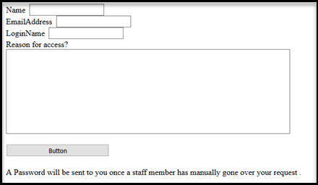

5) Debug the Client-Side code (Browser), Server-Side code (Visual Studio), and SQL code (SQL Profiler) to capture screenshots of the process.

Write a Paper
Create a Word document that outlines how you created and debugged your ASP.NET website. Write the document as a simple tutorial that coworker could read to understand what this technology does and how you might use it.

The document should be about 2 to 4 pages (including any pictures) in length, including screenshots. Please use Microsoft Word or something compatible with Word. I recommend that you start with the images, place them in your Word document, and then add a short paragraph to describe what you are seeing/doing.

NOTE: Format it like a college paper instead of the text message. I always expect things like having your name, date, class, and citations on your documents!

Submit your work to the Canvas site
After you complete you your Assignment website, place the resulting files and folders into another folder, and turn everything into a single zip file. Then post the zip file on the Canvas website, in the appropriate module under Assignments.
(http://www.wikihow.com/Zip-Files-Together)

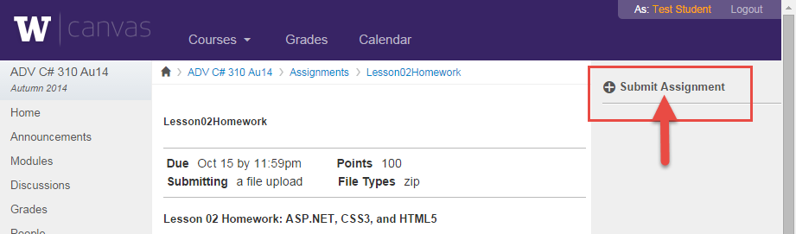

You’re done!

