Assignment 06: Managing State Data

In this “hands on” activity you will discover more about how to deal with state data and ASP.NET pages. This activity will take you about 3 to 6 hours, so plan accordingly!

The activity consists of the follow steps:
- Study web resources.
- Create your own demo
- Submit your work to the Canvas site.

Study web resource:
Please familiarize yourself with the following topics.

- ASP Tutorial
- http://www.w3schools.com/asp/asp_inputforms.asp
- http://www.w3schools.com/asp/asp_cookies.asp
- http://www.w3schools.com/asp/asp_sessions.asp
- http://www.w3schools.com/aspnet/aspnet_viewstate.asp

2) JSON Tutorial
- https://www.youtube.com/watch?v=EHkL__QIOUU

3) JSON Video
- https://www.youtube.com/watch?v=9xXr2EZfDPQ

Create your own demo
In Module 6, you saw your instructor used different ways to hold State data. You also saw examples from the internet. With that knowledge, demonstrate these concepts by creating 3 ASP.NET pages that show how Hidden inputs, Cookies, and Sessions are used to control state.

Next create a Word document showing what your demos do, written as if it were a tutorial (like the ones you have been using!).

1) Create a new ASP.NET website project called “Assignment06.”
2) Create 3 ASP.NET pages that show different method of managing state.
3) Create a tutorial document showing how to work with state in ASP.NET web pages.

NOTES:
1) Make your paper better by considering these tips:
http://justinseeley.com/tutorials/create-great-tutorials-subject/
2) Make sure you format it like a college paper instead of the text message. Things like having your name, date, class, and citations are always expected of a college student!
Please review this website for some examples: http://jerz.setonhill.edu/writing/academic1/mla-style-papers/ (Links to an external site.)
Note: Not putting your name, course, and date at the top of the document you will cost you 25% of your grade.

Submit your work to the Canvas site.
After you complete you your Assignment website, place the resulting files and folders into another folder, both the document and the Visual Studio Solution/Project sub-folder, and turn everything into a single zip file. Then post the zip file on the Canvas website, in the appropriate module under Assignments.
(http://www.wikihow.com/Zip-Files-Together)

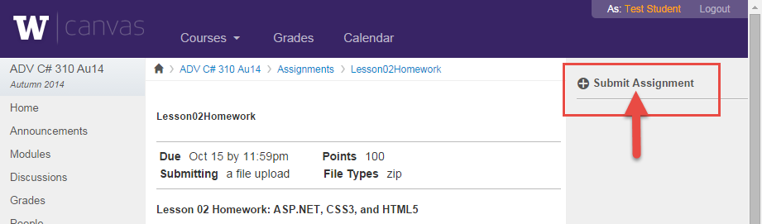

You’re done!!!

