**Introduction 2**

**Initial Setup 3**

**SQL Statements 3**

**● CREATE DATABASE & TABLES.sql 3**

**● INSERT INTO Dates.sql 3**

**● INSERT INTO Finances.sql 3**

**● INSERT INTO Origins.sql 3**

● INSERT INTO Platinums.sql 3

● INSERT INTO Trophies.sql 3

**● SELECT FROM.sql 3**

**● UPDATE TABLES.sql 3**

SQL Output 3

● complete_tables.xlsx 3

● dates_&_finances_all-time.xlsx 3

● dates_&_finances_monthly.xlsx 3

● origins.xlsx 3

● trophies & platinums.xlsx 3

● wishlist.xlsx 3

**Questions 4**

● Spending & Savings 4

● Countries & Developers 4

● Value for Money 4

● Purchases & Backlog 4

● Trophies 4

Spending & Savings 5

Countries & Developers 9

Value for Money 13

Annual Game Log & Backlog 16

Trophies 17

**References 18**

PSPrices 18

PSNProfiles 18

# **Introduction**

I decided to create this repository to display my relational databases, consisting of both my PlayStation & Nintendo video game collections.

I earned a Higher Diploma in Data Analytics from ATU Galway, along with the IT Specialist Certificate in Databases from Pearson Vue.

I thought of my video game collections as the perfect example of implementing my learnings from the above courses.

I have set up local T-SQL databases via Microsoft SQL Server 2014, and I am planning on implementing the databases on a website for remote access soon.

Data compilation and analysis were carried out to discover insights in relation to various matters, such as pricing & purchases of games per year or per month:

* Video game receipts issued to my Gmail account at times of purchase
* Raw data temporarily entered & compiled in Google Sheets files over a number of years, to be added to the database via Microsoft SQL Server 2014
* PSPrices, a video game deals tracker to help gamers find the best video game bargains.
* PSNProfiles, a video game tracker that logs video gaming activities

# **Initial Setup**

## **SQL Statements**

The sub-repository: **playstation/statements**, contains the following SQL files with queries created in relation to database design & management:

### **CREATE DATABASE & TABLES.sql**

* + Creates tables named **Dates, Finances, Origins, Platinums & Trophies**, containing various fields/columns of data.

### **INSERT INTO Dates.sql**

### **INSERT INTO Finances.sql**

### **INSERT INTO Origins.sql**

### **INSERT INTO Platinums.sql**

### **INSERT INTO Trophies.sql**

* + These INSERT INTO SQL files contain all info for data entry into each table.

### **SELECT FROM.sql**

* + Selects data from the tables, results are output & saved in XLSX format.

### **UPDATE TABLES.sql**

* + Updates values within the tables, such as correcting typos & numerical errors (misspelling of developers or prices).

## **SQL Output**

The sub-repository: playstation/output, contains the following XLSX files.

The results of SQL queries made in Microsoft SQL Server 2014 are saved in XLSX format & cross-checked via Google Sheets:

### **complete_tables.xlsx**

### **dates_&_finances_all-time.xlsx**

### **dates_&_finances_monthly.xlsx**

### **origins.xlsx**

### **platinums & trophies.xlsx**

### **wishlist.xlsx**

### 

# **Questions**

I noted the following topics in order to gain further insight into the collected data:

## **Spending & Savings**

* + The total number of video games & consoles in the collection
  + The total number of games purchased per console
  + Video games purchased per year
  + Video games purchased per month
  + The total number of video games redeemed as gifts & via subscription

## **Countries & Developers**

* + The total number of distinct countries & developers in the collection
  + The total number of games developed per distinct country
  + The total number of games developed per distinct developer

## **Value for Money**

* + The total hours & value for money per game in the collection:
    - Value for Money = **paid_price / hours**

## **Purchases & Backlog**

* + **TBC** - Queries to SELECT from tables to see filtered information regarding various dates such as release dates & finish dates of specific games

## **Trophies**

* + Platinum, Gold, Silver & Bronze trophies earned from 2009 to present.
    - Data to be updated monthly.

## **Spending & Savings**

* **complete_tables.xlsx & origins/consoles.xlsx (as of 4th December 2024):**
  + **1,047** distinct video games across **8** distinct consoles in the collection.
    - **PS1, PS2, PSP, PS3, VITA, PS4, PSVR, PS5**

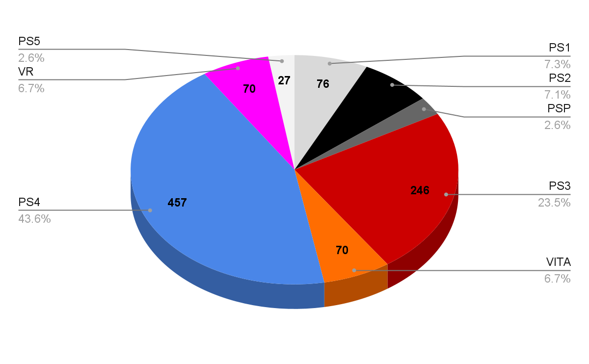

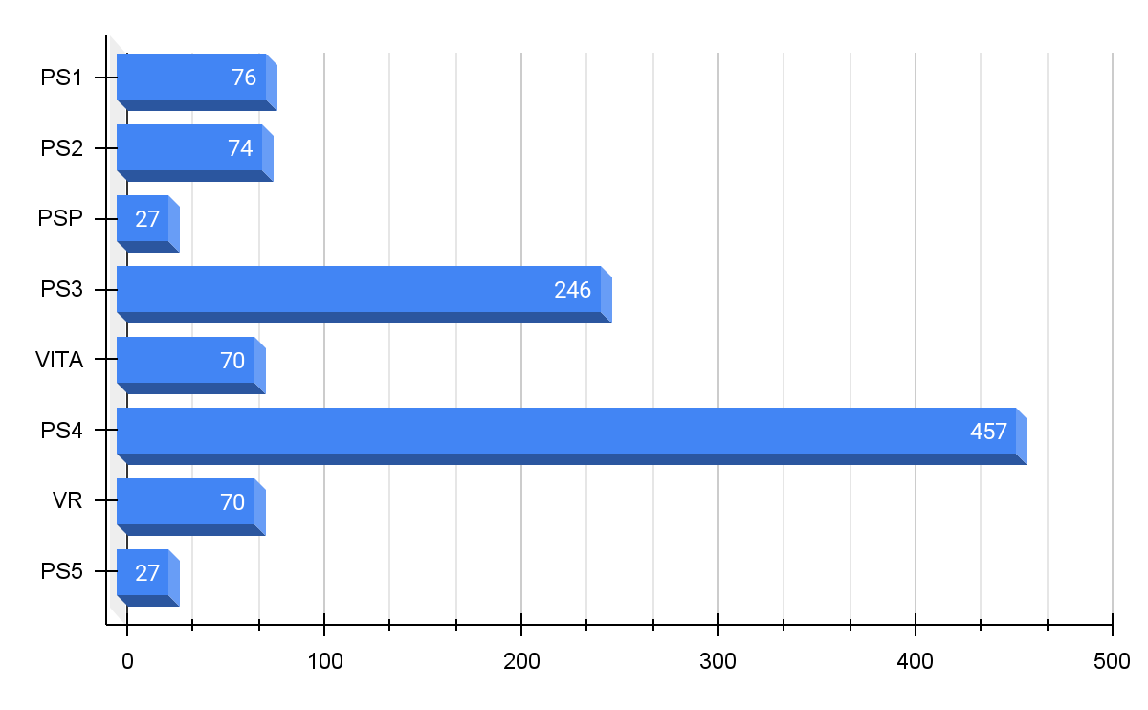

* **dates_&_*finances_all-time*.xlsx (as of 4th December 2024):**

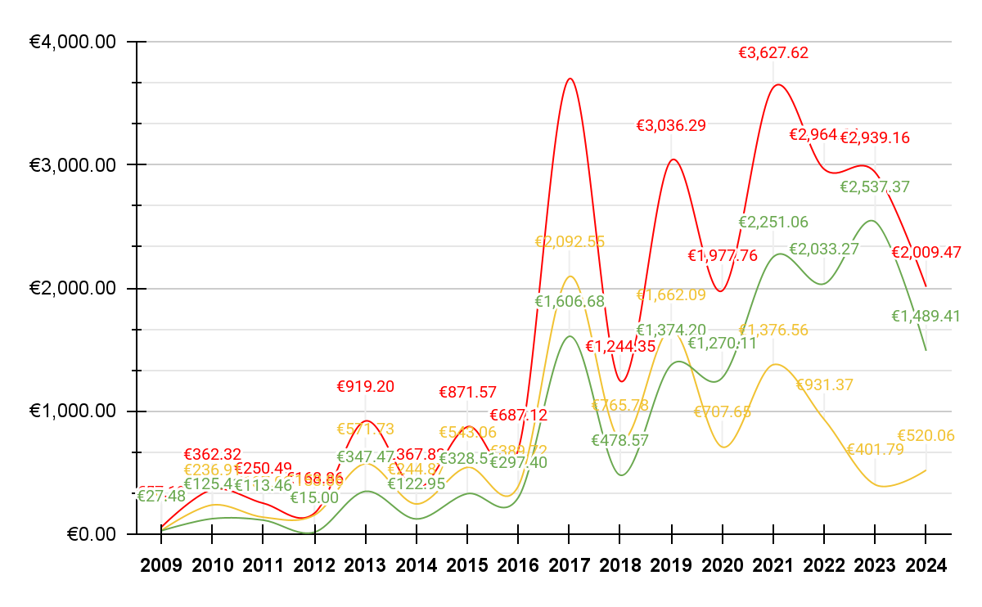

| **Year** | **Full_Price** | **Paid_Price** | **Savings** |
| --- | --- | --- | --- |
| **2009** | **€57.13** | **€29.65** | **€27.48** |
| **2010** | **€362.32** | **€236.91** | **€125.41** |
| **2011** | **€250.49** | **€137.03** | **€113.46** |
| **2012** | **€168.86** | **€153.86** | **€15.00** |
| **2013** | **€919.20** | **€571.73** | **€347.47** |
| **2014** | **€367.82** | **€244.87** | **€122.95** |
| **2015** | **€871.57** | **€543.06** | **€328.51** |
| **2016** | **€687.12** | **€389.72** | **€297.40** |
| **2017** | **€3,699.23** | **€2,092.55** | **€1,606.68** |
| **2018** | **€1,244.35** | **€765.78** | **€478.57** |
| **2019** | **€3,036.29** | **€1,662.09** | **€1,374.20** |
| **2020** | **€1,977.76** | **€707.65** | **€1,270.11** |
| **2021** | **€3,627.62** | **€1,376.56** | **€2,251.06** |
| **2022** | **€2,964.64** | **€931.37** | **€2,033.27** |
| **2023** | **€2,939.16** | **€401.79** | **€2,537.37** |
| **2024** | **€2,009.47** | **€520.06** | **€1,489.41** |
| **Totals** | **€25,183.03** | **€10,764.68** | **€14,418.35** |

* The full prices of all games on recorded purchase dates came to a total of **€25,183.03.**
* The paid prices (including birthday & Christmas gifts along with the PlayStation Plus Essential subscription service) came to a total of **€10,764.68**.
* This resulted in total savings of **€14,418.35** (**57%** of the full price):
  + The years 2017-2024 accounted for **€13,040.67** (**90%**) of total savings.
* How many video games were purchased in selected months?
  + **dates_&_finances_monthly.xlsx (as of 4th December 2024):**

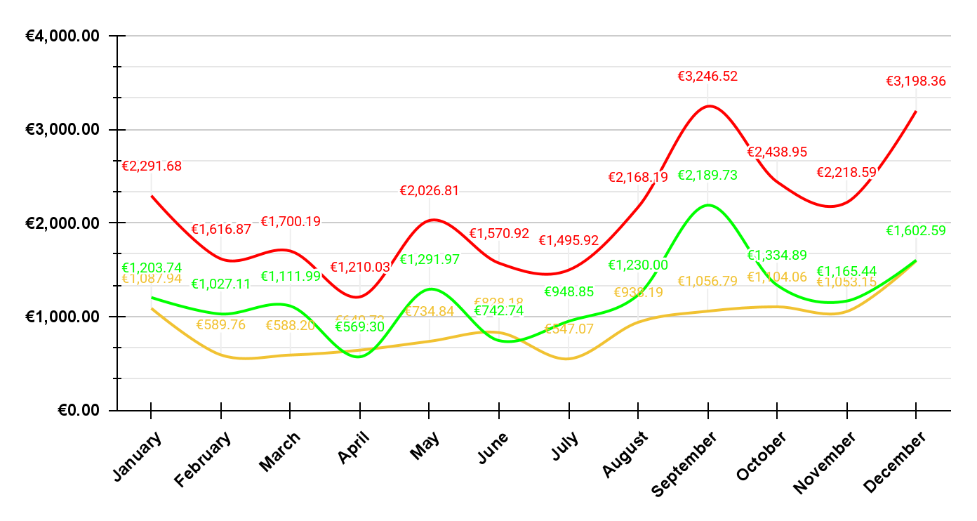

| **Month** | **Full_Price** | **Paid_Price** | **Savings** |
| --- | --- | --- | --- |
| **January** | **€2,291.68** | **€1,087.94** | **€1,203.74** |
| **February** | **€1,616.87** | **€589.76** | **€1,027.11** |
| **March** | **€1,700.19** | **€588.20** | **€1,111.99** |
| **April** | **€1,210.03** | **€640.73** | **€569.30** |
| **May** | **€2,026.81** | **€734.84** | **€1,291.97** |
| **June** | **€1,570.92** | **€828.18** | **€742.74** |
| **July** | **€1,495.92** | **€547.07** | **€948.85** |
| **August** | **€2,168.19** | **€938.19** | **€1,230.00** |
| **September** | **€3,246.52** | **€1,056.79** | **€2,189.73** |
| **October** | **€2,438.95** | **€1,104.06** | **€1,334.89** |
| **November** | **€2,218.59** | **€1,053.15** | **€1,165.44** |
| **December** | **€3,198.36** | **€1,595.77** | **€1,602.59** |
| **Totals** | **€25,183.03** | **€10,764.68** | **€14,418.35** |

* **September** saw the most game purchases & most savings, my birthday month.
* **August** was also a busy month, as a result of redeeming pre-orders prior to my birthday.
* **December & January** were also busy months as a result of the Christmas season with gifts received, along with the January sales for the best deals to redeem via the gifts.
* How many games were purchased via gift cards & PlayStation Plus?
  + **dates_&_finances_all-time.xlsx (as of 4th December 2024):**

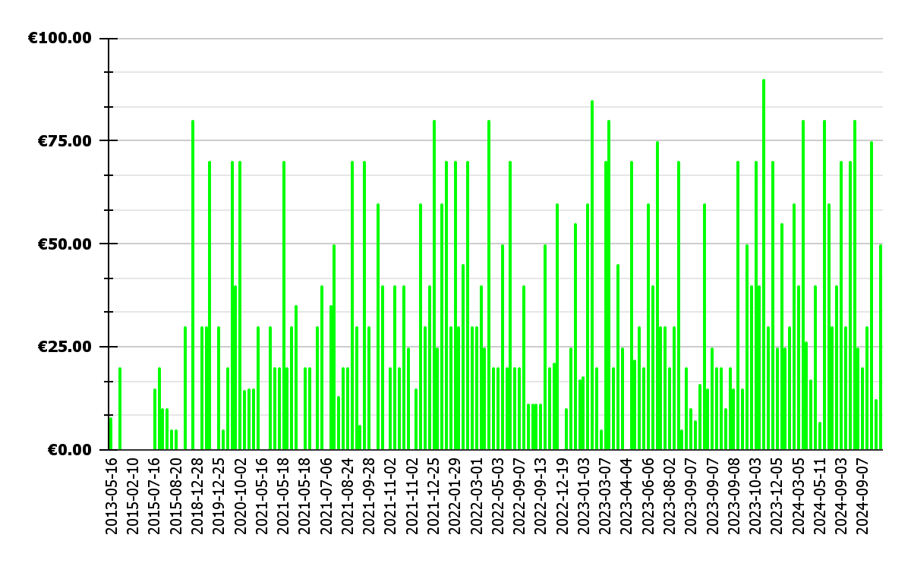

* + **180** games were purchased via birthday or Christmas gifts, along with the PlayStation Plus subscription service.
  + The total savings compared to the full price came to **€5,678.90** (an average of **€31.55** per game).
  + These savings account for approximately **33%** of the total savings.

## **Countries & Developers**

* How many distinct countries & developers make up the game collection?
  + **origins.xlsx (as of 4th December 2024):**
    - **526** distinct developers from **47** distinct countries:

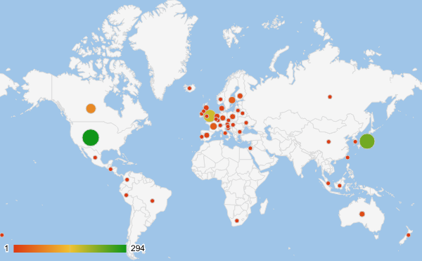

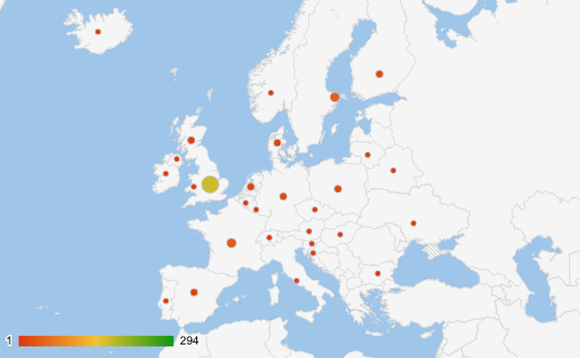

| **Country** | **Games** | **Country** | **Games** |
| --- | --- | --- | --- |
| **USA** | **294** | **Hungary** | **2** |
| **Japan** | **230** | **Korea Republic** | **2** |
| **England** | **171** | **Belarus** | **2** |
| **Canada** | **87** | **Lithuania** | **2** |
| **Sweden** | **40** | **Northern Ireland** | **2** |
| **France** | **38** | **New Zealand** | **1** |
| **Australia** | **21** | **Israel** | **1** |
| **Finland** | **18** | **Norway** | **1** |
| **Germany** | **17** | **Switzerland** | **1** |
| **Poland** | **16** | **Brazil** | **1** |
| **Spain** | **12** | **Peru** | **1** |
| **Netherlands** | **11** | **Portugal** | **1** |
| **Scotland** | **9** | **El Salvador** | **1** |
| **Denmark** | **9** | **Mexico** | **1** |
| **Italy** | **8** | **Luxembourg** | **1** |
| **Russia** | **6** | **Slovenia** | **1** |
| **Ukraine** | **6** | **Taiwan** | **1** |
| **China** | **5** | **Croatia** | **1** |
| **Wales** | **4** | **Iceland** | **1** |
| **Austria** | **4** | **Belgium** | **1** |
| **Singapore** | **4** | **Bulgaria** | **1** |
| **Indonesia** | **3** | **South Africa** | **1** |
| **Republic of Ireland** | **3** | **Colombia** | **1** |
| **Czech Republic** | **3** |  |  |

* Which countries & developers have contributed the most video games in the collection?
  + **origins.xlsx (as of 4th December 2024):**

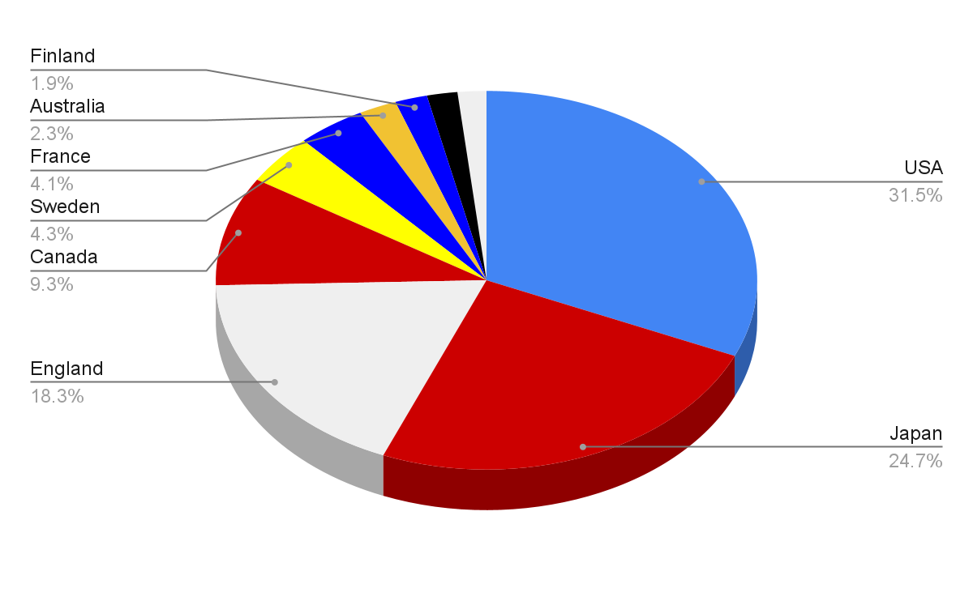

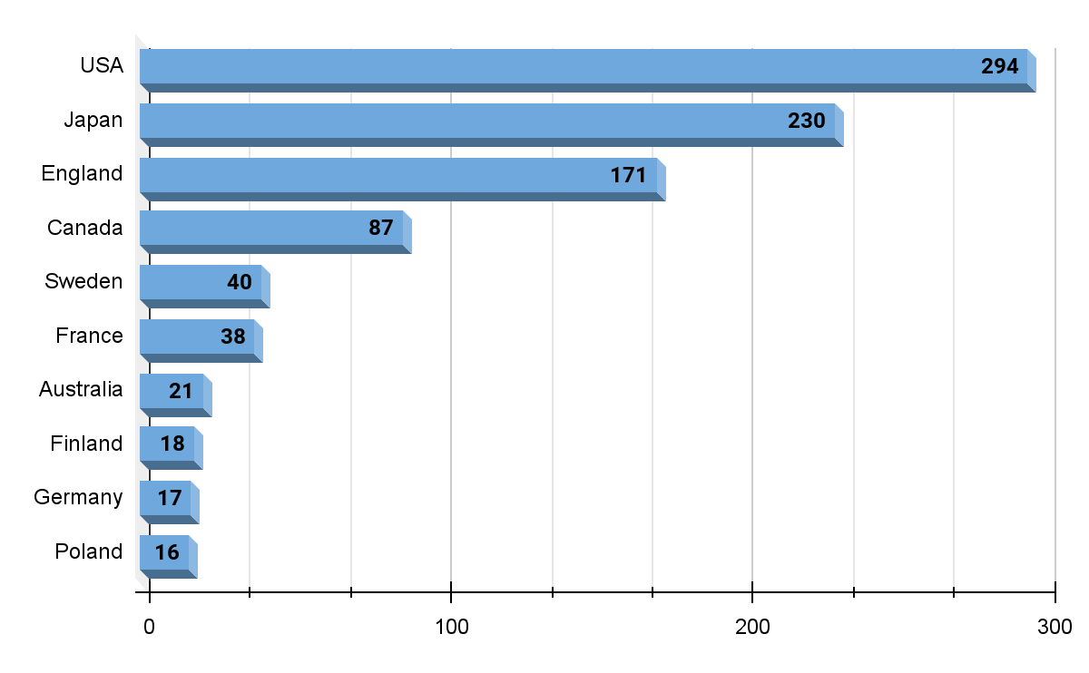

* + **origins.xlsx (as of 4th December 2024):**

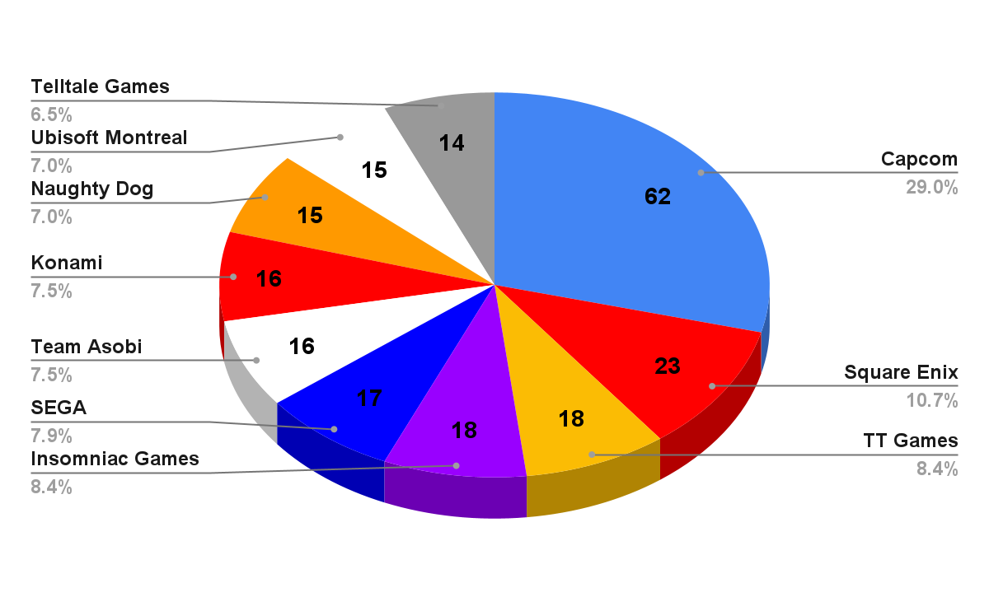

**FURTHER DATA ANALYSIS OF COUNTRIES & DEVELOPERS TBC:**

* Which games each developer & country are responsible for (group by country and developer similar to above, while listing each entry in an XLSX file)?
  + **origins/finances.xlsx to be incorporated in README ASAP.**
* How many games were developed by AAA, SME or Indie developers?
  + Research developers & available resources to determine if AAA, SME or Indie.
  + Discuss my personal favourite games based on all the above charts.

## **Value for Money**

* Which games have accumulated the most amount of hours played?
  + **dates_&_finances_all-time.xlsx (as of 4th December 2024):**

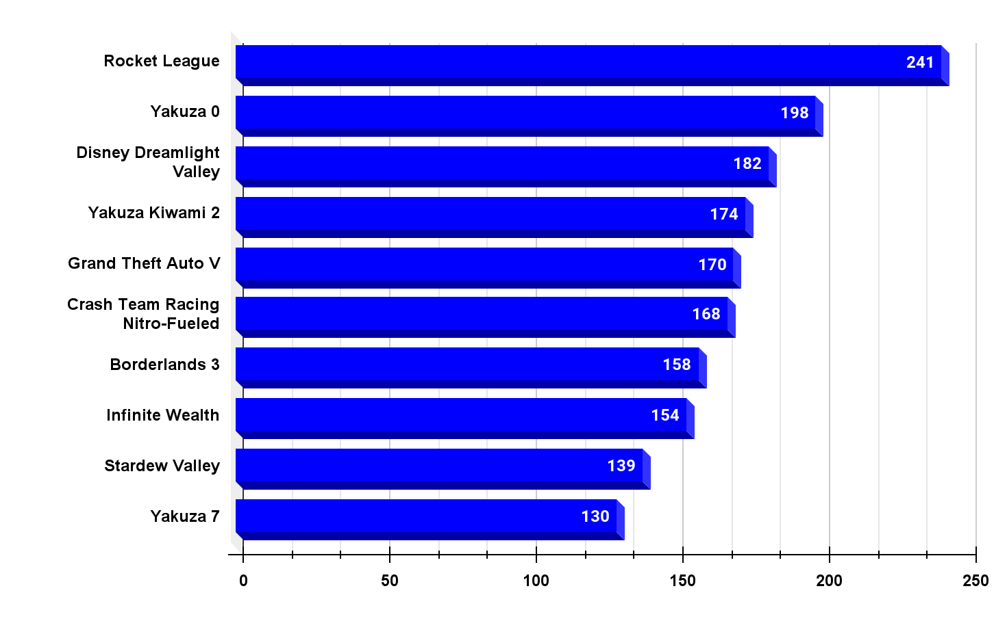

* Which games have the best value for money (**paid price per hour played**)?
  + **dates_&_finances_all-time.xlsx (as of 4th December 2024):**

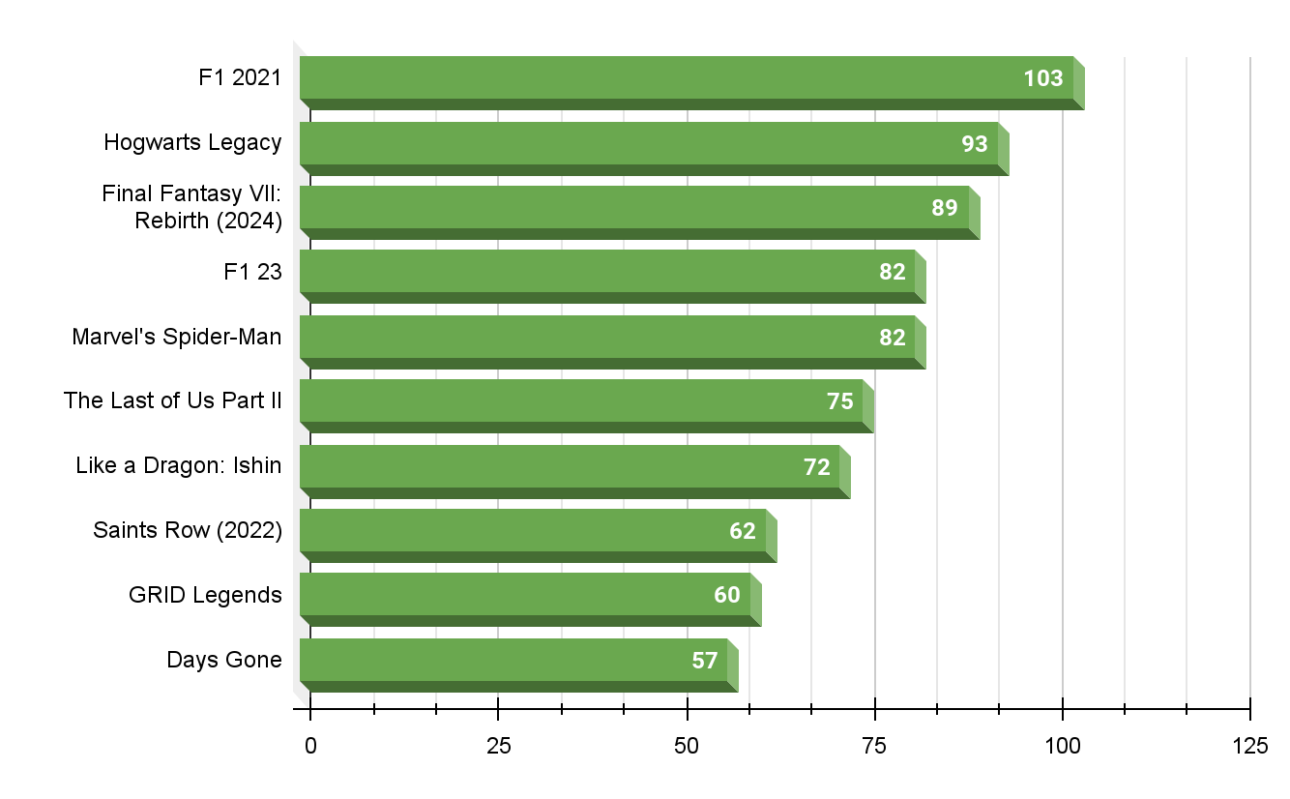

* **Like a Dragon (Yakuza)**
  + **dates_&_finances_all-time.xlsx (as of 4th December 2024):**

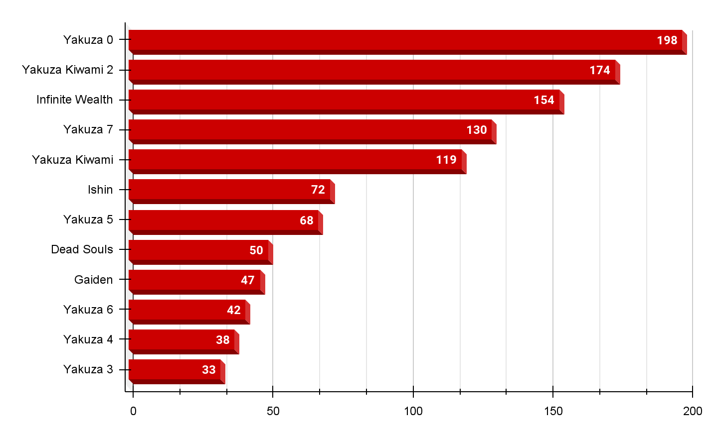

* Information to be written on this page detailing a favourite game series of mine, Like a Dragon (Yakuza):
  + **TBC**

## **Annual Game Log & Backlog**

* Various columns have been added to the dates table to track the following aspects:
  + **release_date** - when the game was released over the decades
  + **purchase_date** - when I purchased the game since the release_date
  + **start_date** - when I started playing the game since the purchase_date
  + **finish_date** - when I have finished playing the game

## **Trophies**

* **platinums & trophies.xlsx (as of 4th December 2024):**

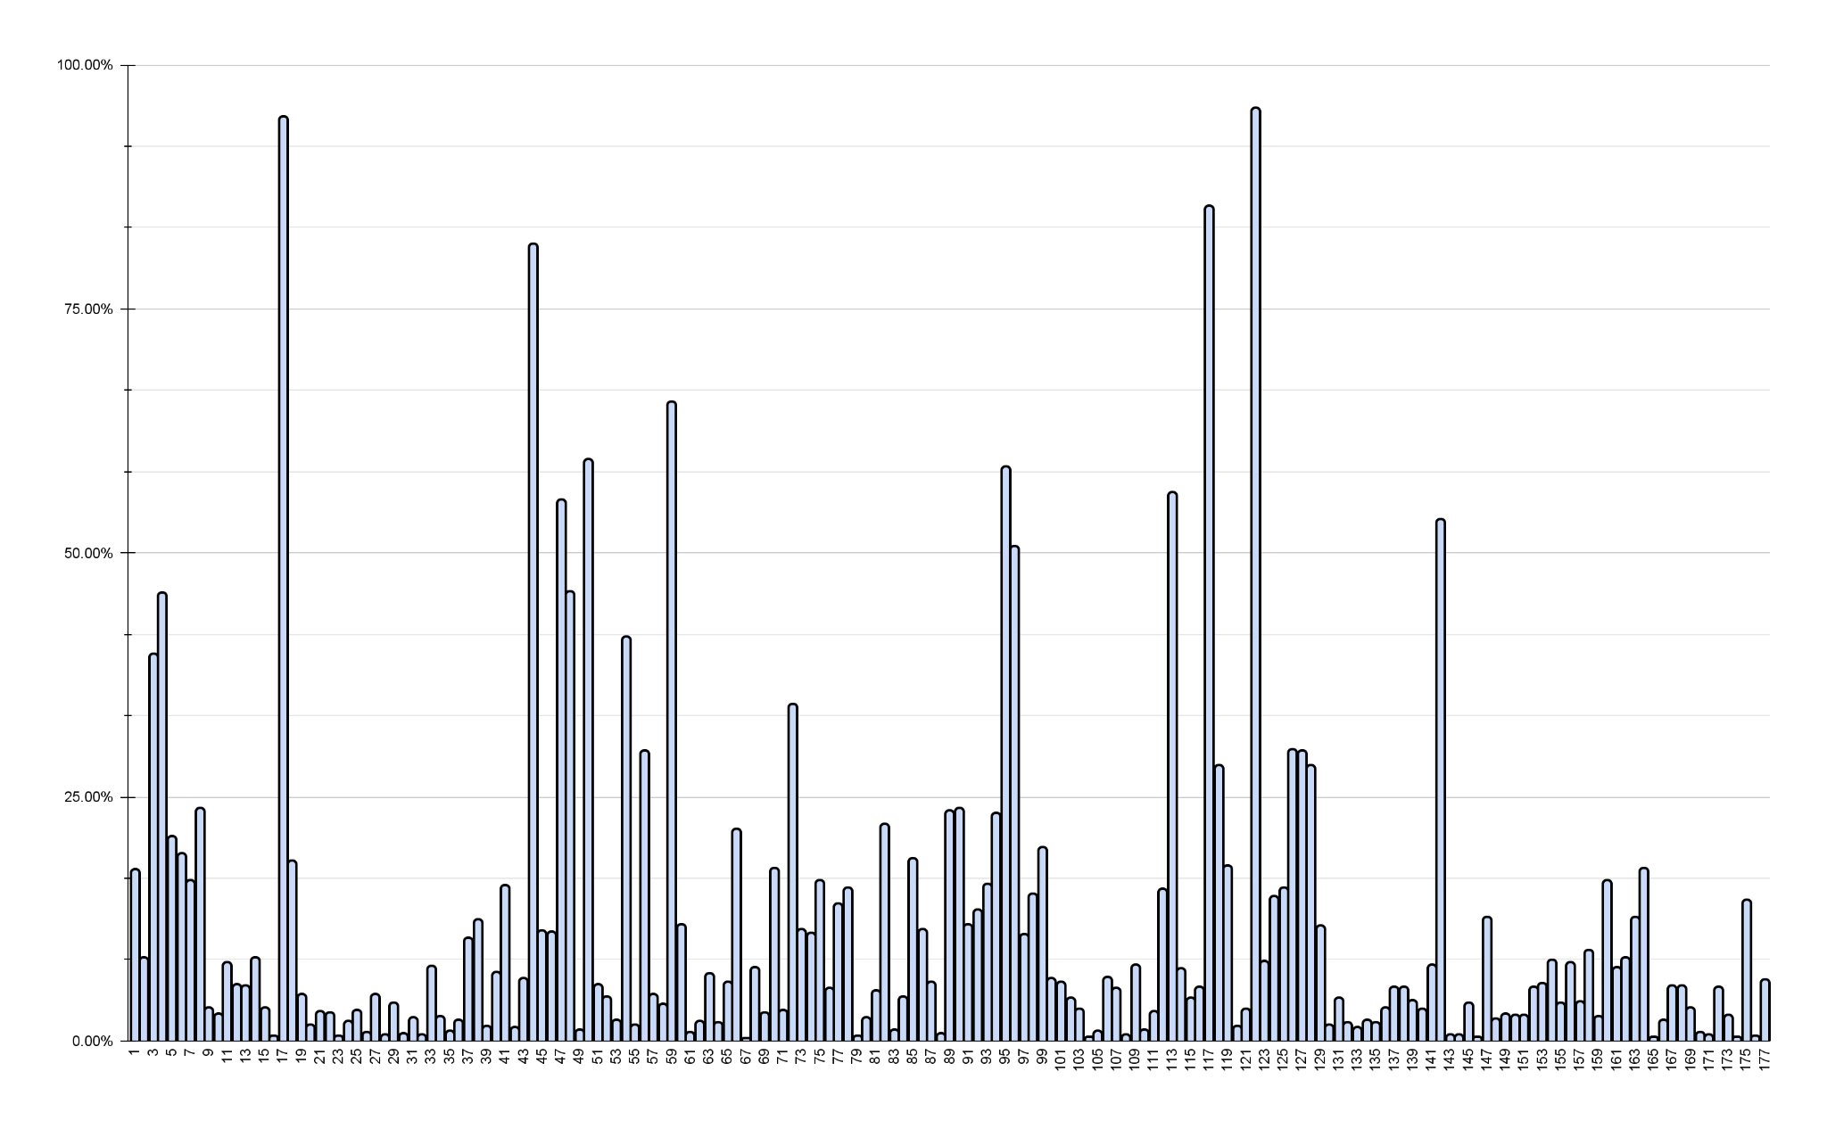

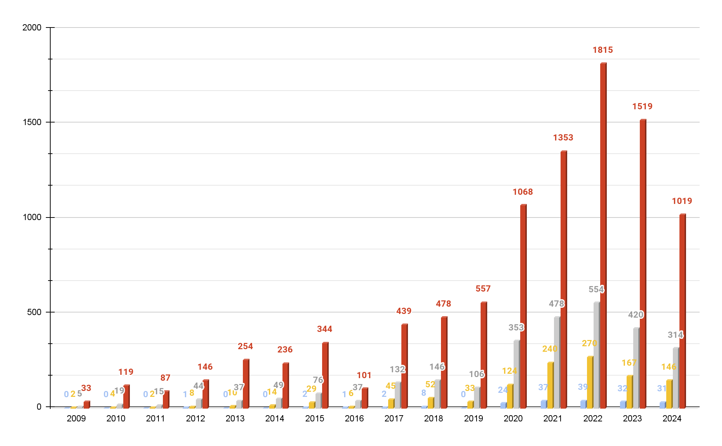

# **References**

## **PSPrices**

* No one likes missing a good sale!
* PSPrices are a video game deals tracker based in London, who gather offers from the digital storefronts of PlayStation, Xbox and Nintendo, to help gamers find the best video game bargains from anywhere in the world.
* Upon signing up for free, I decided to contribute a one-off lifetime payment to the developers of PSPrices in order to show my gratitude for their service.
* While similar sites would show game deals, PSprices also allow you to track your entire game collection across different consoles.
* Just pick your favourite games, click Subscribe, and PSPrices will send you an email when the prices of games drop in the sales, as well as upcoming games.
* It's a neat way to keep track of what you own and even rediscover some old favourites.
* Join the PSprices community today at [**hello@psprices.com**](mailto:hello@psprices.com)
* hoff_jager PSN Game Wishlist - [**https://psprices.com/wish-list/HQkF82kb**](https://psprices.com/wish-list/HQkF82kb)

## **PSNProfiles**

* PSNProfiles are a video game tracker that logs how recently you have played your video games, along with in-game trophy achievements earned towards video game completion.
* Upon signing up for free, I decided to contribute a one-off lifetime payment to the developers of PSNProfiles, in order to show my gratitude in addition to unlocking the Premium features of their website, such as:
  + Frequent trophy server synchronization
  + Digital trophy cabinet displaying my Top 10 rare trophies achieved
* hoff_jager PSN Gamer Profile - [**https://psnprofiles.com/hoff_jager**](https://psnprofiles.com/hoff_jager)