Table of Contents

# **Database Setup**

## **SQL Statements**

The sub-repository: **playstation/statements**, contains the following SQL files with queries created in relation to database design & management:

### **CREATE DATABASE & TABLES.sql**

* Creates tables named **Dates, Finances, Origins, and Platinums & Trophies**.

### **INSERT INTO TABLES.sql**

* **INSERT INTO Dates.sql**
* **INSERT INTO Finances.sql**
* **INSERT INTO Origins.sql**
* **INSERT INTO Platinums.sql**
* **INSERT INTO Trophies.sql**
  + These INSERT INTO SQL files contain all info for data entry into each table.

### **SELECT FROM TABLES.sql**

* **SELECT FROM All.sql**
* **SELECT FROM Dates.sql**
* **SELECT FROM Finances.sql**
* **SELECT FROM Origins, Platinums & Trophies.sql**
  + These SELECT FROM SQL files select specific data from the tables, then the results are output & saved in XLSX format.

### **UPDATE TABLES.sql**

* **UPDATE Dates.sql**
* **UPDATE Finances.sql**
* **UPDATE Origins.sql**
* **UPDATE Platinums.sql**
* **UPDATE Trophies.sql**
  + These UPDATE SQL files update values within the tables, such as correcting typos & numerical errors (misspelling of developers or prices).

## **SQL Output to XLSX**

The sub-repository: **playstation/output**, contains the following XLSX files:

### **1. wishlist**

* Stores a number of video games that have or haven’t been released and purchased, with the following fields to export to all_data [MASTER] XLSX file:
  + ID, Game, Console,
  + Release_Date, Purchase_Date, Start_Date, Finish_Date,
  + Full_Price, Sale_Price, Savings, Hours, Value,
  + Developer, Country

### **all_data [MASTER]**

* Stores new data imported from 1. wishlist XLSX file, and verifies data from the following queries within the SELECT FROM All SQL file, inserted into the following XLSX tabs:

#### **complete**

* + - * *SELECT d.id, d.game, d.console,*

*d.release_date, d.purchase_date, d.start_date, d.finish_date,*

*f.full_price, f.paid_price, f.savings, f.hours, f.value,*

*o.developer, o.country*

*FROM finances f*

*JOIN dates d ON d.id = f.id*

*JOIN origins o ON o.id = f.id*

#### **dates**

* + - *SELECT * FROM dates*

#### **finances**

* + - *SELECT * FROM finances*

#### **origins**

* + - *SELECT * FROM origins*

### **dates_timeline**

* Stores data imported from the all_data [MASTER] XLSX file, and verifies existing data from the following queries within the SELECT FROM Dates SQL file, inserted into the following XLSX tabs:

#### **charts**

* + - * *SELECT COUNT(*) AS ‘Games’ FROM dates*

*WHERE YEAR(release_date) = ‘1995’*

* + - * *SELECT COUNT(*) AS ‘Games’ FROM dates*

*WHERE YEAR(release_date) BETWEEN ‘1995’ AND ‘1999’*

#### **releases**

* + - *SELECT * FROM dates ORDER BY release_date, purchase_date ASC*
    - *SELECT * FROM dates WHERE YEAR(release_date) = ‘1995’*

*ORDER BY release_date, purchase_date ASC*

#### **pre-orders**

* + - *SELECT * FROM dates WHERE purchase_date < release_date*

*ORDER BY release_date DESC*

#### **unplayed**

* + - *SELECT d.id, d.game, d.console,*

*d.release_date, d.purchase_date, d.start_date, d.finish_date, f.hours FROM finances f*

*JOIN dates d ON d.id = f.id WHERE f.hours = 1*

*ORDER BY d.release_date, d.purchase_date ASC*

#### **backlog**

* + - *SELECT COUNT(*) AS ‘Games’ FROM dates*

*WHERE YEAR(start_date) = ‘2009’*

* + - *SELECT COUNT(*) AS ‘Games’ FROM dates*

*WHERE YEAR(finish_date) = ‘2009’*

#### **started**

* + - *SELECT * FROM dates ORDER BY start_date ASC*

#### **finished**

* + - *SELECT * FROM dates ORDER BY finish_date DESC*

### **finances_all-time**

* Stores data imported from all_data [MASTER] XLSX file, and verifies existing data from the following queries within SELECT FROM Finances SQL file, inserted into the following XLSX tabs:

#### **totals**

* + - *SELECT COUNT(id) AS ‘Total Number of Games’,*

*SUM(full_price) AS ‘Total Full Price’,*

*SUM(paid_price) AS ‘Total Sale Price’,*

*SUM(savings) AS ‘Total Savings’,*

*SUM(hours) AS ‘Total Hours Played’ FROM finances*

* + - *SELECT COUNT(id) AS ‘Total Number of Games’,*

*AVG(full_price) AS ‘Average Full Price’,*

*AVG(paid_price) AS ‘Average Sale Price’,*

*AVG(savings) AS ‘Average Savings’,*

*AVG(hours) AS ‘Average Hours Played’ FROM finances*

#### **savings**

* + - *SELECT SUM(full_price) AS ‘Full Price’,*

*SUM(paid_price) AS ‘Paid Price’,*

*SUM(savings) AS ‘Savings’ FROM finances f*

*JOIN dates d ON d.id = f.id WHERE YEAR(purchase_date) = ‘2025’*

#### **gifts**

* + - *SELECT d.id, d.game, d.console, d.purchase_date*

*f.full_price, f.paid_price, f.savings FROM finances f*

*JOIN dates d ON d.id = f.id WHERE f.paid_price = 0*

*ORDER BY d.purchase_date ASC*

#### **t10hours**

* + - *SELECT * FROM finances ORDER BY hours DESC, value ASC, savings DESC*

#### **t10free**

* + - *SELECT * FROM finances*

*WHERE value = 0.00 ORDER BY hours DESC, savings DESC*

#### **t10yakuza**

* + - *SELECT * FROM finances*

*WHERE game LIKE (‘Yakuza%’) OR game LIKE (‘Like a Dragon%’)*

*OR game LIKE (‘%Judgment%’) ORDER BY hours DESC*

#### **ranges_hrs & hours**

* + - *SELECT * FROM finances WHERE hours BETWEEN 91 AND 100*

*ORDER BY hours DESC, value ASC, savings DESC*

#### **ranges_pr & prices**

* + - *SELECT * FROM finances*

*WHERE full_price BETWEEN 0.01 AND 9.99 ORDER BY full_price ASC*

* + - *SELECT * FROM finances*

*WHERE paid_price BETWEEN 0.01 AND 9.99 ORDER BY paid_price ASC*

* + - *SELECT * FROM finances*

*WHERE savings BETWEEN 0.01 AND 9.99 ORDER BY savings ASC*

#### **2025 to 2009**

* + - *SELECT d.id, d.game, d.console, d.purchase_date,*

*f.full_price, f.paid_price, f.savings FROM finances f*

*JOIN dates d ON d.id = f.id WHERE YEAR(d.purchase_date) = ‘2025’*

*ORDER BY d.purchase_date ASC*

### **finances_monthly**

* Stores data imported from XLSX & SQL files above, inserted into the following tabs:

#### **savings**

* + - *SELECT SUM(full_price) AS ‘Full Price’,*

*SUM(paid_price) AS ‘Paid Price’,*

*SUM(savings) AS ‘Savings’ FROM finances f*

*JOIN dates d ON d.id = f.id WHERE MONTH(purchase_date) = ‘03’*

#### **Jan to Dec**

* + - *SELECT d.id, d.game, d.console, d.purchase_date,*

*f.full_price, f.paid_price, f.savings FROM finances f*

*JOIN dates d ON d.id = f.id WHERE MONTH(d.purchase_date) = ‘03’*

*ORDER BY d.purchase_date ASC*

### **finances_origins**

* Stores data imported from the all_data [MASTER] XLSX file, and verifies existing data from the following queries within the SELECT FROM Origins, Platinums & Trophies SQL file, inserted into the following XLSX tabs:

#### **distinct**

* + - *SELECT DISTINCT country*

*FROM origins*

*ORDER BY country*

* + - *SELECT DISTINCT developer, country*

*FROM origins*

*WHERE country = ‘USA’*

*ORDER BY country*

* + - *SELECT DISTINCT developer*

*FROM origins*

*ORDER BY developer*

* + - *SELECT DISTINCT developer, country*

*FROM origins*

*ORDER BY developer*

#### **c_finances**

* + - *SELECT o.country, o.developer,*

*d.id, d.game, d.console,*

*d.release_date, d.purchase_date, d.start_date, d.finish_date,*

*f.full_price, f.paid_price, f.savings, f.hours, f.value*

*FROM finances f*

*JOIN dates d ON d.id = f.id*

*JOIN origins o ON o.id = f.id*

*ORDER BY country, console, release_date*

#### **c_chart**

* + - *SELECT SUM(full_price) AS ‘Full Price’,*

*SUM(paid_price) AS ‘Paid Price’,*

*SUM(savings) AS ‘Savings’,*

*SUM(hours) AS ‘Hours’,*

*SUM(value) AS ‘Value’*

*FROM origins o*

*JOIN finances f ON o.id = f.id*

*WHERE country = ‘USA’*

#### **countries**

* + - *SELECT country, COUNT(*) AS ‘Games’*

*FROM origins*

*GROUP BY country ORDER BY COUNT(*) DESC*

#### **d_finances**

* + - *SELECT o.country, o.developer,*

*d.id, d.game, d.console,*

*d.release_date, d.purchase_date, d.start_date, d.finish_date,*

*f.full_price, f.paid_price, f.savings, f.hours, f.value*

*FROM finances f*

*JOIN dates d ON d.id = f.id*

*JOIN origins o ON o.id = f.id*

*ORDER BY country, developer, console, release_date*

* + **d_chart**
    - *SELECT SUM(full_price) AS ‘Full Price’,*

*SUM(paid_price) AS ‘Paid Price’,*

*SUM(savings) AS ‘Savings’,*

*SUM(hours) AS ‘Hours’,*

*SUM(value) AS ‘Value’*

*FROM origins o*

*JOIN finances f ON o.id = f.id*

*WHERE developer = ‘Naughty Dog’*

* + **developers**
    - *SELECT developer, COUNT(*) AS ‘Games’*

*FROM origins*

*GROUP BY developer ORDER BY COUNT(*) DESC*

* + **consoles**
    - *SELECT console, COUNT(*) AS ‘Games’*

*FROM origins*

*GROUP BY console ORDER BY COUNT(*) DESC*

### **platinums & trophies**

* Stores data imported from the PlayStation App and PSNProfiles, inserted into the following XLSX tabs:
  + **platinums**
    - *SELECT * FROM platinums*
    - *SELECT * FROM platinums ORDER BY rarity ASC*
      * #, Game, Console, Completion_Date, Rarity
  + **trophies**
    - *SELECT * FROM trophies ORDER BY id ASC*
    - *SELECT * FROM trophies WHERE year = ‘2025’*
      * ID, Year, Platinum, Gold, Silver, Bronze

# **Topics**

## **Dates & Backlog**

* The total number of video games released per year & per decade.
* List of all video games sorted by release date in ascending order.
* List of all pre-ordered video games sorted by purchase date in descending order.
* List of all unplayed video games sorted by release date in ascending order.
* Backlog of all video games with start dates & finish dates listed.

## **Spending & Savings**

* The total number of video games & consoles in the collection.
* The sum & average values of full prices, paid prices, savings and hours.
* The number of games & the sum of full prices, paid prices, savings per year.
* The total number of video games redeemed as gifts & via subscription.
* List of all video games sorted by hours played in descending order, followed by value for money in ascending order, and savings in descending order.
* List of all video games redeemed as gifts & via subscription sorted by hours played in descending order, followed by savings in descending order.
* List of all games from my favourite video game series, Yakuza/Like a Dragon/Judgment, sorted by hours played in descending order.
* The total number of video games played for a range of hours (from 1 hour, to 11-20 hours, and over 100 hours).
* List of all video games played for a range of hours, sorted by hours played in descending order, followed by value for money in ascending order, and savings in descending order.
* The total numbers of video games purchased, with a range of different prices (from < €0.01, to €0.01 - €9.99, and over €79.99) outlining the values of full price, paid price and savings upon purchasing.
* List of video games purchased with the range of different prices, sorted by full price, paid price and savings in ascending order.
* List of video games purchased per year, sorted by purchase dates in ascending order.
* The number of games & the sum of full prices, paid prices, savings per month.
* List of video games purchased per month, sorted by purchase dates in ascending order.

## **Countries & Developers**

* The total number of distinct countries & video game developers in the collection.
* List of countries & developers with their developed video games & complete information, sorted by country in alphabetical order, followed by console generation from earliest release ascending, and by release date ascending.
* The sum of all video games developed, video game developers, full prices, paid prices, savings, hours and value per country.
* List of all countries sorted by hours in descending order, showing the number of games developed per country.
* List of countries & developers with their developed video games & complete information, sorted by country in alphabetical order, followed by developer in alphabetical order, followed by console generation from earliest release ascending, and by release date ascending.
* List of all developers, their country of origin, including the sum of each video game developed, full prices, paid prices, savings, hours and value, sorted by hours in descending order, followed by value in ascending order, and savings in descending order.
* List of all developers sorted by hours in descending order, showing the number of games developed per developer.
* The total number of console generations in the collection along with the number of games per console.

## **Trophies**

* The total number of platinum trophies achieved, sorted by ID or sorted by percentage rarity in ascending order.
* The total number of all trophies earned per year.

# **Dates & Backlog**

## **dates_timeline**

### **charts & releases**

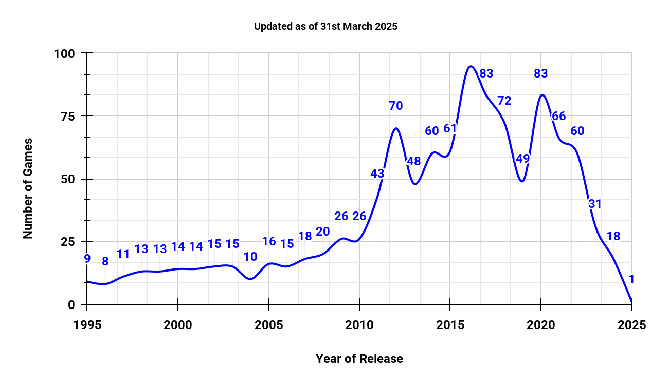

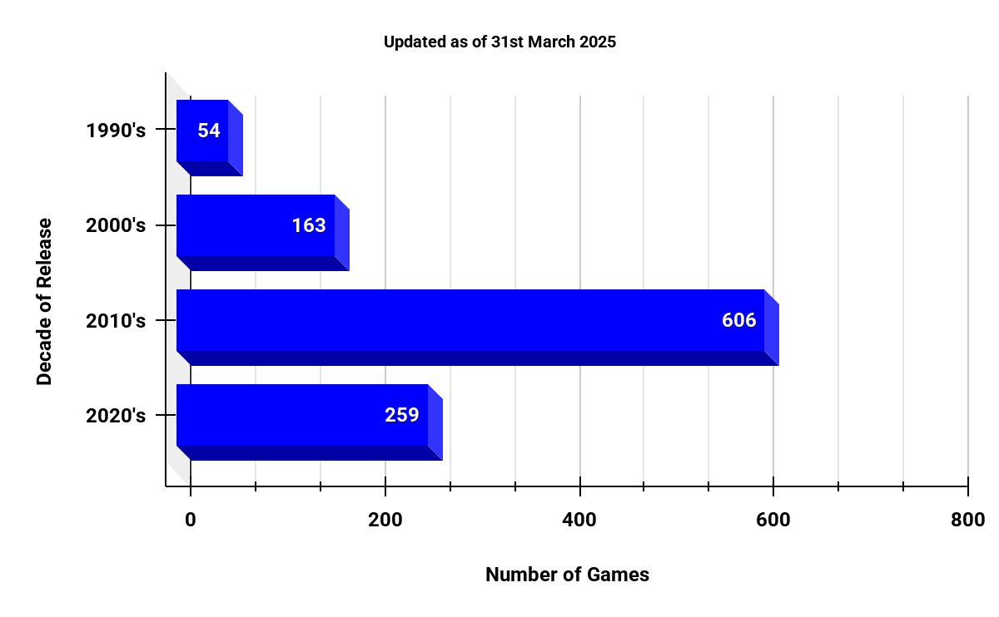

* The majority of video games in the collection were released in the ***2010’s and 2020’s****.*
* These decades account for ***80% (865/1082; 4/5)*** of the entire video game collection:
  + The ***2010’s*** account for ***56% (606/1082)*** of the collection.
  + The ***2020’s*** account for ***24% (259/1082)*** of the collection.
* All video games have been sorted by the earliest release dates, followed by the earliest purchase dates.

### **pre-orders**

* There are ***21 instances of pre-orders*** in the video game collection, ***beginning in 2017.***
* The pre-orders have been sorted by the most recent release dates in descending order.

### **unplayed**

* There are ***430 video games in the collection that have yet to be played.***
* Unplayed games account for ***40% (430/1082; 2/5)*** of the entire video game collection.
* All unplayed video games have been sorted by the earliest release dates, followed by the earliest purchase dates.

### **backlog, started & finished**

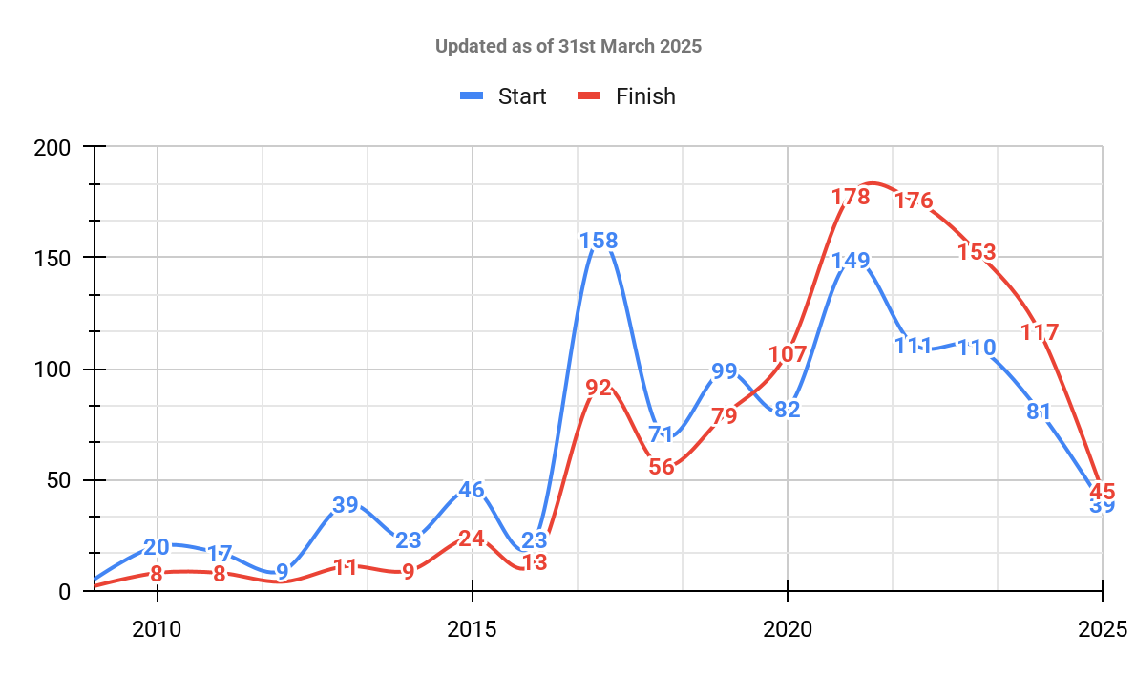

* The backlog shows many games that would have been at least purchased in a specific year, or started and finished playing.
* Likewise, games would have been at least purchased in a specific year, and then branded as both started & finished (to match the purchase date until games are started).
* ***The majority of games were purchased from 2017 onwards***, meaning a greater volume of games in the backlog that have yet to be played if not started and finished.
* The started video games are sorted by the earliest start dates (dating back to 2009).
* The finished video games are sorted by the most recent finish dates in descending order.

# **Spending & Savings**

## **finances_all-time**

| **Total Number of Games** | **Sum of**  **Full Price** | **Sum of**  **Paid Price** | **Sum of**  **Savings** | **Sum of**  **Hours** |
| --- | --- | --- | --- | --- |
| 1,082 | €25,895.82 | €10,871.92 | €15,023.90 | 15,415 |
| **Total Number of Games** | **Average**  **Full Price** | **Average**  **Paid Price** | **Average Savings** | **Average**  **Hours** |
| 1,082 | €23.93 | €10.05 | €13.88 | 14 |

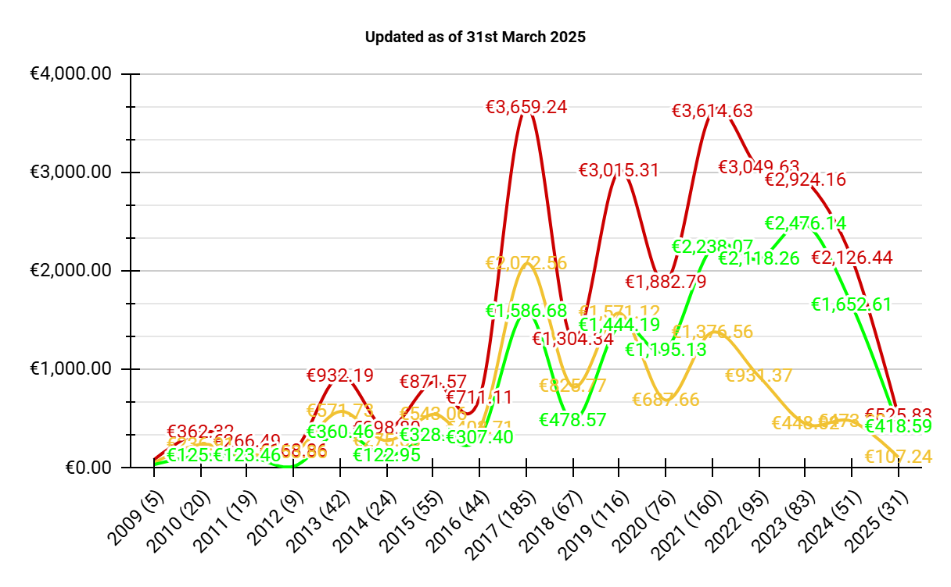

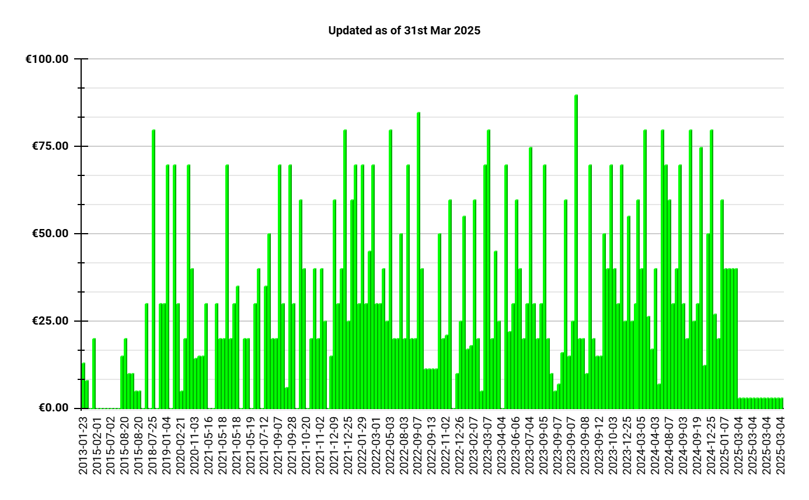

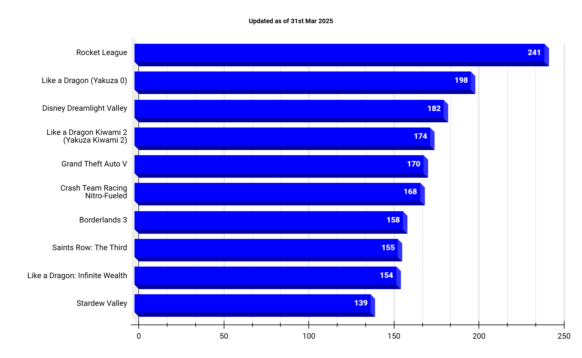

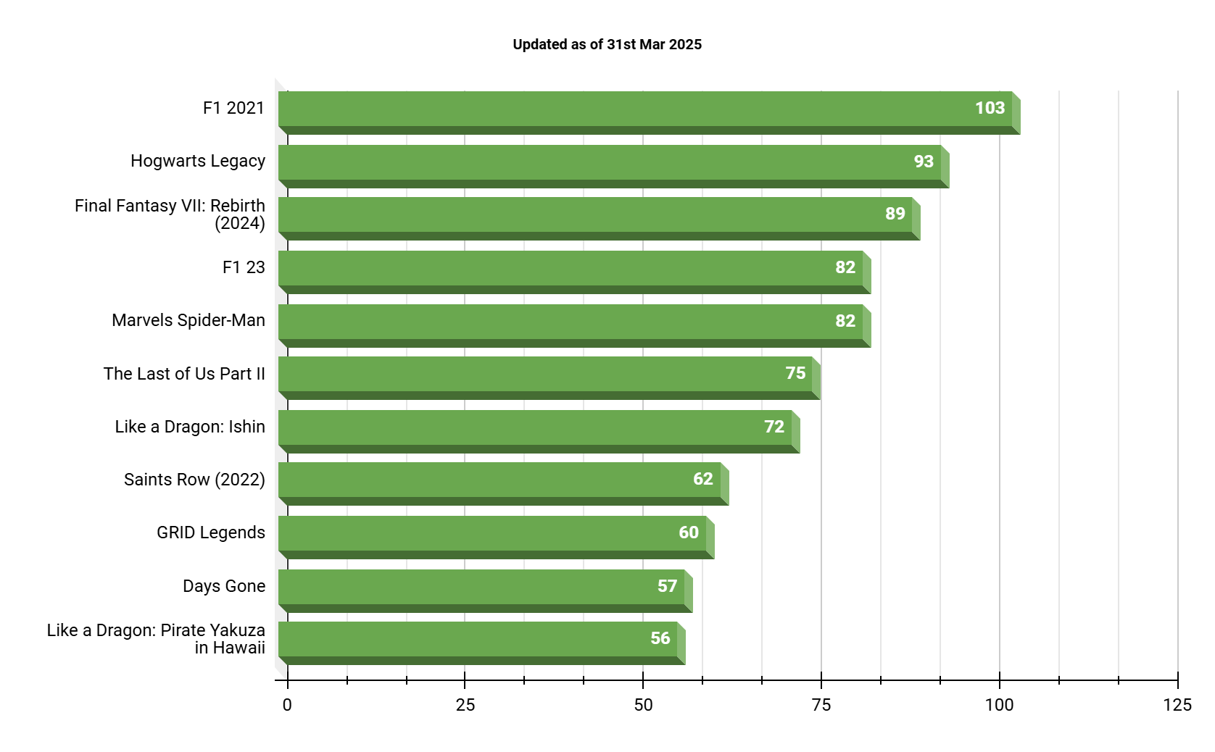

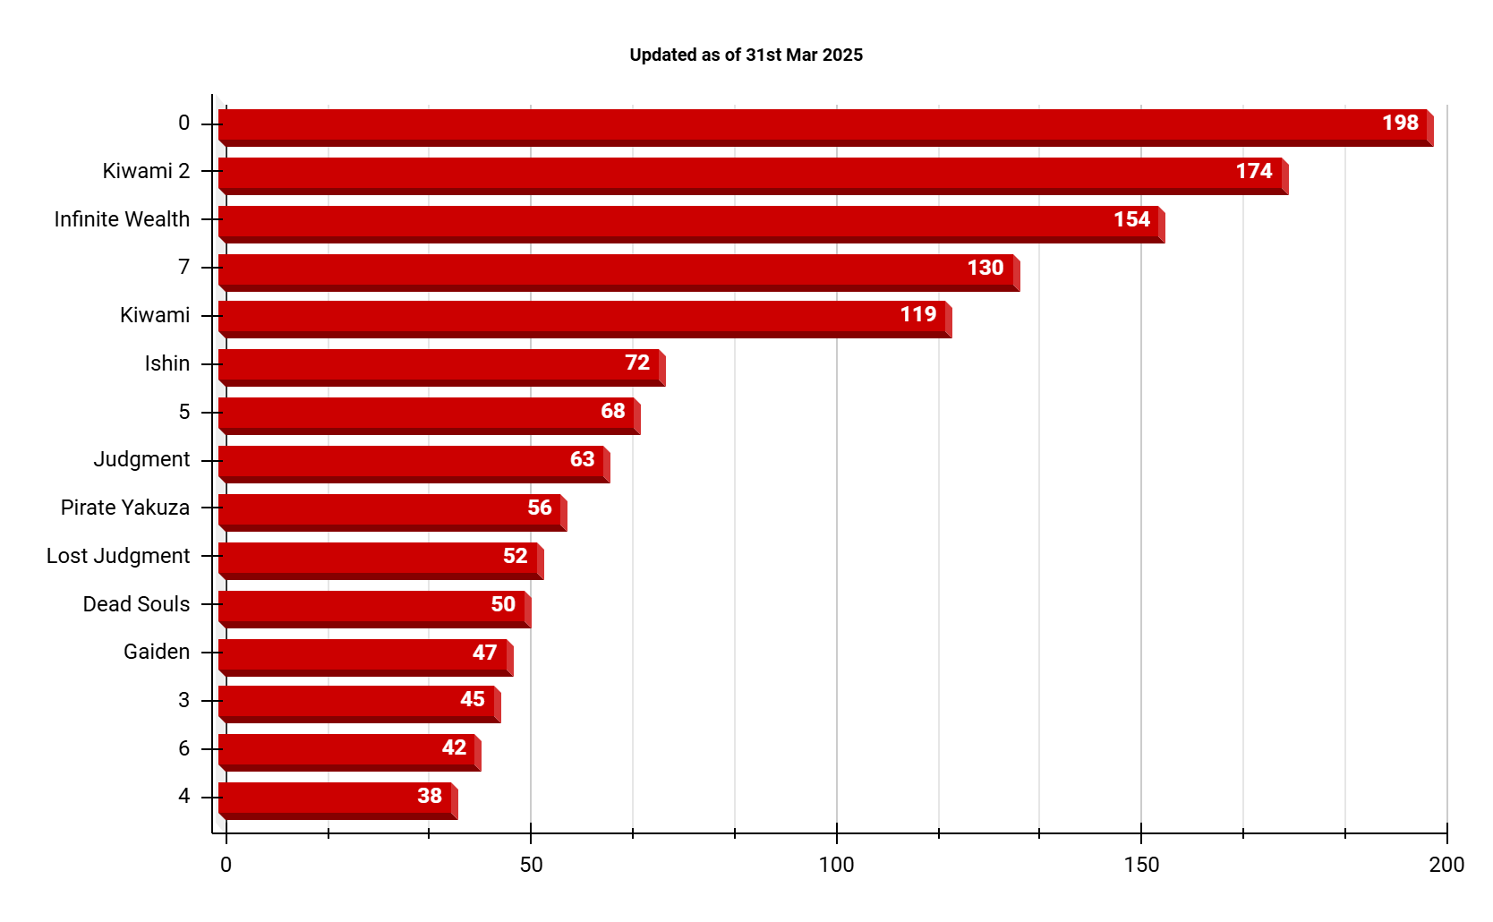

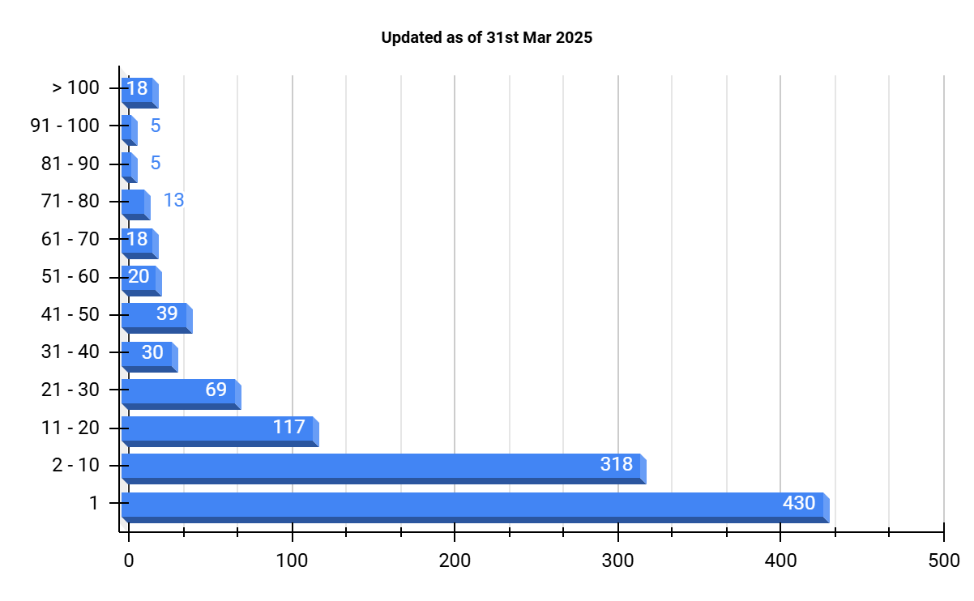

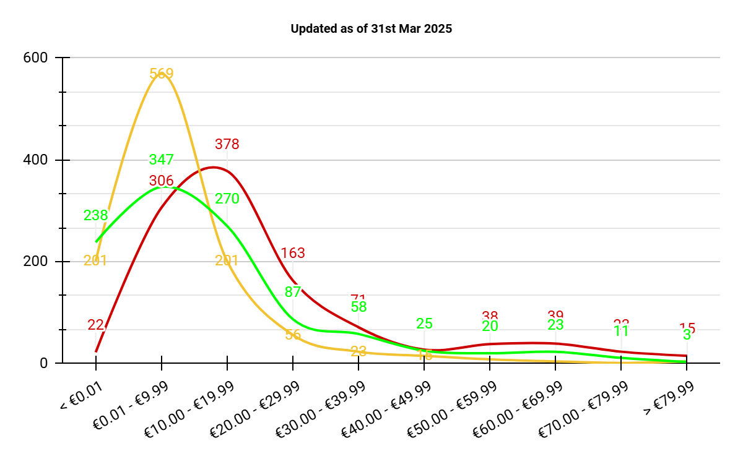

### **totals**

* The collection consists of a total of ***1,082 games, purchased since 2009 and across 8 distinct PlayStation consoles*:**
  + **PS1, PS2, PSP, PS3, VITA, PS4, PSVR, PS5**
* The entire collection would have cost ***€25,895.82 at full price.***
* Thanks to sales, gifts and the PlayStation Plus Essential subscription service, the collection cost ***€10,871.92.***
* This resulted in ***savings of €15,023.90 (58% of the full price).***
* The ***average full price per game*** would work out at ***€23.93.***
* Whereas the ***average paid price per game is €10.05.***
* Resulting in ***average savings of €13.89 per game.***

### **savings**

* The years ***2017 - 2025*** accounts for ***savings of €13,608.24 (91% of the total savings).***
* The majority of games in the collection were ***purchased from 2017 onwards,*** resulting in higher full prices & paid prices, but also resulting in higher savings, compared to pre-2017.

### **gifts**

* There are a total of ***201 games purchased via birthday or Christmas gifts, along with the PlayStation Plus Essential subscription service***, since 2013.
* ***Savings compared to the full price came to €6,065.81*** (***average of €30.18*** per game).
* These savings account for approximately ***40% of the total savings.***

### **t10hours**

* A total of ***1,739 hours were spent on the Top 10 games*** in the video game collection.
* The ***Top 10 accounts for 11% (1739/15415) of the total hours*** played in the collection.
* The XLSX tab consists of the following ranking system based on hours played:
  + ***The Top 100***
    - ***Gold Tier: Top 10;*** *Hours Played: 139 - 241*
    - ***Silver Tier: 11th - 55th****; Hours Played: 65 - 139*
    - ***Bronze Tier: 56th - 100th;*** *Hours Played: 45 - 65*
  + ***Class I (101st - 400th)***
    - *Hours Played: 8 - 45*
  + ***Class II (401st - 700th)***
    - *Hours Played: 1 - 8*
  + ***Class III (701st - 1000th)***
  + ***Class RED (1001st - 1082nd)***
    - *Hours Played: 1*
* Video games in the t10hours XLSX tab are sorted by hours played in descending order:
  + In the event that games are equal in hours played, those games are then sorted by value for money in ascending order:
    - Value for money is a metric that consists of the paid price divided by the hours played, to yield the cost per hour played.
    - This will result in the games with lower values, to be listed as a higher priority in the rankings.
    - This confirms that they are better value for money, in comparison to other games with an equal number of hours played.
  + In the event that games are also equal in value for money, those games are then sorted by savings in descending order:
    - This will result in the games with the highest savings, to be listed as a higher priority in the rankings.

### **t10free**

* A total of ***775 hours were spent on the Top 10 free games*** in the collection.
* The XLSX tab consists of the following ranking system based on hours played:
  + ***The Top 100***
    - ***Gold Tier: Top 10***
      * *Hours Played: 57 - 103*
    - ***Silver Tier: 11th - 55th***
      * *Hours Played: 7 - 57*
    - ***Bronze Tier: 56th - 100th***
      * *Hours Played: 1 - 7*
  + ***Class I (101st - 201st)***
    - *Hours Played: 1*

### **t10yakuza**

* A total of ***1,308 hours were spent across all 15 games in the Yakuza/Like a Dragon/Judgment series***, developed by SEGA and Ryu Ga Gotoku Studio.
* The XLSX tab consists of the following ranking system based on hours played:
  + ***The Top 3***
    - ***Gold Tier: #1***
      * *Yakuza 0, Hours Played: 198*
    - ***Silver Tier: #2***
      * *Yakuza Kiwami 2, Hours Played: 174*
    - ***Bronze Tier: #3***
      * *Like a Dragon: Infinite Wealth, Hours Played: 154*
  + ***Class I***
    - ***4th - 15th***
      * *Hours Played: 38 - 154*

### **ranges_hrs & hours**

* Many video games have yet to be played ***(430 games recorded at 1 hour).***
* Many video games were played briefly ***(318 games recorded between 2 to 10 hours).***
  + These 748 games account for ***69% (748/1082)*** of the collection.
* There is a trend where there are a lower number of games with more hours played through each ascending range of values (117 between 11 to 20 hours, 69 between 21 to 30 hours, etc).
* Video games in the hours XLSX tab are sorted the same as the t10hours XLSX tab:
  + In the event that games are equal in hours played, those games are then sorted by value for money in ascending order.
  + In the event that games are also equal in value for money, those games are then sorted by savings in descending order.

### **ranges_pr & prices**

* Many video games ***cost no higher than €39.99 to purchase at full price***:
  + ***940 games (22 + 306 + 378 + 163 + 71), 87% of the collection****.*
* Many video games were ***purchased for no higher than €29.99***:
  + That accounts for ***1,027 games (201 + 569 + 201 + 56), 95% of the collection.***
* Purchasing video games resulted in ***savings of between €0.01 to €39.99:***
  + That accounts for ***762 games (347 + 270 + 87 + 58), 70% of the collection.***

### **2025 to 2009**

* List of video games purchased per year, sorted by purchase dates in ascending order.

## **finances_monthly**

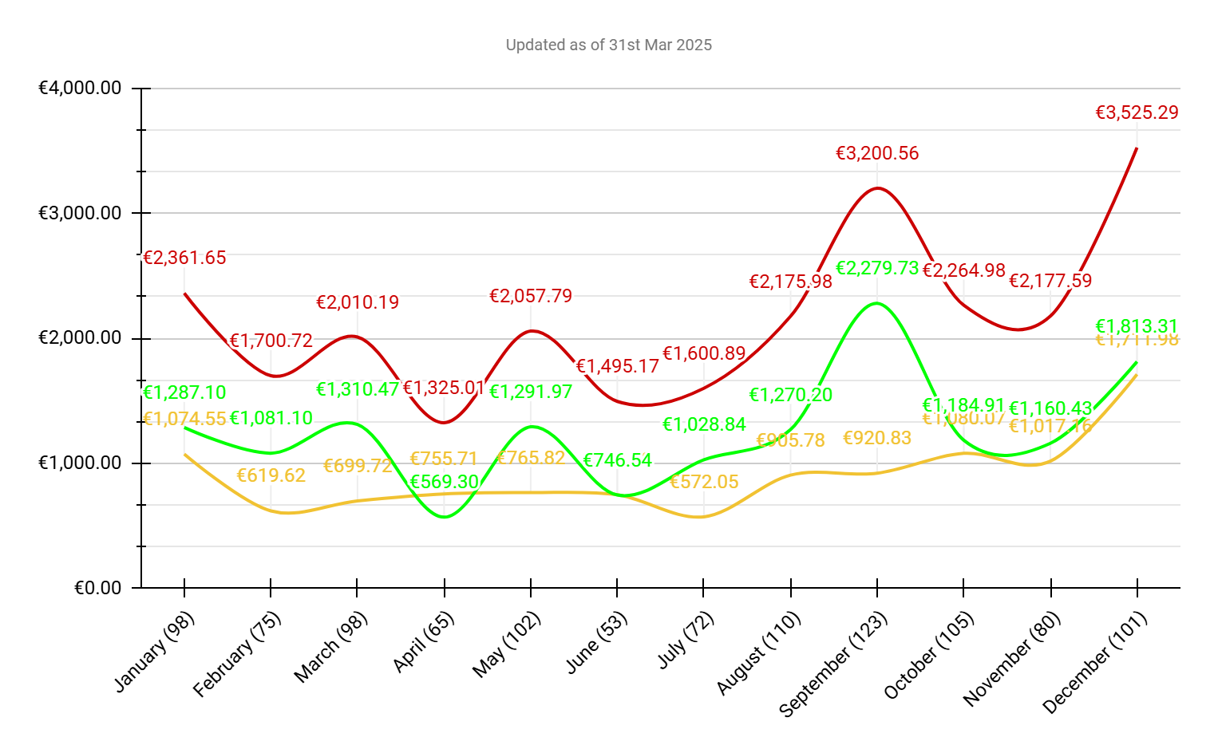

### **savings**

* **September** saw the most game purchases & most savings, my birthday month.
* **August** was also a busy month, as a result of redeeming pre-orders prior to my birthday.
* **December & January** were also busy months as a result of the Christmas season with gifts received, along with the January sales for the best deals to redeem via the gifts.

### **Jan to Dec**

* List of video games purchased per month, sorted by purchase dates in ascending order.

# **Countries & Developers**

## **finances_origins**

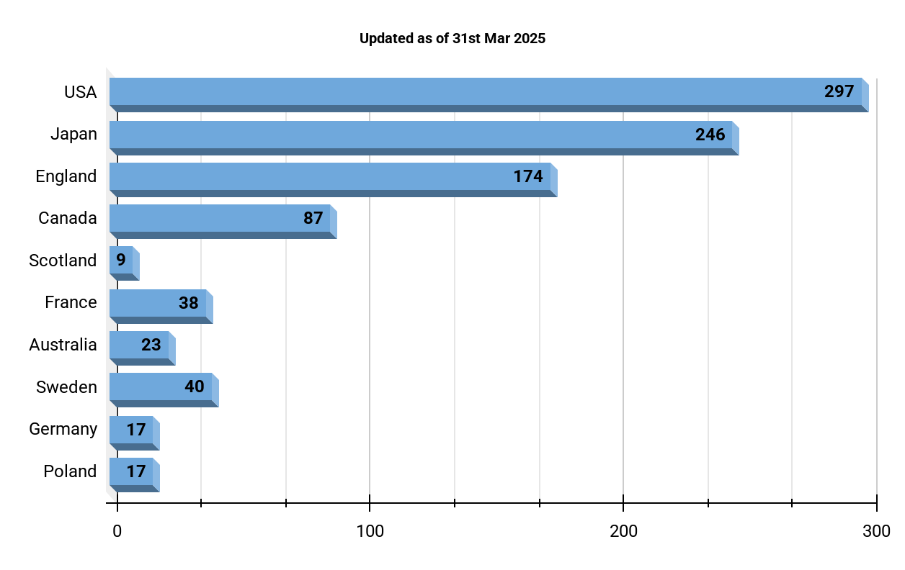

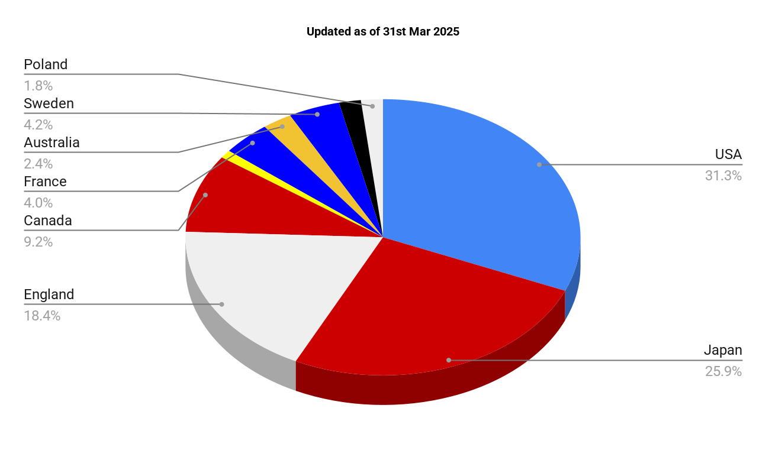

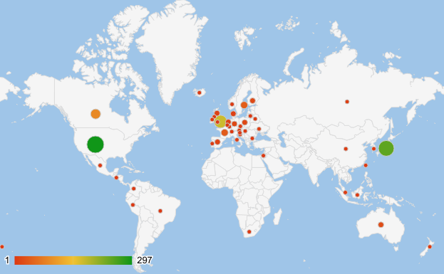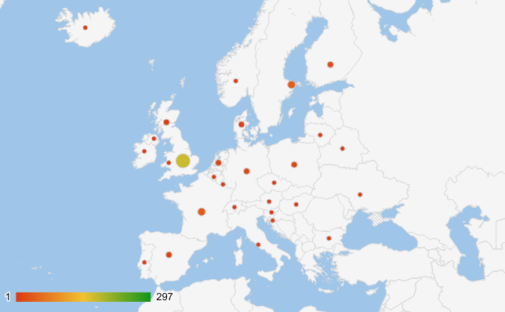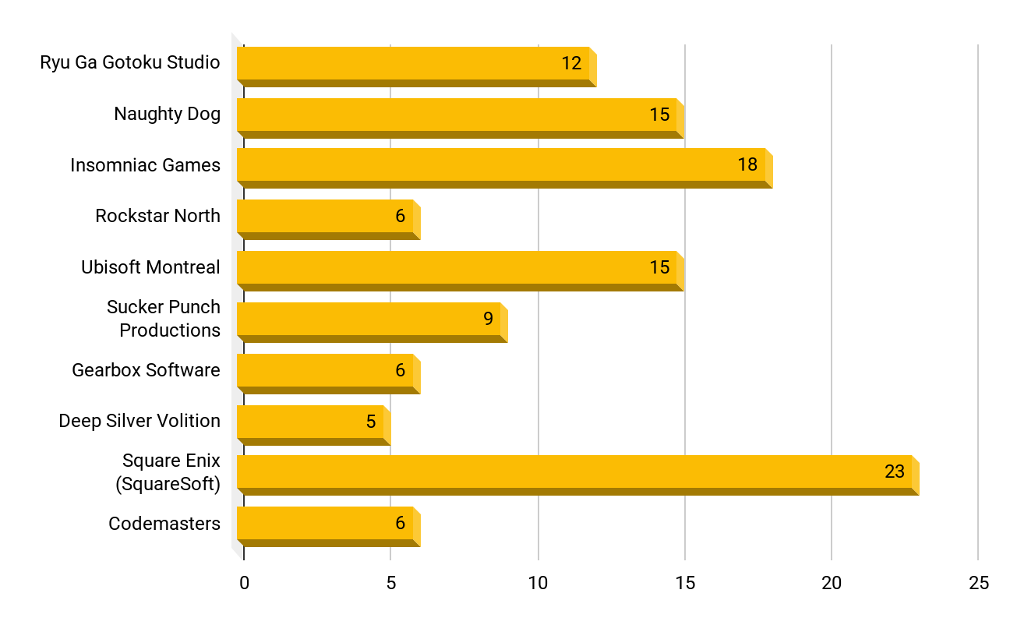

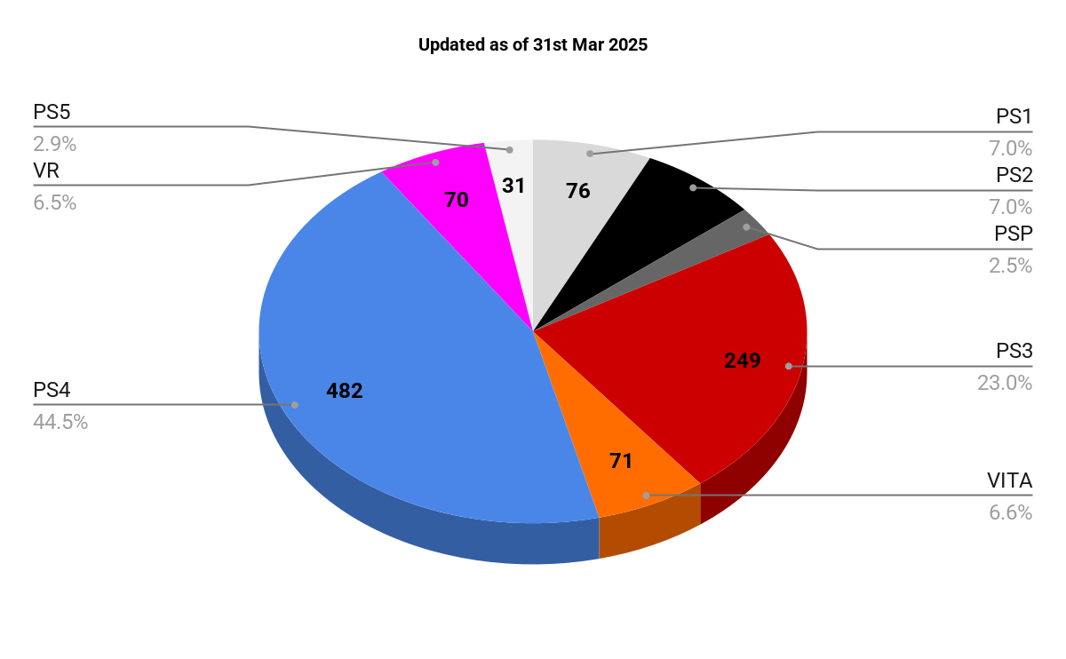

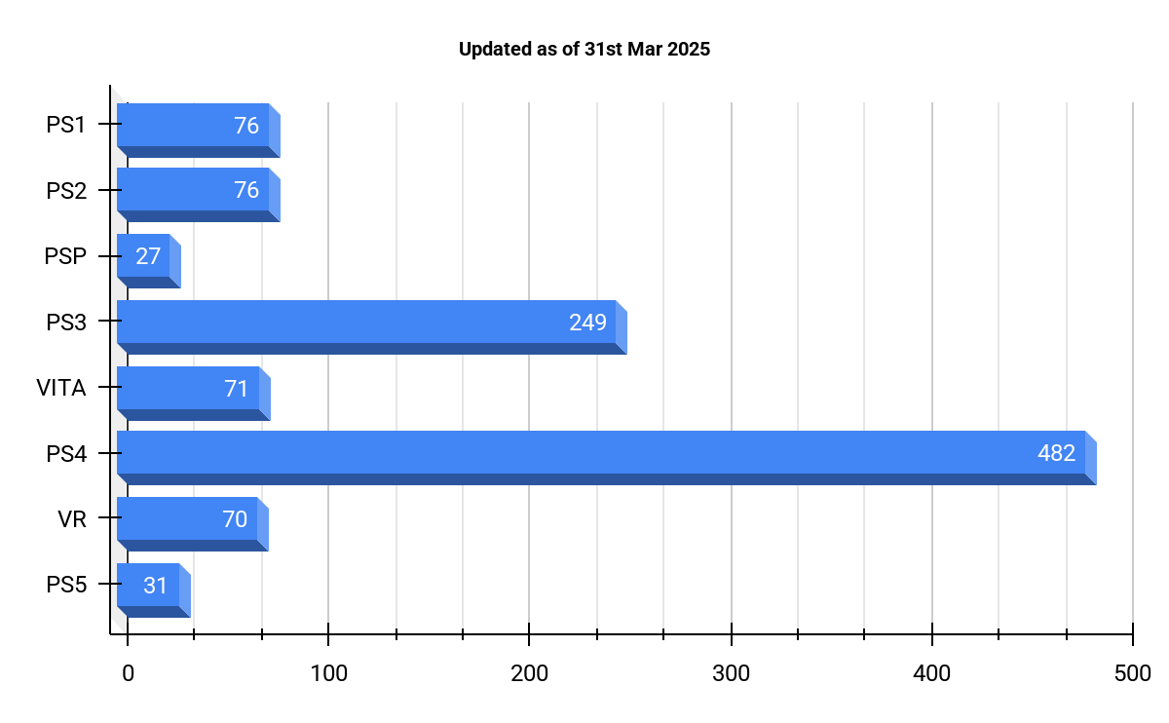

### **distinct**

* There are 535 distinct video game developers from 47 distinct countries.

### **c_finances & c_chart**

* List of countries & developers with their developed video games & complete information, sorted by country in alphabetical order, followed by console generation from earliest release ascending, and by release date ascending.
* The sum of all video games developed, video game developers, full prices, paid prices, savings, hours and value per country.

### **countries**

* List of all countries sorted by hours in descending order, showing the number of games developed per country.

### **d_finances & d_chart**

* List of countries & developers with their developed video games & complete information, sorted by country in alphabetical order, followed by developer in alphabetical order, followed by console generation from earliest release ascending, and by release date ascending.
* The sum of all video games developed, video game developers, full prices, paid prices, savings, hours and value per country.
* List of all developers, their country of origin, including the sum of each video game developed, full prices, paid prices, savings, hours and value, sorted by hours in descending order, followed by value in ascending order, and savings in descending order.

### **developers**

* List of all developers sorted by hours in descending order, showing the number of games developed per developer.

### **consoles**

* The total number of console generations in the collection, along with the number of games per console.

**FURTHER DATA ANALYSIS UNDER CONSIDERATION:**

* How many games were developed by AAA, SME or Indie developers?
  + Research developers to determine if they are AAA, SME or Indie.
  + Discuss my personal favourite games based on all the above charts.

# **Trophies**

## **platinums & trophies**

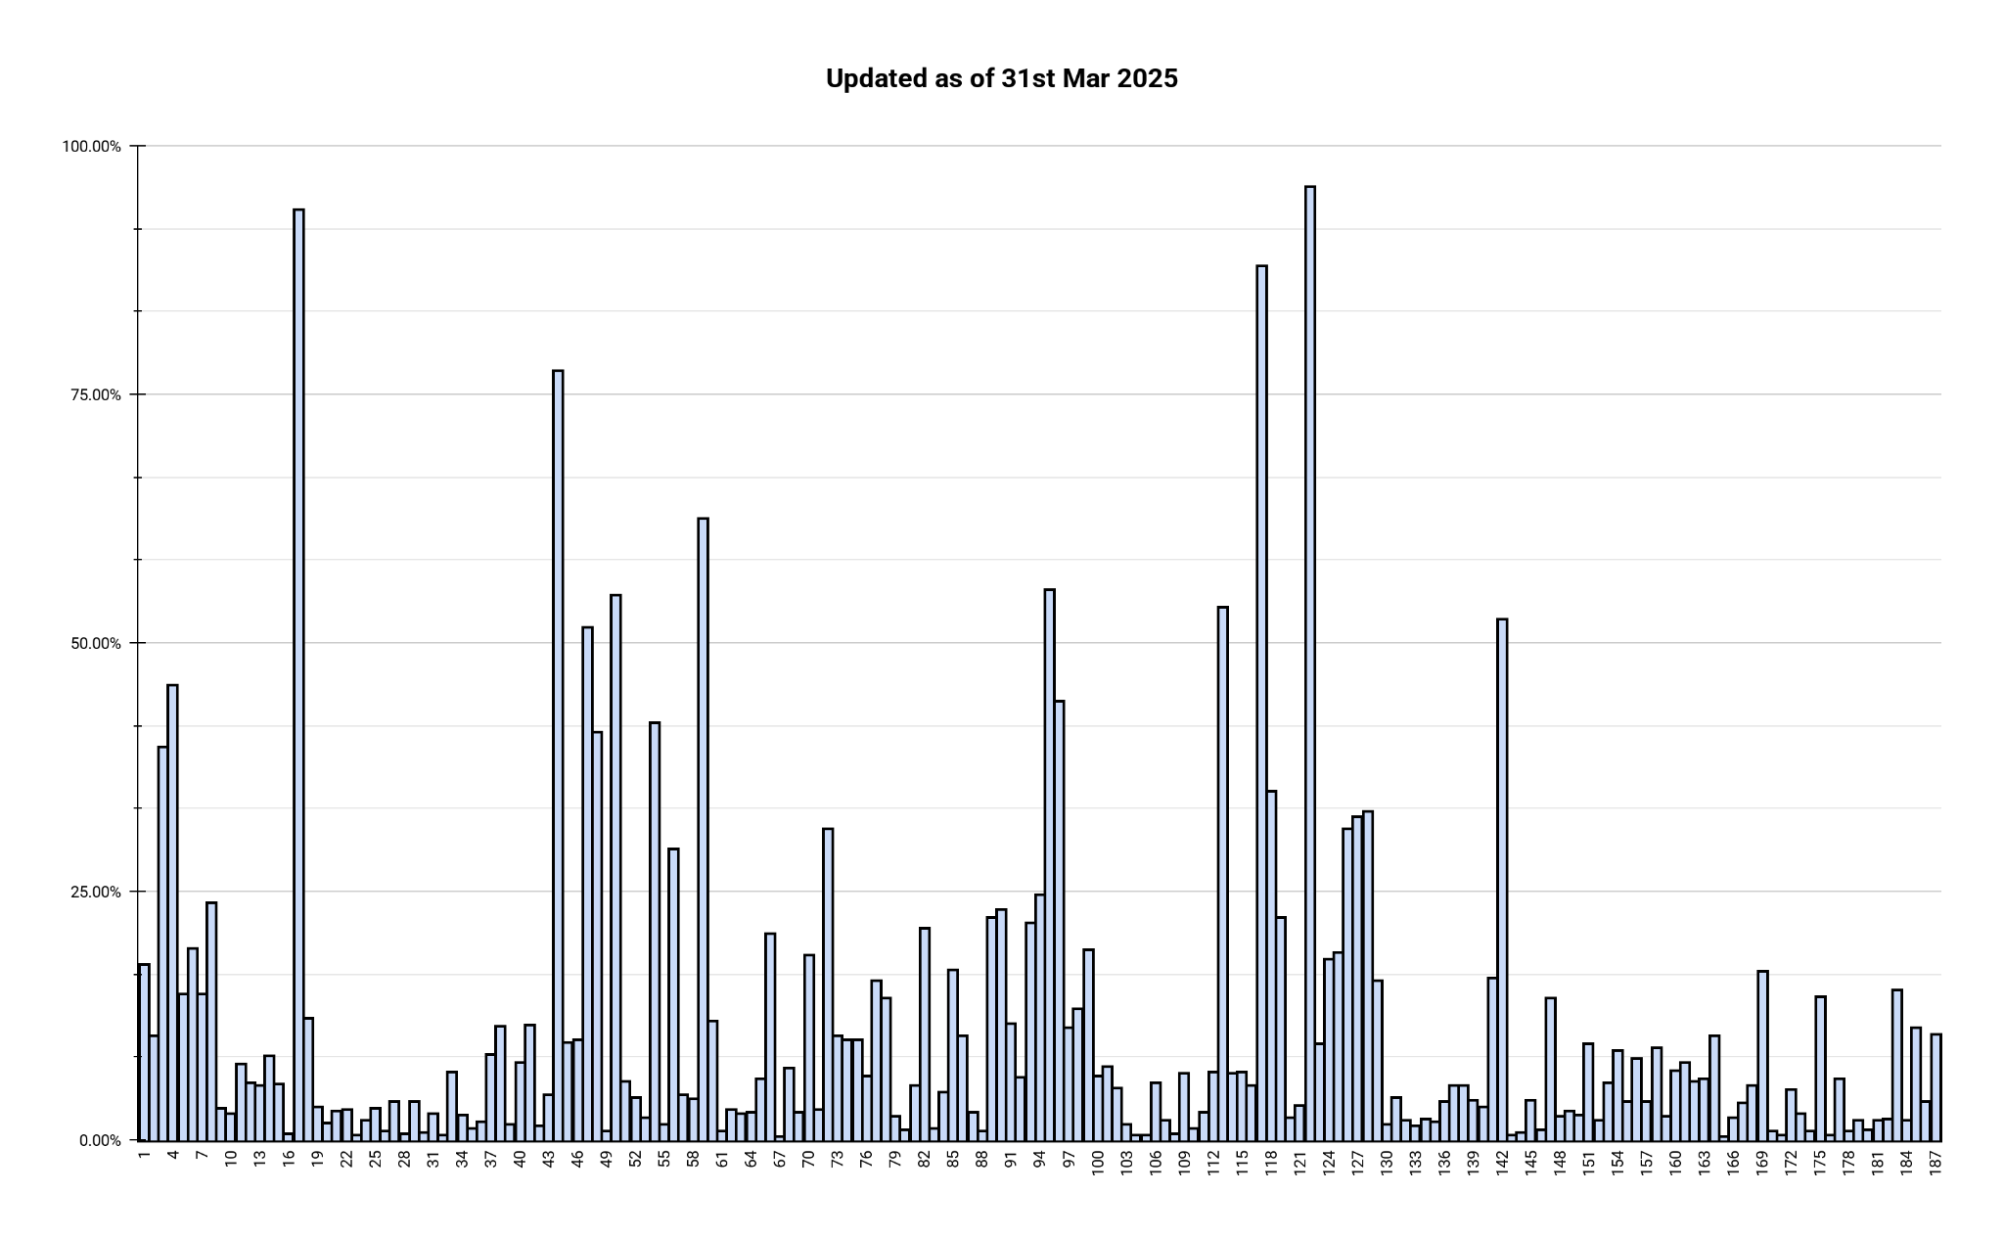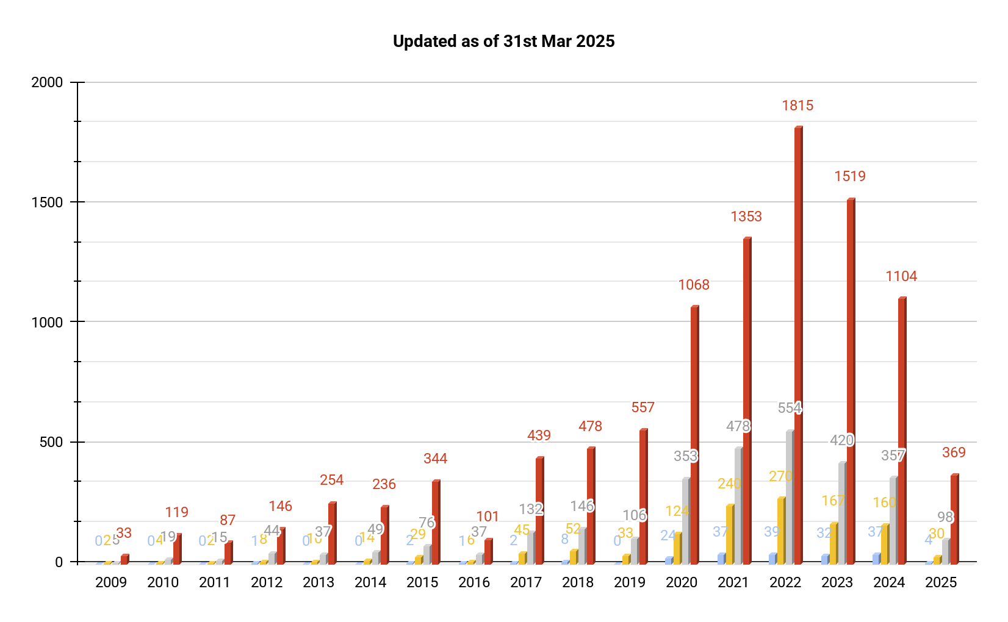

### **platinums**

* There have been ***187 platinum trophies earned,*** since the 1st platinum trophy achieved in 2012.

### **trophies**

* Total number of all trophies earned per year since 2009.

# **References**

## **PSPrices**

* No one likes missing a good sale!
* PSPrices are a video game deals tracker based in London, who gather offers from the digital storefronts of PlayStation, Xbox and Nintendo, to help gamers find the best video game bargains from anywhere in the world.
* Upon signing up for free, I decided to contribute a one-off lifetime payment to the developers of PSPrices in order to show my gratitude for their service.
* While similar sites would show game deals, PSprices also allow you to track your entire game collection across different consoles.
* Just pick your favourite games, click Subscribe, and PSPrices will send you an email when the prices of games drop in the sales, as well as upcoming games.
* It's a neat way to keep track of what you own and even rediscover some old favourites.
* Join the PSprices community today at [**hello@psprices.com**](mailto:hello@psprices.com)
* hoff_jager PSN Game Wishlist - [**https://psprices.com/wish-list/HQkF82kb**](https://psprices.com/wish-list/HQkF82kb)

## **PSNProfiles**

* PSNProfiles are a video game tracker that logs how recently you have played your video games, along with in-game trophy achievements earned towards video game completion.
* Upon signing up for free, I decided to contribute a one-off lifetime payment to the developers of PSNProfiles, in order to show my gratitude in addition to unlocking the Premium features of their website, such as:
  + Frequent trophy server synchronization
  + Digital trophy cabinet displaying my Top 10 rare trophies achieved
* hoff_jager PSN Gamer Profile - [**https://psnprofiles.com/hoff_jager**](https://psnprofiles.com/hoff_jager)