// form library

/**
* http://sandbox.threejs.hofk.de/
*/

// +++ Add your form to the end of the file. +++ // description / @author ... / http://... /

var geometry = new THREE.Geometry(); // create a base geometry
geometry.createMorphGeometry = THREEf.createMorphGeometry; // insert the method from THREEf

// then apply the method with the appropriate parameters
geometry.createMorphGeometry({

// set the list of parameters from examples below

});

/** ----------------------------------------------------------------------------------------------------

/* parameter overview --- all parameters are optional ---

p = {

// simple properties

radius, // reference radius, multiplier for functions
height, // reference height, multiplier for functions
radiusSegments, // radius segments (number)
heightSegments, // height segments (number)
circOpen, // circular connected or disconnected
withTop, // with a top
withBottom, // with a bottom
waffled, // four faces / segment, with center vertex
style, // 'map', 'cover', 'complete'

// functions: u,v and result normally 0 .. 1, otherwise specific / interesting results!
// ( trigonometric functions often with factor n * PI )
// u radial, v heigt, t time

rCircHeight, // function ( u, v, t ) // radius depending on segment location
centerX, // function ( v, t ) // centerpoint x by height
centerY, // function ( v, t ) // centerpoint y by height
centerZ, // function ( v, t ) // centerpoint z by height
unrollCover, // function ( v, t ) // 0 closed, 1 linear open (to -1*radius)
waffleDeep, // function ( u, v, t ) // radius difference center vertex
moveX, // function ( u, v, t ) // factor for radius, move in x direction
moveY, // function ( u, v, t ) // factor for height, move in y direction
moveZ, // function ( v, u, t ) // factor for radius, move in z direction
endCircAngle, // function ( v, t ) // circular end angle (per height)
startCircAngle, // function ( v, t ) // circular starting angle (per height)
scaleCircAngle, // function ( u, t ) // scaling between start and end of circular angle
topHeight, // function ( u, t ) // top height (per circular angle)
bottomHeight, // function ( u, t ) // bottom height (per circular angle)
scaleHeight, // function ( v, t ) // scaling between bottom and top height
materialTop, // function ( u, t ) // material top ( per circular sector)
materialBottom, // function ( u, t ) // material bottom ( per circular sector)
materialCover, // function ( u, v, t ) // material cover ( per circular sector and height )
// material: round( result*10 ) is material index 0 .. 10

// string array (strings of digits) seperated with a ,

fixedMaterial, // fixed given material index, overrides materialCover

// array of center points replaces heightSegments, scaleHeight and the center functions centerX, centerY, centerZ

centerPoints // array of arrays of coordinates [ [ x0, y0, z0 ], .. [ xi , yi, zi ] ], values normally 0 .. 1

}
*/

// ----------------- lists of parameters, all others by default -----------------

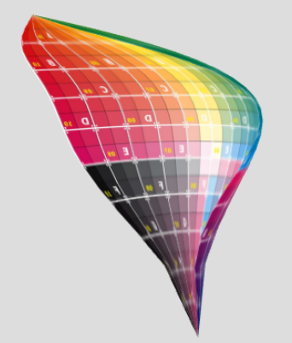
// leaf / @author hofk / http://sandbox.threejs.hofk.de/
radius: 20,
height: 80,
radiusSegments: 20,
heightSegments: 20,
circOpen: true,
rCircHeight: function ( u, v, t ) { return Math.sin( 3.14 * v ) + 0.05 },
unrollCover: function ( v, t ) { return 0.5 * Math.sin( 3.14 * v) - 0.05 },
moveX: function ( u, v, t ) { return -5 * Math.sin( v ) * Math.cos( v ) },
moveZ: function ( u, v, t ) { return 4 * v },
endCircAngle: function ( v, t ) { return 0.83 },
startCircAngle: function ( v, t ) { return 0.17 },
scaleHeight: function ( v, t ) { return Math.sqrt( v ) }

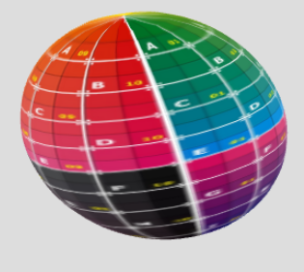
// sphere / @author hofk / http://sandbox.threejs.hofk.de/
radius: 50,
radiusSegments: 36,
heightSegments: 36,
rCircHeight: function ( u, v, t ) { return Math.sqrt( 1 - ( 2 * v - 1 ) * ( 2 * v - 1 ) ) }

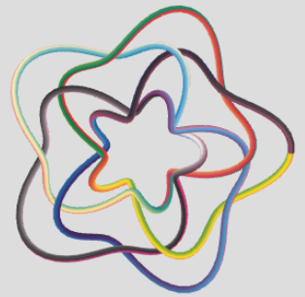
// knot / various knots - http://www.mi.sanu.ac.rs/vismath/taylorapril2011/Taylor.pdf
radius: 4,
heightSegments: 400,
centerX: function ( v, t ) { return Math.cos( 4*v *2*Math.PI ) * ( 1 + 0.5 * ( Math.cos( 5*v *2*Math.PI ) + 0.4 * Math.cos( 20*v *2*Math.PI ))) },
centerY: function ( v, t ) { return Math.sin( 4*v *2*Math.PI ) * ( 1 + 0.5 * ( Math.cos( 5*v *2*Math.PI ) + 0.4 * Math.cos( 20*v *2*Math.PI ))) },
centerZ: function ( v, t ) { return 0.35 * Math.sin( 15*v *2*Math.PI ) }

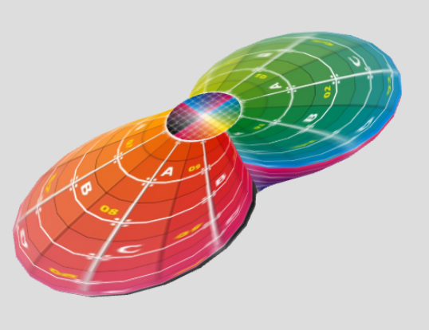
// double / @author hofk
radius: 50,
height: 25,
radiusSegments: 40,
heightSegments: 20,
withTop: true,
withBottom: true,
rCircHeight: function ( u, v, t ) { return 0.2 + ( Math.abs( Math.sin( 6.28 * u ) ) * Math.sin( 3.14 * v ) ) }

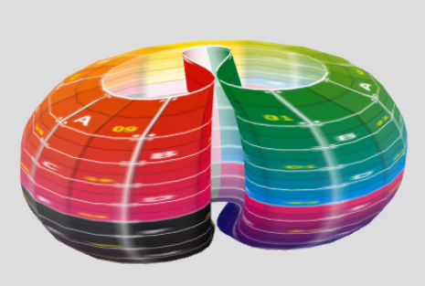
// concave / @author hofk
radius: 100,
radiusSegments: 50,
scaleCircAngle: function ( u, t ) { return 1 / ( 1 + Math.exp( - 12 * ( u - 0.5 ) ) ) },
moveX: function ( u, v, t ) { return -0.5 * ( 1 + Math.cos( 2 * Math.PI * u ) ) },
moveZ: function ( u, v, t ) { return -0.12 * Math.sin( 6 * Math.PI * u ) },
rCircHeight: function ( u, v, t ) { return 0.5 + 0.5 * Math.sqrt( 1 - ( 2 * v - 1 ) * ( 2 * v - 1 ) ) }

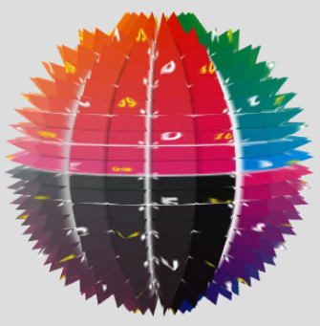
// spiked ball / @author hofk
radius: 50,
radiusSegments: 20,
heightSegments: 20,
waffled: true,
waffleDeep: function ( u, v, t ) { return -10 },
rCircHeight: function ( u, v, t ) { return Math.sqrt( 1 - ( 2 * v - 1 ) * ( 2 * v - 1 ) ) }

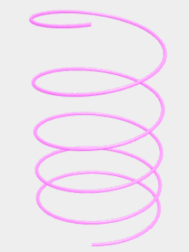
// coil spring (moved by t) / @author hofk
radius: 2,
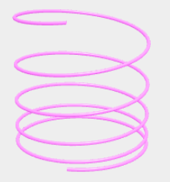
height: 160,
radiusSegments: 16,
heightSegments: 500,
centerX: function ( v, t ) { return 0.5 * Math.sin( 10 * Math.PI * v ) },
centerY: function ( v, t ) { return v * ( v + 0.4 * ( 1 + Math.sin( t ) ) ) },
centerZ: function ( v, t ) { return 0.5 * Math.cos( 10 * Math.PI * v ) } snapshots

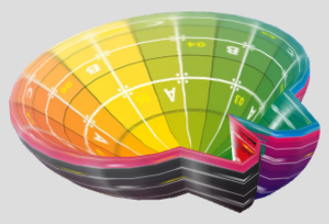
// washbowl / @author hofk
radius: 80,
radiusSegments: 36,
heightSegments: 36,
rCircHeight: function ( u, v, t ) { return Math.sqrt( 1 - ( 2 * u - 1 ) * ( 2 * u - 1 ) ) * Math.sqrt( 1 - ( 2 * v - 1 ) * ( 2 * v - 1 ) )},
moveX: function ( u, v, t ) { return u < 0.1 || 0.9 < u ? 0.4* Math.cos( 6.3 * u ) : 0 },
moveY: function ( u, v, t ) { return -v * v * v * v }

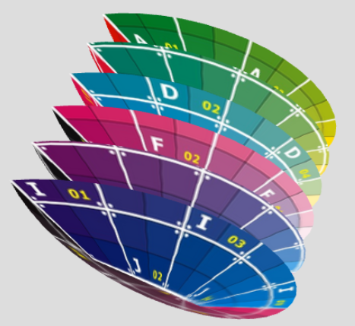
// streamlined / @author hofk
radius: 36,
radiusSegments: 36,
heightSegments: 36,
rCircHeight: function ( u, v, t ) { return 6 * v - Math.floor( 6 * v ) },
moveX: function ( v, t ) { return 4 * ( 0.5 - v ) * ( 0.5 - v ) }

// gramophone / @author hofk / http://sandbox.threejs.hofk.de/
rCircHeight: function ( u, v, t ) { return 0.25-Math.pow(2, 10 * (v - 1)) * Math.sin((v - 1.1) * 5 * Math.PI) },
centerX: function ( v, t ) { return 0.25-Math.pow(2, 10 * (v - 1)) * Math.sin((v - 1.1) * 5 * Math.PI) },
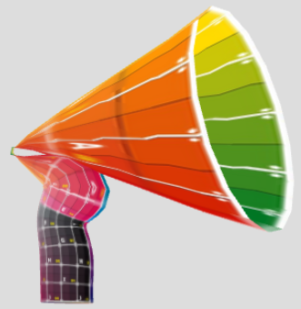
radius: 25,
height: 50,
radiusSegments: 16,
heightSegments: 32,
withBottom: true

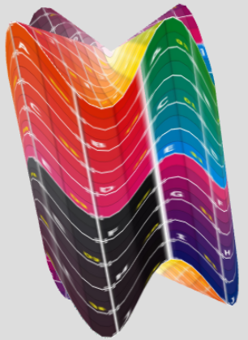
// unknown / @author hofk
radius: 60,
radiusSegments: 60,
withTop: true,
withBottom: true,
topHeight: function ( u, t ) { return 0.75 + 0.25 * ( 1 + Math.sin( 8 * Math.PI * u ) ) },
bottomHeight: function ( u, t ) { return -0.75 + 0.25 * ( 1 + Math.cos( 8 * Math.PI * u ) ) }

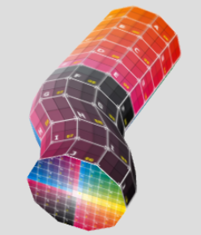
// curved cylinder / @author hofk
withBottom: true,
moveX: function ( u, v, t ) { return Math.exp( -200 * v * v * v * v ) }

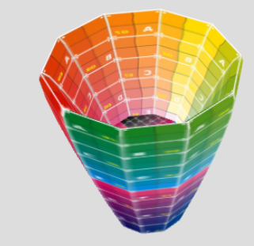
// vase / @author hofk
radius: 50,
withTop: true,
withBottom: true,
scaleHeight: function ( v, t ) { return Math.sin( 2.6 * v ) },
rCircHeight: function ( u, v, t ) { return Math.sin( 0.4 + 2.3 * v ) }

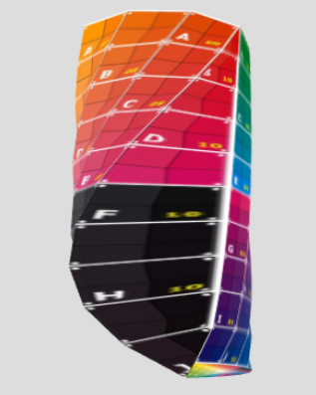
// half twisted / @author hofk
height: 60,
withBottom: true,
endCircAngle: function ( v, t ) { return Math.sqrt(0.19 + 1.28 * v) },
startCircAngle: function ( v, t ) { return Math.sqrt(0.01 * v ) }

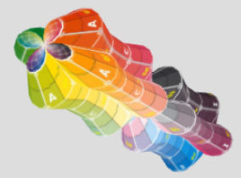
// eight-part / @author hofk
withTop: true,
radiusSegments: 40,
rCircHeight: function ( u, v, t ) { return 0.5 * ( Math.abs( Math.sin( u * 4 * Math.PI ) ) + Math.abs( Math.sin( v * 4 * Math.PI ) ) ) }

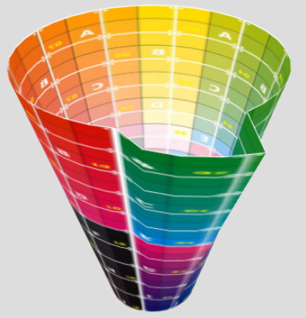
// cup with spout / @author hofk
radius: 32,
radiusSegments: 36,
withBottom: true,
rCircHeight: function ( u, v, t ) { return u < 0.125 ? v * ( 1 + 2 * Math.sqrt( u ) ) + 0.5 : v + 0.5 }

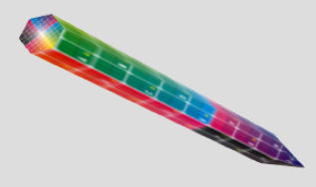
// pencil / @author hofk
radius: 4,
radiusSegments: 6,
withTop: true,
rCircHeight: function ( u, v, t ) { return v < 0.2 ? 5 * v : 1 }

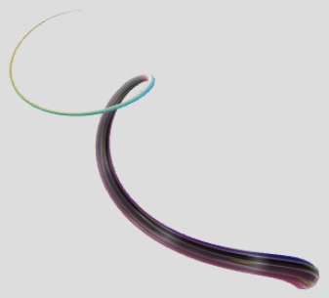
// whip / @author hofk
radius: 4,
heightSegments: 80,
rCircHeight: function ( u, v, t ) { return Math.exp( -3 * v ) - 0.05 },
centerX: function ( v, t ) { return 0.1 * Math.cos( 12 * v) },
centerY: function ( v, t ) { return 1 - Math.exp( -3 * v ) },
centerZ: function ( v, t ) { return 0.1 * Math.sin( 12 * v) }

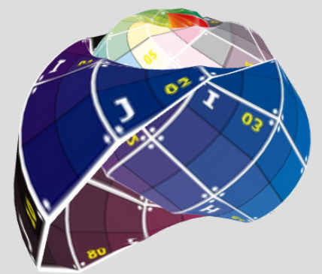
// snail / @author hofk / http://sandbox.threejs.hofk.de/
radius: 120,
heightSegments: 80,
rCircHeight: function ( u, v, t ) { return 1 - v },
centerX: function ( v, t ) { return 0.1 * Math.cos( 12 * v) },
centerZ: function ( v, t ) { return 0.1 * Math.sin( 12 * v) },
moveY: function ( u, v, t ) { return 0.2 * Math.sin( 1.9 * v ) }

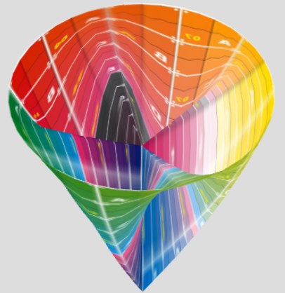
// lace bag with chambers / @author hofk
radius: 40,
radiusSegments: 40,
rCircHeight: function ( u, v, t ) { return Math.sin( v ) },
bottomHeight: function ( u, t ) { return 0.4 + 0.4 * Math.sin( 8 * Math.PI * u ) }

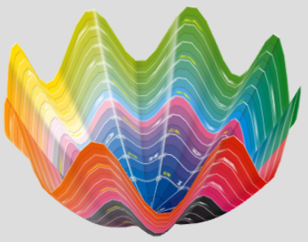
// curved shell / @author hofk
radius: 80,
radiusSegments: 80,
rCircHeight: function ( u, v, t ) { return Math.sqrt( v ) },
topHeight: function ( u, t ) { return 0.8 + 0.2 * Math.sin( 16 * Math.PI * u ) }

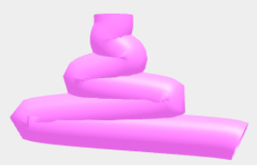
// superimposed / @author hofk
heightSegments: 100,
centerX: function ( v, t ) { return ( v - 1 ) * ( v - 1) * Math.cos( 6 * Math.PI * v ) }

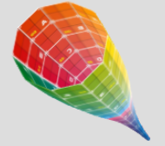
// goblet / @author hofk
rCircHeight: function ( u, v, t ) { return 1 / ( 1 + Math.exp( - 6 * ( v - 0.5 ) ) ) }

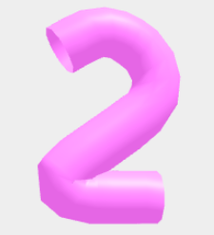
// 2 / @author hofk
centerPoints: [ [ .6, 0, 0 ], [ .5, 0, 0 ], [ .4, 0, 0 ],[ .3, 0, 0 ], [ .2, 0, 0 ],[ .1, .01, 0 ], [ .02, .07, 0 ], [ 0, .1 , 0 ], [ .02, .13, 0 ], [ .1, .21, 0 ], [ .2, .28, 0 ], [ .3, .35 , 0 ], [ .4, .42 , 0 ], [ .5,.5 , 0 ],[ 0.58, .6 , 0 ],[ .6, .7, 0 ], [ .58, .8, 0 ], [ .51, .9, 0 ], [ .44, .95, 0 ], [ .38, .98, 0 ], [ .3, 1, 0 ],[ .2, .99, 0 ], [ .1, .94, 0 ], [ 0, 0.88, 0 ] ]

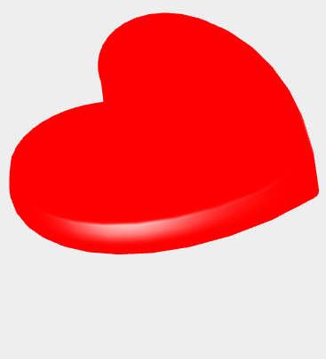
// heart / @author hofk
radiusSegments: 50,
height: 10, snapshot
withTop: true,
withBottom: true,
rCircHeight: function ( u, v, t ) { return 20 * ( u - 0.5 ) * ( u - 0.5 ) + 0.3 * Math.sin ( Math.PI * v ) + 0.3 * Math.sin( t ) },
moveX: function ( u, v, t ) { return -Math.cos( 2 * Math.PI * u ) },
topHeight: function ( u, t ) { return 0.6 * ( 1.4 + Math.cos ( Math.sin( t ) * Math.sin( t ) * u ) ) }

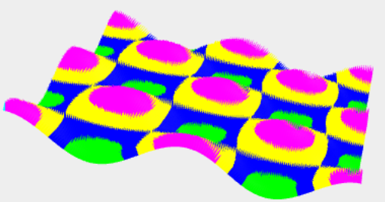
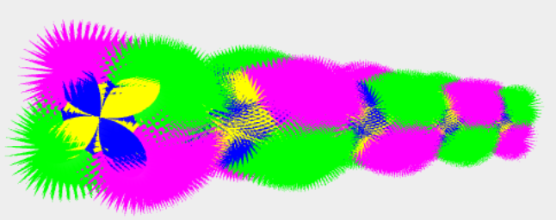
// wave with spikes / @author hofk
without
style:'cover',

default
'complete'
style: 'cover',
waffled: true,
waffleDeep: function ( u, v, t ) { return -3 },
radiusSegments: 160,
heightSegments: 160,
rCircHeight: function ( u, v, t ) { return 0.33 * Math.cos( 12.6 * u ) * Math.cos ( 12.6 * v ) },
materialCover: function ( u, v, t ) { return 0.3 + 0.2 * ( 1 + Math.cos( 12.6 * u ) * Math.cos ( 12.6 * v ) ) }

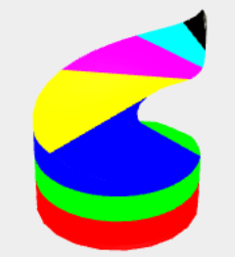
// screwed / @author hofk
radius: 40,
radiusSegments: 36,
heightSegments: 36,
endCircAngle: function ( v, t ) { return Math.exp( 1 - 3 * v ) },
startCircAngle: function ( v, t ) { return Math.exp( -3 * v ) },
materialCover: function ( u, v, t ) { return 0.2 + 0.7 * v }

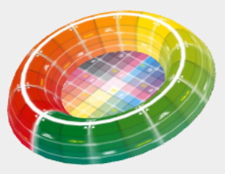
// food bowl / @author hofk
radius: 72,
radiusSegments: 36,
withTop: true,
rCircHeight: function ( u, v, t ) { return 0.6 + 0.6 * v },
scaleHeight: function ( v, t ) { return 1 - ( 0.5 - v ) * ( 0.5 - v ) }

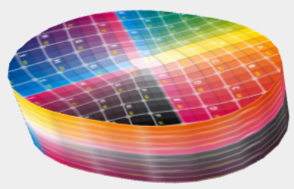
// oval can / @author hofk
height: 8,
radiusSegments: 36,
withTop: true,
withBottom: true,
rCircHeight: function ( u, v, t ) { return 0.85 - 0.15 * Math.sin( 4 * Math.PI * u ) }

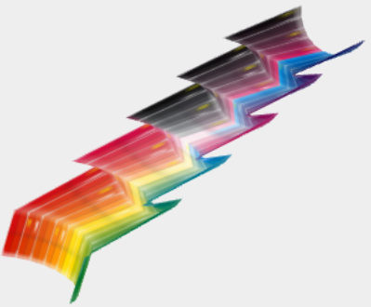
// water staircase / @author hofk
radius: 6,
circOpen: true,
centerPoints: [ [ 0, 0, 0 ], [ .1, .1, 0 ], [ .2, 0.01, 0 ], [ .3, .1, 0], [ .4, 0.01, 0 ], [ .5, 0.1, 0 ], [ .6, 0.01, 0 ], [ .7, 0.1, 0 ], [ .8, 0.01, 0 ], [ .9, 0.1, 0 ], [ 1, 0.0, 0 ] ],
unrollCover: function ( v, t ) { return 1.4 }

// your form / @author ...

