Data Collection
I used the following query to extract the temperatures for my local city of Chicago and join that with the global temperatures on year. Doing so happens to have removed several earlier years for Chicago that did not have temperatures making it unnecessary to deal with missing data.
SELECT
a.year,
a.city,
a.country,
a.avg_temp chicago_temp,
c.avg_temp global_temp
FROM
city_data a
INNER JOIN city_list b ON
a.country = b.country
AND a.city = b.city
INNER JOIN global_data c ON
a.year = c.year
WHERE
b.country = 'United States'
AND b.city = 'Chicago'

Data Processing
I then loaded the CSV data into a Google spreadsheet and added a ten year rolling average temperature for both Chicago as well as global temperatures. Doing so does remove the first nine years from comparison since there would be no rolling averages for those first nine years. I then created a relatively simple line chart of the two averages for comparison.
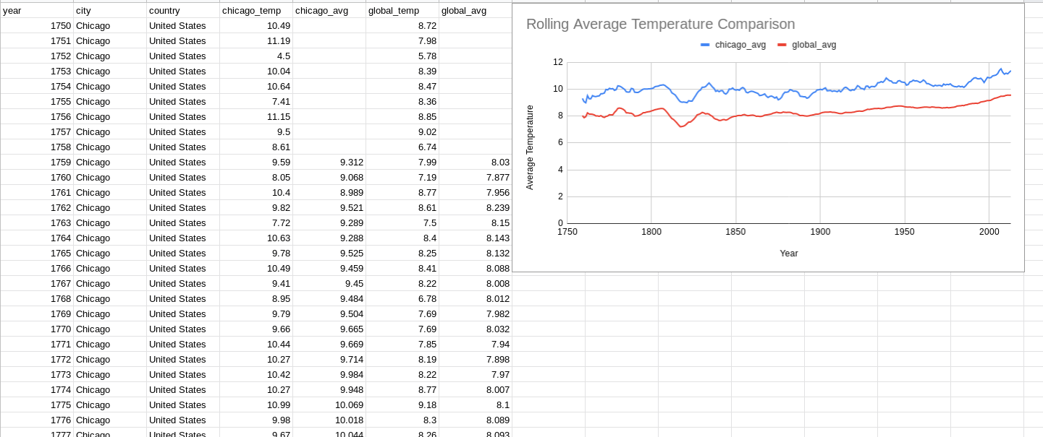

Observations
The first observation is that Chicago is consistently warmer than the global average but only slightly (Brrr).
Both averages are trending upward with almost two degrees of increase over 250 years.
There was a sudden sharp decline in average temperatures in the early 1800’s followed by a spike in temperature back to previous levels that was just as sudden.
The upward trend in average temperatures appears to begin around 1900.

