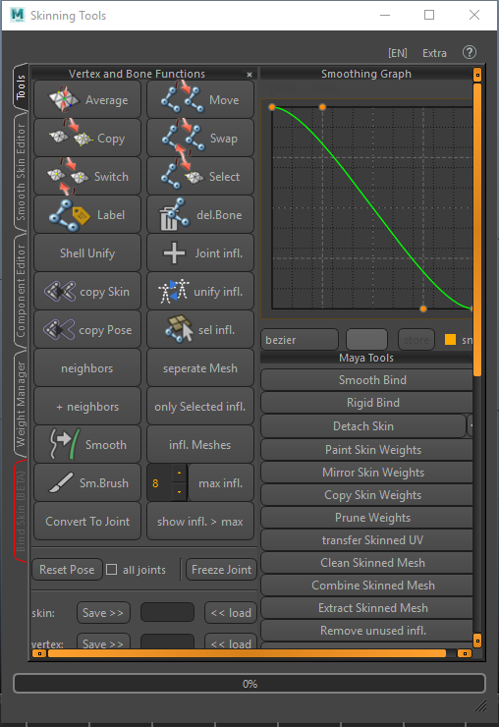Skinning Tools UI

Tools

* Vertex and Bone Functions
* Smoothing Graph
* Maya Tools
* Copy/Transfer by Range
* Match Vertex Weights

Smooth Skin Editor

Component Editor

Weight Manager

Bind Skin (BETA)

# Layout

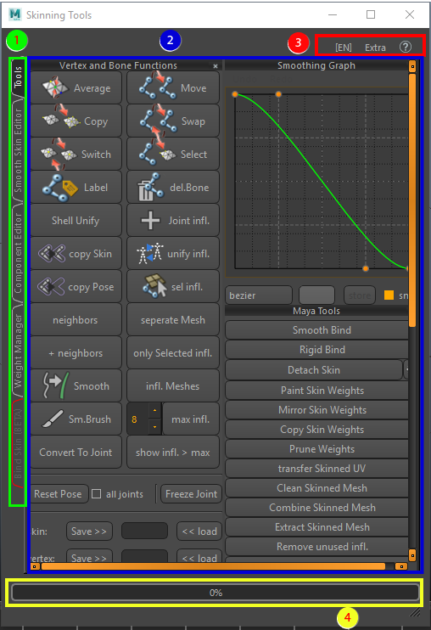

1. Tabs

Different tabs with functionality to work on skin clusters;

* Tools: Maya toolset functionality
* Smooth Skin Editor: sliders that allow the user to control vertex skinning influences
* Component Editor: similar to the one in Maya with added functionality
* Weight Manager: widget to save and restore skin cluster information
* Bind Skin (BETA): tool to create a “decent” skin bind from scratch.

1. Toolsets

This is where the different (main) toolsets and functions live for the skinning tool.

1. Menu tools:

Change language form English to Japanese

Extra functions:

* Hold and fetch: clean copy past function from one scene to another
* Make tools floatable: convert the dock widgets in Tools tab to detachable widgets
* Skeleton > Obj: creates a polygonal object out of the skeleton
* Unlock Beta Tab: unlocks the tab under beta for testing.

Help functions, show documentation or enhance the tooltip

1. Progress bar

Visualizes the progress on some of the more invasive tools.

# Vertex and bone functions:

1. Skin weight functions:

**Average vertices (repeat last)**

The average button needs at least 2 “vertices” as an input,

If 2 vertices are selected it will generate a path of edges between the 2 vertices and average the weights over the distance

If 3 vertices or more are selected, it will add all the weighting information from every joint on those vertices and combines them. Then it will divide the values by the amount of vertices and apply them on the last selected vertex.

If 2 edge loops are selected (i.e. close to an elbow and wrist), it will search vertices on a connecting loop and smooth in between.

Makes use of the **Smoothing Graph**

Right click the button to change average function to percentage or distance

**Copy vertices (repeat last)**

The copy button is to make sure that multiple vertices have the same value (really useful for solid objects in between stretching skin)

Select all the vertices you want to have the same value, as last select the vertex that has the value you want to apply to all the vertices selected and the use the copy tool.

**Switch vertices (repeat last)**

This tool only works on 2 vertices not more; it switches the values for both vertices

**Label (no repeat last)**

The label will automatically figure out what type a joint is based on naming: it tries to label the joint either “Left”, “right” or “center”, it will open up a dialogue which presents options as to which naming convention to follow! This will make sure that copying skin, and mirroring skin will have fewer problems with joints that are on top of each other (like roll bones)

**Shell Unify (repeat last)**

Converts selection into separate clusters, each cluster will be analyzed for its average weight value and this will then be applied to that cluster. Makes for easy hard surface skinning.

**Copy skin (repeat last)**

This will transfer skin from first selected object to other objects using Maya’s default copy skin method; this will make sure that the meshes that will receive the skin value are detached from their skin cluster before creating a new one

**Copy Pose (repeat last)**

this will do the same as the Transfer skin button except it deletes the history of the skin cluster before copying the skin keeping the pose the mesh is in. (right click options added for non-smooth operation and for skinning based on uv positions which is better for LODs)

**Neighbors/neighbors + (repeat last)**

these options can smooth out the weights, they use a less invasive way of smoothing then the weights hammer, “neighbors” only smooth’s the first detectable components outside of the selection, while “neighbors +” smooth’s the selection first and then smooth’s the first detectable components outside of the selection, this will give a better falloff.

**Smooth (repeat last)**

The smooth button works similar to the average button, but it will find all the neighboring vertices for you. Select all vertices that need a smoothed influence on the skin and hit this button to smooth these out (weight hammer works similar but is a bit more harsh)

**Smooth Brush (repeat last)**

The smooth brush is an adaptation of the smooth button to a brush, it will allow to smooth over all bones at once (standard smooth brush of Maya allow smoothing only over 1 bone at a time)

**Convert to joint (repeat last)**

Convers selection or cluster into a joint with selection as influence, also takes in smooth selection operations.

**Move bones (repeat last)**

When you want to have all the influence that are on one joint removed and applied to another joint the move tool will do this. Really handy if you want to remove a joint and also be sure where all the weighting values are distributed. Select the bone which has the values, then the bone you want to apply the values to and lastly the mesh which is attached to the bones.

**Swap bones (repeat last)**

This tool switches the values from one bone to another bone and vice versa. This is especially handy if you have extra joints in for example the shoulder (rolls bone and shoulder bone) if you apply the weights in the wrong order, this tool will switch the weighting values for you while keeping the other values intact. So first select the joints you want the influences switched, then select the mesh to which they are bound and run the tool.

**Select influences (repeat last)**

This is a visualization tool which allows you to select all the vertices that are influenced by a bone or a multiple selection of bones( no matter how small) this makes it easy to see if vertices are influenced that should not be.

**Delete Bone (no repeat last)**

The delete bone button will remove a bone and try to fix the skinning (note: the bone should not have any children and should be parented to the bone that will take on its influences) this makes sure that the skin will not be broken

**Add joint infl. (repeat last)**

Adds a joint to the selected mesh as an influence, it will be added with 0.0 weight value for the joint so it does not break the skin.

**Unify Joint infl. (repeat last)**

Select 2 meshes with a skin cluster, this option will make sure that the same bones are influencing both objects; all objects that are added to make sure the influences are unified will be added with 0.0 weight values.

**Select joint infl. (repeat last)**

This option will select all the joints that are influencing the current selected mesh.

**Separate Mesh: ( no repeat last)**

Separates the skinned meshes by their mesh shells but keeps the skinning information intact, allows the used to focus on the skinned mesh piece by piece, the mesh can later be combined back into one piece if desired.

**Only selected Inf.: ( repeat last)**

Select components you want to isolate joint influences for, and select the joints. When used this function will remove all the influences of all the joints that are not selected from your selected components.

**Influence meshes (no repeat last)**

Selects all objects that are influenced by current joint selection.

**Max infl. (no repeat last)**

The field that comes with this button allows for input how many joints you want to have as an influence per vertex as a maximum, for example; 8 will allow only 8 bones to influence a certain vertex for every vertex in that selected mesh.

**Show infl. > max (no repeat last)**

This will help visualize and select which vertices have more bone influences then specified in the input above

1. joint options:

**Reset pose(no repeat last)**resets the mesh’s bindpose positions allows for the moving of bones without destroying the skincluster

**Freeze joint(no repeat last)**re-computes joint orientation of skinned or constrained joints, making sure that the rotations are set back to 0

1. quick store functions:

**Skin: save > < load (no repeat last)**save stores the entire skin cluster, now the mesh can be adjusted even history deleted, load will re-apply the entire skin cluster ( only works if vertex ids are still the same)

**Vertex: save > < load (no repeat last)**save stores weight information from one vertex, load will set the weight of that stored vertex onto other selected vertices ( could be from another mesh object, as long as the influences are the same!)

1. border selection:

**Store inner**: store current polygon component selection

**< Shrink** : once the selection has grown, shrink the selection back to previous state

**Grow >** : grow the selection, but remove inner selection from result

# Smoothing Graph

The smoothing graph is a Bezier curve display that visualizes and controls the falloff for the average vertex weigh button in the “vertex and bone functions” widget.

1. Graph display, has 4 points to change the curve, first and last point can be changed in position but not advisable, middle 2 points should be used most of the time
2. Combo box to change between different stored curves, currently stored:  
   Bezier: simple Bezier with smooth in and smooth out

Linear: middle handles placed in a position to give a linear falloff

1. If a curve is set to a desired position which might be used more than once or applicable for future projects, a name can be given and stored in the combo box (2)
2. Snap function allows for a bit more precise control to snap to the grid, when snap is off, handles have full freedom to be moved.

# MayaTools

1. Default Maya option commands:

First part of the tool consists off all useful Maya tools combined in one window for ease of access. All buttons open the toolbox options to make sure that all settings are correct and for easy adjustment, except for detach skin which has the option to show the toolbox “[]”.

1. Some Maya specific single click tools modified to work with skin clusters, have settings with best results or created so newly added tools work similar in older Maya versions:

**Transfer skinned UV:**

Transfer skinning from one object to a skinned mesh, forces the UV’s to be set before deformation stack

**Clean Skinned Mesh:**

Cleans skinned object, cleans transform and removes non deformer history

**Combine skinned mesh:**

Similar to function in Maya but added this functionality for versions before Maya 2016.

**Extract Skinned Mesh:**

Converts selected face components to a separate mesh with skin cluster intact

**Go to bind pose:**

Set joints to bind pose based on bind pose node or by using pre-bind matrices.

**Delete bind poses:**

Removes all bind pose nodes in scene

**Weight hammer:**

Smooth skin operation on selected components, set with default settings that give nice result.

1. Proxy settings:

**Create Proxy**

This function dissects the skinned mesh based on skinning influences, and attaches these pieces back to the joints with a constraint

**Internal:**

Prevents overlap on cut pieces/allows holes in geometry

**Fast:**

Less invasive function to cut the geometry, if unchecked, it will give better results but will take a lot longer

# Copy/Transfer by Range

This will allow you to copy the skin influences from a selection of vertices, to another selection of vertices on the same mesh or from mesh to mesh.

1. Amount of points to look for in search, 1 is fast but might give shearing on skinning, the higher the value the more smooth, but will also add more influences to a vertex
2. **Transfer mesh to mesh:**

Using one mesh as a base to copy its skinning information to another, the meshes points do no need to be the same as the base mesh will be converted to a point cloud, the higher the amount of search points the smoother the result will be

1. **Copy components:**

“<< source” needs to have a selection of components to copy from

“<< target” needs to have the selection to copy to

Using the same technique as “transfer mesh to mesh” it will create a point cloud out of the first selection and set its skinning information to the target selection.

“Reset“will clear all information from the UI

# Match Vertex Weights

This works fast if you want to copy weights between duplicate objects, select the vertices that have the correct weight information and store them on the second object.

1. Store selections:

**Store selection**

Store the selected vertices so they can be selected easily again, think of this as being a selection set in the skinning tool window

**Clear list**

This will remove all the stored selection sets

1. information matcher

**Grab source**

Grab the skin cluster from the selected source object

**Grab target**

Grabs the skin cluster from the selected target object

**Copy selected vertices**

This will copy over the weights from the source to the target overwriting the vertex weights of the target object

1. Additive check, This will add the source weights to the target weights and will normalize after applying

# Smooth-skin editor

This window shows the selected vertices and the weight information attached. As you can see “pPlane1” is selected and from that a couple of vertices are selected.

1. Current manipulating joints,

The sliders show the influence of the joint, double clicking the slider allows user input on the value same as sliding the blue bar

1. The lock buttons allow the user to force the value for the joint to be set and hold in position, this way when sliding another joint it will take this value out of calculation while keeping all values normalized
2. Unused joints can be added by unlocking them and adding a value.
3. Reload, will force reload the widget, useful when another selection is made

Live, forces the widget to reload when selection is changed in scene.

# Component Editor

Simple component editor similar to the one already in Maya

1. Joints:

Shows joints that influence current selected vertices, if a joint label is selected it allows the user to set the values for all vertices at once

1. Table view:

Display of influences on current joint and vertices, to edit value, click the cell, all influences will be adjusted to keep normalization.

The cell consists out of a spin box so user can scroll through the value instead of putting it in by hand

1. Hide zero columns;

Show or hide the columns with 0.0 value for influence

1. Reload, will force reload the widget, useful when another selection is made

Live, forces the widget to reload when selection is changed in scene.

# Weight Manager

The weights manager can store xml based files wrapped in a zip. it will list all stored data files in the UI. If no name is specified it will open a window to allow saving the weights in different folders.

1. Exporting

Export skin weights, saves a zip file with skin weight xml data on through a file dialog, but if a name is specified it will place them in the weights folder of the this tool and add them to a quick select list in the UI

1. Quick select list.

Skin weights files stored in the weights folder of the skinning tool will pop up here, for quick selection

1. Import settings.

When loading a skin cluster, if anything is different between the current mesh and the stored skin cluster it will try to solve the skinning based on known data, searching vertices based on world space positions or UV space positions, the spin box determines how many vertices to look for and to smooth between

1. Selection based options:

Import skin weights, if an object is selected in the quick select list (2) it will load this information on the selection in the scene, if nothing is selected in the scene it will search by naming convention in the loaded information and provide a rematch table if necessary, same for the joints. If nothing is selected in the UI, it will open a file dialog to search for skin cluster information files.

Delete skin weights: allows the user to delete a selected skin weights file from the quick select list (2)

# Bind Skin (BETA)

Currently in beta, a different way to do a basic skin bind for a character, it uses a Voronoi solution using joints as basepoints and the mesh to be divided.

1. Skeleton visualizer,

The coverage represents the line of the joints, from the actual beginning of the joint all the way to a connecting joint, coverage means how long this line is, primary axis is to make sure that the line is detected correctly.

Visualizer button, attaches a node with openGL functionality to display how the mesh will be divided for skinning

1. Visualizer attributes

Allows the user to set the attributes of the visualizer node without having to switch between panels.

1. Bind skin, creates a skin cluster and distributes skinning data based on the placement of the visualizer

Divisions, set how many divisions are added to the joint segments, each division adds a point to the Voronoi calculation

Smooth, sets how many points may look at the same point on the mesh

1. Vertex color binding info

Analyze, converts skinning info to selection lists with vertex color, extra selections and colors can be added with “add selection group”

Hard/soft surface will turn current selection clusters hard or smooth based on the skinning information in the selection

# Marking Menu

How to access:

* Select components of the mesh
* Middle-click and hold on top of a bone
* This enters the marking menu of what you can do for the selected component weights and the bone that is under the mouse
* Also works with smooth selection (will apply the smooth values accordingly).

1. Displays current joint influence that is going to be manipulated
2. All the different options that can be used to set or remove values of influence
3. When smooth selection is used before going into the marking menu this option will appear, allows the user to switch between surface aware or ignore surface connection and select everything within components radius
4. The .5 value in the menu set (2) can be changed in the increment value menu, it can change values to the 3rd decimal