Hybrid Failbit Map Analysis Architecture for Known Classification and Unknown Discovery
Gildong Hong¹, Cheolsu Kim¹
¹ Semiconductor Research Center, Samsung Electronics, Hwaseong-si, Republic of Korea
(Abstract) Failbit Maps are ultra-high-resolution data generated in semiconductor EDS tests, with roughly 10 million pixels per wafer, and are a key source for defect-pattern analysis. However, in practical operations, large-scale retrieval and inspection of Failbit Maps have been impractical, and even the limited analysis that was feasible relied heavily on manual inspection by engineers. This work addresses that limitation by building a large-scale Failbit Map data pipeline and implementing an architecture in which Known defects are handled by two-stage supervised classification and Unknown defects are discovered by self-supervised learning. Data transformation speed was improved by about 100x through Cython, while the image storage footprint was reduced by about 75% through a 32-color palette-indexed PNG. For Known defects, a ConvNeXtV2-based first-stage classifier was combined with a second-stage ROI (Region of Interest)-based YOLO classifier for low-confidence samples, achieving a weighted F1 of 0.95. For Unknown defects, a SimCLR-family model was trained with contrastive learning using grid-structured local sampling to reflect the zone-based nature of wafer defect interpretation. After training on 10,000 Failbit Maps collected over five production days, the model was applied to 2,000 maps from an additional day. It detected 13 defect groups, 7 of which were confirmed by domain engineers as real defect groups, demonstrating practical applicability in production.
Keywords: Failbit Map, Wafer Failure Analysis, ConvNeXtV2, YOLO, Contrastive Learning, HDBSCAN

1. INTRODUCTION
A Failbit Map represents defect severity at the memory-cell-block level in EDS testing using grades from 0 to 7. Because a single wafer contains roughly 10 million blocks, it is an ultra-high-resolution representation of defect location and morphology. In current practice, Measure-based analysis alone cannot capture this information, making exhaustive Failbit Map analysis necessary.
Two limitations have hindered practical adoption in production. First, the existing system did not have sufficient processing performance to transform equipment logs into large numbers of Failbit Maps and to store and browse them at scale. Equipment logs are typically 10 to 50 MB per wafer, and roughly 20,000 wafers are produced per day across all products. Under the previous environment, large-volume processing was limited by speed and memory constraints, and the number of maps that could be checked at once was restricted to about 48. Second, even when maps were generated, defect judgment and type identification still depended on manual inspection by engineers, making full analysis difficult. To address these limitations, this paper proposes an integrated analysis architecture. The main contributions are as follows.
First, we implemented a data-processing foundation capable of real-time ingestion of large equipment logs and hourly Failbit Map generation, enabling sustained large-scale map creation and operational use. Second, for Known defects, we used ConvNeXt V2 to classify wafer-level defect-chip distribution patterns in the first stage, and then applied ROI-based YOLO to perform chip-level object detection on samples prone to confusion due to similar distribution patterns, as a second-stage refinement. Third, for newly emerging defects not registered in the existing taxonomy, we implemented a SimCLR-family contrastive-learning framework for Unknown defect discovery. In addition, grid-structured local sampling was introduced to encode spatial occurrence information, enabling more precise Unknown defect detection.
2. PROPOSED METHOD
The architecture consists of a data pipeline, a two-stage Known classifier, and a self-supervised Unknown detector, deployed as a dedicated analysis web application[5].
2.1 DATA PIPELINE
The data pipeline was designed to ingest equipment raw logs in real time and generate Failbit Maps on an hourly basis. The main bottlenecks were the hex-to-grade conversion speed for roughly 10 million encoded test values per wafer and the storage footprint of the resulting images; the former was accelerated by about 100x with Cython (Fig. 1), and the latter was reduced by about 75% with a 32-color palette-indexed PNG (Fig. 2). Generated maps are stored in a central repository and served through the analysis web application[5] for large-scale browsing and analysis.

Hex-to-grade conversion
Raw:
090B0C0D0E0F090A0B0C
Decoding:
"0C" -> "C" -> 12 (hex to decimal) -> 3
Python:
interpreter-based loop execution
Cython:
compiled integer loop execution
Grade:
0 2 3 4 5 6 0 1 2 3
Fig. 1. Hex-to-grade conversion accelerated by Cython

RGB PNG vs Palette-indexed PNG
RGB PNG:
[(123,54,24), (123,54,24), ..., (123,54,24)],
[(123,54,24), (123,54,24), ..., (123,54,24)]
Palette-indexed PNG:
P[3] = (123,54,24)
[(3), (3), ..., (3)],
[(3), (3), ..., (3)]
RGB_to_Palette:
(123,54,24) -> (3)
Fig. 2. Palette-indexed PNG for failbit map compression.

2.2 Known Defect Classification
Known-defect analysis targeted 16 registered classes. We designed a two-stage structure combining a ConvNeXtV2[1]-based wafer-level first-stage classifier and a second-stage ROI (Region of Interest)-based YOLO for low-confidence samples, and trained it on 1,500 labeled Failbit Maps.
While the ConvNeXtV2-based wafer-level classifier showed high overall accuracy and throughput, its performance degraded on classes with similar wafer-level distributions of defective chips. To compensate for this, the second stage was configured so that ROI-based YOLO re-examines low-confidence samples and detects defect-chip morphology and appearance patterns within the ROI (Fig. 3).

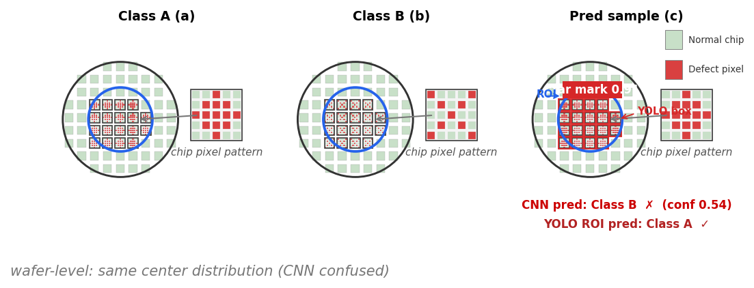
Fig. 3. Representative patterns of Class A(a) and Class B(b), and a true Class A sample(c) misclassified as Class B by the first-stage CNN but corrected to Class A by the second-stage ROI-YOLO. The blue circle indicates the ROI, and the red boxes denote YOLO detections of chip-level defect patterns within the ROI.

Table 1. Backbone comparison and staged improvements for known-fail classification (16-class, test weighted F1)
Configuration | Pre Train | Test F1 | Note
ViT | IN-21k | 0.81 | fine-tune
Swin | IN-1k | 0.84 | fine-tune
EffNetV2 | IN-1k | 0.85 | fine-tune
MaxViT | IN-21k | 0.87 | fine-tune
ConvNeXtV2 (Ref) | IN-22k | 0.87 | selected
Ref + Optuna | IN-22k | 0.92 | HPO
Ref + Optuna + ROI | IN-22k | 0.95 | 2-stage

MaxViT[2] and ConvNeXtV2 (Ref) achieved the same weighted F1 of 0.87, but ConvNeXtV2 was selected as the final backbone because it was more efficient, with about 26% fewer parameters (119.5M -> 88.6M) and about 39% fewer FLOPs (74.2G -> 45.1G). Optuna was then used to optimize fine-tuning hyperparameters such as learning rate, weight decay, focal loss, and class weight, improving weighted F1 to 0.92, and ROI-YOLO refinement further increased the final score to 0.95.
2.3 Unknown Defect Discovery
Unknown defect discovery was defined as the task of grouping similar patterns and identifying candidate defect groups. Using 10,000 production maps from five days, a SimCLR[3]-family model was trained with contrastive learning using grid-structured local sampling to reflect the zone-based nature of wafer defect interpretation. HDBSCAN[4] was then applied to a separate set of 2,000 maps from one additional day to group similar patterns.


Fig. 4. Unknown-fail grouping on production images.

For Unknown defects, grouping on 2,000 production images yielded 13 candidate groups, and validation by domain engineers confirmed that 7 of them were real defect groups. The remaining 6 were lot-specific warnings or non-defect patterns.
3. CONCLUSION
This study implemented an integrated architecture for end-to-end Failbit Map generation and automated defect analysis. Cython optimization and a 32-color palette-indexed PNG enabled large-scale map generation, storage, and operational use, while the combination of Known two-stage classification and Unknown self-supervised discovery established an automated defect-analysis workflow.
REFERENCES
[1] S. Woo et al., "ConvNeXt V2: Co-Designing and Scaling ConvNets With Masked Autoencoders," in Proceedings of the IEEE/CVF Conference on Computer Vision and Pattern Recognition (CVPR), pp. 16133-16142, 2023.
[2] Z. Tu et al., "MaxViT: Multi-Axis Vision Transformer," in Proceedings of the European Conference on Computer Vision (ECCV), pp. 459-479, 2022.
[3] T. Chen, S. Kornblith, M. Norouzi, and G. Hinton, "A Simple Framework for Contrastive Learning of Visual Representations," in Proceedings of the 37th International Conference on Machine Learning (ICML), PMLR 119, pp. 1597-1607, 2020.
[4] R. J. G. B. Campello, D. Moulavi, and J. Sander, "Density-Based Clustering Based on Hierarchical Density Estimates," in Advances in Knowledge Discovery and Data Mining, PAKDD 2013, pp. 160-172, 2013.
[5] FBM, https://www.failbitmap.com

