Soft shadows for King Kong on Xbox 360

During the design phase of the renderer for King Kong on Xbox 360 we had to decide how shadows would be handled. In KK, the environment is mostly vegetal (jungle), soft (mossy ground) and foggy/misty. Soft shadows were therefore implicitly required both because of the environment they would be featured in, and because they are the norm on next-generation consoles.

We basically started off the usual shadow buffer technique and then tried different algorithms to get the soft effect.

The first technique we tried was to apply a 15x15 Gaussian blur kernel on the buffer containing the result of applying shadows to the scene. The following article is the basis for our algorithm:

http://www.gamedev.net/reference/articles/article2193.asp

This looked very nice but exhibited a “halo” problem when a non-shadowed object could be seen in front of a shadowed one. See the picture below.

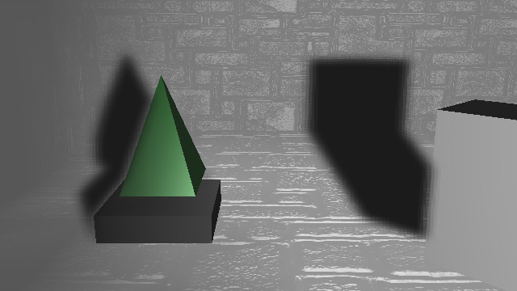

We tried fixing this fundamental problem by doing edge detection and not blurring when differences in depth were over a predefined threshold. That didn’t work too well and a “cut” was visible where the threshold was reached. Recently ATI released a sample with their SDK that seems to solve the problem by averaging blur coefficients with respect to the difference in depth of neighbouring pixels. It came too late for us to test it out, but it’s certainly worth a try for our next project.

We then decided to try another soft shadow technique documented in GPU Gems 2 and for which NVidia has a sample in their SDK. It works by jittering shadow map samples and averaging the sum of the comparison results. This technique yields a nice physically-correct penumbra, but some screen-space stipple pattern is visible and can ruin the effect in low resolutions when not enough samples are used.

The third method we tried was a hybrid of the two techniques described above. We wanted the smooth edges of the first method without the halo effect but we also liked the penumbra effect of the jitter technique. So we basically tried applying a Gaussian filter to the result of the jittering. This reduced the halo effect and smoothened out the jitter pattern. Not bad! The problem is that it was much too expensive for us in the pixel shader.

We did as many as 23 texture fetches per pixel because for the blurring and jittering and that made performance unacceptable.

After this reality check on performance, it was decided to go back to the first technique (Gaussian blur) and tweak the hell out of it to get better performance and reduce the halo effect the best we could.

The final technique can be summed up into the following stages:

- Render the shadow buffers
- Render a Z pre-pass of the scene
- Render a full-screen quad that transforms pixels from screen to light space
- Blur the shadow result texture
- Use the shadow result texture as a mask when lighting

Render shadow buffers

There’s not much to say about this step. It's the usual rendering to a depth buffer from the light’s point of view. The resolution of the buffers was 892x892 in 720p mode and 512x512 in 640x480.

Render a Z pre-pass of the scene

A Z pre-pass is required because the next step will use it to compare depth values and determine whether a pixel should be shadowed or not. We simply render the scene from the camera point of view without any color target and resolve it to a texture. This Z pre-pass texture is used for other effects like fog and light shafts and is also necessary to reduce overdraw.

Render a full-screen quad that transforms pixels from screen to light space

This step is the innovative part. We render a quad with a pixel shader that looks up the corresponding Z value for the current pixel and figures out its X and Y by interpolation. This gives a 3D (X, Y, Z) coordinate in screen space. With the right sequence of matrices we can un-project the point to camera space, then do a change of coordinate system to go to projected light space. From there we can compare the new Z value with the content of shadow buffer for this light and store the result of the comparison (0 or 1) to the render target. This screen-size “shadow result” texture can be of RGBA 8888 format and have each channel correspond to a different light.

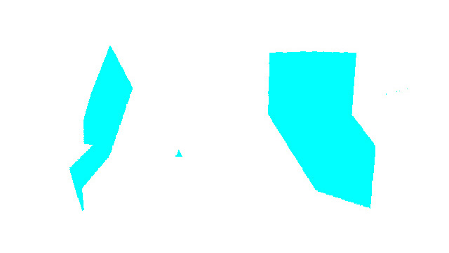

Blur the shadow result texture

We originally blurred the shadow result texture using15x15 separable Gaussian filter: a 15-sample horizontal blur followed by a 15-sample vertical blur. Although the desired degree of softness was reached, it proved to be highly inefficient. We settled for a 7x7 filter, compromising some quality for performance.



In King Kong we actually supported a maximum of six shadow-casting lights per frame: three for static objects such as scenery and three for dynamic objects such as character. Therefore two shadow result quads had to be calculated, each with its set of shadow buffers, then superimposed, then the result blurred. Conceptually we could have supported a total of eight shadow-casting lights without modifications (two shadow result textures containing four channels each) but for performance reasons we decreased the number to six.

