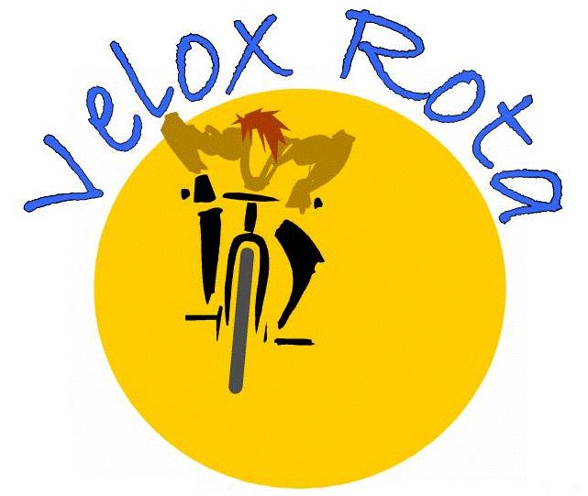

Cape Cod Getaway Ms 150
Ride To Benefit the Central New England Chapter Of
The National Multiple Sclerosis Society

Team Velox Rota
June 26 -27, 2010

Dear [Name of Potential Sponsor] or To Whom It May Concern:

Our team of over 50 riders from the greater Boston area is planning to ride in the Cape Cod Getaway, a two-day, 150-mile bicycle ride from Quincy to Provincetown, MA to benefit the National Multiple Sclerosis Society on June 26th and 27th. MS is a chronic disease of the central nervous system which is not presently curable. It strikes people between the ages of 20 and 40, and you likely know someone who has the disease. MS can result in lifelong physical and emotional problems, ranging in severity from numbness in limbs to paralysis.

With your help, we could come one step closer to finding a cure for this disease. Our team is looking for corporate sponsorship and we thought of you as a potential candidate. Last year, we raised over $70,000. This year we hope to exceed this figure. The cost of a company sponsorship is a minimum donation of $250. We intend to publicize your support by proudly displaying your logo on our cycling jerseys and identifying you or your company in our press releases and on our website with your permission. It’s important to know that every dollar we raise goes to the National MS Society and we will pay for the cost of our team jerseys ourselves. We hope to generate positive press coverage and we intend to use every possible opportunity to publicly thank our sponsors.

If you are interested in sponsoring the team, please call or email me or return the attached form with your contribution included as soon as possible. Checks should be payable to “National MS Society”. Lastly, please include a camera-ready copy of your logo or if sending electronically be sure that the logo is in a vector format as required by the manufacturer.. If you do not have camera-ready art, our supplier will craft something to indicate your support to be placed on our jerseys. The deadline for submission of logos is April 4, 2010. Thank you for your support.

Sincerely,
Your Name

