Marine Imaging Workshop 2026:  19 – 21 May 2026  Gibraltar  Contact:  SMES@unigib.edu.gi | 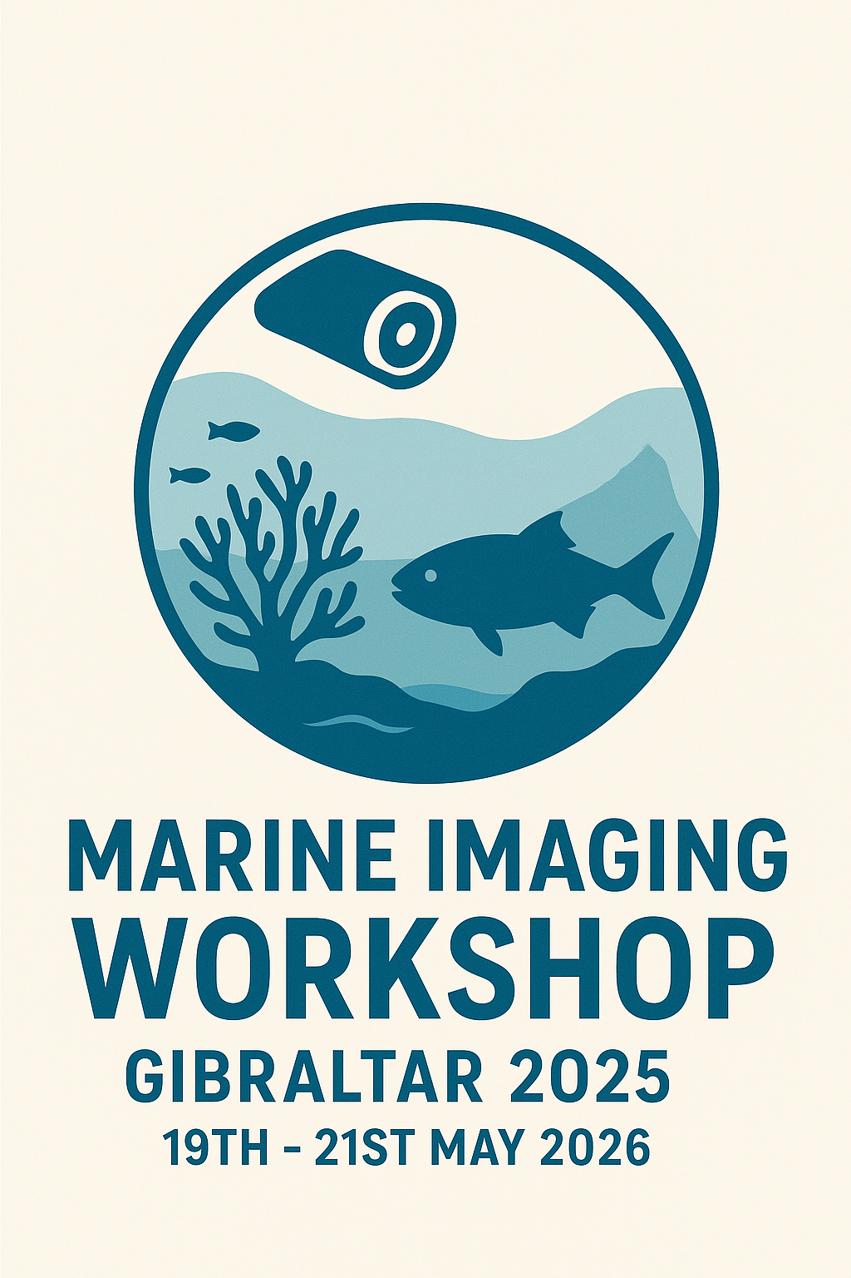

Student travel grant application (deadline 13th March)
Name & institute

Email address
Abstract submitted | ☐ Oral presentation  ☐ Interactive Workshop  ☐ Poster display & Lightning talk
Course & year

Short description of need for grant and benefit of travel grant (max 500 words)

Please send the completed form to the MIW email:
SMES@unigib.edu.gi

