Homework 2. Problem-Solving and Search Strategies
The N-Queens agent: state design, state transition graph, BFS and DFS
Student: Huseyn Movla
Professor: Leyla Muradkhanli
Subject: Foundations of Artificial Intelligence

1. The agent and its environment
The agent is a goal-based problem-solving agent that has to place N queens on an N×N chessboard so that no two queens attack each other. A queen attacks every square in its row, its column and both of its diagonals. The agent does not act in the world move by move. It first searches for a sequence of actions that leads to a goal state, and then it can carry that sequence out.
The environment is fully observable, deterministic, static, discrete and single-agent, and the agent knows the rules completely. This makes it a good fit for classical search: the agent can predict exactly which state each action leads to.
PEAS | N-Queens agent
Performance | Reach a goal state (N non-attacking queens); expand as few states as possible; use little memory
Environment | N×N chessboard, initially empty
Actuators | Place a queen on a square of the next empty row
Sensors | The full board: which squares hold queens and which squares are attacked

2. Designing the states
A naive design would allow a queen anywhere on the board, which gives 64⁸ ≈ 2.8 × 10¹⁴ placement sequences for N=8. My design uses two facts to shrink the state space:
- Every solution has exactly one queen per row, so the agent fills the rows from top to bottom. A state only needs the column of each placed queen.
- The agent never places a queen on an attacked square, so every state it reaches is already conflict-free. Bad branches are cut off as soon as they appear.

2.1 Problem formulation
Component | Definition | In the code (search.py)
State | Tuple of column indices, one per filled row. (1, 3) means queens at row 0 col 1 and row 1 col 3 | tuple, e.g. (1, 3)
Initial state | Empty board | ()
Actions | Place a queen in the next empty row, in any column not attacked by an earlier queen | actions(n, state)
Transition model | Add the chosen column to the tuple | result(state, col)
Step cost | 1 for every queen placed | stepCost(state, col)
Path cost | Number of queens placed, g(s) = len(s) | pathCost(state)
Goal test | N queens are on the board (they cannot attack each other, by construction) | isGoal(n, state)

A dead end is a state with fewer than N queens where every column of the next row is attacked. It has no successors, so the search has to back up from it.

2.2 Size of the state space
Because only safe placements are allowed, the state space is a tree. It is far smaller than the naive one:
N | States | Transitions | Goal states | Dead ends
4 | 17 | 16 | 2 | 4
5 | 54 | 53 | 10 | 4
6 | 153 | 152 | 4 | 46
8 | 2 057 | 2 056 | 92 | —

The program state_graph.py builds this graph explicitly and prints these counts.

3. State diagram and state transition graph
Figure 1 shows the complete state transition graph for N=4. Every node is a state, drawn as a small board. Every edge is an action, labelled with the column it uses and its step cost. The depth of a node equals its path cost g. The initial state is blue, dead ends are red and the two goal states are green.
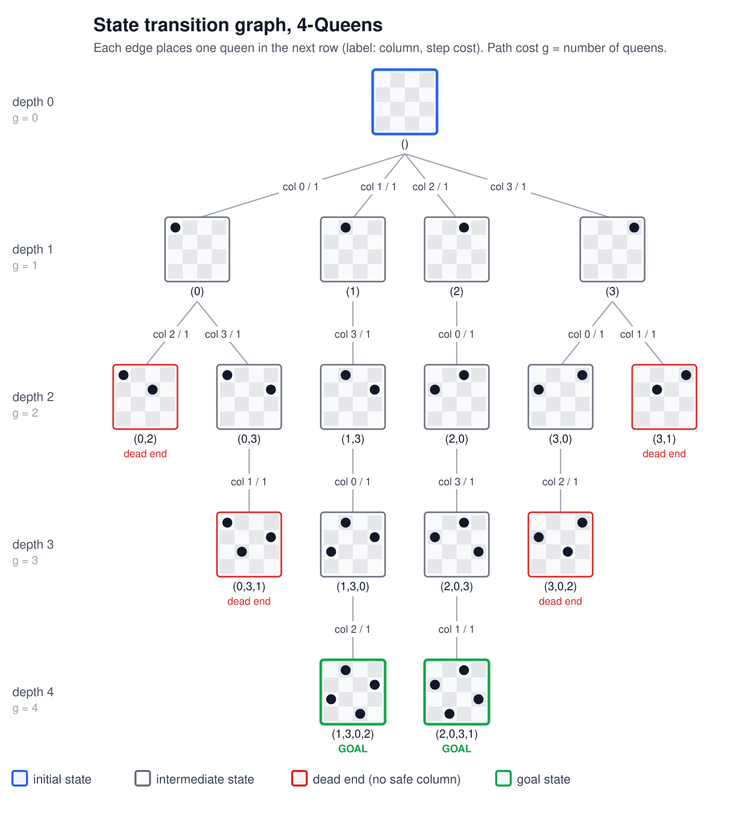
Figure 1. Complete state transition graph for 4-Queens (17 states, 16 transitions, 2 goal states).
Reading the graph:
- From () there are four actions, one for each column of row 0. Each costs 1.
- State (0) has only two successors, because the queen at (0,0) attacks columns 0 and 1 of row 1.
- (0,2), (3,1), (0,3,1) and (3,0,2) are dead ends: no column in the next row is safe.
- Exactly two paths reach depth 4. They end in the goal states (1,3,0,2) and (2,0,3,1), each with path cost 4. The two solutions are mirror images of each other.

3.1 The graph in code
The graph is stored as an adjacency list, {state: [(child, cost), ...]}. It is built by expanding every reachable state with the successor function:
def successors(n, state):
"""Transitions out of a state as (child, cost) pairs."""
return [(result(state, c), stepCost(state, c)) for c in actions(n, state)]

def buildGraph(n):
"""Every state reachable from (), as {state: [(child, cost), ...]}."""
graph, todo = {}, [()]
while todo:
state = todo.pop()
graph[state] = successors(n, state)
todo.extend(child for child, _ in graph[state])
return graph
Running python state_graph.py 4 prints the whole graph as text:
N=4: 17 states, 16 transitions, 2 goal states, 4 dead ends

() g=0 START
col 0 -> (0) [cost 1], col 1 -> (1) [cost 1], col 2 -> (2) [cost 1], col 3 -> (3) [cost 1]
(0) g=1
col 2 -> (0,2) [cost 1], col 3 -> (0,3) [cost 1]
(0,2) g=2 dead end
(0,3) g=2
col 1 -> (0,3,1) [cost 1]
...
(1,3,0) g=3
col 2 -> (1,3,0,2) [cost 1]
(1,3,0,2) g=4 GOAL
(2,0,3,1) g=4 GOAL
The same program writes the graph as SVG (--svg) or Graphviz DOT (--dot). Figure 2 shows the graph for N=5, which already has 54 states and 10 goal states.
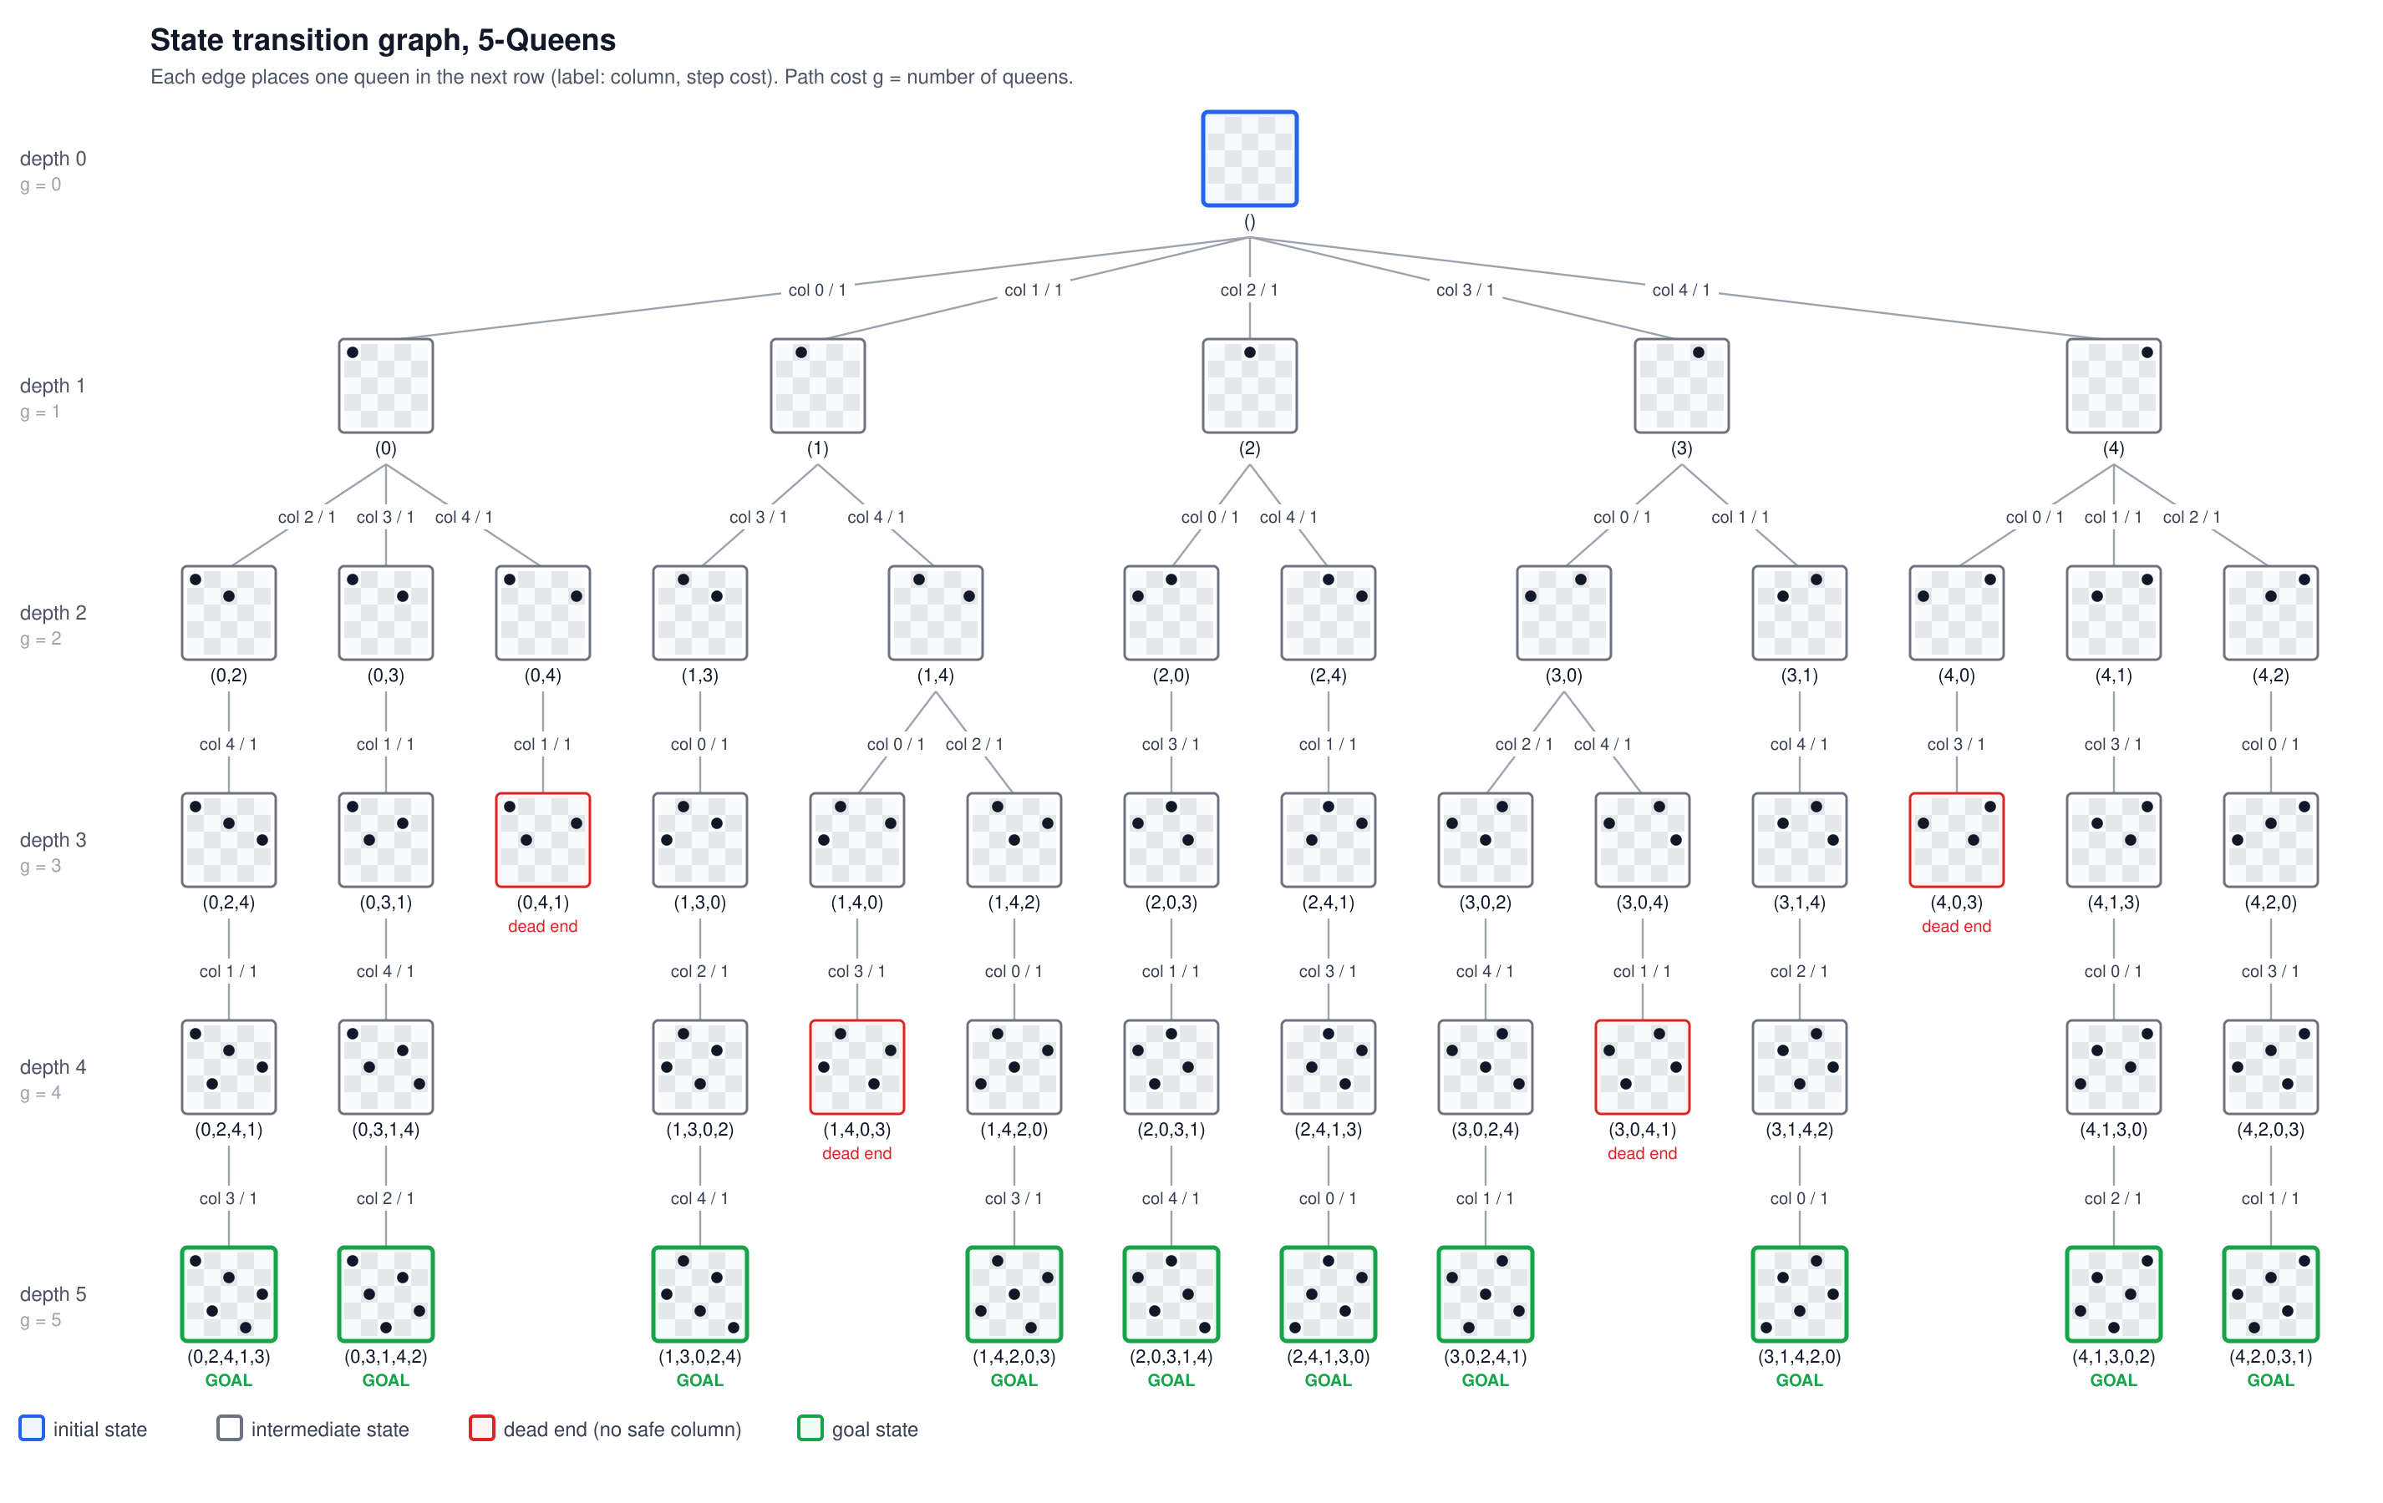
Figure 2. State transition graph for 5-Queens (54 states, 10 goal states).

4. Searching for the goal state: BFS and DFS
Both algorithms use the same problem definition and differ only in the frontier data structure. The goal test is applied when a state is taken off the frontier. This makes the expansion order easy to show on the graph.

4.1 Breadth-first search
BFS keeps the frontier in a FIFO queue, so it expands all states at depth d before any state at depth d+1.
def bfs(n, findAll=False):
frontier = deque([()])
order, goals, peak = [], [], 1
while frontier:
state = frontier.popleft() # FIFO: oldest state first
order.append(state)
if isGoal(n, state):
goals.append(state)
if not findAll:
break
continue
for child, _ in successors(n, state):
frontier.append(child)
peak = max(peak, len(frontier))
return {"goals": goals, "order": order, "peak": peak}

4.2 Depth-first search
DFS keeps the frontier in a LIFO stack, so it always expands the newest state and goes deep first. Children are pushed in reverse order so that the leftmost column is tried first, the same order as the recursive backtracking solver in main.py.
def dfs(n, findAll=False):
frontier = [()]
order, goals, peak = [], [], 1
while frontier:
state = frontier.pop() # LIFO: newest state first
order.append(state)
if isGoal(n, state):
goals.append(state)
if not findAll:
break
continue
for child, _ in reversed(successors(n, state)):
frontier.append(child)
peak = max(peak, len(frontier))
return {"goals": goals, "order": order, "peak": peak}

4.3 Expansion order on 4-Queens
Figures 3 and 4 number the states in the order each algorithm expands them. Faded states are never expanded.
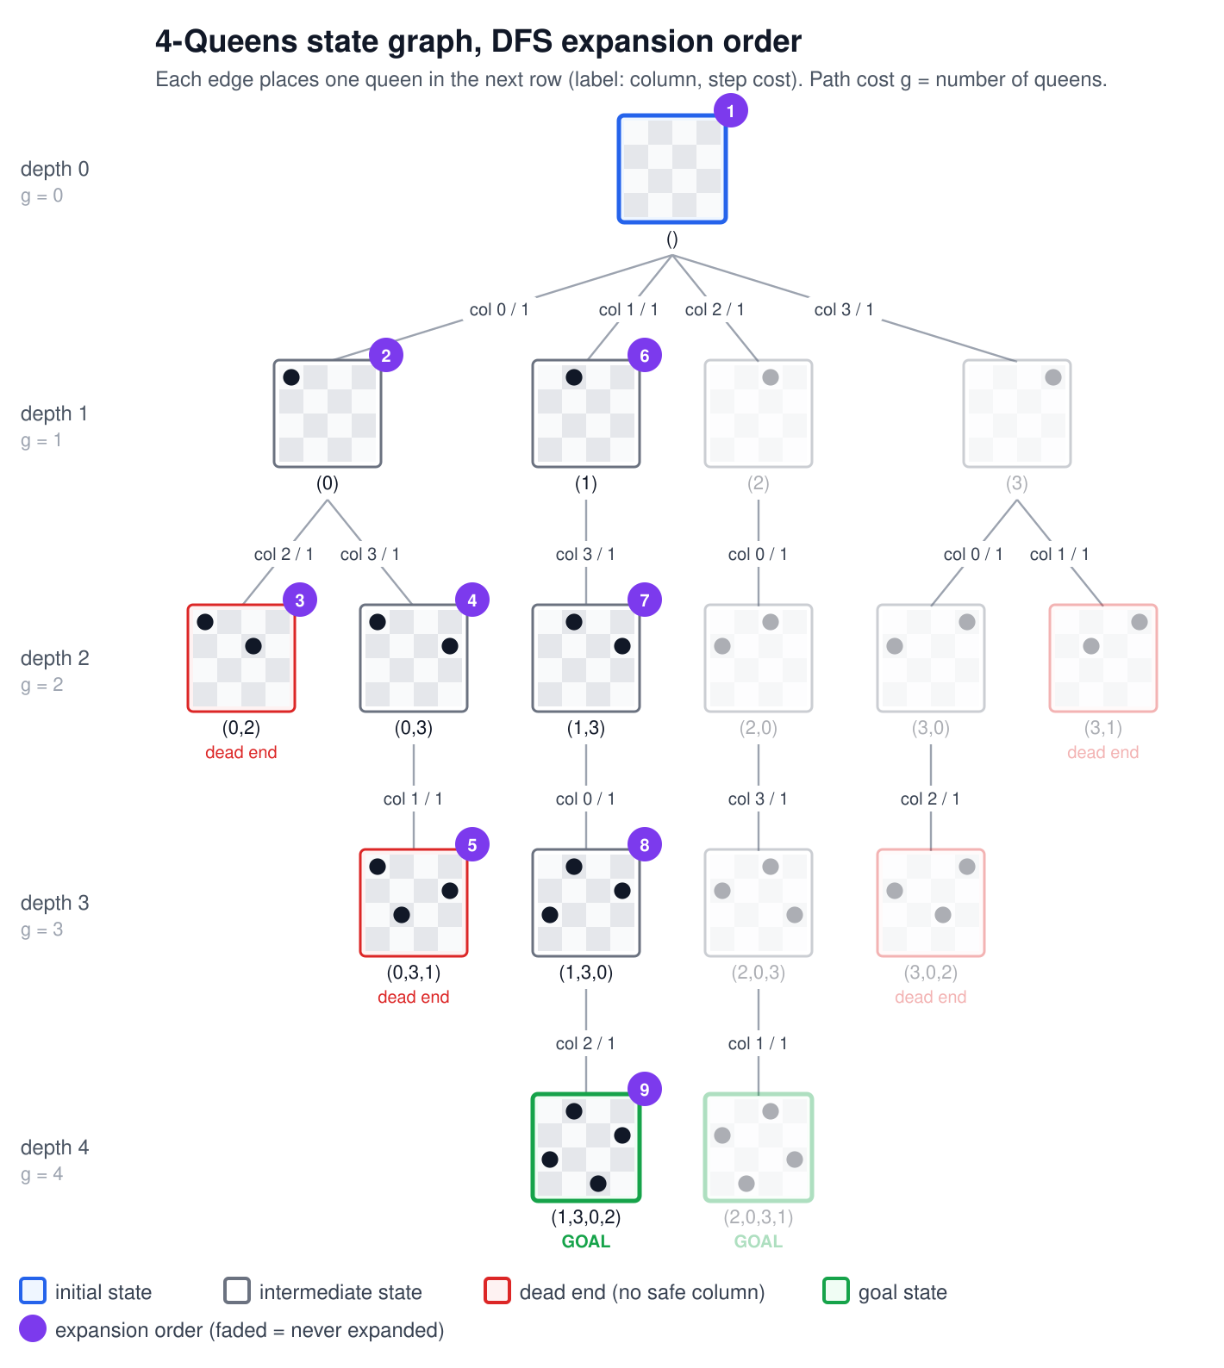
Figure 3. DFS on 4-Queens: the goal is found after expanding 9 states.
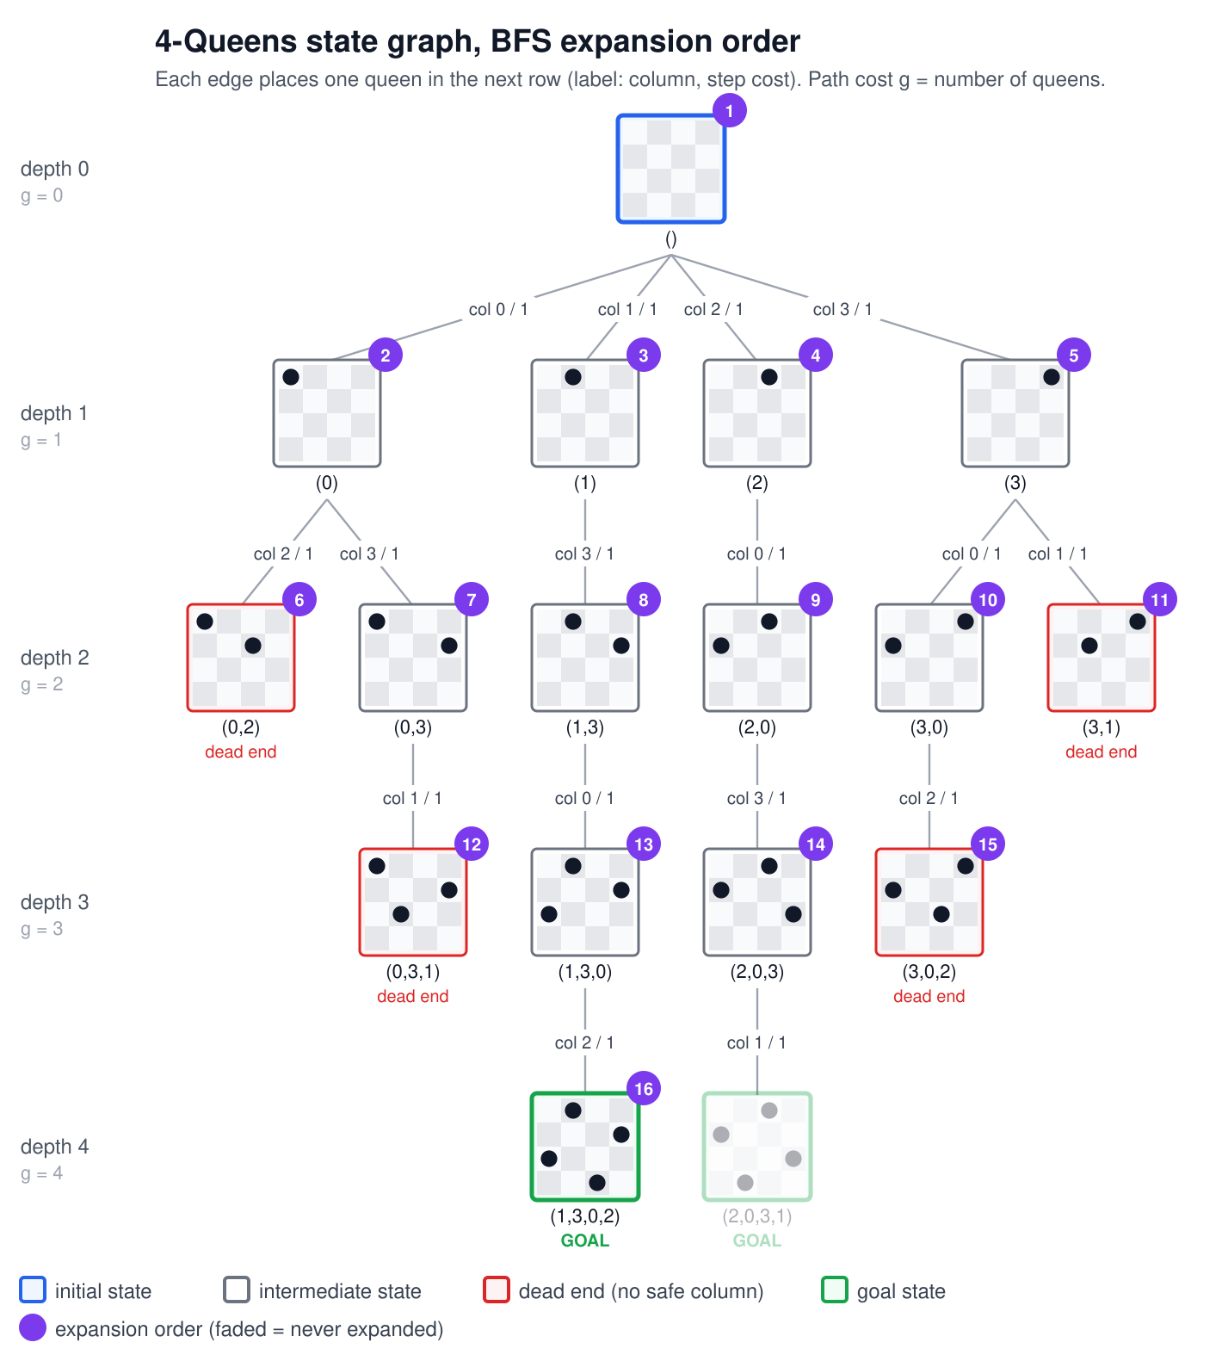
Figure 4. BFS on 4-Queens: the goal is found only after expanding 16 of the 17 states.
DFS dives down the (0) branch, hits two dead ends, backs up, and then goes straight down (1) to the goal (1,3,0,2). BFS has to expand every state at depths 0 to 3 before it even looks at depth 4. Both find the same goal, with the same path cost of 4.

4.4 Comparison
python search.py N runs both algorithms and reports how many states each expanded and the largest size its frontier reached:
N | DFS expanded | DFS peak frontier | BFS expanded | BFS peak frontier
4 | 9 | 5 | 16 | 6
5 | 6 | 7 | 45 | 14
6 | 32 | 10 | 150 | 46
8 | 114 | 19 | 1 966 | 573
10 | 103 | 30 | 34 816 | 9 643

Property | BFS | DFS
Frontier | FIFO queue | LIFO stack
Complete? | Yes | Yes here, because the tree is finite (depth N)
Optimal? | Yes for equal step costs, but every goal costs N anyway | No in general, but every goal here costs N, so any goal is optimal
Time | O(bᵈ): expands almost all states above depth N | O(bᵐ) worst case, but usually finds a goal early
Memory | O(bᵈ): the whole next level is stored | O(b·m): one path plus its siblings, at most N² states

Conclusion. In N-Queens every goal state lies at the same depth N and every step costs 1, so BFS's guarantee of the shallowest, cheapest goal gives no benefit. It only makes BFS store whole levels of the tree. For N=10 that means more than 9 600 states in memory at once, against 30 for DFS. DFS is clearly the better strategy for this problem, which is why the fast solver in main.py is a depth-first backtracking search.

5. Running the code
python search.py 8 # DFS and BFS: goal, path, cost
python search.py 8 --algo bfs --all # every goal state (92 for N=8)
python state_graph.py 4 # states, transitions, goals
python state_graph.py 4 --svg g.svg --order dfs # draw with DFS order
python main.py 8 --vis 1 # animate the backtracking
python -m unittest -v # 14 unit tests
The unit tests in test_search.py check the action and transition functions, the goal test and the path cost. They confirm that both searches return valid solutions and find the known number of solutions for N=1 to 8, and they check the size of the 4-Queens graph.

