Intelligent Agent Design: Tic-Tac-Toe
A simple reflex agent and a model-based agent with a finite state machine
Student: Huseyn Movla
Professor: Leyla Muradkhanli
Subject: Foundations of Artificial Intelligence

1. The agent
My agent plays tic-tac-toe in a digital game world, on any m×m board where k marks in a row win. It reads the board, chooses an empty cell and places its mark against a human or another agent. I built two versions:
- Simple reflex agent: six if-else rules on the current board only: win, block, centre, opposite corner, corner, any cell.
- Model-based agent: it remembers the opponent's moves and the line it is building. A finite state machine (START, OPENING, BUILD, ATTACK, DEFEND, FINISH, GAME_OVER) picks its behaviour, and it looks one move ahead for forks.

2. PEAS
 | Tic-tac-toe agent
Performance | Win +1, draw 0, loss −1; never lose; win in as few moves as possible
Environment | m×m board, k-in-a-row rule, an opponent, alternating turns (X first)
Actuators | Placing its mark in an empty cell (row, col)
Sensors | Reading every cell of the board (X, O or empty)

Environment type: fully observable, multi-agent (competitive), deterministic, sequential, static, discrete, known.

3. Design

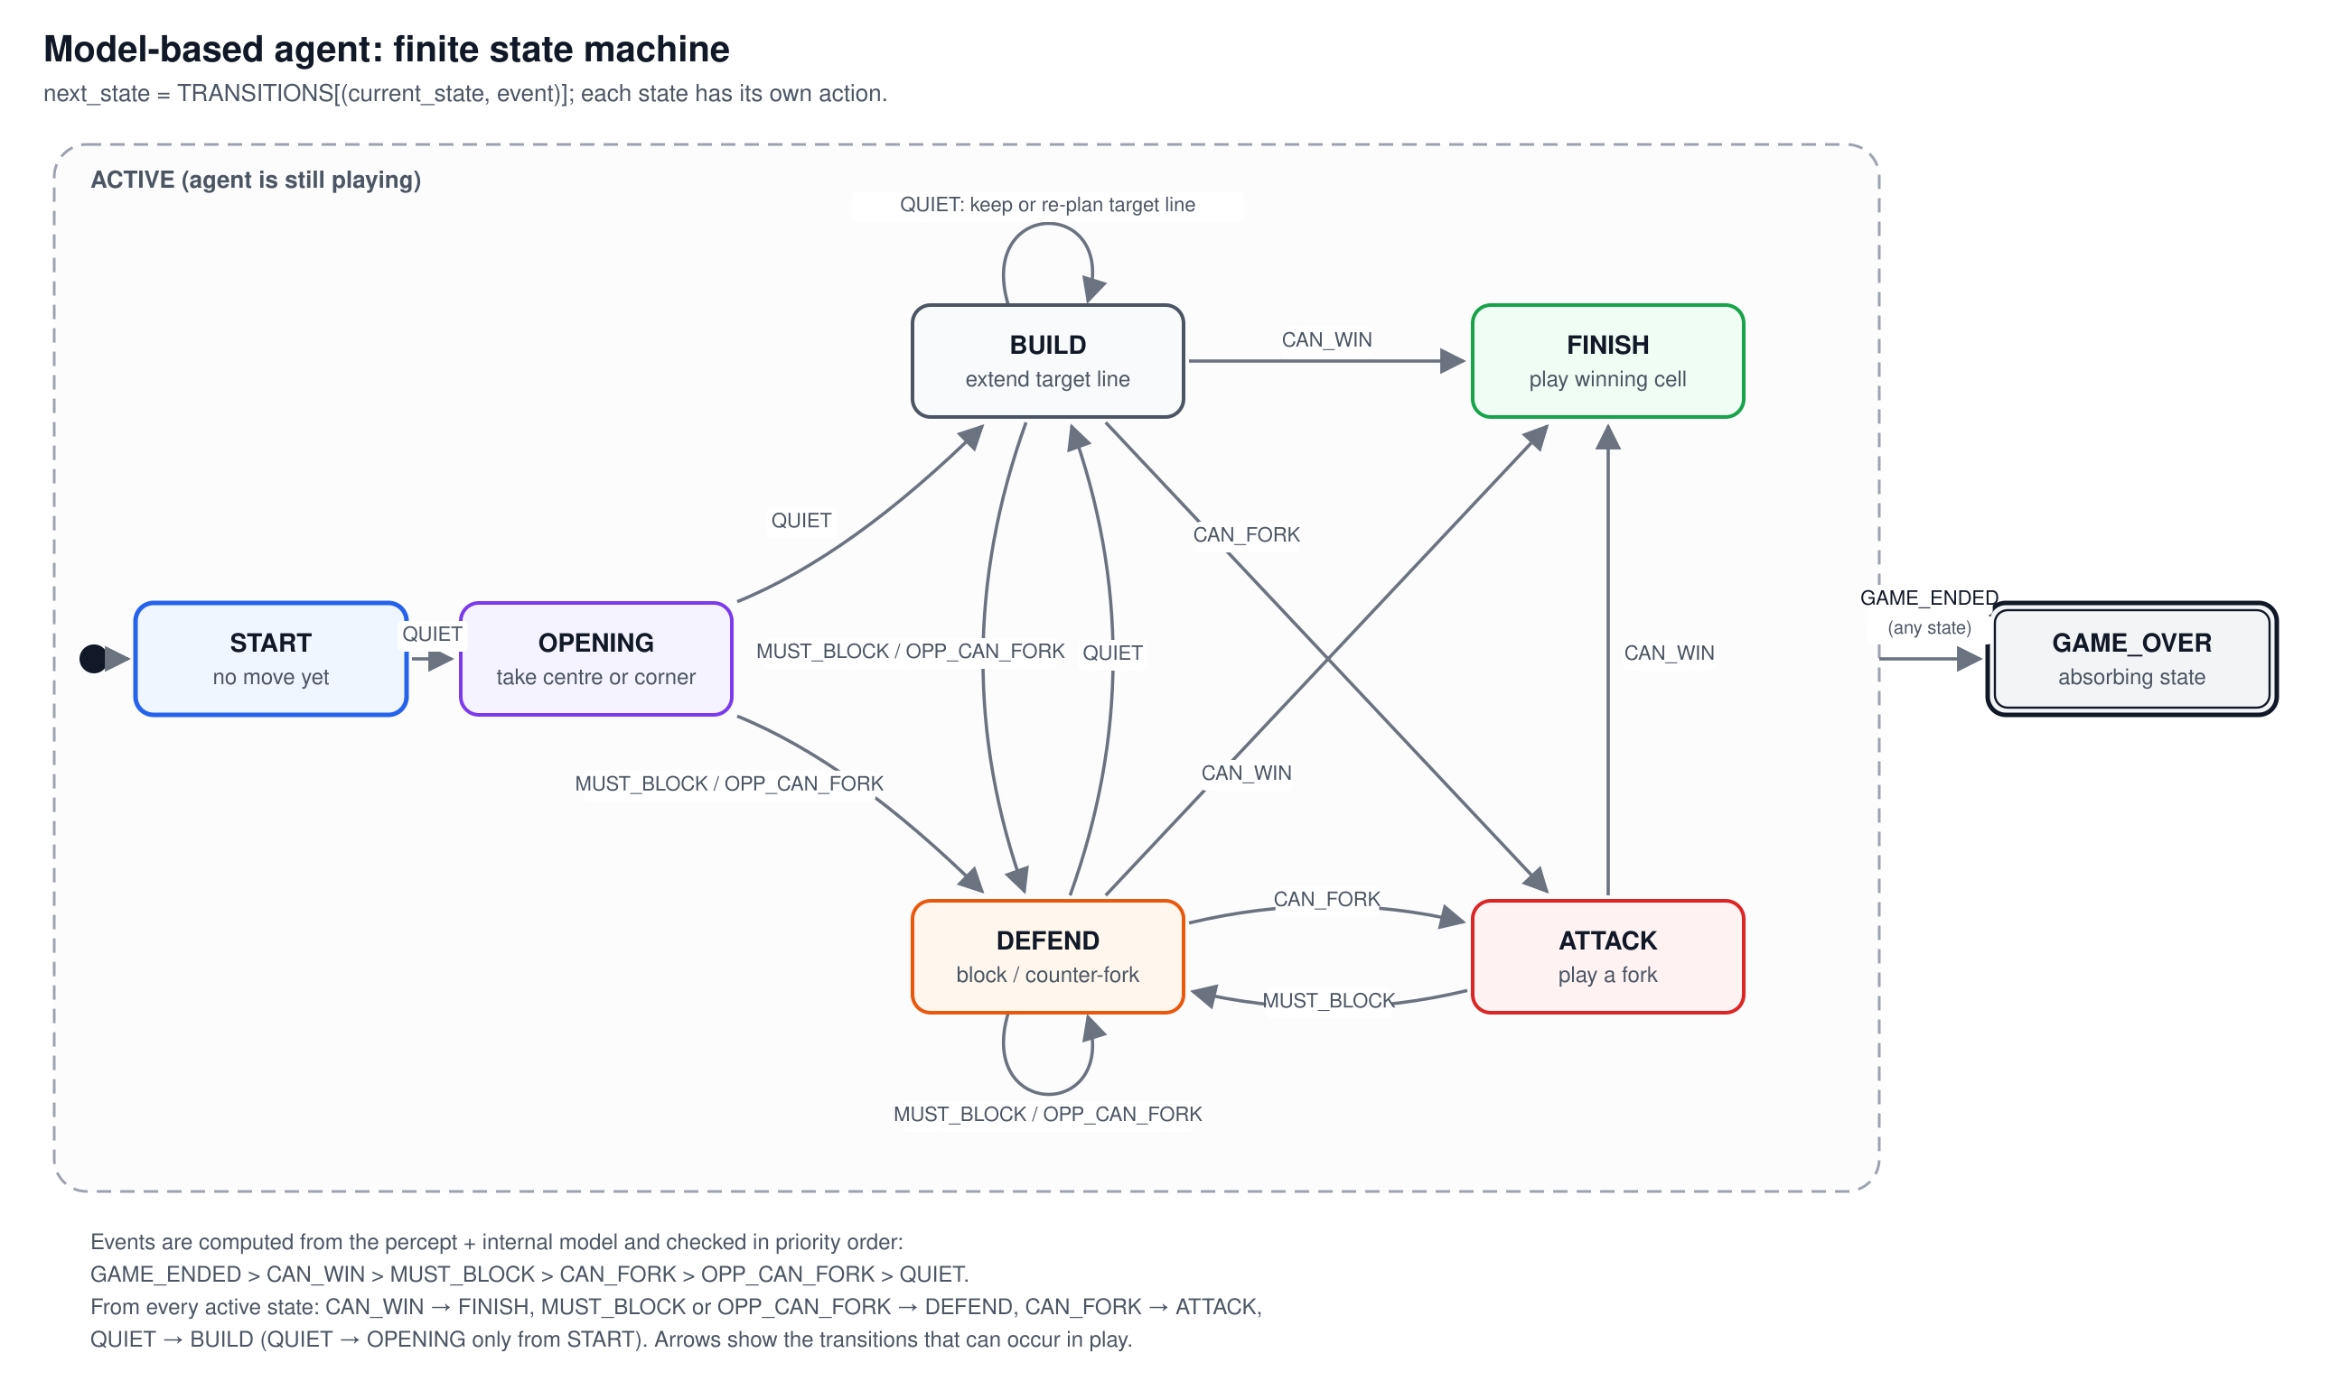
Figure 1. State machine of the model-based agent.
Every possible opponent sequence on 3×3 was tested. The reflex agent loses 6 games to fork traps. The model-based agent never loses, because its model lets it see a fork coming one move ahead. Rules, code, tests and the demo are described in README.md.

4. My imaginations
- Physical robot: a camera reads a paper grid and a robot arm draws the mark. The board memory would help correct misread cells.
- Metaverse NPC: a character who challenges players. The state machine makes personalities easy: an aggressive NPC prefers ATTACK, a friendly one sometimes lets children win.
- Bigger games: the same engine handles Gomoku (15×15, five in a row). Adding minimax with alpha-beta from my C++ version would make it a strong player.

