Racer Wanted
Thank you for purchasing this package.
Racer game can be build to android,ios & windows phone 8.It is strongly recommend to open this package in an empty Project to avoid tag and iTween conflicts.
BUILD SETTINGS
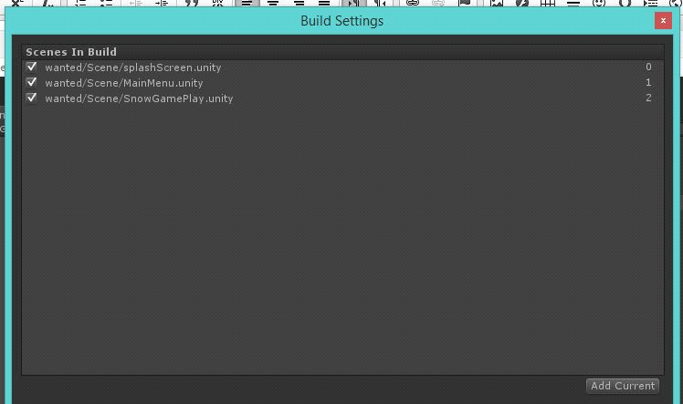
Make sure you added these scenes as per order.

Tag Errors :
As of UNITY 5.0.0f3 editor ,it does't exporting tags into package .so you will need to write these tags names into the Tags and layer inspector .
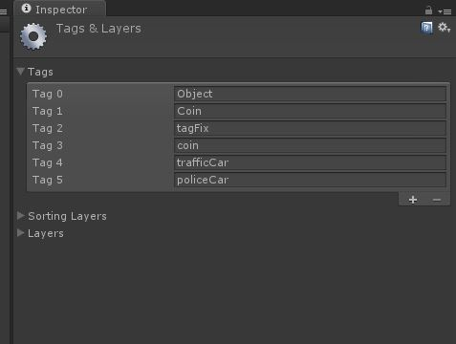
first don't play any scenes in the package .Go to EDIT->Project Setttings ->Tags and Layers. If they were not imported please write them with same naming and order.
and play the snow gameplay scene , if game behaviour is unexpected and unable to detect collision between coins,policeCar ,then tag issue still exists.delete the all floder inside the project ,and reimport again the package ,this time tag names already exists in projects ,so the game will work.
previously this kind of issues exists in old unity editions ,this might on official release of unity5.

Scripts :

1) playerCarControl.cs
This script will control player car movements from lane to other lane. this script functions leftsidemoving() ,rightsidemoving() is controlled by inputcontroller.cs attach to gamecontroller object.
Car is controlled by two enum states , carStates and Roadlanes
in inputcontroller.cs ,we are keyboard control when no touch is recived . based on player swipe value we are switching between left side or right .

2)GamePlayController.cs
This script will create new rocks, side objects, traffics cars, Rock Mountains etc.
TiltTuto script will start the traffic cars and coins by sending a message to GameController Object’s OnGameStart ().
Player car is created based on carSelection’s carindex static variable from mainmenu scene ,see the Start() on GamePlayController.
If the player car collided with traffic car having “trafficCar” tag ,gameEnded event will be fire ,see the “OnCollisionEnter” of the playerCarControl.cs script .
Traffic cars ,coins ,side trees and rocks are created based one time difference value ,see OnGameStart()

3)RoadGenerator.cs
This script will translate the road blocks to create infite loop , once the player car
Having “Player” tag triggered with collider ,this will shift the otherblock variable gameobject to infront of it.
4)EndScoreDisplayer.cs
This script will have a static event showFullScreenAd,
You can make ad network calls to display ads when it is fired .

Reskining
NOTE :To replace Texures ,you must have same image format as originals,which is here PNG format .also CLOSE UNITY while replacing .
For Player Cars
To Create a New player Car , drag and drop any playerCar prefab from floder
wanted/Prefabs/playerCars on empty scene ,replace the carbody mesh and carbody transform and wheel objs of this script . save it your new location and assasing it on gameplayController script player cars array .

For Traffic Cars
process is same like playerCars ,expect take any prefab from floder wanted/Prefabs/trafficCars/ and begin from there .

For RoadBlock
you need two sets of road groups of your preferable 3d format ,we used fbx from maya .
you need to place them in the scenes roadblock 1 below the z-axis of it ,place the second set ,or else put same block as second . add a trigger to it ,and attach a
roadgenerator.cs scirpt and change the at onTriggerEnter() with second block position.z value .
see the snowgameplay scene.

To Change UI Images.
step 1 : goto floder Racer/UI/ .
step 2 : you will find all UI Buttons,Menu bg's etc ,Replace with your images With same name .

Support
For Quick questions & support, contact me at kiran.killstreak@gmail.com

Thanks
Kiran

