A Color X-ray Camera for 2 – 6 keV Using a Mass-Produced CMOS Sensor

Oliver R. Hoidn1, William M. Holden1, and Gerald T. Seidler1,*

1Physics Department, University of Washington, Seattle WA 98195-1560

(*) [Seidler@uw.edu](mailto:Seidler@uw.edu)

We report here the development of an x-ray camera for the 2 – 6 keV using mass-produced sensors and commercial control electronics. This instrument has several favorable characteristics for advanced x-ray spectroscopy studies in the laboratory, at synchrotron light sources, at x-ray free electron lasers, or using pulsed x-ray sources such as for laser plasma physics research. These characteristics include fine position and energy resolution for individual photon events; high saturation rates; easy user maintenance for damaged sensors; and software for real-time processing. We present results that evaluate this camera for use a as an alternative to traditional energy-dispersive solid-state detectors, such as silicon drift detectors, and also illustrate its use in a dispersive x-ray emission spectrometer that has recently been reported elsewhere (Holden, et al., 2017).

The capabilities of a variety of x-ray techniques at the synchrotron, x-ray free electron laser (XFEL) and university-scale laboratory are heavily dependent on the characteristics of the x-ray detectors with which they are implemented. One technological regime of interest is that of pixel area detectors combining spectroscopic and spatial resolution with features such as high readout rate, large collection solid angle, and hardness to ionizing radiation and electromagnetic pulses (EMPs). The advent of time-resolved spectroscopy with pulsed photon sources, such as x-ray free electron lasers (XFELs), where it is often necessary to collect large numbers of signal photons quasi-instantaneously and with repetition rates exceeding 100 Hz, has greatly expanded the need for this class of detectors. Similar needs are also present in laser-plasma physics, where entire fluorescence, x-ray band thermal emission, or inelastic scattering spectra must often be collected in truly single-pulse experiments.

While there is an impressive effort aimed at either improvement of existing state-of-the-art technology or *de novo* development of new ideas for truly advanced high-performance detectors, there is another route that requires consideration. Highly mass-produced, commercial multipixel sensors intended for primary use at optical wavelengths are, by the standards of x-ray science, already stunningly advanced sensors. For example, recent advances in the performance of mass-produced CMOS image sensors, including readout rates above 200 Mpix/second and optical-wavelength quantum efficiencies exceeding 80%, significantly increases their potential for scientific applications. The direct application of such sensors to the x-ray regime is limited mainly by the fact that their small pixel thicknesses lead to greatly decreased quantum efficiency for hard x-rays. That being said, the use of CMOS image sensors in the x-ray regime has been explored in prior literature, which has established them as viable spectroscopic imaging detectors having a favorable combination of low cost (a consequence of chip-level integration of all sensor functions), high framerates, and improved radiation hardness relative to comparable charge coupled devices (CCDs). (cite prior CMOS x ray sensor papers, including our first RSI). By ‘spectroscopic’, we mean that the camera output contains sufficient information for determination of both the energy of a photoabsorbed x-ray and also its position – such devices are often referred to as ‘color x-ray cameras’.

In a prior publication we presented an x-ray camera platform for the 2-6 keV photon energy range based on a legacy CMOS image sensor, the Aptina MT9M001. Here, we introduce a new camera that incorporates a modern back-illuminated CMOS sensor with significantly improved readout rates and finer spectral and positional resolution compared to the previous model. We find an energy resolution of ~150 eV at 2 keV with saturation rates above 106/s at ~80 Hz frame rate. These spectroscopic benefits are complemented by a spatial resolution of 2.9 mm and real-time processing of all results, but are constrained by a ~65% quantum efficiency at 2 keV that decreases to below 20% at 5 keV.

This manuscript continues as follows. First, in section II, we describe the commercial hardware, and its modification used in the present instruments, and also the new software package that has been developed to support real-time spectral analysis or real-time energy-windowed imaging. A key point here is that not only the sensor, but also the entire camera read-out system that is commercially available because of the high demand for extreme low-light sensitivity for, e.g., amateur astronomy. Next, in section III, we present results and discussion, demonstrating the cluster-binning methods and also both energy-dispersive and photon-counting modes for the camera. This includes representative data from a wavelength-dispersive spectrometer whose design has recently been described elsewhere. [cite Holden RSI] Finally, in section IV we conclude and provide future directions.

**II. Experimental**

**II.A. Hardware**

The hardware consists of a commercial amateur astronomy camera (ZWO Company) based on the Sony IMX290, a high-sensitivity back-illuminated CMOS image sensor with a pixel pitch of 2.9-µm, resolution of 1936×1096, and maximum framerate of 170 fps. We have modified the camera in two ways. First, the main camera board has been reworked by removing the IMX290 sensor and replacing it with a custom IC socket (company name). This was done to more easily allow sensor replacement if radiation damage occurred. Second, the sensor itself has been modified by removal of the glass cover (company name). A photo of the resulting camera is shown in Fig. 1. The yellow plastic part holding down the sensor is a simple clamp used to press the sensor against the socket contact pads.

**II.B. Software**

Charge separation generated by an x-ray photon absorbed in the active layer of a sensor pixel results in a signal with expectation value proportional to the photon’s energy. In the simplest case, wherein the entire charge cloud from an x-ray absorption event is concentrated in a single pixel, the detecting pixel has intrinsic sensitivity to the energy of the incident x-ray photon. In the majority of events, however, the charge cloud spreads over a cluster of several adjacent pixels.45, 46 We have found that, in order to optimize the camera’s quantum efficiency (QE) and spectroscopic sensitivity, it is essential to use this prior information to recover the energy and position of each detected photon on an event-by-event basis. To do this we perform a “breadth-first” search(cite Lee 1961) of every frame to identify sets of connected pixels with ADC values above a user-specified signal threshold For each cluster thus identified, the signal is summed over all member pixels and the event’s position is inferred from the cluster’s center of mass. This technique is similar to event-reconstruction algorithms used for the same purpose in prior literature, with the difference that we place no constraint on the size and shape of signal clusters (*cite Servoli and double-check that this statement is true).* The sensor’s low noise floor (under 1 e- per pixel) (*cite datasheet)* allows the use of an aggressively low threshold level, resulting in a high level of signal.

To implement the above analysis while avoiding the prohibitively large quantity of disk storage that offline processing demands, we developed a real-time data processing pipeline; the general framework for this pipeline is shown in Fig. 2. It consists of a collection of several software components communicating with one another over ZeroMQ sockets. First, a customized version of the open source image capture program oaCapture (*cite)* controls the camera’s readout, allowing the user to configure the camera’s gain and per-frame exposure time. Event reconstruction, which requires the computational throughput of multiple CPU cores, is done by a pool of worker processes collecting frames from the capture application in round-robin fashion. The resulting filtered frames from this parallel pipeline are aggregated on a sink node that communicates with an API component that, in turn, provides users with high-level functions for acquiring and visualizing pre-processed camera data.

**III. Results and Discussion**

In this section we address four aspects of the camera operation and performance: the cluster algorithm, energy dispersive operation, quantum efficiency, and finally single-photon counting mode for spectroscopically-constrained imaging. First, a magnified view of a small region of a captured image is presented in Fig. 3, where single-photon signal clusters are readily identifiable. The distribution of cluster sizes is strongly skewed; the largest clusters contain more than 10 pixels, while the mean number is 2.1.

Second, when operated as a spectroscopic sensor, the camera’s user-visible output is a histogram, summed over all frames, of number of events binned by per-event signal. This is demonstrated in Fig. 4 (top panel), which shows the direct-illumination spectrum of a laboratory x-ray tube source. The dominant components of the signal are the tube’s continuous bremsstrahlung spectrum and Rh L-shell emission from the anode. Two detector artifacts are also visible. First, a peak at the energy of Si Kα is generated by Si fluorescence photons emitted in the sensor that propagate far enough from their originating interaction sites to be registered as separate events. Second, the escape of Si fluorescence from the absorption sites of Rh L photons creates echos of the Rh L peaks (termed escape peaks) that are downshifted by 1.74 keV, the energy of Si Kα. We find that the camera’s energy resolution at the energy of P K is 150 eV (Fig. 4 bottom panel), somewhat inferior to SDD’s at this energy but still sufficient for many applications.

Third, the quantum efficiency (QE) of the detector was characterized by measurement of the K-shell fluorescence spectra of several elements, using a low-power laboratory x-ray tube source to excite 1s core holes in each measured sample. The intensity of resulting Kα and Kβ emission registered by the detector was referenced to that recorded at the same position by a commercial Si drift detector (Amptek XR-100SDD) having known QE. Results are presented in Fig. 5; we note a maximum QE of 60% at the energy of P K, a more than two-fold improvement over our previous camera [cite]. Under uniform illumination, the observed count rates have only minimal deviations from linearity at count rates up to 2 x 106 photons per second 80 Hz frame rate (see Fig. 6) – an impressive performance that is higher than the typical saturation rate of commercial silicon drift detectors.

Finally, the camera’s combination of high saturation count rates and small pixel dimension makes it a strong fit as a position-sensitive detector in compact dispersive spectrometer designs. In such an application the camera’s spectroscopic sensitivity may be employed for background rejection (i.e., for rejection of photons with energies outside a pre-specified range), thus minimizing the need for shielding from stray scatter. Holden et al. have demonstrated this advantage in a novel compact dispersive refocusing Rowland (DRR) spectrometer design with a 10 cm-Rowland circle that incorporates the camera as its position-sensitive detector (Fig. 7). The spectrometer’s small dimensions, which are enabled in part by the camera’s fine spatial resolution, give it a large collection efficiency which results in count rates in laboratory studies (using low-power x-ray tube sources) comparable to those at a third-generation synchrotron insertion device. The instrument has thus far been demonstrated in the university-scale laboratory and at the synchrotron; its potential use at the Linac Coherent Light Source (LCLS) is currently being investigated, especially as the sensor frame rate can likely be matched to the 120 Hz repetition rate of that XFEL.

**IV. Conclusions and Future Directions**

In conclusion, we have reported the development of a quite capable x-ray camera based on a mass-produced consumer product. The observed performance suggests a range of potential applications as a high-speed spectroscopic detector with fine spatial resolution and adequate quantum efficiency in the 2 - 6 keV photon energy range. Among these applications, we have demonstrated effective use of the camera as a position-sensitive detector in a novel high-performance compact dispersive spectrometer.

*(talk about future tech directions, if any)*

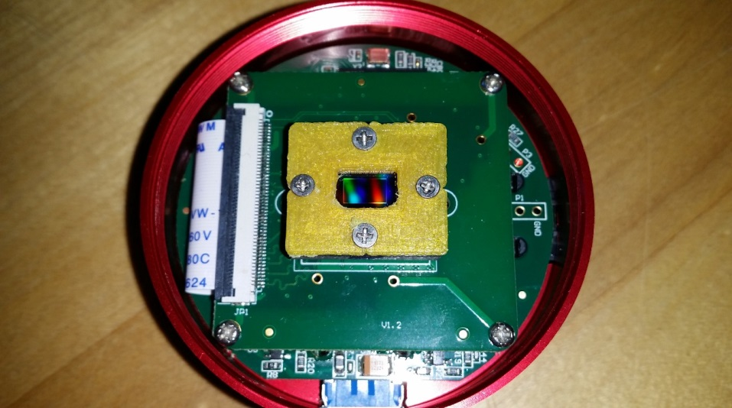

Figure 1: Photograph of the modified camera. The original commercial product has been reworked to install an IC socket for the sensor and to remove the glass cover of the sensor.

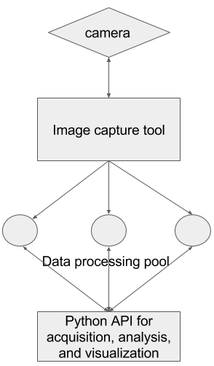

Figure 2: Diagram of camera data processing pipeline.

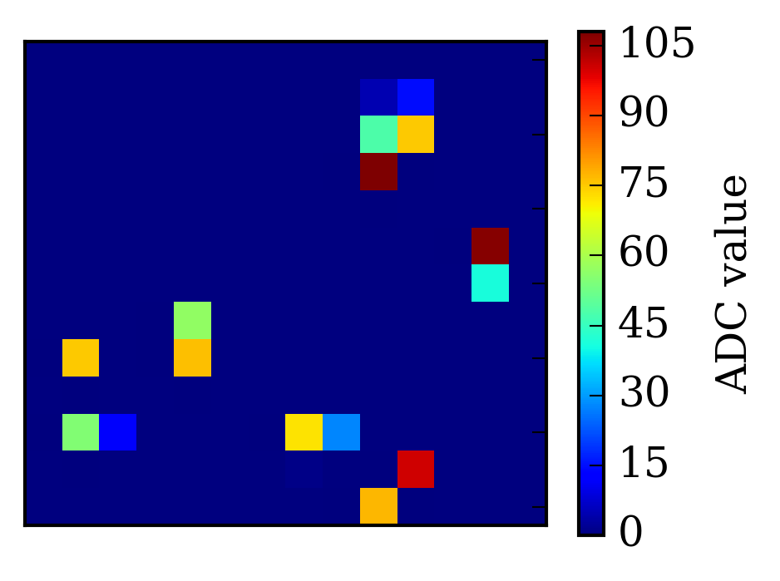

Figure 3: Representative cropped region of a camera frame during direct illumination by a Rh anode x-ray tube source operating at 6 keV bias voltage, with the camera detecting 2 × 106 photons/s at an 80 Hz frame rate.

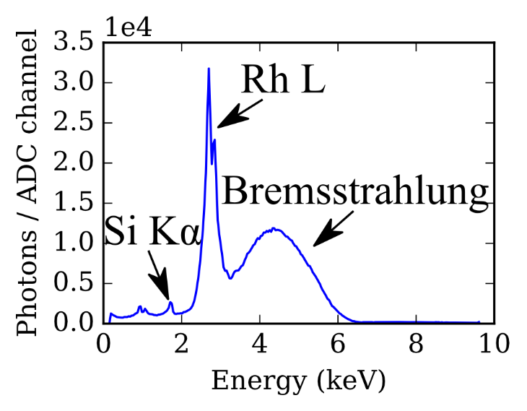

Figure 4: Energy dispersive spectrum from direct illumination of the camera by a Rh anode x-ray tube source operating at 6 keV bias voltage. See the text for discussion.

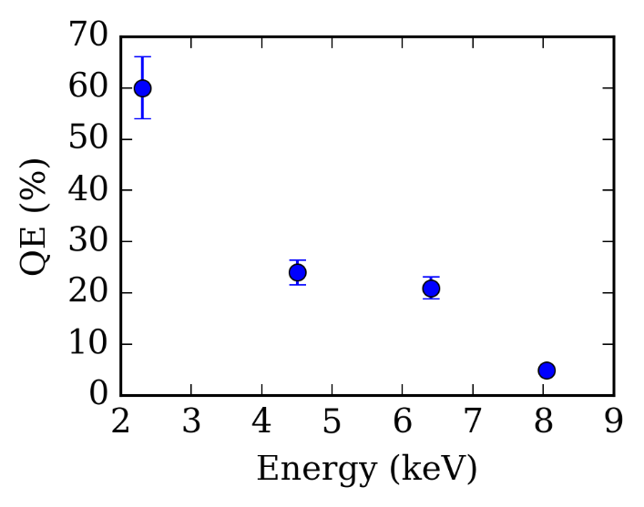

Figure 5: The camera’s quantum efficiency as a function of x-ray photon energy, as established by comparison with a commercial Si drift detector.

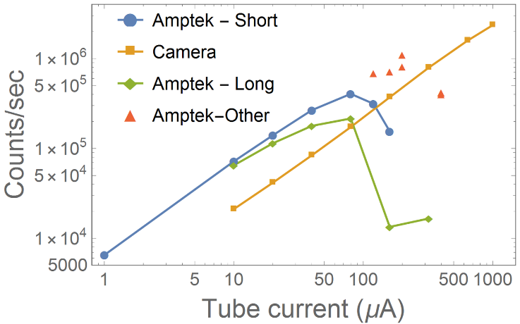

Figure 6: Camera count rate as a function of incident photon intensity, controlled via current provided to an x ray tube source directly illuminating the camera (orange). Comparison to the same curve for a commercial SDD (blue) demonstrates the camera’s higher photon count rate capacity.

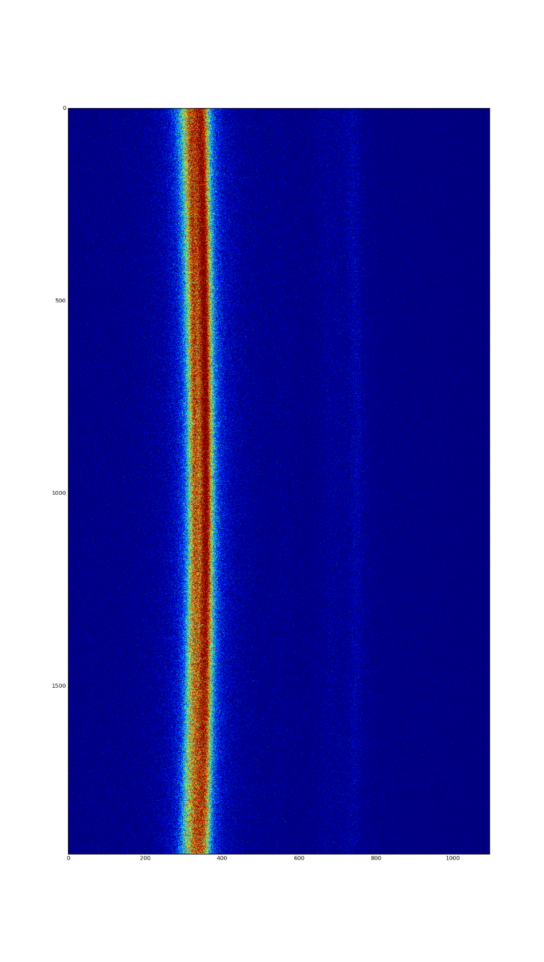

Figure 7: Image of the sensor’s output when serving as the position-sensitive area detector in a DRR spectrometer. (Cite Holden et al.). The signal shown is a S k alpha spectrum. In order to reduce the background level, the camera was configured to reject all events with photon energies outside of the spectrometer’s 200-eV bandwidth (*is this right*?).