Electronic Structure Effects in Crystalline Tepid Dense Matter

Oliver Hoidn1, Ryan Valenza1, Gerald T. Seidler1,(*), Alexander Ditter1, William Holden1, Evan Jahrman1, Samuel Vinko2, Josh Kas1, Fer Vila1, Alison M. Saunders3, Luis Avila4, Galen O’Neil4, Hae Ja Lee5, Bob Nagler5,

1Department of Physics, University of Washington, Seattle WA 98122

2 Department of Physics, Clarendon Laboratory, University of Oxford, Parks Road, Oxford OX1 3PU, UK

3Department of Physics, University of California, Berkeley CA 94720

4National Institute of Standards and Technology, Boulder CO 80305

5Stanford Linear Accelerator Center, Menlo Park CA 94025

X-ray heating by x-ray free electron laser (XFEL) pulses is emerging as an important method to create matter under extreme conditions. Many prior reports of XFEL heating have focused on achieving extremely high levels of ionization, and then have used advanced x-ray methods to with the goal of evaluating the use of traditional plasma-theoretic approaches to the resulting warm dense matter (WDM) where such approaches may, or may not, be perturbatively applicable. Here, we adopt a complementary strategy wherein we use more modest XFEL heating to create more weakly ionized, ‘tepid’ dense matter so as to investigate the earliest stages of ionization and elucidate the boundaries of applicability of traditional solid state physics ideas upon the breakdown of its assumptions of, e.g., high electronic degeneracy and coincident long range order of ion cores and valence charge density. Specifically, we choose to study the early stages of XFEL heating of MgO because of its large ground state bandgap, whose existence is a direct consequence of such long range order, and because the rocksalt structure of MgO holds special benefits in that its x-ray diffraction (XRD) pattern can be used not only to look for changes in average ionization of the unit cell but also for differential ionization between Mg and O sites. We find an anomalously low onset for valence-level O 2p ionization that requires the presence a large density of states within the ground state band gap, despite the strong evidence that no ion core motion has occurred during the x-ray pulse itself and despite the fact that the O 2p ionization is still much too small for screening effects to cause ionization potential depression. We propose that this may instead be a consequence of the destruction of long-range order of the electronic potentials due to site-disorder of the ionization, an effect that would be an extreme manifestation of the Lifshitz tail effect that is well-known in semiconductor physics.

(*) seidler@uw.edu

**I. Introduction**

The ‘warm dense matter’ (WDM) regime resides in an important and theoretically interesting middle-ground between the conditions typical of high-pressure studies in condensed matter physics and those instead of great interest to traditional plasma physics, where atoms are fully ionized. WDM is defined by partial ionization, solid-like or higher densities, substantial Fermi degeneracy ($T≤ E_{F}$), and values for the plasma coupling parameter Γ of order unity or larger. [1] The collective properties of WDM—such as its equations of state (EOS), opacities, and viscosities—are of fundamental importance in geophysics, planetary and stellar astrophysics, and inertial confinement fusion (ICF). [2,3]

However, the very intermediacy of WDM between condensed matter and plasma physics conditions poses new challenges to fundamental theoretical treatment of this state of matter because, on the one hand, high degrees of ionization and incomplete Fermi degeneracy are poorly treated even at a perturbative level by solid state physics electronic structure methods and, on the other hand, the importance of the ion core potentials, possible long-range order, and exchange interactions between valence and core electrons pose unsolved challenges to adaptations of theories intended for dense, more-completely ionized plasmas. In this context, WDM created by electronic heating from x-ray free electron laser (XFEL) pulses holds special promise, and has led to interesting results for the electronic structure of matter at solid density and relatively extreme degrees of valence-level ionization. [4,5] Such results are enabled not only by the creation of the WDM state by the x-ray pulse but also by the experimental diagnostics enabled by those same pulses, such as x-ray diffraction (XRD) and different implementations of x-ray spectroscopies. [6-10]

However, we choose here a complementary paradigm for the scientific opportunity provided by XFEL heating of dense matter. In contrast to extreme ionization and inquiry into the perturbative persistence of theories from the dense plasma physics literature, we instead seek to finely interrogate the earliest stages of XFEL heating with an eye toward seeing how far methods of solid state physics can find new, extended relevance in a ‘tepid dense matter’ regime where plasma-theoretic approaches to electronic structure, such as screening approaches to ionization potential depression, will not be applicable because of choice of material or degree of ionization. In particular, we report here a wide-angle XRD study of XFEL heating of the wide-bandgap semiconductor MgO. The choice of method and material are intertwined and are motivated by our overall scientific mission via two main considerations.

First, a novel perspective on the use of elastic x-ray scattering, i.e., XRD, in the study of crystalline WDM has recently been presented by Valenza and Seidler. [11] While all early XRD studies of WDM were performed in laser-shock studies where long-range crystalline order of the target is destroyed, [12] those authors instead address the question of XRD from WDM created by heating of crystalline targets by the extremely fast pulses created by x-ray free electron lasers (XFELs). One key result of Valenza and Seidler is the large contribution to XRD of the nominally ‘free’ electrons for low-Z systems, but there are two more overarching perspectives in that work that are more relevant for the present study. To begin, XRD from crystalline WDM provides an important testing ground for finite-T electronic structure theory, giving direct measurement of the fundamental quantity predicted in DFT approaches, i.e., the spatial distribution of charge density. For example, for low-Z systems, finite-T studies of XRD might give an especially salient inquiry into exchange functional effects under intermediate degeneracy of the unbound electrons. [13-15] Next, and of greater relevance here, XRD from a WDM state where the ion cores are at least effectively stationary is a rich experiment that, through the careful choice of target material crystal structure, can be designed to have far higher information content about microscopic parameters, such as species-specific ionization states, than has been the case in studies of disordered WDM or simple elemental metal targets. In particular, we show here that species-specific ionization state sensitivity can be obtained by judiciously selecting a crystalline compound whose diffraction peaks express a combination of destructive and constructive interference between different atomic sites in the unit cell. The rock-salt structure taken by MgO is a classic textbook example of exactly this effect. Of relevance here, the (200) and (220) Bragg peaks have perfect constructive interference between charge density at the Mg and O sites in the unit cell, whereas the (111) peak instead has perfect destructive interference.

Second, the choice of MgO is particularly appropriate here because of its ground state electronic structure. MgO is a strongly ionic, very wide-band gap insulator. As such, unlike with an elemental metal target such as Al or Cu, the valence electronic charge density is quite spatially localized and has a strong contribution to the XRD that must rapidly change upon ionization. For example, prior study of strongly electronically excited KH2PO4 using optical bandgap excitation and XRD diagnostics found clean signatures of the resulting changes in real space charge distribution. In the present case, with an ionic rather than molecular crystal, it is important to recognize that the wide bandgap of MgO, 7.8 eV, is a special manifestation of the ground state crystalline symmetry and long-range order of both the atomic positions and the local electronic structure. As such, the large ground-state band gap provides a special, potentially very sensitive, opportunity to see the initial consequences of the breakdown of the ground-state symmetries.

With background complete, we summarize our results. During the single-shot studies, where heating and diffraction occur simultaneously, we find no signatures of long-range lattice disorder, such as either Debye-Waller or ‘Bragg gating’ effects, across a range of energy deposition densities reaching 150 eV per unit cell. However, we measure a monotonic rise in normalized intensity of the (111) peak of MgO with increasing XFEL flux density. This effect is the fully expected signature of a loss of destructive interference within the MgO unit cell as the valence electrons progressively delocalize from their O 2*p*-like ground state locations. This is an observation of short-range, purely electronic charge reorganization in a solid-density, partially-ionized plasma that constitutes an initial demonstration of the general type of ‘warm dense crystallographic’ effect predicted by Valenza, et al. [11] The observed onset for strong O 2*p* ionization is, however, anomalously low when compared to constraints that would be imposed by the large ground-state band gap of nearly 8 eV. We propose that the site-disorder of ionization that is a hallmark of x-ray heating is likely introducing a significant density of states within the ground state band gap, thus giving a new mechanism, independent of, e.g., traditional inonization potential depression (IPD), for enhanced ionization effects in WDM. Such ‘Lifshitz tails’ are well known in the theory of semiconductor physics but have not previously been discussed in the context of WDM. Although the lack of local thermal equilibrium (LTE) in the present study limits the utility of comparisons to theory, the experiment validates wide-angle XRD as an effective probe of local real-space electronic reorganization in crystalline warm dense matter. It thus presents the appealing prospect of future XRD studies on XFEL-heated WDM and solid-density plasmas designed to empirically constrain DFT-based predictions of finite-temperature electronic structure, especially for experiments performed using two-color x-ray pump, x-ray probe methods where many limitations of the present study will be ameliorated.

We continue as follows. First, in section II we describe experimental methods. In section III we discuss approaches for modeling variations in the Bragg diffraction signal as a consequence of XFEL heating. This includes ground-state, molecular, density functional theory, and species-by-species radiative combination calculations. In section IV we present and discuss experimental and modeling results, the most consequential of which is that the presence of valence disorder substantially complicates interpretation of WDM structure by invalidating ground state-based treatments of the electronic structure and providing a new route for effective enhancement of ionization effects that is specific to crystalline dense plasmas.. Finally, in section IV we conclude and discuss future directions.

**II. Experimental Methods**

**II. A. Experimental Details**

The experiment was performed at the matter of extreme conditions (MEC) endstation of the Linac Coherent Light Source (LCLS), where XFEL pulses were used to excite MgO samples consisting of a 100 nm-thick layer of PMMA with embedded MgO nanoparticles (Sigma Aldrich, typical size 50 nm) on an 8 m-thick polyimide substrate. We used self-amplified stimulated emission (SASE) pulses of 45 fs mean duration, average pulse energies of 2 mJ, and a nominal x-ray energy of 9 keV. Variations in the mean photon energy of each pulse are monitored by a downstream dispersive spectrometer. We controlled the flux density incident on the sample via a stack of Be lenses, with which we varied the focal spot diameter of XFEL pulses at the sample position from 2 to 60 µm; these diameters were determined using an ablative imprint method to measure the spatial profile of the focused XFEL beam. [16] Using the full available range of focal spot sizes and the unattenuated beam, we obtained incident flux densities ranging from 30 to 2000 J/cm2.

During data collection the sample's position was rastered at a rate of 100 µm between the XFEL pulses, whose repetition rate was 120 Hz. At every XFEL pulse the Bragg scattering signal was collected and read out from a quad CSPAD solid state detector having 800 x 800 resolution and a pixel pitch of 100 m. [17,18] The 8 x 8 cm2 active area of the detector subtended the range of scattering angles from 10 to 58 degrees, encompassing the (111), (200), and (220) Bragg reflections of MgO (located at 33.5, 38.8, and 55.9 degrees, respectively, for 9 keV incident photons).

**II.B. Data Reduction and Analysis**

Several steps of processing and event selection were performed prior to generating powder diffraction patterns. For each event the quad CSPAD readout was corrected by subtracting pixel pedestals (measured using previously-collected dark exposures) as well as common-mode noise in each of the detector’s 16 individual tiles. [17,18] Due to the small number of photon hits in a single shot residual ADC noise often dominated the Bragg scattering signal. To address this we made use of a standard component of the analysis pipeline for CSPAD data in low-photon count rate experiments at the LCLS, such as macromolecular imaging and crystallography, which identifies clusters of spatially-concentrated signal resulting from x-ray photon hits, rejecting the output of noise-dominated pixels. [19]

For each LCLS pulse a powder diffraction pattern is generated from the quad CSPAD frame by the summation of elliptically-shaped strips of pixels at equal scattering angle. The mapping of pixel coordinate to scattering angle is calculated from the CSPAD’s location and orientation relative to the sample and incident XFEL beam; this geometry is in turn obtained from the conic section parameters of powder diffraction peaks in data from a known reference material measured in the same source-detector geometry. After generation of a powder pattern, two corrections are made. First, the each peak is shifted to correct for angular offsets caused by imperfect flatness of the sample substrate and also event-to-event jitter in the mean photon energy of the XFEL. Second, a linear fit is made to the background of each peak, and this background is subtracted from the peak signal. The signal-to-background ratio for this peak is then computed by comparison of the background level derived from the linear fit to a simple integration of the background-subtracted peak. Events in which any of the peak signal-to-background ratios fall below a threshold (chosen to be 0.2) are rejected in subsequent summation over data from multiple events.

Bragg peak scattering intensity is the most significant derived quantity from each powder pattern in this study, but its estimation requires correcting the effect of variations in the total scattering signal caused by sample non-uniformity and temporal variation of the XFEL pulse energy. The latter contribution can be corrected using direct measurement of incident pulse intensities available from an upstream nitrogen detector; for comparison of Bragg peak intensities at different flux density values, however, we normalize each pattern to the integral intensity of its (200) peak in order to control for variations in sample thickness, or fluctuations in nanoparticle volume in the beam, such as from nonuniform aggregation..

**III. Modeling Methods**

Finally, the relationship between the incident flux density and the resultant energy density in the MgO nanoparticles requires some care. The small (100 nm) sample thickness requires that a significant portion of higher-energy electrons created in the relaxation cascade following, e.g., primary photoionization of the Mg 1s orbital, will necessarily escape into the surrounding low-Z substrate and surrounding binder, causing a reduction in the density of *locally deposited,* versus absorbed, energy from the incident XFEL pulse. This effect has recently been discussed in detail, and proposed to be especially important for the design of XFEL x-ray heating targets. [20] In the present case, using the methods described in [20] we use PENELOPE to perform Monte Carlo simulations for 9 keV incident photons striking a target consisting of a 50-nm thick MgO layer clad with graphite, where graphite is taken as representative of carbonaceous binder and substrate materials. This simulation implements particle-tracking simulation of electron showers in which elastic scattering differential cross sections are calculated from partial-wave solutions to the Dirac equation, while inelastic interactions (involving both impact ionization and collective excitations) are represented using a modified version of Liljequist’s ‘delta-oscillator’ generalized oscillator strength (GOS) model. [20]

The average energy deposited per unit cell is then calculated on the basis of the incident pulse energy, the focal spot size, standard (cold) cross sections for x-ray absorption, which greatly dominates Compton and elastic scattering, and the above correction. This calculation is an upper bound, in that it assumes that long-wavelength electronic excitations, e.g., plasmons, are a minor contributor to the energy distribution at any moment in the relaxation cascade and will have decayed to simple electron-hole excitations during the time duration of the pulse.

To model the dependence of the XRD signal on the electronic configurations of the Mg and O ions we use the Hartree-Fock code of Cowan [21] to calculate the atomic form factors of Mg and O decomposed by subshell. The crystal's structure factor is subsequently calculated as a sum over basis atoms and subshells; i.e.,

$S\left(\vec{Q}\right)=\sum_{j}{∑_{n,l}N_{n,l}f{}_{j,n,l}\left(Q\right)e^{-i \vec{Q}∙\vec{r_{j}}} },$ (1)

where $f{}_{j,n,l}\left(Q\right)$ is the atomic form factor of the subshell $n,l$ of the jth species, where $n$ and $l$ are principal and orbital angular momentum quantum numbers, and $N_{n,l}$ is the subshell’s population. The intensity of a given Bragg reflection (neglecting Debye-Waller quenching and the geometric dependence of scattering by a powder of crystallites) is then obtained by evaluating $S\left(h a_{1}+ k a_{2}+ l a_{3}\right)$, where $a_{1}, a_{2}$ and $a_{3}$ are the basis vectors of the reciprocal lattice and $h$, $k$ and $l$ are Miller indices. Following standard practice in plasma physics modeling, we treat ionization of atomic electrons as a uniform (real-space) smearing of free electrons; thus, ionization of an atomic orbital simply corresponds to reduction of its weight $N_{n,l}$.

In the high-energy density regime, defined as having mean temperatures above 2 eV, we simulated the temporal evolution of the MgO charge state distribution (CSD) over the course of an XFEL pulse using a variant of the collisional radiative code SCFLY that Vinko et al. have modified to self-consistently support elemental mixtures. [5] The code implements a local density-based treatment of continuum lowering that Vinko et al. have demonstrated accurately reproduces experimental ionization potential shifts at high charge states in several solid-density plasma mixtures. Unlike other collisional radiative codes, SCFLY models the plasma’s free electron energy density self-consistently with respect to XFEL heating and interaction with ions (e.g. impact ionization and Auger decay). Its principal caveat in the current setting, where the plasma is heated via photoexcitation by photons with energies far above the absorption edges of Mg and O, is its assumption of an instantly-equilibrating thermal distribution of free electrons. [22]

Our inputs to SCFLY were the sample composition and XFEL photon energy, flux density, and temporal profile (which we took as a Gaussian with a 45-fs FWHM duration); the main outputs were temporal profiles of the charge state populations of Mg and O during the XFEL pulse. With the help of a simplifying approximation (discussed in section III below) that relates Mg and O charge states to 2p ionization, we used the AFF ionization model to obtain predicted Bragg peak intensity ratios for each simulated incident flux density.

In the low-energy density regime we instead adopt three alternate models that capture aspects of the condensed phase physics under contrasting assumptions and limiting conditions. First, we use the Vienna ab-initio Simulation Package (VASP) [23], a density functional theory (DFT) code, to compute the X-ray diffraction signal at finite temperature using the charge distributions of Kohn-Sham eigenstates populated by Fermi-Dirac Statistics. The relation between temperature and deposited energy density is derived from the zero-temperature density of states of MgO, which we compute using the code FEFF. [24] Under this model it is assumed that the potential landscape and density of states are not significantly altered by finite-temperature redistribution of charge. Additionally, the presence of local thermal equilibrium is implicit.

Second, we take a simplified picture of XFEL heating where all energy deposited in the MgO sample contributes to excitation of O 2p states. Departing from the ground state density of states (DOS), we assume that the energy required to delocalize an O *2p* electron is equal to the band gap, 7.8 eV. Under these assumptions a given XFEL dose therefore generates a known amount of O 2p ionization; from this, the AFF model is used to calculate the resulting XRD response. We term this approach the ground state model.

Third and finally, we consider the limit in which perturbation of the electronic structure creates a large density of states in the band gap and the O *2p* ionization potential is determined by local interactions alone. In this molecular model we approximate the ionization potential of O2-, embedded in a dielectric background mimicking bulk MgO, using a delta SCF (self-consistent field) calculation. [25] This approximation yields an ionization potential of 1.9 eV, from which the XRD response can be calculated in the same fashion as in the ground state model

**III. Results and Discussion**

To begin, in Fig. 1 (a), we show the experimentally measured intensity of the MgO (200) peak as a function of energy deposited per MgO unit cell. The ~15% scatter in the observed scattering intensity upon increasing excitation is explained as being due to variations in MgO nanoparticle content across different regions of the sample. Consequently, our first result is clear: the MgO nanoparticles remained substantially, and possible completely, crystalline for the duration of the XFEL pulse. There is no evidence for ‘Bragg-gating’ or other self-limiting diffraction signals that are known to be important in the context of macromolecular crystallography at XFELs. [26]

In Fig. 1 (b) we plot the normalized experimental intensity of the (111) and (220) Bragg peaks of MgO as a function of incident flux density (together with curves for several models, which we discuss below). Specifically, for each Bragg peak, the entire curve is normalized to the intensity of the “cold” (lowest-flux density) dataset and each individual data point is normalized to the (200) peak intensity for the corresponding flux density. The normalization to the intensity of the (200) peak helps to remove fluctuations in diffracted intensity due to sample thickness nonuniformity. We hereafter refer to intensities normalized in this fashion, for a given peak (hkl), as $I_{hkl}/I_{200}$. Displayed error bars are estimated systematic errors due to background subtraction and peak integration; counting statistics-derived errors are negligible. The most salient feature is a 20% rise in the relative intensity of the (111) peak between the lowest and highest flux densities. In contrast, the relative intensity of the (220) peak fluctuates but does not display a monotonic progression. The behavior of both curves—and in particular the rise in relative intensity of the (111) peak—is strongly at odds with the any Bragg peak quenching that would result from a Debye-Waller thermal-like, uncorrelated, increase in the mean squared displacement of atoms from their lattice sites. The absence of any such signature further supports the crystallinity of the heated target and the isolation of the deposited energy in the electronic, rather than lattice, degrees of freedom.

A first step toward understanding the increase in relative intensity of the (111) Bragg peak comes from consideration of the ground-state x-ray crystallography of MgO. MgO’s rock salt-type crystal structure consists of two interpenetrating FCC lattices of Mg and O, with one of the lattices shifted by half of the FCC lattice constant in the direction of one of the lattice basis vectors. This has consequences for the dependence of the (200), (111), and (220) Bragg peak intensities on the characteristics of the ions on the two sites in the primitive basis, as is frequently discussed in introductory texts. [27] In particular, the (200) and (220) peaks result from perfect constructive interference between the two unit cell sites while the (111) peak, on the other hand, instead has perfect destructive interference between the two unit cell site. The nominal ground-state ionic species of MgO, Mg2+ and O2-, have identical electron configurations and have only very slightly different ionic form factors for x-ray scattering as a secondary consequence of the different nuclear potentials on the spatial extent of the electronic wavefunctions. This offers an explanation for the small ground-state intensity of the (111) Bragg peak, as well as for its monotonic rise with increasing incident x-ray flux: as temperature increases electrons of the weakly-bound O 2p orbitals are ionized at a higher rate than those of Mg semi-core 2p orbitals, increasing the dissimilarity of the form factors of the O and Mg ions.

This relationship is illustrated by Fig. 2, which shows $I_{111}/I_{200}$ as a function of O 2*p* and Mg 2*p* population under the AFF ionization model presented in section II. Three curves denoting different scenarios for the electronic configuration of Mg and O following x-ray heating are indicated in Fig. 2b, and the corresponding Bragg peak intensity progressions are plotted in Fig. 2b. First, trajectory (i) corresponds to progressive ionization of the O 2p electrons with a fixed (ground state) population of Mg 2*p* electrons; it encompasses possible states of the x-ray excited system following relaxation of all deeply-bound Mg 2*p* holes. Along trajectory (i), removal of O 2p charge density causes the (111) Bragg peak intensity to increase monotonically due to reduction in the O electrons’ cancellation of the Mg charge density’s scattering amplitude. Conversely, on trajectory (ii) only Mg 2*p* electrons are ionized; noting that the Mg K shell dominates the photoelectric cross section of MgO at hard x-ray energies, this corresponds to the locus of possible initial states following instantaneous x-ray ionization. In this case, ionizing the Mg 2p orbitals (starting from the ground state) reduces the magnitude of the total scattering amplitude until total destructive interference is reached before the scattering factors differ again as Mg 2*p* ionization continues. The resulting intensity progression for case (ii) in Fig. 2b therefore has a local minimum (located at an Mg 2*p* population of approximately 3.5 electrons). Finally, trajectory (iii) represents an intermediate scenario wherein the levels of O and Mg 2*p* ionization are (artificially) equal. Here, the dominant effect is a slow decrease in intensity due to uniform reduction of the scattering amplitude contributions of all 2p electrons in the unit cell.

Referring back to the results of Fig, 1c for $I_{111}/I_{200}$, we see a more gradual enhancement than is the case for a thermalized system with only O 2*p* ionization and there is no evidence of initial decreases for states dominated by Mg 2*p* ionization. The resulting qualitative conclusion is then a trajectory intermediate between (i) and (ii), where any theoretical treatment will need to include both the lifetime of the Mg 2*p* core holes during the x-ray excitation and also the presence and significant, if incomplete, thermalization of O 2*p* valence-level electrons. Because of the counteracting effects of O and Mg *2p* ionization in this regime, the value of $I_{111}/I_{200}$ does not fully constrain the extent of either O or Mg *2p* ionization. Trajectory (i) nevertheless delimits the minimum extent of O *2p* delocalization as a function of $I_{111}/I_{200}$; the largest experimental value of $I_{111}/I_{200}$ corresponds to an O *2p* ionization level of at least 5 %.

Hence, predicting the consequences of single-pulse XFEL heating on XRD requires separate calculation of an average of the probed Mg and O ionization states —both temporal (over the duration of an XFEL pulse) and spatial (over all probed unit cells). We begin with the low-energy limit. In the regime where energy deposition per unit cell is less than 1 eV, condensed matter physics and the details of valence-level electronic structure should be dominant. For example, prior work on the XRD from KH2PO4 after strong optical excitation from the valence band to the conduction band could be well-interpreted in the general arena defined by the ground-state electronic structure of the crystalline phase. [28]

Here, the absence of local thermal equilibrium (LTE) is a challenge for modeling fs-scale electronic reorganization in the 0.1-1eV temperature regime because—unlike in the plasma limit, where the atomic kinetics are unambiguous (modulo treatment of the ionization potential depression)—there is a lack of established frameworks for calculating the time-evolved electronic structure. We thus forgo *ab initio* simulation and take a simple assumption of proportionality between the density of deposited energy and the level of O 2*p* ionization. Under this assumption, we then consider two idealized bounds on the excitation kinetics.

First, we consider the case where the ground state electronic structure is taken as a static venue that is unperturbed by even relatively high levels of ionization, i.e., where the energy needed to excite an O 2p electron is equal to the band gap of MgO, $E_{g}$ = 7.8 eV no matter the level of O 2*p* ionization. The results of this naïve ground state model are shown as a shaded region (orange) with label AFF 7.8 eV in Fig. 1. Under this condition, and defining $ρ_{E}$ as the density of deposited XFEL energy, it follows that ${ρ_{E}/E}_{g}$ is an upper bound on the concentration of O 2*p* excitations (i.e., corresponding to all XFEL energy coupled into O 2*p* excitation). The yellow shaded region of Fig. 1 shows the ground state model’s predicted intensity progression of the (111) Bragg reflection as a consequence of a density of deposited energy equal to ${ρ_{E}/E}_{g}.$ The measured onset of the (111) peak intensity’s rise is much delayed compared to the model’s prediction, from which we can infer that the experimental level of O 2*p* delocalization is significantly higher than that allowed by the ground state density of states of MgO – in other words, there must be a plethora of states in the band gap that occur as a consequence of the x-ray excitation, even while periodicity of the ion-core locations is preserved. This inconsistency is corroborated by comparison of the experimental progression with a more advanced calculation of the same ilk, a finite-temperature DFT-based calculation, which also fails to reproduce the (111) peak’s early rise (teal region in Fig. 1, labeled VASP).

Second, as an alternative bounding case, one may consider an isolated, atomic O2- in an MgO-like dielectric background results in a much lower calculated ionization threshold of 1.9 eV. This limit would be representative of a complete breakdown of any band-like effects. The general, quadratic shape is still shown (color, label in Fig. 1), but this lowest possible ionization threshold results in an overestimate of the onset for O 2*p* ionization. Hence, the dilute-plasma limit, modified only by ion-pairing for local neutrality, has omitted too much of the condensed phase physics.

Given the above discussion, the question then arises as to possible explanations for the observed enhancement of O 2*p* ionization at lower incident energy densities. Prosaically, some part of this effect may be due to our choice of nanophase material. Unsurprisingly, the finite size of MgO nanostructures manifest surface states with energies inside the ground state band gap. [29] However, the magnitude of the present effect requires a more intrinsically bulk-like behavior. Though the effect superficially resembles ionization potential depression (IPD), conventional models of IPD inevitably fail in the low-energy density regime because they treat variations in the continuum level as a consequence of screening, with dependence only on the average ionization and ion density of a plasma, quantities that are showing only very small changes here compared to that needed for substantial changes in screening. [5,30] Here, the key physics may instead be the fact that while long-range structural order persists, long-range *electronic* order has been significantly weakened by the site-randomness of ionization on both the O sites (by valence-level ionization) and on the Mg sites (due to the long lifetime of Mg 2p vacancies created during the relaxation cascade).. It is known that site disorder in an otherwise perfectly crystalline solid (for instance lattice vacancies, impurities, or, as in our case, randomly-distributed electron vacancies) can introduce localized states with energies inside the band gap, a spectral phenomena referred to as Lifshitz tails. [31] One particularly celebrated example of this is Anderson delocalization. [32] The possibility that this classic idea in solid state physics may find new application in dense plasma physics is an interesting result that can be further interrogated with, e.g., large-cluster quantum chemistry calculations or with other real-space DFT methods where site disorder of ionization state can be directly manipulated.

We now turn our attention to high energy deposition densities in Fig. 1. In this regime, treatment of the interaction between atomic and free electrons, which gives rise to plasmas physics effects such as continuum lowering, becomes necessary. The above atomic and solid state treatments become inappropriate—even for the purpose of establishing rough bounds on the concentration of excitations—and we instead turn to time-resolved collisional radiative simulation.

The principal outputs of such a simulation are temporal evolutions in electron temperature and atomic species charge states. Figs. 3 and 4 display these data for simulated XFEL heating of an MgO target,with an incident XFEL intensity equal to the highest experimental value using the code SCFLY. Notably, the charge state distribution is strongly athermal: the difference between the initial and final Mg 2p population levels is 0.8 electrons, which exceeds the equilibrium ionization level corresponding to the final temperature of 19 eV by a large factor. One reason for the lack of LTE is readily apparent. The lifetime of Mg 2p holes is large compared to the 45 fs XFEL pulse duration [33,34] and the simulated free-electronic temperatures are far below the Mg 2p binding energy. Consequently, the production of Mg 2p holes will be dominated by rates of 2p and 1s photoionization and electron impact ionization during the XFEL pulse.

The low value of the free electronic temperature relative to the *K* shell binding energies of O and Mg allows a simplification in application of the AFF ionization model to the output of SCFLY. Because only the 2*p* orbitals of Mg and O are substantially ionized, the charge state of each species uniquely determines its electronic configuration under Eq. 1. Progressions of Mg and O charge states (or, equivalently, Mg and O 2*p* populations) therefore contain sufficient information to compute Bragg peak intensities using the AFF model. Fig. 1cshows the output of the resulting SCFLY-based XRD calculation evaluated over the full range of flux densities simulated with SCFLY At high flux density agreement between the experimental Bragg peak intensity data and SCFLY-based model is poor but shares a qualitative features with the experimental data, namely a rapid rise in intensity of the (111) peak beyond a 5 eV per unit cell energy deposition.

A few explanations can be proposed for the plateau in $I_{111}/I_{200}$ at higher flux densities, although additional work will clearly be needed. First, the population of excitons may saturate at high flux densities due to dependence on the exciton recombination rate on deposited energy density. A robust modeling of the energy relaxation cascade that includes both long-wavelength excitations (plasmons) and also point-like excitations (ionization) would be needed to better understand such a proposition. Alternatively, a reduction in the rate of ionization may arise from an increase in the 2*p* ionization potential as more electrons enter excited states (though this effect competes with IPD).

**IV. Conclusion and Future Directions**

We have explored the use of single hard x-ray XFEL pulses to simultaneously create and probe crystalline WDM via wide-angle x-ray diffraction. We present experimental results on the consequences of XFEL heating on the electronic structure of MgO as a function of deposited energy density, using a Hartree-Fock orbital-based model of ionization to infer electronic subshell populations from experimental Bragg peak intensities. We find that the experimental XRD signal is a sensitive measure of charge reconfiguration, allowing inference of valence ionization levels with a precision of under 0.1 electrons per unit cell. This sensitivity is in large part contingent on the structure of the system chosen: the odd-numbered Bragg reflections of MgO exhibit near-destructive interference in the ground state with a rapid, easily-measurable increase in intensity upon delocalization of electrons in the highest occupied molecular orbital (HOMO).

The experimental data shows a rapid delocalization of O 2p electrons at deposited energy densities per unit cell far below the 7.8 eV band gap of MgO, which constitutes evidence for the creation of excitations within the ground state band gap. Significantly, we find no indication of a loss of long-range order in the positions of ion cores; we propose that the presence of states in the ground state band gap is instead a consequence of long-range disorder in the electric potential caused by ionization-derived site disorder.

Theoretical interpretation of the data is made difficult by the lack of LTE (a consequence of the presence of long-lived Mg 2p holes), which renders comparison to finite-temperature DFT calculations impossible. Consequently, future experiments will aim for a closer approach to local thermal equilibrium in the probed system. One way of achieving this will be by studying systems free of long-lived excitations like those of the Mg 2p core hole that complicate the present analysis. Heavier rock-salt materials such as KCl are promising candidates as they exhibit shorter-lived *p* vacancies than MgO while sharing its most important features: namely, a large band gap and a diffraction signal with high sensitivity to site-specific charge delocalization. A closer approach to local thermal equilibrium can also be achieved by using time-resolved measurements under two-color pump-probe operation of the XFEL: specifically, a sufficient delay between pump and probe provides time for thermalization of electronic degrees of freedom. An additional benefit of two-color pump/probe configurations is the ability to interrogate temporally uniform states, instead of integration over a sample’s evolution during XFEL stimulation (as is the case with single-pulse simultaneous pump/probe). Given the present hypothesis of strong changes in the density of states within the ground-state bandgap, it is also interesting to consider x-ray pump studies with optical (or UV) probe to directly evaluate changes to the electronic energy landscape on the energy scale of the band gap and ionization thresholds. In future studies it may be worthwhile, finally, to study non-rock salt compounds that similarly manifest a combination of destructive- and constructive-interference diffraction peaks. One possibility is layered binary dielectrics, in which one would expect strong sensitivity to interplanar charge reorganization effects.

**References**

[1] M. Koenig *et al.*, Plasma Physics and Controlled Fusion **47**, B441 (2005).

[2] S. Atzeni and J. Meyer-ter-Vehn, *The Physics of Inertial Fusion: BeamPlasma Interaction, Hydrodynamics, Hot Dense Matter* (Oxford University Press on Demand, 2004), Vol. 125.

[3] G. Faussurier, C. Blancard, P. Cossé, and P. Renaudin, Physics of Plasmas **17**, 052707 (2010).

[4] D. Rackstraw *et al.*, Physical review letters **114**, 015003 (2015).

[5] O. Ciricosta *et al.*, Nature Communications **7**, 11713 (2016).

[6] A. Höll *et al.*, High Energy Density Physics **3**, 120 (2007).

[7] B. E. Warren, *X-ray Diffraction* (Courier Corporation, 1969).

[8] J. Yano and V. K. Yachandra, Photosynthesis Research **102**, 241 (2009).

[9] B. W. McNeil and N. R. Thompson, Nature photonics **4**, 814 (2010).

[10] H. N. Chapman *et al.*, Nature **470**, 73 (2011).

[11] R. A. Valenza and G. T. Seidler, Physical Review B **93**, 115135 (2016).

[12] T. Ma *et al.*, Physical Review Letters **110**, 065001 (2013).

[13] V. V. Karasiev, T. Sjostrom, and S. Trickey, Physical Review E **86**, 056704 (2012).

[14] J. W. Dufty and S. Trickey, Physical Review B **84**, 125118 (2011).

[15] T. Sjostrom, F. E. Harris, and S. Trickey, Physical Review B **85**, 045125 (2012).

[16] J. Chalupsky *et al.*, Nuclear Instruments and Methods in Physics Research Section A: Accelerators, Spectrometers, Detectors and Associated Equipment **631**, 130 (2011).

[17] S. Herrmann *et al.*, Nuclear Instruments and Methods in Physics Research Section A: Accelerators, Spectrometers, Detectors and Associated Equipment **718**, 550 (2013).

[18] P. Hart *et al.*, in *Proc. SPIE* **8504**, *The CSPAD megapixel x-ray camera at LCLS,* 2012, p. 85040C.

[19] D. Damiani *et al.*, Journal of Applied Crystallography **49**, 672 (2016).

[20] O. R. Hoidn and G. T. Seidler, arXiv preprint arXiv:1704.04348 (2017).

[21] J. Abdallah Jr, R. E. Clark, and R. D. Cowan, Theoretical atomic physics code development I: CATS: Cowan Atomic Structure Code, 1988.

[22] H.-K. Chung, B. Cho, O. Ciricosta, S. Vinko, J. Wark, and R. Lee, in *AIP Conference Proceedings* **1811**, *Atomic processes modeling of X-ray free electron laser produced plasmas using SCFLY code,* AIP Publishing, 2017, p. 020001.

[23] J. Hafner, Journal of computational chemistry **29**, 2044 (2008).

[24] A. L. Ankudinov, B. Ravel, J. J. Rehr, and S. D. Conradson, Physical Review B **58**, 7565 (1998).

[25] F. Neese, JBIC Journal of Biological Inorganic Chemistry **11**, 702 (2006).

[26] C. Caleman, N. Timneanu, A. V. Martin, H. O. Jonsson, A. Aquila, A. Barty, H. A. Scott, T. A. White, and H. N. Chapman, Optics Express **23**, 1213 (2015).

[27] C. Kittel, *Introduction to Solid State Physics* (Wiley, 2005).

[28] F. Zamponi, P. Rothhardt, J. Stingl, M. Woerner, and T. Elsaesser, Proceedings of the National Academy of Sciences **109**, 5207 (2012).

[29] S. Stankic, M. Müller, O. Diwald, M. Sterrer, E. Knözinger, and J. Bernardi, Angewandte Chemie International Edition **44**, 4917 (2005).

[30] S. Vinko, O. Ciricosta, and J. Wark, Nature communications **5**, 3533 (2014).

[31] T. M. Nieuwenhuizen, Physical Review Letters **62**, 357 (1989).

[32] F. A. de Moura and M. L. Lyra, Physical Review Letters **81**, 3735 (1998).

[33] O. Keski-Rahkonen and M. O. Krause, Atomic Data and Nuclear Data Tables **14**, 139 (1974).

[34] J. C. Fuggle and J. E. Inglesfield, in *Unoccupied Electronic States* (Springer, 1992), pp. 1.

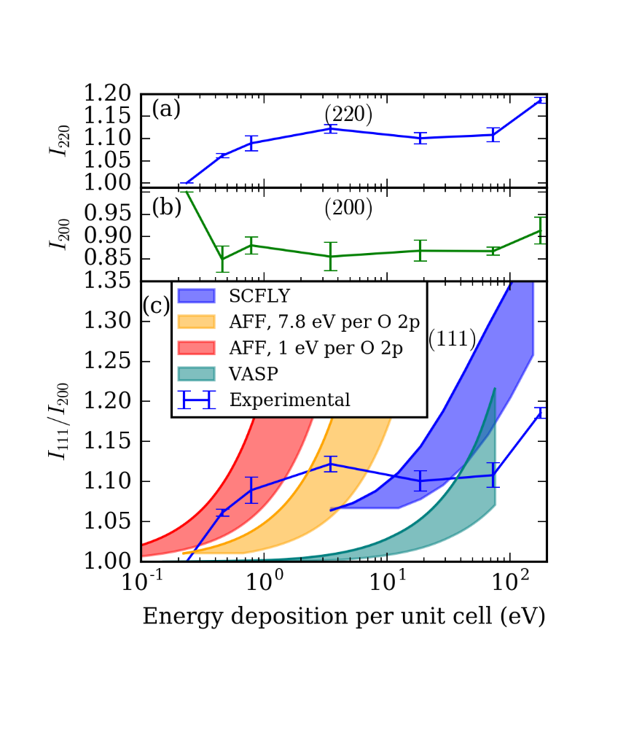

**Fig. 1**. (a): Experimental intensity of the (220) Bragg peak from a sample of MgO simultaneously heated and probed by 45-fs duration XFEL pulses, as a function of XFEL energy deposited per MgO unit cell, with no normalization across individual data points. (b): Equivalent data for the (200) peak. (c): Experimental intensities of the (111) peak, compared to several models. Each experimental data point is normalized by (1) its intensity at minimum flux density and (2) the (200) peak intensity. For each of the four displayed models, the shaded region corresponds to the locus of possible curves once the loss of in-sample energy deposition due to nonlocal heat transport by hot electrons is accounted for. See the text for discussion.

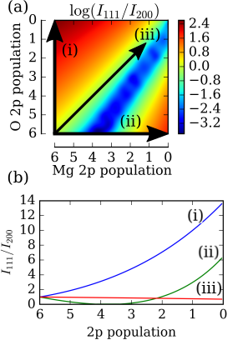

**Fig. 2**. Dependence of $I_{111}/I_{200}$ on population of the *2p* orbitals of ${Mg}^{2+}$ and $O^{2-}$, according to an atomic form factor (AFF) based model of ionization. This ratio reaches a maximum factor of 13.8 times the unperturbed value at full ionization of the O 2p electrons.

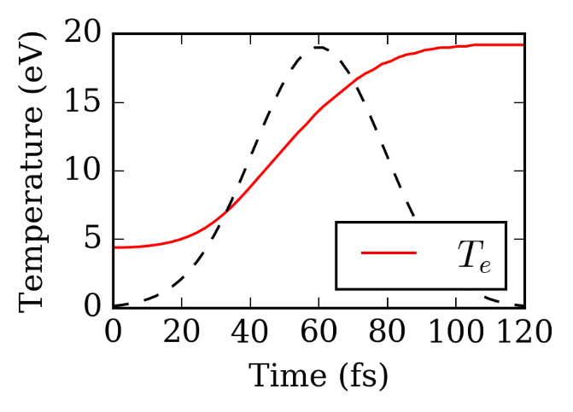

**Fig. 3**. Electronic temperature evolution during an XFEL pulse simulated by the radiative collisional code SCFLY. The incident XFEL photon energy and flux density are 9 keV and 2 x 104­ J/cm2, respectively. The dashed line represents the temporal profile of the incident XFEL pulse.

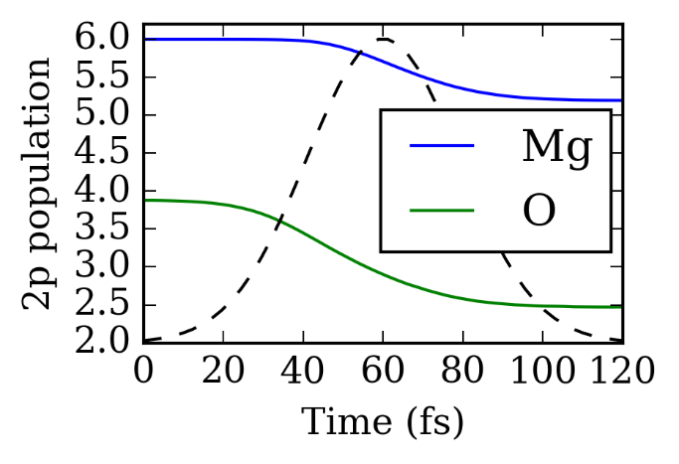

**Fig. 4**. Evolution of the mean charge states Mg and O of during an XFEL pulse simulated by the radiative collisional code SCFLY. The incident XFEL photon energy and flux density are 9 keV and 2 x 104­ J/cm2, respectively. The dashed line represents the temporal profile of the incident XFEL pulse.