Finite-T Charge Transfer in MgO Under Extreme X-ray Heating: A Crystal of Hollow Atoms

Oliver Hoidn, Ryan Valenza, Gerald T. Seidler(*), Alexander Ditter, William Holden, Evan Jahrman, Luis Avila, Galen O’Neil, (*MEC people? Who am I forgetting?)*, Josh Kas, Fer Vila, Sam Vinko

Physics Department, University of Washington, Seattle WA

National Institute of Standards and Technology, Boulder CO

(*) seidler@uw.edu

Abstract here

**Introduction**

The ‘warm dense matter’ (WDM) regime resides in an important, and theoretically interesting middle-ground between conditions typical of high-pressure studies in condensed matter physics and those instead of greatest interest to contemporary plasma physics, where atoms are fully ionized. (a few sentences with citations of why WDM is neato, define as partially ionized, solid density or higher, T~EF, etc, .)

WDM, however, presents unique practical challenges. While some obvious difficulties accrue from the details of how this transient state of matter is actually created, more fundamental problems come from the question of experimental diagnostics. Specifically, the high opacity of dense, partially-ionized matter renders ineffective the well-developed suite of optical-wavelength tools that are regularly used to obtain detailed microscopic information for low density plasmas. The community has therefore instead turned to x-ray wavelength diagnostics, each of which has a different connection to microscopic observables of interest. X-ray absorption spectroscopy interrogates the unoccupied electronic density of states, x-ray fluorescence informs us about semi-core and core-level occupancies of the ions, and elastic and inelastic x-ray scattering characterize the real-space charge density and momentum-space distribution functions, respectively.

The possible roles of elastic x-ray scattering, i.e., x-ray diffraction (XRD), in the study of WDM has seen recent discussion by Valenza and Seidler [cite]. While all early XRD studies of WDM were performed in laser-shock studies where long-range crystalline order of the target is destroyed, those authors instead address the question of WDM created by heating of crystalline targets by the extremely fast pulses created by x-ray free electron lasers (XFELs). While one key result of that work is the large contribution of the nominally ‘free’ electrons to XRD for low-Z systems, there is are two overarching perspectives in that work that help motivate the present study. First, XRD from crystalline WDM provides an important testing ground for finite-T electronic structure theory, giving direct measurement of the fundamental quantity predicted in DFT approaches, i.e., the spatial distribution of charge density. For example, for low-Z systems, finite-T studies of XRD might be used to give an especially salient inquiry into exchange functional effects under intermediate degeneracy of the unbound electrons. Second, and of greater relevance here, XRD from a WDM state where the ion cores are at least effectively stationary is a rich experiment that, through the careful choice of target material crystal structure, can be designed to have far higher information content than has been the case in studies of disordered WDM.

We report here a study of the XRD from nanophase XFEL-heated targets of the simple compound MgO. In the context of the above discussion, this choice is highly desirable. First, MgO, which has the NaCl rock-salt structure, is an example of the simplest crystal structure where there are low-angle Bragg peaks that have either purely constructive or purely destructive interference between the dissimilar species in the unit cell. This property is nontrivial, and it gives the experiment sensitivity to not just the average ionization across the unit cell but instead the ionization of each species. Second, the combination of slightly heavier atoms than in the Valenza [cite] work together with favorably distribution conduction-band charge densities allows interpretation in the context of a simple atomic form factor model that ignores the contributions to XRD from the unbound electrons. Third, the long semicore lifetime of Mg 2p holes provides an interesting problem for the present work, where there is then a meaningful competition between O valence-level and Mg 2p-level depopulation, but also provides an natural extension to the future where x-ray pump/probe studies with delays (blah blah say something to make it sound ‘good’ that we chose something with an obnoxiously long 2p core hole lifetime, if possible) Finally, while the nanophase nature of the target poses some added complications in calculating the average energy actually deposited in each unit cell, it ensures good sample isotropy so that the XRD rings are uniform for each single shot. This is needed if background subtractions are going to work, or something like that. (It would also be good to put in a Goldilocks statement. We need to be complex enough to get a mix of contructive and desctructive interference in the unit cell but not so complex, such as macromolecules as an extreme, where those details wash out to give a simple proportionality between intensity and unit-cell-average ionization.)

We find (summarize results)

The manuscript continues as follows. First, in section II…..

**II. Methods**

II. A. Experimental Details

The experiment was performed at the matter of extreme conditions (MEC) endstation of the Linac Coherent Light Source (LCLS), where XFEL pulses were used to excite MgO samples consisting of 100 nm-thick layer of MgO nanoparticles deposited onto an 8 um-thick kapton substrate and confined using a binding matrix of Poly(methly methacrylate) (PMMA). We used SASE pulses of duration of 30 fs (check this), with mean pulse energies of 2 mJ (check this) and a nominal x-ray energy of 9 keV. Variations in the mean photon energy of each pulse are monitored by a downstream dispersive spectrometer. The intensity of every shot was measured using an upstream nitrogen fluorescence detector (check this).(Not right) We controlled flux density incident on the sample via a stack of Be lenses, with which we varied the focal spot diameter of XFEL pulses at the sample position from 2 to 60 um; these diameters were determined using an ablative imprint method to measure the spatial profile of the focused XFEL beam (cite <http://doi.org/10.1016/j.nima.2010.12.040>). Using the full available range of focal spot sizes and a constant (unattenuated) beam intensity, we obtained incident flux densities ranging from 30 to 2000 J/cm2.

During data collection the sample's position was rastered at a rate of 100 um (*check this*) between the XFEL pulses, whose repetition rate was 120 Hz. At every XFEL pulse the Bragg scattering signal was collected and read out from a quad CSPAD solid state detector having 800 x 800 resolution and a pixel pitch of 100 um. (cite CSPAD papers) The 8 x 8 cm2 active area of the detector subtended the range of scattering angles from 10 to 58 degrees, encompassing the 111, 200, and 220 Bragg reflections of MgO (located at x, y, and z degrees, respectively).

II.B. Data Reduction and Analysis

Several steps of processing and event selection were performed prior to generating powder diffraction patterns. For each event the quad CSPAD readout was corrected by subtracting pixel pedestals (measured using previously-collected dark exposures) as well common-mode noise in each of the detector’s 16 individual tiles. (cite CSPAD paper). Due to the small number of photon hits in a single shot residual ADC noise often dominated the Bragg scattering signal. To address this we made use of a standard component of the analysis pipeline for CSPAD data in low-photon count rate experiments at the LCLS, such as macromolecular imaging and crystallography, which identifies clusters of spatially-concentrated signal resulting from x-ray photon hits, rejecting the output of noise-dominated pixels. . (*citation needed*).

For each LCLS pulse a powder diffraction pattern is generated from the quad CSPAD frame by the summation of elliptically-shaped strips of pixels at equal scattering angle. The mapping of pixel coordinate to scattering angle is calculated from the CSPAD’s location and orientation relative to the sample and incident XFEL beam; this geometry is in turn obtained from the conic section parameters of powder diffraction peaks in data from a known reference material measured in the same source-detector geometry. After generation of a powder pattern, two corrections are made. First, the each peak is shifted to correct for angular offsets caused by (1) the sample substrate’s lack of flatness and (2) event-to-event jitter in the mean photon energy of the XFEL. Second, a linear fit is made to the background of each peak, and this background is subtracted from the peak signal. The signal-to-background ratio for this peak is then computed by comparison of the background level derived from the linear fit to a simple integration of the background-subtracted peak. Events in which any of the peak signal-to-background ratios fall below a threshold (chosen to be 0.2) are rejected in subsequent summation over data from multiple events.

Bragg peak scattering intensity is the most significant derived quantity from each powder pattern in this study, but its estimation requires correcting the effect of variations in the total scattering signal caused by sample non-uniformity and temporal variation of the XFEL pulse energy. The latter contribution can be corrected using direct measurement of incident pulse intensities available from an upstream nitrogen detector; for comparison of Bragg peak intensities at different flux density values, however, we normalize each pattern to the integral intensity of its 200 peak in order to control for variations in sample thickness.

II.C. Modeling

Finally, the relationship between the incident flux density and the resultant energy density in the MgO nanoparticles requires some care. The small (100 nm) sample thickness requires that a significant portion of higher-energy electrons created in the relaxation cascade following, e.g., primary photoionizatin of the Mg 1s orbital, will necessarily escaped into the surrounding low-Z substrate and surrounding binder, causing a reduction in the density of *deposited,* versus absorbed, energy. *(cite HEF paper and others)* This effect has recently been discussed in detail, and proposed to be especially important for the design of XFEL x-ray heating targets. In the present case, using the methods described in ref [x] we use PENELOPE to perform Monte Carlo simulations for 9 keV incident photons striking a target consisting of a 100-nm thick MgO layer clad with xxxx. This simulation includes (say something about all the contributions that PENELOPE includes) On the basis of these calculations, we find that the absorbed energy density in the MgO nanoparticles of 40% the value that would otherwise be expected for a bulk MgO target.

The average energy deposited per unit cell is then calculated on the basis of the incident pulse energy, the focal spot size, standard (cold) cross sections for x-ray absorption, which greatly dominates Compton and elastic scattering, and the above correction. This calculation is an upper bound, in that it assumes that long-wavelength electronic excitions, e.g., plasmons, either are a minor contributor to the energy distribution at any moment in the relaxation cascade and will have decayed to simple electron-hole excitations during the time duration of the pulse.

To model the dependence of the XRD signal on the electronic configurations of the Mg and O ions we use the Hartree-Fock code of Cowan (cite) to calculate the atomic form factors of Mg and O decomposed by subshell. The crystal's structure factor is subsequently calculated as a sum over basis atoms and subshells; i.e.,

$S\left(\vec{Q}\right)=\sum_{j}{∑_{n,l}N_{n,l}f{}_{j,n,l}\left(Q\right)e^{-i \vec{Q}∙\vec{r_{j}}} },$ (1)

where $f{}_{j,n,l}\left(Q\right)$ is the atomic form factor of the subshell $n,l$ of the jth species, where $n$ and $l$ are principal and orbital angular momentum quantum numbers, and $N_{n,l}$ is the subshell’s population. The intensity of a given Bragg reflection (neglecting Debye-Waller quenching and the geometric dependence of scattering by a powder of crystallites) is then obtained by evaluating $S\left(h a_{1}+ k a_{2}+ l a_{3}\right)$, where $a_{1}, a_{2}$ and $a_{3}$ are the basis vectors of the reciprocal lattice and $h$, $k$ and $l$ are Miller indices. Following standard practice in plasma physics modeling, we treat ionization of atomic electrons as a uniform (real-space) smearing of free electrons; thus, ionization of an atomic orbital simply corresponds to reduction of its weight $N_{n,l}$. *(cites. Can also use this as an opportunity to acknowledge probable inadequacy of this approach; finite-T DFT predictions of non-spherically symmetric charge reorganization*).

In the high-energy density regime, defined as having mean temperatures above 2 eV, we simulated the temporal evolution of the MgO charge state distribution (CSD) over the course of an XFEL pulse using a variant of the collisional radiative code SCFLY that Vinko et al. have modified to self-consistently support elemental mixtures. The code implements a local density-based treatment of continuum lowering that Vinko et al. have demonstrated accurately reproduces experimental ionization potential shifts at high charge states in several solid-density plasma mixtures. (*cite Vinko nature comm.*). Unlike other certain other collisional radiative codes, SCFLY models the plasma’s free electron energy density self-consistently with respect to XFEL heating and interaction with ions (e.g. impact ionization and Auger decay). Its principal caveat in the current setting, where the plasma is heated via photoexcitation by photons with energies far above the absorption edges of Mg and O, is its assumption of an instantly-equilibrating thermal distribution of free electrons. (*cites, and maybe should address implications of this issue).*

**Results and discussion:**

First, in figure 1, we show the intensity of the MgO 200 peak as a function of energy deposited per MgO unit cell. The ~15% scatter in the observed scattering intensity upon increasing excitation is explained as being due to variations in MgO nanoparticle content across different regions of the sample. Consequently, our first result is clear: the MgO nanoparticles remained substantially, and possible completely, crystalline for the duration of the XFEL pulse. There is no evidence for ‘Bragg gating’ or other self-limiting diffraction signals that are known to be important in the context of macromolecular crystallography at XFELs.[cites]

Here, the fact that the MgO nanoparticles are still crystalline allows us to interpret our observed high-intensity XRD patterns using methods of traditional solid-state physics (discussed in section II.C, above), modified to account for the varying degree of ionization as a function of the deposited energy per unit cell. One should then note that of the three lowest-angle Bragg peaks, in order the (200), (111) and (220), there are significant differences in their expected changes due to ionization of the two species in the unit cell (discuss Mg versus O ionization )

Somewhere in paragraphs below, need to mention absence of deBye Waller effect further emphasizes crystalline nature: Increasing MgO is wildly contrary to disorder…

In Fig. 4 we plot the experimental intensity of the three lowest-order Bragg peaks of MgO as a function of incident flux density (together with curves for several models, which will be discussed below). For each Bragg peak, the entire curve is normalized to the intensity of the “cold” (lowest-flux density) dataset and each individual data point is normalized to the 200 peak intensity for the corresponding flux density. Displayed error bars are estimated systematic errors due to background subtraction and peak integration; counting statistics-derived errors are negligible. The most salient feature is a 20% rise in the relative intensity of the 111 peak between the lowest and highest flux densities. In contrast, the relative intensity of the 220 peak has small fluctuations but does not display a monotonic progression..

The increase in relative intensity of the 111 Bragg peak is understood by examining the structure of MgO in the context of the powder diffraction from a sample under ambient conditions (*figure reference? We don't really have a nice powder pattern to show*). MgO’s rock salt-type crystal structure consists of two interpenetrating FCC lattices of Mg and O, with one of the lattices shifted by half of the FCC lattice constant in the direction of one of the lattice basis vectors. The two ionic species of MgO, Mg2+ and O2-, have identical electron configurations and therefore similar ionic form factors. If the ionic form factors were fully identical, the superposition of FCC lattices would become a simple cubic lattice with lattice constant a/2 (where a is the constant of the original FCC lattice), and under which Bragg reflections of the original FCC lattice having odd Miller indices are forbidden. In MgO, on the other hand, the modest difference between the atomic form factors of Mg2+ and O2- causes substantial—but incomplete—destructive interference at the momentum transfers of odd Miller indices. This offers an explanation for the small intensity of the 111 Bragg peak, as well as for its monotonic rise with increasing incident x-ray flux: as temperature increases electrons of the weakly-bound O 2p orbitals are ionized at a higher rate than those of Mg, increasing the dissimilarity of the form factors of the O and Mg ions. This relationship is illustrated by Fig. 2.

Using this atomic form factor (AFF) representation to predict the consequences of XFEL heating on XRD requires separate calculation of an average of the probed MgO ionization state —both temporal (over the duration of an XFEL pulse) and spatial (over all probed unit cells). We consider here two approaches to this calculation that respectively address the low- and high-energy density regimes. Each individually captures some relevant physics while falling short of describing the entire range of experimentally-sampled states.

Our inputs to SCFLY were the sample composition and XFEL photon energy, flux density, and temporal profile (which we took as a Gaussian with a 45s FWM duration); the main outputs were temporal profiles of the charge state populations of Mg and O during the XFEL pulse. Fig. 3 displays the simulated evolution of temperature and Mg and O total charge states during a 45fs XFEL pulse with 2x10^4 J/cm^2 flux density (the highest experimental value). It is notable that the charge state distribution is strongly athermal: the final Mg charge state of 0.8 exceeds by a factor of *how much?* the (grand canonical) equilibrium value corresponding to the final temperature of 19(?) eV. The lack of LTE could have been stated *a priori,* with no need for simulation: because lifetimes of 2p holes in Mg exceed 100 fs (cite Fuggle and Inglesfield book; Keski-Rahkohnen et al.) these excitations cannot significantly thermalize at temperatures below the Mg 2p binding energy, and the population of Mg holes will be almost purely determined by rates of 2p and 1s photo- and electron impact ionization during the XFEL pulse.

The low value of the free electronic temperature compared to the K shell binding energies of O and Mg, together with the short lifetime of the 2s core holes of both O and Mg (*cite)*, allow a simplifying approximation in the application of the AFF ionization model. Because only the 2p orbitals of Mg and O are substantially depopulated, the charge state of each species uniquely determines its electronic configuration under equation (1). (*Need to justify why we ignore 2s as well (basically because of the shorter lifetime of the 2s vacancies))* The AFF model can therefore be used to compute measured Bragg peak intensities from charge state progressions (instead of full electronic configurations). Fig. 4shows the output of the resulting SCFLY-based XRD calculation evaluated over the full range of flux densities simulated with SCFLY. Comparison to the experimental progression of Bragg peak intensity ratios shows thorough disagreement at low flux densities, where the rapid rise in the experimental ratio of the 111 to 200 peak intensity is not reproduced by the SCFLY-derived model. This reflects the inaccuracy of SCFLY’s charge state distribution at low temperatures—a consequence of SCFLY’s insensitivity to condensed state physics and its IPD model’s temperature-independent placement of the continuum below the M shell potential, which causes an unphysical combination of atomic charge states at zero temperature (Mg2+ with neutral O). At high flux density agreement between the experimental data and SCFLY-based model is better, with both exhibiting a shallow plateau in the 111/200 Bragg peak ratio, followed by a rapid rise beyond a 5 eV/unit cell energy deposition. This agreement, however, is only crude and qualitative.

Our second modeling approach attempts to reproduce the effect of XFEL heating on the XRD signal at low flux densities. In the regime of < 1 eV energy deposition per unit cell condensed matter physics and the details of valence-level electronic structure become significant. This physics falls entirely outside the scope of collisional radiative plasma physics codes such as SCFLY, and must be addressed separately. The absence of local thermal equilibrium (LTE) is a challenge for modeling fs-scale electronic reorganization in the 0.1-1eV temperature regime because—unlike in the plasma limit, where the atomic kinetics are unambiguous (modulo treatment of the ionization potential depression)—there is a lack of established frameworks for calculating the time-evolved electronic structure. We have performed DFT calculations of XRD from finite-temperature MgO using the Vienna ab-initio Simulation Package (VASP) that more explicitly illustrate the inadequacy of assuming LTE. As shown in Fig. 4, the VASP-based model severely fails to reproduce the early-onset rise in intensity of the 111/200 Bragg peak ratio seen in the experimental data. (*the somewhat sketchy part about this claim is that we equated SCFLY’s temperatures VASP’s in order to get everything on the same scale. Should mention this in either the text or the figure caption).*

We thus forgo ab-initio simulation and use the following *ad-hoc*, but realistic, models: we assume that, in the early stages of heating, all XFEL energy deposited in the MgO sample contributes to production of low-energy excitons through removal of either (1) states at the edge of the valence band or (2) 2p electrons of the O2- ion, depending on whether one models MgO as a solid-state or atomic system, respectively. (*need to elaborate on this assumption?)* In both approaches, ionization is translated into an XRD response via removal of O 2p electrons in the AFF model; the only difference is in the assumed ionization potential. In the solid-state picture we use an ionization potential of 7.8 eV per electron, equal to the experimental band gap of MgO. (note: *MgO has a direct band gap).*  For the atomic representation we approximate the ionization potential of O2- using Koopmans’ theorem in a configuration consisting of a single O2- ion in a background of (+2) point charges at the sites of the nearest-neighbor Mg cations (*what Hartree-Fock code is Fer using for this calculation?)*. This approximation yields an ionization potential of 1 eV.

Fig. 4 shows predicted progressions of Bragg peak intensities for these two *ad-hoc* models. Promisingly, they both manifest a rapid early rise in the relative 111 Bragg peak intensity; the experimental data points below 1eV/unit cell energy density are inscribed between the two model curves. A couple pieces of conjecture can be given as possible explanations for the plateau in the experimental 111/200 Bragg peak ratio at higher flux densities (i.e., the rapid divergence from both model curves). First, the population of excitons may saturate at high flux densities due to dependence on the exciton recombination rate on deposited energy density. Alternatively, a reduction in the rate of ionization could arise from an increase in the 2p ionization potential as more electrons enter excited states. (*which would be the opposite of IPD. Sounds fairly dubious; need to think about it some more. I don’t know of any relevant modeling in this regime)*

Although this approximate agreement is an encouraging datum in support of the modeling approach presented……

Future direction: look for LTE with 2-color, lays groundwork for better comparison to finite-T DFT. Look at systems without long 2p lifetime so that time-evolution calculations are easier. ….

**Conclusion**

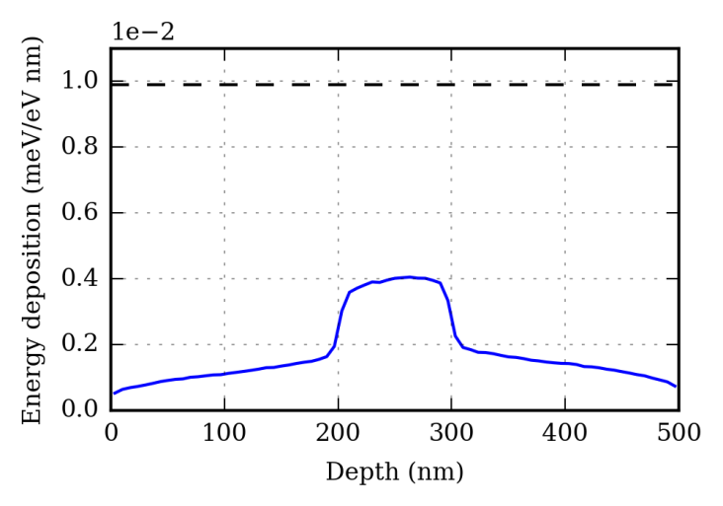

**Fig. 1**. Linear energy deposition density due to 9 keV photons incident on a 100 nm-thick MgO sample clad on two sides with 200 nm polymer (solid), compared to bulk MgO sample (dashed).

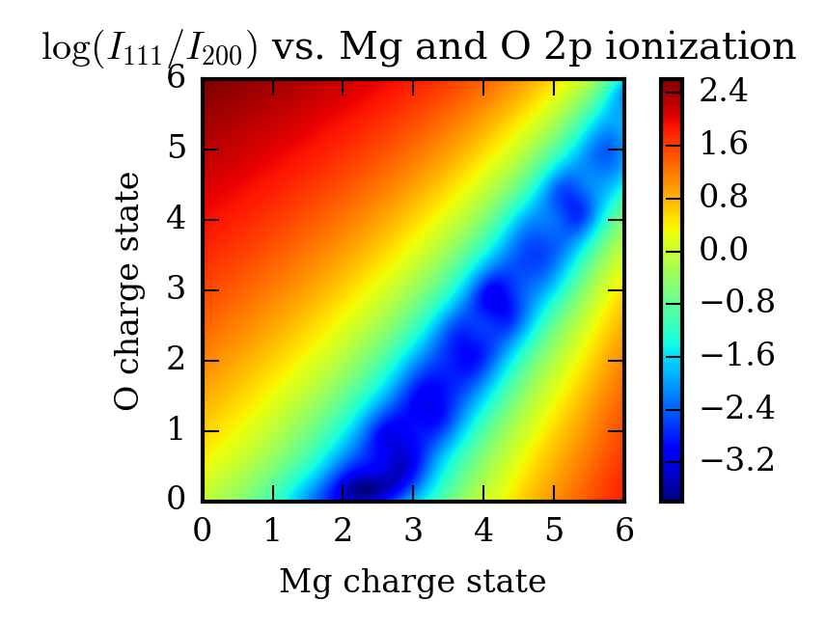

**Fig. 2**. Dependence of the intensity ratio of the 111 to 200 Bragg reflections of MgO as a function of ionization of the 2p orbitals of Mg2+ and O2-, according to an atomic form factor (AFF) based model of ionization. This ratio reaches a maximum factor of 13.9 times the unperturbed value at full ionization of the O 2p electrons.

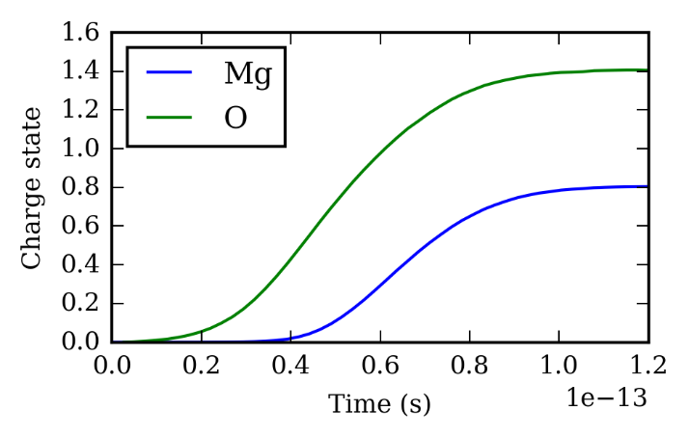

**Fig. 3**. Charge state evolutions of Mg and O during an XFEL pulse simulated by the radiative collisional code SCFLY. The incident XFEL photon energy and flux density are 9 keV and 2 x 104­ J/cm2, respectively.

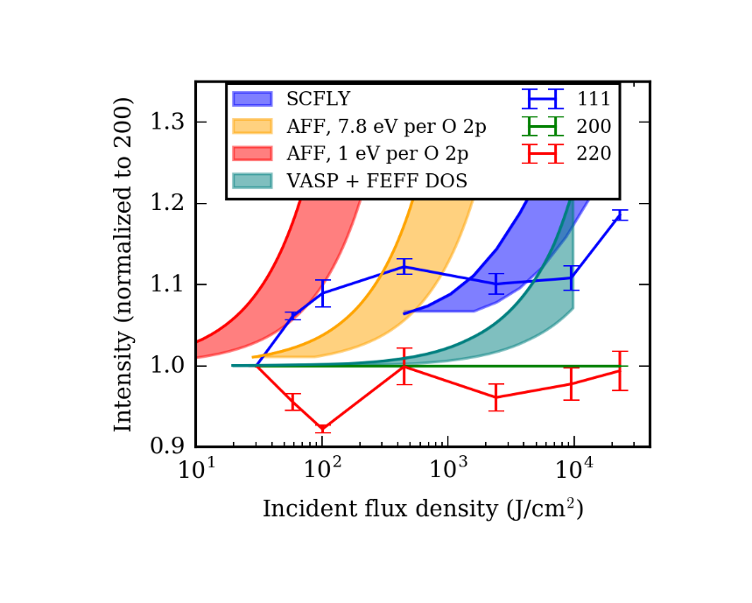

**Fig. 4**. Experimental and modeled intensities of lowest-order diffraction peaks from a sample of MgO simultaneously heated and probed by 45 fs-duration XFEL pulses, as a function of XFEL flux density. For each peak, values are normalized by (1) its intensity at minimum flux density and (2) the 200 peak intensity. For each of the four displayed models, the shaded region corresponds to the locus of possible curves once the loss of in-sample energy deposition due to nonlocal heat transport by hot electrons (as illustrated in Fig. 1) is accounted for. See the text for discussion.