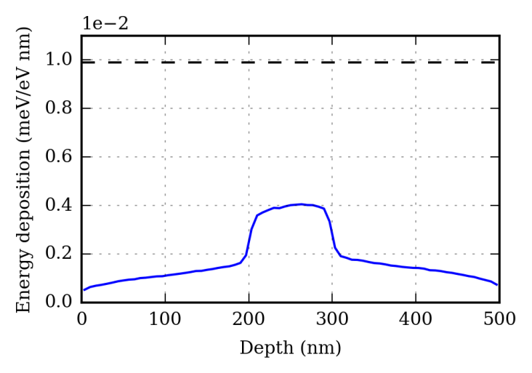

**Fig. 1**. Linear energy deposition density due to 9 keV photons incident on a 100 nm-thick MgO sample clad on two sides with 200 nm polymer (solid), compared to bulk MgO sample (dashed).