**VAD Platform**

Solution Design

for

Bitel PE

Date: Friday February 19th, 2018 Version: 1.5

DISCLAIMER

THIS DOCUMENT AND ANY ATTACHED MATERIALS ARE THE SOLE PROPERTY OF CHANNEL VAS HOLDINGS LIMITED, SUBSIDIARIES & PARTNERS AND ARE NOT TO BE USED FOR ANY PURPOSE OTHER THAN TO EVALUATE THE SERVICE. THIS DOCUMENT MAY NOT BE DISSEMINATED, DISTRIBUTED, OR OTHERWISE CONVEYED THROUGHOUT YOUR ORGANIZATION TO EMPLOYEES WITHOUT A NEED FOR THIS INFORMATION OR TO ANY THIRD PARTIES WITHOUT THE EXPRESS WRITTEN PERMISSION OF CHANNEL VAS HOLDINGS LIMITED, SUBSIDIARIES & PARTNERS.

REVISION HISTORY

|  |  |  |  |
| --- | --- | --- | --- |
| **Date** | **Version** | **Author** | **Comments** |
| 10/07/2017 | 1.0 | C. LINA | Document Template |
| 12/02/2018 | 1.1. | G. Bouleros | New Document – Solution draft |
| 13/02/2018 | 1.2 | G.Bouleros | Internal Review document |
| 14/02/2018 | 1.3 | G.Bouleros | Updated with API changes |
| 15/02/2018 | 1.4 | G.Bouleros | Network |
| 19/02/2018 | 1.5 | G.Bouleros | Customer Review |

***Contents***

1. Scope 7
2. Service overview 7
   1. Service flow overview 8
   2. Service Key Points 8
   3. QUALIFIED USERS, ELIGIBLE USERS AND LOAN Denominations 9
   4. Subscriber Lifecycle 10
   5. DEFAULTED LOANS 12
   6. CONSTRAINTS ON MARKETING ACTIVITIES 12
3. Hardware, Virtualization & Hosting Specifications 13
   1. Solution H/W Components 13
   2. Hardware specifications 13
   3. Virtualization S/W specifications 14
   4. Hardware hosting specifications 14
   5. Space Requirements 14
   6. Power Consumption & Heat dissipation 14
   7. Hardware Support 16
   8. High level topology diagram 16
   9. Network and IP specifications 17
      1. Open Points 17
      2. INTERNAL NETWORKS 17
   10. Virtualization Solution Design 19
       1. H/W Management IPs 20
       2. Production Systems IPs 20
       3. Operations and Monitoring 21
       4. Staging 22
   11. Site to Site VPN 22
       1. Open Points 22
4. Datacenter contacts and location 24
   1. Onsite Contacts 24
   2. Datacenter Address 25
   3. Rack Location 25
5. VAD software solution design 26
   1. Software modules 26
   2. Integration points & protocols 27
   3. ADVANCE AND RECOVERY DESIGN 28
      1. Loan Operations / Account Adjustments 28
      2. Examples 28
   4. Use-cases 30
      1. Advance Use Cases 30
      2. Recovery Use Cases 33
   5. IVR 35
      1. Inbound IVR call 35
      2. Failed Called Routing (Redirection to IVR) 36

C O P Y R I G H T © C V A S 3

* 1. ZERO BALANCE LANDING PAGE 38
  2. Low Balance Notification & Failed Bundle completion 39

1. System Integrations 41
   1. Gateway - OCS Integration 41
      1. Open Issues 41
      2. Connectivity Purpose 41
      3. Communication 41
      4. Configurations 42
      5. Methods 42
   2. USSD Gateway 43
      1. Open Issues 43
      2. Connectivity Purpose 43
      3. Communication 43
      4. USSD Details 44
   3. SMSGW 45
      1. Open Issues 45
      2. Connectivity Purpose 45
      3. SMSC Details 45
      4. SMSGW Accounts information 46
   4. SIP 47
      1. Open Issues 47
      2. Connectivity Purpose 47

C O P Y R I G H T © C V A S 4

* + 1. Network & SIP Setup 47
  1. SAT Push (thru middleware) 48
     1. Open Issues 48
     2. Connectivity Purpose 49
     3. Communication 49
     4. Configurations 49
     5. Methods 50
  2. CVAS Mediation 50

1. Data Files: CDR & Dumps 51
   1. Open Issues 51
   2. Data Types 51
   3. Historical data dumps 52
      1. Columns of Historical data 52
   4. Live data feeds 54

7.2.1 Column Details per CDR .............................................. **Error! Bookmark not defined.**

7.2.2 Filtering Rules per CDR .................................................. **Error! Bookmark not defined.**

7.2.3 Destination Paths per CDR........................................... **Error! Bookmark not defined.**

##### APPENDICES 67

* 1. Middleware (Gateway) API 67
     1. Configurations 67
     2. Operations 67
     3. Method: LendBalance 69
     4. Method: LendBundle 72
     5. Method: QueryProfile 75
     6. Method: ProvisionBundle 79
     7. Method: CheckTranStatus 81
     8. Method: SendSATpush 84
     9. Method: SATpushNotification 86

# Scope

This document describes the VAD solution.

*Section 2* provides a service overview

*Section 3* describes the hosting requirements, network requirements and of the VMs that will be used for the service delivery

*Section 4* lists the hosting Data Centre contact details.

*Section 5* details the VAD solution design and provides use cases and flow diagrams.

*Section 6* includes the platform design, the integration and interactions with Operator’s Telco

and IT platforms. Configuration items will be added to this section when provided.

*Section 7* details the data requirements

*Appendices* details the custom APIs will be used in certain integrations

# Service overview

Virtual Airtime Distribution (VAD) is the platform that deliver the LCS service offered to Bitel’s prepaid mobile subscriber base to facilitate advance of airtime and data payable on the next monetary recharge.

Subscribers can request an advance (airtime / data / bundle) and check their LCS account through any of the available channels, namely **SMS**, **USSD**, **SAT push**, **IVR**, **Web**.

When the customer makes an Airtime Credit request through one of the available channels, upon meeting the eligibility rules, the system will credit the loan amount on his account. The borrowed airtime will be repaid the next time or times the customer recharges his account. Same flow applies for data or bundle loan requests as well.

|  |  |
| --- | --- |
| **Recovery is performed by** | Operator |
| **Recovery order** | 1 - Principal (debt) 2 - Fee |
| **Multiple Loans** | They will be available to all prepaid subscribers |
| **Service Fee** | 20% |
| **Prepaid base** | 3.000.000 |
| **Supported Languages** | Spanish only |
| **Black Hours for broadcast** | 19:00 – 0800, Saturday, Sunday, Holiday |
| **Black Hours for LBN, EOCN** | **Service related** (*Low Balance triggers, Failed purchase SAT PUSH*  *etc*): There are **no black hours**. |
| **“Do Not Distrurb” list** | It will be uploaded once per month on VAD mediation server |
|  | C O P Y R I G H T © C V A S 8 |

## Service flow overview

* + 1. The **LCS** service shall be marketed through various **real – time triggered** or **scheduled** informative activities using all the available channels, namely **SMS**, **SAT Push**, **OBD**, **Push Notifications**, **Web landing pages**.
    2. Subscribers can request an advance (airtime, data, bundles) through any available channel.
    3. The VAD platform checks the subscriber’s eligibility for the loan request. If the

subscriber is eligible, VAD attempts to provision the requested loan

* + 1. If loan provisioning operation is successful, VAD sends a notification about the successful service delivery to the subscriber via SMS.
    2. The subscriber depletes his/her airtime balance
    3. Subscriber recharges his account using any of the traditional top-up channels or received monetary transfer from another subscriber
    4. Bitel’s IN triggers recovery and, in case recovery is successful, Bitel sends an SMS notification to the subscriber to update him for the repayment (full or partial)
    5. Bitel’s IN generated the recharge and recovery CDR
    6. The VAD platform is notified of the recharge and the recovery via CDR

## Service Key Points

## QUALIFIED USERS, ELIGIBLE USERS AND LOAN Denominations

**Qualified Users** for using the service are prepaid Bitel subscribers that do not belong to a special list of service-excluded or blacklisted users.

**User Eligibility** is decided upon considering the following checks:

|  |  |  |
| --- | --- | --- |
| **#** | **Check** | **Error if check fails** |
| **1** | Subscriber is prepaid | The service is offered only to prepaid subscribers |
| **2** | Network tenure at least X days  **Note:** X will be defined after CVAS receives the historical data and profiles the subscribers | You must be on the network for at least X months to qualify for the service. |
| **3** | Subscriber is not in service-excluded lists or black-listed | Kindly note that your account doesn't currently qualify for the service. |
| **~~4~~** | Average monthly recharge > X monthly recharge (last Y months) for lowest TCL band  **Note:** X & Y will be defined after CVAS receives the historical data and profiles the subscribers | To qualify for an advance, you must recharge a minimum of X in the previous Y months. |
| **5** | Last Recharge Date | Kindly note that your account doesn't currently qualify for the service. |
| **6** | Subscriber has zero TCL | Kindly note that your account doesn't currently qualify for the service. |

##### Airtime(Monetary) Lending bands

|  |  |  |
| --- | --- | --- |
| **Denomination** | **Fee (20%)** | **Recovery** |
| S/ 1.0 | S/ 0.2 | S/ 1.2 |

|  |  |  |
| --- | --- | --- |
| S/ 2.0 | S/ 0.4 | S/ 2.4 |
| S/ 3.0 | S/ 0.6 | S/ 3.6 |
| S/ 5.0 | S/ 1.0 | S/ 6.0 |
| S/ 10.0 | S/ 2.0 | S/ 12.0 |
| S/ 20.0 | S/ 4.0 | S/ 24.0 |

**Data Lending bands**

Subscribers will be able to take out data loans that are within their credit limit. The data packages that can be taken as loans are the following:

|  |  |  |  |  |  |
| --- | --- | --- | --- | --- | --- |
| **Package** | **PRICE**  **(S/)** | **VALIDITY** | **RECOVERY**  **(S/)** | **FEE**  **(S/)** | **Data Offering**  **(MB)** |
| **PREMIMAX3** | 3 | 1 DAY | 3.6 | 0.6 | 100 |
| **PREMIMAX5** | 5 | 3 DAYS | 6 | 1 | 200 |
| **PREMIB5** | 5 | 1 DAY | 6 | 1 | 1000 |
| **PREMIMAX10** | 10 | 7 DAYS | 12 | 2 | 500 |

##### Bundles Lending bands

Subscribers will be able to take out bundle loans that are within their credit limit. The bundles that can be taken as loans are the following:

|  |  |  |  |  |  |  |  |  |
| --- | --- | --- | --- | --- | --- | --- | --- | --- |
| **Package** | **PRICE** | **VALIDITY** | **RECOVERY** | **FEE** |  | **Bundle Offering** | |  |
|  | **(S/)** |  | **(S/)** | **(S/)** | On Net min | All Net min | SMS | Data MB |
| **BF5** | 5 | 3 DAYS | 6 | 1 | 30 | 0 | 0 | 150 |
| **BF10** | 10 | 7 DAYS | 12 | 2 | 60 | 0 | 0 | 450 |

## Subscriber Lifecycle

There are five states for OCS prepaid subscriber, which are **Inactive**, **Active**, **Block1**, **Block2**

and **Terminate**.

The following diagram show the flow between these states.



Inactive

* Initial state

Active

* On first call

Block 1

* After 30 days of inactivity

Block 2

* After 30 days of inactivity

Terminate

* After 30 days of inactivity

|  |  |
| --- | --- |
| **States** | **Description** |
| **Inactive** | The msisdn remains in **Inactive** state until the first call is made. msisdn in the  **Inactive** state cannot receive any call or short messages. |
| **Active** | Msisdn is activated and If msisdn recharges, it extends its validity period **for 30 days**.  If a subscriber in the Active state does not recharge for a long time, upon the expiry of the validity period of the Active state, his/her account will enter Block1 state. |
| **Block1** | In this state, the subscriber cannot dial regular numbers and send short messages, but may answer calls or receive short messages.  After the subscriber in the Block1 state recharges his/her account, he/she will re-enter the Active state and renew his/her validity period.  If a subscriber in the Block1 state does not recharge **for 30 days**, upon the expiry of the validity period of the Block1 state, the subscriber will enter Block2 state automatically. |
| **Block2** | In this state, the subscriber cannot dial regular numbers, answer calls, send message or receive messages.  After the subscriber in the Block2 state recharges his/her account, he/she will re-enters the Active state with his/her validity period renewed. |

|  |  |
| --- | --- |
|  | If a subscriber in the Block2 state does not recharge **for 30 days**, upon the expiry of the validity period of the Block2 state, his/her account will enter Terminate state automatically. |
| **Terminate** | In this state, the subscriber is considered **churned**.  When a subscriber enters **Terminate** state, the system will delete the corresponding accounts. |

## DEFAULTED LOANS

A loan is considered defaulted when the subscriber churns after XX days

## CONSTRAINTS ON MARKETING ACTIVITIES

### 2.6.1 Open Points

|  |  |  |
| --- | --- | --- |
| P1 | Share a sample of the “DnD” list | Will be sent by emal |

Black hours and contact rules will be specified between marketing departments of Bitel and Channel VAS.

A **Do Not Disturb** list exists and will be shared once per month with CVAS. VAD will process the list and will update its own list accordingly.

Channel VAS’s customer care web tool includes the functionality of excluding on ad-hoc basis an msisdn from marketing activities (e.g. after the subscriber calls the client support and explicitly requests to not receive marketing communication)

1. Hardware, Virtualization & Hosting Specifications

Hardware and 3rd party software licenses required for the hosting of the VAD service will be procured by us.

## Solution H/W Components

The solution is comprised of redundant h/w components for high availability. The list of components includes:

* 2 x Servers
* 1 x Storage
* 2 x Network Switches

## Hardware specifications

|  |  |  |
| --- | --- | --- |
| **Node** | **Quantity** | **Description** |
| Servers | 2 | HP DL360 Gen9  CPU: 2 x Intel® Xeon® Processor E5-2650 v4 (12 cores HT) Memory: 256GB RAM DDR4 2400Mhz  Disk: 32GB SD Flash Media, Ethernet ports: 2 x 4 ports 1Gb FC ports: 2 port 16Gb FC |
| Storage | 1 | HP MSA 1050 Storage with dual controllers Disks: 16 x 1.2TB 10K SAS |
| Switch | 2 | Cisco SRW2024-K9 |

## Virtualization S/W specifications

Vmware ESXi 6.0 is used for the virtual infrastructure.

|  |  |
| --- | --- |
| Quantity | Description |
| 1 | VMWare vSphere Essentials Pro VMWare vCenter |

## Hardware hosting specifications

All hardware components will be hosted in Bitels’s Datacenter at an existing rack.

## Space Requirements

|  |  |  |  |  |
| --- | --- | --- | --- | --- |
|  | **Server Name** | **Quantity** | **Space/Item** | **Total** |
| 1 | HP DL360G9 | 2 | 1U | 2U |
| 2 | Cisco Switch | 2 | 1U | 2U |
| 3 | HP MSA Storage | 1 | 2U | 2U |
|  | **TOTAL** |  |  | **6U** |

## Power Consumption & Heat dissipation

##### PDU 1

|  |  |  |  |  |
| --- | --- | --- | --- | --- |
|  | **Server Name** | **Description** | **Redundant** | **Max Power Watts** |
| 1 | HP DL360G9 | VMHOST1 | Y | 460 |
| 2 | HP DL360G9 | VMHOST2 | Y | 460 |
| 3 | Cisco Switch | SWC1 | N | 190 |

|  |  |  |  |  |
| --- | --- | --- | --- | --- |
| 4 | HP MSA Storage | STORAGE | Y | 337 |
| PDU 1 TOTAL | | | | 1447 |

**PDU 2**

|  |  |  |  |  |
| --- | --- | --- | --- | --- |
|  | **Server Name** | **Description** | **Redundant** | **Max Power Watts** |
| 1 | HP DL360G9 | VMHOST1 | Y | 460 |
| 2 | HP DL360G9 | VMHOST2 | Y | 460 |
| 3 | Cisco Switch | SWC2 | N | 190 |
| 4 | HP MSA Storage | ROUT1 | Y | 337 |
| PDU 2 TOTAL | | | | 1447 |

|  |  |  |
| --- | --- | --- |
| Server Name | Items | Heat Dissipation per server  BTU/hour |
| HP DL360G9 | 2 | 1980 |
| HP MSA Storage | 1 | 1174 |
| Cisco Switch | 2 | 90 |

## Hardware Support

Hardware is covered by next business day replacement support. Below are the contact details for the technical support.

TBD

TBD

TBD

TBD

TBD

**Contact Details**

Full Name

Email address

Phone Number

Department

Support Ticket URL

## High level topology diagram

The high-level topology diagram below depicts the hardware components and their intra- connectivity. The characteristics of the design are:

* the redundant servers
* the SAN with redundant controllers and RAID, offering high throughput fiber connectivity
* the dual path connectivity of servers with the SAN over redundant fiber
* the dual path connectivity of the servers with the network switches over redundant Ethernet links from redundant network cards

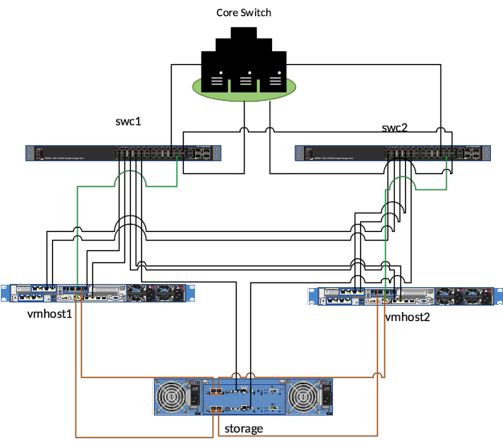

## Network and IP specifications

### Open Points

|  |  |  |
| --- | --- | --- |
| P1 | Operation’s network to be increased to a /26 subnet | Confirmed 10.121.15.64/26 |
| P2 | A management IP required for the second switch | Confirmed 10.121.10.78 |

### INTERNAL NETWORKS

For security and data protection purposes, network zoning is applied to the infrastructure and is separated in 5 zones, namely:

* + - * Service data traffic
      * CVAS O&M traffic
      * Bitel Management traffic
      * SIP signaling traffic
      * RTP Media traffic

The type of traffic that crosses the five-network zone is detailed below:

* + - * CVAS Operations & Management Network

Operations & Management Network is for all the administration and maintenance operations that need to be performed periodically. Also, for the remote 24x7 health check monitoring of the service.

* + - * Bitel Management Network

In this deployment, there is an existing management network operated by the operator and IPs will be assigned hardware systems.

* + - * Service Data Network

This is the network through which all the traffic concerning the application will pass. Essentially, this is the network to be used to interconnect with operator’s platforms like IN, SMS-C, USSD-GW etc.

* + - * SIP signaling and RPT Media Network

These are the two networks related IVR traffic. Both networks will be used to support the Failed Call Redirection feature.

The subnet configuration is depicted in the following table:

|  |  |  |  |  |  |
| --- | --- | --- | --- | --- | --- |
|  | **Description** | **Network** | **Gateway** | **Mask** | **Vlan ID** |
| 1 | Service Data  (Application) | 10.121.15.0/26 | 10.121.15.1 | /26 | 500 |
| 2 | CVAS O&M | 10.121.15.64/26 | 10.121.15.65 | /26 | 501 |
| 3 | RTP Media | 10.121.15.128/27 | 10.121.15.129 | /27 | 502 |
| 4 | SIP signaling | 10.121.15.160/28 | 10.121.15.161 | /28 | 503 |
| 5 | Bitel Management | Assigned IPs *see below* | 10.121.10.126 | /25 | 241 |

##### Bitel Management IPs

|  |  |  |  |  |  |
| --- | --- | --- | --- | --- | --- |
|  | **IP** | **Mask** | **Gateway** | **Device** | **Vlan ID** |
| 1 | 10.121.10.75 | 255.255.255.128 | 10.121.10.126 | Server 01 | 241 |
| 2 | 10.121.10.76 | Server 02 | 241 |
| 3 | 10.121.10.77 | Switch 01 | 241 |
| 4 | 10.121.10.78 | Switch 02 | 241 |
| 5 | 10.121.10.79 | Storage | 241 |
| 6 | 10.121.10.89 | 241 |

**Other Network services**

|  |  |  |  |
| --- | --- | --- | --- |
| **Service** | **IPs** | **Ports** | **Comments** |
| NTP Server | 10.121.3.65, 10.121.3.81 |  |  |

## Virtualization Solution Design

We use VMware to build a private cloud on top of the physical infrastructure to efficiently manage the underlie resources. Two environments are configured on the private cloud:

* The **production** environment

Consists of the pool of servers hosting the production VAD platform and supporting services. This set of servers will interact with the production telco and IT platforms of the operator.

* The **staging** environment

Consists of the pool of servers hosting the staging VAD platform, which is a copy of the production and is used for QA before any new release or bug fix goes to production. This set of server will only interact with the staging telco and IT platforms of the operator.

### H/W Management IPs

|  |  |
| --- | --- |
| **Description** | **Bitel Management IPs** |
| **Cisco Switch 1** | 10.121.10.77 |
| **Cisco Switch 2** | 10.121.10.78 |
| **iLO Host 1** | 10.121.10.75 |
| **iLO Host 2** | 10.121.10.76 |
| **ESXi Host 1** | 10.21.15.105 |
| **ESXi Host 2** | 10.21.15.106 |
| **HP MSA Storage** | 10.121.10.79, 10.121.10.89 |

***\*\*Note:*** *When network subnets are finalized, the operation IPs will be updated accordingly*

### Production Systems IPs

|  |  |  |  |
| --- | --- | --- | --- |
| **Server name** | **Role(s)** | **O&M (VLAN 501)** | **Data (VLAN 500)** |
| [**postgres.prod.pe.bitel**](http://postgres.prod.pe/) | Postgres | 10.21.15.68 | 10.21.15.4 |
| [**mediation.prod.pe.bitel**](http://mediation.prod.pe/) | Mediation | 10.21.15.69 | 10.21.15.5 |
| [**smsgw.prod.pe.bitel**](http://smsgw.prod.pe/) | Smsgw | 10.21.15.70 | 10.21.15.6 |
| [**jbosslb.prod.pe.bitel**](http://jbosslb.prod.pe/) | Jbosslb | 10.21.15.71 | 10.21.15.7 |
| [**jboss0.prod.pe.bitel**](http://jboss0.prod.pe/) | Jboss0 | 10.21.15.72 | 10.21.15.8 |
| [**jboss1.prod.pe.bitel**](http://jboss1.prod.pe/) | Jboss1 | 10.21.15.73 | 10.21.15.9 |
| [**jboss2.prod.pe.bitel**](http://jboss2.prod.pe/) | Jboss2 | 10.21.15.74 | 10.21.15.10 |
| [**jboss3.prod.pe.bitel**](http://jboss3.prod.pe/) | Jboss3 | 10.21.15.75 | 10.21.15.11 |
| [**jboss4.prod.pe.bitel**](http://jboss4.prod.pe/) | Jboss4 | 10.21.15.76 | 10.21.15.12 |
| [**jboss5.prod.pe.bitel**](http://jboss5.prod.pe/) | Jboss5 | 10.21.15.77 | 10.21.15.13 |
| [**jboss6.prod.pe.bitel**](http://jboss6.prod.pe/) | Jboss6 | 10.21.15.78 | 10.21.15.14 |

|  |  |  |  |
| --- | --- | --- | --- |
| [**jboss7.prod.pe.bitel**](http://jboss7.prod.pe/) | Jboss7 | 10.21.15.79 | 10.21.15.15 |
| [**jboss8.prod.pe.bitel**](http://jboss8.prod.pe/) | Jboss8 | 10.21.15.80 | 10.21.15.16 |
| [**jboss9.prod.pe.bitel**](http://jboss9.prod.pe/) | Jboss9 | 10.21.15.81 | 10.21.15.17 |
| [**reports.prod.pe.bitel**](http://reports.prod.pe/) | Reports | 10.21.15.82 | 10.21.15.18 |
| [**opensips1.prod.pe.bitel**](http://opensips1.prod.pe/) | OpenSip1 | 10.21.15.83 | 10.21.15.19 |
| [**opensips2.prod.pe.bitel**](http://opensips2.prod.pe/) | OpenSip2 | 10.21.15.84 | 10.21.15.20 |
| [**asterisk1.prod.pe.bitel**](http://asterisk1.prod.pe/) | Asterisk1 | 10.21.15.85 | 10.21.15.21 |
| [**asterisk2.prod.pe.bitel**](http://asterisk2.prod.pe/) | Asterisk2 | 10.21.15.86 | 10.21.15.22 |
| [**sems1.prod.pe.bitel**](http://sems1.prod.pe/) | Sems1 | 10.21.15.87 | 10.21.15.23 |
| [**sems2.prod.pe.bitel**](http://sems2.prod.pe/) | Sems2 | 10.21.15.88 | 10.21.15.24 |

### Operations and Monitoring

|  |  |  |  |
| --- | --- | --- | --- |
| **Server name** | **Role(s)** | **O&M (VLAN 501)** | **Data (VLAN 500)** |
|  | Backup VDP | 10.21.15.89 |  |
|  | DB Backup | 10.21.15.90 |  |
|  | LDAP | 10.21.15.91 | 10.21.15.25 |
| **monitoring.prod.pe.bitel** | Monitoring | 10.21.15.92 |  |
| **graphite.prod.pe.bitel** | Graphite | 10.21.15.93 | 10.21.15.26 |
|  | SIEM/Audit | 10.21.15.94 |  |
|  | Vcenter | 10.21.15.95 |  |
| **rdp.prod.pe.bitel** | RDP | 10.21.15.96 | 10.21.15.27 |
| **veeam.pe.bitel** | veeam | 10.21.15.97 |  |

* + 1. Staging

|  |  |  |  |
| --- | --- | --- | --- |
| **Server name** | **Role(s)** | **O&M (VLAN 501)** | **Data (VLAN 500)** |
| [**postgres.stage.pe.bitel**](http://postgres.stage.pe/) | Postgres | 10.21.15.98 | 10.21.15.28 |
| [**mediation.stage.pe.bitel**](http://mediation.stage.pe/) | Mediation | 10.21.15.99 | 10.21.15.29 |
| [**smsgw.stage.pe.bitel**](http://smsgw.stage.pe/) | Smsgw | 10.21.15.100 | 10.21.15.30 |
| [**jbosslb.stage.pe.bitel**](http://jbosslb.stage.pe/) | Jbosslb | 10.21.15.101 | 10.21.15.31 |
| [**jboss0.stage.pe.bitel**](http://jboss0.stage.pe/) | Jboss0 | 10.21.15.102 | 10.21.15.32 |
| [**jboss1.stage.pe.bitel**](http://jboss1.stage.pe/) | Jboss1 | 10.21.15.103 | 10.21.15.33 |
| [**reports.stage.pe.bitel**](http://reports.stage.pe/) | Reports | 10.21.15.104 | 10.21.15.34 |

## Site to Site VPN

### Open Points

|  |  |  |
| --- | --- | --- |
| P1 | The VPN should provide access to both:   * Bitel mgmt. IP allocated to us * and, CVAS O&M subnet | Confirmed and sent to configure on  Bitel’s side |

A site-to-site IPsec VPN tunnel needs to be established for the technical team to be able to securely access the infrastructure. **Both the Management and Operations subnets of the VAD installation is included in the encryption domain.**

Purpose of the VPN:

* + - 1. Service 24x7 health monitoring
      2. Service 24x7 performance monitoring and campaign management
      3. Security monitoring
      4. IT management and maintenance operations

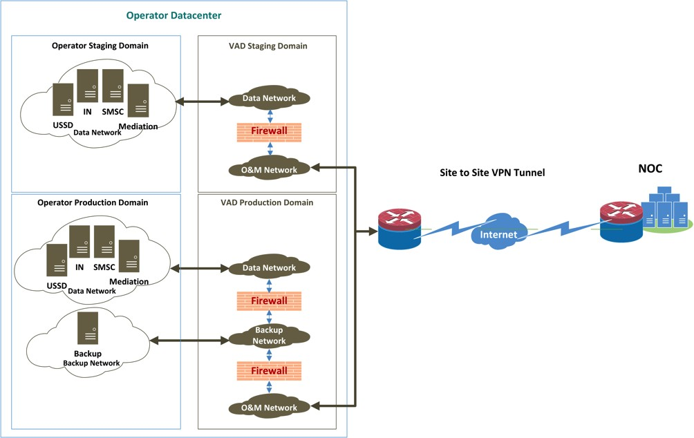

# Datacenter contacts and location

## Onsite Contacts

Contact information for onsite support in case of an issue related to the hardware infrastructure. To be filled in.

|  |  |
| --- | --- |
| **Electrician** | **Contact Information** |
| Name | Andres Villegas HuayllaQuispe |
| Phone number | 51 930 810 078 |
| E-mail | [andres.villegas@bitel.com.pe](mailto:andres.villegas@bitel.com.pe) |

|  |  |
| --- | --- |
| **Network Administrator (Only support and Coordination)** | **Contact Information** |
| Name | Joel Barja / Thang Do Chien |
| Phone number | 51 931 783 060 / 51 930 790 098 |
| E-mail | [joel.barja@bitel.com.pe](mailto:joel.barja@bitel.com.pe) / [thangdc2@viettel.com.vn](mailto:thangdc2@viettel.com.vn) |

|  |  |
| --- | --- |
| **Infrastructure**  **(Only support and Coordination)** | **Contact Information** |
| Name | Joel Barja / Thang Do Chien |
| Phone number | 51 931 783 060 / 51 930 790 098 |
| E-mail | [joel.barja@bitel.com.pe](mailto:joel.barja@bitel.com.pe) / [thangdc2@viettel.com.vn](mailto:thangdc2@viettel.com.vn) |

## Datacenter Address

Location and contact information of the Data Center:

|  |  |
| --- | --- |
| **Address Information** | |
| Street Address | Calle 21, No 878 Urb. Corpac - San Isidro |
| City | Lima |
| Post Code | San Isidro 15036 |
| Country | Peru |

|  |  |  |
| --- | --- | --- |
| **Contact Information** | | |
| **Details** | **Level 1** | **Level 2** |
| **Name** | 24/7 shift Data Center Staff | Andres Villegas HuayllaQuispe |
| **Designation** | Data Center Staff | Data center Team Leader |
| **Email ID** | No Available | [andres.villegas@bitel.com.pe](mailto:andres.villegas@bitel.com.pe) |
| **Mobile No** | 51 930 987 317 | 51 930 810 078 |
| **Desk** | Technical Department. Main Office, 3rd Floor. Data Center team | Technical Department. Main Office, 3rd Floor. Data Center team |

## Rack Location

Rack location in the Data Center. To be filled in.

|  |  |
| --- | --- |
| Rack ID | To be provided once excel sheet is filled. |

# VAD software solution design

## Software modules

Our VAD software platform is modular and is built on a multi-tier architecture. The 5 tiers with their respective modules are:

* + 1. Database Cluster Tier
    2. Application Cluster Tier
    3. Web Tier
    4. Mediation Tier
    5. Management Tier

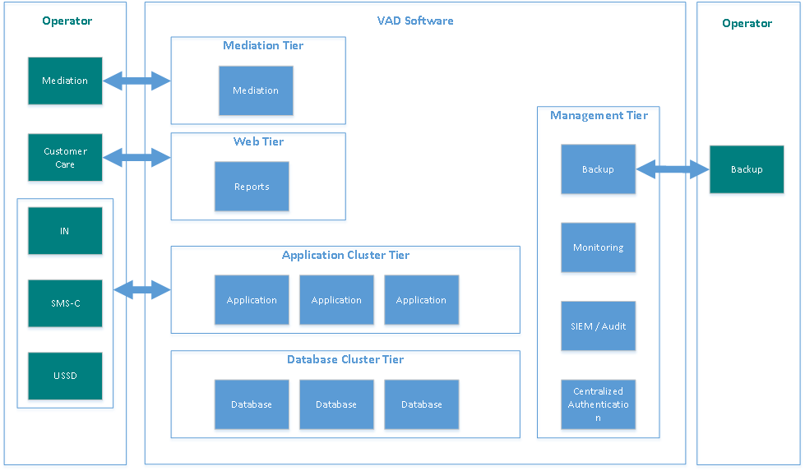Schema below depicts the tiers, the modules of each tier and in high level the interaction required with the platforms of the mobile operator.

## Integration points & protocols

To deliver the new loan service, the VAD platform will be integrated with various operator systems. These are:

|  |  |  |
| --- | --- | --- |
| **Operator System** | **Protocol** | **Connectivity purpose** |
| **OCS platform (thru middleware)** | SOAP/XML | Inquire the IN profile of the subscriber and dispense loans to the subscribers |
| **SMSGW** | SMPP | Submit SMS notifications, receive SMS requests from subscribers and reply to them |
| **USSD Gateway** | Custom TCP | Offer a menu based USSD interface to subscribers to interact with the service |
| **SIP Servers & Media Gateways** | SIP | Offer interactive voice menu and outbound calls |
| **Mediation** | FTP | Recharge CDRs, Account adjustment CDRs (main and tracking), low balance notifications etc. |
| **SAT Push (thru middleware)** | SOAP/XML | To push interactive notification to subscribers |

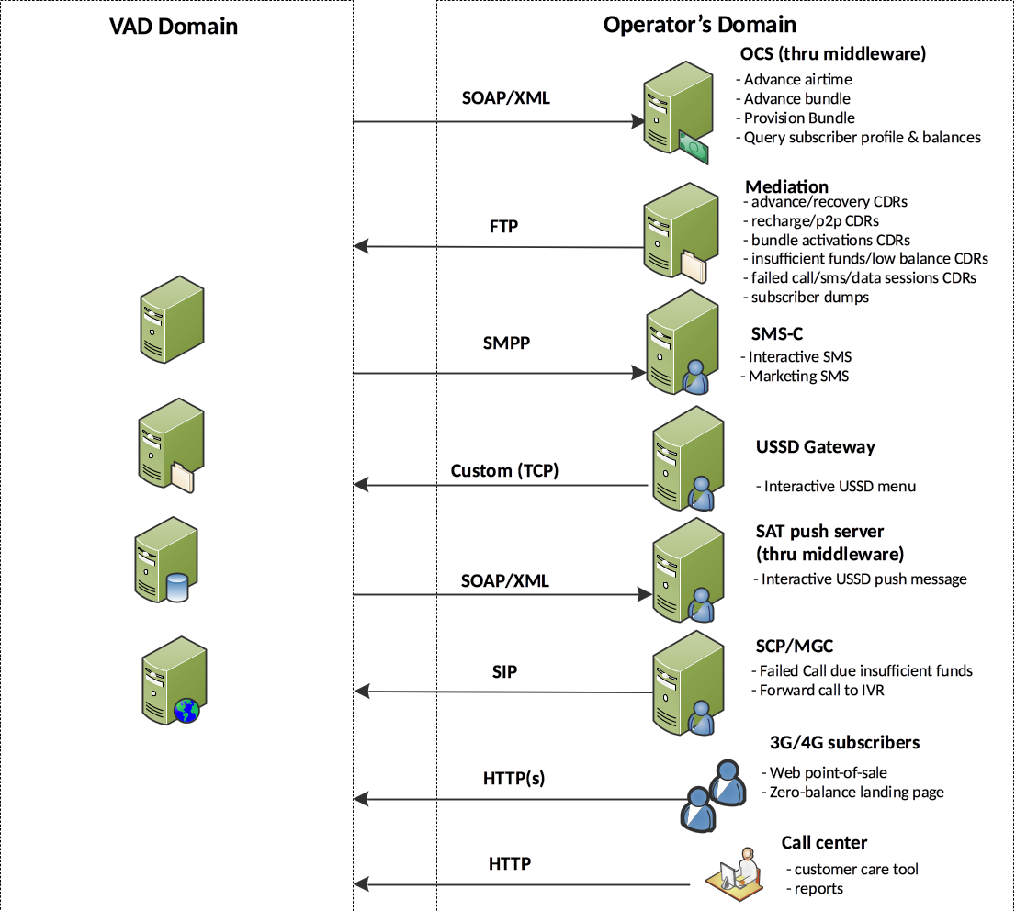The following diagrams show the interconnection diagram of all the systems

## ADVANCE AND RECOVERY DESIGN

This section describes the design of advances and recoveries for the loan credit service.

To deliver the loan service, Bitel and CVAS have agreed to use the following subscriber-level accounts:

* Monetary loans will be credited to main account
* One dedicated non-charging account will be used for tracking the **outstanding principal loan amount,** which does not include service fee (DA_TrackPrincipal)
* One dedicated non-charging account will be used for tracking the **outstanding of service fee** (DA_TrackFee)

### Loan Operations / Account Adjustments

To provide a loan, CVAS will have to use an interface exposed by the IN platform (e.g. web service) that will credit the above-mentioned subscriber accounts and tracking accounts appropriately. This operation constitutes the **loan advance** operation.

**Loan recovery** is an operation that will be triggered on the IN each time the subscriber recharges his account. For users with open loans, recovery process will debit the tracking dedicated account (DA) appropriately prior to adjusting the main account with any residual amount left from the recharge.

Any type of recharge (scratch card, electronic recharge etc.) or increase in the subscriber’s main balance of other type (e.g. p-2-p monetary transfers among subscribers) should trigger recovery for users with outstanding loans.

In case the recharge amount is sufficient to repay the complete outstanding loan amount the recovery is considered a **full recovery**. While, when the recharge amount is smaller than the outstanding loan amount the recovery is considered a **partial recovery**.

### Examples

The following examples show of how the related balances will be adjusted on loan advance and recovery operations for monetary loans. In the following examples, monetary

loans are credited to the subscriber’s main account and 20% exclusive fee is applied on the loan.

###### Example #1: Full recovery of two open loans

|  |  |  |  |  |
| --- | --- | --- | --- | --- |
| ***Step*** | ***Description*** | ***Main Account*** | ***DA Principal*** | ***DA Fee*** |
| ***0*** | Initial balance | 0 | 0 | 0 |
| ***1*** | Subscriber gets a loan advance of S/ 20 (will have to pay back S/ 24) | 0 + 20 = 20 | 0 + 20 = 20 | 0 + 4 = 4 |
| ***2*** | Use of S/ 10 for a voice call | 20 – 10 = 10 | 20 | 4 |
| ***3*** | Subscriber gets another loan advance of S/ 20 (will have to pay back S/ 24) | 10 + 20 = 30 | 20 + 20 = 40 | 4 + 4 =8 |
| ***4*** | Subscriber recharges with S/ 50 Full recovery of loan amount | 30 + (50 – 40 – 8 ) =  32 | 40 – 40 = 0 | 8 – 8 = 0 |

***Example #2: Partial recovery followed by a full recovery of a loan***

|  |  |  |  |  |
| --- | --- | --- | --- | --- |
| ***Step*** | ***Description*** | ***Main Account*** | ***DA Principal*** | ***DA Fee*** |
| ***0*** | Initial balance | 0 | 0 | 0 |
| ***1*** | Subscriber gets a loan advance of S/ 20 (will have to pay back S/ 24) | 0 + 20 = 20 | 0 + 20 = 20 | 0 + 4 = 4 |
| ***2*** | Use of S/ 15 for a voice call | 20 – 15 = 5 | 20 | 4 |
| ***3*** | Subscriber recharges with S/ 15 Partial recovery of S/ 15  **Note**: Recovery order is first Principal account and then Fee. | 5 + (15 – 15) = 5 | 20 – 15 = 5 | 4 |
| ***4*** | Subscriber recharges with S/ 20 Full recovery of the remaining amount S/ 9 | 5+ (20 – 9) = 16 | 5 – 5 = 0 | 4 – 4 =0 |

## Use-cases

The use-cases that should be supported for the delivery of the service are:

1. Advance a monetary loan
2. Advance a bundle or a data loan
3. Full recovery of a loan after a topup
4. Partial recovery of a loan after a p2p (balance transfer)

Flow diagrams below depict the needful interactions between the nodes and required functionality per node for the support of each use case.

### Advance Use Cases

A customer can request an airtime (monetary) or a bundle/data advance in one of the following ways:

* + - * by sending a request via SMS,
      * by calling the service’s USSD code and requesting an advance via the menu
      * by calling the service’s IVR number and requesting an advance via the menu
      * by responding to instructions given through a SAT Push message
      * by responding to instructions given through an outgoing SMS
      * by responding to instructions given through an IVR, after trying to make a call and there is insufficient airtime balance
      * by responding to instructions given through a Web Page, when in a data session and there is insufficient data balance

The following diagrams details the flows of two type of advances. The USSD channel is used in these diagrams, similar flows will be used by the rest of the channels.

##### Use Case #1: Advance a monetary loan

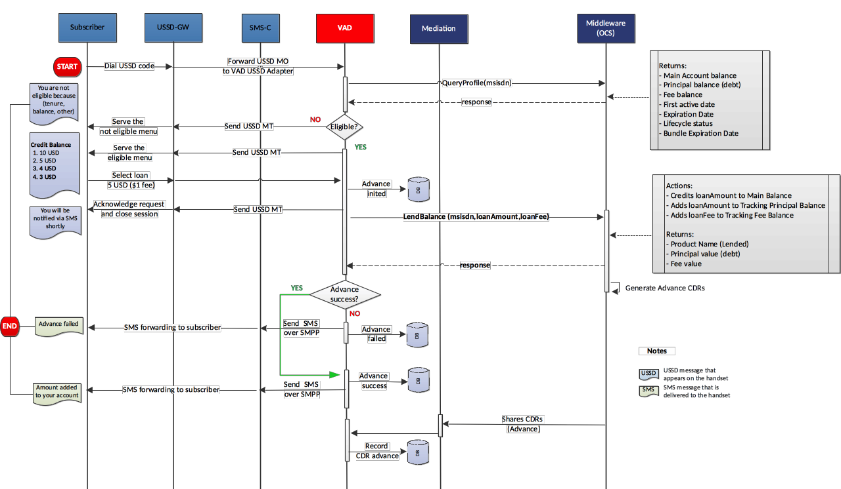

###### Notes:

1. User requests a monetary loan from CVAS VAD Platform
2. VAD inquires the OCS for subscriber’s balances and profile
3. VAD runs eligibility checks to decide whether the user can obtain the loan
4. VAD requests the loan monetary advance to the OCS. The VAD makes a single web service call and all the following adjustments are performed in **one transaction**:

*(Note If an adjustment fails, then all adjustments should be failed.)*

* 1. The loan amount is **credited** to the subscriber’s MA
  2. The loan amount is **credited** to the subscriber’s DA for principal
  3. The service fee is **credited** to the subscriber’s DA for fee

1. VAD sends an SMS notification to the subscriber for the provision of the loan

In case the user is not eligible for a loan VAD will inform the user for the reason of the ineligibility. Also, in case loan provisioning fails with the OCS, VAD will also inform the user appropriately.

##### Use Case #2: Advance a bundle or data loan

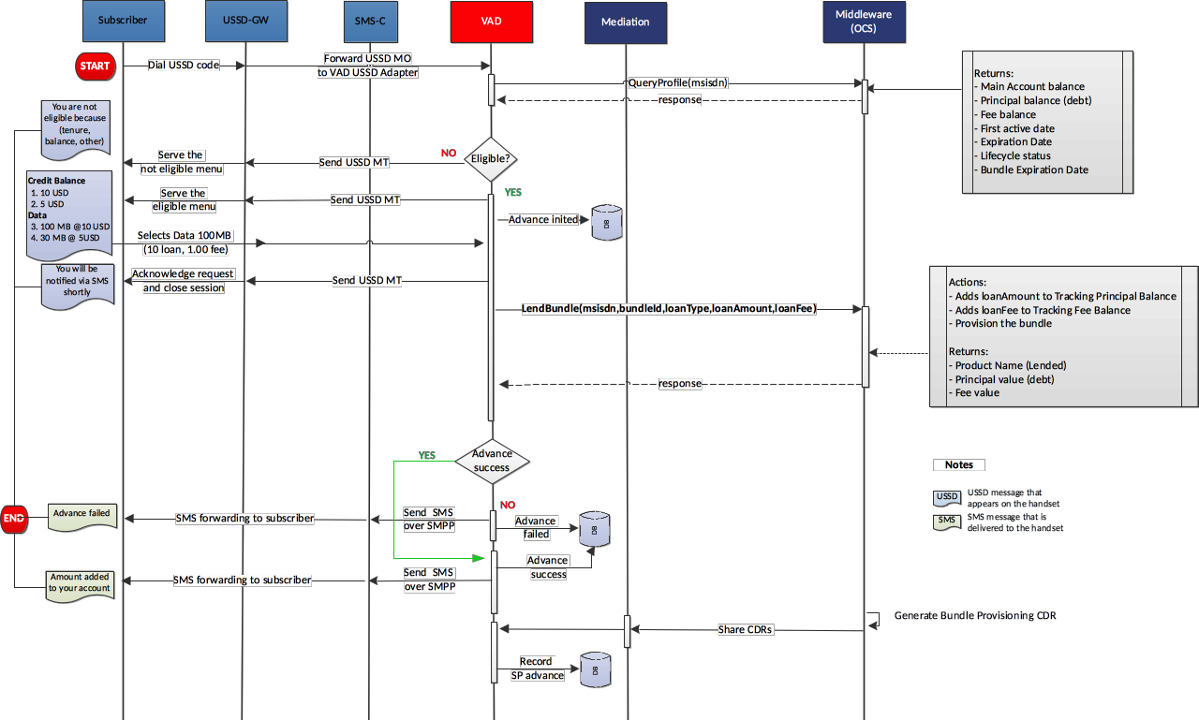

###### Notes:

1. User requests a bundle or data loan from CVAS VAD Platform
2. VAD inquires the OCS for subscriber’s balances and profile
3. VAD runs eligibility checks to decide whether the user can obtain the loan
4. VAD requests the loan monetary advance to the OCS. The VAD makes a single web service call and all the following adjustments are performed in **one transaction**:

*(Note If an adjustment fails, then all adjustments should be failed.)*

* 1. The bundle or data loan is **provisioned** to the subscriber
  2. The bundle loan amount is **credited** to the subscriber’s DA for principal
  3. The service fee is **credited** to the subscriber’s DA for fee

1. CVAS sends an SMS notification to the subscriber for the provision of the loan

In case the user is not eligible for a loan VAD will inform the user for the reason of the ineligibility. Also, in case loan provisioning fails with the OCS, VAD will also inform the user appropriately.

### Recovery Use Cases

For a customer with one or more open loans, the OCS should recover the outstanding debt each time when the customer either:

1. recharges his mobile or
2. receives a balance transfer from another customer.

The amount requested for recovery will be less or equal to the recharge amount. VAD will be notified by the CDRs generated for top-up and p2p recharge events. **Use Case #4: Full Recovery of a loan after topup**

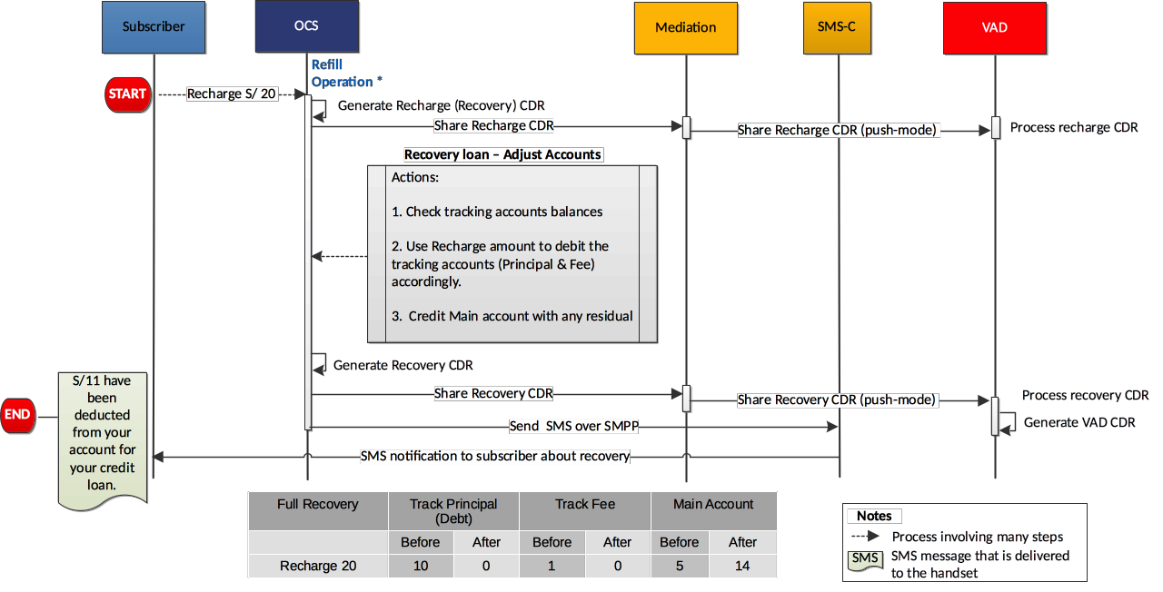

* 1. User recharges his account with Y amount
  2. OCS generates and shares recharge CDR real-time with credit of the MA account. CVAS receives and the records the recharge CDR.
  3. Due to recharge event, OCS triggers recovery using the top-up amount (Y) by adjusting of subscriber’s accounts. The following steps should be performed in **one transaction:**

*(Note: if any adjustment fails, all should fail)*

* + 1. If the amount of DA Track_Principal account is X, the DA Track_Princpal account is **debited** with either X or Y amount, whichever is larger, to recover the loan principal.
    2. If there is a residual (Y-X) from the above operation and the amount of DA Track_Fee account is Z, the DA Track_Fee is **debited** with either Z or (Y-X), which is ever is larger, to recover the loan fee
    3. Any amount left from the recharged Y amount, after debits of step 1 and 2, is **credited** to subscriber’s main account.
  1. OCS sends an SMS notification to the subscriber for the recovery of the loan Mediation shares recovery CDR real-time with the debit record of the account and the CDR of the main account adjustment.

##### Use Case #5: Partial Recovery of a loan after p2p

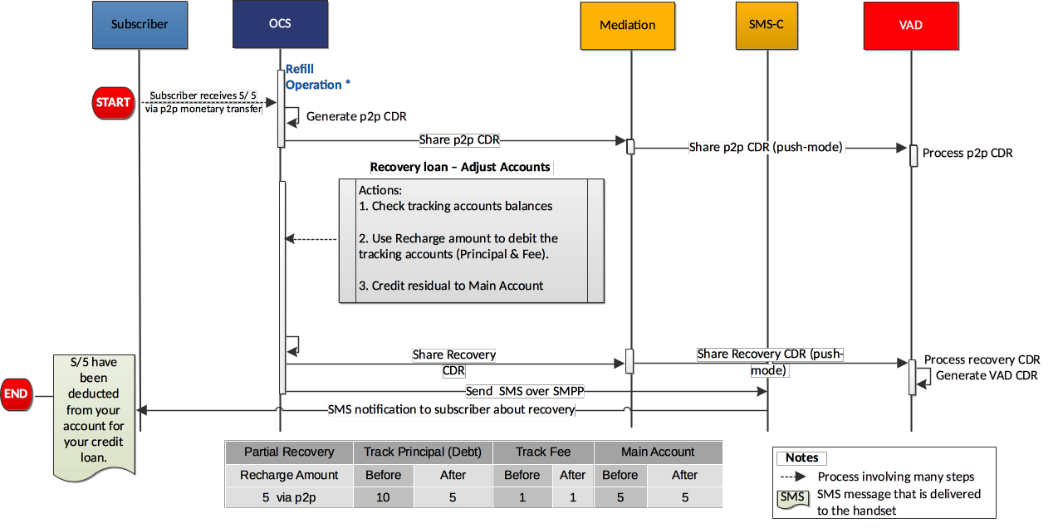

1. User receives Y amount via P2P monetary transfer
2. OCS generates and shares p2p CDR real-time with credit of the MA account.
3. CVAS receives and records the p2p CDR
4. Due to p2p event, OCS triggers recovery using the top-up amount (Y) by adjusting of subscriber’s accounts. The following steps should be performed in

##### one transaction:

*(Note: if any adjustment fails, all should fail)*

* 1. If the amount of DA Track_Principal account is X, the DA Track_Princpal account is **debited** with either X or Y amount, whichever is larger, to recover the loan principal.
  2. If there is a residual (Y-X) from the above operation and the amount of DA Track_Fee account is Z, the DA Track_Fee is **debited** with either Z or (Y-X), which is ever is larger, to recover the loan fee
  3. Any amount left from the recharged Y amount, after debits of step 1 and 2, is **credited** to subscriber’s main account.

1. OCS sends an SMS notification to the subscriber for the recovery of the loan Mediation shares recovery CDR real-time with the debit record of the account and the CDR of the main account adjustment.

## IVR

### Inbound IVR call

Subscriber will be able to dial to a short code and access the CVAS IVR menu. Based on subscriber’s eligibility status, the subscriber will listen to a prerecorded message. The message dynamically will list the denominations that corresponds to subscriber’s TCL score and they are available to him/her. In case the subscriber accepts the offer, a confirmation SMS will be send as a confirmation.

If the subscriber is non-eligible, a different message will be played informing the subscriber to recharge.

##### Inbound short codes

**Test**

152152

**Production**

152

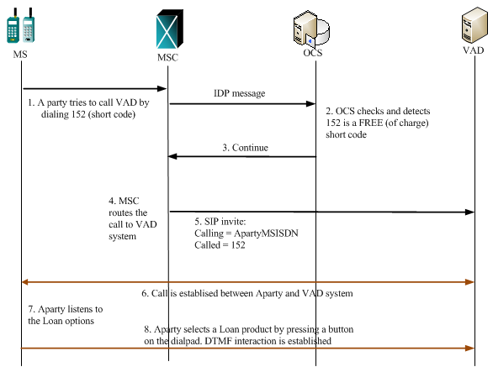

### Failed Called Routing (Redirection to IVR)

|  |  |
| --- | --- |
| Average volume of failed calls in a day and the average volume of failed calls during business hours | 1.3M from 8AM-8PM, 130k at peak hour, 500k unique subscriber a day |

FCR (Failed Call Routing) is a VAR feature which utilises the IVR channel when a subscriber does not have enough balance to initiate a new call.

The scenario is the following:

* + - 1. A Subscriber tries to make a call
      2. MSC/SCP receives the call and detects that subscriber balance is insufficient for the call.
      3. The call is redirected to the VAD’s IVR
      4. VAD’s IVR receives the incoming calls, accepts it and plays the menu.
      5. The subscriber listens to the options available and either selects an Advance (a) or end the call (b).
         1. VAD’s IVR receives the selected options and informs the subscriber that his

request has been accepted and terminates the call.

* + - * 1. VAD’s IVR does not receive any input, so it ends the call and send a SAT

Push message

* + - 1. Subscriber’s balance is credited
      2. The subscriber can make a new call.

The following diagram shows the flow when a subscriber tried to make a call and does not have enough balance

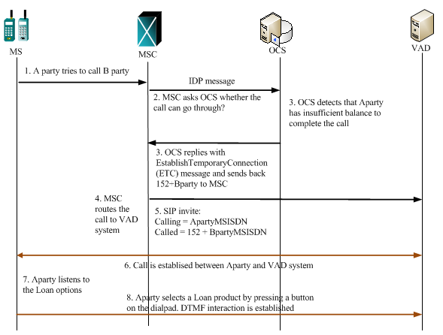

## ZERO BALANCE LANDING PAGE

Zero balance landing page is a web page that a subscriber is redirected to when he/she depletes the data balance. The page shows the eligible bundle options, which the subscriber can request an advance for.

##### Flow

The GGSN node monitors the data usage of subscriber’s data session and sends credit control messages to OCS/PCFR. The OCS updates the subscriber’s data balances and if there is no enough balance, returns with the clear code **4012**.

When the GGSN receives clear code 4012, does one of the following:

* + - If customer is using applications or https websites: Normally, GGSN will clear the session by sending CCR-T (Credit Control Request- Terminated) to OCS and OCS will send back CCA-T accordingly, and the customer will not be able to access the internet.
    - If the customer is surfing a website (except for https): GGSN will re-direct customer to free sites of the operator.

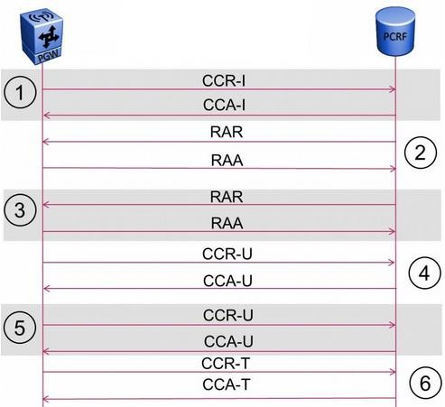

##### Configuration Parameters

|  |  |
| --- | --- |
| **Public IP to host the web point of sale (the zero-balance landing page)** | Public IP to be NATed to a data IP. GGSN will enrich with msisdn info |
| **Domain name and A record DNS entry.**  **This domain name will host the web point of sale of the service and will be resolved to the public IP** | adelanto.bitel.com.pe |

## Low Balance Notification & Failed Bundle completion

The **Low Balance Notification** and the **Failed Bundle Completion** events are **triggers** to the VAD platform and they are used to engage eligible subscribers by offer them appropriate loan options.

|  |  |  |  |
| --- | --- | --- | --- |
| **Event** | **Triggered when** | **Received by** | **SMS notification** |
| **Low Balance Notification** | Subscriber’s balance becomes less  than a predefined threshold | CDR | Sent by VAD |
| **Failed Bundle Completion** | Subscriber tries to buy a bundle and the balance is insufficient to complete the transaction | CDR | Send BY Bitel |

These events generate CDRs by OCS, which are received by the VAD platform. VAD will use the SAT Push channel to engage subscribers and offer them a monetary loan option from the list of loan options that are available to the subscribers according to their eligibility.

##### Flows

Both flows follow the same process. The differences are the trigger event and that in Failed Bundle Completion, after advancing the loan, VAD provisions of the bundle.

1. Subscriber’s action triggers one of the abovementioned event.
2. OCS generates and shares the event’s CDR in real-time.
3. VAD receives the CDR and triggers the corresponding process.
4. VAD inquires the OCS for subscriber’s balances and profile
5. VAD runs eligibility checks to decide whether the user can obtain the loan.
6. VAD prepares a SAT Push message according with the loan option available to the subscriber
7. VAD request the transmission of the SAT Push message and waits for the response (Accept/Reject) from the customer.
8. Subscriber receives the message and accepts.
9. VAD receives the accept notification and
   1. In case of Low Balance Notification,
      1. VAD requests a monetary loan advance to OCS.
      2. VAD notifies subscriber with an SMS
   2. In case Failed Bundle Completion,
      1. VAD requests a monetary loan advance to OCS.
      2. VAD requests the bundle provision to OCS.
      3. VAD notifies the subscriber with an SMS for the monetary advance. Bitel notifies the subscriber for the Bunlde provisioning*.*

# System Integrations

## Gateway - OCS Integration

### Open Issues

|  |  |  |
| --- | --- | --- |
| P1 | Share IP, ports and endpoints of the service | IP: 10.121.6.207, 10.121.6.209,  10.121.6.210, 10.121.6.211.  Ports:8166, 8069 |
| P2 | Share account credentials (Username and Password) | Username: airtime Password: @1rt1m3 |
| P3 | Share OCS Error Code list | Will be sent once API is developed |
| P4 | Bitel to review the API and provide feedback  *API is detailed in Appendices* Middleware (Gateway) API |  |

### Connectivity Purpose

Gateway will proxy requests to OCS. It will expose methods to inquire the OCS’s profile and

balances of the subscriber, as well as to advance loans and provision bundles.

### Communication

**Protocol**

**Retransmission**

A SOAP API will be used to communicate with Gateway. All methods should be performed synchronously, meaning that VAD will send a

request and will wait for the corresponding response.

**1 retry after CheckTransStatus**

In case of no response received, first check the operation status by calling the **CheckTransStatus** and if there is an error, send the request again **once**.

### Configurations

##### Production Configuration

|  |  |  |  |
| --- | --- | --- | --- |
| ***Type*** | ***Configuration Item*** | ***Value*** | Notes |
| Middleware Production endpoint(s) | IP:port | IPs: 10.121.6.207, 10.121.6.209, 10.121.6.210,  10.121.6.211. Ports: 8166, 8069 |  |
| Endpoint URI | http://10.121.6.210:8166/BCCSGateway |  |
| CVAS Username | Name | airtime |  |
| CVAS password | Password | @1rt1m3 |  |

**Staging Configuration**

|  |  |  |  |
| --- | --- | --- | --- |
| ***Type*** | ***Configuration Item*** | ***Value*** | Notes |
| Middleware Production endpoint(s) | IP:port | 10.121.6.209 |  |
| Endpoint URI | http://10.121.6.210:8069/BCCSGateway |  |
| CVAS Username | Name | airtime |  |
| CVAS password | Password | @1rt1m3 |  |

### Methods

|  |  |  |
| --- | --- | --- |
| **#** | **Methods** | **Usage** |
| **1** | **LendBalance** | * provision a monetary loan by crediting the Main account during advance |

|  |  |  |
| --- | --- | --- |
|  |  | * credit the Principal and Fee tracking accounts with the corresponding values |
| **2** | **LendBundle** | * provision the bundle for the subscriber * credit the tracking accounts of principal loan and fee amount |
| **3** | **QueryProfile** | * request the subscriber's profile info and balances |
| **4** | **ProvisionBundle** | * provision a bundle for a subscriber |
| **5** | **CheckTransStatus** | * check the status of an earlier operation |

## USSD Gateway

### Open Issues

|  |  |  |
| --- | --- | --- |
| P1 | Share IP, ports and endpoints of the service | 10.121.5.14, 10.121.5.15: 6998, 8991 |
| P2 | Share any protocol parameter required or configuration item |  |

### Connectivity Purpose

Offer a menu based USSD interface to subscribers to interact with the service. Provide functionality to request a loan, check eligibility status, view transaction history and others.

### Communication

To integrate with the USDD, a TCP-based **custom** protocol will be used. The protocol requires **two connections** (TCP binds) between systems, one per direction. So, the USSD requests are received over one TCP bind and the responses are sent over a different TCP bind.

### USSD Details

|  |  |
| --- | --- |
| **Description** | **Comment by operator** |
| Support for Unicode and GSM charsets on USSD | Yes, but ASCII is enough |
| Support outbound (application initiated) USSD dialogs | Yes |
| Documentation and APIs for integrating with the USSD-gw | Custom (TCP) |

##### Short Codes

|  |  |
| --- | --- |
| **Test Short Code** | *152152# |
| **Production Short Code** | *152# |

**USSD IP list**

|  |  |  |  |
| --- | --- | --- | --- |
| **Name** | **Direction** | **IP** | **Port** |
| **PE-GATEWAY01** | Incoming Request | **10.121.5.14** | **6998** |
| **PE-GATEWAY02** | Incoming Request | **10.121.5.15** | **6998** |
| **PE-GATEWAY01** | Outgoing Response | **10.121.5.14** | **8991** |
| **PE-GATEWAY02** | Outgoing Response | **10.121.5.15** | **8991** |

## SMSGW

### Open Issues

|  |  |  |
| --- | --- | --- |
| P1 | Share IP, ports and endpoints of the service | 10.121.6.102, 10.121.6.105: 3800 |
| P2 | Share SMPP configuration items |  |
| P3 | Share SMSGW account details (test and production) |  |

### Connectivity Purpose

This interface will be used by VAD to send system messages, like reminders and marketing communication.

### SMSC Details

|  |  |
| --- | --- |
| **Description** | **Comment by operator** |
| Support for Unicode and GSM charsets on both inbound and outbound SMS | ASCII will be used |
| Support for long (concatenated) outbound SMS on Unicode and  GSM | Yes |
| High-level interconnections plan with the SMS-C (or SMS-gws) and associated APIs in case it is not industry standard (e.g. SMPP). Plan should detail:   * the different nodes (if more than one) * the usage of each node (if different nodes for outbound only and others for interactive) * the concurrent connections, the connection type and the throughput per node | SMPPv3.4 |

##### Short Codes

|  |  |  |
| --- | --- | --- |
| **Test Short Code** | 152152 | Must be FREE of charge for both Production and Staging |
| **Production Short Code** | 152 |

### SMSGW Accounts information

|  |  |  |
| --- | --- | --- |
| **SMS Configuration** | **Production** | **Notes** |
| **TPS (per node)** | 150 |  |
| **SMPP Server IP** | 10.121.6.102, 10.121.6.105 |  |
| **Port** | 3800 |  |
| **System ID** | airtime |  |
| **Password** | airtime |  |
| **Sender for MTs** | 10.121.6.102, 10.121.6.105 |  |
| **Bind type** | SMPP 3.4 |  |
| **Bind mode** | Transceiver |  |
| **Concurrent binds** | 4 | As proposed and received an OK from George |
| **Source TON** | 1 |  |
| **Source NPI** | 1 |  |
| **Destination TON** | 1 |  |
| **Destination NPI** | 1 |  |
| **Enquiry link interval** | 20 |  |
| **Character set** | ASCII |  |
| **Max concatenated messages** | 540 character max (140 each) |  |

## SIP

### Open Issues

|  |  |  |
| --- | --- | --- |
| P1 | Share SIP servers (MSC) names, IPs and ports | Shared |
| P2 | Share SIP media (RTP) name, IPs and ports | Shared |
| P3 | Provide test dial number to validate service |  |
| P4 | Share any protocol parameter required or configuration items |  |

### Connectivity Purpose

This interface will be used by FCR feature, in order to redirect subscribers to CVAS IVR when they have insufficient balance to initiate a call.

### Network & SIP Setup

Channel VAS will deploy signaling nodes and media nodes that will handle voice connectivity between Bitel’s MSCs/SCP and the VAD’s IVR platform.

All MSCs are going to be connected directly with VAD’s IVR over SIP. Inbound traffic would

be routed from each Bitels’s MSC directly to one of the VAD’s SIP servers.

##### Interconnection Details

|  |  |  |  |  |
| --- | --- | --- | --- | --- |
|  | **Bitel** | | **CVAS** | |
| **Nodes Type** | **IP Addresses** | **Ports** | **IP Addresses** | **Ports** |
| Signalling (SIP) | 10.131.1.1 (SIMS01)  10.131.3.1 (SIMS02) | 5060 | * + - 1. (opensips1)       2. (opensips2) | 5060 |
| Media (RTP) | 10.131.1.64/25 (SIMW01)  10.131.2.64/25 (SIMW01)  10.131.3.64/25 (SIMW02)  10.131.4.64/25 (SIMW02) | 10000 - 60000 | 10.21.15.133  10.21.15.134  10.21.15.135  10.21.15.136 | 10000-60000 |

**SIP conformance and compliancy**

|  |  |  |
| --- | --- | --- |
|  | **Operator** | **Channel VAS** |
| **Protocol Supported** | SIP | SIP |
| **Manufacturer of signalling servers:** | Huawei | OpenSIPs |
| **Model of signalling servers:** | MSOFTX3000 | OpenSIPs 2.1 |
| **OS of signalling servers:** | Linux | Linux Centos 6 64bit |
| **RTP Port Range** | 10000 – 60000 | 10000 – 60000 |
| **Codecs/payload (G.729r8, G.711**  **uLaw/ALaw)** | G729, G711a | G711a, G711u |
| **DTMF (inband, RFC2833, INFO)** | RFC2833 | RFC2833 |
| **Dialing Formats** | E.164 | E.164 |
| **Called/Calling Party Number** | CC + NUM | CC + NUM |
| **Prefix** | TBD | - |
| **Packetization Time** | 20ms | 20ms |
| **RFCs Supported** | 3515, 3485, 3325, 3324, 3323,  3261, 3262, 3263, 3264, 3265,  3266, 2976 | 3515, 3485, 3325, 3324, 3323,  3261, 3262, 3263, 3264, 3265,  3266, 2976 |

## SAT Push (thru middleware)

### Open Issues

|  |  |  |
| --- | --- | --- |
| P1 | Share IP, ports and endpoints of the service | 10.121.6.207, 10.121.6.209, 10.121.6.210,  10.121.6.211: 8166, 8069 |

|  |  |  |
| --- | --- | --- |
| P2 | Share account credentials (Username and Password) | airtime/@1rt1m3 |
| P4 | Bitel to review the API and provide feedback |  |

### Connectivity Purpose

Gateway will proxy requests to SAT Push Server. It will expose a method to send **SAT push messages** to the subscriber and it will use the call back **SAT Push notification** method (exposed by VAD) to return the subscriber’s response.

### Communication

**Protocol**

**Retransmission**

A SOAP API will be used to communicate with Gateway. All methods

should be performed synchronously, meaning that VAD will send a request and will wait for the corresponding response.

**1 retry after 1 minute**

In case of no response received or an error occurs, VAD can retry

**once** after one minute.

### Configurations

**Production Configuration**

|  |  |  |  |
| --- | --- | --- | --- |
| ***Type*** | ***Configuration Item*** | ***Value*** | Notes |
| Middleware Production endpoint(s) | IP:port | 10.121.6.207, 10.121.6.209, 10.121.6.210,  10.121.6.211: 8166 |  |
| Endpoint URI | http://10.121.6.210:8166/BCCSGateway |  |
| CVAS Username | Name | airtime |  |
| CVAS password | Password | @1rt1m3 |  |

**Staging Configuration**

|  |  |  |  |
| --- | --- | --- | --- |
| ***Type*** | ***Configuration Item*** | ***Value*** | Notes |
| Middleware Production endpoint(s) | IP:port | 10.121.6.209:8069 |  |
| Endpoint URI | http://10.121.6.210:8069/BCCSGateway |  |
| CVAS Username | Name | airtime |  |
| CVAS password | Password | @1rt1m3 |  |

### Methods

|  |  |  |  |
| --- | --- | --- | --- |
| **#** | **Methods** | **Exposed by** | **Usage** |
| **1** | **SendSATpush** | Middleware (Gateway) | Send a SAT Push message to the subscriber |
| **2** | **SATpushNotification** | VAD | Send back the SAT push response. |

## CVAS Mediation

**Connection Details**

|  |  |  |
| --- | --- | --- |
|  | **Production** | **Staging** |
| **IP:port** | 10.21.15.5 | 10.21.15.29 |
| **Protocol** | FTP & SFTP | FTP & SFTP |
| **FTP username** | vad_production | vad_staging |
| **FTP password** | | |
| **Sharing Mode** | Operator will push the files | Operator will push the files |

# Data Files: CDR & Dumps

## Open Issues

|  |  |  |
| --- | --- | --- |
| P1 | Advance Balance CDRs will have records for any type loans | Yes |
| P2 | Buy Addon will have both:   * Bundle/ Data loan * Bundle / Data package provisions | Yes |
| P3 | Share the Historical Data |  |
| P4 | Enable data feeds, once VAD’s mediation server is online |  |
| P5 | Recharge CDRs list of values for TradeMethod and TradeType |  |

## Data Types

The Data files required are separated in the following types according to how will be used by the VAD.

|  |  |  |
| --- | --- | --- |
|  | **Type** | **Description** |
| **1** | **Historical Data for Credit Scoring** | To instantiate internal structures and user profiles  To prepare user credit profiles and initial credit score according to their information and usage of services for the last 12 months |
| **2** | **Live Data for Credit Scoring and Marketing** | To keep updated the users’ profiles and credit scores  To track users’ usage in order to trigger marketing campaigns |

## Historical data dumps

Since these files are used for the credit scoring of the service, it is important to have a continues set of data. So, the following deliverables required:

|  |  |  |
| --- | --- | --- |
| **Set to share** | **What to share** | **When to share** |
| **First set** | the **12 months of data** | as soon as possible |
| **Second set** | The **data deltas** between the two sets. | After the live feed is enabled |

##### Historical Data types

|  |  |  |  |
| --- | --- | --- | --- |
| **#** | **Type** | **Description** | **Deliverable** |
| H1 | **Recharges** | Recharge CDRs with one row per transaction | one file per month |
| H2 | **Bundle Activation** | Bundle Activation CDRs with one row per transaction | one file per month |
| H3 | **Subscribers’ Dump** | A full dump of all subscribers | One file |
| H4 | **P2P transfers** | Subscriber to subscriber balance transfer with one row per transaction | one file per month |

**Columns of Historical data**

|  |  |  |  |
| --- | --- | --- | --- |
| **#** | **Type** | **Minimum Columns required** | **Notes** |
| H1 | **Recharges** | * Msisdn * Timestamp * Recharge Amount * Balance Before * Balance After |  |

|  |  |  |
| --- | --- | --- |
| H2 | **Bundle Activation** | * Msisdn * Timestamp * Bundle Type (Data/SMS/Minutes/Mix) * Bundle Name * Bundle Price * Balance Before * Balance After * Bundle Activation Date |
| H3 | **Prepaid**  **Subscribers’ Dump** | * Msisdn * Activation date * Status * Type |
| H4 | **P2P transfers** | * Sender Msisdn * Recipient msisdn * Timestamp * Transfer Amount * Sender Balance Before * Sender Balance After * Recipient Balance Before * Recipient Balance After |

## Live data feeds

These files are feeds that need to be enabled a few weeks in advance, before the launch date.

|  |  |  |  |
| --- | --- | --- | --- |
| **#** | **Type** | **Description** | **Notes** |
| L1 | **Loan Advances** | Loan advance events. Contains both monetary and bundle or data advances | |
| L2 | **Loan Recoveries** | Loan recoveries events |  |
| L3 | **New Activations** | New subscriber activation events | |
| L4 | **Terminations** | Subscriber termination events |  |
| L5 | **Lifecycle Status Change** | Subscribers’ status changes events  (Block/Unblock) | |
| L6 | **Bundle Activations** | Contains al Bundle or data purchases events both successful and unsuccessful. | |
| L7 | **Failed Bundle Activations** | Unsuccessful bundle or data purchases events due to insufficient balance | |
| L8 | **Low Balance Notifications** | List of msisdns for which the main balance became less than the 1 sole threshold. | |
| L9 | **Recharges** | Subscribers’ recharge events |  |

* + 1. Loan Advances

|  |  |  |
| --- | --- | --- |
| **Content description** |  | VAD Loan Advances both monetary and bundle/data |
| **Filename** | Pattern | LoanCDR_YYYYMMDD_NNNNN.txt |
|  | Example | LoanCDR_20180301_1899348.txt |
| **Path** |  | /INCOMING/ADJUSTMENTS/ |
| **Avg Reception Frequency** |  | Within 3 to 5 minutes from generation |
| **Content Format** |  | text format, pipe-delimited |

##### Sample

Transaction_ID|Loan_Time|MSISDN|MainBalance_BeforeLoan|Loan_Amount|MainBalance_AfterLoan|D ebtBalance_BeforeLoan|DebtBalance_Loan|DebtBalance_AfterLoan|FeeBalance_BeforeLoan|FeeBala nce_Loan|FeeBalance_AfterLoan

14568980|2018-03-01

01:59:10|51931999895|11000|50000|61000|20000|50000|70000|10000|10000|20000

##### Columns

|  |  |  |  |
| --- | --- | --- | --- |
| **#** | **Columns** | **Description** | **Format** |
| **1** | Transaction_ID | Tranasction id | Long integer |
| **2** | Loan_Time | Time of transaction | yyyy-mm-dd hh:mi:ss |
| **3** | MSISDN | Msisdn with country code |  |
| **4** | MainBalance_BeforeLoa  n | Main balance before loan. Divide by 10000 to  get unit in Sole |  |
| **5** | Loan_Amount | Advance amount. Divide by 10000 to get unit in  Sole |  |
| **6** | MainBalance_AfterLoan | Main balance after loan. Divide by 10000 to get  unit in Sole |  |
| **7** | DebtBalance_BeforeLoa  n | Debt tracking balance. Divide by 10000 to get  unit in Sole |  |
| **8** | DebtBalance_Loan | Debt of transaction. Divide by 10000 to get unit  in Sole |  |

|  |  |  |  |
| --- | --- | --- | --- |
| **9** | DebtBalance_AfterLoan | Debt tracking balance after loan. Divide by  10000 to get unit in Sole |  |
| **10** | FeeBalance_BeforeLoan | Fee balance before loan. Divide by 10000 to get  unit in Sole |  |
| **11** | FeeBalance_Loan | Fee of transaction. Divide by 10000 to get unit  in Sole |  |
| **12** | FeeBalance_AfterLoan | Fee balance after loan. Divide by 10000 to get  unit in Sole |  |

**Filtering Rules**

|  |  |  |
| --- | --- | --- |
| **What to distinguish** | **Filter to apply** | **Reasoning** |
| **Monetary Loans** | If loanAmount > 0 | The monetary loans have a value in loanAmount and the principal of the loan appears in DebtBalance_Loan. The two values should be the same |
| **Bundle/Data Loan** | If loanAmount = 0 | The bundle/data loans do not have a value in loanAmount, the principal of the loan appears in the DebtBalance_Loan |

* + 1. Loan Recoveries

|  |  |  |
| --- | --- | --- |
| **Content description** |  | VAD Loan Recoveries |
| **Filename** | Pattern | RecoveryCDR_YYYYMMDD_NNNNN.txt |
|  | Example | RecoveryCDR_20180301_1899348.txt |
| **Path** |  | /INCOMING/ADJUSTMENTS/ |
| **Avg Reception Frequency** |  | Within 3 to 5 minutes from generation |
| **Content Format** |  | text format, pipe-delimited |

**Sample**

Recovery_Time|MSISDN|MainBalance_BeforeRecovery|Recharge_Amount|MainBalance_AfterRecovery| DebtBalance_BeforeRecovery|DebtBalance_Recovery|DebtBalance_AfterRecovery|FeeBalance_Befor eRecovery|FeeBalance_Recovery|FeeBalance_AfterRecovery

2018-03-01 01:59:10|51931999895|11000|200000|141000|50000|50000|0|20000|20000|0

2018-03-01 01:59:11|51931999896|1000|100000|21000|60000|60000|0|20000|20000|0

2018-03-01 01:59:12|51931999897|100|100000|100|100000|100000|0|20000|0|20000

##### Columns

|  |  |  |  |
| --- | --- | --- | --- |
| **#** | **Columns** | **Description** | **Format** |
| **1** | Recovery_Time | Time of transaction. | yyyy-mm-dd hh:mi:ss |
| **2** | MSISDN | with country code |  |
| **3** | MainBalance_BeforeRe  covery | Main balance before Recovery. Divide by 10000  to get unit in Sole |  |
| **4** | Recharge_Amount | Recovery amount. Divide by 10000 to get unit in  Sole |  |
| **5** | MainBalance_AfterReco  very | Main balance after Recovery. Divide by 10000 to  get unit in Sole |  |
| **6** | DebtBalance_BeforeRec  overy | Debt tracking balance. Divide by 10000 to get  unit in Sole |  |
| **7** | DebtBalance_Recovery | Debt of transaction. Divide by 10000 to get unit  in Sole |  |
| **8** | DebtBalance_AfterReco  very | Debt tracking balance after Recovery. Divide by  10000 to get unit in Sole |  |
| **9** | FeeBalance_BeforeReco  very | Fee balance before Recovery. Divide by 10000 to  get unit in Sole |  |
| **10** | FeeBalance_Recovery | Fee of transaction. Divide by 10000 to get unit in  Sole |  |
| **11** | FeeBalance_AfterRecov  ery | Fee balance after Recovery. Divide by 10000 to  get unit in Sole |  |

**Filtering Rules**

|  |  |  |
| --- | --- | --- |
| **What to distinguish** | **Filter to apply** | **Reasoning** |
| **Full Recovery** | If DebtBalance_AfterRecovery = 0 and FeeBalance_AfterRecovery =0 | Both Principal balance and Fee balance after the recovery should be zero |
| **Partial Recovery** | If DebtBalance_AfterRecovery > 0 or FeeBalance_AfterRecovery >0 | If there is balance in any of the Principal or the Fee balances |

* + 1. New Activations

|  |  |  |
| --- | --- | --- |
| **Content description** |  | Subscribers’ activations.  Contains only new **Prepaid** activations.  **Postpaid** doesn't generate such CDR |
| **Filename** | Pattern | in010_G_80_A_NNNNNNNNNNNN_YYYYMMDD.s |
|  | Example | in010_G_80_A_00001022116_20180301.s |
| **Path** |  | /INCOMING/LIFECYCLE/ |
| **Avg Reception Frequency** |  | Within 3 to 5 minutes from generation |
| **Content Format** |  | text format, pipe-delimited |

**Sample**

MSISDN|Active_time|Billing_Number|LAC|CELL|PRODUCT_ID 51928136681|20180301225920|51928136681|0|716153080317073|1683

##### Columns

|  |  |  |  |
| --- | --- | --- | --- |
| **#** | **Columns** | **Description** | **Format** |
| **1** | MSISDN | mobile number |  |
| **2** | Active_time | Activation timestamp | yyyymmddhhmiss |
| **3** | Billing_Number | ignore |  |
| **4** | LAC | ignore |  |

|  |  |  |  |
| --- | --- | --- | --- |
| **5** | CELL | ignore |  |
| **6** | Product_ID | ignore |  |

**Filtering Rules**

No filtering is required. All records will be used.

### Terminations

|  |  |  |
| --- | --- | --- |
| **Content description** |  | Subscribers’ terminations. Network  disconnections. |
| **Filename** | Pattern | TerminationYYMMDDHHNNNN.txt |
|  | Example | Termination180301011543.txt |
| **Path** |  | /INCOMING/LIFECYCLE/ |
| **Avg Reception Frequency** |  | Within 3 to 5 minutes from generation |
| **Content Format** |  | text format, comma-delimited |

##### Sample

MSISDN,Before_State,Before_state_set,State,Now_state_set,Change_State_date 51926545790,E,00200000000000,B,00000000000000,2018-03-01 01:15:27

51926546701,E,00200000000000,B,00000000000000,2018-03-01 01:15:27

51910118001,E,00200000000000,B,00000000000000,2018-03-01 01:15:27

51910118465,E,00200000000000,B,00000000000000,2018-03-01 01:15:27

51910120926,E,00200000000000,B,00000000000000,2018-03-01 01:15:27

##### Columns

|  |  |  |  |
| --- | --- | --- | --- |
| **#** | **Columns** | **Description** | **Format** |
| **1** | MSISDN | Number terminated, include country code |  |
| **2** | Before_State | Old status. Status values:  A (Active), D (Block 01 way), E (Block 02 ways), B (Terminated). |  |
| **3** | Before_state_set | Ignore |  |
| **4** | State | Current status. Status values: |  |

|  |  |  |  |
| --- | --- | --- | --- |
|  |  | A (Active), D (Block 01 way), E (Block 02 ways), B  (Terminated). |  |
| **5** | Now_state_set | Ignore |  |
| **6** | Change_State_date | Timestamp status change | yyyy-mm-dd hh:mi:ss |

**Filtering Rules**

|  |  |  |
| --- | --- | --- |
| **What to distinguish** | **Filter to apply** | **Reasoning** |
| **Terminations** | If State = ‘B’ | States column shows the current state |

* + 1. Lifecycle status change

|  |  |  |
| --- | --- | --- |
| **Content description** |  | Subscribers’ lifecycle status changes between Active and Blocked. |
| **Filename** | Pattern | OCSCSYYYYMMDD_NNNNNNN.txt |
|  | Example | OCSCS20180301_1610262.txt |
| **Path** |  | /INCOMING/LIFECYCLE/ |
| **Avg Reception Frequency** |  | Within 3 to 5 minutes from generation |
| **Content Format** |  | text format, pipe-delimited |

**Sample**

MSISDN|Product|Before_State|Before_state_set|State|Now_state_set|Change_State_date 51926434662|IChip29_9C|A|00000000000000|D|01000000000000|2018-03-01 23:15:46

51935439705|IChip29_9C|A|00000000000000|D|01000000000000|2018-03-01 23:15:46

51934547652|IChip29_9C|A|00000000000000|D|01000000000000|2018-03-01 23:15:46

51910183730|IChip29_9C|A|00000000000000|D|01000000000000|2018-03-01 23:15:46

51957350049|IChip29_9C|A|00000000000000|D|01000000000000|2018-03-01 23:15:46

##### Columns

|  |  |  |  |
| --- | --- | --- | --- |
| **#** | **Columns** | **Description** | **Format** |

|  |  |  |  |
| --- | --- | --- | --- |
| **1** | MSISDN | Number terminated, include country code |  |
| **2** | Product | Product code (plan of mobile number) |  |
| **3** | Before_State | Old status. Status values:  A (Active), D (Block 01 way), E (Block 02 ways), B (Terminated). |  |
| **4** | Before_state_set | Ignore |  |
| **5** | State | Current status. Status values:  A (Active), D (Block 01 way), E (Block 02 ways), B (Terminated). |  |
| **6** | Now_state_set | Ignore |  |
| **7** | Change_State_date | Timestamp status change | yyyy-mm-dd hh:mi:ss |

**Filtering Rules**

|  |  |  |
| --- | --- | --- |
| **What to distinguish** | **Filter to apply** | **Reasoning** |
| **Active** | If State = ‘A’ | The subscriber is activated |
| **Block** | If State <> ‘A’ | The subscriber is blocked or terminated |

* + 1. Bundle Activations

|  |  |  |
| --- | --- | --- |
| **Content description** |  | Bundle or data purchases events |
| **Filename** | Pattern | PRE_3G_YYYYMMDD_NNN.txt |
|  | Example | PRE_3G_20180302_189.txt |
| **Path** |  | /INCOMING/BUNDLE_ACTIVATIONS/ |
| **Avg Reception Frequency** |  | Within 3 to 5 minutes from generation |
| **Content Format** |  | text format, pipe-delimited |

**Sample**

PRODUCT_CODE|SENDER|IP|CONTRACT_ID|SUB_ID|MSISDN|ACTION_ID|REG_DATE|FEE|DESCRIPTION|STATUS

|BACKUP1|BACKUP2|BACKUP3|BACKUP4|BACKUP5|BACKUP6|

Pre_MX1|164||0|37974976|51910482197|0|20180302002717|1|Register product promotion MX1|0||||0||

##### Columns

|  |  |  |  |
| --- | --- | --- | --- |
| **#** | **Columns** | **Description** | **Format** |
| **1** | PRODUCT_CODE | Code of the product provisioned |  |
| **2** | SENDER | Ignore |  |
| **3** | IP | Ignore |  |
| **4** | CONTRACT_ID | Ignore |  |
| **5** | SUB_ID | Ignore |  |
| **6** | MSISDN | mobile number |  |
| **7** | ACTION_ID | 0 = register addon, 1 = cancel (unregister,  remove, change) addon |  |
| **8** | REG_DATE | event time. Format | yyyymmddhhmiss |
| **9** | FEE | addon price, fee charged for purchasing addon |  |
| **10** | DESCRIPTION | description |  |
| **11** | STATUS | 0 = success, other |  |
| **12** | BACKUP1-6 | Ignore |  |

**Filtering Rules**

|  |  |  |
| --- | --- | --- |
| **What to distinguish** | **Filter to apply** | **Reasoning** |
| **Successful** | If STATUS = 0 | The package was provisioned |
| **Failed** | If STATUS <> 0 | The package failed to be provisioned |

* + 1. Failed Bundle Activations

|  |  |  |
| --- | --- | --- |
| **Content description** |  | Unsuccessful bundle or data purchases events due to insufficient balance |
| **Filename** | Pattern | REGDATA_YYYYMMDDHHNNNN_N.txt |
|  | Example | REGDATA_20180108093112_2.txt |
| **Path** |  | /INCOMING/FAILED_EVENTS/ |
| **Avg Reception Frequency** |  | Within 3 to 5 minutes from generation |
| **Content Format** |  | text format, pipe-delimited |

**Sample**

msisdn|sub_id|product_code|register_time|current_balance|data_package_price|missing_balanc e|register_syntax| addon_name|addon_code

51931999895|5468|Inteno39|20180116 09:07:11|10.00|30|20.00|D30|Data max 30|Post_D30

##### Columns

|  |  |  |  |
| --- | --- | --- | --- |
| **#** | **Columns** | **Description** | **Format** |
| **1** | MSISDN | mobile number. include country code |  |
| **2** | SUB_ID | Ignore |  |
| **3** | PRODUCT_CODE | plan name |  |
| **4** | register_time | register time | yyyy-mm-dd hh:mi:ss |
| **5** | current_balance | current balance. Unit: sole | 2 decimal digits |
| **6** | data_package_price | price of addon. Unit: sole | 2 decimal digits |
| **7** | missing_balance | missing balance to purchase addon. Unit: sole | 2 decimal digits |
| **8** | register_syntax | syntax to register addon by SMS | yyyymmddhhmiss |
| **9** | addon_name | addon name |  |
| **10** | addon_code | addon code |  |

**Filtering Rules**

No filtering is required. All rows should be parsed as failures due to insufficient balance.

### Low Balance Notifications

|  |  |  |
| --- | --- | --- |
| **Content description** |  | List of msisdns for which the main balance became less than the 1 sole threshold. |
| **Filename** | Pattern | lowbal_NNNNNNNNNNN_YYYYMMDDNNNNNN.txt |
|  | Example | lowbal_00001235751_20171013015829.txt |
| **Path** |  | /INCOMING/THRESHOLD_NOTIFICATIONS/ |
| **Avg Reception Frequency** |  | Within 3 to 5 minutes from generation |
| **Content Format** |  | text format, pipe-delimited |

##### Sample

MSISDN|Event_Begin_time 51928940217|2017-10-07 02:15:19

51930391544|2017-10-07 02:15:56

51929689629|2017-10-07 02:03:58

51926216385|2017-10-07 02:16:07

51910194291|2017-10-07 02:16:08

51921530344|2017-10-07 02:16:10

##### Columns

|  |  |  |  |
| --- | --- | --- | --- |
| **#** | **Columns** | **Description** | **Format** |
| **1** | MSISDN | mobile number has balance go under 1 sole.  Include country code |  |
| **2** | Event_Begin_time | time of event | yyyy-mm-dd hh:mi:ss |

**Filtering Rules**

No filtering is required. All rows should be parsed as low balance notifications.

### Recharges

|  |  |  |
| --- | --- | --- |
| **Content description** |  | Subscribers’ recharge events |

|  |  |  |
| --- | --- | --- |
| **Filename** | Pattern | RechargeCDR_YYYYMMDD_NNNNNNN8.DAT |
|  | Example | RechargeCDR_20180301_1899348.DAT |
| **Path** |  | /INCOMING/RECHARGES / |
| **Avg Reception Frequency** |  | Within 3 to 5 minutes from generation |
| **Content Format** |  | text format, pipe-delimited |

##### Sample

VCtradeSN|TradeTime|TradeMethod|TradeType|AccountCode|VCPIN|RechargeAmount|ExtendDays|MSIS DN|PreBalance|Balance|PreExpDate|ExpDate|Brand|BENEFIT_RULE|ZONE_CODE|PROMOTION_CODE|CONTR ACT_ID|PresentInfo|AcctBookListPresent

VC109067610|01/03/2018 23:53:09|C|C|1440610601||50000||51927328796|0|- 50000|||8845||||0|2:-100000;10:-432000;40:-5368709120;;2;0;-100000;10;0;-432000;40;0;-

5368709120|1:0:-50000,2:0:-100000,10:0:-432000,40:0:-5368709120

VC109067611|01/03/2018 23:53:14|C|C|1435519733||30000|3|51929991870|-10|-30010|29/03/2018 10:41:45|01/04/2018 10:41:45|8946||||0||1:-10:-30010

VC109067612|01/03/2018 23:53:15|C|C|1426143844||50000|0|51925159173|-50000|- 100000|01/04/2018 00:00:00|01/04/2018 00:00:00|1683||||0|8:-20971520;10:-432000;40:-

1024;52:-259200;;8;-20971520;-41943040;10;-863841;-1295841;40;-47104;-48128;52;-259200;-

518400|1:-50000:-100000,8:-20971520:-41943040,10:-863841:-1295841,40:-47104:-48128,52:-

259200:-518400

VC109067613|01/03/2018 23:53:21|C|C|1429756134||50000|6|51935877949|0|-50000|26/03/2018 00:00:00|01/04/2018 00:00:00|623||||0|8:-20971520;40:-1024;52:-2327;;8;0;-20971520;40;-

11264;-12288;52;0;-259200|1:0:-50000,8:0:-20971520,40:-11264:-12288,52:0:-259200

##### Columns

|  |  |  |  |
| --- | --- | --- | --- |
| **#** | **Columns** | **Description** | **Format** |
| **1** | VCtradeSN | Ignore |  |
| **2** | TradeTime | Recharge time | yyyy-mm-dd hh:mi:ss |
| **3** | TradeMethod | Recharge channel. |  |
| **4** | TradeType | Recharge type |  |
| **5** | AccountCode | Ignore |  |
| **6** | VCPIN | Ignore |  |
| **7** | RechargeAmount | Recharge amount. Divide to 10000 to get unit in  Sole |  |
| **8** | ExtendDays | Ignore |  |

|  |  |  |  |
| --- | --- | --- | --- |
| **9** | MSISDN | mobile number. include country code |  |
| **10** | PreBalance | main balance (basic balance) before recharge.  Divide to 10000 to get unit in sole |  |
| **11** | Balance | main balance after recharge. Divide to 10000 to  get unit in sole |  |
| **12** | PreExpDate | Ignore |  |
| **13** | ExpDate | Ignore |  |
| **14** | Brand | Ignore |  |
| **15** | BENEFIT_RULE | Ignore |  |
| **16** | ZONE_CODE | Ignore |  |
| **17** | PROMOTION_CODE | Ignore |  |
| **18** | CONTRACT_ID | Ignore |  |
| **19** | PresentInfo | Ignore |  |
| **20** | AcctBookListPresent | Ignore |  |

**Filtering Rules**

No filtering is required. All rows should be parsed as successful recharges.

1. **APPENDICES**

## Middleware (Gateway) API

### Configurations

##### Production Configuration

|  |  |  |  |
| --- | --- | --- | --- |
| *Type* | *Configuration Item* | *Value* | **Notes** |
| **Middleware Production endpoint(s)** | **IP:port** |  |  |
| **Endpoint URI** |  |  |
| **CVAS Username** | **Name** |  |  |
| **CVAS password** | **Password** |  |  |

**Staging Configuration**

|  |  |  |  |
| --- | --- | --- | --- |
| *Type* | *Configuration Item* | *Value* | **Notes** |
| **Middleware Staging endpoint(s)** | **IP:port** |  |  |
| **Endpoint URI** |  |  |
| **CVAS Username** | **Username** |  |  |
| **CVAS password** | **Password** |  |  |

* + 1. Operations

All operations share the following input and output fields/structure

##### Input Fields

*Tag <Input> Field*

|  |  |  |  |  |  |
| --- | --- | --- | --- | --- | --- |
| **Field** | **Description** | **Mandatory** | **Type** | **Example** | **Notes** |

|  |  |  |  |  |  |
| --- | --- | --- | --- | --- | --- |
| **wscode** | The operation identifier | Yes | string | LendBalance |  |
| **username** | The predefined username to  access the service | Yes | string |  |  |
| **password** | The predefined password to access the service | Yes | string |  | This should be hashed |
| **param** | A list of parameters. Each  operation has its own parameter | Yes | Type based on param |  |  |
| **rawData** | *TBD* | No | string |  |  |

*<Param> Tags*

|  |  |
| --- | --- |
| *Tag format* | <param name="*paramName*" value="*paramValue*" /> |
| **ParamName** | The parameter name or identifier |
| **ParamValue** | The value that of the parameter |

##### Output Fields

*Tag <Result> Field*

|  |  |  |  |  |  |
| --- | --- | --- | --- | --- | --- |
| **Field** | **Description** | **Mandatory** | **Type** | **Example** | **Notes** |
| **error** | Indicates if operation was succesful or there was an error   * Zero (0) => Success: go and read the original response, * Not Zero => Error: there was an error on gw and original response carries no info. Use the *checktransactionstatus* to find out what happened | Yes | integer |  |  |
| **return** | *TBD* | No | string |  |  |
| **original** | An XML string that contains the OCS message as received from the middleware. Each  operation has its own | Yes | string |  |  |

<Original> tag - OCS response

|  |  |
| --- | --- |
| **Description** | The tag contains the OCS response. |
| *Tag format* | <original><![CDATA[*OCS-RESPONSE*]]></original> |
| **OCS Structure** | The statucture is based on the Opertation. |

* + - 1. *Method: LendBalance*

##### Exposed by: Middleware (Gateway)

LendBalance operation is used for

* + - * + provision a monetary loan by crediting the Main account during advance
        + credit the Principal and Fee tracking accounts with the corresponding values

##### Input

*List of ParamNames*

|  |  |  |  |  |
| --- | --- | --- | --- | --- |
| **Param**  **Name** | **Description** | **Param Value Type** | **Example** | **Notes** |
| **tranId** | CVAS transaction id | Long Integer | 14568979 |  |
| **msisdn** | Subscriber MSISDN | Long Integer | 51931999895 | International format |
| **loanAmount** | Principal Amount | Decimal with 2 decimals | 10.00 |  |
| **loanFee** | Fee amount | Decimal with 2 decimals | 2.00 |  |

##### Return

*OCS response - XML Structure*

|  |  |
| --- | --- |
| *OCS RESPONS*  *E Format* | <?xml version="1.0" ?><S:Envelope xmlns:S="[http://schemas.xmlsoap.org/soap/envelope/">](http://schemas.xmlsoap.org/soap/envelope/)<S:Body><ns2:processRespons e xmlns:ns2="ws">*OCS-XML-RETURN*</ns2:processResponse></S:Body></S:Envelope> |
| **OCS XML**  **Return Structure** | <return>  <errCode>0</errCode>  <errOcs>Lend success</errOcs>  <message>tranId:14568979|Lended:12.2|debt:12.2|fee:2.44</message>  <value>14.64</value>  </return> |

Format of <return> tag

|  |  |  |  |  |
| --- | --- | --- | --- | --- |
| **Tag Name** | **Description** | **Param Value Type** | **Example** | **Notes** |
| **errCode** | Success/Failure indicator | Integer | 0 |  |
| **errOcs** | Error Desciption | string | "Lend success" |  |
| **message** | A pipe (|) seperated list of values related to the request | string | tranId:14568979|Lended:12.2|debt:12.2|fee:2.44 |  |
| **value** | The total amount (Principal + Fee) | Decimal with 2 decimals | 14.64 |  |

Format of <message> tag

A pipe (|) seperated list of values related to the request

|  |  |  |  |
| --- | --- | --- | --- |
| **Column Name** | **Description** | **Type** | **Example** |
| **tranId:** | CVAS Transaction id | Long Integer | 14568979 |
| **Lended:** | Monerary Value (product) | Decimal with 2 decimals | 12.2 |
| **debt:** | Principal amount | Decimal with 2 decimals | 12.2 |
| **fee:** | Fee amount | Decimal with 2 decimals | 2.44 |

--Advance balance:

<soapenv:Envelope [xmlns:soapenv="http://schemas.xmlsoap.org/soap/envelope/"](http://schemas.xmlsoap.org/soap/envelope/) xmlns:web[="http://webservice.bccsgw.viettel.com/">](http://webservice.bccsgw.viettel.com/)

<soapenv:Header/>

<soapenv:Body>

<web:gwOperation>

<Input>

<username>54f546875ddf0a</username>

<password>b7aecae98b0df9</password>

<wscode>LendBalance</wscode>

<param name="tranId" value="14568979" />

<param name="msisdn" value="51931999895" />

<param name="loanAmount" value="10.00" />

<param name="loanFee" value="2.00" />

<!--Optional:-->

<rawData>?</rawData>

</Input>

</web:gwOperation>

</soapenv:Body>

</soapenv:Envelope>

-Success Return, errCode = 0:

<S:Envelope [xmlns:S="http://schemas.xmlsoap.org/soap/envelope/">](http://schemas.xmlsoap.org/soap/envelope/)

<S:Body>

<ns2:gwOperationResponse [xmlns:ns2="http://webservice.bccsgw.viettel.com/">](http://webservice.bccsgw.viettel.com/)

<Result>

<error>0</error>

<return/>

<original>

<![CDATA[<?xml version="1.0" ?><S:Envelope [xmlns:S="http://schemas.xmlsoap.org/soap/envelope/"><S:Body><ns2:processResponse](http://schemas.xmlsoap.org/soap/envelope/) xmlns:ns2="ws"><return><errCode>0</errCode><errOcs>Lend success</errOcs><message>tranId:14568979|Lended:12.2|debt:12.2|fee:2.44</message><value>14

.64</value></return></ns2:processResponse></S:Body></S:Envelope>]]>

</original>

</Result>

</ns2:gwOperationResponse>

</S:Body>

</S:Envelope>

#### Method: LendBundle

##### Exposed by: Middleware (Gateway)

LendBundle operation is used to

* + - * + provision the bundle for the subscriber
        + credit the tracking accounts of principal loan and fee amount

##### Input

*List of ParamNames*

|  |  |  |  |  |
| --- | --- | --- | --- | --- |
| **Param**  **Name** | **Description** | **Param Value Type** | **Example** | **Notes** |
| **tranId** | CVAS  transaction id | Long Integer | 14568979 |  |
| **msisdn** | Subscriber MSISDN | Long Integer | 51931999895 | International format |
| **command** | Bundle Type | List of values:   * Voice * Data * SMS * Bundle | Bundle | , will be configured per product) |
| **param** | OCS product id | String | BF5 | values will be provided per product;  each product has bundleId+loanType |
| **debtAmount** | Principal Amount | Decimal with 2 decimals | 5.00 |  |
| **loanFee** | Fee amount | Decimal with 2 decimals | 1.00 |  |

##### Return

*OCS response - XML Structure*

|  |  |
| --- | --- |
| *OCS RESPONS*  *E Format* | <?xml version="1.0" ?><S:Envelope xmlns:S="[http://schemas.xmlsoap.org/soap/envelope/">](http://schemas.xmlsoap.org/soap/envelope/)<S:Body><ns2:processRespons e xmlns:ns2="ws">*OCS-XML-RETURN*</ns2:processResponse></S:Body></S:Envelope> |
| **OCS XML**  **Return Structure** | <return>  <errCode>0</errCode>  <errOcs>Lend success</errOcs>  <message>tranId:14568980|Lended:BF5|debt:5|fee:1</message>  <value>6.00</value>  </return> |

Format of <return> tag

|  |  |  |  |  |
| --- | --- | --- | --- | --- |
| **Tag Name** | **Description** | **Param Value Type** | **Example** | **Notes** |
| **errCode** | Success/Failure indicator | Integer | 0 |  |
| **errOcs** | Error Desciption | string | "Lend success" |  |
| **message** | A pipe (|) seperated list of values related to the request | string | tranId:14568979|Lended:12.2|debt:12.2|fee:2.44 |  |
| **value** | The total amount (Principal + Fee) | Decimal with 2 decimals | 6.00 |  |

Format of <message> tag

A pipe (|) seperated list of values related to the request

|  |  |  |  |
| --- | --- | --- | --- |
| **Column Name** | **Description** | **Type** | **Example** |
| **tranId:** | CVAS Transaction id | Long Integer | 14568979 |
| **Lended:** | Bundle ID (Product) | string | BF5 |
| **debt:** | Principal amount | Decimal with 2 decimals | 5.00 |
| **fee:** | Fee amount | Decimal with 2 decimals | 1.00 |

--Advance bundle/package/addon:

<soapenv:Envelope [xmlns:soapenv="http://schemas.xmlsoap.org/soap/envelope/"](http://schemas.xmlsoap.org/soap/envelope/) [xmlns:web="http://webservice.bccsgw.viettel.com/">](http://webservice.bccsgw.viettel.com/)

<soapenv:Header/>

<soapenv:Body>

<web:gwOperation>

<Input>

<username>54f546875ddf0a</username>

<password>b7aecae98b0df9</password>

<wscode>LendBundle</wscode>

<param name="tranId" value="14568980" />

<param name="msisdn" value="51931999895" />

<param name="loanType" value="Bundle" />

<param name="bundleId" value="BF5" />

<param name="loanDebt" value="5.00" />

<param name="loanFee" value="1.00" />

<!--Optional:-->

<rawData>?</rawData>

</Input>

</web:gwOperation>

</soapenv:Body>

</soapenv:Envelope>

-Success Return, errCode = 0:

<S:Envelope xmlns:S[="http://schemas.xmlsoap.org/soap/envelope/">](http://schemas.xmlsoap.org/soap/envelope/)

<S:Body>

<ns2:gwOperationResponse [xmlns:ns2="http://webservice.bccsgw.viettel.com/">](http://webservice.bccsgw.viettel.com/)

<Result>

<error>0</error>

<return/>

<original>

<![CDATA[<?xml version="1.0" ?><S:Envelope [xmlns:S="http://schemas.xmlsoap.org/soap/envelope/"><S:Body><ns2:processResponse](http://schemas.xmlsoap.org/soap/envelope/) xmlns:ns2="ws"><return><errCode>0</errCode><errOcs>Lend success</errOcs><message>tranId:14568980|Lended:BF5|debt:5|fee:1</message><value>6.00</val ue></return></ns2:processResponse></S:Body></S:Envelope>]]>

</original>

</Result>

</ns2:gwOperationResponse>

</S:Body>

</S:Envelope>

#### Method: QueryProfile

##### Exposed by: Middleware (Gateway)

QueryProfile operation is used to request the request the subscriber's profile info and balances

##### Input

*List of ParamNames*

|  |  |  |  |  |
| --- | --- | --- | --- | --- |
| **Param Name** | **Description** | **Param Value Type** | **Example** | **Notes** |
| **tranId** | CVAS transaction id | Long Integer | 14568979 |  |
| **msisdn** | Subscriber MSISDN | Long Integer | 51931999895 | International format |

##### Return

*OCS response - XML Structure*

|  |  |
| --- | --- |
| *OCS RESPON SE*  *Format* | <?xml version="1.0" ?><S:Envelope xmlns:S="[http://schemas.xmlsoap.org/soap/envelope/">](http://schemas.xmlsoap.org/soap/envelope/)<S:Body><ns2:processResponse xmlns:ns2="ws">*OCS-XML-RETURN*</ns2:processResponse></S:Body></S:Envelope> |
| **OCS XML**  **Return Structur e** | <return>  <errCode>0</errCode>  <errOcs>Query success</errOcs>  <message>tranId:14568981|Type:Pre|mainBalance:5.10|debt:2.20|fee:1.00|a ctiveDate:2017-01-21|expireDate:2018-03-15|status:active|bundleexpire:2018-02- 28</message>  <value>0.00</value>  </return> |

Format of <return> tag

|  |  |  |  |  |
| --- | --- | --- | --- | --- |
| **Tag Name** | **Description** | **Param Value Type** | **Example** | **Notes** |
| **errCode** | Success/Failure indicator | Integer | 0 |  |

|  |  |  |  |  |
| --- | --- | --- | --- | --- |
| **errOcs** | Error Desciption | string | "Lend success" |  |
| **message** | A pipe (|) seperated list of values related to the request | string | tranId:14568979|Lended:12.2|debt:12.2|fee:2.44 |  |
| **value** | Not Applicable |  | 0.00 |  |

Format of <message> tag

A pipe (|) seperated list of values related to the request

|  |  |  |  |
| --- | --- | --- | --- |
| **Column Name** | **Description** | **Type** | **Example** |
| **tranId:** | CVAS Transaction id | Long Integer | 14568979 |
| **Type:** | Indicator of subscriber type Prepaid/PostPaid | List of values:   * Pre (Prepaid) * Pos (Postpaid) | Pre |
| **mainBalance:** | Main account balance | Decimal with 2 decimals |  |
| **debt:** | Principal amount | Decimal with 2 decimals | 12.2 |
| **fee:** | Fee amount | Decimal with 2 decimals | 2.44 |
| **activeDate:** | SIM activation date | Date | 2017-01-  21 |

|  |  |  |  |
| --- | --- | --- | --- |
| **expireDate:** | expireDate is the date when the subscriber status changes from active to block1 | Date |  |
| **status:** |  | List of values:   * active * block1 * block2 |  |
| **bundleexpire:** | bundleexpire is the date the current bundle expires.  if more than one budles are provisioned then  the expiry date is the latest one; in case of no bundle then bundleexpire will be null | Date | 2018-02-  28 |

--Query profile:

<soapenv:Envelope [xmlns:soapenv="http://schemas.xmlsoap.org/soap/envelope/"](http://schemas.xmlsoap.org/soap/envelope/) [xmlns:web="http://webservice.bccsgw.viettel.com/">](http://webservice.bccsgw.viettel.com/)

<soapenv:Header/>

<soapenv:Body>

<web:gwOperation>

<Input>

<username>54f546875ddf0a</username>

<password>b7aecae98b0df9</password>

<wscode>QueryProfile</wscode>

<param name="tranId" value="14568981" />

<param name="msisdn" value="51931999895" />

<!--Optional:-->

<rawData>?</rawData>

</Input>

</web:gwOperation>

</soapenv:Body>

</soapenv:Envelope>

-Success Return, errCode = 0, case 1 - prepaid:

<S:Envelope [xmlns:S="http://schemas.xmlsoap.org/soap/envelope/">](http://schemas.xmlsoap.org/soap/envelope/)

<S:Body>

<ns2:gwOperationResponse [xmlns:ns2="http://webservice.bccsgw.viettel.com/">](http://webservice.bccsgw.viettel.com/)

<Result>

<error>0</error>

<return/>

<original>

<![CDATA[<?xml version="1.0" ?>

<S:Envelope [xmlns:S="http://schemas.xmlsoap.org/soap/envelope/">](http://schemas.xmlsoap.org/soap/envelope/)

<S:Body>

<ns2:processResponse xmlns:ns2="ws">

<return>

<errCode>0</errCode>

<errOcs>Query success</errOcs>

<message>tranId:14568981|Type:Pre|mainBalance:5.10|debt:2.20|fee:1.00|activeDate:20 17-01-21|expireDate:2018-03-15|status:active|bundleexpire:2018-02-28</message>

<value>00</value>

</return>

</ns2:processResponse>

</S:Body>

</S:Envelope>]]>

</original>

</Result>

</ns2:gwOperationResponse>

</S:Body>

</S:Envelope>

-Success Return, errCode = 0, case 2 - postpaid:

<S:Envelope xmlns:S[="http://schemas.xmlsoap.org/soap/envelope/">](http://schemas.xmlsoap.org/soap/envelope/)

<S:Body>

<ns2:gwOperationResponse [xmlns:ns2="http://webservice.bccsgw.viettel.com/">](http://webservice.bccsgw.viettel.com/)

<Result>

<error>0</error>

<return/>

<original>

<![CDATA[<?xml version="1.0" ?>

<S:Envelope [xmlns:S="http://schemas.xmlsoap.org/soap/envelope/">](http://schemas.xmlsoap.org/soap/envelope/)

<S:Body>

<ns2:processResponse xmlns:ns2="ws">

<return>

<errCode>0</errCode>

<errOcs>Query success</errOcs>

<message>tranId:14568981|Type:Pos|mainBalance:5.1|debt:2.2|fee:1|activeDate:2017- 01-21|expireDate:2018-03-15|status:active|bundleexpire:2018-02-28</message>

(Type: PosControl / PosOpen)

(PosControl in phase2 might be eligible for the

service)

(status: active/block1/block2 for PosControl)

<value>000</value>

</return>

</ns2:processResponse>

</S:Body>

</S:Envelope>]]>

</original>

</Result>

</ns2:gwOperationResponse>

</S:Body>

</S:Envelope>

-Success Return, errCode = 0, case 3 - prepaid block:

<S:Envelope [xmlns:S="http://schemas.xmlsoap.org/soap/envelope/">](http://schemas.xmlsoap.org/soap/envelope/)

<S:Body>

<ns2:gwOperationResponse [xmlns:ns2="http://webservice.bccsgw.viettel.com/">](http://webservice.bccsgw.viettel.com/)

<Result>

<error>0</error>

<return/>

<original>

<![CDATA[<?xml version="1.0" ?>

<S:Envelope [xmlns:S="http://schemas.xmlsoap.org/soap/envelope/">](http://schemas.xmlsoap.org/soap/envelope/)

<S:Body>

<ns2:processResponse xmlns:ns2="ws">

<return>

<errCode>0</errCode>

<errOcs>Query success</errOcs>

<message>tranId:14568981|Type:Pre|mainBalance:5.10|debt:2.20|fee:1.00|activeDate:20 17-01-21|expireDate:2018-02-15|status:block1</message>

<value>01</value>

</return>

</ns2:processResponse>

</S:Body>

</S:Envelope>]]>

</original>

</Result>

</ns2:gwOperationResponse>

</S:Body>

</S:Envelope>

#### Method: ProvisionBundle

##### Exposed by: Middleware (Gateway)

ProvisionBundle operation is used to provision a bundle for a subscriber

##### Input

*List of ParamNames*

|  |  |  |  |  |
| --- | --- | --- | --- | --- |
| **Param Name** | **Description** | **Param Value Type** | **Example** | **Notes** |
| **tranId** | CVAS  transaction id | Long Integer | 14568979 |  |
| **msisdn** | Subscriber MSISDN | Long Integer | 51931999895 | International format |
| **command** | OCS product id | String | BF5 | values will be provided per product;  each product has bundleId+loanType |

##### Return

*OCS response - XML Structure*

|  |  |
| --- | --- |
| *OCS RESPONS*  *E Format* | <?xml version="1.0" ?><S:Envelope xmlns:S="[http://schemas.xmlsoap.org/soap/envelope/">](http://schemas.xmlsoap.org/soap/envelope/)<S:Body><ns2:processRespons e xmlns:ns2="ws">*OCS-XML-RETURN*</ns2:processResponse></S:Body></S:Envelope> |
| **OCS XML**  **Return Structure** | <return>  <errCode>0</errCode>  <errOcs>Lend success</errOcs>  <message>tranId:14568980|Provisioned:BF5|fee:5.00</message>  <value>5.00</value>  </return> |

Format of <return> tag

|  |  |  |  |  |
| --- | --- | --- | --- | --- |
| **Tag Name** | **Description** | **Param Value Type** | **Example** | **Notes** |
| **errCode** | Success/Failure indicator | Integer | 0 |  |
| **errOcs** | Error Desciption | string | "Lend success" |  |
| **message** | A pipe (|) seperated list of values related to the request | string | tranId:14568979|Lended:12.2|debt:12.2|fee:2.44 |  |
| **value** | The Fee amount | Decimal with 2 decimals | 5.00 |  |

Format of <message> tag

A pipe (|) seperated list of values related to the request

|  |  |  |  |
| --- | --- | --- | --- |
| **Column Name** | **Description** | **Type** | **Example** |

|  |  |  |  |
| --- | --- | --- | --- |
| **tranId:** | CVAS Transaction id | Long Integer | 14568979 |
| **Provisioned:** | Bundle ID (Product) | string | BF5 |
| **fee:** | Fee amount | Decimal with 2 decimals | 1.00 |

--Provision bundle/package/addon:

<soapenv:Envelope [xmlns:soapenv="http://schemas.xmlsoap.org/soap/envelope/"](http://schemas.xmlsoap.org/soap/envelope/) [xmlns:web="http://webservice.bccsgw.viettel.com/">](http://webservice.bccsgw.viettel.com/)

<soapenv:Header/>

<soapenv:Body>

<web:gwOperation>

<Input>

<username>54f546875ddf0a</username>

<password>b7aecae98b0df9</password>

<wscode>ProvisionBundle</wscode>

<param name="tranId" value="14568980" />

<param name="msisdn" value="51931999895" />

<param name="bundleId" value="BF5" /> (the value of the column "register syntax" of the failed purchase CDR)

<!--Optional:-->

<rawData>?</rawData>

</Input>

</web:gwOperation>

</soapenv:Body>

</soapenv:Envelope>

-Success Return, errCode = 0:

<S:Envelope [xmlns:S="http://schemas.xmlsoap.org/soap/envelope/">](http://schemas.xmlsoap.org/soap/envelope/)

<S:Body>

<ns2:gwOperationResponse [xmlns:ns2="http://webservice.bccsgw.viettel.com/">](http://webservice.bccsgw.viettel.com/)

<Result>

<error>0</error> (0=success, else is error, we will receive all the error

codes)

<return/>

<original>

<![CDATA[<?xml version="1.0" ?><S:Envelope

[xmlns:S="http://schemas.xmlsoap.org/soap/envelope/"><S:Body><ns2:processResponse](http://schemas.xmlsoap.org/soap/envelope/) xmlns:ns2="ws"><return><errCode>0</errCode><errOcs>Lend success</errOcs><message>tranId:14568980|Provisioned:BF5|fee:5</message><value>5</value></ return></ns2:processResponse></S:Body></S:Envelope>]]>

</original>

</Result>

</ns2:gwOperationResponse>

</S:Body>

</S:Envelope>

#### Method: CheckTranStatus

##### Exposed by: Middleware (Gateway)

CheckTranStatus operation is used to check the status of an earlier operation

##### Input

*List of ParamNames*

|  |  |  |  |  |
| --- | --- | --- | --- | --- |
| **Param Name** | **Description** | **Param Value Type** | **Example** | **Notes** |
| **refTranId** | CVAS transaction id | Long Integer | 14568979 |  |

##### Return

*OCS response - XML Structure*

|  |  |
| --- | --- |
| *OCS RESPONS*  *E Format* | <?xml version="1.0" ?><S:Envelope xmlns:S="[http://schemas.xmlsoap.org/soap/envelope/">](http://schemas.xmlsoap.org/soap/envelope/)<S:Body><ns2:processRespons e xmlns:ns2="ws">*OCS-XML-RETURN*</ns2:processResponse></S:Body></S:Envelope> |
| **OCS XML**  **Return Structure** | <return>  <errCode>0</errCode>  <errOcs>Lend success</errOcs>  <message>tranId:14568980|Status:Success</message>  <value>00</value>  </return> |

Format of <return> tag

|  |  |  |  |  |
| --- | --- | --- | --- | --- |
| **Tag Name** | **Description** | **Param Value Type** | **Example** | **Notes** |
| **errCode** | Success/Failure indicator | Integer | 0 |  |
| **errOcs** | Error Desciption | string | "Lend success" |  |
| **message** | A pipe (|) seperated list of values related to the request | string | tranId:14568980|Status:Success |  |
| **value** | Non Applicable |  |  |  |

Format of <message> tag

A pipe (|) seperated list of values related to the request

|  |  |  |  |
| --- | --- | --- | --- |
| **Column Name** | **Description** | **Type** | **Example** |
| **tranId:** | Transaction id of the operation in question | Long Integer | 14568979 |
| **Status:** | Status of the transaction | List of values:   * Success * Fail * Pending * NoData | Success |

--Check Transaction Status

<soapenv:Envelope [xmlns:soapenv="http://schemas.xmlsoap.org/soap/envelope/"](http://schemas.xmlsoap.org/soap/envelope/) [xmlns:web="http://webservice.bccsgw.viettel.com/">](http://webservice.bccsgw.viettel.com/)

<soapenv:Header/>

<soapenv:Body>

<web:gwOperation>

<Input>

<username>54f546875ddf0a</username>

<password>b7aecae98b0df9</password>

<wscode>CheckTranStatus</wscode>

<param name="refTranId" value="14568980" />

<!--Optional:-->

<rawData>?</rawData>

</Input>

</web:gwOperation>

</soapenv:Body>

</soapenv:Envelope>

-Success Return, errCode = 0:

<S:Envelope [xmlns:S="http://schemas.xmlsoap.org/soap/envelope/">](http://schemas.xmlsoap.org/soap/envelope/)

<S:Body>

<ns2:gwOperationResponse [xmlns:ns2="http://webservice.bccsgw.viettel.com/">](http://webservice.bccsgw.viettel.com/)

<Result>

<error>0</error>

<return/>

<original>

<![CDATA[<?xml version="1.0" ?><S:Envelope [xmlns:S="http://schemas.xmlsoap.org/soap/envelope/"><S:Body><ns2:processResponse](http://schemas.xmlsoap.org/soap/envelope/) xmlns:ns2="ws"><return><errCode>0</errCode><errOcs>Lend success</errOcs><message>tranId:14568980|Status:Success</message><value>00</value></return

></ns2:processResponse></S:Body></S:Envelope>]]>

</original>

</Result>

</ns2:gwOperationResponse>

</S:Body>

</S:Envelope>

#### Method: SendSATpush

##### Exposed by: Middleware (Gateway)

**Input**

*List of ParamNames*

|  |  |  |  |  |
| --- | --- | --- | --- | --- |
| **Param Name** | **Description** | **Param Value Type** | **Example** | **Notes** |
| **tranId** | CVAS transaction id | Long Integer | 14568979 |  |
| **msisdn** | Subscriber MSISDN | Long Integer | 51931999895 | International format |
| **bodyMessage** | The message to communicate | String | blablabla |  |

##### Return

*OCS response - XML Structure*

|  |  |
| --- | --- |
| *OCS RESPONS*  *E Format* | <?xml version="1.0" ?><S:Envelope xmlns:S="[http://schemas.xmlsoap.org/soap/envelope/">](http://schemas.xmlsoap.org/soap/envelope/)<S:Body><ns2:processRespons e xmlns:ns2="ws">*OCS-XML-RETURN*</ns2:processResponse></S:Body></S:Envelope> |
| **OCS XML**  **Return Structure** | <return>  <errCode>0</errCode>  <errOcs>Lend success</errOcs>  <message>tranId:14568980|Status:Success</message>  <value>00</value>  </return> |

Format of <return> tag

|  |  |  |  |  |
| --- | --- | --- | --- | --- |
| **Tag Name** | **Description** | **Param Value Type** | **Example** | **Notes** |
| **errCode** | Success/Failure indicator | Integer | 0 |  |
| **errOcs** | Error Desciption | string |  |  |
| **message** | A pipe (|) seperated list of values related to the request | string | tranId:14568980|Status:Success |  |
| **value** | Non Applicable |  |  |  |

Format of <message> tag

A pipe (|) seperated list of values related to the request

|  |  |  |  |
| --- | --- | --- | --- |
| **Column Name** | **Description** | **Type** | **Example** |
| **tranId:** | Transaction id of the operation in question | Long Integer | 14568979 |
| **Status:** | Status of the transaction | List of values:   * Success * Fail * Pending * NoData | Success |

**--Send SATpush:**

<soapenv:Envelope [xmlns:soapenv="http://schemas.xmlsoap.org/soap/envelope/"](http://schemas.xmlsoap.org/soap/envelope/) [xmlns:web="http://webservice.bccsgw.viettel.com/">](http://webservice.bccsgw.viettel.com/)

<soapenv:Header/>

<soapenv:Body>

<web:gwOperation>

<Input>

<username>54f546875ddf0a</username>

<password>b7aecae98b0df9</password>

<wscode>SendSATpush</wscode>

<param name="tranId" value="14568979" /> (long integer)

<param name="msisdn" value="51931999895" /> (international format)

<param name="bodyMessage" value="blablabla" /> (up to 160 ASCII chars)

<!--Optional:-->

<rawData>?</rawData>

</Input>

</web:gwOperation>

</soapenv:Body>

</soapenv:Envelope>

**-Success Return, errCode = 0:**

<S:Envelope [xmlns:S="http://schemas.xmlsoap.org/soap/envelope/">](http://schemas.xmlsoap.org/soap/envelope/)

<S:Body>

<ns2:gwOperationResponse [xmlns:ns2="http://webservice.bccsgw.viettel.com/">](http://webservice.bccsgw.viettel.com/)

<Result>

<error>0</error>

<return/>

<original>

<![CDATA[<?xml version="1.0" ?><S:Envelope [xmlns:S="http://schemas.xmlsoap.org/soap/envelope/"><S:Body><ns2:processResponse](http://schemas.xmlsoap.org/soap/envelope/) xmlns:ns2="ws"><return><errCode>0</errCode><errOcs>Lend success</errOcs><message>tranId:14568979|Status:Success</message><value>14.64</value></ret urn></ns2:processResponse></S:Body></S:Envelope>]]>

</original>

(Status can be Success | Fail)

</Result>

</ns2:gwOperationResponse>

</S:Body>

</S:Envelope>

#### Method: SATpushNotification

##### Exposed by: VAD Platform

**Input**

*List of ParamNames*

|  |  |  |  |  |
| --- | --- | --- | --- | --- |
| **Param Name** | **Description** | **Param Value Type** | **Example** | **Notes** |
| **tranId** | CVAS transaction id | Long Integer | 14568979 |  |
| **response** | Subscriber’s response to SAT Push message | List of values:   * Accept * Reject | Accept |  |

**--SATpush Notification:**

<soapenv:Envelope [xmlns:soapenv="http://schemas.xmlsoap.org/soap/envelope/"](http://schemas.xmlsoap.org/soap/envelope/) [xmlns:web="http://webservice.bccsgw.viettel.com/">](http://webservice.bccsgw.viettel.com/)

<soapenv:Header/>

<soapenv:Body>

<web:gwOperation>

<Input>

<username>54f546875ddf0a</username>

<password>b7aecae98b0df9</password>

<wscode>=SATpushNotification</wscode>

<param name="tranId" value="14568979" /> (long integer)

<param name="response" value="Accept" /> (response can be Accept | Reject)

</Input>

</web:gwOperation>

</soapenv:Body>

</soapenv:Envelope>

**-Success Return, errCode = 0:**

<S:Envelope [xmlns:S="http://schemas.xmlsoap.org/soap/envelope/">](http://schemas.xmlsoap.org/soap/envelope/)

<S:Body>

<ns2:gwOperationResponse [xmlns:ns2="http://webservice.bccsgw.viettel.com/">](http://webservice.bccsgw.viettel.com/)

<Result>

<error>0</error> (0-> received , anything else -> error then retry once

after 1 minute)

</Result>

</ns2:gwOperationResponse>

</S:Body>

</S:Envelope>