Machine Intelligence I
Exercise 04
Rolf Schröder, Robin Vobruba

The first two figures show the MLP with a fixed learn rate. The MLP has been trained 10000 times with the whole training set. The green lines represent the activations of hidden layer's neurons., whereas the blue dots show the network's final prediction. We can observe, that the output is a good approximation of the problem. Given a fixed learn rate, this result can only be achieved with sufficient number of iterations.
The second figure illustrates the training error's development during the training. Most of the time, the error decreases which means, that the MLP is able to learn. The plotted peaks probably need some explanation: It seems that network sometimes raises the error very quick in order to optimize afterwards. These local changes can be explained by the weight adjustment. If the neuron's total input swaps from a negative to a positive value (or vice versa), it's activation changes a lot which then induces an error temporarily.

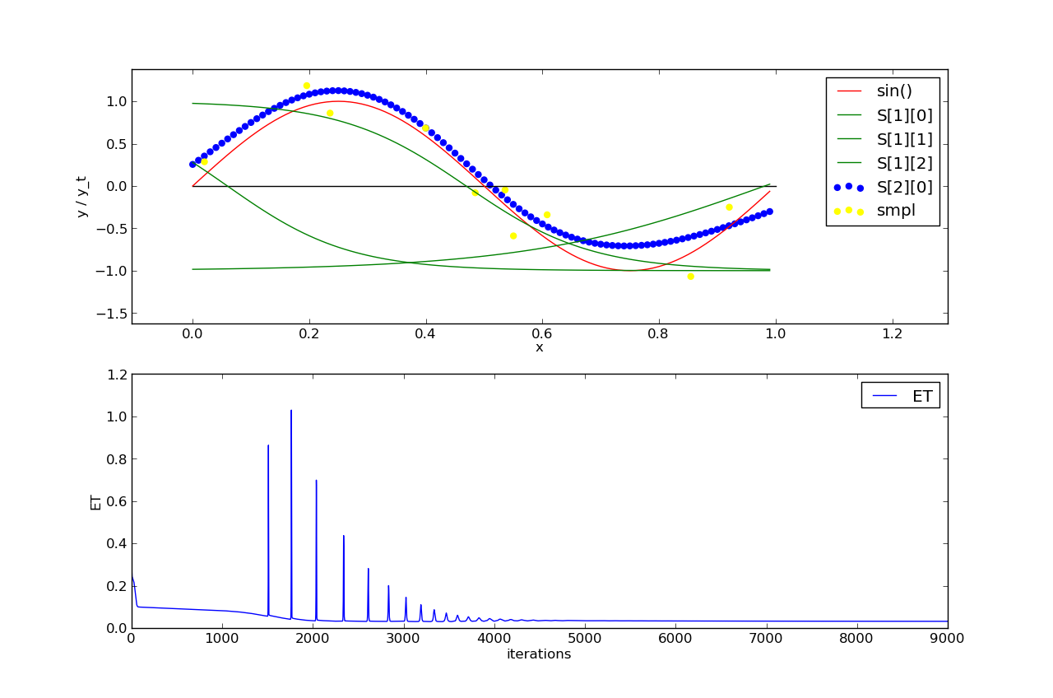

smpl = samples, ET = training error (average over the data points)

The second two figures show an MLP training with an adaptive learn rate. As one can see, the network has reached a good performance already after around 1500 iterations. Thus, an adaptive learn rate strongly increases the MLP's learning capacity. We can see the learning process in the second figure: At first, the network predicts poorly. It therefore undertakes big learning steps to cope with the substantial differences between the predicted and the desired output. After having reached a certain level of correct prediction, the adjustment is more smoothly to improve minor failures until the goody goodness prediction ;-)

