rest("/getCustomerData")
.get("/data")
.route()
.to("direct:aaaaa")
.endRest();

from("direct:aaaaa")
.setBody(constant("AAAAAAAAAAAAAAAAAAAAAAAAAAAAAAAAAAAAAAAAAAAAAA"))
.to("aws-sqs://test-queue.fifo?messageGroupIdStrategy=useExchangeId");

from("aws-sqs://test-queue.fifo?messageGroupIdStrategy=useExchangeId")
.log("Received new message: ${body}");
Run as expected, send and receive in one route.
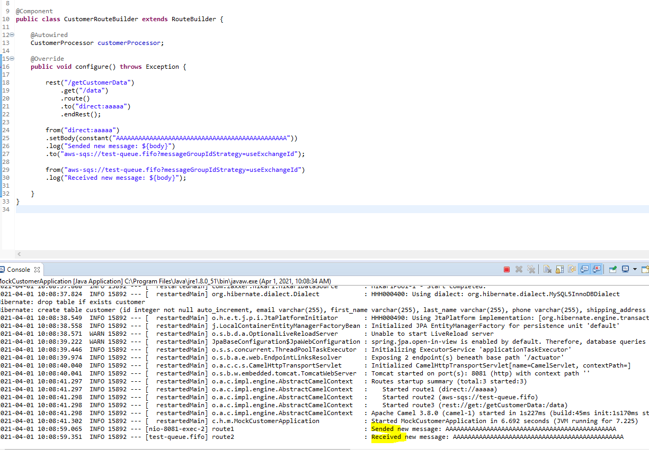

- Convert POJO JSON:
  - Use marshall/ un marshall https://camel.apache.org/components/3.4.x/dataformats/json-jackson-dataformat.html ( camel-jackson dependency)
  - Use ObjectMapper (import com.fasterxml.jackson.databind.ObjectMapper )
  - …………
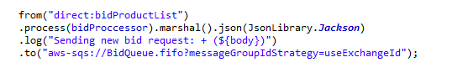
- Object of Body is Generic type : POJO, JSON, XML, String……..
- Why use convert to JSON? Because in micro-service project, some module use different language, use JSON for all can communicate with each other. POJO is Java.
- Received camel POST request data - Handle – Send to another place.............
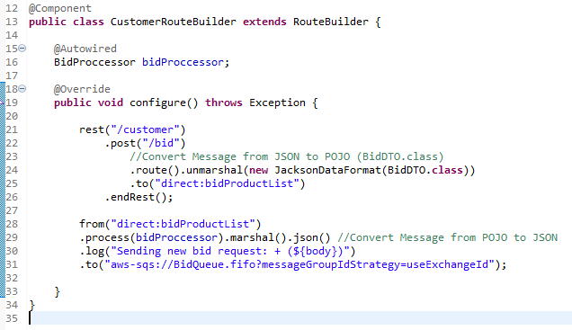

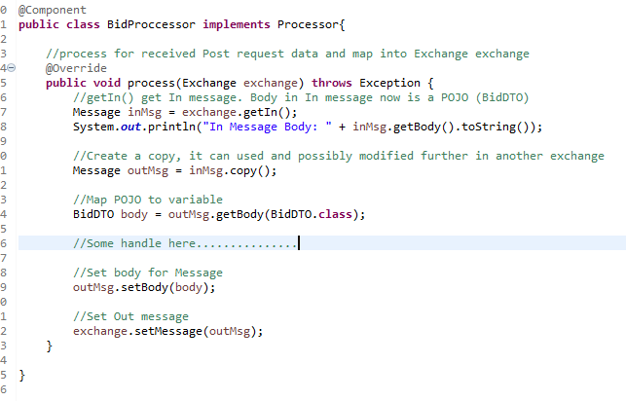
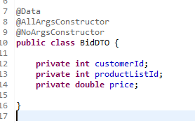 | 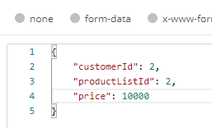

Problem: Get value from JSON object

