01.04.2021

rest("/getCustomerData")
.get("/data")
.route()
.to("direct:aaaaa")
.endRest();

from("direct:aaaaa")
.setBody(constant("AAAAAAAAAAAAAAAAAAAAAAAAAAAAAAAAAAAAAAAAAAAAAA"))
.to("aws-sqs://test-queue.fifo?messageGroupIdStrategy=useExchangeId");

from("aws-sqs://test-queue.fifo?messageGroupIdStrategy=useExchangeId")
.log("Received new message: ${body}");
Run as expected, send and receive in one route.
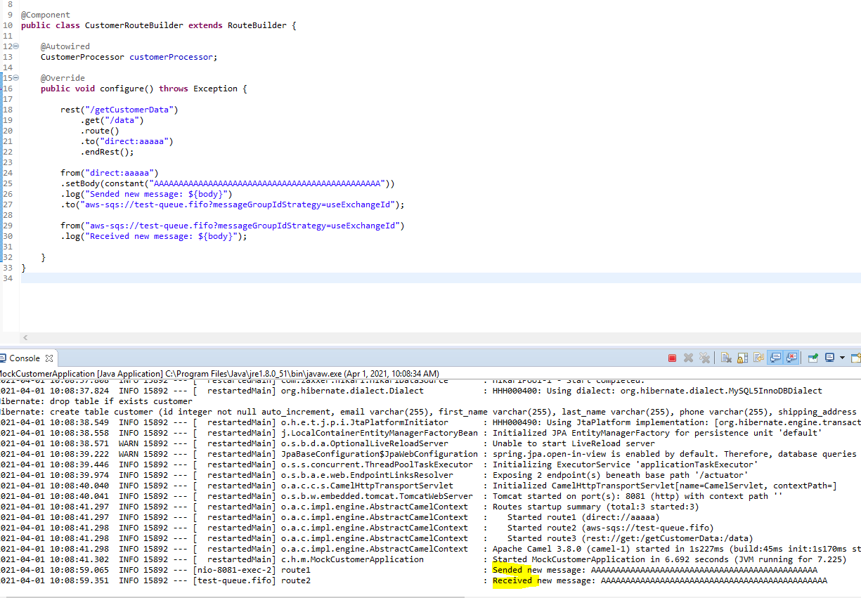

Q1. Convert POJO JSON:
  - Use marshall/ un marshall https://camel.apache.org/components/3.4.x/dataformats/json-jackson-dataformat.html ( camel-jackson dependency)
  - Use ObjectMapper (import com.fasterxml.jackson.databind.ObjectMapper )
  - …………
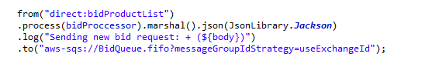

Q2. Object of Body is Generic type : POJO, JSON, XML, String……..

Q3. Why use convert to JSON?

Because in micro-service project, some module use different language, use JSON for all can communicate with each other. POJO is Java.
- Received camel POST request data - Handle – Send to another place.............
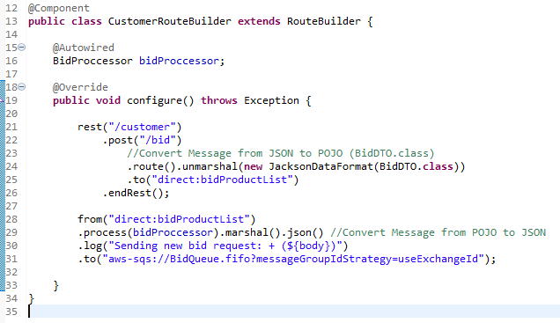

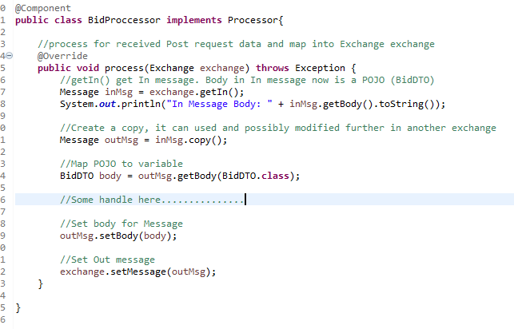
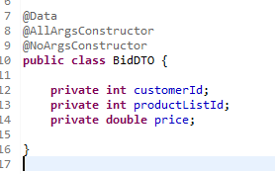 | 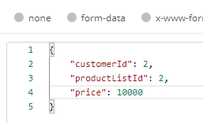

Q4 Problem: Get value from JSON object

Solution:
- Use DTO
  - Read more about DTO pattern
- Build file Jar included DTO and use for all modules
  - Pls understand all tag in pom.xml
- Use Hash Map
  - Pls review Java collection, especially Hash Map
  - Review solution of Mr.Trung
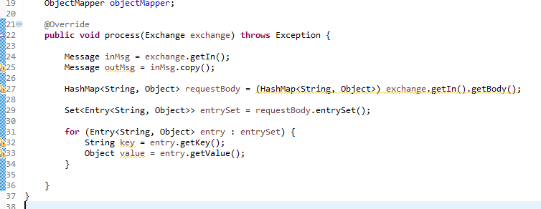

Q5. Wanna AllArgument + NoAgrument + CustomArgument Constructor. If available?

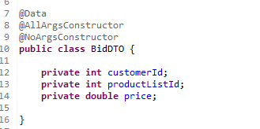
Solution: Use Lombok.NonNull annotations
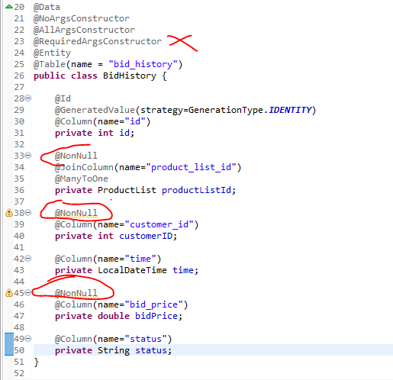

Q6: Fix dialect bug:

Use org.hibernate.dialect.MySQL5Dialect instead of org.hibernate.dialect.MySQL5InnoDBDialect
InnoDB use for mock_customer
Non-InnoDB use for mock_platform.
Question: What’s different between mysql5dialect and mysql5innodbdialect

Q7. Create table or properties of MySQL coincides with MySQL reserved words:

Ref: https://dev.mysql.com/doc/refman/8.0/en/keywords.html

Q8 Queue with Multi type of message

Không nên nhưng cứ thử để học cách dung các thành phần khác của Message
Học thêm về cha con
x
EX: Customer to platform, platform to customer

Q9 try catch or if else, try catch in processors or services

Đọc thêm về try catch
onException(Exceptiom).procees();
xử lý try catch của camel

Q10 Learn about HashMap & Code of MR.Trung sharing.


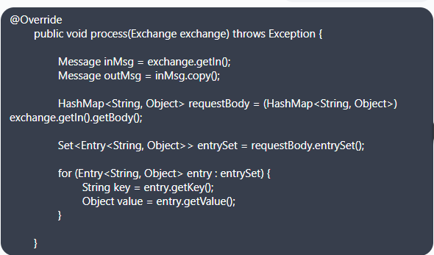

Q11. Config AWS CLI for windows

Configure CLI at windows
https://docs.aws.amazon.com/cli/latest/userguide/welcome-versions.html
How to setup:
https://docs.aws.amazon.com/cli/latest/userguide/install-cliv2-windows.html
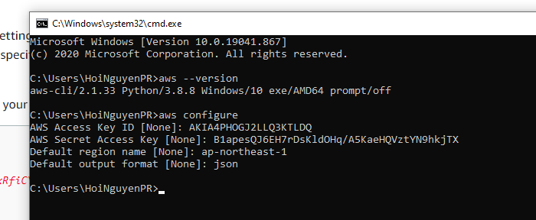

Q12. What different between REST & Queue by Mr.Thong

REST | Queue
Chủ động send request để nhận message | Waiting for message ( from(……….)). Không request, just waiting.

