React JS

1. Giới thiệu:

* React thiên về phát triển giao diện người dùng.
* React có 2 loại:
  + ReactJs: thiên về thiết kế giao diện phát triển web.
  + React-native: thiên về thiết kế giao diện phát triển IOS, android.
* ReactJs hoạt động như thế nào:
  + Làm sao chúng ta biết web-site có đang dùng reactJs hay ko?
  + Google chrome plug-in.
    - React detector.
    - React developer tools.
  + Demo load image.
  + Work-flow.

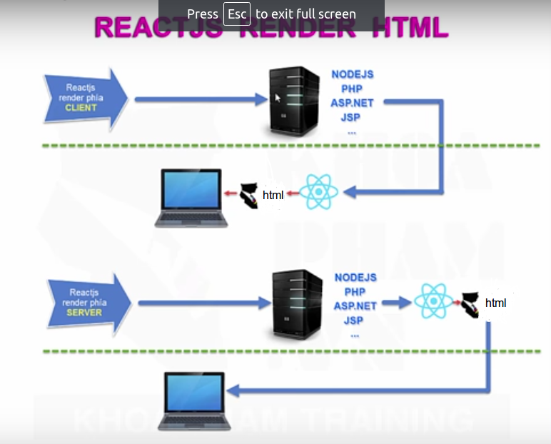

1. Setup environment develop.

* install nodejs tham khảo từ [www.nodejs.org](http://www.nodejs.org/).
  + kiểm tra phiên bản đã được install: node –version.
* install git-scm.
  + Git –version.
* Create project.
  + make folder.
  + # cd to folderJustMake from terminal.
  + # npm init
  + make project với folder vừa mới tạo.
  + file package.json duoc tao ra.
  + Npm install express ejs
  + xem 1_demo_helloworld.zip

1. React embedded.

* Truy cap vao trang goc react : <https://facebook.github.io/react/>
  + select docs/installation/using a CDN
  + <script src="<https://unpkg.com/react@15/dist/react.js>"></script>
  + <script src="https://unpkg.com/react-dom@15/dist/react-dom.js"></script>
  + <script src="<https://unpkg.com/babel-core@5.8.38/browser.min.js>"></script>
* Refer to 2_demo_embedded_1.tar.gz

1. Improvement speed load page.

* Download 3 files script to ./public/lib/
* Refer to 2_demo_embedded_2.tar.gz

1. Khai niem thu vien jsx va thu vien babel-core

* Refer to 5_demo_jsxBabel.tar.gz

1. Tach react ra file rieng.

* Refer to 6_demo_splitFile.tar.gz

1. Component trong reactJs

* 7_demo_component.tar.gz

1. Component long nhau.

* 8_demo_component_inner.tar.gz
* Xem image component

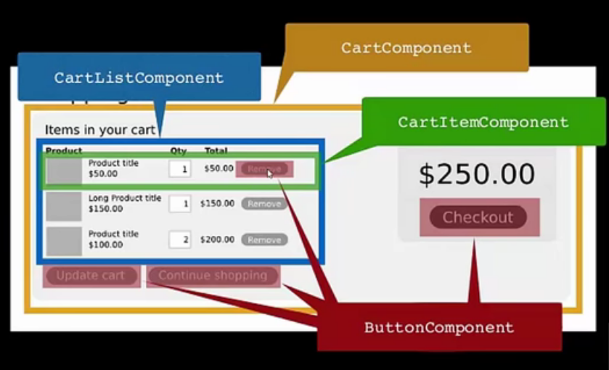

1. props trong reactJs

* props khong bao gio thay doi gia tri cua no: props nhu la constant.
* Refer 9_demo_props.tar.gz

1. props dac biet children.

* 10_demo_props_children.tar.gz

1. event handler

* 11_demo_event_handler.tar.gz

1. event handler 2

* 11_demo_even_handler_2.tar.gz

1. state trong reactJs

* 12_demo_state.tar.gz

1. state 2

* 13_demo_state_2.tar.gz

1. ref trong reactjs

* 14_demo_ref.tar.gz

1. continue
2. abcd