Objective

This session introduces students to String, StringBuffer, Arrays, References, Vector and finally garbage collection.

Pointer
A “Pointer” is a variable that contains the address of another variable. Every field/variable/constant you declare is assigned a piece of memory. You can think of computer memory as a long city street (like Broadway in Manhattan). Each field/variable/constant in memory is like a house or store on that street. Each house or store on the street is assigned a unique address, like 240 Broadway. In case of memory addresses, it is a hexadecimal number like x1000. Let’s take a look at the following example:

Public static void main(String[] args){

int age = 30;
}

The statement can literally be broken down to two statements:

int age; //Declaration

age=30; // Assignment

The first statement reserves a piece of memory required to store an int (let’s say x1000) and assigns it the name age. From now on, we can access the memory location x1000 using its name age.

The second statement says, “store a value of 30 at the memory location reserved by the name age.”

Here is the picture:

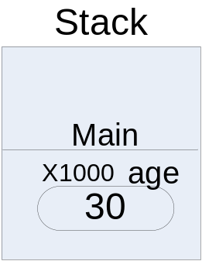

Some languages such as C/C++ allow the programmer to access the memory location directly. Consider the following C/C++ example:

Public static void main(String[] args){

int age = 30;

int* pAge= &age;
}

The statement says, “save the memory location of age (x1000 is this case) in a pointer variable pAge”.

Here is the picture:

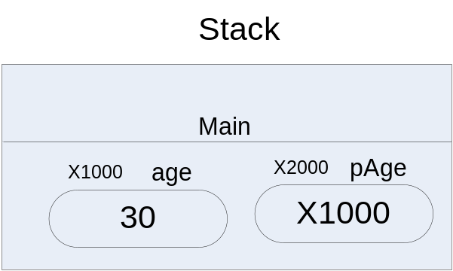

Now, let’s look at the following C/C++ example:

Public static void main(String[] args){

int age = 30;

int* pAge= &age;

*pAge= 67;
}

“Assign the value 67 to the memory location contained in the pointer variable pAge” (x1000 that is). This will change the value of age to 67.

Here is the picture:

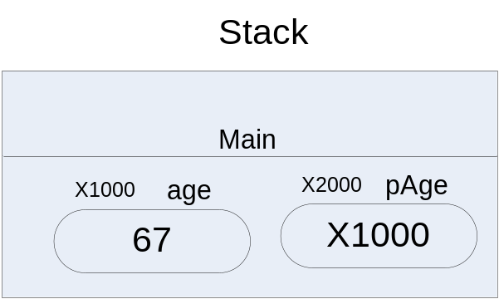

C/C++ goes further than that and allows you move to the next memory location by doing pointer arithmetic like pAge++, --pAge to go to x1001 or x999.

Java does not let you access or manipulate the memory location directly. Therefore, in Java you can only do the first part…..

int age; //Declaration

age=30; // Assignment

… which means, “reserves a piece of memory (let’s say x1000) and assign it the name age and then store a value of 30 at the memory location reserved by the name age”.

Reference
We just saw an example of a primitive data type variable. Object variables, on the other hand, are created in a slightly different fashion. Consider the following example:

Public static void main(String[] args){

BankAccount citiAccount= new BankAccount();
}

Again, this statement can be broken down into two statements:

BankAccount citiAccount;

citiAccount = new BankAccount();

The first statement does two things:

- It loads BankAccount class in Static memory
- It reserves a piece of memory (let’s say x1000) in Stack required to store the memory address of any BankAccount object and assigns it the name citiAccount. So, citiAccount is really a “pointer” right now. It is a “pointer” because it is expected to store a memory location. Java is pretty strict about making sure that you assign some memory location to this variable before you use it.

The second statement is little more involved. The right-hand side of the statement ‘new BankAccount()’ executes first. It goes ahead and takes the memory it needs from a special pool of memory that Java controls called the heap and creates a new object of BankAccount type. Once that’s done, it returns the memory address of heap that is taken by the new object. At this point, the left-hand side of the statement is executed, and then the right hand side simply saves the heap address to the variable citiAccount. Here is the picture:

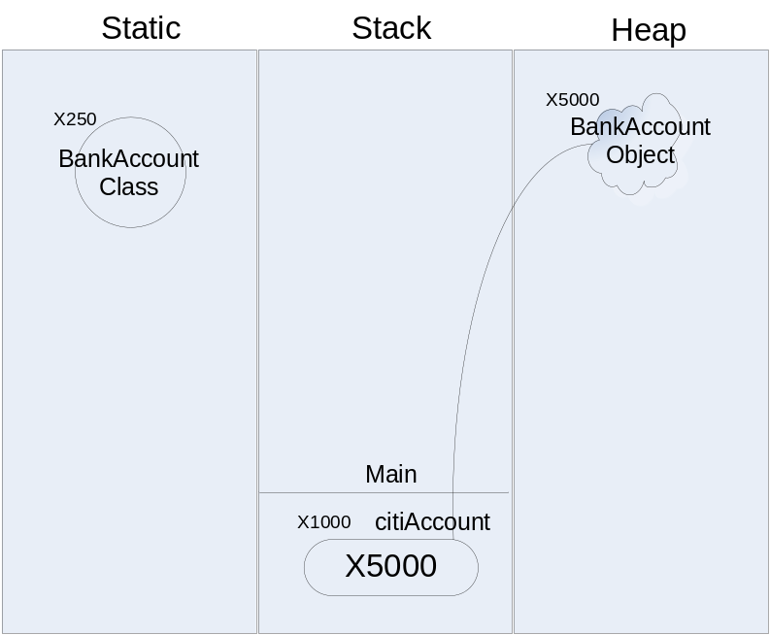

Now the variable citiAccount has the memory address of a new BankAccount object. In Java, this type of pointer to an object (there are no pointers to primitive data types in Java) is called a “reference”.

In other words, in C/C++ pointers can be pointing to primitives or objects and they are simply called pointers. In Java, pointers can only be pointing to objects, and they are called references. In C/C++ pointer arithmetic like ++,-- etc are allowed but in Java references can be used for arithmetic operation.

You can think of a reference as a name for an object. Let’s say, I have a cat. The cat is an object. His name is “Jack”. Jack is a reference to the cat object. I can give my cat many names and they all are going to point to the same object – my cat Jack. Consider the following example:

BankAccount chaseAccount;
chaseAccount = citiAccount;

Now, chaseAccount and citiAccount are both referring to the same object in the heap. I just made two references to the same object. Here is the picuture:

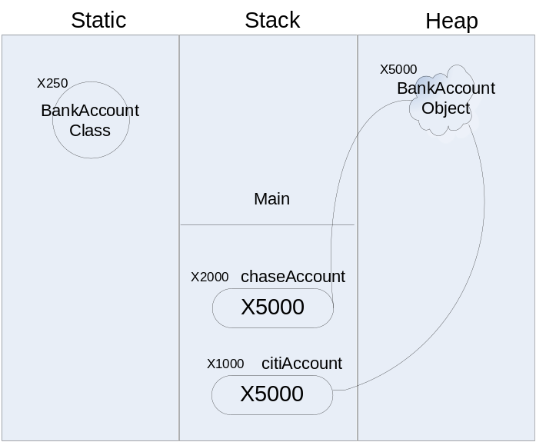

Arrays
An array object contains a number of values. The values contained in an array have no names; instead they are referenced by indexes of the array. These values are called the components of the array. If an array has n components, we say n is the length of the array; the components of the array are referenced using integer indices from 0 to n-1, inclusive. All the components of an array have the same type.

Arrays are objects that are allocated much like any other object. The following declares an array of integers:

int myIntArray[ ];

The brackets indicate that this is a reference to an array. The brackets can be placed either before or after the reference name as follows:

int[ ] myIntArray;

My recommendation is that you follow the second syntax int[], the reason for that will become clear soon.

Before you can use this array for any practical purposes, you have to declare the size of the array using the “new” keyword as follows:

myIntArray = new int[3];

You can do the two steps in one as follows:

int[ ] myIntArray = new int[3];

or

int myIntArray[ ] = new int[3];

Now that we have an array of integers, we can individually assign values to each element of the array as follows:

myIntArray[0]=5;

myIntArray[1]=10;

myIntArray[2]=15;

If you know the array element values beforehand, Java provides a shortcut for both declaring and assigning values in one step:

int myIntArray[] = {5,10,15};

The statement above will create an array of size 3 and assign the values on the elements in order. Arrays have a length field that keeps the number of elements in the array. In Java, arrays are fixed size - you can not change the size of the array.

Even though an array can hold multiple values, it is one and only one object. Therefore, we can use an array to return First Name, Middle Name, Last Name as elements of that array.

Here is a getName() method that does that:

public String[] getName()

{

String[] Name = new String[3];

Name[0]=firstName;

Name[1]=middleName;

Name[2]=lastName;

return Name;

}

Arrays from Reference Prospective
Arrays are probably the most confusing objects. Now that we understand references, let’s look at the following example:

Public static void main(String[] args){
int[] myIntArray = new int[3];
}

Again, it can be broken down into two statements:

int[] myIntArray;
myIntArray = new int[3];

The first statement reserves a piece of memory (let’s say x1000) required to store the memory address of any int array object. The memory address of an array object is always the same irrespective of its size because it is one object after all. Then, it assigns a name myIntArray to it.

Now, the second statement: The right-hand side of the statement ‘new int[3]’ executes first. It goes ahead and takes the memory it needs to hold 3 integers on the heap and creates a new object of type int[]. Once that’s done, it returns the memory address of heap that is taken by the new object array. At this point, the left-hand side of the statement is executed, the right hand side simply saves the heap address to the variable myIntArray.

Of course, the array object is implemented in such a way that it will have 3 slots inside it to hold 3 int values.

Here is the picture:

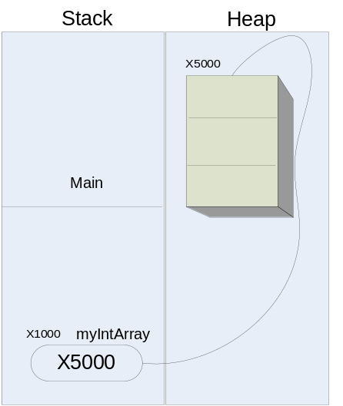

Now, if we say:

myIntArray[0] =5;
myIntArray[2]=myIntArray[0];

Both myIntArray[0] and myIntArray[2] will have a value of 5.

Here is the picture:
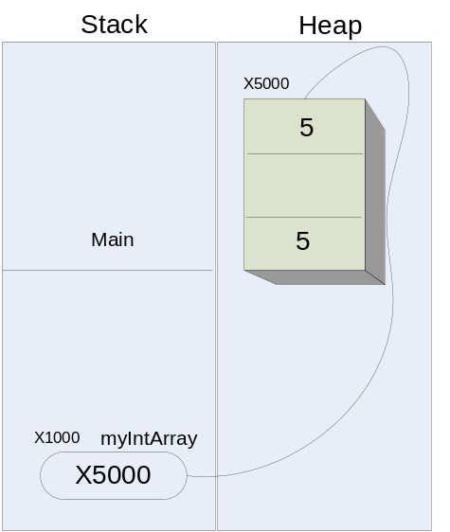

Later on, if we say:

myIntArray[2] = 8;

myIntArray[2] will have 8 and myIntArray[0] will still have 5 because the 5 was literally copied from myIntArray[0] to myIntArray[2].

Here is the picture:

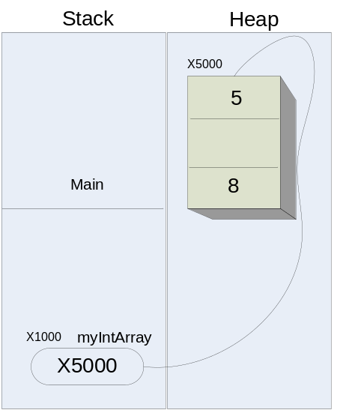

Arrays of Objects
Arrays of objects do not act exactly the same way as primitive types. However, the concept is the same but the consequences are different. Let’s look at the following example:

Public static void main(String[] args){
BankAccount bankAccountArray[ ] = new BankAccount[3];
}

Again, it can be broken down into two statements:

BankAccount[] bankAccountArray;
new BankAccount[3];

The first statement reserves a piece of memory (let’s say x1000) required to store the memory address of any array object. The memory address of an array object is always the same irrespective of its size because it is one object after all. Then it assigns a name bankAccountArray to it. So bankAccountArray is really pointing to junk data right now.

The second statement: The right-hand side of the statement ‘new BankAccount[3]’ executes first. It goes ahead and takes the memory it needs to hold 3 references to BankAccount objects on the heap and creates a new object of type array. Once that’s done, it returns the memory address of heap that is taken by the new object array. At this point, the left-hand side of the statement is executed the right-hand side simply saves the heap address to the variable bankAccountArray.

Of course, the array object is implemented is such a way that it will have 3 slots inside it to hold 3 BankAccount references.

Here is an interesting question. At this point, how many BankAccount object have we created? Three? One? None? The right answer is, NONE. We merely created an array that is capable of storing references to three BankAccount object but we haven’t created a single BankAccount yet.

Consider the following statement now:

bankAccountArray[0] = new BankAccount(500);

This statement is more involved than one using primitive data types. The-right hand side of the statement ‘new BankAccount(500)’ executes first. It goes ahead and takes the memory it needs to hold a BankAccount on the heap and creates a new object of BankAccount type. Once that’s done, it returns the memory address of heap that is taken by the new BankAccount object. At this point, the left-hand side of the statement is executed the right-hand side simply saves the heap address of the BankAccount object to slot 0 of heap address referred by bankAccountArray. Right now, bankAccountArray is holding a reference of BankAccount at slot 0. The other two slots are still empty.

Here is the picture:

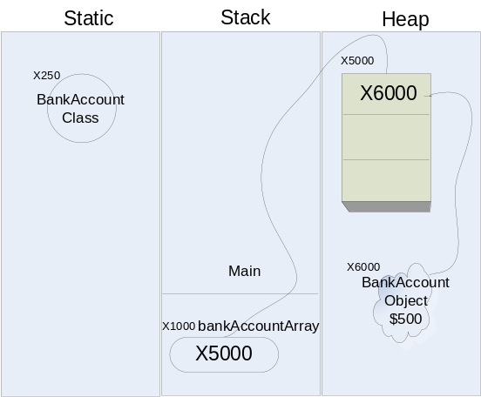

Now, let’s do the following:

bankAccountArray[2] = bankAccountArray[0];

What is bankAccountArray[0] again? It is a reference to a BankAccount object somewhere on the heap that has $500 initial deposit. What does bankAccountArray[2] get? It gets a copy of the reference to the same BankAccount object that has $500 initial deposit.

Here is the picture:

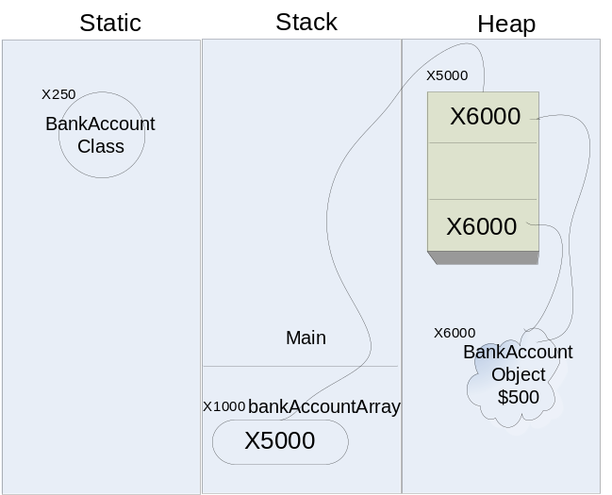

If we run the following statements …

System.out.println("Balance in bankAccountArray[2] is: " + bankAccountArray[2].getBalance());
System.out.println("Balance in bankAccountArray[0] is: " + bankAccountArray[0].getBalance());

… we get,

Balance in bankAccountArray[2] is: 500.0
Balance in bankAccountArray[0] is: 500.0

Fair enough. Things really go crazy when you do the following:

bankAccountArray[2].deposit(700);

If we run the following statement …

System.out.println("Balance in bankAccountArray[2] is: " + bankAccountArray[2].getBalance());

… we get,

Balance in bankAccountArray[2] is: 1200.0

Fine. If we run the following statement …

System.out.println("Balance in bankAccountArray[0] is: " + bankAccountArray[0].getBalance());

… we get,

Balance in bankAccountArray[0] is: 1200.0

How come? We did not touch bankAccountArray[0]. It was 500.0

Remember, there is only one BankAccount object we created so far and both bankAccountArray[0] and bankAccountArray[2] have references to the exact same BankAccount object. Therefore, they are manipulating the exact same object.

Here is the picture:

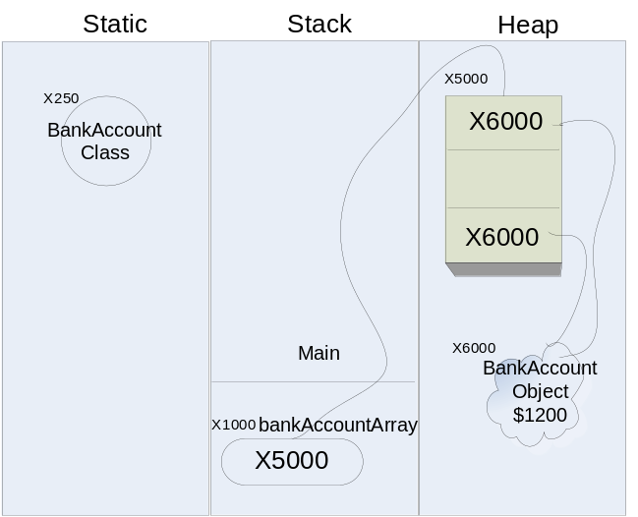

As a side note, if we now do something like this …

bankAccountArray[2] = new BankAccount(800);

bankAccountArray[2] will suddenly refer to a new object with initial deposit of $800.

Here is the picture:

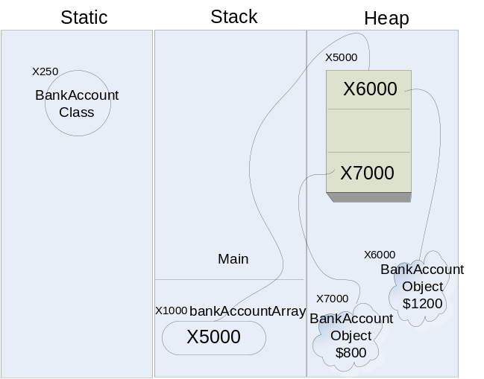

and the following code …

bankAccountArray[2].deposit(700);

… will change the balance of this new BankAccount to 800+700 = $1500 but the balance of bankAccountArray[0] will continue to be $1200. In other words, the ‘new BankAccount(800)’ broke the chain between bankAccountArray[0] and bankAccountArray[2].

Here is the picture:

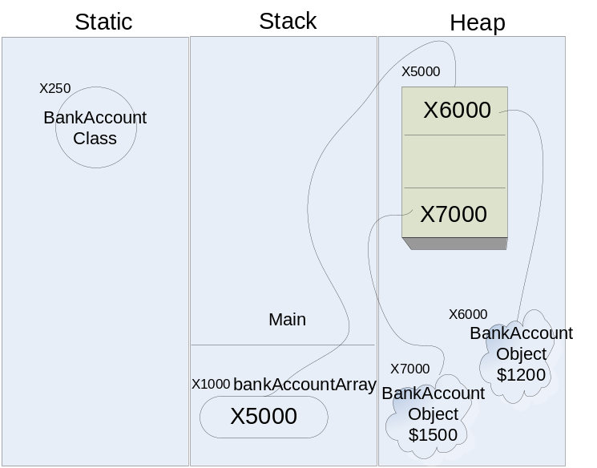

The Array Class
We know now that arrays are objects. If arrays are objects, where is the array class? For every primitive data type as well as classes (that either exists or we create). Java automatically creates a corresponding array class. This set of classes is transparent to us but they do exist.

The statement:

int[] myIntArray = new int[10];

should really be read as:

int[] myIntArray = new int[](10); //this is not a valid Java statement

Here, the class name is int[] and we are creating a new object myIntArray from the class int[], which has a constructor that takes number of elements as an argument, and we are passing 10. Makes sense? Unfortunately, Java (just like C/C++) does not create array objects using this syntax.

Parameter Passing in Java
Before we discuss how parameters are passed in Java, we have to understand two ways of passing parameters in general:

- By Value
- By Reference

Let’s take this example:

Public static void main(String[] args){
int age=30;
UpdateAge(age);
System.out.println(age); // what is prited, 30 or 45?
}

public static void UpdateAge(int newAge){
newAge = 45;
}

What should be printed on the monitor? The correct answer is it depends on how parameters are being passed.

- If “age” is passed by value, then “newAge” will receive 30 from “age” and then it will change its value to 45. The value of “age” will still be untouched, and the output to the monitor will be 30.

Here is the picture:

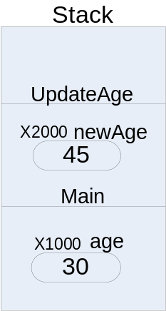

- However, if “age” is passed by reference, then “newAge” will receive the reference of “age” (let’s say x1000) and newAge will write 45 to that memory address (x1000), and at the end both age and newAge will both be 45. The output to the monitor will be 45.

Here is the picture:

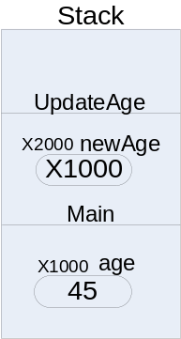

Now that we know what could possibly happen, the question is, what does actually happen in Java?

There are two distinct camps on this matter. They both say the same thing but they say it completely differently:

Group A:
- Java passed primitive data type parameters (int, double etc) by value. So, in the above example 30 will be printed on the Monitor.
- Java passed object data type parameters (String objects, citiAccountetc.) by reference. Remember, object variable only have a reference to the object. It does not have the actual object – the actual object is in heap. Therefore, it must pass the reference to the object.

Group B:
Java passed everything by value.
- When the parameter is of primitive data type, the receiving variable (argument) actually gets a local copy the value.
- However, if the variables happens to be an object variable, its value is a memory address (let’s say x1000) to an object, and the receiving variable (argument) gets a local copy of the memory address (x1000).

Both groups have valid points and in the end, it does not really matter which version of the interpretation you accept. The main important thing is to understand the fact that when an object variable is passed to a method as a parameter, the method can change the state of the object unexpectedly.

Strings from an immutable prospective
Java documentation says that Strings are immutable, Strings are constant; their values cannot be changed after they are created.

Fair enough. If you read the documentation on String further you will see that the String class has methods like toUpperCase, toLowerCase, Replace, etc. That’s confusing. If String is so immutable, what do these methods do? Let’s try this:

String nameString="john";
nameString.toUpperCase();
System.out.println(nameString);

What’s the output? The output is still “john” (in lowercase). What did we do wrong?

Let’s try it again now, this time slightly differently:

String nameString="john";
nameString=nameString.toUpperCase();
System.out.println(nameString);

What’s the output? Sure enough it is “JOHN” (in uppercase), as we would normally expect. What happened to immutability?

Here is what’s happening. Normally speaking, when you call a method on an object the method operates on the object itself. For example:

citiAccount.deposit(500);

This will increment the balance field of citiAccountby 500. In other words, the deposit method works on the citiAccountobject itself.

However, in case of toUpperCase() that’s not the case. The toUpperCase() method makes a copy of the original String object nameString to another memory location in heap, changes every character of String to upper case letter, and then returns the new String object. It never touches the original object nameString.

In the first example we did not save the returned value of toUpperCase(). Therefore, nameString is still pointing to “john” and the newly created “JOHN” is not at all referenced.

Here is the picture:
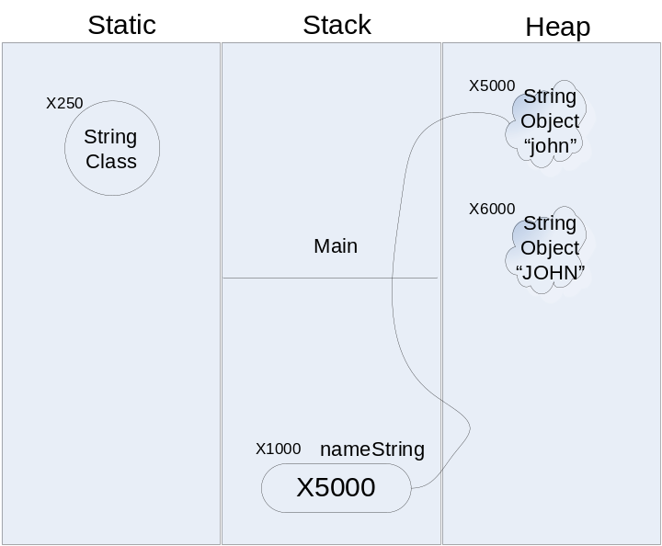

In the second example, we assigned the newly created string object back to the same variable nameString – that’s what made it look like we changed the original string “john” to “JOHN”. In fact, if we can search the heap, we will find that both “john” and “JOHN” exist as two separate objects.

Here is the picture:

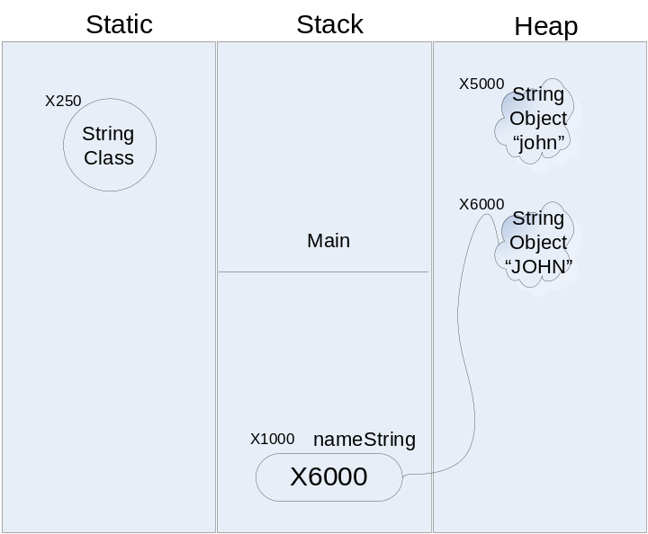

In other words, all the methods of String class operate on a copy of the original object, and never touch the original object, making Strings immutable.

Constructors
String() | Initializes a newly created String object so that it represents an empty character sequence.
String(String value) | Initializes a newly created String object so that it represents the same sequence of characters as the argument; in other words, the newly created string is a copy of the argument string.
String(StringBuffer buffer) | Allocates a new string that contains the sequence of characters currently contained in the string buffer argument.
String(char[] value) | Allocates a new String so that it represents the sequence of characters currently contained in the character array argument.
String(char[] value, int offset, int count) | Allocates a new String that contains characters from a subarray of the character array argument.
String(byte[] bytes) | Construct a new String by converting the specified array of bytes using the platform's default character encoding.
String(byte[] bytes, int offset, int length) | Construct a new String by converting the specified subarray of bytes using the platform's default character encoding.
String(byte[] bytes, int offset, int length, String enc) | Construct a new String by converting the specified subarray of bytes using the specified character encoding.
String(byte[] bytes, String enc) | Construct a new String by converting the specified array of bytes using the specified character encoding.

As I mentioned before in addition to the above constructors, Java provides a shortcut to initialize String variables as follows:

String nameString = “John Smith”;

In addition, we can use the + sign to concatenate String with any other data type.

Useful Methods
length() | Int | Returns the length of this string.  Example:  String name="John";  int length=nameString.length(); //Returns 4
equals(Object anObject) | boolean | Compares this string to the specified object. This method is mostly use to compare with another String.  Example:  String name1= new String("Smith");  String name2= new String("Smith");  String name3 = new String("Michael");  boolean name12Equals=name1.equals(name2); //Returns true  boolean name21Equals=name2.equals(name1); //Returns true  boolean name13Equals=name1.equals(name3); //Returns false  boolean name31Equals=name3.equals(name1); //Returns false
equalsIgnoreCase(String anotherString) | boolean | Compares this String to another String, ignoring case considerations  Example:  String name4="john";  String name5="JOHN";  boolean equalsIngoreCase=name4.equalsIgnoreCase(name5); //Returns true.
concat(String str) | String | Concatenates the specified string to the end of this string. The shortcut for this method is the + (plus) sign.  Example:  String firstName="John";  String lastName="Smith";  String concatName=firstName.concat(" ").concat(lastName); // Returns "John Smith"  String plusName=firstName + " " + lastName; // Shortcut Returns "John Smith"
substring(int beginIndex) | String | Returns a new string that is a substring of this string.  Example:  String word="Hello There";  String sub = word.substring(6); //Returns “There”  Note: Index is zero-based.
substring(int beginIndex, int endIndex) | String | Returns a new string that is a substring of this string.  Example:  String line="How are you?";  String sub=line.substring(4,7); //Returns “are”
replace(char oldChar, char newChar) | String | Returns a new string resulting from replacing all occurrences of oldChar in this string with newChar.  Example:  String original = "I*am*not*doing*well";  String replaced = original.replace('*','-');  // Returns “I-am-not-doing-well”
valueOf(char c) | static String | Returns the string representation of the char argument.  Example:  char c = 'c';  String a = String.valueOf(c);  String a = "" + c; //shortcut
String valueOf(boolean b) | static | Returns the string representation of the boolean argument.  Example:  boolean b = true;  String m = String.valueOf(b); //Returns "true"  String m = "" + b; //shortcut
valueOf(double d) | static String | Returns the string representation of the double argument.  Example:  double d = 34.56;  String r = String.valueOf(d);  String r = "" +d; //shortcut
valueOf(float f) | static String | Returns the string representation of the float argument.  Example:  float f = 30.74F;  String q = String.valueOf(f);  String q = "" + f; //shortcut
valueOf(int i) | static String | Returns the string representation of the int argument.  Example:  int n = 7;  String k = String.valueOf(n);  String k = "" + n; //shortcut
valueOf(long l) | static String | Returns the string representation of the long argument.  Example:  long l = 10;  String p = String.valueOf(l);  String p = "" + l; //shortcut
valueOf(Object obj) | static String | Returns the string representation of the Object argument.
valueOf(char[] data) | static String | Returns the string representation of the char array argument.Example:  char[] cArray = new char[2];  cArray[0]='H';  cArray[1]='i';  String hi= String.valueOf(cArray); // Returns "Hi"
trim() | String | Removes white space from both ends of this string.  Example:  String spaced = " Hi there ";  String trimmed = spaced.trim(); // Returns "Hi there"
toLowerCase() | String | Converts all of the characters in this String to lower case.  Example:  String proper="John";  String lower = proper.toLowerCase(); // Returns "john"
toUpperCase() | String | Converts all of the characters in this String to upper case.  Example:  String proper="John";  String upper= strProper.toUpperCase(); //Returns "JOHN"
startsWith(String prefix) | boolean | Tests if this string starts with the specified prefix.  Example:  String city="New York";  boolean startsWithNew=city.startsWith("New"); // Returns true  boolean startsWithPhi=city.startsWith("Phi"); // Returns false
endsWith(String suffix) | boolean | Tests if this string ends with the specified suffix.  Example:  String city="New York";  boolean endsWithYork=city.endsWith("York"); // Returns true  boolean endsWithTon=city.endsWith("Ton"); // Returns false
charAt(int index) | char | Returns the character at the specified index (zero based index)  Example:  String fruit = "Orange";  char cAt3=fruit.charAt(3); //returns 'n' the 4th character
getBytes() | byte[] | Convert this String into an array of bytes according to the platform's default character encoding, storing the result into a new byte array.  Example:  String word="Hello There";  byte[] bArray=word.getBytes();  char H=(char) bArray[0]; // Returns 'H'
indexOf(String str) | int | Returns the index within this string of the first occurrence of the specified substring.  Example:  String proper="John";  int index=proper.indexOf("oh"); //Returns 1 meaning 2nd position on the string.
indexOf(String str, int fromIndex) | int | Returns the index within this string of the first occurrence of the specified substring, starting at the specified index.  Example:  String question="Where did everyone go?";  int index = question.indexOf("e",7); //returns 10
lastIndexOf(String str) | int | Returns the index within this string of the rightmost occurrence of the specified substring. Example:  String fullName="John Smith";  int index= fullName.lastIndexOf("h"); //Returns 9 not 2
toCharArray() | char[] | Converts this string to a new character array. Example:  String hello="Hello";  char[] cArrayHello;  cArrayHello= hello.toCharArray(); //saves "Hello" in character array cArrayHello

String Objects and = = Operator
In Java you compare if two values are equal by == operator as follows:

int i = 9;

int j = 9;

if (i == j)

System.out.println("They are equal");

else

System.out.println("They are not equal");

This works fine with primitive data type. However, objects (like String) should not be compared in this fashion.

Let’s try this example with two String variables:

String name1="john";

String name2="john";

if (name1 == name2){

System.out.println("Equal");
}

else{

System.out.println("Not Equal");
}

The output is “Equal”, which makes us believe that the == operator works for strings.

Let’s try the example in a slightly new fashion:

String name1=new String("john");

String name2=new String("john");

if (name1 == name2){

System.out.println("Equal");
}

else{

System.out.println("Not Equal");
}

This time the output is “Not Equal”. How come?

In the first case there is only one String object “john” and both name1 and name2 have reference to the same object.

Here is the picture:

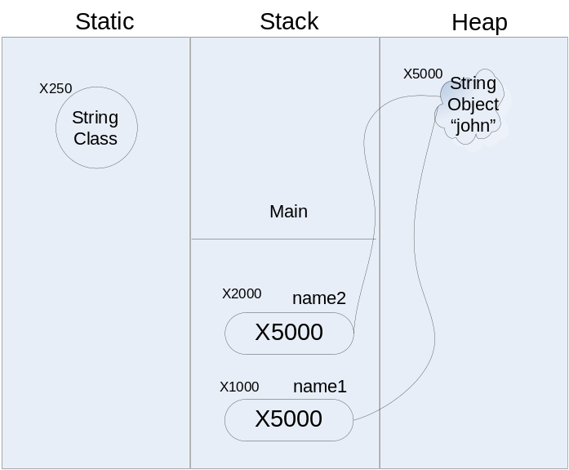

However, in the second case, the first statement:

String name1=new String("john");

Creates a String object “john” and returns the reference to this object and the variable name saves the reference.

The next statement:

String name2=new String("john");

Creates another String object “john” and returns the reference to this object and variable name2 saves the reference. Now we have two String object both having the same String “john” but at different memory addresses. Therefore, the reference in variable name1 is different from the reference in variable name2. Here is the picture:

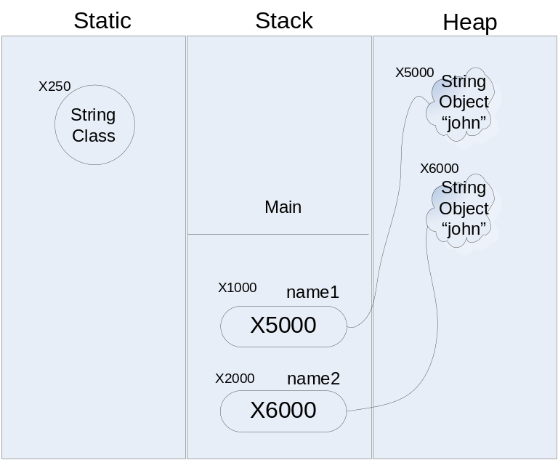

How do we get around this problem? Well, use the equals method of String instead of == operator. For example:

if (name1.equals(name2)){

System.out.println("Equal");
}

else{

System.out.println("Not Equal");
}

This will always give you “Equal” no matter how you assign “john” to name1 or name2 as long as they are both “john”.

The String class has a replace() method, that takes a find character and a replace-with character and returns a string by replacing all occurrences of the find character.

The String class has a replaceAll() and replaceFirst() methods, that take a find string and a replace-with string and returns a string by replacing all or first occurrence of the find character.

Unfortunately, String is missing a replace() function that takes a lower and upper bound and replaces with that boundary.

Here is our version of the replace method that does that:

public class StringUtility{

/** A method that will perform find and replace all occurrences of a string on a given string
* between start and end position.
* @param input Input String.
* @param find Search String.
* @param replaceWith Replacement String.
* @param startPosition Starting position for the search.
* @param endPosition End position for the search. The search will actually stop at (endPosition-1).
* @return Replaced String.
*/
public static String replaceString(String input, String find,
String replaceWith, int startPosition, int endPosition)
{
// declare a temp variable.
String temp;

// find the length of find string.
int findLength=find.length();

// initial return string 0 to (startPosition-1)
String returnValue = input.substring(0,startPosition);

while (true)
{
// if the rest of the string is smaller than the find string
// concatenate the rest with return string and return.
if ((startPosition + findLength)> endPosition){
returnValue=returnValue + input.substring(startPosition);
return returnValue;
}

// get the next chunk
temp=input.substring(startPosition,startPosition+findLength);

// compare with find string.
// if equal, do the replacement
// increment your position by the
// length of find string
if (temp.equals(find)){
returnValue=returnValue+replaceWith;
startPosition += findLength;
}
// if not equal, it is ok to add 1 character
// to the return string and
// increment your position by 1
else
{
returnValue=returnValue+input.charAt(startPosition);
startPosition++;
}
}
}

/** The main method(automatically invoked by JVM) that
* creates String objects and calls the replaceString method.
*/
public static void main(String[] args)
{
//declare variables.
String oldString;
String newString;

// original string
oldString = new String("How are you? How is Everyone else? How is your friend Jim Doing?");

// newString string where "How" is replaced by "Where" between
// position 10 and 20
newString = replaceString(oldString,"How","Where",10,20);

// print the original and replaced string
System.out.println("Old String: " + oldString);
System.out.println("New String: " + newString);

// original string
oldString = new String("Never say never never never never again!!!!");

// newString string where "How" is replaced by "Where" between
// position 10 and 20
newString = replaceString(oldString,"never","ever",16,35);

// print the original and replaced string
System.out.println("Old String: " + oldString);
System.out.println("New String: " + newString);

}

}
Here is the output:

Old String: How are you? How is Everyone else? How is your friend Jim Doing?
New String: How are you? Where is Everyone else? How is your friend Jim Doing?
Old String: Never say never never never never again!!!!
New String: Never say never ever ever ever again!!!!

StringBuffer

A StringBuffer is everything you expected String to be. A StringBuffer implements a mutable sequence of characters. A StringBuffer is like a String, but can be modified. At any point in time, it contains some particular sequence of characters, but the length and content of the sequence can be changed through certain method calls.
The principal operations on a StringBuffer are the append and insert methods, which are overloaded so as to accept data of any type. Each effectively converts a given datum to a string and then appends or inserts the characters of that string to the string buffer. The append() method always adds these characters at the end of the buffer; the insert() method adds the characters at a specified point.

Every string buffer has a capacity. If the internal buffer overflows, the capacity is automatically made larger.

String buffers are used by the compiler to implement the binary string concatenation operator +. For example, the code:

String x = "a" + 4 + "c"

is compiled to the equivalent of:

String x = new StringBuffer().append("a").append(4).append("c").toString()

Here is an Example of StringBuffer:

StringBuffer test1 = new StringBuffer("Hi"); //Sets StringBuffer to “Hi”

test1.append(" how are you?"); //changes StringBuffer to “Hi how are you?”

test1.insert(3,"John, "); //changes StringBuffer to

“Hi John, how are you?”

Constructors
StringBuffer() | Constructs a string buffer with no characters in it and an initial capacity of 16 characters.
StringBuffer(int length) | Constructs a string buffer with no characters in it and an initial capacity specified by the length argument.
StringBuffer(String str) | Constructs a string buffer so that it represents the same sequence of characters as the string argument; in other words, the initial contents of the string buffer is a copy of the argument string.

Useful Methods
indexOf(String str) | int | Returns the index within this string of the first occurrence of the specified substring.
indexOf(String str, int fromIndex) | int | Returns the index within this string of the first occurrence of the specified substring, starting at the specified index.
delete(int start, int end) | StringBuffer | Removes the characters in a substring of this StringBuffer.
deleteCharAt(int index) | StringBuffer | Removes the character at the specified position in this StringBuffer (shortening the StringBuffer by one character).
insert(int offset, String str) | StringBuffer | Inserts the string into this string buffer.
insert(int offset, char c) | StringBuffer | Inserts the string representation of the char argument into this string buffer.
insert(int offset, char[] str) | StringBuffer | Inserts the string representation of the char array argument into this string buffer.
insert(int offset, double d) | StringBuffer | Inserts the string representation of the double argument into this string buffer.
insert(int offset, float f) | StringBuffer | Inserts the string representation of the float argument into this string buffer.
insert(int offset, int i) | StringBuffer | Inserts the string representation of the second int argument into this string buffer.
insert(int offset, long l) | StringBuffer | Inserts the string representation of the long argument into this string buffer.
length() | int | Returns the length (character count) of this string buffer.
replace(int start, int end, String str) | StringBuffer | Replaces the characters in a substring of this StringBuffer with characters in the specified String.
append(String str) | StringBuffer | Appends the string to this string buffer.
append(char c) | StringBuffer | Appends the string representation of the char argument to this string buffer.
append(char[] str) | StringBuffer | Appends the string representation of the char array argument to this string buffer.
append(double d) | StringBuffer | Appends the string representation of the double argument to this string buffer.
append(float f) | StringBuffer | Appends the string representation of the float argument to this string buffer.
append(int i) | StringBuffer | Appends the string representation of the int argument to this string buffer.
append(long l) | StringBuffer | Appends the string representation of the long argument to this string buffer.
charAt(int index) | char | The specified character of the sequence currently represented by the string buffer, as indicated by the index argument, is returned.
reverse() | StringBuffer | The character sequence contained in this string buffer is replaced by the reverse of the sequence.
setCharAt(int index, char ch) | void | The character at the specified index of this string buffer is set to ch.
setLength(int newLength) | void | Sets the length of this String buffer.
substring(int start) | String | Returns a new String that contains a subsequence of characters currently contained in this StringBuffer.The substring begins at the specified index and extends to the end of the StringBuffer.
substring(int start, int end) | String | Returns a new String that contains a subsequence of characters currently contained in this StringBuffer.

Wrapper Classes for Primitive Data Types
Java provides wrapper classes for each primitive data type. The main purpose of having these wrapper classes is to convert primitive data to objects, in other words, to wrap them into objects. By the way, objects from these wrapper classes are immutable like String.

Each of these wrapper classes has two constructors:

- Takes the primitive data as an argument, converts it to an object.
- Takes a string as an argument, converts it to an object. If the string can’t be converted to primitive data, it throws an error message at runtime.

Each of these wrapper classes has a toString() method that converts the primitive data to a string.

Here is the complete list of these wrapper classes:

Primitive  Data Type | Wrapper  Class | Special Methods
boolean | Boolean | valueOf(String s) - Converts string to boolean  booleanValue() - Returns the value of the boolean
char | Character | No method to convert String to char. Use the charAt(int Index) method of String class.  charValue() - Returns the value of the char
Byte | Byte | parseByte(String s) - Converts string to byte.  byteValue() - Returns the value of the byte
short | Short | parseShort(String s) - Converts string to short.  shortValue() - Returns the value of the short
Int | Integer | parseInt(String s) - Converts string to int.  intValue() - Returns the value of this integer.
Long | Long | parseLong(String s) - Converts string to long.  longValue() - Returns the value of the long
Float | Float | parseFloat(String s) - Converts string to float.  floatValue() - Returns the value of the float
double | Double | parseDouble(String s) - Converts string to double.  doubleValue() - Returns the value of the double

Here is an example:

public class WrapperDemo
{

/** The main method(automatically invoked by JVM) that
* creates Wrapper objects like Integer, Boolean etc.
*/
public static void main(String[] args)
{
int n=8;
String s="10";

// convert to Integer Object.
Integer I = new Integer(n);

// convert String to Integer Object.
Integer J = new Integer(s);

// pr the numbers inside Integer Objects.
System.out.println(I.toString()); //prs 8
System.out.println(J.toString()); //prs 10

boolean p=true;
String q="FALSE";

// convert boolean to Boolean Object.
Boolean P=new Boolean(p);

// convert String to Boolean Object.
Boolean Q=new Boolean(q);

// pr the boolean values inside Boolean Objects.
System.out.println(P.toString()); //prs true
System.out.println(Q.toString()); //prs false
}
}

Here is the output:

8
10
true
false

Vector
The Vector class, available in the java.util package, implements a growable array of objects. Like an array, it contains components that can be accessed using an integer index. However, the size of a Vector can grow or shrink as needed to accommodate adding and removing items after the Vector has been created.

Vector is very slow in performance because all its methods are synchronized (we will learn synchronization later). Java introduced a bundle of classes known as “Collection Classes” as replacements for the need of Vector. Unfortunately, we don’t have the time to discuss “Collection Classes” but students are encouraged to learn them.

Since Vector only holds objects, you can’t put primitive data in a Vector. You should use the wrapper classes to convert them to objects first.

Useful Methods
add(Object o) | boolean | Appends the specified element to the end of this Vector. Works, exactly the same way as addElement() except for the fact that add() returns a boolean indication of success.
add(int index, Object element) | void | Inserts the specified element at the specified position in this Vector.
addAll(Collection c) | boolean | Appends all of the elements in the specified Collection to the end of this Vector, in the order that they are returned by the specified Collection's Iterator.
addAll(int index, Collection c) | boolean | Inserts all of the elements in in the specified Collection into this Vector at the specified position.
addElement(Object obj) | void | Adds the specified component to the end of this vector, increasing its size by one. Works exactly the same way as add() except for the fact that addElement() does not return anything.
setElementAt(Object obj, int index) | void | Sets the component at the specified index of this vector to be the specified object. Deletes the current element at that index.
insertElementAt(Object obj, int index) | void | Inserts the specified object as a component in this vector at the specified index.
removeElement(Object obj) | boolean | Removes the first (lowest-indexed) occurrence of the argument from this vector.
removeElementAt(int index) | void | Deletes the component at the specified index bumping up others.
elementAt(int index) | Object | Returns the component at the specified index.
indexOf(Object elem) | int | Searches for the first occurence of the given argument.
firstElement() | Object | Returns the first component (the item at index 0) of this vector.
lastElement() | Object | Returns the last component of the vector.
toArray() | Object[] | Returns an array containing all of the elements in this Vector in the correct order.
isEmpty() | boolean | Tests if this vector has no components.
size() | int | Returns the number of components in this vector.
clear() | void | Removes all of the elements from this Vector.
trimToSize() | void | Trims the capacity of this vector to be the vector's current size.

Here is an example:

import java.util.*;
public class VectorDemo
{

/** The main method(automatically invoked by JVM) that
* creates objects and adds them to a Vector.
*/
public static void main(String[] args)
{
Object element;
int i=1000, j=0;
short m=5, n=0;
boolean q=true, r=false;
String lastName="Smith", foundString="";

// convert int to Integer Object.
Integer I=new Integer(i);

// covert short to Short Object.
Short M= new Short(m);

// convert boolean to Boolean Object.
Boolean Q = new Boolean(q);

// create a new vector object and add elements to it.
Vector vecDemo = new Vector();
vecDemo.addElement(I);
vecDemo.addElement(M);
vecDemo.addElement(Q);
vecDemo.addElement(lastName);

//loop thought the elements in a vector and examine them
for (int s=0; s < vecDemo.size(); s++)
{
// set reference to each element inside the vector as Object.
element=vecDemo.elementAt(s);

// find out if the object is Integer Object.
if (element instanceof Integer)
{
/* cast the object variable to Integer.
** call intValue() method of Integer
** object that returns the int
** inside an Integer Object.
*/
j= ((Integer) element).intValue();

// print the int just extracted.
System.out.println("Integer Found: " + j);
}

/* find out if the object is an Short Object.
** This test can be done in two ways.
** 1. using instanceof as above.
** 2. using getClass().getName() as below.
*/
if ((element.getClass().getName().equals("java.lang.Short")))
{
/* cast the object variable to Short.
** call shortValue() method of Short Object that returns
** the short value inside a Short Object.
*/
n= ((Short) element).shortValue();

// print the short just extracted.
System.out.println("Short Found: " + n);
}

// find out if the object is Boolean Object.
if (element instanceof Boolean)
{
// cast object to Boolean and call booleanValue() method.
r= ((Boolean) element).booleanValue();
//print the boolean.
System.out.println("Boolean Found: " + r);
}

// find out if the object is String.
if (element instanceof String)
{
// get the string out.
foundString= element.toString();

//print the string.
System.out.println("String Found: " + foundString);
}
}
}
}

Here is the output:

Integer Found: 1000
Short Found: 5
Boolean Found: true
String Found: Smith

Garbage Collection
Consider the following example:

public static void main(String[] args)

{

//create a bank account with initial deposit of $2500

BankAccount citiAccount= new BankAccount(2500);

// provide customer info

Customer citiCustomer= new Customer("John","P","Smith","11-25, 178 Street", “Second Floor”, “Apt 2B”, "Flushing", "NY","11368");

citiAccount.setAccountHolderInfo(citiCustomer);

//set interest rate

citiAccount.setInterestRate(5.34);

// deposit $100 and show balance

citiAccount.deposit(100);

}

Here citiAccount, citiCustomer, etc. are local variables in the main() method. When the function exits, these local variables go out of scope. In other words, the variables die and their memory is reclaimed. But what about the objects they refer to? These objects reside in the heap - they still exist, but because we lost the references to these objects, they are not accessible anymore. This could be a big problem in other programming language but in Java, the memory is reclaimed and put back into the heap for use in building new objects. This process is known as “garbage collection” in Java.

How does Java know when to recover?
How does Java figure out that it is OK to kill the object in the heap and return the memory back for future use? Please keep in mind that each object can have multiple references, and it is important that we don’t recycle the heap space occupied by an object until all the references to the object are dead.

When we allocate an object off the heap, Java creates the object and also saves room for the reference count. This count is automatically incremented every time the object is assigned to a reference. Whenever a reference goes out of scope, the reference count of the object is decremented.

Here is an example:

BankAccount citiAccount= new BankAccount(2500); // the reference count is 1

BankAccount myAccount = citiAccount; // the reference count is 2

myAccount = null; //reference count is 1

citiAccount= null; // reference count is 0

Now that the reference count is 0, Java can garbage collect the object and put the memory space back on the heap.

How often does Java perform garbage collection?
Java performs garbage collection under the following circumstances:

- Whenever it needs to. When the amount of memory remaining in the heap falls below a certain level, the program stops and performs garbage collection in an attempt to regain whatever memory it can.
- Whenever you ask. You can force garbage collection by calling System.gc().
- Whenever it gets around to it. Java continually executes a background task that looks for things to throw away. This task is low priority so as not to affect the performance of the system; however, Java will eventually get around to picking up any discarded objects left lying around.

Finalizer
Java also allows you to define a function that is automatically called before an object is reclaimed and the memory is returned to the heap. Such a method is called the finalizer and is defined with the special name finalize(), as follows:

void finalize()
{
}

You must be careful not to rely too heavily on the finalizer. The finalize method is not called when the object reference is lost, but rather when the object is returned to the heap. It might be a long time before garbage collection recovers the object. As a matter of fact, most Java classes don’t put any code in the finalize() method.

Homework:
Reading:

Topic Just Java 2 Head First Java
Arrays Chapter 9 Chapter 3, Appendix B
String and StringBuffer Chapter 3 Appendix B
Vector ------- Appendix B
Wrapper Classes Chapter 3 Chapter 10
Garbage Collection Chapter 10 Chapter 9
Parameter Passing Chapter 5 Chapter 4

Programming Assignment:

Coding Policy:

- You must follow a naming convention.
- You must have enough comments in your code.

Please note that the second method should call the first method and the forth method should call the third method to get the job done. In other words, you should not write the same code in both first and second methods. You should not write the same code in both third and forth methods either. Overloaded methods should be “re-useable”.

Please note that the replaceStringBuffer function is about doing in-place replacement of the StringBuffer. The whole idea to learn how to manipulate the StringBuffer and to deal with the dynamic behavior of the StringBuffer – for example, dealing with dynamic length change. A String-used solution (which is very easy to do) is not an acceptable solution. You are only allowed to take a sub-string (which is a String) from the StringBuffer and check if it is equal to the find string, rest should happen in StringBuffer.

- Write a class StringUtility2 as follows:

public class StringUtility2
{
/** A method that will perform find on a string
* between start and end position.
* @param input Input String.
* @param find Search String.
* @param startPosition Starting position for the search.
* @param endPosition End position for the search. The search will actually stop at (endPosition-1).
* @return Number of occurrences.
*/
public static int findString(String input, String find, int startPosition, int endPosition)
{
// your code goes here
}

/** A method that will perform find on an entire string.
* @param input Input String.
* @param find Search String.
* @return Number of occurrences.
*/
public static int findString(String input, String find)
{
//your code goes here
}

/** A method that will perform find and replace on a string buffer
* between start and end position.
* @param input Input StringBuffer.
* @param find Search String.
* @param strReplaceWith Replacement String.
* @param startPosition Starting position for the search.
* @param endPosition End position for the search. The search will actually stop at (endPosition-1).
* @return Nothing but the original StringBuffer will be modified.
*/
public static void replaceStringBuffer(StringBuffer input,
String find, String strReplaceWith, int startPosition, int endPosition)
{
//your code goes here
}

/** A method that will perform find and replace on an entire string buffer.
* @param input Input StringBuffer.
* @param find Search String.
* @param strReplaceWith Replacement String.
* @return Nothing but the original StringBuffer will be modified.
*/
public static void replaceStringBuffer(StringBuffer input, String find,
String strReplaceWith)
{
//your code goes here
}

/** The main method(automatically invoked by JVM) that
* creates String and StringBuffer objects and
* performs search and search & replace.
*/
public static void main (String[] args)
{

// test string.
String quote="To be or not to be";

// search "be" between 0 and 12
System.out.println("# of 'be' between 0 and 12 : " + findString(quote,"be",0,12));
System.out.println();

// search "be" on the entire string.
System.out.println("Total # of 'be': " + findString(quote,"be"));
System.out.println();

// another test string.
quote="aaaa";

// search "aa" on the entire string.
System.out.println("Total # of 'aa': " + findString(quote,"aa"));
System.out.println();

// test string buffer
StringBuffer line1= new StringBuffer("How are you my friend, How is everyone, How is John?");

System.out.println("Before Replacement of 'How' with 'Where' between 0 and 26:");
System.out.println(line1);
System.out.println();

// replace "How" with "Where" between 0 and 26
replaceStringBuffer(line1,"How","Where",0,26);

System.out.println("After Replacement of 'How' with 'Where' between 0 and 26:" );
System.out.println(line1);
System.out.println();

// another test string buffer.
StringBuffer line2= new StringBuffer("Would you help me with my homework John, would you John? Why not John?");

System.out.println("Before All Replacement of 'John' with 'Larissa':");
System.out.println(line2);
System.out.println();

// replace "John" with "Larissa" on the entire string butter.
replaceStringBuffer(line2,"John","Larissa");

System.out.println("After All Replacement of 'John' with 'Larissa':");
System.out.println(line2);
System.out.println();

// another test string buffer.
line2= new StringBuffer("Would you help me with my homework John, would you John? Why not John?");

System.out.println("Before All Replacement of 'o' with 'oo' :");
System.out.println(line2);
System.out.println();

// replace "o" with "oo" on the entire string buffer.
replaceStringBuffer(line2,"o","oo");

System.out.println("After All Replacement of 'o' with 'oo' :");
System.out.println(line2);
System.out.println();

// another test string buffer.
line2= new StringBuffer("Would you help me with my homework John, would you John? Why not John?");

System.out.println("Before All Replacement of 'John' with 'Jay' :");
System.out.println(line2);
System.out.println();

//replace "John" with "Jay" on the entire string buffer.
replaceStringBuffer(line2,"John","Jay");

System.out.println("After All Replacement of 'John' with 'Jay':");
System.out.println(line2);
System.out.println();

line2= new StringBuffer("Would you help me with my homework Barbara,Barbara would you? Why not Barbara?");

System.out.println("Before All Replacement of 'Barbara' with 'Jay' :");
System.out.println(line2);
System.out.println();

//replace "Barbara" with "Jay" on the entire string buffer.
StringUtility2.replaceStringBuffer(line2,"Barbara","Jay");

System.out.println("After All Replacement of 'Barbara' with 'Jay':");
System.out.println(line2);
System.out.println();
}

}

You should get the following output:

# of 'be' between 0 and 12 : 1

Total # of 'be': 2

Total # of 'aa': 2

Before Replacement of 'How' with 'Where' between 0 and 26:
How are you my friend, How is everyone, How is John?

After Replacement of 'How' with 'Where' between 0 and 26:
Where are you my friend, Where is everyone, How is John?

Before All Replacement of 'John' with 'Larissa':
Would you help me with my homework John, would you John? Why not John?

After All Replacement of 'John' with 'Larissa':
Would you help me with my homework Larissa, would you Larissa? Why not Larissa?

Before All Replacement of 'o' with 'oo' :
Would you help me with my homework John, would you John? Why not John?

After All Replacement of 'o' with 'oo' :
Woould yoou help me with my hoomewoork Joohn, woould yoou Joohn? Why noot Joohn?

Before All Replacement of 'John' with 'Jay' :
Would you help me with my homework John, would you John? Why not John?

After All Replacement of 'John' with 'Jay':
Would you help me with my homework Jay, would you Jay? Why not Jay?

Before All Replacement of 'Barbara' with 'Jay' :
Would you help me with my homework Barbara,Barbara would you? Why not Barbara?

After All Replacement of 'Barbara' with 'Jay':
Would you help me with my homework Jay,Jay would you? Why not Jay?

Footnote:

You may argue that total number of “aa” in “aaaa” is really 3 not 2. If you feel strongly about that please go ahead and code that way – 3 would be right answer. However, in order to keep things simple for replace, I preferred to use the logic that returns 2.

