Objective
AWT discussion is continued from the previous session here.

Adding Components on a Container
Containers like Frame has an add method that allows you to add components on it. Here is how it is defined:

public void add(Component p1)

Using this add method we can add Labels, Buttons, Check Boxes etc. on any container like Frame.

Button
A Button is a simple component that looks like a pustbutton that displays a specified textual label (like Ok, Cancel etc) . When the button is clicked it generates ActionEvent. The constructor of the Button can take the text to be displayed as an argument or you can use the setLabel method to set the text. You can retrieve the label of a button by calling its getLabel method.

Constructors
Button() | Constructs a Button with no label.
Button(String label) | Constructs a Button with the specified label.

Useful Methods
addActionListener(ActionListener l) | void | Adds the specified action listener to receive action events from this button.
removeActionListener(ActionListener l) | void | Removes the specified action listener so that it no longer receives action events from this button.
setLabel(String label) | void | Sets the button's label to be the specified string.
getLabel() | String | Gets the label of this button.

Here is an example of adding a Button to a Frame that changes its label on every click:

// Code 9A
/** A Frame that has a button on it.
* @author Mohammed Ashequr Rahman
* @version 1.0
*/
import java.awt.*;
import java.awt.event.*;
public class ButtonAddedFrame extends ClosableFrame
{
// the button.
private Button button;
// click counter
private int count;
/** Constructor that adds a button on the frame.*/
public ButtonAddedFrame()
{
// all the super constructor.
super();
// instantiate a new button with caption.
button=new Button("Click Me");
// instantiate color object for button foreground, background.
Color foreground = new Color(200,10,15);
Color background = Color.lightGray;
// instantiate a font object.
Font font = new Font("TimesRoman",Font.BOLD,18);
// set font and color of the button.
button.setFont(font);
button.setForeground(foreground);
button.setBackground(background);
// instantiate light gray color object for frame background.
Color frameBackground = Color.lightGray;
// set the frame background color.
setBackground(frameBackground);
// add the button to the frame.
add(button);
// add action listener to the button.
button.addActionListener(new ButtonAddedFrame.InnerActionListener());
}
/** Inner action listener class
*/
private class InnerActionListener implements ActionListener
{
/** Overridden method of action listener interface that
* counts the number of clicks on the button.
*/
public void actionPerformed(ActionEvent p1)
{
// change the caption of the button with click count.
button.setLabel("Click Count: " + ++count);
}
}
/** The main method for testing this class.*/
public static void main(String[] args)
{
// instantiate this frame object.
ButtonAddedFrame frame = new ButtonAddedFrame();
// make it visible.
frame.setVisible(true);
}
}

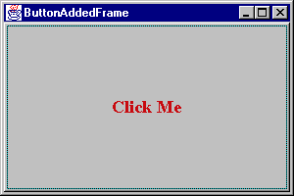
Here is the output:

After 3 clicks:

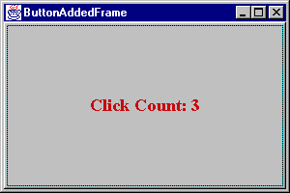

Layout Managers
Now that we know how to add a button on a Frame, let’s add 5 buttons on a Frame as follows:

// Code 9B
/** A Frame that has 5 buttons on it.
* @author Mohammed Ashequr Rahman
* @version 1.0
*/
import java.awt.*;
import java.awt.event.*;
public class MultiButtonAddedFrame extends ClosableFrame
{
// an array for buttons.
private Button[] buttons=new Button[5];
private int[] counts= new int[5];
/** Constructor that adds buttons to the frame.*/
public MultiButtonAddedFrame()
{
// call the super constructor
super();
// call the addButtons method that adds 5 buttons.
addButtons();
// instantiate blue Color and set it as background of the frame.
Color frameBackground = Color.blue;
setBackground(frameBackground);
}
/** This method will add 5 buttons to the frame.*/
private void addButtons()
{
// loop for 5 times.
for (int n=0; n < buttons.length; n++)
{
// instantiate buttons and assign caption.
buttons[n]=new Button("Button " + n);
// instantiate light gray color and use it for backcolor of buttons.
Color buttonBackground = Color.lightGray;
buttons[n].setBackground(buttonBackground);
// instantiate font object and use it for buttons.
Font buttonFont = new Font("TimesRoman",Font.BOLD,18);
buttons[n].setFont(buttonFont);
// add the buttons to the frame.
add(buttons[n]);
}
}
/** main method to test this class.*/
public static void main(String[] args)
{
// instantiate this object and make it visible.
MultiButtonAddedFrame frame = new MultiButtonAddedFrame();
frame.setVisible(true);
}
}

Here is the output:

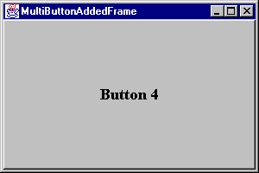
We have added “Button 0” through “Button 4” – 5 buttons. It is surprising to see that only the last button “Button 4” shows up on the Frame. How come? Since we did not tell the Frame how to lay these buttons out, it laid them out on top of each other, as a result the last button is visible. In order to solve the problem we have to add layout manager to the Frame. Layout Managers are added to a container using setLayout method. There are quite a few layout managers in Java. They are as follows:

Border Layout
This is the default layout manager for Frame. In border layout you put four controls around four edges (south, north, east, west) and the fifth one in the middle (center). You can optionally declare horizontal and vertical gap between them and components are laid out accordingly. Obviously you can add upto 5 components using this layout. We can easily get around this limitation by introducing intermediate containers that will contain other components. Code 9B actually uses border layout yet the buttons did not appear except for the last one. Since we did not specify where (east, west etc.) these buttons should appear they all used the default location – center. As a result they overlaid on top of each other. Here is the same program with a border layout:

// Code 9C

/** A Frame that has uses Border Layout.

* @author Mohammed Ashequr Rahman

* @version 1.0

*/

import java.awt.*;

import java.awt.event.*;

public class BorderLayoutAddedFrame extends ClosableFrame

{

// an array for buttons.

private Button[] buttons=new Button[5];

private int[] counts= new int[5];

/** Constructor that adds buttons to the frame.*/

public BorderLayoutAddedFrame()

{

// call the super constructor

super();

// instantiate Light Gray Color and set it as background of the frame.

Color frameBackground = Color.lightGray;

setBackground(frameBackground);

// set the layout of the frame.

// Horizontal gap between buttons: 10

// Vartical gap between buttons: 12

setLayout(new BorderLayout(10,12));

// call the createButtons method that instantiate 5 buttons.

createButtons();

// add the first button on the side North.

// set the caption to "North".

add(buttons[0],"North");

buttons[0].setLabel("North");

// same for the rest 4 buttons.

add(buttons[1],"South");

buttons[1].setLabel("South");

add(buttons[2],"East");

buttons[2].setLabel("East");

add(buttons[3],"West");

buttons[3].setLabel("West");

add(buttons[4],"Center");

buttons[4].setLabel("Center");

}

/** This method will instantiate 5 buttons.*/

private void createButtons()

{

// loop for 5 times.

for (int n=0; n < buttons.length; n++)

{

// instantiate buttons and assign caption.

buttons[n]=new Button();

// instantiate orange color and use it for backcolor of buttons.

Color buttonBackground = Color.orange;

buttons[n].setBackground(buttonBackground);

// instantiate font object and use it for buttons.

Font buttonFont = new Font("TimesRoman",Font.BOLD,18);

buttons[n].setFont(buttonFont);

}

}

/** main method to test this class.*/

public static void main(String[] args)

{

// instantiate this object and make it visible.

BorderLayoutAddedFrame frame = new BorderLayoutAddedFrame();

frame.setVisible(true);

}

}

Here is the output:

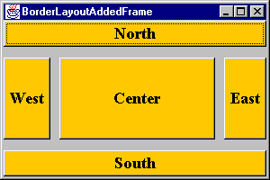

Flow Layout
A flow layout means that components are added left to right, keeping them centered on the Container and starting a new line whenever necessary. When you resize the container, components might move to next line or move up to the previous line depending on the size of the container. Components can be left or right justified on a line (instead of centered by default) by passing LEFT or RIGHT constant to the constructor of the flow layout manager. Here is the previous example with flow layout manager added in the constructor:

// Code 9D
/** A Frame that uses Flow Layout.
* @author Mohammed Ashequr Rahman
* @version 1.0
*/
import java.awt.*;
import java.awt.event.*;
public class FlowLayoutAddedFrame extends ClosableFrame
{
// an array for buttons.
private Button[] buttons=new Button[5];
private int[] counts= new int[5];
/** Constructor that adds buttons to the frame.*/
public FlowLayoutAddedFrame()
{
// call the super constructor
super();
// call the addButtons method that adds 5 buttons.
addButtons();
// instantiate Light Gray Color and set it as background of the frame.
Color frameBackground = Color.lightGray;
setBackground(frameBackground);
// set flow layout (with left justification)
setLayout(new FlowLayout(FlowLayout.LEFT));
}
/** This method will add 5 buttons to the frame.*/
private void addButtons()
{
// loop for 5 times.
for (int n=0; n < buttons.length; n++)
{
// instantiate buttons and assign caption.
buttons[n]=new Button("Button " + n);
// instantiate orange color and use it for backcolor of buttons.
Color buttonBackground = Color.orange;
buttons[n].setBackground(buttonBackground);
// instantiate font object and use it for buttons.
Font buttonFont = new Font("TimesRoman",Font.BOLD,18);
buttons[n].setFont(buttonFont);
// add the buttons to the frame.
add(buttons[n]);
}
}
/** main method to test this class.*/
public static void main(String[] args)
{
// instantiate this object and make it visible.
FlowLayoutAddedFrame frame = new FlowLayoutAddedFrame();
frame.setVisible(true);
}
}

Here is the output:
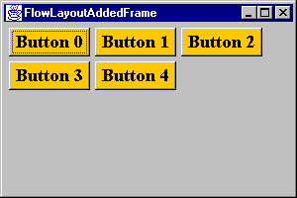

Notice the buttons on the second line are left justified not centered.

After resizing the window, the output looks like this:

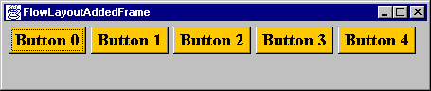

After another resize, it looks like this:

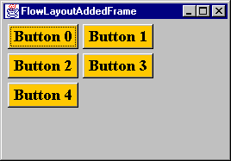

Grid Layout
In grid layout you specify the number of rows and columns and (optional) horizontal and vertical gap between them and components are laid out accordingly. One surprising thing about grid layout is that components change there size to match the grid size.

Here is the same program with grid layout:

// Code 9E
/** A Frame that uses Grid Layout.
* @author Mohammed Ashequr Rahman
* @version 1.0
*/
import java.awt.*;
import java.awt.event.*;
public class GridLayoutAddedFrame extends ClosableFrame
{
// an array for buttons.
private Button[] buttons=new Button[5];
private int[] counts= new int[5];
/** Constructor that adds buttons to the frame.*/
public GridLayoutAddedFrame()
{
// call the super constructor
super();
// call the addButtons method that adds 5 buttons.
addButtons();
// instantiate Gray Color and set it as background of the frame.
Color frameBackground = Color.lightGray;
setBackground(frameBackground);
// set grid layout.
// Rows:3
// Cols:2
// Horizontal gap:10
// Vartical gap:12
setLayout(new GridLayout(3,2,10,12));
}
/** This method will add 5 buttons to the frame.*/
private void addButtons()
{
// loop for 5 times.
for (int n=0; n < buttons.length; n++)
{
// instantiate buttons and assign caption.
buttons[n]=new Button("Button " + n);
// instantiate orange color and use it for backcolor of buttons.
Color buttonBackground = Color.orange;
buttons[n].setBackground(buttonBackground);
// instantiate font object and use it for buttons.
Font buttonFont = new Font("TimesRoman",Font.BOLD,18);
buttons[n].setFont(buttonFont);
// add the buttons to the frame.
add(buttons[n]);
}
}
/** main method to test this class.*/
public static void main(String[] args)
{
// instantiate this object and make it visible.
GridLayoutAddedFrame frame = new GridLayoutAddedFrame();
frame.setVisible(true);
}
}

Here is the output:

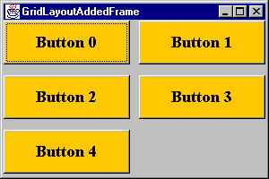
After resizing the window, the output looks like this:

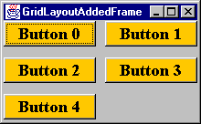

There are more layout managers but we will stop here. There is probably not a single layout manager that will meet your need. Instead, we have to group related components onto intermediate containers using one of the layout manager and then add the intermediate containers to the Frame. The Frame will probably use a different layout manager. In this fashion, we can mix and match different layouts to give us the desired layout.

Using No Layout Manager
Although is it recommended to use a layout manager, if you really don’t want to bother with layout manager but just want to drop components at certain location you can do that by calling setLayout(null) and then using the setBounds method of each component. setBounds takes four arguments x, y coordinate followed by width and height. However, here is the modified two methods:

// Code 9F
/** A Frame that uses No Layout.
* @author Mohammed Ashequr Rahman
* @version 1.0
*/
import java.awt.*;
import java.awt.event.*;
public class NoLayoutAddedFrame extends ClosableFrame
{
// an array for buttons.
private Button[] buttons=new Button[5];
private int[] counts= new int[5];
/** Constructor that adds buttons to the frame.*/
public NoLayoutAddedFrame()
{
// call the super constructor
super();
// call the addButtons method that adds 5 buttons.
addButtons();
// instantiate Gray Color and set it as background of the frame.
Color frameBackground = Color.lightGray;
setBackground(frameBackground);
// set no layout.
setLayout(null);
}
/** This method will add 5 buttons to the frame.*/
private void addButtons()
{
// intial x and y coordinate of button.
int nX=0;
int nY=40;
// loop for 5 times.
for (int n=0; n < buttons.length; n++)
{
// instantiate buttons and assign caption.
buttons[n]=new Button("Button " + n);
// instantiate orange color and use it for backcolor of buttons.
Color colButtonBackground = Color.orange;
buttons[n].setBackground(colButtonBackground);
// set the size of each button.
buttons[n].setBounds(nX,nY,80,40);
// instantiate font object and use it for buttons.
Font fntButtonFont = new Font("TimesRoman",Font.BOLD,18);
buttons[n].setFont(fntButtonFont);
// add the buttons to the frame.
add(buttons[n]);
// increment x and y coordinate for the next button.
nX +=84;
nY +=44;
}
}
/** main method to test this class.*/
public static void main(String[] args)
{
// instantiate this object, set it's size and make it visible.
NoLayoutAddedFrame nlafNew = new NoLayoutAddedFrame();
nlafNew.setSize(450,300);
nlafNew.setVisible(true);
}
}

Here is how the output looks:

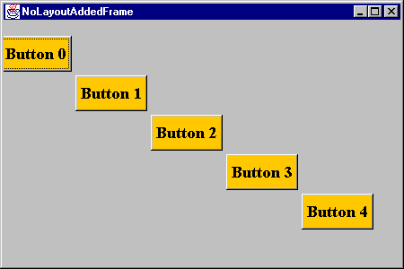

Label
A Label object is a component for placing text in a container. A label displays a single line of read-only text. The text can be changed by the application, but a user cannot edit it directly. A Label, as the name implies, is primarily used to label other visual component.

Constructors
Label() | Constructs an empty label.
Label(String text) | Constructs a new label with the specified string of text, left justified.
Label(String text, int alignment) | Constructs a new label that presents the specified string of text with the specified alignment.

Useful Methods
setText(String text) | void | Sets the text for this label to the specified text.
getText() | String | Gets the text of this label.
setAlignment(int alignment) | void | Sets the alignment for this label to the specified alignment.
getAlignment() | int | Gets the current alignment of this label.

TextField

A TextField object is a text component that allows for the editing of a single line of text.

Constructors
TextField() | Constructs a new text field.
TextField(int columns) | Constructs a new empty text field with the specified number of columns.
TextField(String text) | Constructs a new text field initialized with the specified text.
TextField(String text, int columns) | Constructs a new text field initialized with the specified text to be displayed, and wide enough to hold the specified number of columns.

TextArea

A TextArea object is a multi-line region that allows editing.

Constructors
TextArea() | Constructs a new text area.
TextArea(int rows, int columns) | Constructs a new empty text area with the specified number of rows and columns.
TextArea(String text) | Constructs a new text area with the specified text.
TextArea(String text, int rows, int columns) | Constructs a new text area with the specified text, and with the specified number of rows and columns.
TextArea(String text, int rows, int columns, int scrollbars) | Constructs a new text area with the specified text, and with the rows, columns, and scroll bar visibility as specified. Available choices for scrollbars are :  SCROLLBARS_NONE  SCROLLBARS_VERTICAL_ONLY  SCROLLBARS_HORIZONTAL_ONLY  SCROLLBARS_BOTH  These are four ‘static int’ variables in TextArea Class.

Useful Methods of TextField and TextArea
setText(String t) | void | Sets the text that is presented by this text component to be the specified text.
getText() | String | Gets the text that is presented by this text component.
setEditable(boolean b) | void | Sets the flag that determines whether or not this text component is editable.
isEditable() | boolean | Indicates whether or not this text component is editable.
append(String str) | void | Appends the given text to the text area's current text.
insert(String str, int pos) | void | Inserts the specified text at the specified position in this text area.
replaceRange(String str, int start, int end) | void | Replaces text between the indicated start and end positions with the specified replacement text.
addTextListener(TextListener l) | void | Adds the specified text event listener to receive text events from this text component.
removeTextListener(TextListener l) | void | Removes the specified text event listener so that it no longer receives text events from this text component If l is null, no exception is thrown and no action is performed.
selectAll() | void | Selects all the text in this text component.
select(int selectionStart, int selectionEnd) | void | Selects the text between the specified start and end positions.
getSelectedText() | String | Gets the selected text from the text that is presented by this text component.
setSelectionStart(int selectionStart) | void | Sets the selection start for this text component to the specified position.
getSelectionStart() | int | Gets the start position of the selected text in this text component.
setSelectionEnd(int selectionEnd) | void | Sets the selection end for this text component to the specified position.
getSelectionEnd() | int | Gets the end position of the selected text in this text component.
paramString() | String | Returns the parameter string representing the state of this text area.

TextField Specific Methods
setEchoChar(char c) | void | Sets the echo character for this text field.
getEchoChar() | char | Gets the character that is to be used for echoing.
echoCharIsSet() | boolean | Indicates whether or not this text field has a character set for echoing.
addActionListener(ActionListener l) | void | Adds the specified action listener to receive action events from this text field.
removeActionListener(ActionListener l) | void | Removes the specified action listener so that it no longer receives action events from this text field.

TextArea Specific Methods
setRows(int rows) | void | Sets the number of rows for this text area.
getRows() | int | Gets the number of rows in the text area.
setColumns(int columns) | void | Sets the number of columns for this text area.
getColumns() | int | Gets the number of columns in this text area.
getScrollbarVisibility() | int | Gets an enumerated value that indicates which scroll bars the text area uses.

Panel
Panel is the simplest intermediate container class. A panel provides space in which an application can attach any other component, including other panels. The default layout manager for a panel is the FlowLayout layout manager. Panel’s add method allows us to add components to the Panel and then the Panel needs to be added to a top level container like Frame or Applet. Panel allows us to group a number of components together and apply a different layout manager from the top level container’s layout manager.

Constructors
Panel() | Creates a new panel using the default layout manager.
Panel(LayoutManager layout) | Creates a new panel with the specified layout manager.

Here is an example of Label, TextField, TextArea, Panel and Button used in one window:

// Code 9G
/** A Frame that has label and text components.
* @author Mohammed Ashequr Rahman
* @version 1.0
*/
import java.awt.*;
import java.awt.event.*;
public class LabelAndTextComponentAddedFrame extends ClosableFrame
{
private Panel panel;
private Label labelId;
private TextField textFieldId;
private Label labelPassword;
private TextField textFieldPassword;
private Button showButton;
private TextArea textArea;
/** Constructor.*/
public LabelAndTextComponentAddedFrame()
{
// call super constructor.
super();
// add controls on the frame.
addControls();
// change backcolor to light gray.
Color frameBackground = Color.lightGray;
setBackground(frameBackground);
}
/** Add panel, label, textfield and textarea on the frame.*/
private void addControls()
{
// label and field for user id.
labelId = new Label("Enter User ID:");
textFieldId = new TextField(8);
// label and field for password.
labelPassword= new Label("Enter Password");
textFieldPassword = new TextField(8);
// change the text field's echo character to '*'.
textFieldPassword.setEchoChar('*');
// a button.
showButton = new Button("Show Input");
// add action listener to the button.
showButton.addActionListener(new LabelAndTextComponentAddedFrame.InnerActionListener());
// read only text area.
textArea = new TextArea(2,20);
textArea.setEditable(false);
// panel as intermediate container.
panel = new Panel();
//add labels and text fields and a button to the panel.
// panel uses flow layout by default.
panel.add(labelId);
panel.add(textFieldId);
panel.add(labelPassword);
panel.add(textFieldPassword);
panel.add(showButton);
// add the panel to the "North" side of the frame.
// frame uses border layout by default.
// since the panel contains label, text fields and button
// they will also apprea on the north side of the frame.
add(panel,"North");
// add the text area to the "Center" of the frame.
add(textArea,"Center");
}
private class InnerActionListener implements ActionListener
{
/** overridden method of action listener interface.
* that shows user id and password.
*/
public void actionPerformed(ActionEvent p1)
{
// show user id and password on the text area.
textArea.setText("ID: " + textFieldId.getText() + "\n"
+ "Password: " + textFieldPassword.getText() + "\n");
}
}
/** tester for this class.*/
public static void main(String[] args)
{
// instantiate an object of this class.
LabelAndTextComponentAddedFrame frame = new LabelAndTextComponentAddedFrame();
// set size and make it visible.
frame.setSize(500,200);
frame.setVisible(true);
}
}

Here is the output:

Please note that we did not specify any Layout Manager in the above example. The Frame is using Border Layout Manager by Default and the Panel is using Flow Layout Manager by Default.

Also note that we made the text area is read-only, we can not modify the content of the text area.

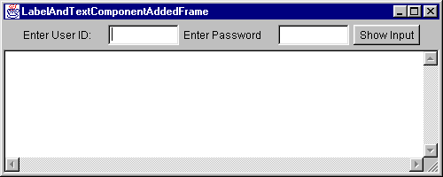

CheckBox
A check box is a graphical component that can be in either an "on" (true) or "off" (false) state. Clicking on a check box changes its state from "on" to "off," or from "off" to "on."

Constuctors
Checkbox() | Creates a check box with no label.
Checkbox(String label) | Creates a check box with the specified label.
Checkbox(String label, boolean state) | Creates a check box with the specified label and sets the specified state.
Checkbox(String label, boolean state, CheckboxGroup group) | Creates a check box with the specified label, in the specified check box group, and set to the specified state.
Checkbox(String label, CheckboxGroup group, boolean state) | Constructs a Checkbox with the specified label, set to the specified state, and in the specified check box group.

Useful Methods
setLabel(String label) | void | Sets this check box's label to be the string argument.
getLabel() | String | Gets the label of this check box.
setState(boolean state) | void | Sets the state of this check box to the specified state.
getState() | boolean | Determines whether this check box is in the "on" or "off" state.
addItemListener(ItemListener l) | void | Adds the specified item listener to receive item events from this check box.
removeItemListener(ItemListener l) | void | Removes the specified item listener so that the item listener no longer receives item events from this check box.
setCheckboxGroup(CheckboxGroup g) | void | Sets this check box's group to be the specified check box group.
getCheckboxGroup() | CheckboxGroup | Determines this check box's group.
paramString() | String | Returns the parameter string representing the state of this check box.

Here is an example where we are logging the state of the checkboxes as they are changing:

// Code 9H
/** A Frame that has checkbox.
* @author Mohammed Ashequr Rahman
* @version 1.0
*/
import java.awt.*;
import java.awt.event.*;
public class CheckboxAddedFrame extends ClosableFrame
{
private Panel panel;
private Checkbox red;
private Checkbox green;
private Checkbox blue;
private TextArea textArea;
/** Constructor that adds controls on the frame.*/
public CheckboxAddedFrame()
{
// call super contructor and add controls.
super();
addControls();
// change backcolor to light gray.
Color frameBackground = Color.lightGray;
setBackground(frameBackground);
}
/** Add checkbox on the frame.*/
private void addControls()
{
// instantiate three checkboxes with listeners.
red = new Checkbox("Red");
red.addItemListener(new InnerRedItemListener());
green = new Checkbox("Green");
green.addItemListener(new CheckboxAddedFrame.InnerGreentemListener());
blue = new Checkbox("Blue");
blue.addItemListener(new InnerBlueItemListener());
// instantiate readonly testarea.
textArea = new TextArea(2,20);
textArea.setEditable(false);
// instantiate a panel with grid layout.
panel = new Panel(new GridLayout(0,1));
// add three checkboxes to the panel.
panel.add(red);
panel.add(green);
panel.add(blue);
// add the panel to the "West" side of the frame.
add(panel,"West");
// add the text area to the "Center" of the frame.
add(textArea,"Center");
}
private class InnerRedItemListener implements ItemListener
{
/** overridden method of item listener interface.*/
public void itemStateChanged(ItemEvent p1)
{
String stateString;
// get the stateString of the checkbox being clicked on.
boolean state=((Checkbox) p1.getSource()).getState();
stateString= "Red: " + state;
// append the check box name and it's stateString on the text area.
textArea.setText(textArea.getText() + stateString + "\n");
}
}
private class InnerBlueItemListener implements ItemListener
{
/** overridden method of item listener interface.*/
public void itemStateChanged(ItemEvent p1)
{
String stateString;
// get the stateString of the checkbox being clicked on.
boolean state=blue.getState();
stateString= "Blue: " + state;
// append the check box name and it's stateString on the text area.
textArea.setText(textArea.getText() + stateString + "\n");
}
}
private class InnerGreentemListener implements ItemListener
{
/** overridden method of item listener interface.*/
public void itemStateChanged(ItemEvent p1)
{
// append the check box name and it's stateString on the text area.
textArea.setText(textArea.getText() + "Green: " + green.getState() + "\n");
}
}
/** tester for this object.*/
public static void main(String[] args)
{
// instantiate an object of this class.
CheckboxAddedFrame frame = new CheckboxAddedFrame();
// set size and make it visible.
frame.setSize(500,300);
frame.setVisible(true);
}
}

Here is the output:

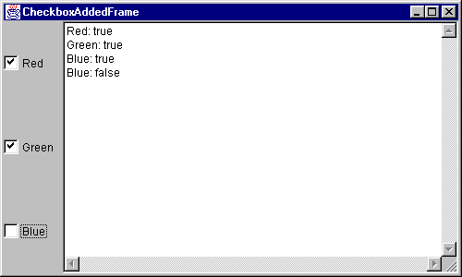

CheckboxGroup
The CheckboxGroup class is used to group together a set of Checkbox buttons.
Exactly one check box button in a CheckboxGroup can be in the "on" state at any given time. Pushing any button sets its state to "on" and forces any other button that is in the "on" state into the "off" state. In other words, check boxes become Radio Buttons (also known as Option Buttons) when they are part of check box group.

Constructor
CheckboxGroup() | Creates a new instance of CheckboxGroup.

Useful Methods
setSelectedCheckbox(Checkbox box) | void | Sets the currently selected check box in this group to be the specified check box.
getSelectedCheckbox() | Checkbox | Gets the current choice from this check box group.

Here is the same set of check boxes appearing as mutually exclusive Option Button because they are part of CheckBoxGroup:

// Code 9I
/** A Frame that has radio buttons.
* @author Mohammed Ashequr Rahman
* @version 1.0
*/
import java.awt.*;
import java.awt.event.*;
public class CheckboxGroupAddedFrame extends ClosableFrame
{
private CheckboxGroup group;
private Panel panel;
private Checkbox red;
private Checkbox green;
private Checkbox blue;
private TextArea textArea;
/** Constructor that adds controls on the frame.*/
public CheckboxGroupAddedFrame()
{
// call super contructor and add controls.
super();
addControls();
// change backcolor to light gray.
Color frameBackground = Color.lightGray;
setBackground(frameBackground);
}
/** Add checkbox on the frame.*/
private void addControls()
{
// instantiate a check box group object.
group = new CheckboxGroup();
// instantiate three checkboxes under the same group.
// make them unchecked by using the flag 'false'.
// add listener the checkboxes.
red = new Checkbox("Red",group,false);
red.addItemListener(new InnerRedItemListener());
green = new Checkbox("Green",group,false);
green.addItemListener(new InnerGreentemListener());
blue = new Checkbox("Blue",group,false);
blue.addItemListener(new InnerBlueItemListener());
// instantiate readonly testarea.
textArea = new TextArea(2,20);
textArea.setEditable(false);
// instantiate a panel with grid layout.
panel = new Panel(new GridLayout(0,1));
// add three checkboxes to the panel.
panel.add(red);
panel.add(green);
panel.add(blue);
// add the panel to the "West" side of the frame.
add(panel,"West");
// add the text area to the "Center" of the frame.
add(textArea,"Center");
}
private class InnerRedItemListener implements ItemListener
{
/** overridden method of item listener interface.*/
public void itemStateChanged(ItemEvent p1)
{
String stateString;
// get the state of the checkbox being clicked on.
boolean state=((Checkbox) p1.getSource()).getState();
stateString= "Red: " + state;
// append the check box name and it's state on the text area.
textArea.setText(textArea.getText() + stateString + "\n");
}
}
private class InnerBlueItemListener implements ItemListener
{
/** overridden method of item listener interface.*/
public void itemStateChanged(ItemEvent p1)
{
String stateString;
// get the state of the checkbox being clicked on.
boolean state=blue.getState();
stateString= "Blue: " + state;
// append the check box name and it's state on the text area.
textArea.setText(textArea.getText() + stateString + "\n");
}
}
private class InnerGreentemListener implements ItemListener
{
/** overridden method of item listener interface.*/
public void itemStateChanged(ItemEvent p1)
{
// append the check box name and it's state on the text area.
textArea.setText(textArea.getText() + "Green: " + green.getState() + "\n");
}
}
/** tester for this object.*/
public static void main(String[] args)
{
// instantiate an object of this class.
CheckboxGroupAddedFrame frame = new CheckboxGroupAddedFrame();
// set size and make it visible.
frame.setSize(500,300);
frame.setVisible(true);
}
}

Here is the output:

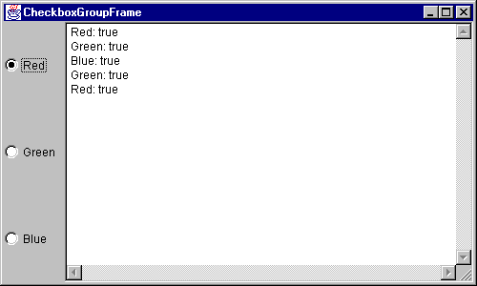
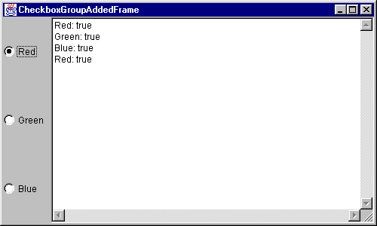

Choice

The Choice class presents a drop down list of choices.

Constructor
Choice() | Creates a new instance of choice.

Useful Methods
select(int pos) | void | Sets the selected item in this Choice menu to be the item at the specified position. If the index is out of bound Java throws exception. Use getItemCount() before using this method.
select(String str) | void | Sets the selected item in this Choice menu to be the item whose name is equal to the specified string. If no matching string is found Java simply ignores it and selected the first item.
getSelectedItem() | String | Gets a representation of the current choice as a string.
getSelectedIndex() | int | Returns the index of the currently selected item.
add(String item)  addItem(String item) | void | Adds an item to this Choice. Both method does the exact same thing!!!  Use add method to be consistent with List.
insert(String item, int index) | void | Inserts the item into this choice at the specified position. If the index is out of bound Java simply ignores it and adds the item at the bottom.
getItem(int index) | String | Gets the string at the specified index in this Choice menu. If the index is out of bound Java throws exception. Use getItemCount() before using this method.
remove(int position) | void | Removes an item from the choice menu at the specified position. If the index is out of bound Java throws exception. Use getItemCount() before using this method.
remove(String item) | void | Remove the first occurrence of item from the Choice menu. If the String is not found Java throws exception.
removeAll() | void | Removes all items from the choice menu.
getItemCount() | int | Returns the number of items in this Choice menu.
addItemListener(ItemListener l) | void | Adds the specified item listener to receive item events from this Choice menu.
removeItemListener(ItemListener l) | void | Removes the specified item listener so that it no longer receives item events from this Choice menu.
paramString() | String | Returns the parameter string representing the state of this choice menu.

Here is an example:

// Code 9J
/** A Frame that has dropdown list (Choice).
* @author Mohammed Ashequr Rahman
* @version 1.0
*/
import java.awt.*;
import java.awt.event.*;
public class ChoiceAddedFrame extends ClosableFrame
{
private Panel panel;
private Choice fruits;
private TextField textArea;
/** Constructor that adds drop down list on a frame.*/
public ChoiceAddedFrame()
{
// call super constructor and add drop down list.
super();
addControls();
// change backcolor of the frame to light gray.
Color frameBackground = Color.lightGray;
setBackground(frameBackground);
}
/** method to add drop down list on a frame.*/
private void addControls()
{
// instantiate a choice object.
fruits = new Choice();
// add items to the choice.
fruits.add("Apple");
fruits.add("Orange");
fruits.add("Banana");
// add listener.
fruits.addItemListener(new InnerItemListener());
// instantiate a readonly text field
textArea = new TextField();
textArea.setEditable(false);
// instantiate a panel with left justified flow layout.
panel = new Panel(new FlowLayout(FlowLayout.LEFT));
// add choice to the panel.
panel.add(fruits);
// add the panel to the north side of the frame.
add(panel,"North");
// add the text field to the south side of the frame.
add(textArea,"South");
}
private class InnerItemListener implements ItemListener
{
/** overridden method of the item listener interface.*/
public void itemStateChanged(ItemEvent p1)
{
// show the selected item on the text field.
textArea.setText("Selected Item: "+
fruits.getSelectedItem());
}
}
/** tester for this class.*/
public static void main(String[] args)
{
// instantiate an object of this class.
ChoiceAddedFrame frame = new ChoiceAddedFrame();
// set size and make it visible.
frame.setSize(200,200);
frame.setVisible(true);
}
}

Here is the output:

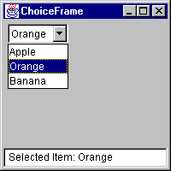
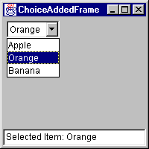

List

Constructor
List() | Creates a new scrolling list.
List(int rows) | Creates a new scrolling list initialized with the specified number of visible lines.
List(int rows, boolean multipleMode) | Creates a new scrolling list initialized to display the specified number of rows.

Useful Methods
addItemListener(ItemListener l) | void | Adds the specified item listener to receive item events from this list.
removeItemListener(ItemListener l) | void | Removes the specified item listener so that it no longer receives item events from this list.
addActionListener(ActionListener l) | void | Adds the specified action listener to receive action events from this list.
removeActionListener(ActionListener l) | void | Removes the specified action listener so that it no longer receives action events from this list.
setMultipleMode(boolean b) | void | Sets the flag that determines whether this list allows multiple selections.
isMultipleMode() | boolean | Determines whether this list allows multiple selections.
add(String item) | void | Adds the specified item to the end of scrolling list.
add(String item, int index) | void | Adds the specified item to the scrolling list at the position indicated by the index. This replaces the insert() method of Choice. There is insert() method for List.
replaceItem(String newValue, int index) | void | Replaces the item at the specified index in the scrolling list with the new string.
remove(int position) | void | Remove the item at the specified position from this scrolling list.
remove(String item) | void | Removes the first occurrence of an item from the list.
removeAll() | void | Removes all items from this list.
select(int index) | void | Selects the item at the specified index in the scrolling list. There is no Select(String item) method of List.
deselect(int index) | void | Deselects the item at the specified index.
getSelectedItem() | String | Get the selected item on this scrolling list.
getSelectedItems() | String[] | Get the selected items on this scrolling list.
getSelectedIndex() | int | Gets the index of the selected item on the list,
getSelectedIndexes() | int[] | Gets the selected indexes on the list.
getItem(int index) | String | Gets the item associated with the specified index.
isIndexSelected(int index) | boolean | Determines if the specified item in this scrolling list is selected.
getItemCount() | int | Gets the number of items in the list.
getItems() | String[] | Gets the items in the list.
getRows() | int | Get the number of visible lines in this list.
makeVisible(int index) | void | Makes the item at the specified index visible.
getVisibleIndex() | int | Gets the index of the item that was last made visible by the method makeVisible.
paramString() | String | Returns the parameter string representing the state of this scrolling list.

Here is an example of list:

// Code 9K
/** A Frame that has listbox.
* @author Mohammed Ashequr Rahman
* @version 1.0
*/
import java.awt.*;
import java.awt.event.*;
public class ListAddedFrame extends ClosableFrame
{
private Panel panel;
private List fruits;
private TextField textField;
/** Constructor that adds listbox on a frame.*/
public ListAddedFrame()
{
// call super constructor and add listbox.
super();
addControls();
// change backcolor of the frame to light gray.
Color frameBackground = Color.lightGray;
setBackground(frameBackground);
}
/** method to add listbox on a frame.*/
private void addControls()
{
// instantiate a List object.
// the list will display 3 rows at any time.
fruits = new List(3);
// add items to the List.
fruits.add("Apple");
fruits.add("Orange");
fruits.add("Banana");
fruits.add("Grape");
fruits.add("Mango");
// add listener.
fruits.addItemListener(new InnerItemListerner());
// instantiate a readonly text field
textField = new TextField();
textField.setEditable(false);
// instantiate a panel with left justified flow layout.
panel = new Panel(new FlowLayout(FlowLayout.LEFT));
// add List to the panel.
panel.add(fruits);
// add the panel to the north side of the frame.
add(panel,"North");
// add the text field to the south side of the frame.
add(textField,"South");
}
private class InnerItemListerner implements ItemListener
{
/** overridden method of the item listener interface.*/
public void itemStateChanged(ItemEvent p1)
{
// show the selected item on the text field.
textField.setText("Selected Item: "+
fruits.getSelectedItem());
}
}
/** tester for this class.*/
public static void main(String[] args)
{
// instantiate an object of this class.
ListAddedFrame frame = new ListAddedFrame();
// set size and make it visible.
frame.setSize(200,200);
frame.setVisible(true);
}
}

Here is the output:

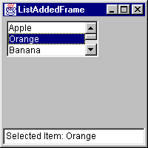
A list also be multi-select list if you set the multiple mode in its constructor or using setMultipleMode() method. Here is an example of multi-select list:

// Code 9L
/** A Frame that has multiselect listbox.
* @author Mohammed Ashequr Rahman
* @version 1.0
*/
import java.awt.*;
import java.awt.event.*;
public class MultiSelectListAddedFrame extends ClosableFrame
{
private Panel panel;
private List fruits;
private TextArea textArea;
/** no-argument constructor.*/
public MultiSelectListAddedFrame()
{
// call super constructor.
super();
// add objects to the frame.
addControls();
// change backcolor of the frame to light gray.
Color frameBackground = Color.lightGray;
setBackground(frameBackground);
}
/** adds multiselect list box to the frame.*/
private void addControls()
{
// instantiate a list with 4 visible rows
// make it multiselect by passing 'true' flag
fruits = new List(4,true);
// add items to the list.
fruits.add("Apple");
fruits.add("Orange");
fruits.add("Banana");
fruits.add("Grape");
fruits.add("Mango");
// add listener to the list.
fruits.addItemListener(new InnerItemListener());
// instantiate readonly textarea
textArea = new TextArea(5,0);
textArea.setEditable(false);
// instantiate panel.
panel = new Panel(new FlowLayout(FlowLayout.LEFT));
// add list to the panel.
panel.add(fruits);
// add panel to the "North" side.
add(panel,"North");
// add text area to the "South" side.
add(textArea,"South");
}
private class InnerItemListener implements ItemListener
{
/** overridden method of item listener interface.*/
public void itemStateChanged(ItemEvent p1)
{
// an array for selected item.
String[] fruitsArray;
// string to store selected items.
String selectedFruits=new String();
// get the selected items.
fruitsArray=fruits.getSelectedItems();
// if one or more item is selected - prepare the string for display.
if (fruitsArray.length >0)
{
selectedFruits="Selected Items:\n";
// loop through all the selected items.
for (int n=0; n < fruitsArray.length; n++)
{
selectedFruits=selectedFruits + fruitsArray[n] + "\n";
}
}
// display the string.
textArea.setText(selectedFruits);
}
}
/** the main method for testing this class.*/
public static void main(String[] args)
{
// instantiate a multi select list frame.
MultiSelectListAddedFrame frame = new MultiSelectListAddedFrame();
//set size and make it visible.
frame.setSize(200,300);
frame.setVisible(true);
}
}

Here is the output:
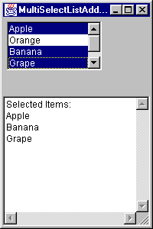

Creating Menu
First of all, menus are not subclasses of component hierarchy. The classes in the java.awt package that enables you to create menu form a separate class hierarchy based on the class MenuComponent which is derived from object.

There are a few classes related to Menu:

- Menu Bar – this is the horizontal bar that holds a set of menu items like File, Edit, View etc.
- Menu – these are the menu options appear on menu bar. File, Edit, View etc are menus.
- MenuItem – these are the menu options appear on menu. Open, Close, Print etc. are menu items.
4) CheckboxMenuItem – these are the menu items that has a checkbox next to them.

MenuBar
The MenuBar class encapsulates the platform's concept of a menu bar bound to a frame. In order to associate the menu bar with a Frame object, call the frame's setMenuBar method.

Constructor
MenuBar() | Creates a new MenuBar.

Useful Methods
add(Menu m) | Menu | Adds the specified menu to the menu bar.
remove(int index) | void | Removes the menu located at the specified index from this menu bar.
remove(MenuComponent m) | void | Removes the specified menu component from this menu bar.
setHelpMenu(Menu m) | void | Sets the help menu on this menu bar to be the specified menu.
getHelpMenu() | Menu | Gets the help menu on the menu bar.
getMenuCount() | int | Gets the number of menus on the menu bar.
getMenu(int i) | Menu | Gets the specified menu.
getShortcutMenuItem(MenuShortcut s) | MenuItem | Gets the instance of MenuItem associated with the specified MenuShortcut object, or null if none of the menu items being managed by this menu bar is associated with the specified menu shortcut.
shortcuts() | Enumeration | Gets an enumeration of all menu shortcuts this menu bar is managing.

Menu
A Menu object is a pull-down menu component that is deployed from a menu bar.
A menu can optionally be a tear-off menu. A tear-off menu can be opened and dragged away from its parent menu bar or menu. It remains on the screen after the mouse button has been released. The mechanism for tearing off a menu is platform dependent, since the look and feel of the tear-off menu is determined by its peer. On platforms that do not support tear-off menus, the tear-off property is ignored.
Each item in a menu must belong to the MenuItem class. It can be an instance of MenuItem, a submenu (an instance of Menu), or a check box (an instance of CheckboxMenuItem).

Constructors
Menu() | Constructs a new menu with an empty label.
Menu(String label) | Constructs a new menu with the specified label.
Menu(String label, boolean tearOff) | Constructs a new menu with the specified label, indicating whether the menu can be torn off.

Useful Methods
add(MenuItem mi) | MenuItem | Adds the specified menu item to this menu.
add(String label) | void | Adds an item with the specified label to this menu.
insert(MenuItem menuitem, int index) | void | Inserts a menu item into this menu at the specified position.
insert(String label, int index) | void | Inserts a menu item with the specified label into this menu at the specified position.
addSeparator() | void | Adds a separator line, or a hypen, to the menu at the current position.
insertSeparator(int index) | void | Inserts a separator at the specified position.
remove(int index) | void | Removes the menu item at the specified index from this menu.
remove(MenuComponent item) | void | Removes the specified menu item from this menu.
removeAll() | void | Removes all items from this menu.
getItemCount() | int | Get the number of items in this menu.
getItem(int index) | MenuItem | Gets the item located at the specified index of this menu.
isTearOff() | boolean | Indicates whether this menu is a tear-off menu.

MenuItem

The MenuItem object embodies a simple labeled menu item.

Constructors
MenuItem() | Constructs a new MenuItem with an empty label and no keyboard shortcut.
MenuItem(String label) | Constructs a new MenuItem with the specified label and no keyboard shortcut.
MenuItem(String label, MenuShortcut s) | Create a menu item with an associated keyboard shortcut.

Useful Methods
setLabel(String label) | void | Sets the label for this menu item to the specified label.
getLabel() | String | Gets the label for this menu item.
setEnabled(boolean b) | void | Sets whether or not this menu item can be chosen.
isEnabled() | boolean | Checks whether this menu item is enabled.
addActionListener(ActionListener l) | void | Adds the specified action listener to receive action events from this menu item.
removeActionListener(ActionListener l) | void | Removes the specified action listener so it no longer receives action events from this menu item.
setShortcut(MenuShortcut s) | void | Set the MenuShortcut object associated with this menu item.
deleteShortcut() | void | Delete any MenuShortcut object associated with this menu item.
getShortcut() | MenuShortcut | Get the MenuShortcut object associated with this menu item,
setActionCommand(String command) | void | Sets the command name of the action event that is fired by this menu item.
getActionCommand() | String | Gets the command name of the action event that is fired by this menu item.

CheckboxMenuItem
This class is a subclass of MenuItem. This class represents a check box that can be included in a menu. Clicking on the check box in the menu changes its state from "on" to "off" or from "off" to "on."

Constructors
CheckboxMenuItem() | Create a check box menu item with an empty label.
CheckboxMenuItem(String label) | Create a check box menu item with the specified label.
CheckboxMenuItem(String label, boolean state) | Create a check box menu item with the specified label and state.

CheckboxMenuItem inherits add methods from MenuItem. In addition, it has the following useful methods:

Useful Methods
setState(boolean b) | void | Sets this check box menu item to the specifed state.
getState() | boolean | Determines whether the state of this check box menu item is "on" or "off."
addItemListener(ItemListener l) | void | Adds the specified item listener to receive item events from this check box menu item.
removeItemListener(ItemListener l) | void | Removes the specified item listener so that it no longer receives item events from this check box menu item.
getSelectedObjects() | Object[] | Returns the an array (length 1) containing the checkbox menu item label or null if the checkbox is not selected.

MenuShortcut
A class which represents a keyboard accelerator for a MenuItem. MenuShortcut objects are used by the MenuItem to create shortcuts like Control + C, Control + O etc. for MenuItems.

Constructors
MenuShortcut(int key) | Constructs a new MenuShortcut for the specified key.
MenuShortcut(int key, boolean useShiftModifier) | Constructs a new MenuShortcut for the specified key.

Here is an example of menu added frame:

// Code 9M
/** A Frame that has menu.
* @author Mohammed Ashequr Rahman
* @version 1.0
*/
import java.awt.*;
import java.awt.event.*;
public class MenuAddedFrame extends ClosableFrame
{
private MenuBar menuBar;
private Menu fileMenu;
private MenuItem fileOpenMenuItem;
private MenuItem fileCloseMenuItem;
private MenuItem fileExitMenuItem;
private Menu editMenu;
private MenuItem editCutMenuItem;
private MenuItem editCopyMenuItem;
private MenuItem editPasteMenuItem;
private Menu colorMenu;
private CheckboxMenuItem redCheckboxMenuItem;
private CheckboxMenuItem greenCheckboxMenuItem;
private CheckboxMenuItem blueCheckboxMenuItem;
private TextField textField;
/** constructor that adds menu.*/
public MenuAddedFrame()
{
// call the super constructor and add menu.
super();
addControls();
// set backcolor.
Color frameBackground = Color.lightGray;
setBackground(frameBackground);
}
/** method that adds menu.*/
private void addControls()
{
// instantiate a menubar.
menuBar= new MenuBar();
// instantiate a file menu.
fileMenu = new Menu("File");
// instantiate a Control+O shortcut for open.
MenuShortcut fileOpenMenuShortcut= new MenuShortcut('O'); //Control+O;
// intantiate a menu item for open with shortcut.
fileOpenMenuItem = new MenuItem("Open",fileOpenMenuShortcut);
// instantiate a menu item for close with shortcut Control+L.
MenuShortcut fileCloseMenuShortcut= new MenuShortcut('L'); //Control+L;
fileCloseMenuItem = new MenuItem("Close",fileCloseMenuShortcut);
// instantiate a menu itme for exit with shortcut Control+Shift+X.
// the last flag 'true' is used to include shift on the shortcut.
MenuShortcut fileExitMenuShortcut= new MenuShortcut('X',true); //Control+Shift+X;
fileExitMenuItem = new MenuItem("Exit",fileExitMenuShortcut);
// add open and close menu items to file menu.
fileMenu.add(fileOpenMenuItem);
fileMenu.add(fileCloseMenuItem);
// add a separator to file menu.
fileMenu.addSeparator();
// now add exit menu item to file menu.
fileMenu.add(fileExitMenuItem);
// instantiate edit menu.
editMenu = new Menu("Edit");
// instantiate cut, copy and paste menu items with shortcuts.
MenuShortcut editCutMenuShortcut= new MenuShortcut('X'); //Control+X;
editCutMenuItem = new MenuItem("Cut",editCutMenuShortcut);
MenuShortcut editCopyMenuShortcut= new MenuShortcut('C'); //Control+C;
editCopyMenuItem = new MenuItem("Copy",editCopyMenuShortcut);
MenuShortcut editPasteMenuShortcut= new MenuShortcut('V'); //Control+V;
editPasteMenuItem = new MenuItem("Paste",editPasteMenuShortcut);
// add cut, copy and paste menu items to edit menu.
editMenu.add(editCutMenuItem);
editMenu.add(editCopyMenuItem);
editMenu.add(editPasteMenuItem);
// add a separator to edit menu.
editMenu.addSeparator();
// instantiate a color menu.
colorMenu = new Menu("Color");
// instantiate check box menu items red, green and blue.
// make green checked by adding the flag 'true'.
redCheckboxMenuItem= new CheckboxMenuItem("Red");
greenCheckboxMenuItem =new CheckboxMenuItem("Green",true);
blueCheckboxMenuItem=new CheckboxMenuItem("Blue");
// add the check box menu items to color menu.
colorMenu.add(redCheckboxMenuItem);
colorMenu.add(greenCheckboxMenuItem);
colorMenu.add(blueCheckboxMenuItem);
// add the color menu to edit menu.
// notice we are adding menu(not menu item) to menu.
editMenu.add(colorMenu);
// add the file and edit menu to the menu bar.
menuBar.add(fileMenu);
menuBar.add(editMenu);
// add the menu bar to the frame.
setMenuBar(menuBar);
// instantiate a readonly text field and add it to the frame.
textField = new TextField();
textField.setEditable(false);
add(textField,"South");
// add action listener to all the menu items.
fileOpenMenuItem.addActionListener(new InnerActionListener());
fileCloseMenuItem.addActionListener(new InnerActionListener());
fileExitMenuItem.addActionListener(new InnerActionListener());
editCutMenuItem.addActionListener(new InnerActionListener());
editCopyMenuItem.addActionListener(new InnerActionListener());
editPasteMenuItem.addActionListener(new InnerActionListener());
// add item listener to all the check box menu items.
redCheckboxMenuItem.addItemListener(new InnerItemListener());
blueCheckboxMenuItem.addItemListener(new InnerItemListener());
greenCheckboxMenuItem.addItemListener(new InnerItemListener());
}
private class InnerItemListener implements ItemListener
{
public void itemStateChanged(ItemEvent p1)
{
// display the status of the check box items on the text field.
CheckboxMenuItem checkboxMenuItem = (CheckboxMenuItem) p1.getSource();
textField.setText(checkboxMenuItem.getLabel() + " State: " +
checkboxMenuItem.getState());
}
}
private class InnerActionListener implements ActionListener
{
public void actionPerformed(ActionEvent p1)
{
// display the status of the menu items on the text field.
MenuItem menuItem= (MenuItem) p1.getSource();
textField.setText("Menu Item Clicked: " +
menuItem.getLabel());
}
}
/** main method to test this class.*/
public static void main(String[] args)
{
// instantiate this object and show it.
MenuAddedFrame frame = new MenuAddedFrame();
frame.setSize(200,200);
frame.setVisible(true);
}
}

Here is the output:
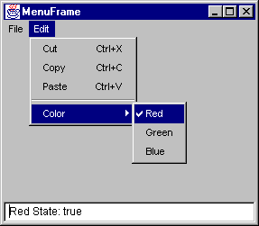
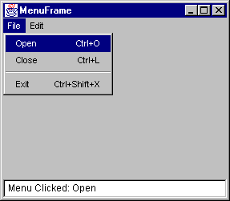

Dialog
A Dialog is a top-level window with a title and a border that is typically used to take some form of input from the user. The size of the dialog includes any area designated for the border.

The default layout for a dialog is BorderLayout.

A dialog must have either a frame or another dialog defined as its owner when it's constructed. When the owner window of a visible dialog is hidden or minimized, the dialog will automatically be hidden from the user. When the owner window is subsequently re-opened, then the dialog is made visible to the user again.

A dialog can be either modeless (the default) or modal. A modal dialog is one which blocks input to all other top-level windows in the app context. In other words, you can switch to any other window until the modal dialog is closed.

Constructors
Dialog(Dialog owner) | Constructs an initially invisible, non-modal Dialog with an empty title and the specified owner dialog.
Dialog(Dialog owner, String title) | Constructs an initially invisible, non-modal Dialog with the specified owner dialog and title.
Dialog(Dialog owner, String title, boolean modal) | Constructs an initially invisible Dialog with the specified owner dialog, title, and modality.
Dialog(Frame owner) | Constructs an initially invisible, non-modal Dialog with an empty title and the specified owner frame.
Dialog(Frame owner, boolean modal) | Constructs an initially invisible Dialog with an empty title, the specified owner frame and modality.
Dialog(Frame owner, String title) | Constructs an initially invisible, non-modal Dialog with the specified owner frame and title.
Dialog(Frame owner, String title, boolean modal) | Constructs an initially invisible Dialog with the specified owner frame, title, and modality.

Useful Methods
show() | void | Makes the Dialog visible.
hide() | void | Hides the Dialog and then causes show() to return if it is currently blocked.
dispose() | void | Disposes the Dialog and then causes show() to return if it is currently blocked.
setTitle(String title) | void | Sets the title of the Dialog.
setModal(boolean b) | void | Specifies whether this dialog should be modal.
isModal() | boolean | Indicates whether the dialog is modal.
getTitle() | String | Gets the title of the dialog.
setResizable(boolean resizable) | void | Sets whether this dialog is resizable by the user.
isResizable() | boolean | Indicates whether this dialog is resizable by the user.

Here is example of a Parent Frame and Child Dialog:

// Code 9N
/** A Dialog that has radio buttons.
* @author Mohammed Ashequr Rahman
* @version 1.0
*/
import java.awt.*;
import java.awt.event.*;
public class CheckboxGroupAddedDialog extends Dialog
{
private CheckboxGroup group;
private Panel panel;
private Checkbox red;
private Checkbox green;
private Checkbox blue;
private TextArea textArea;
/** Constructor that adds controls on the frame.
* @param prentFrame Parent Frame for this dialog.
*/
public CheckboxGroupAddedDialog(Frame prentFrame)
{
// call super contructor and add controls.
super(prentFrame);
addControls();
// change backcolor to light gray.
Color dialogBackground = Color.lightGray;
setBackground(dialogBackground);
}
/** Add checkbox on the frame.*/
private void addControls()
{
// instantiate a check box group object.
group = new CheckboxGroup();
// instantiate three checkboxes under the same group.
// make them unchecked by using the flag 'false'.
// add listener the checkboxes.
red = new Checkbox("Red",group,false);
red.addItemListener(new InnerRedItemListener());
green = new Checkbox("Green",group,false);
green.addItemListener(new InnerGreentemListener());
blue = new Checkbox("Blue",group,false);
blue.addItemListener(new InnerBlueItemListener());
// instantiate readonly testarea.
textArea = new TextArea(2,20);
textArea.setEditable(false);
// instantiate a panel with grid layout.
panel = new Panel(new GridLayout(0,1));
// add three checkboxes to the panel.
panel.add(red);
panel.add(green);
panel.add(blue);
// add the panel to the "West" side of the frame.
add(panel,"West");
// add the text area to the "Center" of the frame.
add(textArea,"Center");
}
private class InnerRedItemListener implements ItemListener
{
/** overridden method of item listener interface.*/
public void itemStateChanged(ItemEvent p1)
{
String stateString;
// get the state of the checkbox being clicked on.
boolean state=((Checkbox) p1.getSource()).getState();
stateString= "Red: " + state;
// append the check box name and it's state on the text area.
textArea.setText(textArea.getText() + stateString + "\n");
}
}
private class InnerBlueItemListener implements ItemListener
{
/** overridden method of item listener interface.*/
public void itemStateChanged(ItemEvent p1)
{
String stateString;
// get the state of the checkbox being clicked on.
boolean state=blue.getState();
stateString= "Blue: " + state;
// append the check box name and it's state on the text area.
textArea.setText(textArea.getText() + stateString + "\n");
}
}
private class InnerGreentemListener implements ItemListener
{
/** overridden method of item listener interface.*/
public void itemStateChanged(ItemEvent p1)
{
// append the check box name and it's state on the text area.
textArea.setText(textArea.getText() + "Green: " + green.getState() + "\n");
}
}
}

// Code 9O
/** A Frame that has menu and the menu opens Dialog.
* @author Mohammed Ashequr Rahman
* @version 1.0
*/
import java.awt.*;
import java.awt.event.*;
public class ParentFrame extends ClosableFrame
{
private MenuBar menuBar;
private Menu fileMenu;
private MenuItem fileOpenMenuItem;
private MenuItem fileCloseMenuItem;
private MenuItem fileExitMenuItem;
private CheckboxGroupAddedDialog dialog;
/** Constructor that adds menu on the frame.*/
public ParentFrame()
{
// call super constructor and add menu.
super();
addControls();
// change color.
Color frameBackground = Color.lightGray;
setBackground(frameBackground);
}
/** Add menu to the frame.*/
private void addControls()
{
// instantiate menu bar.
menuBar= new MenuBar();
// instantiate file menu and open, close and exit menu items
// and add them to file menu.
fileMenu = new Menu("File");
MenuShortcut fileOpenMenuShortcut= new MenuShortcut('O'); //Control+O;
fileOpenMenuItem = new MenuItem("Open",fileOpenMenuShortcut);
MenuShortcut fileCloseMenuShortcut= new MenuShortcut('L'); //Control+L;
fileCloseMenuItem = new MenuItem("Close",fileCloseMenuShortcut);
MenuShortcut fileExitMenuShortcut= new MenuShortcut('X',true); //Control+Shift+C;
fileExitMenuItem = new MenuItem("Exit",fileExitMenuShortcut);
fileMenu.add(fileOpenMenuItem);
fileMenu.add(fileCloseMenuItem);
fileMenu.addSeparator();
fileMenu.add(fileExitMenuItem);
// add file menu to the menu bar.
menuBar.add(fileMenu);
// add menu bar to the frame.
setMenuBar(menuBar);
// add listener to open, close and exit.
fileOpenMenuItem.addActionListener(new InnerActionListener());
fileCloseMenuItem.addActionListener(new InnerActionListener());
fileExitMenuItem.addActionListener(new InnerActionListener());
}
private class InnerActionListener implements ActionListener
{
public void actionPerformed(ActionEvent p1)
{
// get the source of click.
MenuItem menuItem= (MenuItem) p1.getSource();
// if the menu item open is clicked
// and the dialog is not already open - open the dialog.
if ((menuItem==fileOpenMenuItem) && (dialog==null))
{
// instantiate the dialog with the frame as parent.
dialog= new CheckboxGroupAddedDialog(ParentFrame.this);
// set the title, location and size of the dialog.
dialog.setTitle("Child Dialog");
dialog.setLocation(150,150);
dialog.setSize(300,300);
// show the dialog
dialog.show();
}
// if the menu item close is clicked
// and the dialog is already open - close the dialog.
if ((menuItem==fileCloseMenuItem) && !(dialog==null))
{
// dispose the dialog.
dialog.dispose();
// re-set the variable.
dialog=null;
}
// if exit is clicked - terminate the application.
if (menuItem==fileExitMenuItem)
{
System.exit(0);
}
}
}
/** main method for testing this class.*/
public static void main(String[] args)
{
// instantiate a frame of this class.
ParentFrame frame = new ParentFrame();
// set the size and make it visible.
frame.setSize(500,500);
frame.setVisible(true);
}
}

Here is the output:

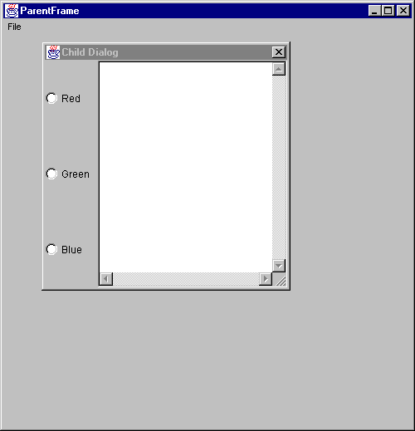

FileDialog
The FileDialog class displays a dialog window from which the user can select a file.
Since it is a modal dialog, when the application calls its show method to display the dialog, it blocks the rest of the application until the user has chosen a file. FileDialog has two static constants LOAD and SAVE that indicates that the purpose of the file dialog window is to locate a file from which to read or the file to which to write.

Constructors
FileDialog(Frame parent) | Creates a file dialog for loading a file.
FileDialog(Frame parent, String title) | Creates a file dialog window with the specified title for loading a file.
FileDialog(Frame parent, String title, int mode) | Creates a file dialog window with the specified title for loading or saving a file.

Useful Methods
setFilenameFilter(FilenameFilter filter) | void | Sets the filename filter for this file dialog window to the specified filter.
getFilenameFilter() | FilenameFilter | Determines this file dialog's filename filter.
setFile(String file) | void | Sets the selected file for this file dialog window to be the specified file.
getFile() | String | Gets the selected file of this file dialog.
setDirectory(String dir) | void | Sets the directory of this file dialog window to be the specified directory.
getDirectory() | String | Gets the directory of this file dialog.
setMode(int mode) | void | Sets the mode of the file dialog.
getMode() | int | Indicates whether this file dialog box is for loading from a file or for saving to a file.

Here is an example of FileDialog

// Code 9P
/** A Frame that has menu and the menu opens file Dialog.
* @author Mohammed Ashequr Rahman
* @version 1.0
*/
import java.awt.*;
import java.awt.event.*;
public class FileDialogAddedFrame extends ClosableFrame
{
private MenuBar menuBar;
private Menu fileMenu;
private MenuItem fileOpenMenuItem;
private MenuItem fileSaveMenuItem;
private MenuItem fileExitItem;
private FileDialog fileDialog;
private TextField textArea;
/** Costructor that adds menu.*/
public FileDialogAddedFrame()
{
// call super constructor and add menu.
super();
addControls();
// change backcolor to light gray.
Color frameBackground = Color.lightGray;
setBackground(frameBackground);
}
/** method that adds menu.*/
private void addControls()
{
// instantiate menu bar.
menuBar= new MenuBar();
// instantiate file menu.
fileMenu = new Menu("File");
// instantiate open, save and exit menu item.
MenuShortcut mscFileOpen= new MenuShortcut('O'); //Control+O;
fileOpenMenuItem = new MenuItem("Open",mscFileOpen);
MenuShortcut mscFileSave= new MenuShortcut('L'); //Control+L;
fileSaveMenuItem = new MenuItem("Save",mscFileSave);
MenuShortcut mscFileExit= new MenuShortcut('X',true); //Control+Shift+C;
fileExitItem = new MenuItem("Exit",mscFileExit);
// add file menu to menu bar.
menuBar.add(fileMenu);
// add menu items to file menu.
fileMenu.add(fileOpenMenuItem);
fileMenu.add(fileSaveMenuItem);
fileMenu.addSeparator();
fileMenu.add(fileExitItem);
// add menu bar to the frame.
setMenuBar(menuBar);
// add listener to the menu items.
fileOpenMenuItem.addActionListener(new InnerActionListener());
fileSaveMenuItem.addActionListener(new InnerActionListener());
fileExitItem.addActionListener(new InnerActionListener());
// intantiate text field and make it readonly.
textArea = new TextField();
textArea.setEditable(false);
// add text field to the frame.
add(textArea,"South");
}
private class InnerActionListener implements ActionListener
{
/** action listener interface method.*/
public void actionPerformed(ActionEvent p1)
{
// get the source of click.
MenuItem menuItem= (MenuItem) p1.getSource();
// if open menu is clicked.
if (menuItem==fileOpenMenuItem)
{
// instantiate a file dialog in open mode.
fileDialog= new FileDialog(FileDialogAddedFrame.this,"Open",FileDialog.LOAD);
// make it visible.
fileDialog.show();
// if the user does not select any file - nothing to show.
if ( fileDialog.getFile()==null)
{
textArea.setText("");
}
// otherwise show the file name.
else
{
textArea.setText("Open: " + fileDialog.getDirectory()
+ fileDialog.getFile());
}
// set the variable to null.
fileDialog=null;
}
// if save menu is clicked.
if (menuItem==fileSaveMenuItem)
{
// instantiate a file dialog in save mode.
fileDialog= new FileDialog(FileDialogAddedFrame.this,"Save",FileDialog.SAVE);
// show the dialog.
fileDialog.show();
// if no file is selected - nothing to show.
if ( fileDialog.getFile()==null)
{
textArea.setText("");
}
// if any file is selected - show the file name.
else
{
textArea.setText("Save: " + fileDialog.getDirectory()
+ fileDialog.getFile());
}
// reset the variable.
fileDialog=null;
}
// if exit menu is clicked.
if (menuItem==fileExitItem)
{
// exit the system.
System.exit(0);
}
}
}
/** main method for testing this class.*/
public static void main(String[] args)
{
// instatiate a frame of this class.
FileDialogAddedFrame frame = new FileDialogAddedFrame();
// set size and make it visible.
frame.setSize(500,500);
frame.setVisible(true);
}
}

Here is the output:

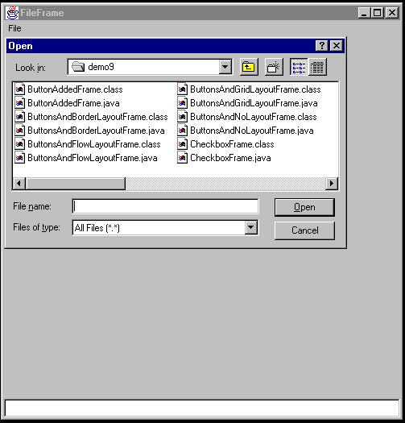

Homework:

Reading:

Just Java:

Chapter 19 – Layouts
Appendix B – AWT Components

Programming Assignment:

Coding Policy:

- You must follow a naming convention.
- You must have enough comments in your code.

- Create a Book Selector User Interface (Frame) that has the following:
- A drop-down list (Choice) of book categories like Java, Visual Basic etc.
- A list of books from which the user can select one or more books (Multi-Select List). The list of books will change as the user changes category.
- A read-only text area to display user’s book selection (Read-Only TextArea)
- Two Label’s to label the Choice and the List Box.

If the user selects Java from the category choice, the list box will show a list of Java Books. If the user selects Visual Basic from the category choice, the list box will show a list of Visual Basic Books.

As the user selects books from the list box, the text area will show the user selection.
Here is how the frame should look like:
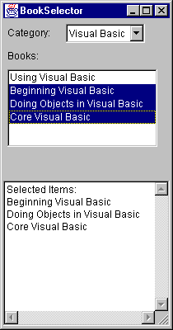
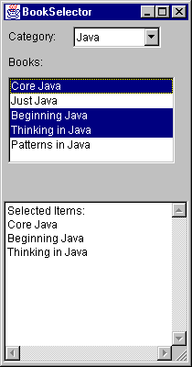

2. Covert the Frame to Applet.
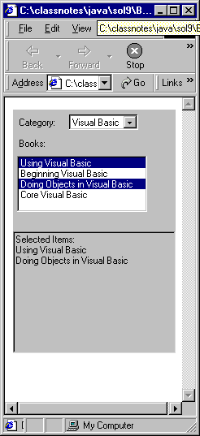
Here is how the output should look like:

