Session 1 Internet Basics and Installation of Tomcat

Objective
This session teaches students how HTTP protocols works between a client browser and web server; how HTML forms are used to capture and submit user input; what Tomcat is; how to install and use Tomcat for server side programming.

HTTP (Hypertext Transfer Protocol)
In distributes application development, the application communication protocol drives the nature of clients and servers. This is true for web applications as well. HTTP is the protocol for communication on the web. It is an application level protocol based on requests and responses that determines the complexity of features possible in the application. In this paradigm, client application (like a web browser) sends requests to the server (like a web server of an online toy shop) and receives information (such as a toy catalog) from the server in response. HTTP is stateless (which makes it difficult to maintain information from page to page) and generally implemented over TCP/IP. HTTP 1.1 defined in Request for Comments (RFC) 2616 and is available at www.faqs.org/rfcs.

An example of HTTP conversion would be when a user enters http://www.cs.nyu.edu/csweb/index.html in Web Browser. The following things happen:

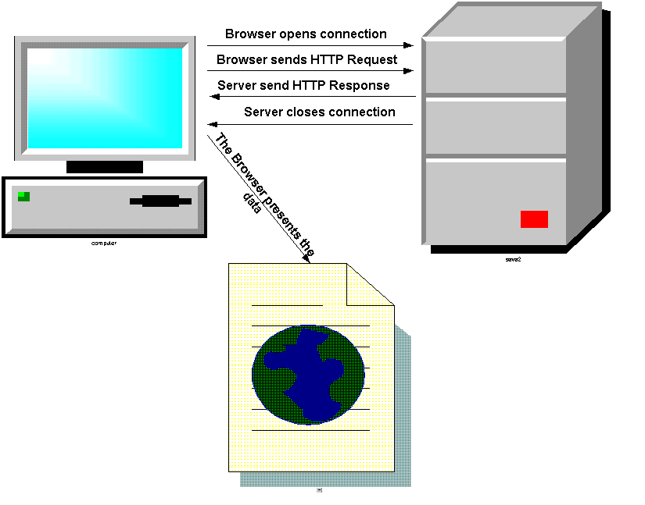

Browser Opens Connection
The browser opens a TCP/IP Socket connection with the server www.cs.nyu.edu. The browser automatically assumes that the server is listening to the default http port 80. If the server is listening to a different port you have to specify as: http://www.cs.nyu.edu:9090/index.html (assuming the server is listening to port number 9090).

Browser Sends HTTP Request
The browser (Client) converts the URL into an HTTP Request and sends it out to the server. An HTTP Request message is composed of:

- Request Line : describes HTTP Command
- Header: browser information
- Message Body: contents of message

In this example:

1) Request Line would look like this:

HTTP method Resource Name Protocol/Version

GET /csweb/index.html HTTP/1.1

2) The browser will provide the Header.

3) The Message Body will be empty.

Here is the complete request:

GET //index.html HTTP/1.1 ← Request Line
Accept: application/vnd.ms-excel, application/msword, application |
/vnd.ms-powerpoint, image/gif, image/x-xbitmap, image/jpeg, image/pjpeg, */* |
Accept-Language: en-us |
Accept-Encoding: gzip, deflate |
User-Agent: Mozilla/4.0 (compatible; MSIE 4.01; Windows NT) | ← Header
Host: localhost:9090 |
Connection: Keep-Alive |

Here are the HTTP methods appear on the Request Line:

HTTP Methods:
GET
POST
HEAD
OPTION
TRACE
……

These methods (Specifically GET and POST) will be discussed in details later.

Of course, most often, we really type something like www.cs.nyu.edu without any protocol or specific file name. In that case, the browser assumes it as a HTTP request by default and sends a HTTP Request as follows:

GET / HTTP/1.1

Since the server does not find a page request (the page name is empty after the slash) it forwards this request to the default page like “index.html” or “default.html” (part of the web application setup on the server) and browser shows that page. In our example it actually forwards to “/csweb/index.html”.

Here is an HTTP Server that receives an HTTP Request and displays it on a swing frame:
//Code1A
import java.net.*;
import java.io.*;
/** This class waits for socket connection with any client.
When it gets connected it displays the connection header on a frame.
*/
public class HttpServer
{
/** main method to instantiate the gui*/
public static void main(String args[])
{
Try
{
// convert server port number received as command
// line argument to int.
int port=Integer.parseInt(args[0]);
// create a server socket object with
// server port number.
ServerSocket serversocket = new ServerSocket(port);
// create a GUI instance
HttpServerGUI httpservergui= new HttpServerGUI();
while (true)
{
//wait for the client
Socket socket = serversocket.accept();
// print after connection.
System.out.println("Client connected.");
// get the inputstream and convert to buffered character stream.
BufferedReader in = new BufferedReader(new InputStreamReader(socket.getInputStream()));
// holds one line of request at a time.
String requestline;
// stores the request as it comes line by line.
StringBuffer request = new StringBuffer();
// read all the request header lines.If an empty line means end of header.
// and it exits the loop.
while(!(requestline = in.readLine()).equals(""))
{
request.append(requestline + "\n");
}
// display the request header on a frame.
httpservergui.display(request.toString());
// close the connection.
in.close();
socket.close();
System.out.println("Client disconnected.");
}
}
// catch exceptions.
catch (IOException e)
{
System.out.println(e);
System.exit(-1);
}
catch (Exception e)
{
System.out.println(e + "\nUsage: java HttpServer [port]");
}
}
}

Here is the swing frame:
//Code1B
import java.awt.*;
import java.awt.event.*;
import javax.swing.*;
/** This this the GUI for HttpServer class.*/
public class HttpServerGUI extends JFrame
{
// private fields GUI objects.
private JTextArea txtMain;
/** Constructor.*/
public HttpServerGUI()
{
System.out.print("Please wait...");
// instantiate a mono spaced fort.
Font courier = new Font("monospaced", Font.PLAIN, 12);
// set the title.
setTitle("HTTP Server");
// instantiate a text area.
txtMain = new JTextArea(20,80);
txtMain.setFont(courier);
// instantiate a scroll pane with the text area.
JScrollPane txtPane = new JScrollPane(txtMain);
// add the scroll pane to the frame.
getContentPane().setLayout(new BorderLayout());
getContentPane().add(txtPane, BorderLayout.CENTER);
// add anonymous window listener
addWindowListener(new WindowAdapter()
{
public void windowClosing(WindowEvent ev)
{
System.exit(0);
}
}
);
// adjust the size of the frame and make it visible.
pack();
setVisible(true);
}
/** public method that displays the string it receives.*/
public void display(String request)
{
txtMain.setText(request);
}
}

Let’s bring this server up with port 9090 by typing:

java HttpServer 9090

Here is what the request looks like on our swing frame when the server runs on port 9090 on the same machine and the user types http://localhost:9090/index.html on the browser. Of Course, the browser will show an error message since no response was returned to the browser.

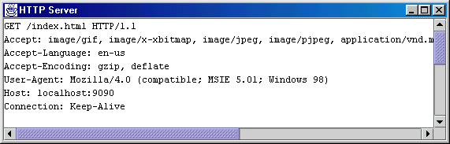

Server Sends HTTP Response
The Server reads and interprets the request and sends an HTTP Response message back to the browser (Client). An HTTP Response message is composed of:

- Response Line: Server protocol and status line
- Header: Response Metadata
- Message Body: Content of Message

Here is what the response will look like:

HTTP/1.1 200 OK ← Response Line
Date: Wed, 14 Feb 2001 20:28:59 GMT |
Server: Apache/1.3.6 (Unix) PHP/3.0.9 |
Last-Modified: Tue, 09 Jan 2001 15:07:24 GMT |
ETag: "36654-f99-3a5b292c" |
Accept-Ranges: bytes |← Header
Content-Length: 3993 |
Connection: close |
Content-Type: text/html |
X-Pad: avoid browser bug |

<html> |
|
<head> |
<title>Computer Science Department</title> |← Message Body
…… |
…… |

The html page that the server returns may have links to other html pages. When the user clicks on those links the browser sends another request to the server, the server sends the response and browser displays the new page and so on.

Here are the status codes used by the server on Response Line:

Status Codes:
Code Range | Category
100-199 | Information
200-299 | Successful (200 OK)
300-399 | Redirection
400-499 | Client Error(404 File Not found,400 Bad Request)
500-599 | Server Error

These status codes will be discussed in details later.

Here are the Multipurpose Internet Mail Extension (MIME) content types used by the server for Header:

MIME Content Types:
text/html
text/plain
text/xml
application/octet-stream
…….

These content types will be discussed in details later.

Here is a Swing Frame that establishes connection with the server and port specified on command prompt and sends out HTTP Requests to the server and displays HTTP Response from the server:
//Code1C
import java.awt.*;
import java.awt.event.*;
import javax.swing.*;
/** This this the GUI for HttpClient class.*/
public class HttpClientGUI extends JFrame
{
// private fields GUI objects.
private JTextField tbRequest;
private JTextArea txtMain;
private JButton btnSend;
// private field for HttpClient.
private HttpClient httpclient;
/** Constructor that receives HttpClient.*/
public HttpClientGUI(HttpClient p_httpclient)
{
System.out.print("Please wait...");
// save the HttpCient object.
httpclient=p_httpclient;
// instantiate a mono spaced fort.
Font courier = new Font("monospaced", Font.PLAIN, 12);
// set the title.
setTitle("HTTP Client");
// instantiate textfield, button and text area.
tbRequest = new JTextField("GET /index.html HTTP/1.0");
tbRequest.setFont(courier);
tbRequest.addActionListener(new InnerActionListener());
btnSend = new Jbutton("Send");
btnSend.setMnemonic('S');
btnSend.addActionListener(new InnerActionListener());
txtMain = new JTextArea(20,80);
txtMain.setFont(courier);
// instantiate a panel and add things to it.
Panel northPanel = new Panel();
northPanel.setLayout(new FlowLayout(FlowLayout.LEFT, 6, 6));
northPanel.add(new Jlabel("HTTP Request:"));
northPanel.add(tbRequest);
northPanel.add(btnSend);
// instantiate a scroll pane.
JScrollPane txtPane = new JScrollPane(txtMain);
// add objects to the frame.
getContentPane().setLayout(new BorderLayout());
getContentPane().add(northPanel, BorderLayout.NORTH);
getContentPane().add(txtPane, BorderLayout.CENTER);
// add anonymous window listener
addWindowListener(new WindowAdapter()
{
public void windowClosing(WindowEvent ev)
{
System.exit(0);
}
}
);
// adjust the size of the frame and make it visible.
pack();
setVisible(true);
}
/** Inner action listener for the button and text field. */
private class InnerActionListener implements ActionListener
{
public void actionPerformed(ActionEvent ev)
{
String response=httpclient.send(tbRequest.getText());
txtMain.setText(response);
}
}
}

Here is the TCP/IP Client Socket program that actually does the job behind the scene:
//Code1D
import java.net.*;
import java.io.*;
/** This class establishes socket connection with any server and sends HTTP requests
and receives HTTP responses.
*/
public class HttpClient
{
// fields to hold host and port number received by the constructor.
private String host;
private int port;
/** Constructor that receives host and port number.*/
public HttpClient(String p_host, int p_port)
{
port = p_port;
host = p_host;
}
/** This method send HTTP request and returns the response from server.*/
public String send(String request)
{
// holds one line of response at a time.
String responseline;
// stores the response as it comes line by line.
StringBuffer response = new StringBuffer();
try
{
// 1. Connect to the server
Socket socket = new Socket(host, port);
// 2. send the request
PrintWriter pw = new PrintWriter(socket.getOutputStream());
pw.println(request + "\n");
pw.flush();
// 3. receive the response from the server
BufferedReader br = new BufferedReader(new InputStreamReader(socket.getInputStream()));
while((responseline = br.readLine())!= null)
{
response.append(responseline + "\n");
}
}
catch (Exception e)
{
System.out.println("Exception sending request: " + e);
}
// 4. return response back to the caller.
return response.toString();
}
/** main method to instantiate the gui*/
public static void main(String args[])
{
try
{
// instantiate HttpClient object with command line arguments.
HttpClient httpclient = new HttpClient(args[0], Integer.parseInt(args[1]));
// instantiate the GUI with HttpClient object.
HttpClientGUI httpclientgui = new HttpClientGUI(httpclient);
}
catch (Exception e)
{
System.out.println(e + "\nUsage: java HttpClient [host] [port]");
}
}
}

Let’s connect this client with a NYU web server by typing:

java HttpClient www.cs.nyu.edu 80

Here is what it looks like after we click on send button:
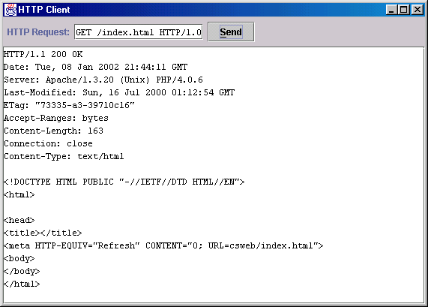

One interesting thing to know about HTTP protocol is that the server generally does not care what type of file is requested. As long the file is publicly available (which basically means the permission setup on the server) the server will return the content of the file as stream of bytes (right now I am assuming the server only supports static pages). The browser looks at the MIME content type of the file and decides whether and how it should display the file on the browser or it should ask user to save it in a file as download. Of course, Microsoft Internet Explorer violates this rule and tries to interpret the content of the file regardless of its MIME content type.

My GUI will display the content of the file regardless of the content type. In fact, every windows machine already has such a GUI tool – it is called Telnet. Try your Telnet to do the same job.

Charles Tool
There is quite a few free tools out there that allows you to monitor the data you are sending and the data you are receiving over TCP/IP socket. In other words, these tools allow you to see the raw request and the raw response. Charles is one of them. Here is how you get it to work.

a) Download Charles from:

http://www.xk72.com/charles/download.php

b) Install Charles

c) Start Charles from your startup menu. You will have a Charles console available to you at this point.

c) Open your browser and hit any url. Charles automatically plugs into your browser as a proxy server and will record your requests and responses in Charles console. If it does not, please read Charles documentation to find how to manually put the proxy setting in your brower.

Tomcat
Tomcat is the servlet container that is used in the official Reference Implementation for the Java Servlet and JavaServer Pages technologies.
There are several versions of Tomcat currently available for download. Tomcat 5.5 is the release of Tomcat that works with JDK 1.5 (also known as JDK 5).

Installing Tomcat 5.5 on Windows
Assuming you already have JDK 1.5 or above installed on your machine, if you are working on Windows machine and you want to install Tomcat 5.5 – it is extremely easy to do so. Just download the .exe file from apache.org website.

Double click on the .exe, select all the default options, check off examples since you need the examples to be installed. Change the destination folder to “c:\tomcat5.5”. This will save you time and energy in future. Also, pick an easy password like “admin” and you are done.

Starting and Stopping Tomcat
You start Tomcat double clicking on tomcat5.exe in Tomcat5028\bin folder.
To stop Tomcat simply close the command window.

Testing Tomcat
Tomcat by default starts on port “8080” which means for every request from a browser you have to specify the port number since the browser assumes that the server is listening on port “80” not “8080”.
Let’s follow the following steps to a do little sanity check on Tomcat:
- Start Tomcat.
- Open up your favorite browser and type:
http://localhost:8080
This should load the page shown below. If you are using IE and you are not connected to the internet, you will have a little problem. First on the “Work Offline” window you have to click on “Try Again” button and then you have click on “Connect” on the next window.
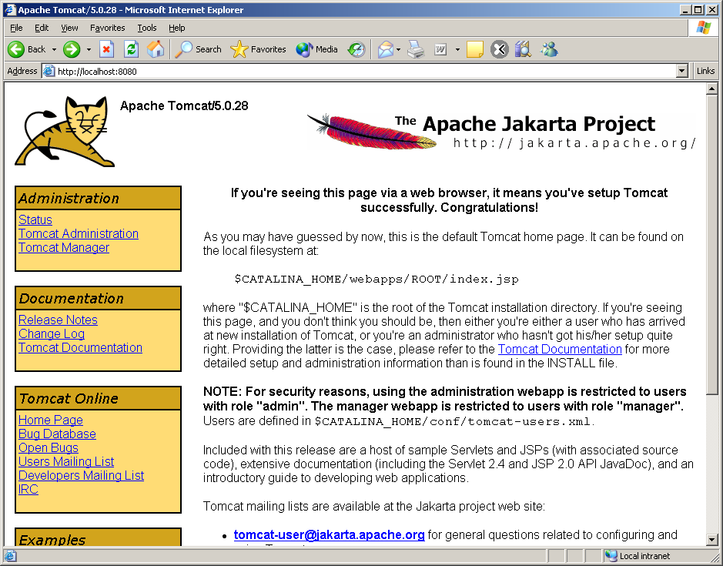

If you see this page, you should pour yourself a glass of wine (beer will do just fine) and celebrate. You just made your life (not to mention mine too) a whole lot easier going forward.

Making Servlet-api.jar Visible to your Compiler (javac)

Although, we know nothing about servlet, compiling code that runs on Tomcat required servlet-api.jar in your classpath. Here is how to find servlet-api.jar and make it visible to your compiler.

First Option: Using CLASSPATH Environment Variable

- NT/XP users should go to Start –> Settings –> Control Panel –> System. Under Environment Tab create or append to the System Variable CLASSPATH “C:\tomcat5.5\common\lib\ servlet-api.jar;.” (if you are appending to your existing classpath, please put a semi-color first and then append)

a) If you already have a CLASSPATH variable put a semi-colon at the end and then append:
“c:\tomcat5.5\servlet-api.jar;.” (Please note I have semi-colon followed by dot at the end to include the current folder too in your classpath). The semi-color followed by a dot is very important.

b) Otherwise create a new environment variable CLASSPATH that has the value equal to “c:\tomcat5.5\servlet-api.jar;.”.

- At this point, the best thing to do is to close your command prompts and open a new command prompt for the changes to kick in.

Alternate Option: Just copying servlet-api.jar

There is actually an easier way to make jar files visible to your compiler. However, this only works if you have only one copy of Java Runtime. You should go to your control panel, add/remove program to double check that you don’t have Java Runtime installed in addition to your J2SDK1.5. If so, simply uninstall the Java Runtime. This will save you a lot of headache in future.

Copy servlet-api.jar from Tomcat’s common\lib folder to your JDK’s “jre\lib\ext” folder and you are done.

If this does not work for you, you can always fallback to the first option – which should always work.

Compiling Servlet
Assuming your classpath is setup properly, using DOS prompt go to the following folder:

C:\tomcat5.5\webapps\servlets-examples\WEB-INF\classes

You will find the following files in this folder:

RequestInfoExample.java
RequestInfoExample.class

From your command prompt, follow the following steps:

- Go to C:\tomcat5.5\webapps\servlets-examples\WEB-INF\classes folder
- Delete RequestInfoExample.class
- type: javac RequestInfoExample.java
- It should compile and generate the class file again. If it does not – you still have problem with your classpath. May be a semi-colon followed by a Dot (.) is missing from your classapth.
- Go back to your browser and type:

http://localhost:8080/servlets-examples/servlet/RequestInfoExample (notice the URL is different from the actual folder name, it is “servlet” instead of” WEB-INF\classes”, also .java or .class is missing at the end of the filename)

It will take a few seconds and then it will load the following page:

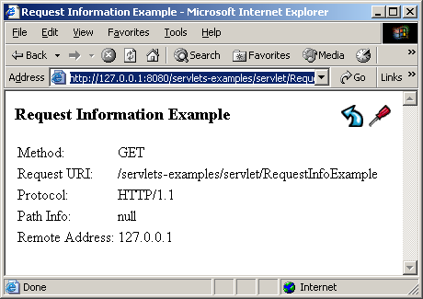

Congratulations!!! Your Tomcat and Servlet development environment is set up.

Monitoring Tomcat with Charles
Assuming Charles is up and running when you brought up your browser, you can look at Charles console to see the request and response for your ulr invocation.

HTML Form
HTML forms let you create a user interface to collect user input using controls and submit them to the server. The submission can happen in one of the two ways:

- Using HTTP GET method that appends the user input at the end of the URL of the page as string, after a question mark.
- Using HTTP POST method that sends the user input in the body of the request message.

The <FORM> tag has the following useful attributes:

- ACTION – The URL where the data is going out to (Usually a Servlet/JSP page). If you don’t put any ACTION the same page returns.
- METHOD – The HTTP method for sending (GET, POST etc.)

Each of two methods has certain advantages and disadvantages as follows:

- GET method:

Advantages:
- Good for debugging, the data appears in the URL.
- URL with data can be book-marked or e-mailed.
Disadvantages:
- Data is visible (including password type data).
- Although HTTP/1.1 does not impose any limit on the length, browsers/servers complying only with HTTP/1.0 may have a limitation on the URL length (mostly it is 1024). In that case anything after the maximum URL length will be truncated.

- POST method:

Advantages:
- No limitation on data length.
- Data is not visible.
- Good for sending binary data.
Disadvantages:
- URL with data cannot be book-marked or e-mailed.

Here are the HTML tags that we can use to capture and send user input:

- The <INPUT> Tag of the following types:
- text
- password
- checkbox
- radio
- submit
- reset

b) The <TEXTAREA> tag for multi-line user input

- The <SELECT> tag for drop down combo and list box

Here is a sample HTML page with FORM tag:

signup.html
<!DOCTYPE HTML PUBLIC "-//W3C//DTD HTML 4.0 Transitional//EN">
<HTML>
<HEAD><TITLE>HTML Form Demo</TITLE></HEAD>
<BODY><H3>Please enter the following information:</H3>
<FORM method="GET" action="thankyou.html">
<TABLE>
<TR>
<TD>Name</TD>
<TD><INPUT type="text" name="user_name" value="" size=40></TD>
</TR>
<TR>
<TD>Password</TD>
<TD><INPUT type="password" name="user_password" size=20></TD>
</TR>
</TABLE>
Member of class e-mail list
<INPUT type="checkbox" name="email_account" value="true">
<BR>
<BR>
Grading policy:
<TABLE border="1" cellspacing="15">
<TR>
<TD>Letter Grade<INPUT type="radio" name="grade" value="LG"></TD>
<TD>Pass/Fail<INPUT type="radio" name="grade" value="PF"></TD>
<TD>Non-Evaluative<INPUT type="radio" name="grade" value="NE"></TD>
<TD>Incomplete<INPUT type="radio" name="grade" value="IC"></TD>
</TR>
</TABLE>
<BR>
Programming Skill
<BR>
<SELECT name="skill">
<OPTION value="E">Experienced Programmer
<OPTION value="I">Intermediate Programmer
<OPTION value="B">Beginner
</SELECT>
<BR>
<BR>
Web Server
<BR>
<SELECT name="webserver" size="3" multiple>
<OPTION value="T">Just Tomcat
<OPTION value="A">Tomcat and Apache
<OPTION value="I">Tomcat and IIS
<OPTION value="O">Others
</SELECT>
<BR>
<BR>
Comments
<BR>
<TEXTAREA name="Comments" rows="5" cols="50" wrap=soft>
</TEXTAREA>
<BR>
<BR>
<INPUT type="submit" value="Send"> <input type="reset" value="Clear">
</FORM>
</BODY>
</HTML>

Here is thankyou.html:

<!DOCTYPE HTML PUBLIC "-//W3C//DTD HTML 4.0 Transitional//EN">
<HTML>
<HEAD><TITLE> Thank you</TITLE></HEAD>
<BODY><H2>Thank you for your submission</H2></BODY>
</HTML>

However, if we change the method to POST in register.html the data will disappear from the URL and will be send as the body of the request.

Tomcat as a Web Server
Since Tomcat is a web server as well let’s copy:

- signup.html
- thankyou.html

files to c:\tomcat5.5\webapps\servlets-examples folder and hit it from a browser by typing:

http://localhost:8080/servlets-examples/signup.html

It should load the page. Please be careful about the filename – Tomcat is case-sensitive – even for html files.
If you are offline and using IE you may see a dialog stating the web page is unavailable. Click on Connect and a select dialog will appear stating work offline. Click on Try Again – you should see the page now.

Here is how it looks:
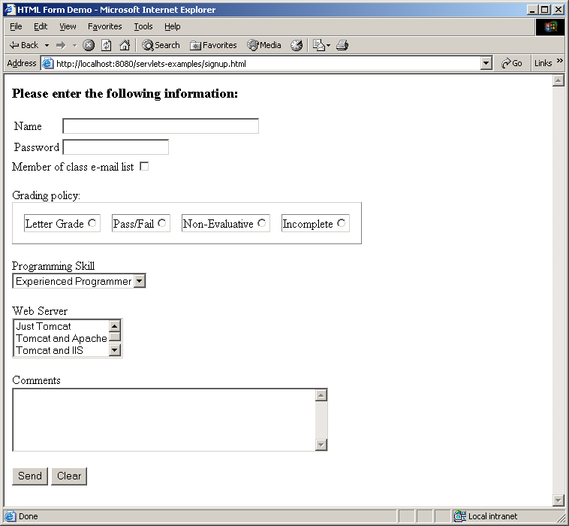

Type your name and click on the Send Button. You should see the thankyou.html page as shown below:
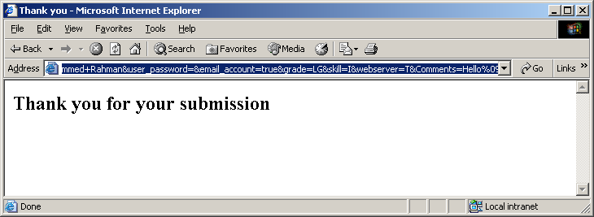

Please look at the URL and you will notice that user input is appended on the URL as follows:
http://localhost:8080/servlets-examples/thankyou.html?user_name=Mohammed+Rahman&user_password=&email_account=true&grade=LG&skill=I&webserver=T&Comments=Hello%09%09

Reading Assignment
- HTTP Protocol - Professional Java Server Programming – Chapter 7
- HTML Forms - Core Servlet and JavaServer Pages - Chapter 16
- Tomcat: http://www.apache.org

Homework Assignment
- Download session1 from the class website that contains demo1 folder which contains signup.html.
- Copy signup.html to another file signup1.html in the directory c:\tomcat5.5\webapps\servlets-examples and modify signup1.html so that it sends a GET request to RequestInfoExample instead of thankyou.html when the user clicks on the send button. If you HTML basic, you should be able to do this in one second. Just keep in mind that Tomcat sees RequestInfoExample is in “\servlet” folder although the physical folder name is “\WEB-INF\classes”.

- Copy signup1.html to another file signup2.html in the same folder and modify signup2.html so that it sends a POST request to RequestInfoExample instead of thankyou.html when the user clicks on the send button.

- Write two differences that you have noticed when the response of step 1 and 2 above returned. Put your answer in a readme.txt file. You will truly find more than one difference if you monitor the traffic using Charles.

- Copy the GET request from Charles and submit it in get.txt Copy the POST request from Charles and submit it in post.txt

You have to submit five files

1) signup1.html

2) signup2.html

3)readme.txt

4) get.xt

5) post.txt

