Objective
This session starts with J2EE architecture and describes all the interfaces and classes related to Servlet. Students also learn how to read a request and send a response using Servlet APIs.

J2EE Architecture – Containers
A typical Java program starts with a main() method. Also, as typical Java programmer we are used to instantiating our objects on our own as we need them. However, J2EE architecture is based on the idea that an application is composed of a number of application components (for example EJBs, Servlets, JSPs etc.) and the programmers of these components are not responsible for instantiating, invoking and managing these components.

Central to the J2EE component-based development model in the notion of container. Containers are JVMs that provides component services. In other words the life-cycle of an application component will be managed by container. The container will create and initialize component, invoke methods on them and destroy, serialize, de-serialize them as and when necessary.

This concept is not new and is very similar to event driven programming in AWT and Swing. In event driven programming we write these event handlers but never invoke any of these methods. The JVM invokes these methods as and when necessary. Our Job is to provide the code for these methods. The same concept is extended to J2EE components – the container does everything. Examples of such containers are Tomcat, WebLogic etc.

If you are familiar with Applets – you are already familiar with this concept. In case of Applet, the web browser is the container and it manages the life cycle of the Applet – you never instantiate or invoke methods of Applet – you only write them.

However, in order for the container to be able to do this job – the application components must implement certain interfaces specified in J2EE. Implementing these interfaces may not always be straightforward – therefore, J2EE provides certain classes that have already implemented these interfaces and our job is to subclass these classes and override methods for customization.

Servlet Interface
Servlets are java programs that run on a web server, acting as a middle layer between a request coming from the web browser and a response going out of web server. Servlets are particularly useful for generating dynamic content.

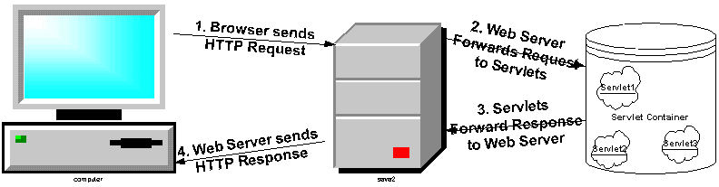

In general, what we mean by Servlet is that Servlet is an application component that implements Servlet interface. Servlet interface has the following methods:

Method | Return Type | Description
init(ServletConfig config) | void | Called by the servlet container – right after the constructor call - to indicate to a servlet that the servlet is being placed into service.
service(ServletRequest req, ServletResponse res) | void | Called by the servlet container to allow the servlet to respond to a request.
destroy() | void | Called by the servlet container to indicate to a servlet that the servlet is being taken out of service.
getServletConfig() | ServletConfig | Returns a ServletConfig object, which contains initialization and startup parameters for this servlet.
getServletInfo() | String | Returns information about the servlet, such as author, version, and copyright.

Obviously, there is more to it – the init() method receives and getServletConfig() method returns an object that implements ServletConfig interface, the service method receives two objects that implements ServletRequest and ServletResponse interface respectively. Clearly – the whole architecture is interface based since the container can’t and doesn’t enforce any rule on the actual components other that making sure that they implement certain interfaces.

Before, we get carried away by these interfaces, let’s just try to understand what these 5 methods do. Servlet interface defines methods to initialize a servlet, to service requests, and to remove a servlet from the server. These are known as life-cycle methods and are called in the following sequence:

- First time the Servlet is required for servicing a client, the container constructs the servlet object then initialized with the init() method. The init()method is never called once the Servlet object is instantiated.
- Any calls from clients to the servlet goes to the service() method. This is the method that is called repeatedly during the lifecycle of a Servlet – every time there is a request to the Servlet from a client.
- When the container feels like removing the servlet (since there is no request for it for a long time) the destroy() method of the Servlet is called, then garbage collected and finalized.

In addition to the lifecycle methods, this interface provides the getServletConfig() method, which the servlet can use to get any startup information provided by the container, and the getServletInfo() method allows the servlet to return basic information about itself, such as author, version, and copyright.

Our First Servlet
Since we know that a servlet is nothing but a class that implements Servlet Interface, why don’t we write such a class.

Here is our first servlet:

// Code 2A
import java.io.IOException;
import javax.servlet.Servlet;
import javax.servlet.ServletConfig;
import javax.servlet.ServletException;
import javax.servlet.ServletRequest;
import javax.servlet.ServletResponse;
import org.apache.log4j.Logger;
public class Servlet1 implements Servlet
{
private static final Logger logger = Logger.getLogger(Servlet1.class);
public void init(ServletConfig servletconfig) throws ServletException
{
logger.debug("In init");
logger.debug("ServletConfig Class: " + servletconfig.getClass().getName());
logger.debug("Finished init");
}
public ServletConfig getServletConfig()
{
logger.debug("In getServletConfig");
return null;
}
public void service(ServletRequest request, ServletResponse response) throws ServletException, IOException
{
logger.debug("In service");
logger.debug("ServletRequest Class: " + request.getClass().getName());
logger.debug("ServletResponse Class: " + response.getClass().getName());
logger.debug("Finished service");
}
public String getServletInfo()
{
logger.debug("In getServletInfo");
return null;
}
public void destroy()
{
logger.debug("In destroy");
}
}

Let’s save it in Tomcat’s webapps\ROOT\WEB-INF\classes as Servlet1.java.

Configuring Log4J
As you can see above, we are using Log4J for logging purposes.

In order for Log4J to work, please copy log4j-1.2.12.jar to Tomcat’s webapps\ROOT\WEB-INF\lib folder.

Please copy log4j.properties to Tomcat’s webapps\ROOT\WEB-INF\classes folder.

Also, please make sure that the following two jars are in your classpath:

- servlet-api.jar – located in Tomcat’s common\lib folder
- log4j-1.2.12.jar – located in Tomcat’s webapps\ROOT\WEB-INF\lib

Configuring Tomcat for Servlets to Run
Before trying to access the servlet from your browser, you have to enable Tomcat to run servlets that don’t need any standard servlet configuration process. To enable this, go to c:\Tomcat5028\conf folder and open web.xml. In this file search for the word “invoker”. You will find 2 sections of web.xml that has invoker:

a)

<servlet>
<servlet-name>invoker</servlet-name>
<servlet-class>
org.apache.catalina.servlets.InvokerServlet
</servlet-class>
<init-param>
<param-name>debug</param-name>
<param-value>0</param-value>
</init-param>
<load-on-startup>2</load-on-startup>
</servlet>

b)

<servlet-mapping>
<servlet-name>invoker</servlet-name>
<url-pattern>/servlet/*</url-pattern>
</servlet-mapping>

Surprising enough, both of these two sections are commented out by using the <!-- .. --> tags.

Please remove the comment tag “<!—“ before and the comment tag “-->” after these 2 blocks, stop and start Tomcat.

Assuming you are running Tomcat 5.0.28, I gave you the modified web.xml in demo2\conf folder that you can simply copy to Tomcat’s conf folder.

Now, you are good to go.

Compiling your Servlet
Before you compile your servlet, please make sure that you have configured log4j and tomcat as described above and your classpath has the two jar files:

- servlet-api.jar – located in Tomcat’s common\lib folder
- log4j-1.2.12.jar – located in Tomcat’s webapps\ROOT\WEB-INF\lib

Compile Servlet1.java in Tomcat’s webapps\ROOT\WEB-INF\classes folder.

Invoking Servlets from browser
From your web browser type:

http://localhost:8080/servlet/Servlet1

Of course, your browser will bring back error since it is expecting response and the servlet is not going to return any. However if you go back to your shell running Tomcat you will see the following:

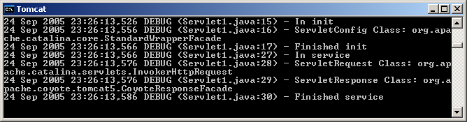

Interesting to notice that among the lifecycle methods, destroy() method did not get called after the service ended which implies that the Servlet1 object did not get destroyed yet. Also, getServletConfig() and getServletInfo() methods were never called, since they are not lifecycle methods, therefore, the container never calls them, you have to call them if you need them.

Go back to your browser and hit refresh a few times. Here is what you will get:

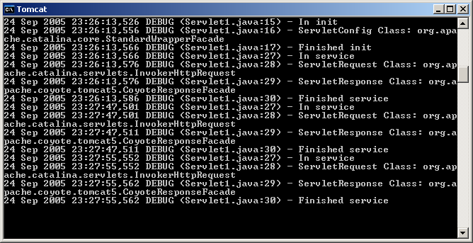

You will notice a trace of service calls on Tomcat for each refresh. Interesting to notice that the init() method did not get called for the subsequent refreshes. This implies that Tomcat is using the same Servlet1 instance (that it instantiated for the first call) for all the subsequent requests to Servlet1.

Examining Log File:
The way Log4J is configured, it also writes all the console output to a file logfile.txt.

Assuming, you started Tomcat using startup.bat from its bin folder, go to the folder where you installed Tomcat and open logfile.txt. You will see the following entries:
24 Sep 2005 23:26:13,526 DEBUG (Servlet1.java:15) - In init
24 Sep 2005 23:26:13,556 DEBUG (Servlet1.java:16) - ServletConfig Class: org.apache.catalina.core.StandardWrapperFacade
24 Sep 2005 23:26:13,566 DEBUG (Servlet1.java:17) - Finished init
24 Sep 2005 23:26:13,566 DEBUG (Servlet1.java:27) - In service
24 Sep 2005 23:26:13,576 DEBUG (Servlet1.java:28) - ServletRequest Class: org.apache.catalina.servlets.InvokerHttpRequest
24 Sep 2005 23:26:13,576 DEBUG (Servlet1.java:29) - ServletResponse Class: org.apache.coyote.tomcat5.CoyoteResponseFacade
24 Sep 2005 23:26:13,586 DEBUG (Servlet1.java:30) - Finished service
24 Sep 2005 23:27:47,501 DEBUG (Servlet1.java:27) - In service
24 Sep 2005 23:27:47,501 DEBUG (Servlet1.java:28) - ServletRequest Class: org.apache.catalina.servlets.InvokerHttpRequest
24 Sep 2005 23:27:47,511 DEBUG (Servlet1.java:29) - ServletResponse Class: org.apache.coyote.tomcat5.CoyoteResponseFacade
24 Sep 2005 23:27:47,511 DEBUG (Servlet1.java:30) - Finished service
24 Sep 2005 23:27:55,552 DEBUG (Servlet1.java:27) - In service
24 Sep 2005 23:27:55,552 DEBUG (Servlet1.java:28) - ServletRequest Class: org.apache.catalina.servlets.InvokerHttpRequest
24 Sep 2005 23:27:55,562 DEBUG (Servlet1.java:29) - ServletResponse Class: org.apache.coyote.tomcat5.CoyoteResponseFacade
24 Sep 2005 23:27:55,562 DEBUG (Servlet1.java:30) - Finished service

This file would be helpful for your debugging going forward.

Starting and Stopping Application in Tomcat
When you are doing the homework, you have to make changes to the same servlet in every 5 minutes and test it. It is annoying that you have to stop and start Tomcat to pick up the latest changes. There is a nice solution to the problem.

Launch Tomcat’s admin page using the following url:

http://localhost:8080/manager/html (you can also select the Tomcat Manager link from http://localhost:8080 – Tomcat’s main page)

Tomcat will challenge you for id and password that you setup during installation(my id ‘admin’ and password is ‘admin’). If you don’t remember what you did, open tomcat-users.xml from c:\tomcat528\conf folder and look it up.

You will see the following screen:

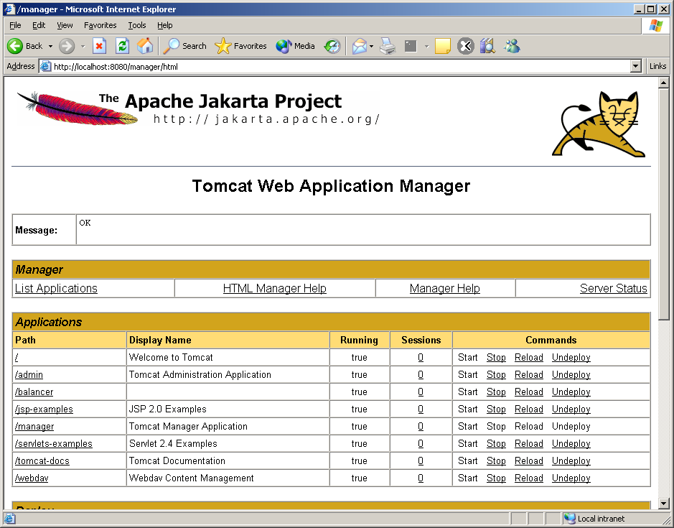

From this screen, you can stop, start or reload any application. For example, if you just made a change to Serlvet1 in ROOT app, click on Reload link of ‘/.’ (/ stands for ROOT in Tomcat) and confirm on the popup dialog. The changes will be in effect. Similarly, if you changed something in servlets-examples, just clink on reload of servlets-example and confirm on the popup dialog.

Just for fun, let’s go ahead and reload “/”. Examine Tomcat’s console. You will see that following:

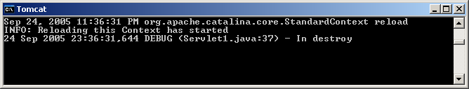

Notice, the destroy() method was called before ROOT was reloaded since Tomcat had to kill all the servlet objects before refreshing ROOT.

GenericServlet Class
People don’t like the idea of implementing all Servlet interface methods, everytime they need to create servlet. There should be some base class that has the basic implementation of Servlet interface and we should subclass from this class – after all, that’s the beauty of inheritance. GenericServlet class is the first step towards that direction. GenericServlet class provides the basic implementation of Servlet interface except for the service() method which is abstract. Since the service() method is the core of a servlet – it is the method that will be called by the container everytime some client makes a request for the servlet – this method would dramatically vary from one servlet to another and there is no generic implementation of it. Therefore, it does not make any sense to even make any attempt to write the service() method in GenericServlet class since it will be overridden by every subclass anyway. This is the classical case when we leave a method as abstract. Because of this abstract method the whole GenericServlet class is abstract. Our job is to subclass it to a non-abstract class and override the service() method.

Here is what the declaration of GenericServlet looks like:
public abstract class GenericServlet implements Servlet, ServletConfig, java.io.Serializable
Important to notice that in addition to implementing Servlet interface, GenericServlet, strangely enough, also implements ServletConfig interface. By implementing ServletConfig – GenericServlet reduced a level of indirection – you don’t have to call getServletConfig() any more to get to the methods of ServletConfig() interface – GenericServlet will have these methods already.

GenericServlet also introduced an overloaded init() method that does note take any argument. The original init(ServletConfig config) method is overridden so that it calls this init() method. If we need to write our own initialization we should override init() instead of overriding init(ServletConfig config).

GenericServlet also implements Serializable interface – this interface is a markup interface in Java that has no method to implement and it allows object to be persistent.

In addition to implementing the 3 interfaces mentioned above, GenericServlet also introduces two overloaded log() methods for writing errors to a servlet log. The name and location of the log file will vary from container to container. In Tomcat it is a file under the folder c:\Tomcat5028\logs.

Since our main focus is the service method of a servlet, lets examine the service() method more carefully. The servlet container sends two objects to the service method. An object that implements ServletRequest interface and another object that implement ServletResponse interface. We certainly need to look at these two interfaces more carefully.
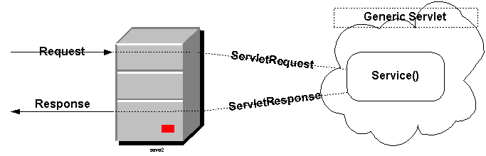

ServletRequest Interface
Defines an object to provide client request information to a servlet. We know already that the client request data comes in text form from the browser to the web server. When a request from a browser is handed over to the servlet container - the container creates an object that transforms row text data into object fields. This object, created by the container, must implement ServletRequest interface and is being passed as an argument to the servlet's service method.

A ServletRequest object contains request data including parameter name and values, attributes, and an input stream.

Unfortunately ServletRequest interface has many methods that need to be implemented. Here are some useful methods of this interface:

Useful Methods:
Method | Return Type | Description
getParameterNames() | Enumeration | Returns an Enumeration of String objects containing the names of the parameters contained in this request. We already know that http request sends HTML Form data as parameters.
getParameter(String name) | String | Returns the value of a request parameter as a String, or null if the parameter does not exist. If there are multiple values for a given parameter, then this method will return the first value in the list. In that case, use getParameterValues() instead.
getParameterValues(String name) | String[] | Returns an array of String objects containing all of the values the given request parameter has, or null if the parameter does not exist. Please keep in mind that although parameters normally have one value, it is allowed that parameters have multiple values. Using this method with getParameterNames() we can examine all parameter names and their values (HTML Form data) within the service() method.
getContentLength() | int | Returns the length, in bytes, of the request body and made available by the input stream, or -1 if the length is not known.
getContentType() | String | Returns the MIME type of the body of the request, or null if the type is not known.
getReader() | BufferedReader | Retrieves the body of the request as character data using a BufferedReader.
getInputStream() | ServletInputStream | Retrieves the body of the request as binary data using a ServletInputStream.
getRemoteAddr() | String | Returns the Internet Protocol (IP) address of the client that sent the request.
getRemoteHost() | String | Returns the fully qualified name of the client that sent the request, or the IP address of the client if the name cannot be determined.
getServerName() | String | Returns the host name of the server that received the request.
getServerPort() | Int | Returns the port number on which this request was received.
getProtocol() | String | Returns the name and version of the protocol the request uses in the form protocol/majorVersion.minorVersion, for example, HTTP/1.1.
getScheme() | String | Returns the name of the scheme used to make this request, for example, http, https, or ftp.
isSecure() | boolean | Returns a boolean indicating whether this request was made using a secure channel, such as HTTPS.
setAttribute(String name, Object o) | Void | Stores an attribute in this request. This is a very useful method when one servlet forwards a request to another servlet or JSP. Servlets/JSPs can add additional data to the request object before forwarding to the next servlet. Also servlet container can add attributes to the request object using this method.
getAttributeNames() | Enumeration | Returns an Enumeration containing the names of the attributes available to this request.
getAttribute(String name) | Object | Returns the value of the named attribute as an Object, or null if no attribute of the given name exists. Using this method with getAttributeNames() a servlet can retrieve all attribute names and values added by other servlets.
removeAttribute(String name) | Void | Removes an attribute from this request.
getRequestDispatcher(String path) | RequestDispatcher | Returns a RequestDispatcher object that acts as a wrapper for the resource located at the given path.

ServletResponse Interface
Now we know that we get the request data from the browser in the form of ServletRequest object. What about the data going back to the browser from the web server? Well, that’s the response. ServletResponse interface defines an object to assist a servlet in sending a response back to the client. The servlet container creates a ServletResponse object that is mostly empty (other than initializing a couple of fields to default values) and passes it as an argument to the servlet's service() method. This way, the response is already in progress and the service method doesn’t have to create the response from scratch. Sending a response turns out to be extremely simple. Basically, you have to get the PrinteWriter object of the ServletResponse by calling getWriter() method on it and then call the print()/println() method on it repeatedly.

Unfortunately ServletResponse interface also has many methods that need to be implemented. Here are some useful methods of this interface:

Useful Methods:
Method | Return Type | Description
setContentType(String type) | Void | Sets the content type of the response being sent to the client.
setContentLength(int len) | Void | Sets the length of the content body in the response In HTTP servlets, this method sets the HTTP Content-Length header. You normally don’t have to set it manually – the container will.
getWriter() | PrintWriter | Returns a PrintWriter object that can send character text to the client.
getOutputStream() | ServletOutputStream | Returns a ServletOutputStream suitable for writing binary data in the response.
SetBufferSize(int size) | Void | Sets the preferred buffer size for the body of the response.
getBufferSize() | Int | Returns the actual buffer size used for the response.
flushBuffer() | Void | Forces any content in the buffer to be written to the client.
IsCommitted() | boolean | Returns a boolean indicating if the response has been committed.
reset() | Void | Clears any data that exists in the buffer as well as the status code and headers.

Our First Servlet – that actually works
Finally, we are ready to write a servlet that will actually send a response back to the browser.

Here is the code:

// Code 2B
import java.io.IOException;
import java.io.PrintWriter;
import javax.servlet.GenericServlet;
import javax.servlet.ServletException;
import javax.servlet.ServletRequest;
import javax.servlet.ServletResponse;
import org.apache.log4j.Logger;
public class Servlet2 extends GenericServlet
{
private static final Logger logger = Logger.getLogger(Servlet2.class);
public void service(ServletRequest request, ServletResponse response)
throws ServletException, IOException{
logger.info("In service");
String name = null;
PrintWriter out = null;
// getting request parameter
name = request.getParameter("name");
logger.debug("Parameter 'name'= " + request.getParameter("name"));
//set the content type to html
response.setContentType("text/html");
// get the writer object and write.
out = response.getWriter();
logger.debug("Sending response");
out.println("<HTML>");
out.println("<HEAD>");
out.println("<TITLE>");
out.println("Welcome to Servlet");
out.println("</TITLE>");
out.println("</HEAD>");
out.println("<BODY>");
if (name==null){
out.println("<H1>Welcome to the wonderful world of servlet</H1>");
}
else{
out.println("<H1> " + name + ", Welcome to the wonderful world of servlet</H1>");
}
out.println("</BODY>");
out.println("</HTML>");
out.close();
logger.info("Finished service");
}
}

Notice, we set the content type of the response first.

Let’s save it in c:\tomcat5028\webapps\ROOT\WEB-INF\classes as Servlet2.java and compile.

From your web browser type:

http://localhost:8080/servlet/Servlet2?name=John

Here is the output:

type:

http://localhost:8080/servlets-examples/servlet/Servlet2?name=John

Here is the output:

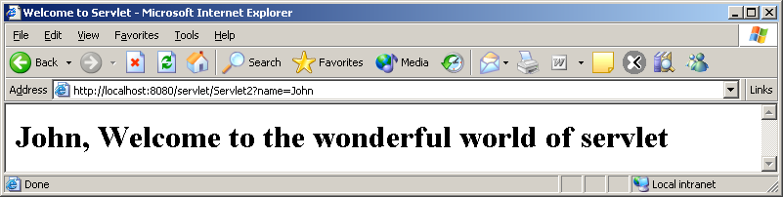

Here is Tomcat’s console output:

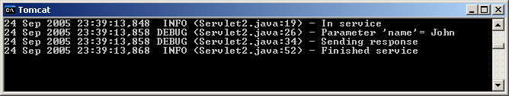

HttpServlet Class
GenericServlet is nice but it is protocol-independent. In order to provide different response for different type of HTTP requests (GET, POST, OPTIONS etc.) we have to lookup the request method in service() method and act differently. Also, there is no method to read HTTP request header information. In order to avoid these problems J2EE provides a sub-class of GenericServlet that is specifically designed to handle HTTP protocol – HttpServlet.

HttpServlet introduces a set of new methods. Interestingly, HttpServlet is an abstract class but all it’s methods are already implemented. Why is this class abstract then? The reason is simple but not obvious. The default implementation of all the important methods of HttpServlet object actually return HTTP error – nothing useful. Hence, it is expected that we will always subclass HttpServlet and override one or more of these methods. In order to ensure that we do – HttpServlet class has been defined abstract.

Here are the new methods introduced and implemented in HttpServlet:

Method | Return Type | Description
service(HttpServletRequest req, HttpServletResponse resp) | protected void | The original public service() method (that receives ServletRequsest and ServletResponse) calls this protected service() method. This method – after receiving standard HTTP requests from the public service method - dispatches them to the doXXX methods defined in this class.  You should not override this method.
doGet(HttpServletRequest req, HttpServletResponse resp) | protected void | Called by the server (via the service method) to allow a servlet to handle a GET request.  The default implementation reports an HTTP BAD_REQUEST error.  Servelets that support HTTP GET request should override this method.
doPost(HttpServletRequest req, HttpServletResponse resp) | protected void | Called by the server (via the service method) to allow a servlet to handle a POST request.  The default implementation reports an HTTP BAD_REQUEST error.  Servelets that support HTTP POST request should override this method.
doHead(HttpServletRequest req) | protected void | Returns HTTP header information.  The default implementation runs doGet() and returns the header only.  Servlets that support HTTP GET requests should override this method to accomplish efficient response.
getLastModified(HttpServletRequest req) | protected long | Returns the time the HttpServletRequest object was last modified, in milliseconds since midnight January 1, 1970 GMT. This method is called by browsers and proxies that cache pages to check if the cached page is still good.  The default implementation returns a negative number, indicating that the modification time is unknown and hence should not be used for conditional GET operations or for other cache control operations as this implementation will always return the contents.  Servlets that support HTTP GET requests should override this method to accomplish efficient response.
doOptions(HttpServletRequest req, HttpServletResponse resp) | protected void | Called by the server (via the service method) to allow a servlet to handle OPTIONS request.  The default implementation determines which HTTP methods the server supports and returns an appropriate header. For example, if a servlet overrides doGet, this method returns the following header: Allow: GET, HEAD, TRACE, OPTIONS  There's no need to override this method.
doPut(HttpServletRequest req, HttpServletResponse resp) | protected void | Called by the server (via the service method) to allow a servlet to handle a PUT request.  The default implementation reports an HTTP BAD_REQUEST error.  Servelets that support HTTP PUT request should override this method.
doDelete(HttpServletRequest req, HttpServletResponse resp) | protected void | Called by the server (via the service method) to allow a servlet to handle a DELETE request.  The default implementation reports an HTTP BAD_REQUEST error.  Servelets that support HTTP DELETE request should override this method.
doTrace(HttpServletRequest req, HttpServletResponse resp) | protected void | Called by the server (via the service method) to allow a servlet to handle a TRACE request.  The default implementation of this method causes a response with a message containing all of the headers sent in the trace request.  There is no need to override this method.

Notice that HttpServlet actually introduces an overloaded protected service() method that receives HttpServletRequest and HttpServletResponse as arguments. But we already know that servlet container calls the other public service() method that receives ServletRequest and ServletResponse as arguments. So who calls this method? The answer is a bit complicated.

HttpServlet overrides the original public service(ServletRequest req, ServletResponse res) method so that it calls the protected service(HttpServletRequest req, HttpServletResponse resp). HttpServletRequest and HttpServletResponse are two new interfaces that are extended from ServletRequest and ServletResponse respectively.

service(HttpServletRequest req, HttpServletResponse resp) method, in turn, checks the HTTP request type (by calling getMethod() on HttpServletRequest) and forwards the request to the appropriate doXXX method (for example doGet(), doPost() etc.).

Typically we would want to send the same response to the user regardless of whether the request is a GET or POST request. In that case, we simple overwrite the doGet() method and call it from doPost() method or vice versa.
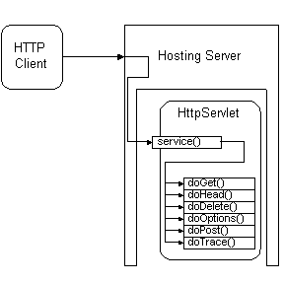

HttpServletRequest Interface
This interface extends the ServletRequest interface to provide request information for HTTP servlets.
The servlet container actually creates an object that implements HttpServletRequest (we were not precisely correct when we said it creates ServletRequest object) and passes it as an argument to the servlet's service method. HttpServletRequest interface has a number of new methods. Here are some useful methods in HttpServletRequest interface:

Useful Methods:
Method | Return Type | Description
getHeader(String name) | String | Returns the value of the specified request header as a String.
getHeaders(String name) | Enumeration | Returns all the values of the specified request header as an Enumeration of String objects. Using this method with getHeaderNames() a servlet can retried all header names and values.
getIntHeader(String name) | int | Returns the value of the specified request header as an int. This method is identical to getHeader() – it merely does an additional String to int conversion.
getDateHeader(String name) | long | Returns the value of the specified request header as a long value that represents a Date object. This method is identical to getHeader() – it merely does an additional String to long conversion.
getMethod() | String | Returns the name of the HTTP method with which this request was made, for example, GET, POST, or PUT.
getHeaderNames() | Enumeration | Returns an enumeration of all the header names this request contains.
getRequestURI() | String | Returns the part of this request's URL that uniquely identifies the servlet on a server.  For example, if my URL looks like:  http://localhost:8080/testapp/servlet/RequestInfoExample  The requested URI would be:  /testapp/servlet/RequestInfoExample
getServletPath() | String | Returns the part of this request's URL that calls the servlet.  For example, if my URL looks like:  http://localhost:8080/testapp/servlet/RequestInfoExample  The servlet path would be:  /servlet/RequestInfoExample
getContextPath() | String | Returns the portion of the request URI that indicates the context of the request.  For example, if my URL looks like:  http://localhost:8080/testapp/servlet/RequestInfoExample  The context path would be:  /testapp
getQueryString() | String | Returns the query string that is contained in the request URL after the path.  For example, if my URL looks like:  http://localhost:8080/testapp/servlet/RequestInfoExample ?user_name=Mohammed&password=1234  The query string would be:  user_name=Mohammed&password=1234
getCookies() | Cookie[] | Returns an array containing all of the Cookie objects the client sent with this request.
getRequestedSessionId() | String | Returns the session ID specified by the client.
isRequestedSessionIdFromCookie() | boolean | Checks whether the requested session ID came in as a cookie.
isRequestedSessionIdFromURL() | boolean | Checks whether the requested session ID came in as part of the request URL.
isRequestedSessionIdValid() | boolean | Checks whether the requested session ID is still valid.
getSession() | HttpSession | Returns the current session associated with this request, or if the request does not have a session, creates one.
getSession(boolean create) | HttpSession | Returns the current HttpSession associated with this request or, if if there is no current session and create is true, returns a new session.
getAuthType() | String | Returns the name of the authentication scheme used to protect the servlet, for example, "BASIC" or "SSL," or null if the servlet was not protected.
getRemoteUser() | String | Returns the login of the user making this request, if the user has been authenticated, or null if the user has not been authenticated.

HttpServletResponse Interface
This interface extends the ServletResponse interface to provide response information for HTTP servlets. The servlet container creates an object that implements HttpServletResponse (again we were not precisely correct when we said ServletResponse) and passes it as an argument to the servlet's service method. HttpServletResponse interface has a number of new methods. Here are some useful methods in HttpServletResponse interface:

Useful Methods:

Method | Return Type | Description
setStatus(int sc) | void | Sets the status code for this response.
addHeader(String name, String value) | void | Adds a response header with the given name and value.
setHeader(String name, String value) | void | Sets a response header with the given name and value.
addIntHeader(String name, int value) | void | Adds a response header with the given name and integer value.
setIntHeader(String name, int value) | void | Sets a response header with the given name and integer value.
addDateHeader(String name, long date) | void | Adds a response header with the given name and date-value.
setDateHeader(String name, long date) | void | Sets a response header with the given name and date-value.
containsHeader(String name) | boolean | Returns a boolean indicating whether the named response header has already been set.
addCookie(Cookie cookie) | void | Adds the specified cookie to the response.
encodeRedirectURL(String url) | String | Encodes the specified URL for use in the sendRedirect method or, if encoding is not needed, returns the URL unchanged.
encodeURL(String url) | String | Encodes the specified URL by including the session ID in it, or, if encoding is not needed, returns the URL unchanged.
sendError(int sc) | void | Sends an error response to the client using the specified status.
sendError(int sc, String msg) | void | Sends an error response to the client using the specified status code and descriptive message.
sendRedirect(String location) | void | Sends a temporary redirect response to the client using the specified redirect location URL.

Servlet – Again!
So, what is Servlet again? Servlets are server-side component that runs in a servlet container like JRun, Tomcat. Servlet container is typically integrated with a web server (like Tomcat can be integrated with Apache Web Server or IIS). Although Servlets can be used in any application it is typically used with web applications. Servlet provides web developers with a simple mechanism for extending the functionality of a web server. Complex web sites often need to provide HTML pages that are tailored for each visitor, or even for each hit. Servlets can be written to process HTML pages and customize them as they are sent to a client. For example, a client may need information from a database; a servlet can be written that receives the request, gets and processes the data as needed by the client, and then returns it to the client.

Servlets have access to the entire family of Java APIs, including the JDBC API to access enterprise databases. Servlets can also access a library of HTTP-specific calls and receive all the benefits of the mature Java language. Today, servlets are a popular choice for building interactive web applications.

Servlet classes and interfaces are defined in two packages

- javax.servlet
- javax.servlet.http

Here is a servlet that examines a request and sends back all the information is gathers from the request:

// Code 2C
import java.io.IOException;
import java.io.PrintWriter;
import java.util.Enumeration;
import javax.servlet.ServletException;
import javax.servlet.http.HttpServlet;
import javax.servlet.http.HttpServletRequest;
import javax.servlet.http.HttpServletResponse;
import org.apache.log4j.Logger;
public class RequestExaminerServlet extends HttpServlet {
private static final Logger logger = Logger.getLogger(RequestExaminerServlet.class);
public void doGet(HttpServletRequest request, HttpServletResponse response)
throws ServletException, IOException
{
logger.info("In doGet");
Enumeration headerNames = null;
String headerName = null;
Enumeration headerValues =null;
String headerValue = null;
PrintWriter out = null;
Enumeration parameterNames = null;
String parameterName = null;
String[] parameterValues =null;
String parameterValue = null;
// get the writer and set output content type
out = response.getWriter();
//set content type
response.setContentType("text/plain");
logger.debug("Calling APIs on request");
// print request info.
out.println("Protocol: " + request.getProtocol());
out.println("Scheme: " + request.getScheme());
out.println("Server Name: " + request.getServerName());
out.println("Server Port: " + request.getServerPort());
out.println("Remote Addr: " + request.getRemoteAddr());
out.println("Remote Host: " + request.getRemoteHost());
out.println("Content Length: " + request.getContentLength());
out.println("Content Type: "+ request.getContentType());
out.println("Locale: "+ request.getLocale());
out.println("Default Response Buffer: "+ response.getBufferSize());
out.println("HTTP Method: " + request.getMethod());
out.println("Request URI: " + request.getRequestURI());
out.println("Context Path: " + request.getContextPath());
out.println("Servlet Path: " + request.getServletPath());
out.println("Request Is Secure: " + request.isSecure());
out.println("Query String: " + request.getQueryString());
out.println();
logger.debug("Reading request headers");
// print request header
out.println("Headers in this request:");
headerNames = request.getHeaderNames();
while (headerNames.hasMoreElements()) {
headerName = (String)headerNames.nextElement();
logger.debug("Header Name: " + headerName);
headerValues = request.getHeaders(headerName);
out.print(" " + headerName + " = ");
while (headerValues.hasMoreElements()) {
headerValue = (String) headerValues.nextElement();
logger.debug("Header Value: " + headerValue);
out.print(headerValue + "\t");
}
out.println();
}
out.println();
logger.debug("Reading request parameters");
// print request parameter
out.println("Parameter names in this request:");
parameterNames = request.getParameterNames();
while (parameterNames.hasMoreElements()) {
parameterName = (String) parameterNames.nextElement();
logger.debug("Parameter Name: " + parameterName);
parameterValues = request.getParameterValues(parameterName);
out.print(" " + parameterName + " = ");
for(int i = 0; i < parameterValues.length; i++) {
parameterValue = parameterValues[i];
logger.debug("Parameter Value: " + parameterValue);
out.print(parameterValue + "\t");
}
out.println();
}
out.println();
logger.info("Finished doGet");
}
}

Let’s save it in c:\tomcat5028webapps\ROOT\WEB-INF\classes as RequestExaminerServlet.java and compile.

From your web browser type:
http://localhost:8080/servlet/RequestExaminerServlet

Here is the output you get:

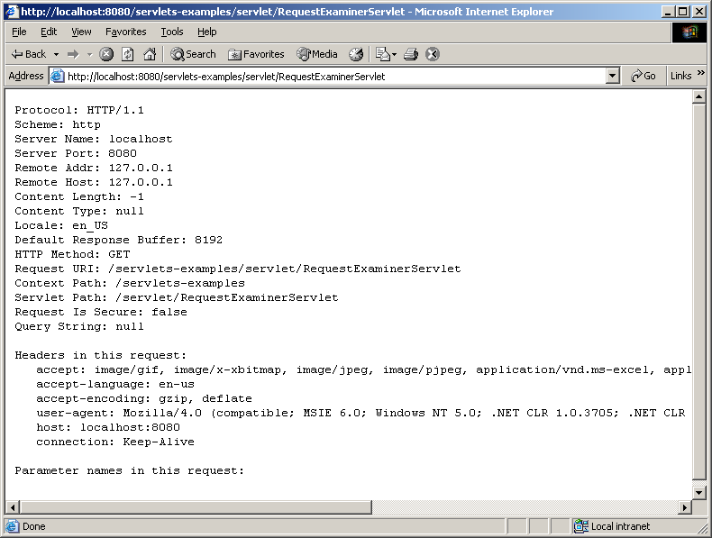

Parameter names in this request:

Notice that the Query String is null and there is no parameter in the request.

Let’s hit the Servlet again as follows:

http://localhost:8080/servlet/RequestExaminerServlet?name=john&age=30

Here is the output we get:

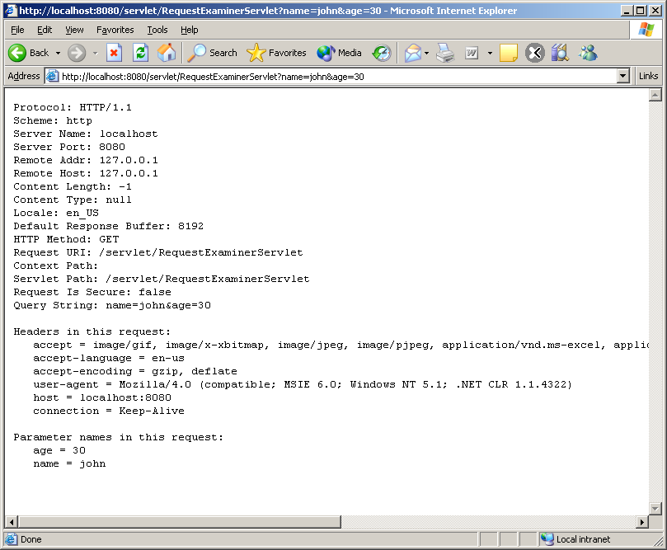

Notice the query string and parameter name & values above.

J2EE Web Terminology
Web Components:
Java Servlet and JSP (which is essentially another form Servlet) are the building blocks for developing web applications. In J2EE – these are called web components.

Web Application:
In J2EE, a web application is a collection of web components like Java Servlets, JSP pages, other helper classes as well as static resources like HTML, XML documents. Web applications reside on web container.

Web Container:
in J2EE, a web container is essentially a Java runtime environment that supports Java Servlets and JSPs. The web container is responsible for initializing, invoking and managing the life cycle of Java Servlets and JSPs. In other words, web container is where web applications reside and run.

Web Server:
In J2EE, a web server is an HTTP server that either serves static page requests or delegates the requests to the web container. Tomcat is an extraordinary web container that can be plugged into many web servers (like IIS or Apache) or it can also server as a web server.

Structure of Web Application
A web application has the following parts:

- A public directory – this is the root directory of the web application. If you are familiar with HTTP servers like IIS this is the wwwroot directory. In case of Apache this would be htdocs direcory. In case of Tomcat – is it the root directory of the web application. This is where you keep your HTML files.
- A “WEB-INF” directory – this directory is private. The container will not directly serve any contain of this directory.
- A “web.xml” file in WEB-INF directory. This is the deployment descriptor for the servlets.
- A “classes” subdirectory under WEB-INF. This is the directory where you put your servlet class files in development mode. Tomcat is case sensitive. Please make sure that the “classes” folder is in lowercase for the application you are working on.
- A “lib” directory under WEB-INF. This is where you keep your packaged JAR files.

By default “classes” and “lib” folders under WEB-INF are mapped to “servlet”.

For example:

When you type:

http://localhost:8080/servlets-examples/servlet/RequestExaminerServlet

The “WEB-INF/classes” folder is mapped to “servlet”

Creating a new Web Application in Tomcat
Let’s consider that we want to create a new Web Application called “testapp” in your Tomcat web container.

- create a “testapp” folder under Tomcat’s webapps folder.
- create a WEB-INF folder under testapp. All uppercase letters in “WEB-INF”.
- create a lib folder under WEB-INF. All lowercase lettters in “lib”.
- copy log4j-1.2.12.jar in the lib folder.
- create a classes folder under WEB-INF. All lowercase lettters in “classes”.
- copy log4j.properties file in the classes folder.
- copy the RequestExaminerServlet.class from ROOT\WEB-INF\classes to testapp\WEB-INF\classes folder.
- copy web.xml from ROOT\WEB-INF folder to testapp\WEB-INF and clean it up so that your web.xml looks like this:

<?xml version="1.0" encoding="ISO-8859-1"?>

<!DOCTYPE web-app
PUBLIC "-//Sun Microsystems, Inc.//DTD Web Application 2.3//EN"
"http://java.sun.com/dtd/web-app_2_3.dtd">

<web-app>
</web-app>

- Stop Tomcat and re-start Tomcat. This is essential for your application to be visible.
- type http://localhost:8080/testapp/servlet/RequestExaminerServlet – it will take a few seconds and bring back the response from RequestExaminerServlet.
- Let’s try to name “RequestExaminerServlet” as “displayrequest.html” without the “servlet” folder name in front of it.
- goto “c:\tomcat5028\webapps\testapp\WEB-INF and open web.xml in wordpad.
- Let’s override the content of web.xml with the following:

<?xml version="1.0" encoding="ISO-8859-1"?>

<!DOCTYPE web-app
PUBLIC "-//Sun Microsystems, Inc.//DTD Web Application 2.3//EN"
"http://java.sun.com/dtd/web-app_2_3.dtd">

<web-app>
<servlet>
<servlet-name>
feedback
</servlet-name>
<servlet-class>
RequestExaminerServlet
</servlet-class>
</servlet>
<servlet-mapping>
<servlet-name>
feedback
</servlet-name>
<url-pattern>
/displayrequest.html
</url-pattern>
</servlet-mapping>
</web-app>

- Stop Tomcat and re-start Tomcat. Again, this is essential for Tomcat to kick-in the changes.

- http://localhost:8080/testapp/displayrequest.html

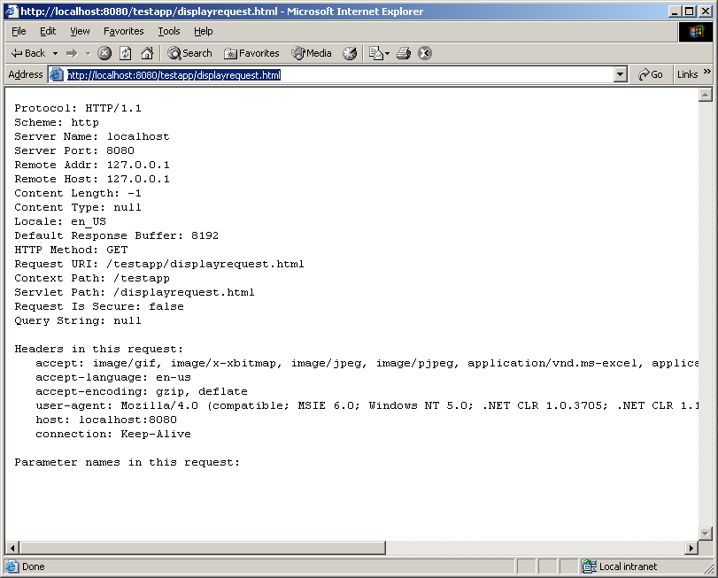
It should bring back following response:

I gave you the whole testapp folder structure with web.xml configured in demo2 folder. You can simply copy and paste the folder structure under Tomcat’s webapps folder and you got the new application deployed.

Just like we gave the servlet a different path than the actual location above, we can do that will the application path too. Let’s say, we want the application to be visible as “realapp” but the actual folder name is “testapp”. We can do that by adding a testapp.xml file in Tomcat’s conf\Catalina\localhost folder. The testapp.xml should contain the following entry:

<Context path="/realapp" docBase="testapp" debug="0" reloadable="true" privileged="true" />

Notice the reloadable=”true” flag as well. This will allow tomcat to automatically pick up modified class files from classes folder (hot deployment) wihout Tomcat being restarted.
In the same folder, let’s app servlets-examples.xml that contain the following entry:

<Context path="/servlets-examples" docBase="servlets-examples" debug="0" reloadable="true" privileged="true" />

From a browser, type the following url:

http://localhost:8080/realapp/displayrequest.html

You will basically get the same output as before, except the application name is realapp.

I gave you the testapp.xml and servlets-examples.xml file with the proper folder structure under demo2 folder. You can simple copy and paste them under Tomcat installation.

Sequence of events related to a HTTP Request
When an HTTP request comes to web server (that has web container plugged in) the following sequence of event occurs:

- The web server figures out whether the incoming request corresponds to a resource that it can handle (like html page) or it is part of a web application. If the web server does not find it as a resource that it can serve, then it consults the web container. A web container may have more than one web application running at any given time. Therefore, the web container uses the notion of context to identify resources that belong to web applications. You have to specify this context when you deploy a new web application on a web container. So far, we have used two web applications – examples-servlets and testapp. Here is how the context of testapp is defined:

<Context path="/realapp" docBase="testapp" debug="0" reloadable="true" privileged="true" />

Notice the context path is “realapp” and the docbase (actual folder name) is “testapp”. Therefore, any url that starts with “realapp” is considered to be part of “testapp”.

- Once, the web application has been decided, now it is time to decide on the resource. In a J2EE web application, an URL can be mapped to a servlet, JSP or static resource like HTML page, an image, an XML document etc using a component deployment descriptor. The component deployment descriptor is web.xml file located in Web-inf folder of the web application. Here is an example of mapping RequestExaminerServlet to displayrequest.html:

<servlet>
<servlet-name>
feedback
</servlet-name>
<servlet-class>
RequestExaminerServlet
</servlet-class>
</servlet>
<servlet-mapping>
<servlet-name>
feedback
</servlet-name>
<url-pattern>
/displayrequest.html
</url-pattern>
</servlet-mapping>

If URLs are not mapped using component deployment descriptor (web.xml) a default mapping schema is used like “WEB-INF\classes” folder maps to “servlet”. All other resouces map to exactly where there are physically located.

- Once the web container figures out the resource as part of a web application, the HTTP server delegates the request to the web container.

- If the web container determines, based on the deployment descriptors of web application and web component that the request should be handled by a servlet, the container:

- Converts the byte steam of request to an HttpServletRequest object. It creates an HttpServletResponse object (almost empty – except for a few default attributes)
- Either creates a brand new servlet instance or re-uses one of the existing servlet instances and delegates the HttpServeltRequest and HttpServletResponse object to the service() method of the servlet.

- The service() method of the servlet delegates the request to the appropriate doXXX method.

- The doXXX method reads the HttpServletRequest object and writes to the HttpServletResponse object. This is where all the custom code goes. Each servlet looks for its own set of parameters in the request object and assembles the response objects – totally dynamically.

- When the service method returns, the web-container decomposes the HttpServletResponse object into a stream of bytes and forwards it to the web server as response.

- The web server sends the response stream of bytes to the browser.

- The browser on the client machine reads the response stream of bytes and presents it the user.

Reading a HTTP Request
We already know that request is composes of three things:
- Request Line
- Request Header
- Request Body

Here is how to read them:

Reading Request Line
The getMethod() method returns the HTTP request method (GET, POST etc). The getRquestURI() method returns the part of the URL that comes after the host and port but before the form data. For example if the request looks like:

http://localhost:8080/thankyou.html?user_name=Mohammed+Rahman&user_password=12345&email_account=true&grade=LG&skill=B&webserver=A&webserver=I&Comments=I+am+sending+a+get+request.%0D%0A%0D%0ALet%27s+see+what+happens+to+the+url%09

The URI is “thankyou.html”

The getProtocol() method returns the third part of the request line, which is generally HTTP/1.0 or HTTP/1.1.

Reading Request Headers
Reading request headers is straightforward, just call the getHeader() method of HttpServletRequest with the header name and the method will return the header value as String if the specified header was supplied on the request, null otherwise.

If the Header can have multiple values use getHeaders() instead.

Unlike parameter, Header names are not case-sensitive. So, for example getHeader(“Connection”) and getHeader(“connection”) are interchangeable. If the header is expected to be int or Date use getIntHeader() or getDateHeader() which will read the specified header convert it to int or Date values respectively.

getIntHeader() returns –1 if the header is not included in the request and throws NumberFormatException if the header can not be converted to int.
getDateHeader() returns – 1 id the header is not included in the request and throws IllegalArgumentException if the header can not be converted to Date.

In addition, getHeaderNames(), getHeaders() methods can be used to find out the names of all the headers and their values.

Although getHeader() is the general-purpose way to read incoming headers – certain headers are so commonly used that they have separate access methods in HttpServletRequest. Here are those:

- getContentType() and getContentLength() – Returns the value of content type(String) and length(int) header.

- getAuthorType() and getRemoteUser() – These two methods break the Authorization headed into its component piece. Authorization will be discussed later.

- getCookies() – Returns the contents of the Cookie header, parsed and stored in an array of Cookie objects. Cookies will be discussed later.

Reading Request Body
One of the nice features of Servlet is that the Query String (Form Data) parsing is handled automatically, regardless whether it is located in the body (POST) or on the url itself (GET). Therefore, you don’t really have to read the body. You simply call the getParameter() method of the HttpServletRequest with the parameter name and the method will return the parameter value as String if the specified parameter was supplied on the request , null otherwise.

If the parameter can have multiple values use getParameterValues() instead.

Unlike Headers, Parameter names are case-sensitive. So, for example, getParameter(“Password”) and getParameter(“password”) are two different things.

Unless, the request message is binary data (which is very rare) you don’t have to look at the input stream of the request.

Writing HTTP Response
We already know that a Response consists of three things:

- Status Line
- Response Header
- Response Message

Here is how to write them:

Writing Response Status Line
A HTTP response status line consists of an HTTP version(like HTTP/1.1), a status code(like 200) and an associated message(like Ok). Since the status message is directly associated with the status code - all a servlet needs to do is to set the status code. The way to do this is by the setStatus() method of HttpServletResponse object. HTTP version is determined and set by the server.

However, most of the time you don’t have to set the status at all. A value of 200(SC_OK) means that everything is fine and this status is automatically set on the response object as default. If you don’t specify the status the response will get 200 status.

If you do want to return a special status code and a document, please be sure to call setStatus() before you write the body of the response. That’s because an HTTP response consists of the status line, one or more headers, a blank line and the actual document, in that order. Although servlet specification version 2.2 allows buffering of response – the size of the buffer is left unspecified. Therefore, the safest thing to do is to set the status first.

The setStatus() method takes int as an argument(as status code) but instead of using explicit numbers, it is clearer and more readable to use the constants defined in HttpServletResponse.

Although the general method of setting status codes is simply to call setStatus(), there are two common cases where a shortcut method in HttpServletResponse can be used. Both of these methods throw IOException, whereas setStatus() doesn’t.

- public void sendError(int code, String message)
The sendError() method sends a status code, usually 404(constant SC_NOT_FOUND) – “Not Found” - along with a short message that is automatically formatted inside an HTML document and sent to the client.

- public void sendRedirect(String url)
The sendRedirect() method sends a status code 302(constant SC_MOVED_TEMPORARILY) along with Location header giving the URL of the new document. The status message was “Moved Temporarily” in HTTP 1.0 but it is “Found” in HTTP 1.1.With servlets specification version 2.1 the String must be an absolute URL but in 2.2 either absolute or relative URL is permitted and the system automatically translates relative URL into absolute URL before putting them in the Location header.

If the response has already been committed, this method throws an IllegalStateException. After using this method, the response should be considered to be committed and should not be written to.

Writing Response Header
Writing response headers is straightforward too, just call the setHeader() method of HttpServletResponse with the header name and header value. Please be sure to call setStatus() (if you must set the status) before you write the header of the response. That’s because an HTTP response consists of the status line, one or more headers, a blank line and the actual document, in that order. Although servlet specification version 2.2 allows buffering of response – the size of the buffer is left unspecified. Therefore, the safest thing to do is to set the headers first.

If the Header can have multiple values use addHeader() instead since setHeader() that overwrites the header value (in servlet specification 2.1 setHeader() always added new values – leaving no option to unset a header). If you want to check whether a specific header is already been set, use containsHeader() method.

As Request Headers, Response Header names are not case-sensitive. So, for example setHeader(“Connection”, “Closed”) and setHeader(“connection”,”Closed”) are interchangeable. If the header is int or Date use setIntHeader() or setDateHeader() respectively. To add multiple values of int or Date header use addIntHeader() or addDateHeader() respectively.

Although setHeader() is the general-purpose way to set outgoing headers – certain headers are so commonly used that they have separate methods in HttpServletResponse. Here are those:

- public void setContentType(String type)
This method sets the content-type header (for example text/html, text/xml, text/plain etc.). This method should be called in a servlet as one of the very first step.

b) public void setContentLength(int len)
This method sets the content-length header and is only useful if the browser supports persistent(keep-alive) connection and the servlet wants to take advantage of it.

c) public void addCookie(Cookie cookie)
This method inserts a cookie into the Set-Cookie header. This method can be called multiple times to set more than one cookie. There is no corresponding setCookie() method. Cookies will be discussed later.

Writing Response Message
Writing Response message is straightforward too. In order to write simple text/html or text/plain message simply call the getWriter() method of HttpServletResponse. This will return a PrintWriter (16 bit – Unicode) object. Use the print() or println() method of the PrintWriter object to write. Finally close the PrintWriter.

In case of binary output you need to call the getOutPutSteam() method of HttpServletResponse. This will return ServletOutputSteam (8 bit – ASCII). Use the print() or println() method of the ServletOutputStream object to write. Finally close the ServletOutputStream.

Here is an html page name.html that captures user input:

<html>
<head><title>Name Entry Screen</title></head>
<body>
<form method="GET" action="/servlet/HelloServlet">
Please enter your name here:<br>
<hr>
Last Name <input type="text" name="lastname" size="15" ><br>
First Name <input type="text" name="firstname" size="15" ><br><br>
<input type="checkbox" name="programmer" >Java Programmer<br>
<hr>
<input type="submit" name="submit" value="Send"><input type="reset" name="cancel" value="Cancel"></p>
</form>
</body>
</html>

Here is the HelloServlet that it calls:

// Code 2D
import java.io.IOException;
import java.io.PrintWriter;
import javax.servlet.ServletException;
import javax.servlet.http.HttpServlet;
import javax.servlet.http.HttpServletRequest;
import javax.servlet.http.HttpServletResponse;
public class HelloServlet extends HttpServlet {
public void doGet(HttpServletRequest request, HttpServletResponse response)
throws ServletException, IOException
{
// get the writer and set output content type
PrintWriter out = response.getWriter();
response.setContentType("text/html");
// print response
out.println("<html>");
out.println("<head>");
out.println("<title>");
out.println("Response from HelloServlet");
out.println("</title>");
out.println("</head>");
out.println("<body>");
if ((request.getParameter("firstname").equals("")) || request.getParameter("lastname").equals("")){
out.println("<h1>You did not enter your name properly</h1>");
}
else{
out.println("<h1>Hello " + request.getParameter("firstname") + " " + request.getParameter("lastname") + "</h1>");
if (request.getParameter("programmer")==null){
out.println("<h3>I am sorry, you are in the wrong class. You must know Java for this class</h3>");
}
else{
out.println("<h3>Wonderful, since you know Java, we can start talking Java now.</h3>");
}
}
out.println("</body>");
out.println("</html>");
}
}

Let’s save it in c:\tomcat5028\webapps\ROOT\WEB-INF\classes and compile. Let’s copy name.html to c:\tomcat5028\webapps\ROOT folder.

Let hit the html page as follows (assuming tomcat is running on port 80):

http://localhost:8080/name.html

Here is what it looks like:

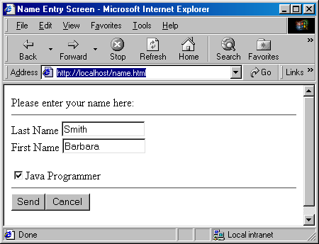

Here is the response when you hit the send button:
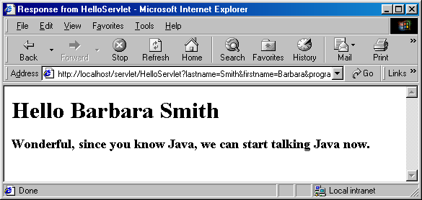

Please note one interest thing about checkboxes. Checkboxes don’t get transmitted as input parameter unless they are checked off. Unchecked check box simply disappears from the input data. You will save yourself a lot of trouble if you know this.

Reading Assignment
- Professional Java Server Programming – Chapter 8
- Core Servlet and JavaServer Pages – Chapter 2,3,4,6,7

Homework Assignment
- Write a servlet called SorryServlet that returns a “Service Unavailable” status with a message “<H3>Sorry, the service is unavailable due to excessive call volume.</H3>” for both GET and POST methods. Please make sure that you use the appropriate constant for status.

If you are using IE5 please go to the Tools Menu, select Internet Options, choose the Advanced Tab and uncheck “Show friendly HTTP error messages”. The default behavior of IE5 is to ignore the error page you send back displays its own, even though doing so contradicts the HTTP specification. Test your servlet.

Here is a sample output in IE5:

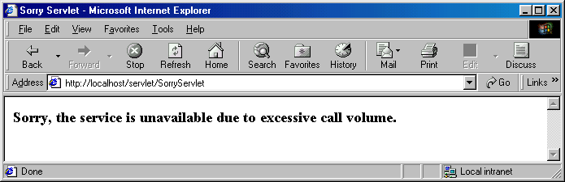

- Write a servlet called RedirectServlet that redirects the request to signup1.html (from hw1) for both GET and POST method. Test your servlet.

Here is a sample output in IE5:

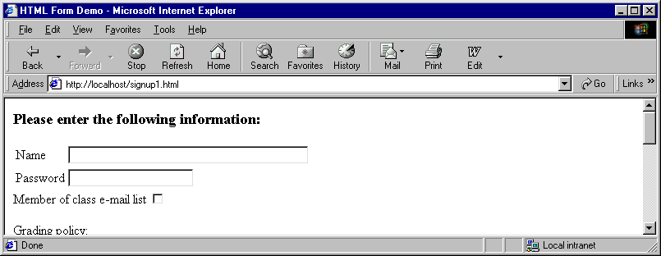
Notice the url points to sighup1.html instead of RedirectServlet due to redirection.

- Write a servlet called ErrorServlet that returns “Not Implemented” status (501) with the following message:

The URL you have requested returned Error

Please use sendError() method.

If you are using IE5 please go to the Tools Menu, select Internet Options, choose the Advanced Tab and uncheck “Show friendly HTTP error messages”. The default behavior of IE5 is to ignore the error page you send back displays its own, even though doing so contradicts the HTTP specification. Test your servlet.

Here is a sample output is IE5:

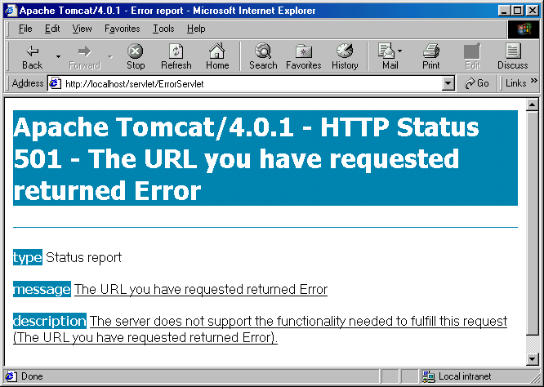
- Write an HTML file random.html that looks like this:

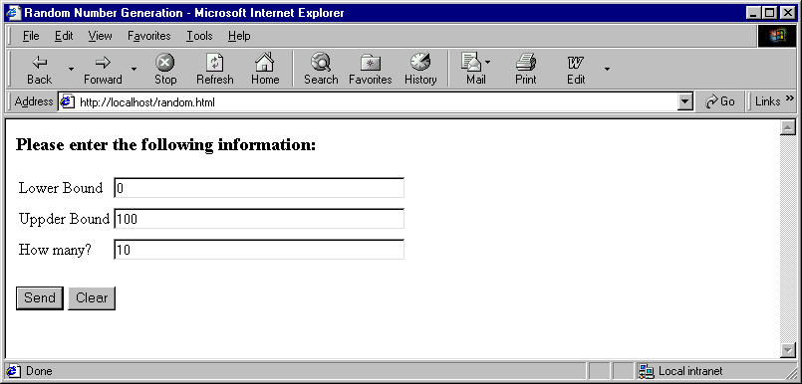
Please note the default values.

Write a servlet “RandomServlet” that meets the following requirements:

- Request parameters must be read by their names not their positional values.
- If the user sends non-numeric or negative data for any of the fields the response looks like this:

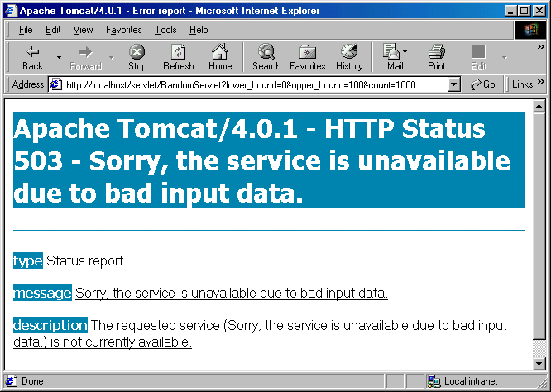

- Upper limit must be greater than lower limit. Otherwise the response should still be the error page shown above.
- If the user enters “how many” greater than or equal to the difference between upper and lower limit the response should still be the error page shown above.
- “how many” should be greater than zero.
- There is no duplicate numbers.
- The numbers are sorted in ascending order and numbered as 1,2,3 … etc.

Here is the normal output:

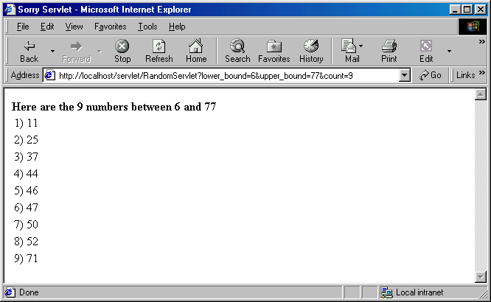

Please make sure of the followings:

Please use TreeSet from java collection classes so that the numbers are sorted and duplicate numbers are avoided. Usage of TreeSet is mandatory.

You can use the following formula to get random numbers between a range:

(int) ((Upperbound - Lowerbound+ 1) * Math.random() + Lowerbound)

