Session 3 - Maintaining State using Cookies and Session

Objective
This session introduces students to the challenge of maintaining state in HTTP protocol and describes how it is done is Java. Cookies are discussed in details as the preferred way of maintaining state in HTTP protocol. Students are then introduced to session tracking APIs of servlet used to maintain state.

Stateless HTTP
Http is a “stateless” protocol – it provides no way for a server to recognize that a sequence of requests are all from the same client. Each time a client retrieve a page, it opens a separate connection to the web server and the server does not automatically know if this is the first connection from the client, or the second or the third. In other words, the server does not maintain contextual information about a client. Even with servers that support persistent (keep-alive) HTTP connections and keep a socket open for multiple client requests that occur very close together, there is no built-in support for maintaining context.

Initially, this does not bother us since we are so used to seeing application maintaining state in client-server environment that statelessness does not strike us as a major problem. What stateless basically means is that while using an on-line banking service we have to log-on on every click/transaction since every click/transaction is a new request to the server. What is also means that while shopping on-line we have to buy every item separately since the concept of shopping cart requires state maintenance.

Fortunately, there are four typical solutions to this problem:

- User Authorization
- URL Rewriting
- Hidden Form Fields
- Cookies

Here are the details on these options.

a) User Authorization
Every HTTP server has a built-in capability to restrict access to some or all its pages to a given set of registered users. How you set up restricted access depends on the server but here is how it works. The first time the browser attempts to access one of these pages, the HTTP server replies that user authentication is required. When the browser receives this response, it usually opens a window asking the user for a name and password appropriate for the page.

Once the user enters his information, the browser again attempts to access the page, this time attaching the user’s name and password along with the request. Once, a user has logged in, the browser remembers and resends user name with each request as the user views new pages on the site. After the client successfully logs in using user id and password, the username (not the password) is available to a servlet through getRemoteUser() method. Now, we can use the username on the server to track the client session.
The biggest advantage of using authorization to perform session tracking is that it’s easy to implement. Another advantage is that the technique works even when the user accesses your site from a different machine.

The disadvantages are that each user has to register for an account and then log in first. This technique also does not work if the user has two browser sessions running at the same time.

b) URL Rewriting
With this approach, the client appends some extra data on the end of each URL. Due to limited space available in rewriting URL, the extra data is normally an unique ID (session ID). The extra data could be in the form of any of the followings:

- Extra path information
- Added Parameter
- Server-specific URL change.

For example, the following URLs have been rewritten to pass the session ID 999:

http://www.nyu.edu/servlet/TestServlet //Original URL
http://www.nyu.edu/servlet/TestServlet/999 //Extra path
http://www.nyu.edu/servlet/TestServlet?sessionid=999 //Added Parameter
http://www.nyu.edu/servlet/TestServlet;$sessionid$999 //server specific change

Each of the above three techniques has its advantages and disadvantages.

Using extra path works for all servers, it works for both GET and POST method – it does not work if the servlet really needs to use extra path information (very common in CGI environment – very rare for servlets).

Using added parameter works for all servers too but it has a major disadvantage that it fails if the page is using POST method. It also has a risk of naming collision with true parameter.

Using a custom, server-specific change works for a server that supports such a feature. Unfortunately it does not work for server that does not support this change. There is also a risk that the browser (like IE) would make an attempt to interpret this change and give error messages.

Any of the above three URL rewriting techniques only works for dynamically created contents.

C) Hidden Form Field
Another way to support session tracking is to use hidden form field – very similar to URL rewriting. As the name applies each page has an extra hidden field as follows:

<INPUT TYPE=hidden NAME=”sessionid” VALUE=”999”>

When the form is submitted, the hidden field is submitted along with the visible fields and the server can access a hidden fields just like any other parameter.

Using hidden parameter works for all servers and all browsers but it only works for POST method – it does not work for GET method.

Also, just like URL rewriting, this technique only works for dynamically created contents.

d) Cookies
A Cookie is a small bit of textual information sent by the web server to a browser that can be later read back from the browser. When the browser receives a cookie, it saves the cookie and thereafter sends the cookie back to the server each time it accesses a page on that server – even days after the cookie was received. Of course, the rules are not this simple and we will discuss them in detail here. The interesting thing to notice here is that Cookies are server side things stored on client machines. Because a cookie’s value can uniquely identify a client, cookies can easily be used for session tracking, client tracking etc.

Cookies were first introduced by Netscape Navigator but because of their usefulness they quickly became a de facto standard of browsers and it is in the process of becoming part of HTTP specification officially as described in Request For Change(RFC) 2109 of Internet Engineering Task Force(IETF)

Cookie Class
Servlet API provides a Cookie class in javax.servlet.http package for working with Cookies.

A Cookie object has a name, a single value, and optional attributes such as a comment, path and domain qualifiers, a maximum age, and a version number.

The Cookie class supports both the Version 0 (by Netscape) and Version 1 (by RFC 2109) cookie specifications. By default, cookies are created using Version 0 to ensure the best interoperability.

Cookie class has only one constructor as shown below, that takes a name and initial value pair to construct a Cookie object:

public Cookie(String name, String value) | Cookie constructor that takes in a name-value pair to construct a Cookie object.

Neither the name nor the value should contain any of the following characters:

[ ] ( ) = , “ / ? @ : ;

If you recall HttpServletResponse object has an addCookie() method. A servlet can send a cookie to the client by passing the Cookie object to the addCookie() method of HttpServletResponse:

public void addCookie(Cookie cookie) | Adds the specified cookie to the response.

A servlet can send more than one Cookie to the browser by repeatedly calling the addCookie() method. Because Cookies are sent using HTTP response headers, they should be added to the response before you send any content of the response. Browsers are only required to accept 20 Cookies per site, 300 total per user and they can limit each Cookie’s size to 4096 bytes.

If you recall HttpServletRequest object has a getCookies() method. This method returns an array of Cookie objects that contains all the Cookies stored in the browser for this web server.

public Cookie[] getCookies() | Returns an array containing all of the Cookie objects the client sent with this request.

How to add a new Cookie:

- Create a new Cookie object using name and value pair
- add it to current response by calling addCookie() method of HttpServletResponse

How to retrieve a Cookie:

- Call the getCookies() method of HttpServletRequest. This will return an array of Cookies (if any) – null otherwise.
- Loop through the array of Cookies and match with the name of the Cookie you are looking for by calling getName() method of the Cookie object.

Here are some useful methods in Cookie class:

Useful Methods:
Method | Return Type | Description
setValue(String newValue) | void | Assigns a new value to a cookie after the cookie is created.
getValue() | String | Returns the value of the cookie.
getName() | String | Returns the name of the cookie. Notice there is no corresponding setName() method. A Cookie's Name can not be changed after creation.
setMaxAge(int expiry) | void | Sets the maximum age of the cookie in seconds.
getMaxAge() | int | Returns the maximum age of the cookie, specified in seconds, By default, -1 indicating the cookie will persist until browser shutdown.
setDomain(String pattern) | void | Specifies the domain within which this cookie should be presented.
getDomain() | String | Returns the domain name set for this cookie.
setPath(String uri) | void | Specifies a path for the cookie to which the client should return the cookie.
getPath() | String | Returns the path on the server to which the browser returns this cookie.
setSecure(boolean flag) | void | Indicates to the browser whether the cookie should only be sent using a secure protocol, such as HTTPS or SSL.
getSecure() | boolean | Returns true if the browser is sending cookies only over a secure protocol, or false if the browser can send cookies using any protocol.
setVersion(int v) | void | Sets the version of the cookie protocol this cookie complies with. By default, the version is 0.
getVersion() | int | Returns the version of the protocol this cookie complies with.
setComment(String purpose) | void | Specifies a comment that describes a cookie's purpose.
getComment() | String | Returns the comment describing the purpose of this cookie, or null if the cookie has no comment.

Cookies, by default, persist until browser shutdown – therefore, they have session level persistence. However, you can change the lifetime of a Cookie by calling the setMaxAge() method with the number of seconds (as int) as argument. A negative value, which is the default, indicates that the Cookie will last only for the current session. Specifying a value of 0 instructs the browser to delete the cookie. In order for a Cookie to last for a year (assuming 365 days in a year) you have to set the age of the Cookie to 60x60x24x365. The getMaxAge() method returns the maximum age of a Cookie in seconds.

Cookies, by default, are returned by the browser to the exact same server that initially sent them to the browser. However, you can use the setDomain() method to instruct the browser to return them to other servers within the same domain by providing domain pattern as argument. The pattern must begin with a dot and must contain at least two dots for non-country domains (like .com, .edu etc.) and three dots for country domains (like .us .uk etc.). For example, Cookies set by a servlet at cs.nyu.edu will normally not be sent to pages at scps.nyu.edu. In order for that to happen, the servlet at cs.nyu.edu must specify the domain as “.nyu.edu” using setDomain() method.

Cookies, by default, are returned by the browser only to URLs in or below the directory containing the page that sent the Cookie in the first place. For example, if “/servlet/CookieMonster” sets a Cookie, the default path is “/servlet” and it’s subdirectories. However, you can use setPath() method to specify something more general by providing path as argument. The path specified must include the current page. For, example, Cookies set by a servlet in “/servlet” path will normally not be sent to pages in “/” directory. In order for that to happen, the servlet at “/servlet” directory must specify “/” as path using setPath() method. A path set to “/” causes a Cookie to be sent to all the pages on the server.

Cookies, by default, are returned by the browser to all connections. However, you can use setSecure() method to instruct the browser to return them to only encrypted (i.e. Secured Socket Layer) connections by providing a boolean “true” as argument.

Cookies, by default, are set as Version 0 – original Netscape specification. However, you can use setVersion() method to set them as Version 1 (RFC 2109).

You can adds comments to a Cookie that describes the purpose of the Cookie by using setComment() method. Browser may choose to display this text to the user. However, Version 0 Cookies don’t send the comment to the client at all.

Here is a servlet that sets up some cookies:

//Code 3A
import java.io.IOException;
import java.io.PrintWriter;
import javax.servlet.ServletException;
import javax.servlet.http.Cookie;
import javax.servlet.http.HttpServlet;
import javax.servlet.http.HttpServletRequest;
import javax.servlet.http.HttpServletResponse;
import org.apache.log4j.Logger;
public class CookieServlet extends HttpServlet {
private static final Logger logger = Logger.getLogger(CookieServlet.class);
public void doPost(HttpServletRequest request, HttpServletResponse response)
throws ServletException, IOException{
logger.info("In doPost");
doGet(request,response);
}
public void doGet(HttpServletRequest request, HttpServletResponse response)
throws ServletException, IOException{
PrintWriter out = null;
Cookie[] cookies = null;
logger.info("In doGet");
// set the content type.
response.setContentType("text/html");
// create an array to hold 3 Cookies.
cookies = new Cookie[3];
// create a session-long Cookie(Default)
cookies[0] = new Cookie("Session-Long-Cookie","S");
logger.debug("Created Session Cookie");
// create a minute long Cookie
cookies[1] = new Cookie("Minute-Long-Cookie","M");
// set 60 sec. age.
cookies[1].setMaxAge(60);
logger.debug("Created Minute Cookie");
// create instant Cookie.
cookies[2] = new Cookie("Instant-Cookie","I");
// set 0 sec. age.
cookies[2].setMaxAge(0);
logger.debug("Created Instant Cookie");
// add Cookies to the response object.
response.addCookie(cookies[0]);
response.addCookie(cookies[1]);
response.addCookie(cookies[2]);
logger.debug("Added cookies to response");
// get a handle on the response printwriter.
out=response.getWriter();
logger.debug("Generating Response");
// generate response.
out.println("<HTML>");
out.println("<HEAD>");
out.println("<TITLE>");
out.println("Cookie Servlet");
out.println("</TITLE>");
out.println("</HEAD>");
out.println("<BODY>");
out.println("<H3>This page has set the following Cookies</H3>");
out.println("<TABLE BORDER=1>");
out.println("<TR>");
out.println("<TD>Name</TD>");
out.println("<TD>Value</TD>");
out.println("</TR>");
// loop through the array of Cookies and print their name and value.
for (int i=0;i<cookies.length;i++){
out.println("<TR>");
out.println("<TD>" + cookies[i].getName() + "</TD>");
out.println("<TD>" + cookies[i].getValue() + "</TD>");
out.println("</TR>");
}
out.println("</TABLE>");
out.println("<BR>");
// link to ShowCookies Servlet to see the Cookies again.
out.println("To see them again, visit <A HREF=\"./ShowCookiesServlet\"> ShowCookies servlet</A>");
out.println("</BODY>");
out.println("</HTML>");
logger.info("Finished doGet");
}
}

Let’s copy this file to c:\tomcat5028\webapps\Root\Web-inf\Classes folder and access it as:

http://localhost/servlet/CookieServlet

Here is the output:
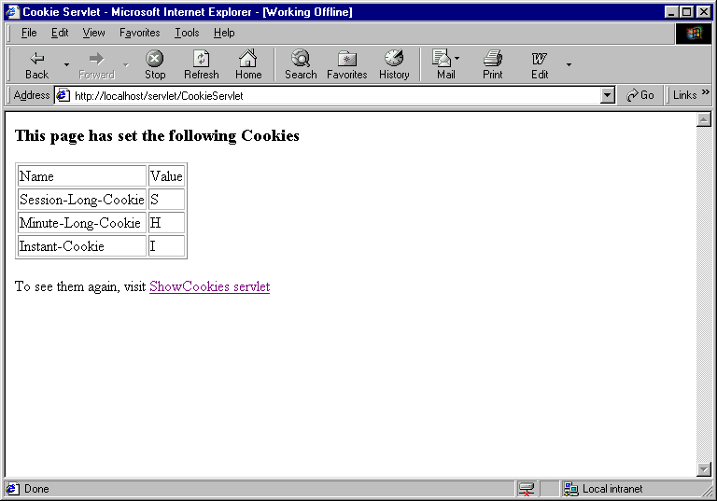

Here is ShowCookies servlet that displays Cookies received from the browser:

// Code 3B
import java.io.IOException;
import java.io.PrintWriter;
import javax.servlet.ServletException;
import javax.servlet.http.Cookie;
import javax.servlet.http.HttpServlet;
import javax.servlet.http.HttpServletRequest;
import javax.servlet.http.HttpServletResponse;
import org.apache.log4j.Logger;
public class ShowCookiesServlet extends HttpServlet{
private static final Logger logger = Logger.getLogger(ShowCookiesServlet.class);
public void doPost(HttpServletRequest request, HttpServletResponse response)
throws ServletException, IOException{
logger.info("In doPost");
doGet(request,response);
}
public void doGet(HttpServletRequest request, HttpServletResponse response)
throws ServletException, IOException{
logger.info("In doGet");
PrintWriter out = null;
Cookie[] cookies = null;
// set the content type of response.
response.setContentType("text/html");
// get a handle on the print writer of response.
out=response.getWriter();
logger.debug("Sending Response");
// generate response.
out.println("<HTML>");
out.println("<HEAD>");
out.println("<TITLE>");
out.println("Show Cookies Servlet");
out.println("</TITLE>");
out.println("</HEAD>");
out.println("<BODY>");
out.println("<H3>This page has received the following Cookies</H3>");
out.println("<TABLE BORDER=1>");
out.println("<TR>");
out.println("<TD>Name</TD>");
out.println("<TD>Value</TD>");
out.println("</TR>");
// extract the array of Cookies from request object.
cookies = request.getCookies();
logger.debug("Got cookies from request");
// if any Cookie received at all.
if (!(cookies==null)){
logger.debug("Found " + cookies.length + " cookies");
// loop through the array of Cookies and print their name and value.
for (int i=0;i<cookies.length;i++){
logger.debug("Cookie Name=" + cookies[i].getName() + " Value= " + cookies[i].getValue());
out.println("<TR>");
out.println("<TD>" + cookies[i].getName() + "</TD>");
out.println("<TD>" + cookies[i].getValue() + "</TD>");
out.println("</TR>");
}
}
out.println("</TABLE>");
out.println("</BODY>");
out.println("</HTML>");
logger.info("Finished doGet");
}
}

Let’s copy this file to c:\tomcat5028\webapps\Root\Web-inf\Classes folder and access it by clicking on “ShowCookies servlet” link of Cookies servlet. Here is the output of ShowCookies when clicked from CookieServlet within one minute:
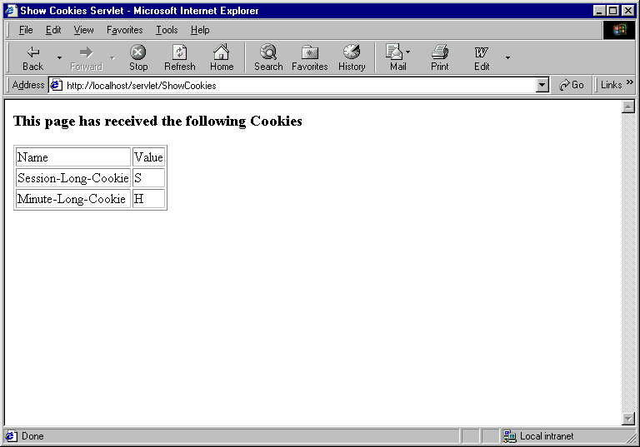

Notice, the Instant-Cookie has disappeared. Here is the output of ShowCookies when refreshed after one minute:
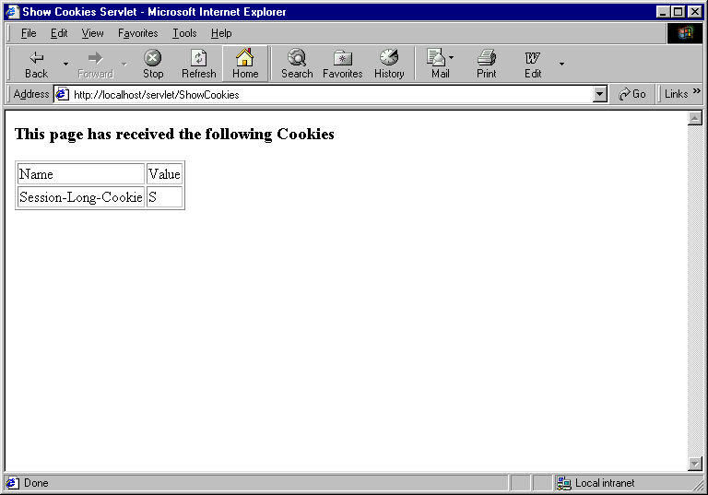

Notice, the Minute-Long-Cookie has disappeared now. However, if you close your browser and reopen it as http://localhost/servlet/ShowCookies, you will get the following output:
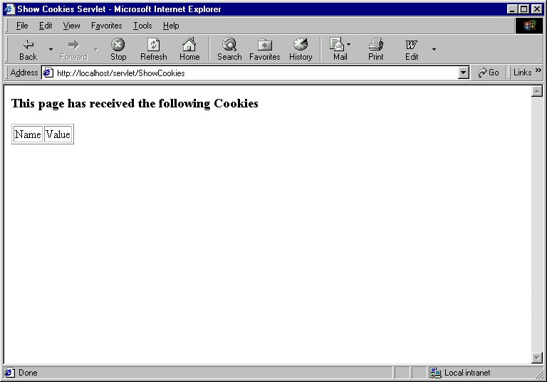

Here is HitCounterServlet servlet that uses session level cookie to count the number of times a client has accessed it:

// Code 3C
import java.io.IOException;
import java.io.PrintWriter;
import javax.servlet.ServletException;
import javax.servlet.http.Cookie;
import javax.servlet.http.HttpServlet;
import javax.servlet.http.HttpServletRequest;
import javax.servlet.http.HttpServletResponse;
import org.apache.log4j.Logger;
public class HitCounterServlet extends HttpServlet {
private static final Logger logger = Logger.getLogger(HitCounterServlet.class);
public void doPost(HttpServletRequest request, HttpServletResponse response)
throws ServletException, IOException{
logger.info("In doPost");
doGet(request,response);
}
public void doGet(HttpServletRequest request, HttpServletResponse response)
throws ServletException, IOException{
logger.info("In doGet");
int hitcount=0;
boolean found=false;
Cookie[] cookies = null;
Cookie cookie = null;
PrintWriter out = null;
logger.debug("Getting cookies from request");
// extract the array of Cookies from request object.
cookies = request.getCookies();
// if Cookie exists.
if (!(cookies==null)){
logger.debug("Found " + cookies.length + " cookies");
// loop through the array of Cookies and find Hit_Counter.
for (int i=0;i<cookies.length;i++){
// if Hit_Counter cookie found.
if (cookies[i].getName().equals("Hit_Counter")){
logger.debug("Found 'Hit_Counter' cookie");
// set the flag.
found=true;
// retrieve the current value and add 1
hitcount=Integer.parseInt(cookies[i].getValue()) + 1;
// set the new value after converting to String.
cookies[i].setValue(String.valueOf(hitcount));
logger.debug("Incremented cookie value to " + cookies[i].getValue());
// although browser has this cookie
// add it to the response.
// so that brower's cookie value gets overridden by incremented value
// VERY IMPORTANT
response.addCookie(cookies[i]);
logger.debug("Added the cookie to the response");
}
}
}
// if Hit_Counter cookie not found.
if (!(found)){
logger.debug("'Hit_Counter cookie not found");
// initialize hitcounter with 1.
hitcount=1;
// create a new session level Hit_Counter cookie.
cookie = new Cookie("Hit_Counter",String.valueOf(hitcount));
logger.debug("Added a new cookie to the response");
// add it to the response.
// VERY IMPORTANT
response.addCookie(cookie);
}
logger.debug("Sending response");
// set the content type of response.
response.setContentType("text/html");
// get a handle on the print writer of response.
out=response.getWriter();
// generate response.
out.println("<HTML>");
out.println("<HEAD>");
out.println("<TITLE>");
out.println("Hit Count Servlet");
out.println("</TITLE>");
out.println("</HEAD>");
out.println("<BODY>");
out.println("<H3>You've visited this page " + hitcount + " time(s) during this session</H3>");
out.println("</BODY>");
out.println("</HTML>");
logger.info("Finished doGet");
}
}

Here is what the page looks like after 8 refresh:



The Session Tracking API
Fortunately, it is not necessary for a servlet to manage its own session using Cookies. The Servlet API provides classes specifically designed to handle session tracking of behalf of the servlets.

Any servlet container will support session tracking. However, the level of support depends on the container. The minimal implementation manages sessions through the use of persistent cookies. However, most servlet container has the ability to revert to using URL rewriting when cookies fail.

Session tracking is very elegant. Every user of a site is associated with a HttpSession object that servlets can use to store or retrieve information about the user.

If you recall HttpServletRequest object has two overloaded getSession() methods that allows you to get hold of existing HttpSession object or create a new one if it did not exist:

public HttpSession getSession() | Returns the current session associated with this request, or if the request does not have a session, creates one.
public HttpSession getSession(boolean create) | Returns the current HttpSession associated with this request or, if there is no current session and create is true, returns a new session.

HttpSession is not a class but an interface. Here are some of the useful methods of HttpSession:

Useful Methods:
Method | Return Type | Description
setAttribute(String name, Object value) | void | Binds an object to this session, using the name specified.
removeAttribute(String name) | void | Removes the object bound with the specified name from this session.
getAttribute(String name) | Object | Returns the object bound with the specified name in this session, or null if no object is bound under the name.
getAttributeNames() | Enumeration | Returns an Enumeration of String objects containing the names of all the objects bound to this session. You can review all session attributes using this method in conjuction with getAttribute method in a loop.
isNew() | boolean | Returns true if the client does not yet know about the session or if the client chooses not to join the session.
getCreationTime() | long | Returns the time when this session was created, measured in milliseconds since midnight January 1, 1970 GMT.
getLastAccessedTime() | long | Returns the last time the client sent a request associated with this session, as the number of milliseconds since midnight January 1, 1970 GMT.
invalidate() | void | Invalidates this session and unbinds any objects bound to it.
getId() | String | Returns a string containing the unique identifier assigned to this session.
setMaxInactiveInterval(int interval) | void | Specifies the time, in seconds, between client requests before the servlet container will invalidate this session.
getMaxInactiveInterval() | int | Returns the maximum time interval, in seconds, that the servlet container will keep this session open between client accesses.

Unlike Cookie that allows you to only store strings, HttpSession allows you to attach any object on it by calling the setAttribute() method with a name for the object. You can , later on, retrieve the object by calling the getAttribute() method or can remove the object by calling removeAttribute() method.

Please don’t confuse these methods with the same methods on HttpServletRequest object. The purpose and usage of them are completely different.

You can expire a session object by calling invalidate() method. A session object automatically expires if the user does not respond within a certain amount of time. You can adjust the expiration time by calling the setMaxInactiveInterval() method.

Each session object has an ID associated with it and you can retrieve it by calling getId() method.

Here are 3 static html files to create a web-site for a music store. Create a “session” folder under c:\tomcat5028\webapps\Root and copy these 3 html files.

index.html
<HTML>
<HEAD><TITLE>Music Store</TITLE></HEAD>
<FRAMESET COLS="25%, *">
<FRAME NAME="menuframe" SRC="menu.html" BORDER="1" >
<FRAME NAME="mainframe" SRC="main.html" BORDER="1" >
</FRAMESET>
</HTML>

menu.html
<P><A HREF="search.html" TARGET="mainframe"><FONT size=4>Search</FONT></A>
<P><A HREF="../ShowShoppingCartServlet" TARGET="mainframe"><FONT size=4>View Cart</FONT></A>

main.html
<HTML>
<BODY>
<H3>Welcome to the Music Store</H3>
<HR>
</BODY>
</HTML>

search.html
<HTML>
<HEAD><TITLE>Music Search</TITLE></HEAD>
<BODY>
<FORM method="get" action="../ShowRecordsServlet">
<B>Please Select a Music Category:</B>
<SELECT name="category">
<OPTION value="Classical" selected >Classical
<OPTION value="Jazz">Jazz
</SELECT>
<INPUT type="submit" value="Search">
</FORM>
</BODY>
</HTML>

Here is how it initially looks:

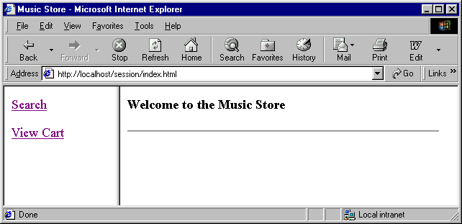
Here is how it looks once you click on Search:

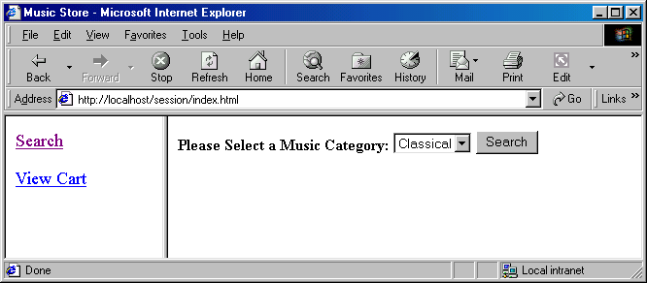

Here is the servlet that returns and displays search result:

// Code 3D
import java.io.IOException;
import java.io.PrintWriter;
import java.util.ArrayList;
import java.util.Iterator;
import javax.servlet.ServletException;
import javax.servlet.http.HttpServlet;
import javax.servlet.http.HttpServletRequest;
import javax.servlet.http.HttpServletResponse;
import org.apache.log4j.Logger;
public class ShowRecordsServlet extends HttpServlet{
private static final Logger logger = Logger.getLogger(ShowRecordsServlet.class);
public void doPost(HttpServletRequest request, HttpServletResponse response)
throws ServletException, IOException{
logger.info("In doPost");
doGet(request,response);
}
public void doGet(HttpServletRequest request, HttpServletResponse response)
throws ServletException, IOException{
logger.info("In doGet");
String category = null;
PrintWriter out = null;
ArrayList matched = null;
Iterator iterator = null;
Item item = null;
// get the category
category = (String) request.getParameter("category");
// set the content type of response
response.setContentType("text/html");
// get a handle on the print writer of response.
out=response.getWriter();
logger.debug("Finding Records that match category: " + category);
//get a list of records
matched = RecordHolder.getByCategory(category);
logger.debug("Found: " + matched.size() + " records");
// generate response.
out.println("<HTML>");
out.println("<HEAD>");
out.println("<TITLE>");
out.println("Show Records Servlet");
out.println("</TITLE>");
out.println("</HEAD>");
out.println("<BODY>");
if (matched.size()==0){
out.println("<H3>Nothing Matched Category: " + category +"</H3>");
}
else{
out.println("<H3>Here are the records under category: " + category +"</H3>");
out.println("<TABLE BORDER=1>");
out.println("<TR>");
out.println("<TD>Artist</TD>");
out.println("<TD>Title</TD>");
out.println("<TD>Price</TD>");
out.println("<TD>ShoppingCart</TD>");
out.println("</TR>");
// get the iterator from the collection.
iterator = matched.iterator();
//loop through all the items.
while (iterator.hasNext()){
// get the next item
item = (Item) iterator.next();
logger.debug("Matching Item: " + item.toString());
logger.debug("Sending to response");
out.println("<TR>");
out.println("<TD>" + item.getArtist() + "</TD>");
out.println("<TD>" + item.getTitle() + "</TD>");
out.println("<TD>" + item.getPrice() + "</TD>");
out.println("<TD>" + "<A HREF=" + "AddItemToShoppingCartServlet?id=" + item.getId() + ">" + "Add" + "</A></TD>");
out.println("</TR>");
}
out.println("</TABLE>");
}
out.println("</BODY>");
out.println("</HTML>");
out.close();
logger.info("Finished doGet");
}
}

Here is the RecordHolder class that is supposed to communicate between our servlet and database and retrieve records by category from the database. Since we don’t have a database yet, records are hardcoded in RecordHolder class.

// Code 3E
import java.util.ArrayList;
import java.util.Collection;
import java.util.HashMap;
import java.util.Iterator;
import org.apache.log4j.Logger;
public class RecordHolder
{
private static final Logger logger = Logger.getLogger(RecordHolder.class);
private static HashMap records= new HashMap();
static
{
Item value;
String key;
logger.info("In RecordHolder static constructor");
value =new Item("Beethoven","Symphonie no 6","Classical",11.99);
key =String.valueOf(value.getId());
records.put(key,value);
logger.debug("Added to RecordHolder: " + value.toString());
value =new Item("Mozart","Amadeus","Classical",14.99);
key =String.valueOf(value.getId());
records.put(key,value);
logger.debug("Added to RecordHolder: " + value.toString());
value=new Item("Dizzy Gillespie","Groovin High","Jazz",10.99);
key =String.valueOf(value.getId());
records.put(key,value);
logger.debug("Added to RecordHolder: " + value.toString());
value=new Item("John Coltrane","Bags and Trane","Jazz",13.99);
key =String.valueOf(value.getId());
records.put(key,value);
logger.debug("Added to RecordHolder: " + value.toString());
logger.info("Finished RecordHolder static constructor");
}
public static ArrayList getByCategory(String category)
{
logger.info("In getByCategory");
// create a temp list
ArrayList categorized = new ArrayList();
//get a collection of all records
Collection all = RecordHolder.records.values();
// get the iterator from the collection.
Iterator iterator = all.iterator();
//loop through all the items.
while (iterator.hasNext())
{
// get the next item
Item item = (Item) iterator.next();
// if the category matches - copy it to the temp collection
if (item.getCategory().equals(category))
{
logger.debug("category: " + category);
logger.debug("Matched Item: " + item.toString());
categorized.add(item);
}
}
logger.info("returning: " + categorized.size() + " items");
return categorized;
}
public static Item get(String id)
{
logger.info("In get");
Item i = (Item) records.get(id);
if (i!=null){
logger.info("returning item: " + i.toString());
}
else{
logger.info("Item Id: " + id + " not found in RecordHolder");
}
return i;
}
}

Both ShowRecordsServlet and RecordHolder is using Item class to represent a musical record. Here is the Item Class:

// Code 3F
import org.apache.log4j.Logger;
public class Item{
private static final Logger logger = Logger.getLogger(Item.class);
private static int nextid;
private String id;
private String artist;
private String title;
private String category;
private double price;
// constructor
public Item(String theArtist,String theTitle,
String theCategory,double thePrice){
logger.info("In Item constructor");
// convert int to string
id = String.valueOf(++nextid);
artist = theArtist;
title = theTitle;
category = theCategory;
price = thePrice;
logger.info("Item constructed: " + this.toString());
}
public String getId(){
return id;
}
public String getArtist(){
return artist;
}
public void setArtist(String theArtist){
artist = theArtist;
}
public String getTitle(){
return title;
}
public void setTitle(String theTitle){
title = theTitle;
}
public String getCategory(){
return category;
}
public void setCategory(String theCategory){
category = theCategory;
}
public double getPrice(){
return price;
}
public void setPrice(double thePrice){
price = thePrice;
}
public String toString(){
return "Id: " + this.id + " " + "Title:" + this.title;
}
}

Copy these 3 java files to c:\tomcat5028\webapps\Root\Web-inf\Classes folder and compile them.

Here is the output of ShowRecordsServlet when you click on the search button:

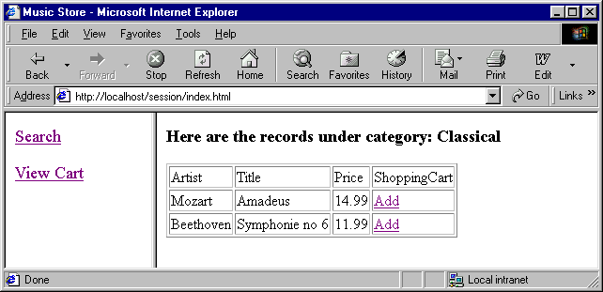
The Add hyperlink above calls AddItemToShoppingCartServlet. Here is the code for AddItemToShoppintCartServlet:

// Code 3G
import java.io.IOException;
import java.io.PrintWriter;
import javax.servlet.ServletException;
import javax.servlet.http.HttpServlet;
import javax.servlet.http.HttpServletRequest;
import javax.servlet.http.HttpServletResponse;
import javax.servlet.http.HttpSession;
import org.apache.log4j.Logger;
public class AddItemToShoppingCartServlet extends HttpServlet
{
private static final Logger logger = Logger.getLogger(AddItemToShoppingCartServlet.class);
public void doPost(HttpServletRequest request, HttpServletResponse response)
throws ServletException, IOException
{
logger.info("In doPost");
doGet(request,response);
}
public void doGet(HttpServletRequest request, HttpServletResponse response)
throws ServletException, IOException
{
logger.info("In doGet");
PrintWriter out = null;
boolean found = true;
ShoppingCart shoppingcart=null;
Item item=null;
String id = null;
HttpSession session = null;
try{
// set the content type of response.
response.setContentType("text/html");
// get a handle on the print writer of response.
out=response.getWriter();
out.println("<HTML>");
out.println("<HEAD>");
out.println("<TITLE>");
out.println("Shopping Cart Problem");
out.println("</TITLE>");
out.println("</HEAD>");
out.println("<BODY>");
// get Item Id from request parameter
id=request.getParameter("id");
// if parameter id not found.
if (id==null)
{
logger.debug("Item Id was not in request");
found=false;
}
if (found)
{
logger.debug("Item Id: " + id);
// get the item from the RecordHolder using id.
item =RecordHolder.get(id);
// if item not found in RecordHolder.
if (item==null)
{
logger.debug("Item Id: " + id + " does not exist in RecordHolder");
found=false;
}
}
// if not found for any of the above reasons
// send back error message.
if (!(found))
{
// generate error response.
out.println("<H3>Sorry,could not add to shopping cart</H3>");
return;
}
// get or create a session;
session = request.getSession();
// get shoppingcart out as object from session and cast it.
shoppingcart = (ShoppingCart) session.getAttribute("shoppingcart");
//if no shoppingcart exists - create one.
if (shoppingcart==null)
{
logger.debug("Shopping cart not found, creating a new shopping cart");
shoppingcart= new ShoppingCart();
}
//add the item to the cart.
shoppingcart.add(item);
// don't forget to add it to the session if
// this is the first time we are creating session object.
// or somehow the shoppingcart has been removed from the session.
if (session.isNew() || (session.getAttribute("shoppingcart")==null)){
logger.debug("Adding shopping cart to the session since there was none");
session.setAttribute("shoppingcart",shoppingcart);
}
logger.debug("Redirecting user to the ShowShoppingCartServlet");
// redirect the response to ShowShoppingCartServlet.
response.sendRedirect("ShowShoppingCartServlet");
}catch(Exception e){
logger.error("In Exception Block",e);
// the catch block was really
// not to catch any exception
// but to have a finally block
throw new ServletException(e);
}
finally{
logger.debug("In Finally Block");
out.println("</BODY>");
out.println("</HTML>");
out.close();
}
logger.info("Finished doGet");
}
}

AddItemToShoppingCart is using a ShoppingCart object. Here is ShoppingCart class:

// Code 3H
import java.util.HashMap;
import java.util.Iterator;
import org.apache.log4j.Logger;
public class ShoppingCart{
private static final Logger logger = Logger.getLogger(ShoppingCart.class);
private HashMap cartitems;
private int numberOfProducts;
public ShoppingCart(){
logger.info("In ShoppingCart constructor");
cartitems = new HashMap();
numberOfProducts = 0;
}
public void add(Item theItem){
logger.info("In add");
String key = theItem.getId();
// if the item is already in the cart.
// get the shoppingcartitem out of the cart.
// increment quantity only.
if(cartitems.containsKey(key)){
logger.debug("Item: " + key + " found in cart, incrementing quantity");
ShoppingCartItem shoppingcartitem = (ShoppingCartItem) cartitems.get(key);
shoppingcartitem.incrementQuantity();
}
// create a brand new cart item and add it to the cart.
else{
logger.debug("Item: " + key + " NOT found in cart, creating ShoppingCartItem");
ShoppingCartItem shoppingcartitem = new ShoppingCartItem(theItem);
cartitems.put(key, shoppingcartitem);
}
// increase the number of items in the cart.
numberOfProducts++;
logger.info("Finished add");
}
public Iterator iterator(){
return cartitems.values().iterator();
}
public int getNumberOfProducts(){
return numberOfProducts;
}
}

The ShoppingCart object above is using ShoppingCartItem object. ShoppingCartItem is nothing but a wrapper around Item just to keep track of quantity per item. Here is ShoppingCartItem:

// Code 3I
public class ShoppingCartItem
{
private Item item;
private int quantity;
public ShoppingCartItem(Item aItem){
item = aItem;
quantity = 1;
}
public Item getItem(){
return item;
}
public int getQuantity(){
return quantity;
}
public void incrementQuantity(){
quantity++;
}
public void decrementQuantity(){
quantity--;
}
}

Both AddItemToShoppingCartServlet and the View Cart hyperlink on Menu.html forwards request to ShowShoppingCartServlet. Here is the code for ShowShoppingCartServlet:

// Code 3J
import java.io.IOException;
import java.io.PrintWriter;
import java.util.Iterator;
import javax.servlet.ServletException;
import javax.servlet.http.HttpServlet;
import javax.servlet.http.HttpServletRequest;
import javax.servlet.http.HttpServletResponse;
import javax.servlet.http.HttpSession;
import org.apache.log4j.Logger;
public class ShowShoppingCartServlet extends HttpServlet{
private static final Logger logger = Logger.getLogger(ShowShoppingCartServlet.class);
public void doPost(HttpServletRequest request, HttpServletResponse response)
throws ServletException, IOException{
logger.info("In doPost");
doGet(request,response);
}
public void doGet(HttpServletRequest request, HttpServletResponse response)
throws ServletException, IOException{
logger.info("In doGet");
boolean found = true;
Object attribute=null;
ShoppingCart shoppingCart=null;
Item item=null;
HttpSession session = null;
PrintWriter out = null;
Iterator iterator = null;
ShoppingCartItem shoppingCartItem = null;
try{
// set the content type of response.
response.setContentType("text/html");
// get a handle on the print writer of response.
out=response.getWriter();
// generate response.
out.println("<HTML>");
out.println("<HEAD>");
out.println("<TITLE>");
out.println("Shopping Cart");
out.println("</TITLE>");
out.println("</HEAD>");
out.println("<BODY>");
// get the session but don't create it.
session = request.getSession(false);
// if null - error.
if (session==null){
logger.debug("There was no session");
found=false;
}
// get the shoppingcart object from session.
// if null - error.
if (found){
attribute = session.getAttribute("shoppingcart");
if (attribute==null){
logger.debug("There was no shopping cart in the session");
found=false;
}
}
// if found is false - it is an error condition.
// return from here.
if (!(found)){
logger.debug("Either the shopping cart or the session not found");
out.println("<H3>Shopping cart is empty</H3>");
return;
}
out.println("<H3>View Shopping Cart</H3>");
out.println("<TABLE BORDER=1>");
out.println("<TR>");
out.println("<TD>Artist</TD>");
out.println("<TD>Title</TD>");
out.println("<TD>Category</TD>");
out.println("<TD>Quantity</TD>");
out.println("<TD>Price</TD>");
out.println("</TR>");
// cast attribute to ShoppingCart object.
shoppingCart = (ShoppingCart) attribute;
logger.debug("Reading Shopping Cart");
// get the iterator and loop
iterator = shoppingCart.iterator();
while (iterator.hasNext()){
// get the cartitem out of the cart.
shoppingCartItem = (ShoppingCartItem) iterator.next();
logger.debug("ShoppingCart Item found: " + shoppingCartItem.toString());
// get the item out of the cartitem.
item=shoppingCartItem.getItem();
out.println("<TR>");
//print artist,title and cagetory from item.
out.println("<TD>" + item.getArtist() + "</TD>");
out.println("<TD>" + item.getTitle() + "</TD>");
out.println("<TD>" + item.getCategory() + "</TD>");
// print quantity from cartitem not item.
out.println("<TD>" + shoppingCartItem.getQuantity() + "</TD>");
// print price.
out.println("<TD>" + item.getPrice() + "</TD>");
out.println("</TR>");
}
out.println("</TABLE>");
}catch(Exception e){
logger.error("In Exception Block",e);
// the catch block was really
// not to catch any exception
// but to have a finally block
throw new ServletException(e);
}
finally{
logger.debug("In Finally Block");
out.println("</BODY>");
out.println("</HTML>");
}
logger.info("Finished doGet");
}
}

Copy these java files to c:\tomcat5028\webapps\Root\Web-inf\Classes folder and compile them.

Here is the output of ShowShoppingCartServlet after adding a few items:
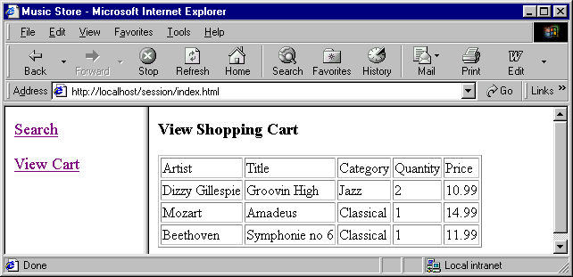

Reading Assignment
- Core Servlet and JavaServer Pages – Chapter 8 and 9
- Professional Java Server Programming – Chapter 9

Homework Assignment
- Add a total line to the shopping cart. We already have getNumberOfProducts() method in shopping cart. Add another method getTotal(). Use these two methods to get total number of items and total price as follows:

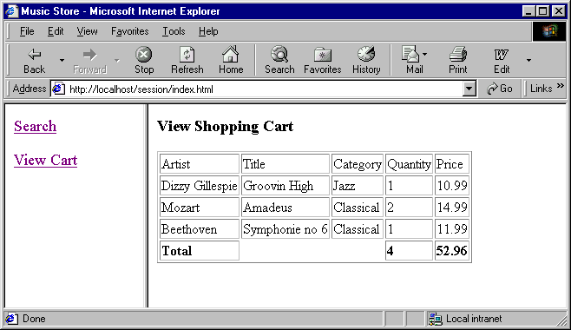

- Right now, there is no way to remove items from the shopping cart. Add a remove column to the shopping cart. Add a new servlet RemoveItemFromShoppingCart. The remove link (pointing to RemoveItemFromShoppingCart) should remove one quantity at a time. If there is only one quantity of the item and the user removes it – the items should disappear from the cart. If all the items are removed from the shopping cart – “Shopping cart is empty” should appear.

Here is a sample output:

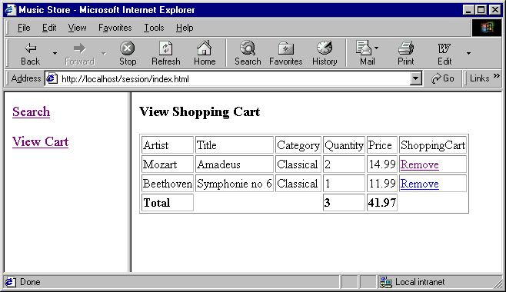
After I remove Symphonie no 6, here is what the cart looks like:
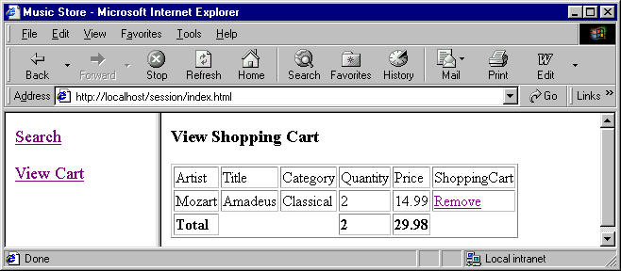
After I removed Amadeus (1 quantity), here is what it looks like:
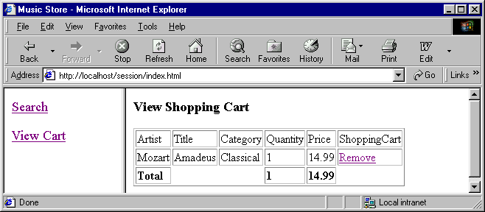
After I removed Amadeus (last item – last quantity), here is what it looks like:
