ServletConfig Interface
As part of the configuration of servlets, each registered servlet can have specific initialization parameters associated with it. These parameters are often used in init() method to set default values of a servlet or to customize a servlet is certain way. The initialization parameters are passed to the init() method through an object as an argument to the init() method. The object that is passed to the init() method implements ServletConfig interface. A ServletConfig interface provides methods to access these initialization parameters.

The Servlet interface has init() method that receives a ServletConfig object as an argument as follows:

init(ServletConfig config) | void | Called by the servlet container to indicate to a servlet that the servlet is being placed into service.

Therefore, the ServletConfig object is readily available in init() method. If you are not in init() method but would like to access ServletConfig object – no problem. The Servlet interface has a getServletConfig() method that returns ServletConfig object. As it turns out, you don’t even have to call the getServletConfig() method at all to access ServletConfig methods since GenericServlet - the superclass of HttpServlet - implements ServletConfig interface – just for convenience. Therefore, all the methods in ServletConfig interface are also methods of HttpServlet class.

Here are the methods in ServletConfig interface:

Method | Return Type | Description
getInitParameter(String name) | String | Returns a String containing the value of the named initialization parameter, or null if the parameter does not exist.
getInitParameterNames() | Enumeration | Returns the names of the servlet's initialization parameters as an Enumeration of String objects, or an empty Enumeration if the servlet has no initialization parameters.
getServletContext() | ServletContext | Returns a reference to the ServletContext in which the servlet is executing.
getServletName() | String | Returns the name of this servlet instance defined in its deployment descriptor. If no name is assigned it returns the servlet class name instead.

The initialization parameters are setup using a deployment descriptor “web.xml” is located in the web-inf directory of the web application.

Here is a ServletConfigInitParameterDemoServlet:

// code 4A
import javax.servlet.*;
import javax.servlet.http.*;
import org.apache.log4j.Logger;
import java.io.*;
public class ServletConfigInitParameterDemoServlet extends HttpServlet {
private static final Logger logger = Logger.getLogger(WeatherForecastServlet.class);
//Process the HTTP Get request
public void doGet(HttpServletRequest request, HttpServletResponse response) throws ServletException, IOException{
logger.info("In doGet");
String message=null;
if (getInitParameter("message")==null){
logger.debug("Servlet Init Parameter 'message' is missing");
message="I am sorry, weather forecast for this week has not arrived yet.";
}
else{
message=getInitParameter("message");
logger.debug("Servlet Init Parameter 'message'= " + message );
}
response.setContentType("text/html");
logger.debug("Sending Response....");
PrintWriter out=response.getWriter();
out.println("<HTML>");
out.println("<HEAD>");
out.println("<TITLE>");
out.println("Weather Forcast Servlet");
out.println("</TITLE>");
out.println("</HEAD>");
out.println("<BODY>");
out.println("<H3>"+message+"</H3>");
out.println("</BODY>");
out.println("</HTML>");
logger.info("Finished doGet");
}
//Process the HTTP Post request
public void doPost(HttpServletRequest request, HttpServletResponse response) throws ServletException, IOException{
logger.info("In doPost");
doGet(request,response);
logger.info("Finished doPost");
}
}

Here is the web.xml file:

<?xml version="1.0" encoding="ISO-8859-1"?>
<!DOCTYPE web-app PUBLIC "-//Sun Microsystems, Inc.//DTD Web Application 2.3//EN"
"http://java.sun.com/dtd/web-app_2_3.dtd">
<web-app>
<servlet>
<servlet-name>
ServletConfigInitParameterDemoServlet
</servlet-name>
<servlet-class>
ServletConfigInitParameterDemoServlet
</servlet-class>
<init-param>
<param-name>
message
</param-name>
<param-value>
Weather Today: Mostly cloudy. High around 46F. Winds SW 15 to 20 mph.
</param-value>
</init-param>
</servlet>
</web-app>

Copy ServletConfigInitParameterDemoServlet.java to c:\tomcat5028\webapps\Root\Web-inf\Classes folder and compile it.

Copy web.xml file to c:\tomcat5028\webapps\Root\Web-inf (not Classes) folder and overwrite the existing web.xml file.

Stop and Start the ROOT app.

Hit the following url:

http://localhost:8080/servlet/ServletConfigInitParameterDemoServlet

Here is the output:

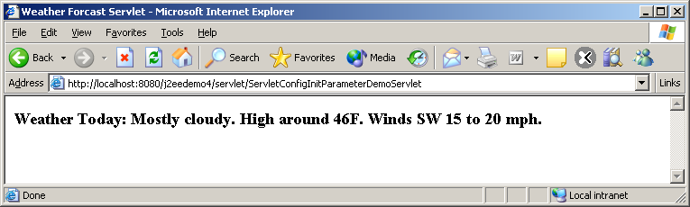

Tomcat loads the content of web.xml file in memory during its app initialization. Therefore, you have to stop and re-start ROOT app to see this output.

ServletContext Interface
ServletConfig interface has a method getServletContext() that returns an object that implement ServletContext interface. So, what is ServletContext? The ServletContext is a reference to the web application a Servlet is part of, and provides access to resources and facilities common to all servlets in the same application. Unlike Session that is specific to a client, the ServletContext is specific to a particular web application – sort of like a global object on the server. Each web application in a container will have a ServletContext object associated with it. Therefore ServletContext literally represents web application.

ServletContext is a very powerful concept. The ServletContext allows you to maintain application level state for all servlets and all clients in the application. ServletContext starts at the root of the application and it encompasses all the sub-folders and files under that root. In Tomcat, you define the root of an application by putting a context tag in server.xml located in conf directory.

ServletContext is not a class but an interface. Here are the methods available in ServletContext interface:

Method | Return Type | Description
setAttribute(String name, Object object) | void | Binds an object to a given attribute name in this servlet context. This is an extremely useful feature. This object is visible to all other servlets within the application and can be used as a global object. This object will live as long as the application is running – which means until you shut down Tomcat.
getAttribute(String name) | Object | Returns the servlet container attribute with the given name, or null if there is no attribute by that name. This method allows you to access can object from a servlet that is placed by another servlet.
getAttributeNames() | Enumeration | Returns an Enumeration containing the attribute names available within this servlet context. Using this method with getAttribute() you can access all the attribute objects.
removeAttribute(String name) | void | Removes the attribute with the given name from the servlet context. Using this method one servlet can remove an object placed by a previous servlet.
getInitParameter(String name) | String | Returns a String containing the value of the named context-wide initialization parameter, or null if the parameter does not exist. This method can make available configuration information useful to an entire "web application". For example, it can provide the name of an application available to every servlet. In Tomcat, you have to declare the init parameters in web.xml file located in web-inf folder of the application using <context-param> tag.
getInitParameterNames() | Enumeration | Returns the names of the context's initialization parameters as an Enumeration of String objects, or an empty Enumeration if the context has no initialization parameters. Using this method with getInitParameter() you can access all initialization parameters of the application.
getRequestDispatcher(String path) | RequestDispatcher | Returns a RequestDispatcher object that acts as a wrapper for the resource located at the given path. This is another extremely useful feature. Using this method one servlet can forward partially processed request and response object to the next servlet – resulting servlet chaining.
getNamedDispatcher(String name) | RequestDispatcher | Returns a RequestDispatcher object that acts as a wrapper for the named servlet. This method is identical to getRequestDispatcher – the only difference is that you can use servlet name here (defined in web.xml) instead of the servlet URL.
getMimeType(String file) | String | Returns the MIME type of the specified file, or null if the MIME type is not known. The MIME type is determined by the configuration of the servlet container, and may be specified in a web application deployment descriptor - server.xml.
getRealPath(String path) | String | Returns a String containing the real path for a given virtual path. For example, it is possible to name a servlet “web-inf/classes/TestServlet” as "/main.html" in web.xml. getRealPath will return you the full path of “TestServlet”.
getResource(String path) | URL | Returns a URL to the resource that is mapped to a specified path – basically convert a String to an URL object.
getResourceAsStream(String path) | InputStream | Returns the resource located at the named path as an InputStream object.  This method is very similar to getResource() except that it returns an InputStram() already opened to the resource.
Log(String msg) | void | Writes the specified message to a servlet log file, usually an event log. You don’t really need to access this method through ServletContext since GenericServlet already implemented this method for convenience.
Log(String message, Throwable throwable) | void | Writes an explanatory message and a stack trace for a given Throwable exception to the servlet log file. You don’t really need to access this method through ServletContext since GenericServlet already implemented this method for convenience.
getContext(String uripath) | ServletContext | This is a very powerful feature of servlet API. This method returns a ServletContext object that corresponds to a specified URL on the server – possibly the URL belongs to another web application. However, due to possible security limitations imposed by the web container this method might return null. However, without security restriction servlets on two different web applications running on the same web container can share data and communicate with each other using this method.
getMajorVersion() | int | Returns the major version of the Java Servlet API that this servlet container supports.
getMinorVersion() | int | Returns the minor version of the Servlet API that this servlet container supports.
getServerInfo() | String | Returns the name and version of the servlet container on which the servlet is running.

Here is an example of a servlet using the context init parameter to display the application name on the title bar:

// Code 4B
import java.io.IOException;
import java.io.PrintWriter;
import javax.servlet.ServletException;
import javax.servlet.http.HttpServlet;
import javax.servlet.http.HttpServletRequest;
import javax.servlet.http.HttpServletResponse;
import org.apache.log4j.Logger;
public class ServletContextInitParameterDemoServlet extends HttpServlet{
private static final Logger logger = Logger.getLogger(ServletContextInitParameterDemoServlet.class);
public void doPost(HttpServletRequest request, HttpServletResponse response)
throws ServletException, IOException{
logger.info("In doPost");
doGet(request,response);
}
public void doGet(HttpServletRequest request, HttpServletResponse response)
throws ServletException, IOException{
logger.info("In doGet");
String title = getServletContext().getInitParameter("caption");
logger.debug("Sending Response...");
response.setContentType("text/html");
PrintWriter out=response.getWriter();
out.println("<HTML>");
out.println("<HEAD>");
out.println("<TITLE>");
if (title==null){
logger.debug("Caption missing");
out.println("No Application Title Found");
}
else{
logger.debug("Caption: " + title);
}
out.println("</TITLE>");
out.println("</HEAD>");
out.println("<BODY>");
if (title==null){
out.println("<h3> No Application Title Found");
}
else{
out.println("<H3> This servlet receives application title as context init parameter: "+ title + "</H3>");
}
out.println("</BODY>");
out.println("</HTML>");
out.close();
logger.debug("Finished doGet");
}
}
Now we have to define the context init parameter in web.xml file. Here is what the web.xml file looks like:

<?xml version="1.0" encoding="ISO-8859-1"?>
<!DOCTYPE web-app PUBLIC "-//Sun Microsystems, Inc.//DTD Web Application 2.3//EN"
"http://java.sun.com/dtd/web-app_2_3.dtd">
<web-app>
<context-param>
<param-name>
caption
</param-name>
<param-value>
Our Little Test Application
</param-value>
</context-param>
<servlet>
<servlet-name>
ServletConfigInitParameterDemoServlet
</servlet-name>
<servlet-class>
ServletConfigInitParameterDemoServlet
</servlet-class>
<init-param>
<param-name>
message
</param-name>
<param-value>
Weather Today: Mostly cloudy. High around 46F. Winds SW 15 to 20 mph.
</param-value>
</init-param>
</servlet>
</web-app>

Notice we have added a context-param section that has a parameter named “caption”

Copy ServletContextDemoServlet.java to c:\tomcat5028\webapps\Root\Web-inf\Classes folder and compile it.

Copy web.xml file to c:\tomcat5028\webapps\Root\Web-inf (not Classes) folder and overwrite the existing web.xml file.

Stop and Start ROOT app.

Hit the following url:

http://localhost:8080/j2eedemo4/servlet/ServletContextInitParameterDemoServlet

Here is the output:

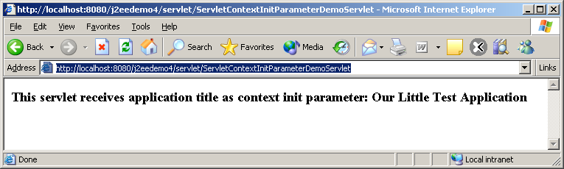

Here is an example of one servlet setting up an application level attribute.

//Code 4C

import java.io.IOException;

import java.io.PrintWriter;

import javax.servlet.ServletException;

import javax.servlet.http.HttpServlet;

import javax.servlet.http.HttpServletRequest;

import javax.servlet.http.HttpServletResponse;

import org.apache.log4j.Logger;

public class SetServletContextAttributeDemoServlet extends HttpServlet {

private static final Logger logger = Logger.getLogger(SetServletContextAttributeDemoServlet.class);

//Process the HTTP Get request

public void doGet(HttpServletRequest request, HttpServletResponse response)

throws ServletException, IOException{

logger.info("In doGet");

// get a random number between 0 and 100

int random = (int) (Math.random()*100);

logger.debug("Got Random Number: " + random);

// convert it to Integer object - since context attribute values can only be objects.

Integer randomInteger = new Integer(random);

getServletContext().setAttribute("random", randomInteger);

logger.debug("Context attribute 'random' is set to: " + randomInteger);

response.setContentType("text/html");

PrintWriter out=response.getWriter();

logger.debug("Sending Response...");

out.println("<HTML>");

out.println("<HEAD>");

out.println("<TITLE>");

out.println("Set Context Attribute Servlet");

out.println("</TITLE>");

out.println("</HEAD>");

out.println("<BODY>");

out.println("<H3> Context Attribute 'random' has been set to a value: "+ getServletContext().getAttribute("random") +"</H3>");

out.println("</BODY>");

out.println("</HTML>");

logger.info("Finished doGet");

}

//Process the HTTP Post request

public void doPost(HttpServletRequest request, HttpServletResponse response)

throws ServletException, IOException{

logger.info("In doPost");

doGet(request,response);

logger.info("Finished doPost");

}

}

Copy the servlet to c:\tomcat5028\webapps\Root\Web-inf\Classes folder and compile them.

Stop and Start ROOT app.

Hit the following url:

http://localhost:8080/j2eedemo4/servlet/SetServletContextAttributeDemoServlet

Here is the output from SetContextAttributeServlet:

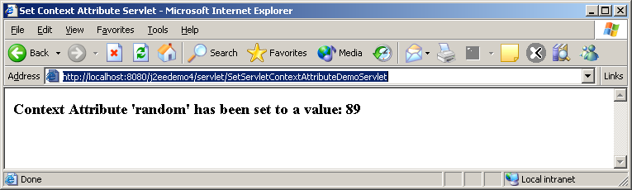

Here is a servlet retrieving such attribute:

// Code 4D
import java.io.IOException;
import java.io.PrintWriter;
import javax.servlet.ServletException;
import javax.servlet.http.HttpServlet;
import javax.servlet.http.HttpServletRequest;
import javax.servlet.http.HttpServletResponse;
import org.apache.log4j.Logger;
public class GetServletContextAttributeDemoServlet extends HttpServlet {
private static final Logger logger = Logger.getLogger(GetServletContextAttributeDemoServlet.class);
//Process the HTTP Get request
public void doGet(HttpServletRequest request, HttpServletResponse response)
throws ServletException, IOException{
logger.info("In doGet");
// get the context attribute random and cast it to Integer
Integer randominteger = (Integer) getServletContext().getAttribute("random");
String message=null;
if (randominteger==null){
logger.debug("No Context Attribute");
message= "<H3>No Context Attribute Found<H3>";
}
else{
// convert it int.
int random = randominteger.intValue();
logger.debug("Context Attribute: " + random);
message = "<H3> Context Attribute value of 'random' has been retrieved: "+ random +"</H3>";
}
logger.debug("Sending response...");
response.setContentType("text/html");
PrintWriter out=response.getWriter();
out.println("<HTML>");
out.println("<HEAD>");
out.println("<TITLE>");
out.println("Get Context Attribute Servlet");
out.println("</TITLE>");
out.println("</HEAD>");
out.println("<BODY>");
out.println(message);
out.println("</BODY>");
out.println("</HTML>");
logger.info("Finished doGet");
}
//Process the HTTP Post request
public void doPost(HttpServletRequest request, HttpServletResponse response)
throws ServletException, IOException{
logger.info("In doPost");
doGet(request,response);
}
}

Here is the output for GetContextAttributeServlet:

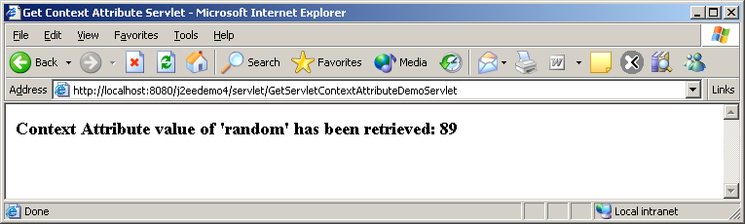

You can close your browser and go back to GetContextAttributeServlet and the value will still be the same – therefore, the value is available beyond the current session. As a matter of fact, the value will be available to all servlets until you restart Tomcat again. Of course, if you run the SetContextAttributeServlet again, the attribute value will change.

RequestDispatcher Interface
ServletContext has two methods getRequestDispatcher() and getNamedDispatcher() both return an object that implements RequestDispatcher interface.

A ReqeustDispatcher allows a servlet to dispatch a request to another servlet. For every request, the servlet container creates the RequestDispatcher object, which is used to dispatch requests to a component (servlet, JSP, static page) by a path or by a name of the component.

Here are the signature of the two methods that brings back RequestDispatcher():

public RequestDispatcher ServletContext.getRequestDispatcher(String path)
public RequestDispatcher ServletContext.getNamedDispatcher(String name)

RequestDispatcher interface has the following two methods:

Method | Return Type | Description
forward(ServletRequest request, ServletResponse response) | void | Forwards a request from a servlet to another resource (servlet, JSP file, or HTML file) on the server. This method allows one servlet to do preliminary processing of a request and another resource to generate the response.
Include(ServletRequest request, ServletResponse response) | void | Includes the content of a resource (servlet, JSP page, HTML file) in the response. In essence, this method enables programmatic server-side includes. The included servlet cannot change the response status code or set headers; any attempt to make a change is ignored.

As it turns out, the RequestDispatcher can be obtained on another servlet by two ways:

- By calling the getRequestDispatcher() or getNamedDispatcher() on ServletContext object
- By calling the getRequestDispatcher() on the ServletRequest (or HttpServletRequest) object.

There is a slight difference between the two. If you get the RequestDispatcher on another servlet from ServletContext you should provide the full path of the second servlet. In other words, if ShowRecordsServlet is calling getRequestDispatcher() of ServletContext to get the RequestDispatcher on RecordsPresentationServlet it must do so as follows:

RequestDispatcher requestdispatcher = getServletContext().getRequestDispatcher("/servlet/RecordsPresentationServlet");

However, if ShowRecordsServlet is calling getRequestDispatcher() of it’s own HttpServletRequest it can use relative path as follows:

RequestDispatcher requestdispatcher = request.getRequestDispatcher("RecordsPresentationServlet");

Notice, in the second case, you don’t have to prefix the servlet name with “/servlet”. Please be careful about using relative path. My experience shows that relative path could easily become a troubleshooting issue and you are better off using absolute path if possible.

Forwarding Data
While forwarding to or including from another servlet, a servlet may need to forward some processed data that did not come from the client as request parameters. Of course, the servlet can start a session and attach data to the session object. Another way to do this is to attach the data on the ServletContext object so that the data is available everywhere in the application. As it turns out Session or ServletContext is not really needed (and is overkill) for this purpose. Also, by using either Session or ServletContext object you are exposing your data to all the Servlets within the application unnecessarily. The best way to forward data is to use the Request Object itself. The Request object has setAttribute() method (just like Session object does) that allows a servlet to attach additional data to the request object. The receiving servlet can get the data from the Request object by calling getAttribute() method on the Request object.

Difference between sendRedirect() and forward()
You might think that sendRedirect() of a response object and forward() method of a request object are very similar but there is significant differences between these two.

- sendRedirect() generates a brand new HTTP GET request. Therefore, all the parameters that this servlet received does not get propagated to the next servlet (unless the programmer appends as QueryString manually). The forward() method takes the request and response object and simply forwards it the next servlet. All the parameters and attributes of the request are intact.
- In case of sendRedirect() the client sees the URL transfer on his browser. He knows that he requested “servlet1” but the response came from “servlet2”. in case of forward() – the client is unaware of this transfer from one servlet to the next.
- In case of forward(), the sender can append more data(any kind of Object) using the setAttribute() method of the request object. In case of sendRedirect() – then sender have to do it manually by appending QueryString which – by the way – can only be String.
- In a nutshell, in case of sendRedirect(), you are forwarding the response (after all, it is a method on Response object) assuming the request has completely been processed. In case of forward(), you are forwarding request (after all, it is a method on the Request object) assuming partial or no processing has been done on the request. The forward() method also allows the separation of processing from presentation which is the key to JSP programming.

Here is a servlet that forwards request:

// Code 4E
import java.io.IOException;
import java.io.PrintWriter;
import javax.servlet.RequestDispatcher;
import javax.servlet.ServletException;
import javax.servlet.http.HttpServlet;
import javax.servlet.http.HttpServletRequest;
import javax.servlet.http.HttpServletResponse;
import org.apache.log4j.Logger;
public class ForwardingServlet extends HttpServlet{
private static final Logger logger = Logger.getLogger(ForwardingServlet.class);
public void doPost(HttpServletRequest request, HttpServletResponse response)
throws ServletException, IOException{
logger.info("In doPost");
doGet(request,response);
logger.info("Finished doPost");
}
Public void doGet(HttpServletRequest request, HttpServletResponse response)
throws ServletException, IOException{
logger.info("In doGet");
// set the content type of response.
response.setContentType("text/html");
// get a handle on the print writer of response.
PrintWriter out=response.getWriter();
// generate response.
Out.println("<HTML>");
Out.println("<HEAD>");
Out.println("<TITLE>");
Out.println("Forwarding Servlet");
Out.println("</TITLE>");
Out.println("</HEAD>");
Out.println("<BODY>");
Out.println("<H3>This line is from the original 'Forwarding Servlet'</H3>");
//get request parameter
String name = request.getParameter("inputname");
logger.debug("Got Request parameter 'inputname': " + name);
request.setAttribute("username", name);
logger.debug("Saved Request parameter 'inputname' in Request attribute 'username'");
logger.debug("Forwading to Forwarded Servlet....");
RequestDispatcher requestdispatcher= getServletContext().getRequestDispatcher("/servlet/ForwardedServlet");
requestdispatcher.forward(request,response);
logger.info("Writing Response, that will never be returned since forwarded already");
out.println("<H3>Again, This line is from the original 'Forwarding Servlet'</H3>");
Out.println("</BODY>");
Out.println("</HTML>");
logger.info("Finished doGet");
}
}

Here is a servlet that get the forwarded input:

// Code 4F
import java.io.IOException;
import java.io.PrintWriter;
import javax.servlet.ServletException;
import javax.servlet.http.HttpServlet;
import javax.servlet.http.HttpServletRequest;
import javax.servlet.http.HttpServletResponse;
import org.apache.log4j.Logger;
public class ForwardedServlet extends HttpServlet{
private static final Logger logger = Logger.getLogger(ForwardedServlet.class);
public void doPost(HttpServletRequest request, HttpServletResponse response)
throws ServletException, IOException{
logger.info("In doPost");
doGet(request,response);
logger.info("Finished doPost");
}
public void doGet(HttpServletRequest request, HttpServletResponse response)
throws ServletException, IOException{
logger.info("In doGet");
//get request attribute
String name = (String) request.getAttribute("username");
logger.debug("Got Request attribute 'username': " + name);
// get a handle on the print writer of response.
PrintWriter out=response.getWriter();
out.println("<H3>This line is from the 'Forwarded Servlet'</H3>");
out.println("<B>Hello " + name + ", How are you?</B>");
}
}

Copy the servlets to c:\tomcat5028\webapps\Root\Web-inf\Classes folder and compile them.

Stop and Start ROOT app.

Hit the following url:

http://localhost:8080/j2eedemo4/servlet/ForwardingServlet?inputname=John

You will get the following output:

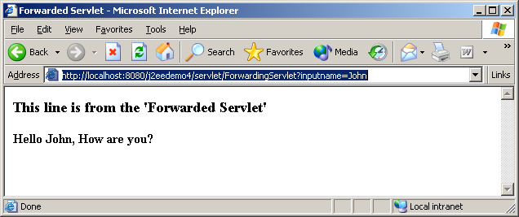

Notice 3 things:

- The url is still ForwardingServlet although the response came from ForwardedServlet
- The code for writing response by ForwardingServlet was never executed due to forwarding.
- If you right click and select ‘view source’ on the browser you will only find response writer by ForwardedServlet – everything written by ForwardingServlet gets overwritten by the ForwardedServlet.

Server Side Includes
Sometimes, it makes sense to even breakup the presentation servlet into multiple servlets for many reasons mostly for re-usable reasons. In that case, one servlet may need to include the content from another servlet. RequestDispatcher’s include() method serves that purpose.

Here is an example of a servlet writing output and including output from another servlet:

// Code 4G
import java.io.IOException;
import java.io.PrintWriter;
import javax.servlet.RequestDispatcher;
import javax.servlet.ServletException;
import javax.servlet.http.HttpServlet;
import javax.servlet.http.HttpServletRequest;
import javax.servlet.http.HttpServletResponse;
import org.apache.log4j.Logger;
public class IncludingServlet extends HttpServlet{
private static final Logger logger = Logger.getLogger(IncludingServlet.class);
public void doPost(HttpServletRequest request, HttpServletResponse response)
throws ServletException, IOException{
logger.info("In doPost");
doGet(request,response);
logger.info("Finished doPost");
}
public void doGet(HttpServletRequest request, HttpServletResponse response)
throws ServletException, IOException{
logger.info("In doGet");
logger.debug("Writing Response ...");
// set the content type of response.
response.setContentType("text/html");
// get a handle on the print writer of response.
PrintWriter out=response.getWriter();
// generate response.
out.println("<HTML>");
out.println("<HEAD>");
out.println("<TITLE>");
out.println("Including Servlet");
out.println("</TITLE>");
out.println("</HEAD>");
out.println("<BODY>");
out.println("<H3>This line is from the 'Including Servlet'</H3>");
logger.debug("Including for another servlet ...");
RequestDispatcher requestdispatcher= getServletContext().getRequestDispatcher("/servlet/IncludedServlet");
requestdispatcher.include(request,response);
logger.debug("Including done, writing more response..");
out.println("<H3>Again, this line is from the 'Including Servlet'</H3>");
out.println("</BODY>");
out.println("</HTML>");
}
}

Here is the included servlet:

// Code 4G
import java.io.IOException;
import java.io.PrintWriter;
import javax.servlet.RequestDispatcher;
import javax.servlet.ServletException;
import javax.servlet.http.HttpServlet;
import javax.servlet.http.HttpServletRequest;
import javax.servlet.http.HttpServletResponse;
import org.apache.log4j.Logger;
public class IncludingServlet extends HttpServlet{
private static final Logger logger = Logger.getLogger(IncludingServlet.class);
public void doPost(HttpServletRequest request, HttpServletResponse response)
throws ServletException, IOException{
logger.info("In doPost");
doGet(request,response);
logger.info("Finished doPost");
}
public void doGet(HttpServletRequest request, HttpServletResponse response)
throws ServletException, IOException{
logger.info("In doGet");
logger.debug("Writing Response ...");
// set the content type of response.
response.setContentType("text/html");
// get a handle on the print writer of response.
PrintWriter out=response.getWriter();
// generate response.
out.println("<HTML>");
out.println("<HEAD>");
out.println("<TITLE>");
out.println("Including Servlet");
out.println("</TITLE>");
out.println("</HEAD>");
out.println("<BODY>");
out.println("<H3>This line is from the 'Including Servlet'</H3>");
logger.debug("Including for another servlet ...");
RequestDispatcher requestdispatcher= getServletContext().getRequestDispatcher("/servlet/IncludedServlet");
requestdispatcher.include(request,response);
logger.debug("Including done, writing more response..");
out.println("<H3>Again, this line is from the 'Including Servlet'</H3>");
out.println("</BODY>");
out.println("</HTML>");
}
}

Copy all the servlets to c:\tomcat5028\webapps\Root\Web-inf\Classes folder and compile them.

Stop and Start ROOT app.

Here is the output:

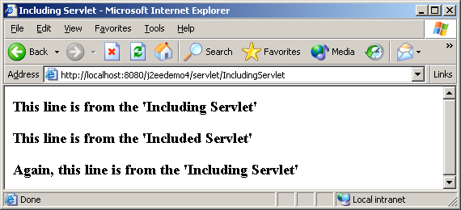

Encoding URL
Every server that supports servlets must implement at least cookie-based session tracking, where the session ID is saved on the client in a persistent cookie. Many web servers (including Tomcat) also support session tracking based on URL rewriting, as a fallback for browsers that don’t accept cookies. However, this requires addition help from servlets.

For a servlet to support session tracking via URL rewriting, it has to rewrite every local URL before sending it to the client. HttpServletResponse has two methods that we have to use to help this process.

Method | Return Type | Description
encodeURL(String url) | String | Encodes the specified URL by including the session ID in it, or, if encoding is not needed, returns the URL unchanged.
encodeRedirectURL(String url) | String | Encodes the specified URL for use in the sendRedirect method or, if encoding is not needed, returns the URL unchanged.

encodeURL() rewrites the specified URL to include the session ID and returns the new URL, or , if encoding is not needed or not supported, it leaves the URL unchanged. The rules to decide when and how to encode the URL depends on the server. All URLs produced by a servlet (except for redirection) should run though this method.

encodeRedirectURL() also rewrites the specified URL to include the session ID but should be used to URLs that are given to sendRedirect() method. This method may use different rules than encodeURL().

Here is a counter servlet that uses cookie based session by default:

// Code 4H
import java.io.IOException;
import java.io.PrintWriter;
import java.util.Date;
import javax.servlet.ServletException;
import javax.servlet.http.HttpServlet;
import javax.servlet.http.HttpServletRequest;
import javax.servlet.http.HttpServletResponse;
import javax.servlet.http.HttpSession;
import org.apache.log4j.Logger;
public class CounterServlet extends HttpServlet{
private static final Logger logger = Logger.getLogger(CounterServlet.class);
public void doGet (HttpServletRequest request, HttpServletResponse response)
throws ServletException, IOException{
logger.info("In doGet");
// Get the session object first!
HttpSession session = request.getSession();
logger.debug("Got Session");
// Get the counter value from the session
Integer counter = (Integer) session.getAttribute("counter");
if (counter == null){
logger.debug("Counter not found in session");
counter = new Integer(1);
}
else{
counter = new Integer(counter.intValue() + 1);
logger.debug("Found counter in session: " + counter);
}
logger.debug("counter value now: " + counter);
// store the updated counter value
session.setAttribute("counter", counter);
logger.debug("Counter is set in Session");
// Send back the page
PrintWriter out = response.getWriter();
response.setContentType("text/html");
logger.debug("Writing response");
out.println("<HTML><HEAD><TITLE>CounterServlet</TITLE></HEAD><BODY>");
out.println("<H2>CounterServlet Output</H2>");
out.println("Counter = <B>" + counter + "</B><P>");
// We should not really use the link without encodeURL
String link = "CounterServlet";
out.println("Click <A href=" + link + "><B>here</B></A> to increment your counter.<P><P>");
displaySessionInfo(request, session, out);
out.println("</BODY><HTML>");
out.close();
}
/**
* Helper method to display additional information about the request and session
*/
private void displaySessionInfo(HttpServletRequest request, HttpSession session, PrintWriter out)
throws IOException {
logger.debug("In displaySessionInfo");
String row;
out.println("<HR>");
out.println("<B>Request and Session Data:<B><P>");
out.println("<TABLE border=1 cellpadding=5>");
row = makeTableRow("Session ID in Request", request.getRequestedSessionId());
out.println(row);
row = makeTableRow("Session ID in Request from Cookie: ", "" + request.isRequestedSessionIdFromCookie());
out.println(row);
row = makeTableRow("Session ID in Request from URL", "" + request.isRequestedSessionIdFromURL());
out.println(row);
out.println("</TABLE>");
out.println("<P><B>Session Data:</B><P>");
out.println("<TABLE border=1 cellpadding=5>");
row = makeTableRow("New Session", "" + session.isNew());
out.println(row);
row = makeTableRow("Session ID", session.getId());
out.println(row);
row = makeTableRow("Creation Time (secs)", "" + session.getCreationTime());
out.println(row);
row = makeTableRow("Creation Time", new Date(session.getCreationTime()));
out.println(row);
row = makeTableRow("Last Accessed Time: ", new Date(session.getLastAccessedTime()));
out.println(row);
row = makeTableRow("Max Inactive Interval (secs): ", "" + session.getMaxInactiveInterval());
out.println(row);
row = makeTableRow("Max Inactive Interval (mins): ", "" + session.getMaxInactiveInterval() / 60);
out.println(row);
out.println("</TABLE>");
logger.debug("Finished displaySessionInfo");
}
/**
* Helper method to generate a table row for a name/value pair
*/
private String makeTableRow(String name, Object value) {
StringBuffer row = new StringBuffer();
row.append("<tr>");
row.append("<td>" + name + "</td>");
row.append("<td>" + value + "</td>");
row.append("</tr>");
return row.toString();
}
}

Copy the servlet to c:\tomcat5028\webapps\Root\Web-inf\Classes folder and compile them.
Stop and Start ROOT app.

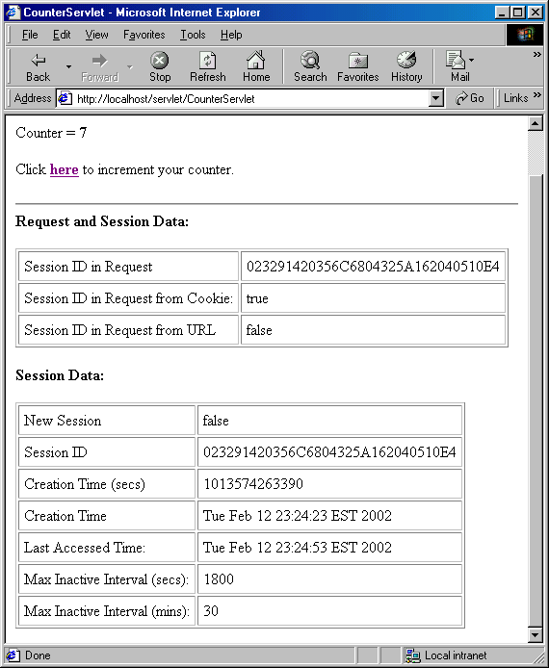
I have Cookie enabled on my browser (default setting). Here is the output after I clicked on the link a few times:

Notice that Session ID in Request from Cookie is true above – which means the servlet is using Cookie to maintain session.

The actual problem is impossible to demonstrate if you are using recent version if Internet Exproler and localhost as your server. IE is too stupid to ignore your cookie settings for localhost.

Assuming Tomcat is running on a different machine. Go ahead and turn off the Cookie for Session in your browser. If you are using Internet Explorer, please click on “Tools” from the main menu and select “Internet Options”. Click on Privacy Tab and then click on “Advanced.. ” button., select Prompt for first and third part cookies. Now, hit the CountServlet again. This time you will get a security alert as follows:

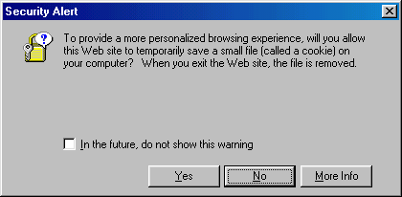

Please carefully select No.

This time you will get the following output:

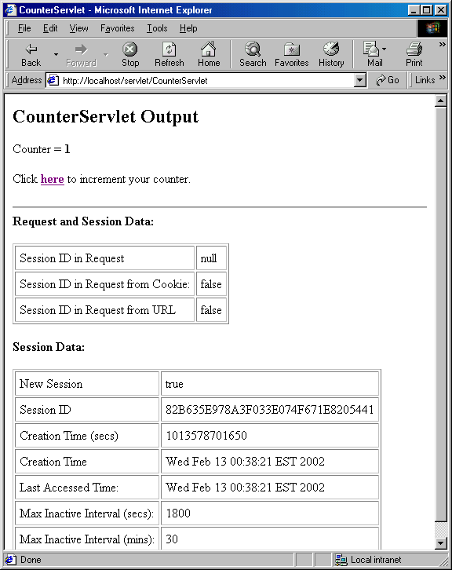

The big difference is that this time Session ID in Request from Cookie is false which basically mean cookies are not available for session tracking.

Click on the link (here) a few times and every time say No to the security alert. You will notice the count will stay at 1 and will never increase.

Now let’s create another servlet CounterServlet2 by coping the code from CounterServlet (make sure you change the class name to CounterServlet2 before saving in CounterServlet2.java) . In CounterServlet2 we will only change the following line:

String link = "CounterServlet";

with the following line:

String link = response.encodeURL("URLEncodedCounterServlet");

(Please note URLEncodedCounterServlet – calling itself)

Copy the servlet to c:\tomcat5028\webapps\Root\Web-inf\Classes folder and compile them.

Stop and Start ROOT App.

Again, keep saying No to security alert. When the page comes back first time you will be disappointed to note that both Session ID in Request from Cookie and URL is false. But, go ahead and click on the link(here). First surprise is that you will NOT get the security alert anymore. Why? Because the servlet is not using cookie at all. Therefore, there is nothing to alert. Secondly, you will get the following output:
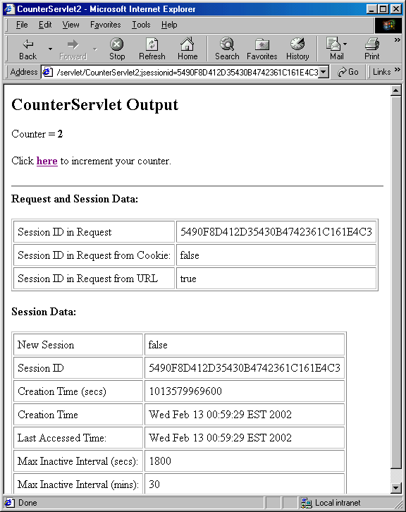

Notice the counter is working. Secondly, Session ID in Request from URL is true. Thirdly, examine the URL on the browser, you can literally see the session ID being passed around.

Now, go back and turn the cookie on and try URLEncodedCounterServlet again. The counter should still work and Session ID in Request from Cookie should be true again instead of URL.

How does URL Encoding work?
Here is how the mechanism works. Obviously first time you hit the servlet, the server does not know if your browser is cookie enabled or not (this information is not available the request header). But you have encoded all your urls in all servlets. What should the server do? Well, the safest thing to do for the server is to send the session id both via cookie as well as url for the links residing on the first servlet. Please check the status line of the browser at the bottom of the following page:

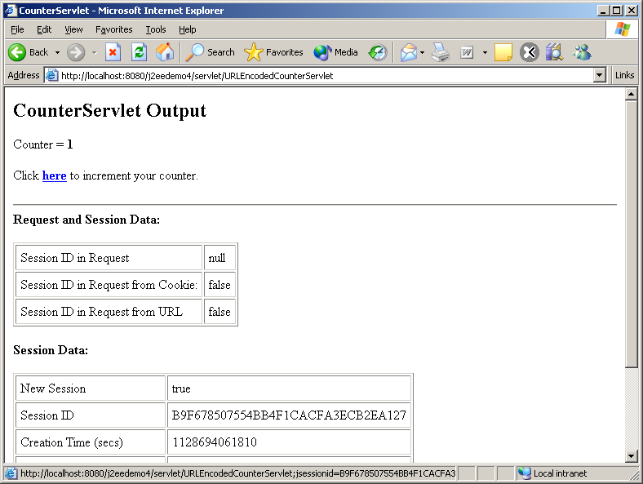

There is jsessionid on the link url.

When you hit the second servlet (in our case the same servlet second time), the server looks for the jsessionid cookie in the request header. If this found – Bingo. The server knows your browser is cookie enabled and does not send the jsessionid in the subsequent urls. Please look at the following:

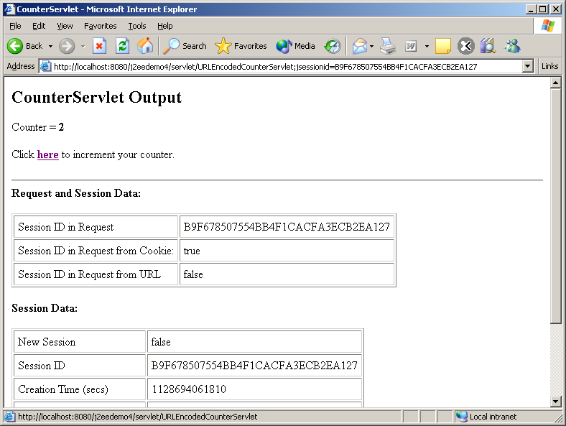

However, if the browser is cookie disabled (which can not demonstrate – shame on IE), the jsessionid would continue to show up on every single subsequent link. Is that nice or what?

Instance Persistence and Thread-Safety of Servlets
In a typical servlet lifecycle, a web container creates a single instance of each servlet when it needs the servlet. We know that the when a request comes in the service() method of the servlet gets call which in turn can call either doGet(), doPost() etc. as appropriate. What happens if two requests come in at the same time. Does the container create two instances? It can but it does not have to. The servlet container creates a new thread to handle each new request to the same servlet and each thread calls the service() method. Therefore, is it possible that two or more threads can be running the service() method on the same servlet instance at the same time? The answer is certainly possible and happens pretty often. Typically this does not cause a problem, unless, of course, the servlet uses instance variables (fields). If a servlet uses instance variable and the service() method (or methods like doGet(),doPost() etc. called from service()) modifies the instance variable and there is always a potential of data corruption. The problem is little hard to demonstrate but it certainly can happen.

Here is a servlet that will give some bizarre output:

// Code 4J
import java.io.IOException;
import java.io.PrintWriter;
import javax.servlet.ServletException;
import javax.servlet.http.HttpServlet;
import javax.servlet.http.HttpServletRequest;
import javax.servlet.http.HttpServletResponse;
import org.apache.log4j.Logger;
public class ThreadUnsafeServlet extends HttpServlet{
private static final Logger logger = Logger.getLogger(ThreadUnsafeServlet.class);
private static final int THIRTY_SECONDS=1000*30;
private int unsafe_servlet_hit_count;
private int safe_servlet_hit_count;
public void doPost(HttpServletRequest request, HttpServletResponse response)
throws ServletException, IOException{
logger.info("In doPost");
doGet(request,response);
logger.info("Finish doPost");
}
public void doGet(HttpServletRequest request, HttpServletResponse response)
throws ServletException, IOException{
logger.info("In doGet");
// set the content type of response.
response.setContentType("text/html");
// get a handle on the print writer of response.
PrintWriter out=response.getWriter();
// generate response.
out.println("<HTML>");
out.println("<HEAD>");
out.println("<TITLE>");
out.println("Unsafe Thread");
out.println("</TITLE>");
out.println("</HEAD>");
out.println("<BODY>");
safe_servlet_hit_count++;
logger.debug("The value of safe variable after increment: " + safe_servlet_hit_count );
out.println("<H3>Number of hits (safe): " + safe_servlet_hit_count + "<H3>");
// read safe_servlet_hit_count to a temp variable;
int temp = unsafe_servlet_hit_count;
Logger.debug("The value of temp: " + temp );
// increment temp
temp=temp+1;
logger.debug("The value of temp after inclement: " + temp );
// pretend that this thread ran out of time by introducing a sleep.
try{
logger.debug("Going to sleep");
Thread.sleep(THIRTY_SECONDS);
}
catch(InterruptedException e){
logger.error("Sleep error", e);
}
// wake up and increment
// but the damage has already been done.
unsafe_servlet_hit_count=temp;
logger.debug("The value of unsafe variable: " + unsafe_servlet_hit_count);
out.println("<H3>Number of hits (unsafe): " + unsafe_servlet_hit_count + "<H3>");
out.println("</BODY>");
out.println("</HTML>");
}
}

Copy the servlet to c:\tomcat5028\webapps\Root\Web-inf\Classes folder and compile them.

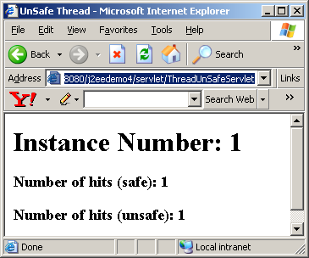
However, getting the expected output from this servlet is little tricky. You have to have two instance of your browser ready to go. From one browser hit http://localhost:8080/servlet/ThreadUnsafeServlet and within 30 seconds hit the servlet from the second browser. The output of each hit will come after 30 seconds because of the wait() call and finally you will get the following output:
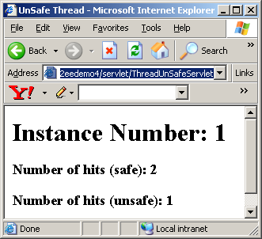

It does not take a rocket scientist to figure out that there is problem with the output on the second browser.

Of course, in order to simulate the problem, I had to save the value of unsafe_servlet_hit_count to temp and read it back from temp which a sleep in between. My point is your hardware does work with a temp (registry) and may do other things between writing to temp and reading back from temp causing temp value outdated.

The reason the problem occurred is because both did exactly the same thing as follows:

- Read unsafe_servlet_hit_count as zero
- Incremented Temp to unsafe_servlet_hit_count + 1 = 1
- Went to sleep for 30 sec.
- Woke up and updated the value of unsafe_servlet_hit_count by the value of temp =1

On the other hand, safe_servlet_hit_count did not use Temp and incremented itself immediately and therefore, has the correct value of 2.

But wait a minute, isn’t it true then that my safe_servlet_hit_count could possibly behave the same way since the hardware use a temp? If you are think in that like you are on to something.

Here is the answer. This kind of problem can never occur if your variable is ‘int’ or smaller. Today’s hardware do atomic computing on ‘int’ and smaller variables. Therefore, there is nothing to worry about if you are dealing with ‘int’ or lower. For, other variables you do have to worry about. That way by safe_servlet_hit_count is really safe since it is an ‘int’.

Fortunately, there are three solutions to this problem:

- Make the doGet() method (or better yet, the service() method) synchronized as follows:

public synchronized void doGet(HttpServletRequest request, HttpServletResponse response)

However, this approach has a major performance hit. This will make sure that only one Thread can execute the doGet() method at a time and all other threads should wait till the current thread finishes.

- Make the critical section of the thread synchronized as follows:

//lock the servlet
synchronized(this)
{
// read instance_hit_count to a temp variable;
int temp = unsafe_servlet_hit_count;

// increment temp
temp=temp+1;

// pretend that this thread ran out of time by introducing a sleep.
try
{
Thread.sleep(THIRTY_SECONDS);
}
catch(InterruptedException e)
{
}
// wake up and increment instance_hit_count
// but the damage has already been done.
unsafe_servlet_hit_count;=temp;
}
This approach will lock the servlet before it enters the critical section of the code and will unlock as soon as it done. This approach is better than the first approach since it locks the servlet for a shorted time.
Here is the output from two different browsers with synchronized block:

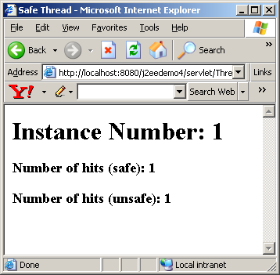
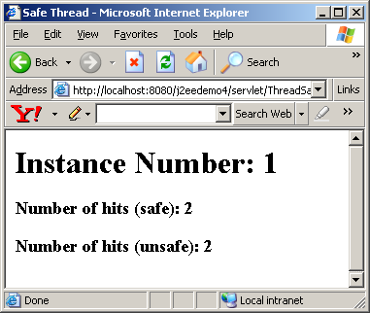
c) Implement SingleThreadModel interface on the servlet as follows:

//Code 40
public class ThreadSafeServlet extends HttpServlet implements SingleThreadModel

The body of the servlet is exactly the same as ThreadUnsafeServlet.

SingleThreadModel interface is an empty, tag interface that defines no method (like Cloneable interface, Serializable interface). A server that loads a servlet that implements SingleThreadModel must guarantee that NO two threads will execute concurrently the service method of that servlet. The easiest implementation of this approach for any server is to create only one instance of the servlet and queue up all the requests coming to the servlet. But in reality, because of performance issues, the server maintains a pool of instances (let’s say 10) of the SingleThreadModel servlet and allocate one from the pool as requests for the same servlet comes from clients.

Here is the output:
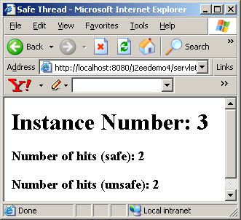
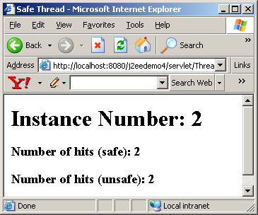

Please note the following from javadoc:

SingleThreadModel does not solve all thread safety issues. For example, session attributes and static variables can still be accessed by multiple requests on multiple threads at the same time, even when SingleThreadModel servlets are used. It is recommended that a developer take other means to resolve those issues instead of implementing this interface, such as avoiding the usage of an instance variable or synchronizing the block of the code accessing those resources. This interface is deprecated in Servlet API version 2.4.

Therefore, you should really use option a) or b) described above.

Filter Interface
A filter is an object that performs filtering tasks on either the request to a web component or on the response from a web component, or both. Filters generally don’t generate responses like servlets do, rather intercept and modify requests going out to a web component. Filters also can intercept and modify responses coming back from web resources.
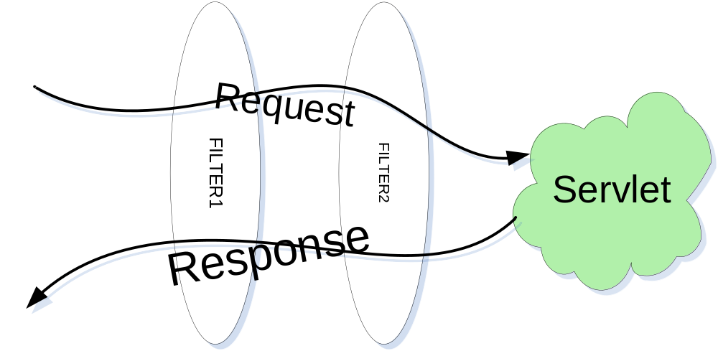
In general, what we mean by Filter is that Filter is an application component that implements Filter interface. Filter interface has the following methods that are very similar to Servlet Interface:

init(FilterConfig filterConfig) | void | Called by the web container to indicate to a filter that it is being placed into service.
doFilter(ServletRequest request, ServletResponse response, FilterChain chain) | void | The doFilter method of the Filter is called by the container each time a request/response pair is passed through the filter due to a client request for a web component.
destroy() | void | Called by the web container to indicate to a filter that it is being taken out of service.

Obviously, there is more to it – the init() method receives an object that implements FilterConfig interface, the doFilter() method receives an object that implements FilterChain interface in addition to the two objects that implements ServletRequest and ServletResponse interface.

FilterConfig Interface
This interface defines a configuration object used by a servlet container to pass information to a filter during initialization. Like servlets, filters can have initialization parameters defined in web.xml and those parameters are made available to a filter via FilterConfig object. FilterConfig allows allows access to servlet context (application) via getServletContext() method.

getFilterName() | String | Returns the filter-name of this filter as defined in the deployment descriptor.
getInitParameter(String name) | String | Returns a String containing the value of the named initialization parameter, or null if the parameter does not exist.
getInitParameterNames() | Enumeration | Returns the names of the filter's initialization parameters as an Enumeration of String objects, or an empty Enumeration if the filter has no initialization parameters.
getServletContext() | ServletContext | Returns a reference to the ServletContext in which the caller is executing.

FilterChain Interface
A FilterChain interface defines an object that gives access to the invocation chain of a filtered request for a resource. Filters receive FilterChain object as an argument to the doFilter() method. Filters can, in their doFilter() method, call the FilterChain’s doFilter() method to invoke the next filter in the chain, or if the calling filter is the last filter in the chain, FilterChain invokes the servlet/html page.

doFilter (ServletRequest request, ServletResponse response) | void | Causes the next filter in the chain to be invoked, or if the calling filter is the last filter in the chain, causes the resource at the end of the chain to be invoked.

Filter Lifecycle
We already know, in web.xml, we can map a servlet to an url. Similarly, in web.xml, filters can be mapped to urls as well. When a container receives an incoming request, it firsts finds the first filter in the list of filters (yes, there can be more than one filter mapped to the same url) mapped to the requested url. The container must ensure that it has instantiated this filter by calling it’s init() method. Only one instance of a particular filter can be instantiated. The container then calls the doFilter() method on the filter. The doFilter() method in a filter can do any of the followings:

- Examine the request’s headers.
- Wrap the request object with a customized implementation of request object to modify the request (header or data).
- Wrap the response object with a customized implementation of request object to modify the response.
- Invoke the next entity in the filter chain. The next entity can be another filter or if it is the last filter then the next entity is a web component.
- Never invoke the next entity in the filter chain. Therefore, short-circuit the url.
- After invocation of the next filters in the chain, the filter can examine the response headers.
- Throw exception. If the filter throws an UnavailableException during its doFilter() method, the container must not attempt continued processing down the chain.

Filter Mapping
In web.xml, filters are mapped exactly the same way servlets are mapped. First, you give the filter class a name as follows:

<filter>
<filter-name>TimeLogingFilter</filter-name>
<filter-class>LogFilter</filter-class>
</filter>

If the filter needs initialization parameter, the mapping would look like this:

<filter>
<filter-name>TimeLogingFilter</filter-name>
<filter-class>LogFilter</filter-class>
<init-param>
<param-name>LogLevel</param-name>
<param-value>10</param-value>
</init-param>
<init-param>
<param-name>DebugLevel</param-name>
<param-value>5</param-value>
</init-param>
</filter>

Like servlet, once the filter has a name, we can we can map the filter to url patterns as follows:

<filter-mapping>
<filter-name>TimeLogingFilter</filter-name>
<url-pattern>/servlet/*</url-pattern>
</filter-mapping>

As an alternate approach, a filter can be mapped to a particular servlet as follows:

<filter-mapping>
<filter-name>TimeLogingFilter</filter-name>
<servlet-name >VideoServlet</servlet-name>
</filter-mapping>

By default, filters ONLY kick-in if the request came directly from client. Filters don’t kick-in if the request came from dispatcher’s forward() or include() call. However, servlet specification 2.4 allows us to enable this by adding dispatcher tag as follows:

<filter-mapping>
<filter-name>TimeLogingFilter</filter-name>
<url-pattern>/servlet/*</url-pattern>
<dispatcher>REQUEST</dispatcher>
<dispatcher>FORWARD</dispatcher>
<dispatcher>INCLUDE</dispatcher>
</filter-mapping>

The absence of any dispatcher tag is equivalent to just having <dispatcher>REQUEST</dispatcher> tag.

If you have multiple filters, name your filters and then map your filters as follows:

<filter>
<filter-name>ContentFilter</filter-name>
<filter-class>ContentLengthControlFilter</filter-class>
</filter>
<filter>
<filter-name>TimeLogingFilter</filter-name>
<filter-class>LogFilter</filter-class>
</filter>
<filter-mapping>
<filter-name>TimeLogingFilter</filter-name>
<url-pattern>/servlet/*</url-pattern>
</filter-mapping>
<filter-mapping>
<filter-name>ContentFilter</filter-name>
<url-pattern>/servlet/*</url-pattern>
</filter-mapping>

Please note that filter naming and filter mapping must appear before servlet naming and servlet mapping inside web.xml. Also please note that the order of execution of filters depends on the on the order of MAPPING, never depends on the order of Naming.

In the above example, TimeLogingFilter would be encountered first and then ContentFilter since they are mapped in that order. The fact that ContentFilter is named first does not have any bearing on the order of execution.

Filter Data Flow

When a url request to a servlet comes in and the requested url maps to a filter, the filter’s doFilter() method is invoked by the container. The Filter’s doFilter() method continues to execute until filterchain’s doFilter() method invocation is encountered. At this point the doFilter() method of the filter is on hold and the filter chain calls the doFilter() method of the next filter. The same thing happens on the next filter. If there is no more filter in the chain, the service() method of the url’s servlet is called. Of course, as we know, the service() method may call doGet(), doPost() etc. Once the service method returns, the last filter’s doFilter() method resumes (this method was on hold, remember?). Once the last filter’s doFilter() returns, the next to last filter’s doFilter() method resumes. When there is no more filter the container returns the response.
If a filter never calls the chain’s doFilter() method, the execution will return from that filter (the url will be short-circuited) and never move to the next filter or servlet whatever is next.

If a filter throws UnavailableException, the execution will return from that filter (the url will be short-circuited) and never move to the next filter or servlet whatever is next.

It makes perfect sense to write the doFilter() method of a Filter in the following manner:

public void doFilter(ServletRequest request, ServletResponse response,
FilterChain chain) throws IOException, ServletException {

// Request processing logic (if any) goes here
chain.doFilter(request, response);
// Response processing logic (if any) goes here

}

Here is an example of a filter that simply records and entry and exit of doFilter methods() as well as the time it takes to complete doFilter:

import java.io.IOException;
import javax.servlet.Filter;
import javax.servlet.FilterChain;
import javax.servlet.FilterConfig;
import javax.servlet.ServletException;
import javax.servlet.ServletRequest;
import javax.servlet.ServletResponse;
import org.apache.log4j.Logger;
public final class LogFilter implements Filter {
private static final Logger logger = Logger.getLogger(LogFilter.class);
private FilterConfig filterConfig = null;
public void init(FilterConfig filterConfig) throws ServletException {
this.filterConfig = filterConfig;
}
public void doFilter(ServletRequest request, ServletResponse response,
FilterChain chain) throws IOException, ServletException {
// Time and log the subsequent processing
long startTime = System.currentTimeMillis();
logger.debug("Entering " + filterConfig.getFilterName() + ".doFilter");
chain.doFilter(request, response);
long stopTime = System.currentTimeMillis();
logger.debug("Exiting " + filterConfig.getFilterName() + ".doFilter : " + (stopTime - startTime) + " milliseconds after chaining");
}
public void destroy() {
this.filterConfig = null;
}
}

Here is a content length checker filter:

import java.io.IOException;
import javax.servlet.Filter;
import javax.servlet.FilterChain;
import javax.servlet.FilterConfig;
import javax.servlet.ServletException;
import javax.servlet.ServletRequest;
import javax.servlet.ServletResponse;
import javax.servlet.http.HttpServletResponse;
import org.apache.log4j.Logger;
public final class ContentLengthControlFilter implements Filter {
private static final Logger logger = Logger.getLogger(ContentLengthControlFilter.class);
private FilterConfig filterConfig = null;
public void init(FilterConfig filterConfig) throws ServletException {
this.filterConfig = filterConfig;
}
public void doFilter(ServletRequest request, ServletResponse response,
FilterChain chain) throws IOException, ServletException {
logger.debug("Entering " + filterConfig.getFilterName() + ".doFilter");
if (request.getContentLength()>10){
logger.debug("Content Length is: " + request.getContentLength());
HttpServletResponse httpResponse = (HttpServletResponse) response;
httpResponse.sendError(HttpServletResponse.SC_BAD_REQUEST,"You have posted more than 10 bytes");
logger.debug("Exiting " + filterConfig.getFilterName() + ".doFilter without chaining any further");
return;
}
chain.doFilter(request, response);
logger.debug("Exiting " + filterConfig.getFilterName() + ".doFilter after chaining");
}
public void destroy() {
this.filterConfig = null;
}
}

Notice if the content length checking fails the filter does not chain any future – it simply returns with error. Otherwise, it chains to the next object which happens to be a servlet.

Here are the entries that go to web.xml to name these two filters:

<filter>
<filter-name>TimeLogingFilter</filter-name>
<filter-class>LogFilter</filter-class>
</filter>
<filter>
<filter-name>ContentFilter</filter-name>
<filter-class>ContentLengthControlFilter</filter-class>
</filter>
<filter-mapping>
<filter-name>TimeLogingFilter</filter-name>
<url-pattern>/servlet/*</url-pattern>
</filter-mapping>
<filter-mapping>
<filter-name>ContentFilter</filter-name>
<url-pattern>/servlet/*</url-pattern>
</filter-mapping>

Copy the filters to Tomcat’s webapps\ROOT\WEB-INF\classes folder. Open Tomcat’s webapp\ROOT\WEB-INF\web.xml and put the filter and mapping entries. Stop and start ROOT app and then hit the following url from a browser:

http://localhost:8080/servlet/IncludingServlet

You will get the response without any surprise but at Tomcat’s console you will get the following output:

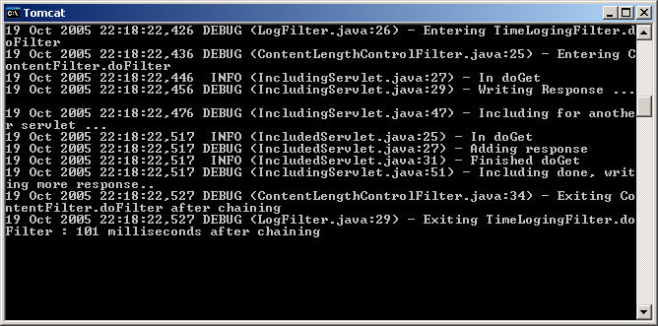

ServletRequestWrapper and HttpServletRequestWrapper Class

ServletResponseWrapper and HttpServletResponseWrapper Class
At session 2 we discussed that we never have to implement ServletRequest Interface or HttpServletRequest interface since the container does this job and sends HttpServletRequest to our doGet() or doPost() method. The same rule also applies for HttpServletResponse. However, there are times when we have to take matters in our own hands. In other words, we have to convert the container generated request to our custom request object or container generated response to our custom response object. There are two good news on this. First the container is not supposed to complain if we do this and should keep forwarding our custom request and response object without a problem. Secondly, we don’t have to write custom request and custom response class from scratch since sun already provides 4 base classes (known as request and response wrappers). These four classes are:
- ServletRequestWrapper
- HttpServletRequestWrapper
- ServletResponseWrapper
- HttpServletResponseWrapper

If we have to provide custom request, we simply have to subclass HttpServletRequestWrapper. If we need to provide custom response, we simply have to subclass HttpServletResponseWrapper.

Using Custom Response Wrapper for gzip compression
Today, all browsers support gzip compression. What that means, in request header browsers broadcast to the server that it can handle gzip compressed response. The server, therefore, can compress the response using gzip compression and send it back to the browser. Of course, the server has to notify the browser that it used gzip compression via response header. The browser, would automatically uncompress the file and present it to the user as if nothing special went on. This could significantly increase the response time if response is text (or html) and big.

In order to accomplish this, we have to introduce a filter that will intercept the calls to servlets and swap out the response object with a custom response object. The custom response object will use gzip compressed output stream. Fortunately sun provides GZIPOutputStream class in java.util.zip package that does exactly that.

Here is the filter class:

import java.io.IOException;
import javax.servlet.Filter;
import javax.servlet.FilterChain;
import javax.servlet.FilterConfig;
import javax.servlet.ServletException;
import javax.servlet.ServletRequest;
import javax.servlet.ServletResponse;
import javax.servlet.http.HttpServletRequest;
import javax.servlet.http.HttpServletResponse;
import org.apache.log4j.Logger;
public class GZIPFilter implements Filter {
private static final Logger logger = Logger.getLogger(GZIPFilter.class);
private FilterConfig filterConfig = null;
public void doFilter(ServletRequest req, ServletResponse res,
FilterChain chain) throws IOException, ServletException {
logger.debug("Entering " + filterConfig.getFilterName() + ".doFilter");
if ((req instanceof HttpServletRequest) && (res instanceof HttpServletResponse)){
HttpServletRequest request = (HttpServletRequest) req;
HttpServletResponse response = (HttpServletResponse) res;
String ae = request.getHeader("accept-encoding");
if (ae != null && ae.indexOf("gzip") != -1) {
logger.debug("GZIP supported, compressing.");
GZIPResponseWrapper wrappedResponse = new GZIPResponseWrapper(response);
Chain.doFilter(req, wrappedResponse);
wrappedResponse.finishResponse();
}
else{
chain.doFilter(req, res);
}
logger.debug("Exiting " + filterConfig.getFilterName() + ".doFilter");
}
}
public void init(FilterConfig filterConfig) {
This.filterConfig = filterConfig;
}
public void destroy() {
This.filterConfig = null;
}
}

Here is our response wrapper:

import java.io.*;
import javax.servlet.*;
import javax.servlet.http.*;
public class GZIPResponseWrapper extends HttpServletResponseWrapper {
protected HttpServletResponse origResponse = null;
protected ServletOutputStream stream = null;
protected PrintWriter writer = null;
public GZIPResponseWrapper(HttpServletResponse response) {
super(response);
origResponse = response;
}
public ServletOutputStream getOutputStream() throws IOException {
if (writer != null) {
throw new IllegalStateException("getWriter() has already been called!");
}
if (stream == null)
stream = createOutputStream();
return (stream);
}
public PrintWriter getWriter() throws IOException {
if (writer != null) {
return (writer);
}
if (stream != null) {
throw new IllegalStateException("getOutputStream() has already been called!");
}
stream = createOutputStream();
writer = new PrintWriter(new OutputStreamWriter(stream, "UTF-8"));
return (writer);
}
public ServletOutputStream createOutputStream() throws IOException {
return (new GZIPResponseOutputStream(origResponse));
}
public void finishResponse() {
try {
if (writer != null) {
Writer.close();
} else {
if (stream != null) {
stream.close();
}
}
} catch (IOException e) {}
}
public void flushBuffer() throws IOException {
stream.flush();
}
public void setContentLength(int length) {}
}

Here is GZIPResponseOutputStream:

import java.io.*;
import java.util.zip.GZIPOutputStream;
import javax.servlet.*;
import javax.servlet.http.*;
public class GZIPResponseOutputStream extends ServletOutputStream {
protected ByteArrayOutputStream baos = null;
protected GZIPOutputStream gzipstream = null;
protected boolean closed = false;
protected HttpServletResponse response = null;
protected ServletOutputStream output = null;
public GZIPResponseOutputStream(HttpServletResponse response) throws IOException {
super();
closed = false;
this.response = response;
this.output = response.getOutputStream();
baos = new ByteArrayOutputStream();
gzipstream = new GZIPOutputStream(baos);
}
public void close() throws IOException {
if (closed) {
throw new IOException("This output stream has already been closed");
}
gzipstream.finish();
byte[] bytes = baos.toByteArray();
response.addHeader("Content-Length",
Integer.toString(bytes.length));
response.addHeader("Content-Encoding", "gzip");
output.write(bytes);
output.flush();
output.close();
closed = true;
}
public void flush() throws IOException {
if (closed) {
throw new IOException("Cannot flush a closed output stream");
}
gzipstream.flush();
}
public void write(int b) throws IOException {
if (closed) {
throw new IOException("Cannot write to a closed output stream");
}
gzipstream.write((byte)b);
}
public void write(byte b[]) throws IOException {
write(b, 0, b.length);
}
public void write(byte b[], int off, int len) throws IOException {
System.out.println("writing...");
if (closed) {
throw new IOException("Cannot write to a closed output stream");
}
gzipstream.write(b, off, len);
}
public boolean closed() {
return (this.closed);
}
public void reset() {
}
}

Here is the entry that goes to web.xml:

<filter>
<filter-name>GZIPFilter</filter-name>
<filter-class>GZIPFilter</filter-class>
</filter>
…………..
…………..

<filter-name>GZIPFilter</filter-name>
<url-pattern>/servlet/*</url-pattern>
</filter-mapping>

Copy the filter and the supported classes to Tomcat’s webapps\ROOT\WEB-INF\classes folder (where WeatherForecastServlet is). Open Tomcat’s webapp\ROOT\WEB-INF\web.xml and put the filter and mapping entries. Stop and start ROOT App and then hit the following url from a browser:

http://localhost:8080/servlet/IncludingServlet

You will get the response from WeatherForecastServlet back without any surprise but at Tomcat’s console you will get the following output:

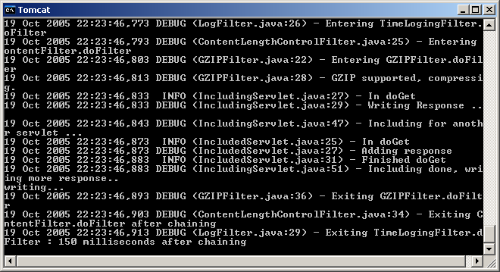

For the above log, we know that our compression filter worked. Of course, we can’t really see the compressed response, for that we need help from some HTTP tunneling tool like TCPMon that comes with AXIS from Apache.

Here is what the response looks like:

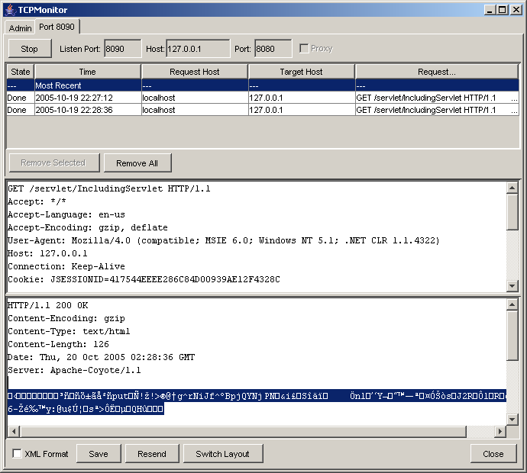

Clearly the response body is zipped.

Security
Security is the science of keeping sensitive information in the hands of authorized users. On the web, there are 2 major issues related to security:

- Authetication: Being able to verify that you are who you claim to be. This is accomplished by assigning User ID and Password to every individual who has access to the system.
- Authorization: Limiting access to resources to a selection set of people. This is accomplished by attaching a set of users to a resource – so that only they can access the resource.

There are many ways to implement security – some are better than others.

Http Authentication
HTTP protocol provided built-in authentication support – called basic authentication – based on a simple challege/response, username/password model. The web server maintains a database of usernames and passwords and identifies certain resources (html files, servlets etc) as protected. When the user asks for a protected resource, the server responds with a request for user id and password. At this point, the browser pops up a dialog window where the user enters id and password.

Basic authentication is very weak in security since passwords are transmitted over the network with a Base64 encryption coding which is well known and easy to break.

HTTP Authentication can be configured using web.xml deployment descriptor. It is done is two steps:

- Granting permission to certain Roles to access certain resources using web.xml
- Assigning individual users to Roles using server specific tools.

Role-based authentication
Using tags in web.xml, security constraints are defined to indicate that certain servlets, html pages are available to users in certain roles.

The web.xml needs three sections <security-constraint>,<login-config>,<security-role> to define constrains, login configuration and security roles. Here is the web.xml that requires that you logon before you see any page (static html or servlet) of the application:

<?xml version="1.0" encoding="ISO-8859-1"?>
<!DOCTYPE web-app PUBLIC "-//Sun Microsystems, Inc.//DTD Web Application 2.3//EN"
"http://java.sun.com/dtd/web-app_2_3.dtd">
<web-app>
<context-param>
<param-name>
caption
</param-name>
<param-value>
Our Little Test Application
</param-value>
</context-param>
<filter>
<filter-name>GZIPFilter</filter-name>
<filter-class>GZIPFilter</filter-class>
</filter>
<filter>
<filter-name>ContentFilter</filter-name>
<filter-class>ContentLengthControlFilter</filter-class>
</filter>
<filter>
<filter-name>TimeLogingFilter</filter-name>
<filter-class>LogFilter</filter-class>
</filter>
<filter-mapping>
<filter-name>TimeLogingFilter</filter-name>
<url-pattern>/servlet/*</url-pattern>
</filter-mapping>
<filter-mapping>
<filter-name>ContentFilter</filter-name>
<url-pattern>/servlet/*</url-pattern>
</filter-mapping>
<filter-mapping>
<filter-name>GZIPFilter</filter-name>
<url-pattern>/servlet/*</url-pattern>
</filter-mapping>
<servlet>
<servlet-name>
ServletConfigInitParameterDemoServlet
</servlet-name>
<servlet-class>
ServletConfigInitParameterDemoServlet
</servlet-class>
<init-param>
<param-name>
message
</param-name>
<param-value>
Weather Today: Mostly chilly. High around 65F. Wind condition is unknown.
</param-value>
</init-param>
</servlet>
<security-constraint>
<web-resource-collection>
<web-resource-name>
GeneralProtection
</web-resource-name>
<url-pattern>
/*
</url-pattern>
<http-method>
GET
</http-method>
<http-method>
POST
</http-method>
</web-resource-collection>
<auth-constraint>
<role-name>
manager
</role-name>
</auth-constraint>
</security-constraint>
<login-config>
<auth-method>
BASIC
</auth-method>
</login-config>
<security-role>
<role-name>
manager
</role-name>
</security-role>
</web-app>

Please note “/*” on the url-pattern section that gives us the security.

Copy and paste this to your exising web.xml located in c:\tomcat5028\webapps\Root\Web-inf folder.

Stop and Start ROOT app. Now type:

http://localhost:8080/signup.html

A simple html page from the root application and you will be prompted with the following screen on Windows machine:

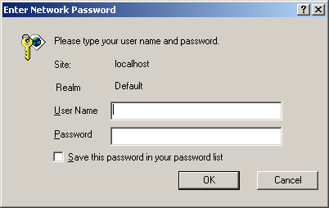

Type user name: “admin” and password: “admin” (lookup tomcat-users.xml in Tomcat’s conf folder if you have a different password) and hit ok and you will see the page. Once login, you can bring any page without further interruption. Close the browser, reopen and type any url and you will be prompted for password again.

If you just want to protect WeatherForecastServlet then your url-pattern will be “/servlet/WeatherForecastServlet” in web.xml. If you want to protect all servlets your url-pattern should be “/servlet/*” and so on.

Assigning Roles

There is no standard for this part of the game. Each server does it different. In Tomcat, you specify users and their roles using tomcat-users.xml file located in c:\tomcat5028\conf folder. Here is the content of the file default:

<?xml version="1.0" encoding="utf-8"?>
<tomcat-users>
<role rolename="tomcat"/>
<role rolename="role1"/>
<role rolename="manager"/>
<role rolename="admin"/>
<user username="tomcat" password="tomcat" roles="tomcat"/>
<user username="both" password="tomcat" roles="tomcat,role1"/>
<user username="role1" password="tomcat" roles="role1"/>
<user username="admin" password="admin" roles="admin,manager"/>
</tomcat-users>

Feel free to add more entries.

Form-Based Authentication
Servlets can also perform authentication without relying on HTTP authentication, by using HTML forms instead. This techniques allows users to login through well-designed forms. When you are using custom forms as opposed to pop-up dialog – everything stats the same except for the <login-config> section of web.xml. Here is the new <login-config> section of web.xml:

<login-config>
<auth-method>
FORM
</auth-method>
<form-login-config>
<form-login-page>
/loginpage.html
</form-login-page>
<form-error-page>
/errorpage.html
</form-error-page>
</form-login-config>
</login-config>

Notice that the auth-method has changed to FORM from BASIC and two html page name has been introduced loginpage.html and errorpage.html for successful login and login failure.

Here is loginpage.html

<!DOCTYPE HTML PUBLIC "-//W3C//DTD HTML 4.0 Transitional//EN">
<HTML>
<HEAD><TITLE>HTML Form Demo</TITLE></HEAD>
<BODY><H3>Please enter the following information:</H3>
<FORM method="POST" action="j_security_check">
<TABLE>
<TR>
<TD>Name</TD>
<TD><INPUT type="text" name="j_username" value="" size=40></TD>
</TR>
<TR>
<TD>Password</TD>
<TD><INPUT type="password" name="j_password" size=20></TD>
</TR>
</TABLE>
<INPUT type="submit" value="Send"> <input type="reset" value="Clear">
</FORM>
</BODY>
</HTML>

There are four mandatory things about login page:

- The method must be POST
- Action must be j_security_check (no underscore before j although some servers have been erroneously require it – not Tomcat)
- User name text box must be j_username
- Password text box must be j_password

Here is errorpage.html

<!DOCTYPE HTML PUBLIC "-//W3C//DTD HTML 4.0 Transitional//EN">

<HTML>

<HEAD><TITLE>Login Denied</TITLE></HEAD>

<BODY>Sorry, either user id or password is wrong,please try again.

</BODY>

</HTML>

Copy these two pages to ROOT folder. Tomcat may have a bug that you actually have to stop and start Tomcat not ROOT app.

Hit the following url:

http://localhost:8080/servlet/IncludingServlet

Here is the login page:

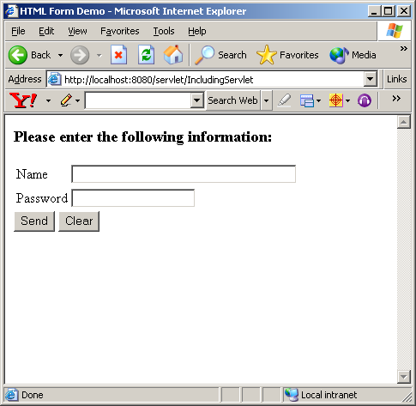

Type admin and admin as user id and password and the page will display fine.

If you make a mistake, you will get the following page:

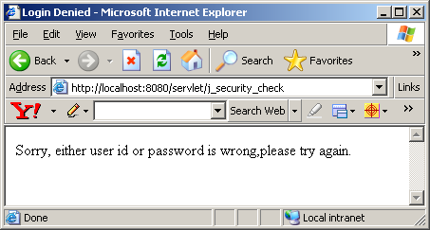

Secure Socket Layer(SSL)

The Secure Socket Layer protocol, or SSL, sits between the application-level protocol (like HTTP) and low-level transport protocol (like TCP/IP) and handles the details of security using public key cryptography. Although, we will not discuss HTTPS (HTTP plus SSL) here, Tomcat does support it and detail discussion on setting it up for Tomcat can be found in “Java Servlet Programming” published by O’Reilly, ISBN: 0-596-00040-5.

Reading Assignment

Homework Assignment
This week’s assignment is very simple (since we have to study a number of topics) and does not require anything that we learned in session 4. In demo4, it is kind of annoying that as soon as we add an item the screen switches to Shopping Cart and does not stay on same screen. Modify demo4 so that we can accomplish this.

In order to be absolutely clear about the assignment, let’s say, the user is looking at the music records under “Classical” category. When the user click on the add button, it seems that nothing happened since the user is still looking at the same set of records. Behind the scene, the click on add button will go back to the server, put the item on the shopping cart and come back with the same list of records under category “Classical” all over again – as if there was no trip to the server at all. You can immediately verify that all that has happened by clicking on the “View Cart” button on the left navigation and visually see the item has been added.

