Session 5 Database Access with JDBC

Objective
This session teaches students how to access databases using JDBC APIs in Java. Retrieving data from the database, manipulating them using web pages and saving them back to the database is the key focus of server side programming in Java and this session teaches exactly how to do all that.

JDBC
JDBC is, by definition, an interface to data sources. A data source can be a local relational database, a remote relational database, a remote mainframe/midrange host providing data access, a spreadsheet or even a text file. The Java Database Connectivity (JDBC) library provides the means for executing SQL statements to access and operate on relational database. JDBC is designed as an object-oriented, java –based API for database access. It is a set of classes and interfaces that provide uniform API for access to a broad range of databases. The JDBC API has two parts:

- JDBC 2.1 Core API – This API is specified in java.sql package and part of Java 2, Standard Edition. This API focuses primarily on basic database programming services such as creating connections, executing statements etc. However, currently the API also supports batch updates, scrollable resultsets etc.

- JDBC 2.0 Optional Package API – This API is specified in javax.sql package and is distributed with the enterprise edition of Java, J2EE. This optional package API addresses JNDI based data sources for managing connections, connection pooling, distributed transactions and rowsets.

The JDBC 2.1 Core API (java.sql)
The JDBC Core API consists of the following important conceptual components:
- DriverManager Class- Keeps track of database drivers and manages the connection between the application and the driver.
- Driver Interface – Translates API calls into operations for the specific data source.
- Connection Interface – A session between an application and a database.
- Statement, PreparedStatement, CallableStatement Interface – A SQL statement.
- DatabaseMetadata, ResultSetMetaData – Information about the data, the database and driver.
- ResultSet – Virtual table that contains rows and columns to hold the data returned by executing the statement.

Database Drivers
A database vendor typically provides a set of proprietary APIs for accessing the data managed by the database server. Popular database vendors such as Oracle, Sybase etc. provide proprietary APIs for client data access. The JDBC API provides a java language alternative to these vendor-specific APIs. However, a JDBC layer may still need to make vendor specific calls. This is where the concept of driver comes to play. A JDBC driver is a middleware layer that translates JDBC calls to the vendor-specific calls.

In other words, the JDBC consists of two layers. The top layer in JDBC API that communicates with the JDBC driver manager API. The driver manager should (transparently) communicate with the various third-party drivers that actually connect to the database and return information.

JDBC Drivers are categorized into the followings:

Type 1 - Relating JDBC to ODBC
One of the fundamental principles of JDBC design was to make practical to build JDBC drivers based on other database APIs. There is a very close mapping between the JDBC architecture and API, and their ODBC counterparts, fundamentally because they are all based on the same standard. A type 1 driver translates JDBC to ODBC and relies on an ODBC driver to communicate with the database. This JDBC-ODBC bridge implements JDBC for any database for which an ODBC driver is already available. Sun includes one such driver, the JDBC-ODBC bridge, with JDK - “sun.jdbc.odbc.JdbcOdbcDriver”. This Bridge is implemented in Java and uses Java native methods to call ODBC. Due to the multiple layers of indirection, this solution is inefficient for high-performance database access. Moreover, this type of drivers can only be used on Windows and Sun Solaris platform since ODBC is available on those two platforms only.
The architecture is shown below:

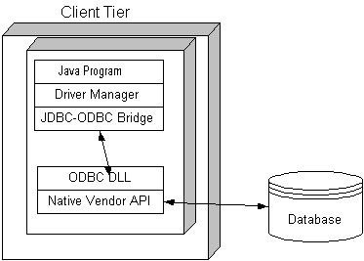

Type 2 – Part Native Driver
Type 2 drivers, Oracle’s JDBC/OCI driver is an example, are written to use Java’s native method interface to conver JDBC database requests into database specific calls. The JDBC drivers require a vendor-supplied library to translate JDBC functions into the DBMS’s specific query language. These drivers are usually written in some combination of Java and C/C++, since the driver must use a layer of C to make calls to the vendon libraries that are written in C. This is very similar to type 1 except that there is one less layer. Here is the architecture:

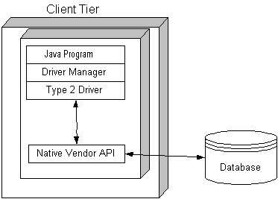

Type 3 – Intermediate Database Access Server
Type 3 drivers are implemented in a three-tiered architecture where the JDBC database requests are translated into a database-independent network protocol and forwarded to the middle-tier server. The middle-tier server then translates the request to the database-specific native-connectivity interface and passes the request to the database server. If the middle tier is written in Java it could use type 1 or 2 JDBC driver to do this. The small JDBC driver executes on the client and implements the logic needed to pass SQL commands over the network to the JDBC server, receives the data back from the server, and manages connection. The middleware server component can be written in native language or java. There are several third part vendors like Merant, I-net Software, OpenLink and so on that supply them. Here is the architecture:

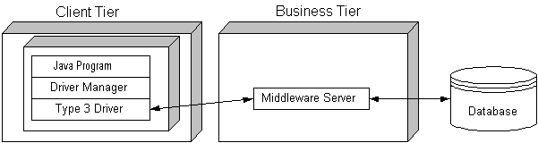

Type 4 – Pure Java Drivers
This is pure java alternative to type 2 drivers. These drivers convert the JDBC API calls to direct network calls using vendor-specific networking protocols by making direct socket connections with the database. An example of this driver is Oracle Thin Driver. This is the most efficient method of accessing database. All major database vendors provide type 4 JDBC drivers for their database. Here is the architecture:

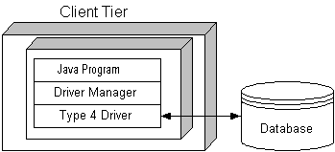

Driver Interface
This is the interface that every Database driver class must implement. Here are the methods of Driver Interface:

Method Name | Return Type | Description
acceptsURL(String url) | boolean | Returns true if the driver thinks that it can open a connection to the given URL.
connect(String url, Properties info) | Connection | Attempts to make a database connection to the given URL.
getMajorVersion() | int | Gets the driver's major version number.
getMinorVersion() | int | Gets the driver's minor version number.
GetPropertyInfo(String url, Properties info) | DriverPropertyInfo[] | Gets information about the possible properties for this driver.
jdbcCompliant() | boolean | Reports whether this driver is a genuine JDBC COMPLIANTTM driver.

Normally, we don’t have to call any of the above methods of Driver interface. All we have to do is load the driver in memory.

Loading Drivers
A driver class can be loaded in two different ways:

- By setting the “jdbc.drivers” property of the System class. You have to call the set Property() method of System class to do so as follows:

System.setProperty(“jdbc.drivers”,”sun.jdbc.odbc.JdbcOdbcDriver”); // type 1
Or
System.setProperty(“jdbc.drivers”,” "org.gjt.mm.mysql.Driver"”); // type 4 driver for MySQL
Or
System.setProperty(“jdbc.drivers”,” "oracle.jdbc.driver.OracleDriver"); // type 4 for Oracle
Or
System.setProperty(“jdbc.drivers”,” "COM.cloudscape.core.JDBCDriver"); // type 4 for Cloudscape

You can specify multiple drivers by separating the driver names within the string by colons.

- By calling the forName method of Class as follows:

Class.forName(”sun.jdbc.odbc.JdbcOdbcDriver”); // type 1
Or
Class.forName("org.gjt.mm.mysql.Driver"); // type 4 driver for MySQL
Or
Class.forName(“"oracle.jdbc.driver.OracleDriver"); // type 4 Oracle
Or
Class.forName(“"COM.cloudscape.core.JDBCDriver"); // type 4 Cloudscape

The advantage of this method, over the first one, is that you can load any driver on the fly even after the DriverManager is initialized.

Each driver class will typically create an instance of itself when it is loaded and register that instance with the DriverManager.

DriverManager Class
The DriverManager class is responsible for establishing connections to the databases. If any driver has been identified in the “jdbc.drivers” property of the System class then the DriverManager class will attempt to load and register that class.

In case of explicit loading of drivers using class.forName(), the driver will automatically be registered with the DriverManager.

You don’t need to and you can’t (even if you want to) create DriverManager objects – since it does not have any public constructor. The DriverManager class has static methods that can be used to get connection to the database, to determine which drivers are loaded, as well as methods that register and unregister drivers on the fly. Here are the methods of DriverManager:

Method Name | Return Type | Description
static getConnection(String url) | Connection | Attempts to establish a connection to the given database URL.
static getConnection(String url, Properties info) | Connection | Attempts to establish a connection to the given database URL.
static getConnection(String url, String user, String password) | Connection | Attempts to establish a connection to the given database URL.
static registerDriver(Driver driver) | void | Registers the given driver with the DriverManager.
static deregisterDriver(Driver driver) | void | Drops a Driver from the DriverManager's list.
static getDriver(String url) | Driver | Attempts to locate a driver that understands the given URL.
static getDrivers() | Enumeration | Retrieves an Enumeration with all of the currently loaded JDBC drivers to which the current caller has access.
static setLoginTimeout(int seconds) | void | Sets the maximum time in seconds that a driver will wait while attempting to connect to a database.
static getLoginTimeout() | int | Gets the maximum time in seconds that a driver can wait when attempting to log in to a database.
static getLogWriter() | PrintWriter | Gets the log writer.
static println(String message) | void | Prints a message to the current JDBC log stream.

Connection Interface
In order to retrieve data from a database you first need a connection to the database. When you need a connection to a datasource you don’t create an instance of Connection because it is an interface. Instead you call the getConnection() method of the DriverManager as follows:

Connection conection = DriverManager.getConnection(url);

When the method getConnection is called, the DriverManager will attempt to locate a suitable driver from amongst those loaded using the url String. The url String carries enough information about the connection and will be discussed next. The connection interface has the following methods:

Method Name | Return Type | Description
createStatement() | Statement | Creates a Statement object for sending SQL statements to the database.
createStatement(int resultSetType, int resultSetConcurrency) | Statement | Creates a Statement object that will generate ResultSet objects with the given type and concurrency.
prepareCall(String sql) | CallableStatement | Creates a CallableStatement object for calling database stored procedures.
prepareCall(String sql, int resultSetType, int resultSetConcurrency) | CallableStatement | Creates a CallableStatement object that will generate ResultSet objects with the given type and concurrency.
prepareStatement(String sql) | PreparedStatement | Creates a PreparedStatement object for sending parameterized SQL statements to the database.
prepareStatement(String sql, int resultSetType, int resultSetConcurrency) | PreparedStatement | Creates a PreparedStatement object that will generate ResultSet objects with the given type and concurrency.
nativeSQL(String sql) | String | Converts the given SQL statement into the system's native SQL grammar.
getMetaData() | DatabaseMetaData | Gets the metadata regarding this connection's database.
setAutoCommit(Boolean autoCommit) | void | Sets this connection's auto-commit mode.
getAutoCommit() | Boolean | Gets the current auto-commit state.
setTransactionIsolation(int level) | void | Attempts to change the transaction isolation level to the one given.
getTransactionIsolation() | int | Gets this Connection's current transaction isolation level.
commit() | void | Makes all changes made since the previous commit/rollback permanent and releases any database locks currently held by the Connection.
rollback() | void | Drops all changes made since the previous commit/rollback and releases any database locks currently held by this Connection.
getWarnings() | SQLWarning | Returns the first warning reported by calls on this Connection.
clearWarnings() | void | Clears all warnings reported for this Connection object.
isClosed() | boolean | Tests to see if a Connection is closed.
close() | void | Releases a Connection's database and JDBC resources immediately instead of waiting for them to be automatically released.
getCatalog() | String | Returns the Connection's current catalog name.
getTypeMap() | Map | Gets the type map object associated with this connection.
isReadOnly() | boolean | Tests to see if the connection is in read-only mode.
setCatalog(String catalog) | void | Sets a catalog name in order to select a subspace of this Connection's database in which to work.
setReadOnly(boolean readOnly) | void | Puts this connection in read-only mode as a hint to enable database optimizations.
setTypeMap(Map map) | void | Installs the given type map as the type map for this connection.

URLs and JDBC
The notion of URLs in JDBC is very similar to the notion of URLs that represents web pages. JDBC uses URLs to identify the location of both drivers and data sources. JDBC URLs have the format:

protocol:<subprotocol>:<subname>
protocol : The only allowed protocol in JDBC is “jdbc”. Therefore, the first part must be “jdbc” – there is no alternative.
subprotocol: The subprotocol is used to identify the database driver. Examples of subprotocols are “odbc”, “oracle” etc.
subname: The syntax and the value of this part is driver specific. In case of ODBC driver – it is the ODBC datasource name. In case of oracle it is a combination of server name, port number and database sys id etc.

Here is an example of the usage of such url:

String url = “jdbc:odbc:biblio”;
Connection connection = DriverManager.getConnection(url);

The protocol and subprotocol name of the url above “jdbc:odbc” tells the driver manager to use
the JDBC-ODBC bridge driver “sun.jdbc.odbc.JdbcOdbcDriver”. Therefore, “sun.jdbc.odbc.JdbcOdbcDriver” must be loaded in memory before using this url.

Here is another example:

String url = "jdbc:mysql://localhost:3306/VSTORE";
The protocol and subprotocol name of the url above “jdbc:mysql” tells the driver manager to use the MySQL driver. The rest tells the driver the database name, location etc.

Here is another example:

String url=”jdbc:oracle:thin:@garnet:1521:oltt02”;
The protocol and subprotocol name of the url above “jdbc:oracle” tells the driver manager to use the Oracle driver. The rest is the database name, location etc.

Here is another example:

String url = "jdbc:cloudscape:c:/data/VSTORE";
The protocol and subprotocol name of the url above “jdbc:cloudscape” tells the driver manager to use the Cloudscape driver. The rest is the database name, location etc.

Statement Interface
A Statement object is an object of a class that implements the Statement interface. When a Statement object is created by calling the createStatement() method of a valid Connection Object, if provides a workspace to create an SQL query, execute it and retrieve the ResultSet object that is returned. Once you have created a Statement object, you can use it to execute an SQL query by calling the executeQuery() method for your Statement object. You pass a String containing your SQL query as the argument to the executeQuery() method. You can also executeUpdate() method to execute an Insert, Update or Delete query (action queries). You may also all simply execute is more than one result is expected.

Here is an example:

Statement statement= connection.createStatement();
ResultSet books = statement.execteQuery(“Select * from Titles where year = 1990”);

Here are the methods of Statement Interface:
Method Name | Return Type | Description
executeQuery(String sql) | ResultSet | Executes an SQL statement that returns a single ResultSet object.
executeUpdate(String sql) | int | Executes an SQL INSERT, UPDATE or DELETE statement.
execute(String sql) | boolean | Executes an SQL statement that may return multiple results.
getMoreResults() | boolean | Moves to a Statement object's next result.
AddBatch(String sql) | void | Adds an SQL command to the current batch of commmands for this Statement object.
clearBatch() | void | Makes the set of commands in the current batch empty.
executeBatch() | Int[] | Submits a batch of commands to the database for execution and if all commands execute successfully, returns an array of update counts.
getResultSet() | ResultSet | Returns the current result as a ResultSet object.
cancel() | void | Cancels this Statement object if both the DBMS and driver support aborting an SQL statement.
clearWarnings() | void | Clears all the warnings reported on this Statement object.
close() | void | Releases this Statement object's database and JDBC resources immediately instead of waiting for this to happen when it is automatically closed.
getConnection() | Connection | Returns the Connection object that produced this Statement object.
setFetchDirection(int direction) | void | Gives the driver a hint as to the direction in which the rows in a result set will be processed.
getFetchDirection() | int | Retrieves the direction for fetching rows from database tables that is the default for result sets generated from this Statement object.
setFetchSize(int rows) | void | Gives the JDBC driver a hint as to the number of rows that should be fetched from the database when more rows are needed.
getFetchSize() | int | Retrieves the number of result set rows that is the default fetch size for result sets generated from this Statement object.
setMaxFieldSize(int max) | void | Sets the limit for the maximum number of bytes in a column to the given number of bytes.
getMaxFieldSize() | int | Returns the maximum number of bytes allowed for any column value.
setMaxRows(int max) | void | Sets the limit for the maximum number of rows that any ResultSet object can contain to the given number.
getMaxRows() | int | Retrieves the maximum number of rows that a ResultSet object can contain.
setQueryTimeout(int seconds) | void | Sets the number of seconds the driver will wait for a Statement object to execute to the given number of seconds.
getQueryTimeout() | int | Retrieves the number of seconds the driver will wait for a Statement object to execute.
getResultSetConcurrency() | int | Retrieves the result set concurrency for ResultSet objects generated by this Statement object.
getResultSetType() | int | Retrieves the result set type for ResultSet objects generated by this Statement object.
getUpdateCount() | int | Returns the current result as an update count; if the result is a ResultSet object or there are no more results, -1 is returned.
getWarnings() | SQLWarning | Retrieves the first warning reported by calls on this Statement object.
setCursorName(String name) | void | Defines the SQL cursor name that will be used by subsequent Statement object execute methods.
setEscapeProcessing(boolean enable) | void | Sets escape processing on or off.

Obviously, execute is the most important thing above and there are 3 versions of them. The executeQuery() method is used to execute a SELECT statement and it returns a ResultSet object that is discussed below. The executeUpdate() is used to execute a INSERT or UPDATE or DELETE statement and it returns the number of rows it has impacted on. The execute() method is called with SELECT statements too but when you are expecting multiple resultsets and you have to use getMoreResults() and getResultSet() methods to get these resultsets out.

ResultSet
The results of executing an SQL query are returned in the form of an object that implements the ResultSet interface and that contains the table produced by the SQL query. The ResultSet object contains something called cursor that you can manipulate to refer to any particular row in the ResultSet. Initially, the ResultSet points to the record immediately preceding the first row, otherwise known as beginning of file(BOF). Calling the next() method of ResultSet will move to the first record. The next() method returns true if you move to a valid row and false if you fall off the end. Usually you process rows in a loop as follows:

while(books.next())
{
//process data
}

Accessing Data in a ResultSet
Using the ResultSet reference, you call the getXXX() method to retrieve the value of any column for the current row by name or by position. Here are the methods of ResultSet interface:

Method Name | Return Type | Description
next() | boolean | Moves the cursor down one row from its current position.
previous() | boolean | Moves the cursor to the previous row in this ResultSet object.
first() | boolean | Moves the cursor to the first row in this ResultSet object.
last() | boolean | Moves the cursor to the last row in this ResultSet object.
absolute(int row) | boolean | Moves the cursor to the given row number in this ResultSet object.
relative(int rows) | boolean | Moves the cursor a relative number of rows, either positive or negative.
afterLast() | void | Moves the cursor to the end of this ResultSet object, just after the last row.
beforeFirst() | void | Moves the cursor to the front of this ResultSet object, just before the first row.
isFirst() | boolean | Indicates whether the cursor is on the first row of this ResultSet object.
isLast() | boolean | Indicates whether the cursor is on the last row of this ResultSet object.
isAfterLast() | boolean | Indicates whether the cursor is after the last row in this ResultSet object.
isBeforeFirst() | boolean | Indicates whether the cursor is before the first row in this ResultSet object.
deleteRow() | void | Deletes the current row from this ResultSet object and from the underlying database.
insertRow() | void | Inserts the contents of the insert row into this ResultSet objaect and into the database.
rowDeleted() | boolean | Indicates whether a row has been deleted.
rowInserted() | boolean | Indicates whether the current row has had an insertion.
rowUpdated() | boolean | Indicates whether the current row has been updated.
moveToCurrentRow() | void | Moves the cursor to the remembered cursor position, usually the current row.
moveToInsertRow() | void | Moves the cursor to the insert row.
refreshRow() | void | Refreshes the current row with its most recent value in the database.
cancelRowUpdates() | void | Cancels the updates made to the current row in this ResultSet object.
clearWarnings() | void | Clears all warnings reported on this ResultSet object.
close() | void | Releases this ResultSet object's database and JDBC resources immediately instead of waiting for this to happen when it is automatically closed.
findColumn(String columnName) | int | Maps the given ResultSet column name to its ResultSet column index.
getArray(int i) | Array | Returns the value of the designated column in the current row of this ResultSet object as an Array object in the Java programming language.
getArray(String colName) | Array | Returns the value of the designated column in the current row of this ResultSet object as an Array object in the Java programming language.
getAsciiStream(int columnIndex) | InputStream | Gets the value of the designated column in the current row of this ResultSet object as a stream of ASCII characters.
getAsciiStream(String columnName) | InputStream | Gets the value of the designated column in the current row of this ResultSet object as a stream of ASCII characters.
getBinaryStream(int columnIndex) | InputStream | Gets the value of a column in the current row as a stream of Gets the value of the designated column in the current row of this ResultSet object as a binary stream of uninterpreted bytes.
getBinaryStream(String columnName) | InputStream | Gets the value of the designated column in the current row of this ResultSet object as a stream of uninterpreted bytes.
getBigDecimal(int columnIndex) | BigDecimal | Gets the value of the designated column in the current row of this ResultSet object as a java.math.BigDecimal with full precision.
getBigDecimal(String columnName) | BigDecimal | Gets the value of the designated column in the current row of this ResultSet object as a java.math.BigDecimal with full precision.
GetBlob(int i) | Blob | Returns the value of the designated column in the current row of this ResultSet object as a Blob object in the Java programming language.
GetBlob(String colName) | Blob | Returns the value of the designated column in the current row of this ResultSet object as a Blob object in the Java programming language.
getBoolean(int columnIndex) | boolean | Gets the value of the designated column in the current row of this ResultSet object as a boolean in the Java programming language.
getBoolean(String columnName) | boolean | Gets the value of the designated column in the current row of this ResultSet object as a boolean in the Java programming language.
GetByte(int columnIndex) | byte | Gets the value of the designated column in the current row of this ResultSet object as a byte in the Java programming language.
GetByte(String columnName) | byte | Gets the value of the designated column in the current row of this ResultSet object as a byte in the Java programming language.
getBytes(int columnIndex) | byte[] | Gets the value of the designated column in the current row of this ResultSet object as a byte array in the Java programming language.
getBytes(String columnName) | byte[] | Gets the value of the designated column in the current row of this ResultSet object as a byte array in the Java programming language.
getCharacterStream(int columnIndex) | Reader | Gets the value of the designated column in the current row of this ResultSet object as a java.io.Reader object.
getCharacterStream(String columnName) | Reader | Gets the value of the designated column in the current row of this ResultSet object as a java.io.Reader object.
GetClob(int i) | Clob | Returns the value of the designated column in the current row of this ResultSet object as a Clob object in the Java programming language.
GetClob(String colName) | Clob | Returns the value of the designated column in the current row of this ResultSet object as a Clob object in the Java programming language.
getConcurrency() | int | Returns the concurrency mode of this ResultSet object.
getCursorName() | String | Gets the name of the SQL cursor used by this ResultSet object.
GetDate(int columnIndex) | Date | Gets the value of the designated column in the current row of this ResultSet object as a java.sql.Date object in the Java programming language.
getDate(int columnIndex, Calendar cal) | Date | Returns the value of the designated column in the current row of this ResultSet object as a java.sql.Date object in the Java programming language.
GetDate(String columnName) | Date | Gets the value of the designated column in the current row of this ResultSet object as a java.sql.Date object in the Java programming language.
getDate(String columnName, Calendar cal) | Date | Returns the value of the designated column in the current row of this ResultSet object as a java.sql.Date object in the Java programming language.
getDouble(int columnIndex) | double | Gets the value of the designated column in the current row of this ResultSet object as a double in the Java programming language.
getDouble(String columnName) | double | Gets the value of the designated column in the current row of this ResultSet object as a double in the Java programming language.
getFetchDirection() | int | Returns the fetch direction for this ResultSet object.
getFetchSize() | int | Returns the fetch size for this ResultSet object.
getFloat(int columnIndex) | float | Gets the value of the designated column in the current row of this ResultSet object as a float in the Java programming language.
getFloat(String columnName) | float | Gets the value of the designated column in the current row of this ResultSet object as a float in the Java programming language.
getInt(int columnIndex) | int | Gets the value of the designated column in the current row of this ResultSet object as an int in the Java programming language.
getInt(String columnName) | int | Gets the value of the designated column in the current row of this ResultSet object as an int in the Java programming language.
getLong(int columnIndex) | long | Gets the value of the designated column in the current row of this ResultSet object as a long in the Java programming language.
getLong(String columnName) | long | Gets the value of the designated column in the current row of this ResultSet object as a long in the Java programming language.
getMetaData() | ResultSetMetaData | Retrieves the number, types and properties of this ResultSet object's columns.
getObject(int columnIndex) | Object | Gets the value of the designated column in the current row of this ResultSet object as an Object in the Java programming language.
getObject(int i, Map map) | Object | Returns the value of the designated column in the current row of this ResultSet object as an Object in the Java programming language.
getObject(String columnName) | Object | Gets the value of the designated column in the current row of this ResultSet object as an Object in the Java programming language.
getObject(String colName, Map map) | Object | Returns the value of the designated column in the current row of this ResultSet object as an Object in the Java programming language.
getRef(int i) | Ref | Returns the value of the designated column in the current row of this ResultSet object as a Ref object in the Java programming language.
getRef(String colName) | Ref | Returns the value of the designated column in the current row of this ResultSet object as a Ref object in the Java programming language.
getRow() | int | Retrieves the current row number.
getShort(int columnIndex) | short | Gets the value of the designated column in the current row of this ResultSet object as a short in the Java programming language.
getShort(String columnName) | short | Gets the value of the designated column in the current row of this ResultSet object as a short in the Java programming language.
getStatement() | Statement | Returns the Statement object that produced this ResultSet object.
getString(int columnIndex) | String | Gets the value of the designated column in the current row of this ResultSet object as a String in the Java programming language.
getString(String columnName) | String | Gets the value of the designated column in the current row of this ResultSet object as a String in the Java programming language.
getTime(int columnIndex) | Time | Gets the value of the designated column in the current row of this ResultSet object as a java.sql.Time object in the Java programming language.
getTime(int columnIndex, Calendar cal) | Time | Returns the value of the designated column in the current row of this ResultSet object as a java.sql.Time object in the Java programming language.
getTime(String columnName) | Time | Gets the value of the designated column in the current row of this ResultSet object as a java.sql.Time object in the Java programming language.
getTime(String columnName, Calendar cal) | Time | Returns the value of the designated column in the current row of this ResultSet object as a java.sql.Time object in the Java programming language.
getTimestamp(int columnIndex) | Timestamp | Gets the value of the designated column in the current row of this ResultSet object as a java.sql.Timestamp object in the Java programming language.
getTimestamp(int columnIndex, Calendar cal) | Timestamp | Returns the value of the designated column in the current row of this ResultSet object as a java.sql.Timestamp object in the Java programming language.
getTimestamp(String columnName) | Timestamp | Gets the value of the designated column in the current row of this ResultSet object as a java.sql.Timestamp object.
getTimestamp(String columnName, Calendar cal) | Timestamp | Returns the value of the designated column in the current row of this ResultSet object as a java.sql.Timestamp object in the Java programming language.
getType() | int | Returns the type of this ResultSet object.
getWarnings() | SQLWarning | Returns the first warning reported by calls on this ResultSet object.
setFetchDirection(int direction) | void | Gives a hint as to the direction in which the rows in this ResultSet object will be processed.
setFetchSize(int rows) | void | Gives the JDBC driver a hint as to the number of rows that should be fetched from the database when more rows are needed for this ResultSet object.
updateAsciiStream(int columnIndex, InputStream x, int length) | void | Updates the designated column with an ascii stream value.
updateAsciiStream(String columnName, InputStream x, int length) | void | Updates the designated column with an ascii stream value.
updateBigDecimal(int columnIndex, BigDecimal x) | void | Updates the designated column with a java.math.BigDecimal value.
updateBigDecimal(String columnName, BigDecimal x) | void | Updates the designated column with a java.sql.BigDecimal value.
updateBinaryStream(int columnIndex, InputStream x, int length) | void | Updates the designated column with a binary stream value.
updateBinaryStream(String columnName, InputStream x, int length) | void | Updates the designated column with a binary stream value.
updateBoolean(int columnIndex, boolean x) | void | Updates the designated column with a boolean value.
updateBoolean(String columnName, boolean x) | void | Updates the designated column with a boolean value.
updateByte(int columnIndex, byte x) | void | Updates the designated column with a byte value.
updateByte(String columnName, byte x) | void | Updates the designated column with a byte value.
updateBytes(int columnIndex, byte[] x) | void | Updates the designated column with a byte array value.
updateBytes(String columnName, byte[] x) | void | Updates the designated column with a boolean value.
updateCharacterStream(int columnIndex, Reader x, int length) | void | Updates the designated column with a character stream value.
updateCharacterStream(String columnName, Reader reader, int length) | void | Updates the designated column with a character stream value.
updateDate(int columnIndex, Date x) | void | Updates the designated column with a java.sql.Date value.
updateDate(String columnName, Date x) | void | Updates the designated column with a java.sql.Date value.
updateDouble(int columnIndex, double x) | void | Updates the designated column with a double value.
updateDouble(String columnName, double x) | void | Updates the designated column with a double value.
updateFloat(int columnIndex, float x) | void | Updates the designated column with a float value.
updateFloat(String columnName, float x) | void | Updates the designated column with a float value.
updateInt(int columnIndex, int x) | void | Updates the designated column with an int value.
updateInt(String columnName, int x) | void | Upates the designated column with an int value.
updateLong(int columnIndex, long x) | void | Updates the designated column with a long value.
updateLong(String columnName, long x) | void | Updates the designated column with a long value.
updateNull(int columnIndex) | void | Gives a nullable column a null value.
updateNull(String columnName) | void | Updates the designated column with a null value.
updateObject(int columnIndex, Object x) | void | Updates the designated column with an Object value.
updateObject(int columnIndex, Object x, int scale) | void | Updates the designated column with an Object value.
updateObject(String columnName, Object x) | void | Updates the designated column with an Object value.
updateObject(String columnName, Object x, int scale) | void | Updates the designated column with an Object value.
updateRow() | void | Updates the underlying database with the new contents of the current row of this ResultSet object.
updateShort(int columnIndex, short x) | void | Updates the designated column with a short value.
updateShort(String columnName, short x) | void | Updates the designated column with a short value.
updateString(int columnIndex, String x) | void | Updates the designated column with a String value.
updateString(String columnName, String x) | void | Updates the designated column with a String value.
updateTime(int columnIndex, Time x) | void | Updates the designated column with a java.sql.Time value.
updateTime(String columnName, Time x) | void | Updates the designated column with a java.sql.Time value.
updateTimestamp(int columnIndex, Timestamp x) | void | Updates the designated column with a java.sql.Timestamp value.
updateTimestamp(String columnName, Timestamp x) | void | Updates the designated column with a java.sql.Timestamp value.
wasNull() | boolean | Reports whether the last column read had a value of SQL NULL.

Catching SQLExceptions
The class SQLException provides information about errors in accessing a database. SQLException, unlike other exceptions has actually three components – a description of the error – can be retrieved by calling getMessage() method on it, an SQLState string which follows the Open Group SQLState conventions – can be retrieved by calling getState() method and finally a vendor error code, an actual error code returned by the underlying database. All three components are very important for troubleshooting and should be printed out. Also, a SQLException can be chained with other SQLExceptions and the entire chain can be accessed by repeteadly calling getNextException() method until the method returns null. Here is a catch block that does exactly that:

catch(SQLException e){
System.out.println("\n--- SQLException caught ---\n");
while (e != null)
{
System.out.println("Message: " + e.getMessage());
System.out.println("SQLState: " + e.getSQLState());
System.out.println("Vendor ErrorCode: " + e.getErrorCode());
e = e.getNextException();
System.out.println();
}
}

Obviously this is a long list of methods. However, you can divide them into categories. There are navigation methods that are very straight forward. There are row insertion and deletion methods that are only available for some databases but certainly not all. There are getXxx() methods to retrieve data from the resultset – where XXX represents data types. There are updateXxx() methods to update the resultset that are only avialble for databases that supports ResultSet updates.

Catching SQLWarning
The class SQLWarning, a subclass of SQLException provides information about database warnings. Warnings do not stop the execution of the application, as exceptions do. A warning can be reported on a Connection object, a Statement object or a ResultSet object. Each of these interfaces has a getWarnings() method, which you must call to see the first warning. Warning have the exact three components an SQLException and should be accessed the same way. Warnings are chained together exactly the same way as SQLException and the next one can be obtained by calling the getNextWarning() method until the method returns null.

Here is an example:
// execute a query using the statement.
// this will return a resultset.
videos = query.executeQuery("select * from Video_Recordings where video_title like " + "'%" + title + "%'");
SQLWarning warning= videos.getWarnings();
if (warning != null){
System.out.println("\n--- SQLWarning caught ---\n");
}
while (warning != null)
{
System.out.println("Warning Message: " + warning.getMessage());
System.out.println("Warning SQLState: " + warning.getSQLState());
System.out.println("Warning Vendor ErrorCode: " + warning.getErrorCode());
warning = warning.getNextWarning();
System.out.println();
}

However, most the database vendors don’t provide any warning yet.

Installing Cloudscape and Loading Data
Please download session5.zip.

Unzip and extract 3 jar files a)Cloudscape.jar b)Cloudview.jar and c)jh.jar. Include these 3 jar files in your class path.

Please also copy Cloudscape.jar file in Tomcat’s common\lib folder. Alternatively, you can copy it to your application’s WEB-INF\classes folder.

You will use cloudview.bat file to start CloudView – a GUI to view cloudscape database.

If cloudview.bat gives you trouble, please do the following:

- Copy cloudview.bat and 3 jar files a) Cloudscape.jar b) Cloudview.jar and c) jh.jar in some folder.
- Open cloudview.bat in notepad and replace the content with the following:
java -classpath .\cloudview.jar;.\cloudscape.jar;.\jh.jar COM.cloudscape.tools.cview
- Save cloudview.bat and run again now.

Unzip VStore.zip file in c:\data folder and you are all set. If you unzip VStrove.zip in some other folder please change the all the source codes in this session to point to that folder.

Open the database using cloudview and browse through the table data and their structures. Totally exit cloudview before running any examples. Cloudscape data can’t be shared using the in-process mode (as we are doing). However, cloudscape can run in stand-alone mode but we are not going to do that.

Here is an example of Servlet using JDBC:

// Code 5A
import java.io.IOException;
import java.io.PrintWriter;
import java.sql.Connection;
import java.sql.DriverManager;
import java.sql.ResultSet;
import java.sql.SQLException;
import java.sql.Statement;
import javax.servlet.ServletException;
import javax.servlet.http.HttpServlet;
import javax.servlet.http.HttpServletRequest;
import javax.servlet.http.HttpServletResponse;
import org.apache.log4j.Logger;
public class VideoSearchServlet extends HttpServlet{
private static final Logger logger = Logger.getLogger(VideoSearchServlet.class);
public void doPost(HttpServletRequest request, HttpServletResponse response)
throws ServletException, IOException{
doGet(request,response);
}
public void doGet(HttpServletRequest request, HttpServletResponse response)
throws ServletException, IOException{
// get the title from request
String title = (String) request.getParameter("title");
// set the content type of response.
response.setContentType("text/html");
// get a handle on the print writer of response.
PrintWriter out=response.getWriter();
// generate response.
out.println("<HTML>");
out.println("<HEAD>");
out.println("<TITLE>");
out.println("Video Search Servlet");
out.println("</TITLE>");
out.println("</HEAD>");
out.println("<BODY>");
if (title==null){
logger.debug("Video search criteria missing");
out.println("<H3>You did not specify any serach criteria</H3>");
out.println("</BODY>");
out.println("</HTML>");
return;
}
Connection con = null;
Statement query = null;
ResultSet videos = null;
try{
logger.debug("Loading driver");
// load the driver class.
Class.forName("COM.cloudscape.core.JDBCDriver");
// string url database.
String url = "jdbc:cloudscape:c:/data/VSTORE";
logger.debug("Connecting to the database...");
// connect to the database.
con = DriverManager.getConnection(url);
// create a statement.
query = con.createStatement();
logger.debug("Executing sql...");
// execute a query using the statement.
// this will return a resultset.
videos = query.executeQuery("select * from Video_Recordings where video_title like " + "'%" + title + "%'");
// move from BOF to the first record.
// if the resultset is empty - print a message.
if (!videos.next()){
logger.debug("No match found");
out.println("<H3>There is no video title containing: " + title + "</H3>");
return;
}
out.println("<H3>Here are the video titles containing: " + title + "</H3>");
out.println("<TABLE BORDER=1>");
out.println("<TR>");
out.println("<TH>Title</TH>");
out.println("<TH>Year</TH>");
out.println("<TH>Category</TH>");
out.println("<TH>Price</TH>");
out.println("</TR>");
//loop through all the items.
do {
logger.debug("Title: " + videos.getString("video_title") );
out.println("<TR>");
out.println("<TD>" + videos.getString("video_title") + "</TD>");
out.println("<TD>" + videos.getInt("year_released") + "</TD>");
out.println("<TD>" + videos.getString("category_name") + "</TD>");
out.println("<TD>" + videos.getDouble("price") + "</TD>");
out.println("</TR>");
} while (videos.next());
out.println("</TABLE>");
}
catch(SQLException e){
logger.error("Exception", e);
while (e != null){
logger.error("Message: " + e.getMessage());
logger.error("SQLState: " + e.getSQLState());
logger.error("Vendor ErrorCode: " + e.getErrorCode());
e = e.getNextException();
}
}
catch(ClassNotFoundException e){
logger.error("Exception", e);
}
finally{
logger.debug("In finally");
out.println("</BODY>");
out.println("</HTML>");
// since close methods throw sqlexception - catch 'em.
try{
logger.debug("Closing connection");
if (videos!=null){
videos.close();
}
if (query!=null){
query.close();
}
if ((con!=null) && (!con.isClosed())){
con.close();
}
}
catch(Exception e){
logger.error("Exception", e);
}
}
}
}

Copy this class to Tomacat’s webapps\Root\WEB-INF\classes folder and compile it.
http://localhost:8080/servlet/VideoSearchServlet?title=man

Stop and Start ROOT app type:

Here is what it looks:

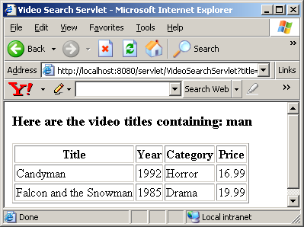

Search for different title and have fun. Also, from your browser View the source HTML and we will notice that all the data in hardcoded in the HTML. Therefore, as far as the browser is concerned, it is a static HTML page although, on the server side, the page was dynamically generated.

Using Scrollable ResultSet
One of the new features of JDBC 2.0 option pack is the ability to move a result set’s cursor backward as well as forward. The trick to make your result set scrollable in either direction is in the createStatement() method of Connection not in the ResultSet. One of the overloaded createStatement() method takes two arguments:

createStatement(int resultSetType, int resultSetConcurrency) | Statement | Creates a Statement object that will generate ResultSet objects with the given type and concurrency.

The possible three values of result set type is defined as public static final fields (constants) in ResultSet interface:

TYPE_FORWARD_ONLY
TYPE_SCROLL_INSENSITIVE
TYPE_SCROLL_SENSITIVE

The possible two values of result set concurrency is also defined as public static final fields (constants) in ResultSet interface:

CONCUR_READ_ONLY
CONCUR_UPDATABLE

The previous(), first() etc. methods are already available in ResultSet interface for backward traversal. You verify whether the resultset is scroll insensitive or not by calling getType method on the resultset.

Here is an example of backward scrolling:

// Code 5B

import java.io.IOException;

import java.io.PrintWriter;

import java.sql.Connection;

import java.sql.DriverManager;

import java.sql.ResultSet;

import java.sql.SQLException;

import java.sql.Statement;

import javax.servlet.ServletException;

import javax.servlet.http.HttpServlet;

import javax.servlet.http.HttpServletRequest;

import javax.servlet.http.HttpServletResponse;

import org.apache.log4j.Logger;

public class DisplayCategoryServlet extends HttpServlet{

private static final Logger logger = Logger.getLogger(DisplayCategoryServlet.class);

public void doPost(HttpServletRequest request, HttpServletResponse response)

throws ServletException, IOException{

logger.info("In doPost");

doGet(request,response);

}

public void doGet(HttpServletRequest request, HttpServletResponse response)

throws ServletException, IOException{

logger.info("In doGet");

// set the content type of response.

response.setContentType("text/html");

// get a handle on the print writer of response.

PrintWriter out=response.getWriter();

Connection con = null;

Statement statement = null;

ResultSet categories = null;

try{

logger.debug("Loading driver");

// load the driver class.

Class.forName("COM.cloudscape.core.JDBCDriver");

// string url database.

String url = "jdbc:cloudscape:c:/data/VSTORE";

logger.debug("Connecting to the database...");

// connect to the database.

con = DriverManager.getConnection(url);

// create a statement

statement = con.createStatement(ResultSet.TYPE_SCROLL_INSENSITIVE,ResultSet.CONCUR_READ_ONLY);

logger.debug("Connection established, executing sql...");

// execute a query using the statement.

// this will return a resultset.

categories = statement.executeQuery("select * from categories order by category_id");

// if can't scroll backward - let user know.

if (!(categories.getType()==ResultSet.TYPE_SCROLL_INSENSITIVE)){

out.println("<H3>Driver does not support backward-scroll.");

logger.debug("Driver does not support backward-scroll");

return;

}

out.println("<H3>Here are the categories in reverse ID order");

out.println("<TABLE BORDER=1>");

out.println("<TR>");

out.println("<TH>ID</TH>");

out.println("<TH>Name</TH>");

out.println("<TH>Type</TH>");

out.println("</TR>");

//move to the last item

categories.afterLast();

//loop through all the items.

while (categories.previous()){

logger.debug("category id: " + categories.getInt("category_id"));

out.println("<TR>");

out.println("<TD>" + categories.getInt("category_id") + "</TD>");

out.println("<TD>" + categories.getString("category_name") + "</TD>");

out.println("<TD>" + categories.getString("category_type") + "</TD>");

out.println("</TR>");

}

out.println("</TABLE>");

}

catch(SQLException e){

logger.error("Exception", e);

while (e != null){

logger.error("Message: " + e.getMessage());

logger.error("SQLState: " + e.getSQLState());

logger.error("Vendor ErrorCode: " + e.getErrorCode());

e = e.getNextException();

}

}

catch(ClassNotFoundException e){

logger.error("Exception", e);

}

finally{

logger.debug("In finally");

out.println("</BODY>");

out.println("</HTML>");

// since close methods throw sqlexception - catch 'em.

try{

logger.debug("Closing connection");

if (categories!=null){

categories.close();

}

if (statement!=null){

statement.close();

}

if ((con!=null) && (!con.isClosed())){

con.close();

}

}

catch(Exception e){

logger.error("Exception", e);

}

}

}

}

Copy this class to Tomcat’s ROOT\WEB-INF\classes folder and compile it.
Here is the output:

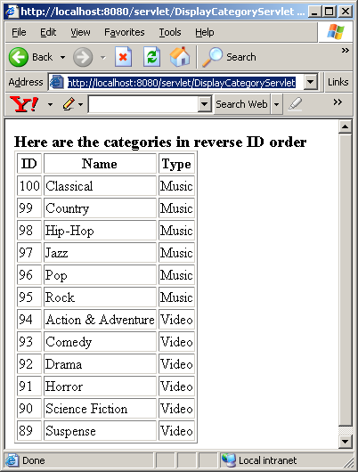

As you can see, the ID are showing up in reverse order than they were originally retrieved from the database due to the backward scrolling through the resultset.

Using Updatable ResultSet
Another new feature in the JDBC 2.0 API is the ability to add rows, modify rows and delete rows from a resultset that will reflect in the database. The trick to do this is to create a TYPE_SCROLL_SENSITIVE and CONCUR_UPDATABLE statement. You check whether your resultset supports update by calling it’s getConcurrency() method. The ResultSet already has a set of updateXXX() methods to perform update on it. XXX represents different datatype like int,double etc.

Here is an example of a Servlet that uses Updatable ResultSet:
// Code 5C
import java.io.IOException;
import java.io.PrintWriter;
import java.sql.Connection;
import java.sql.DriverManager;
import java.sql.ResultSet;
import java.sql.SQLException;
import java.sql.Statement;
import javax.servlet.ServletException;
import javax.servlet.http.HttpServlet;
import javax.servlet.http.HttpServletRequest;
import javax.servlet.http.HttpServletResponse;
import org.apache.log4j.Logger;
public class UpdateResultSetServlet extends HttpServlet{
private static final Logger logger = Logger.getLogger(UpdateResultSetServlet.class);
public void doPost(HttpServletRequest request, HttpServletResponse response)
throws ServletException, IOException{
doGet(request,response);
}
public void doGet(HttpServletRequest request, HttpServletResponse response)
throws ServletException, IOException{
Connection con = null;
Statement result = null;
ResultSet categories = null;
// set the content type of response.
response.setContentType("text/html");
// get a handle on the print writer of response.
PrintWriter out=response.getWriter();
// generate response.
out.println("<HTML>");
out.println("<HEAD>");
out.println("<TITLE>");
out.println("Display Category Servlet");
out.println("</TITLE>");
out.println("</HEAD>");
out.println("<BODY>");
try{
// load the driver class.
Class.forName("COM.cloudscape.core.JDBCDriver");
// string url to the database.
String url = "jdbc:cloudscape:c:/data/VSTORE";
// connect to the database
con = DriverManager.getConnection(url);
logger.debug("Got Connection");
// create a statement
result = con.createStatement(ResultSet.TYPE_SCROLL_SENSITIVE,ResultSet.CONCUR_UPDATABLE);
logger.debug("Got ResultSet");
// execute a result using the statement.
// this will return a resultset.
categories = result.executeQuery("select * from categories order by category_id");
// if not updatable - let use know.
if (!(categories.getConcurrency()==ResultSet.CONCUR_UPDATABLE)){
out.println("<H3>Driver does not support update.");
logger.debug("Driver does not support update");
return;
}
out.println("<H3>Here are the categories before ID changes");
out.println("<TABLE BORDER=1>");
out.println("<TR>");
out.println("<TH>ID</TH>");
out.println("<TH>Name</TH>");
out.println("<TH>Type</TH>");
out.println("</TR>");
//loop through all the items.
while (categories.next()){
out.println("<TR>");
out.println("<TD>" + categories.getInt("category_id") + "</TD>");
out.println("<TD>" + categories.getString("category_name") + "</TD>");
out.println("<TD>" + categories.getString("category_type") + "</TD>");
out.println("</TR>");
}
out.println("</TABLE>");
logger.debug("Updating ResultSet");
int current_id=0;
while (categories.previous()){
current_id=categories.getInt("category_id");
current_id=100-current_id;
categories.updateInt("category_id",current_id);
}
}
catch(SQLException e){
while (e != null)
{
logger.error("Message: " + e.getMessage());
logger.error("SQLState: " + e.getSQLState());
logger.error("Vendor ErrorCode: " + e.getErrorCode());
e = e.getNextException();
}
}
catch(ClassNotFoundException e){
logger.error("Exception",e);
}
finally
{
out.println("</BODY>");
out.println("</HTML>");
// since close methods throw sqlexception - catch 'em.
try{
logger.debug("Closing connection");
if (categories!=null){
categories.close();
}
if (result!=null){
result.close();
}
if ((con!=null) && (!con.isClosed())){
con.close();
}
}
catch(Exception e){
logger.error("Exception",e);
}
}
}
}

Copy this class to Tomcat’s ROOT\WEB-INF\classes folder and compile it.
Unfortunately, Cloudscape database driver does not support updatable resultset and we get the output that says so.

Using PreparedStatement Interface
PreparedStatement interface extends Statement interface. Sometimes it is more convenient or more efficient to use a PreparedStatement object for sending SQL statements to the database. The main feature of PreparedStatement is that, unlike Statement Object, it is given an SQL statement when it is created. The advantage to this is that in most cases, the SQL statement will be sent to Database right away, where it will be precompiled. With prepared statement, a SQL statement execution is broken down into two separate steps – submission of the query and execution of the query. During submission of the query you don’t have to know the values of the variables of your query, you can leave a question mark (“?”) in place of each variable value. Of course right before execution, you have to provide the values for these question marks. This technique makes a SQL statement very much reusable.

The prepareStatement() method of the Connection Object takes a SQL statement as parameter and returns a PreparedStatement Object as follows:
PreparedStatement prepared = con.prepareStatement("select * from Titles where Titles like ?");

We need to supply the values to be used in place of the question mark placeholders before we can execute a PreparedStatement.We can do this by calling setXXX methods (where XXX stands for int,String etc) of the PreparedStatement object as follows:

prepared.setString(1,"%Java%");
ResultSet books=prepared.executeQuery();

Notice that the literal “%Java%” that I am looking for is not wrapped around by single quote (‘) – as it was when we used regular SQL statement. The setString() methods does this job for you and you should not wrap your string with single quote while using setString() method.

In the above example the first parameter “1” is the sequence number of the parameter. The first ? placeholder has “1” as sequence number, the second ? placeholder has “2” as sequence number and so on.

Here is the list of methods for PreparedStatement interface:

Method Name | Return Type | Description
executeQuery() | ResultSet | Executes the SQL query in this PreparedStatement object and returns the result set generated by the query.
executeUpdate() | Int | Executes the SQL INSERT, UPDATE or DELETE statement in this PreparedStatement object.
execute() | boolean | Executes any kind of SQL statement.
clearParameters() | void | Clears the current parameter values immediately.
setString(int parameterIndex, String x) | void | Sets the designated parameter to a Java String value.
setInt(int parameterIndex, int x) | void | Sets the designated parameter to a Java int value.
setDouble(int parameterIndex, double x) | void | Sets the designated parameter to a Java double value.
setLong(int parameterIndex, long x) | void | Sets the designated parameter to a Java long value.
setShort(int parameterIndex, short x) | void | Sets the designated parameter to a Java short value.
setFloat(int parameterIndex, float x) | void | Sets the designated parameter to a Java float value.
setBoolean(int parameterIndex, boolean x) | void | Sets the designated parameter to a Java boolean value.
setByte(int parameterIndex, byte x) | void | Sets the designated parameter to a Java byte value.
setBytes(int parameterIndex, byte[] x) | void | Sets the designated parameter to a Java array of bytes.
setDate(int parameterIndex, Date x) | void | Sets the designated parameter to a value.
setDate(int parameterIndex, Date x, Calendar cal) | void | Sets the designated parameter to the given java.sql.Date value, using the given Calendar object.
setNull(int parameterIndex, int sqlType) | void | Sets the designated parameter to SQL NULL.
setNull(int paramIndex, int sqlType, String typeName) | void | Sets the designated parameter to SQL NULL.
setObject(int parameterIndex, Object x) | void | Sets the value of the designated parameter using the given object.
setObject(int parameterIndex, Object x, int targetSqlType) | void | Sets the value of the designated parameter with the given object.
setObject(int parameterIndex, Object x, int targetSqlType, int scale) | void | Sets the value of the designated parameter with the given object.
setRef(int i, Ref x) | void | Sets the designated parameter to the given REF(<structured-type>) value.
setTime(int parameterIndex, Time x) | void | Sets the designated parameter to a java.sql.Time value.
setTime(int parameterIndex, Time x, Calendar cal) | void | Sets the designated parameter to the given java.sql.Time value, using the given Calendar object.
setTimestamp(int parameterIndex, Timestamp x) | void | Sets the designated parameter to a java.sql.Timestamp value.
setTimestamp(int parameterIndex, Timestamp x, Calendar cal) | void | Sets the designated parameter to the given java.sql.Timestamp value, using the given Calendar object.
addBatch() | void | Adds a set of parameters to this PreparedStatement object's batch of commands.
getMetaData() | ResultSetMetaData | Gets the number, types and properties of a ResultSet object's columns.
setArray(int i, Array x) | void | Sets the designated parameter to the given Array object.
setAsciiStream(int parameterIndex, InputStream x, int length) | void | Sets the designated parameter to the given input stream, which will have the specified number of bytes.
setBigDecimal(int parameterIndex, BigDecimal x) | void | Sets the designated parameter to a java.math.BigDecimal value.
setBinaryStream(int parameterIndex, InputStream x, int length) | void | Sets the designated parameter to the given input stream, which will have the specified number of bytes.
setBlob(int i, Blob x) | void | Sets the designated parameter to the given Blob object.
setCharacterStream(int parameterIndex, Reader reader, int length) | void | Sets the designated parameter to the given Reader object, which is the given number of characters long.
setClob(int i, Clob x) | void | Sets the designated parameter to the given Clob object.

Here is the same example with prepared statement:

//Code 5D

import java.io.IOException;

import java.io.PrintWriter;

import java.sql.Connection;

import java.sql.DriverManager;

import java.sql.PreparedStatement;

import java.sql.ResultSet;

import java.sql.SQLException;

import javax.servlet.ServletException;

import javax.servlet.http.HttpServlet;

import javax.servlet.http.HttpServletRequest;

import javax.servlet.http.HttpServletResponse;

import org.apache.log4j.Logger;

public class MusicSearchServlet extends HttpServlet{

private static final Logger logger = Logger.getLogger(DisplayCategoryServlet.class);

public void doPost(HttpServletRequest request, HttpServletResponse response)

throws ServletException, IOException{

logger.info("In doPost");

doGet(request,response);

}

public void doGet(HttpServletRequest request, HttpServletResponse response)

throws ServletException, IOException{

logger.info("In doGet");

// get the title from request

String title = (String) request.getParameter("title");

// set the content type of response.

response.setContentType("text/html");

// get a handle on the print writer of response.

PrintWriter out=response.getWriter();

// generate response.

out.println("<HTML>");

out.println("<HEAD>");

out.println("<TITLE>");

out.println("Music Search Servlet");

out.println("</TITLE>");

out.println("</HEAD>");

out.println("<BODY>");

if (title==null){

logger.debug("No search criteria found");

out.println("<H3>You did not specify any serach criteria</H3>");

out.println("</BODY>");

out.println("</HTML>");

return;

}

Connection con = null;

PreparedStatement query = null;

ResultSet videos = null;

try{

logger.debug("Loading driver");

// load the driver class.

Class.forName("COM.cloudscape.core.JDBCDriver");

// string url database.

String url = "jdbc:cloudscape:c:/data/VSTORE";

logger.debug("Connecting to the database...");

// connect to the database.

con = DriverManager.getConnection(url);

String querystring = "select music_tracks.track_title,"

+"music_recordings.artist_name,"

+"music_recordings.album_title,"

+"music_recordings.category_name,"

+"music_recordings.price "

+"from music_recordings,"

+"music_tracks where "

+"music_recordings.recording_id=music_tracks.recording_id "

+"and music_tracks.track_title "

+"like ? order by "

+"music_tracks.track_title";

logger.debug("Executing sql...");

// create a prepared statement.

query = con.prepareStatement(querystring);

// provide the data for the question mark.

query.setString(1,"%" + title + "%");

// execute a query

// this will return a resultset.

videos = query.executeQuery();

// move from BOF to the first record.

// if the resultset is empty - print a message.

if (!videos.next()){

logger.debug("No marching title found");

out.println("<H3>There is no music title containing: " + title + "</H3>");

return;

}

out.println("<H3>Here are the music titles containing: " + title + "</H3>");

out.println("<TABLE BORDER=1>");

out.println("<TR>");

out.println("<TH>Title</TH>");

out.println("<TH>Artist</TH>");

out.println("<TH>Album</TH>");

out.println("<TH>Category</TH>");

out.println("<TH>Price</TH>");

out.println("</TR>");

//loop through all the items.

do {

logger.debug("Title: " + videos.getString("track_title"));

out.println("<TR>");

out.println("<TD>" + videos.getString("track_title") + "</TD>");

out.println("<TD>" + videos.getString("artist_name") + "</TD>");

out.println("<TD>" + videos.getString("album_title") + "</TD>");

out.println("<TD>" + videos.getString("category_name") + "</TD>");

out.println("<TD>" + videos.getDouble("price") + "</TD>");

out.println("</TR>");

} while (videos.next());

out.println("</TABLE>");

}

catch(SQLException e){

logger.error("Exception", e);

while (e != null){

logger.error("Message: " + e.getMessage());

logger.error("SQLState: " + e.getSQLState());

logger.error("Vendor ErrorCode: " + e.getErrorCode());

e = e.getNextException();

}

}

catch(ClassNotFoundException e){

logger.error("Exception", e);

}

finally{

logger.debug("In finally");

out.println("</BODY>");

out.println("</HTML>");

// since close methods throw sqlexception - catch 'em.

try{

logger.debug("Closing connection");

if (videos!=null){

videos.close();

}

if (query!=null){

query.close();

}

if ((con!=null) && (!con.isClosed())){

con.close();

}

}

catch(Exception e){

logger.error("Exception",e);

}

}

}

}

Copy this class to Tomcat’s ROOT\WEB-INF\classes folder and compile it.
Stop and Start ROOT App.

http://localhost:8080/servlet/MusicSearchServlet?title=yes

Here is the output:

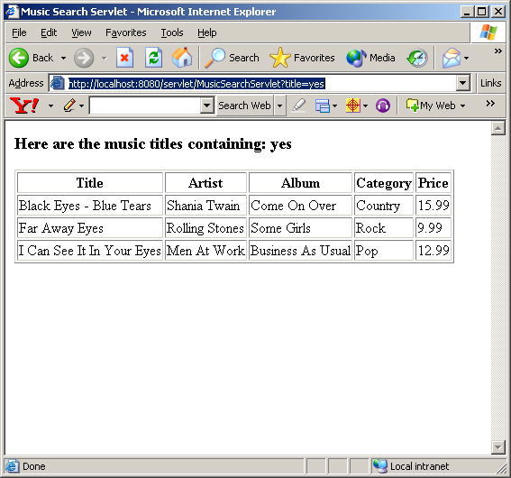

Using Transaction
There are times when you do not what one statement to take effect unless another one also succeeds. For example, when you do balance transfer from one account to another, you want do see that either both withdrawal statement and deposit statement on the database succeeds (hopefully) or both fail (worse case). A transaction is a set of one or more such statements that are executed together as a unit, so either all of the statements are executed or none of them are executed.

When a connection is created, it is already in auto-commit mode by default –which means that each individual SQL statement is treated as a transaction and automatically committed on the database. The first step to start a transaction is to disable the auto-commit by calling setAutoCommit(false) on the connection. Once, the auto-commit is disabled no SQL statement will be committed until we call the commit() method on the connection. If we call the rollback() method instead the entire transaction is aborted. Here is what a typical transaction code looks like:

// connect to the database.
con = DriverManager.getConnection(url);
//let's control transaction manully.
con.setAutoCommit(false);
//Some transactional statement here
if (Some-condition){
con.commit();
else{
con.rollback();
}

Here is an example of a Transactional Servlet:

// Code 5E
import java.io.IOException;
import java.io.PrintWriter;
import java.sql.Connection;
import java.sql.DriverManager;
import java.sql.PreparedStatement;
import java.sql.ResultSet;
import java.sql.SQLException;
import javax.servlet.ServletException;
import javax.servlet.http.HttpServlet;
import javax.servlet.http.HttpServletRequest;
import javax.servlet.http.HttpServletResponse;
import org.apache.log4j.Logger;
public class UpdateCategoryServlet extends HttpServlet{
private static final Logger logger = Logger.getLogger(UpdateCategoryServlet.class);
public void doPost(HttpServletRequest request, HttpServletResponse response)
throws ServletException, IOException{
doGet(request,response);
}
public void doGet(HttpServletRequest request, HttpServletResponse response)
throws ServletException, IOException{
Connection con = null;
PreparedStatement psSelect=null;
PreparedStatement psUpdate=null;
ResultSet categories = null;
// get the flag from request
String flag = (String) request.getParameter("flag");
// set the content type of response.
response.setContentType("text/html");
// get a handle on the print writer of response.
PrintWriter out=response.getWriter();
// generate response.
out.println("<HTML>");
out.println("<HEAD>");
out.println("<TITLE>");
out.println("Update Category Servlet");
out.println("</TITLE>");
out.println("</HEAD>");
out.println("<BODY>");
try{
// load the driver class.
Class.forName("COM.cloudscape.core.JDBCDriver");
// string url to the database.
String url = "jdbc:cloudscape:c:/data/VSTORE";
// connect to the database.
con = DriverManager.getConnection(url);
logger.debug("Got Connection");
//let's control transaction manully.
con.setAutoCommit(false);
logger.debug("Auto Commit is off");
// create a statement
psSelect = con.prepareStatement("select * from categories order by category_id",ResultSet.CONCUR_READ_ONLY,ResultSet.TYPE_SCROLL_INSENSITIVE);
// execute a result using the statement
// this will return a resultset.
categories = psSelect.executeQuery();
logger.debug("Got ResultSet");
out.println("<H3>Here are the categories BEFORE ID changes");
out.println("<TABLE BORDER=1>");
out.println("<TR>");
out.println("<TH>ID</TH>");
out.println("<TH>Name</TH>");
out.println("<TH>Type</TH>");
out.println("</TR>");
//loop through all the items.
while (categories.next()){
out.println("<TR>");
out.println("<TD>" + categories.getInt("category_id") + "</TD>");
out.println("<TD>" + categories.getString("category_name") + "</TD>");
out.println("<TD>" + categories.getString("category_type") + "</TD>");
out.println("</TR>");
}
out.println("</TABLE>");
categories = psSelect.executeQuery();
psUpdate = con.prepareStatement("Update Categories Set category_id = ? where category_id=?");
int current_id=0;
int old_id=0;
while (categories.next()){
old_id=categories.getInt("category_id");
current_id=100-old_id;
psUpdate.setInt(1,current_id);
psUpdate.setInt(2,old_id);
psUpdate.execute();
logger.debug("Executed Update for " + current_id);
}
// if the user sends rollback flag as querystring then rollbac
// otherwise commit.
if (!(flag==null) && (flag.equals("rollback"))){
con.rollback();
logger.debug("Rolled Back");
}
else{
con.commit();
logger.debug("Commited");
}
// execute a result using the statement.
// this will return a resultset.
categories = psSelect.executeQuery();
logger.debug("Got ResultSet again");
out.println("<H3>Here are the categories AFTER ID changes");
out.println("<TABLE BORDER=1>");
out.println("<TR>");
out.println("<TH>ID</TH>");
out.println("<TH>Name</TH>");
out.println("<TH>Type</TH>");
out.println("</TR>");
//loop through all the items.
while (categories.next()){
out.println("<TR>");
out.println("<TD>" + categories.getInt("category_id") + "</TD>");
out.println("<TD>" + categories.getString("category_name") + "</TD>");
out.println("<TD>" + categories.getString("category_type") + "</TD>");
out.println("</TR>");
}
out.println("</TABLE>");
}
catch(SQLException e){
while (e != null)
{
logger.error("Message: " + e.getMessage());
logger.error("SQLState: " + e.getSQLState());
logger.error("Vendor ErrorCode: " + e.getErrorCode());
e = e.getNextException();
}
}
catch(ClassNotFoundException e){
logger.error("Exception",e);
}
finally
{
out.println("</BODY>");
out.println("</HTML>");
// since close methods throw sqlexception - catch 'em.
try{
logger.debug("Closing connection");
if (categories!=null){
categories.close();
}
if (psSelect!=null){
psSelect.close();
}
if (psUpdate!=null){
psUpdate.close();
}
if ((con!=null) && (!con.isClosed())){
con.close();
}
}
catch(Exception e){
logger.error("Exception",e);
}
}
}
}

Copy this class to Tomcat’s ROOT\WEB-INF\classes folder and compile it.

Stop and Start ROOT App and type:

http://localhost:8080/servlet/UpdateCategoryServlet

Here is the output you will get:
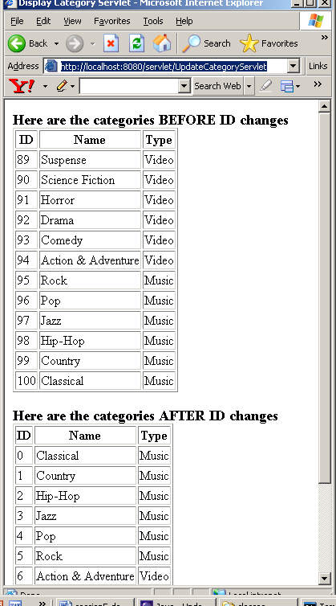

Notice, the Ids have been changed above.

However, if you type the url as:

http://localhost:8080/servlet/UpdateCategoryServlet?flag=rollback (notice the rollback flag on the URL)

You get the following output:

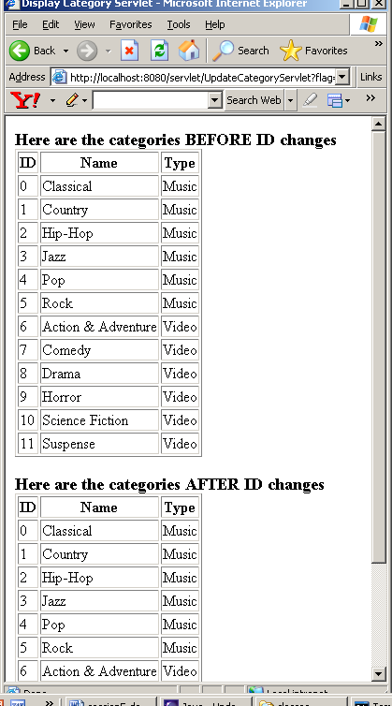
Notice, this time the transaction did not commit and we have the same ID before and after the changes.

Setting AutoCommit to False
If you want to use the same connection to run multiple queries on the database and have all resultsets available please make sure that you turn the autocommit to false on the connect first. Strange thing is, you have to do this even if you are not commiting anything to the database – all the queries are SELECT queries.

Encoding URL
Sometimes URLs need to be converted into into x-www-form-urlencoded format. Without this encoding the query string could be misinterpreted. Consider the following:

<A href=/servlet/ShowVideoServlet?category=Action & Adventure TARGET=main>Action & Adventure</A></TD></TR>

In the above example, the value of category parameter is “Action & Adventure” but the browser will send “Action” because “&” is a special character – a separator of request parameters.
Fortunately, java.net package has URLEncoder class which has a encode method that can take care of this problem. For example:

String encoded = java.net.URLEncoder.encode(("Action & Adventure","UTF-8");

Now, encoded string is “Action+%26+Adventure” – which is in x-www-form-urlencoded form and good for all practical purposes.

Reading Assignment
- Beginning Java Databases – Chapter 8, 9, 12, 13 and 14

Homework Assignment (15 points)
Modify Demo3 so that it actually retrieves and presents the data from the database.

Here is the first page:

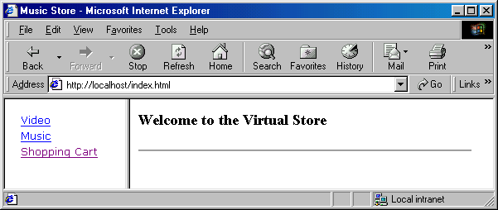

When I click on Music on the left hand menu, the left frame changes to music category menu as follows:

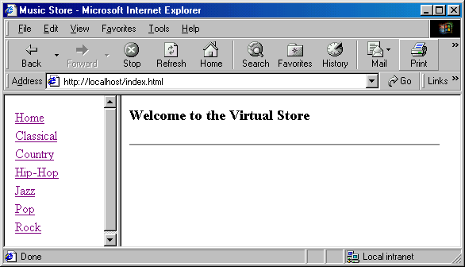

When I click on any music category the right hand size changes as follows:
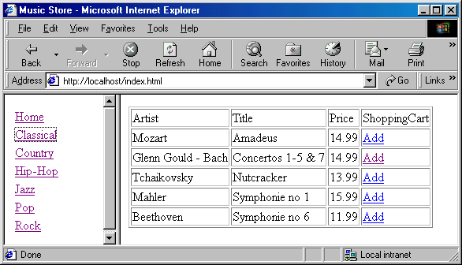

Similarly, when I click on Video on the first screen, the left hand changes as follows:

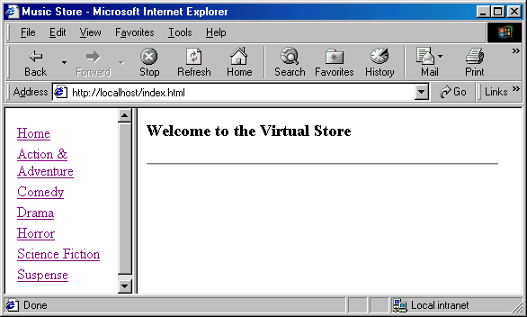

When I click on any Video category, the right frame changes as follows:

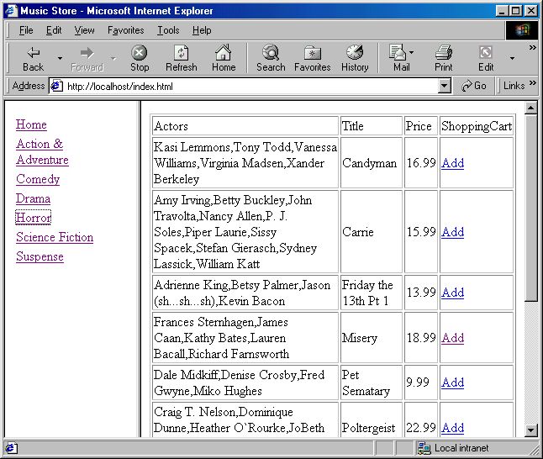

Adding Item to shopping cart should still work. After adding a few music and video recordings the shopping cart looks like this:

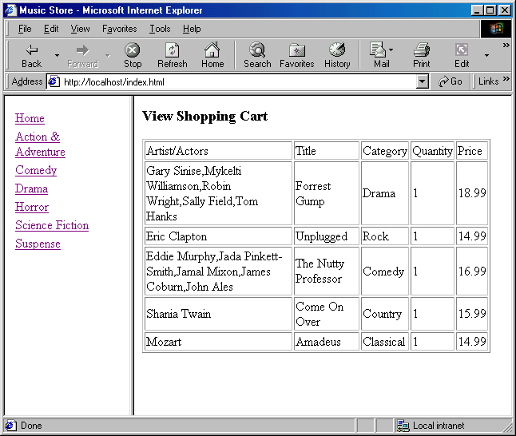

Hints:

Terminologies:
Name | Values
Type | Music, Vidoe
Category (think of it as sub-category of Type) | Classical, Jazz etc. when the Type is Music  Horror, Drama etc. when the Type is Vidoe

- Change the static pages main.html, menu.html so that the initial menu changes are taken care of.
- Get rid of RecordHolder class and introduce a new class VStoreDAO that has the following methods:
  - private static Connection getConnection() // returns a connection to the database that has autocommit set to false already.
  - public static ArrayList getCategoryByType(String type) // returns either Music categories or Video categories based on the input type (Music or Video). The ArrayList is going to be a list of Strings.
  - public static ArrayList getMusicByCategory(String category) // returns Music recordings by category. The ArrayList is going to be a list of Item. Please check RecordHolder for tips.
  - public static ArrayList getVideoByCategory(String category) // returns Video recordings by category. The ArrayList is going to be a list of Item. Please check RecordHolder for tips. Populate the Artist field of Item with the concatenated list of actors so that Music Item and Video Item looks the same.
  - public static Item get(String id, String type) // returns Item by its id and type(like Music and Video). The second argument is necessary since we have two separate tables to go to and we can’t tell by looking at an ID where it is Music or Video Recording ID. This method should go back to database to reconstruct the Item object since we are not caching the Items returned by getMusicByCategory() or by getVideoByCategory() methods.
- Add a new servlet CategoryByTypeServlet that receives a type(like Video or Music) as request parameter and returns a response that contains a list of categories.
- Add a new servlet ShowMusicServlet that receives a Music category (like Classical) as request parameter and returns a response that contains a list of Music Recordings of that category.
- Add a new servlet ShowVideoServlet that receives a Video category (like Horror) as request parameter and returns a response that contains a list of Video Recordings of that category.
- Modify AddItemToShoppingCartServlet so that it receives id and type as request parameter and add the item to the shopping cart. The second request parameter type is necessary now since we can’t tell by looking at an ID where it is Music or Video Recording ID.
- Modify Item class so that its constructor now takes in Recording ID as well as an input parameter instead of generating sequencial Ids. This change is extremely important.
- You have to encode URLs using java.net.URLEncoder.encode() since you will have spaces and “&” in query string that needs encoding. You must use prepared statement if the same SQL is called more than once in the same request.

