Session 6 Advance JDBC

Objective
This session teaches students how to access databases using Data Sources and JNDI. Using connection pooling and RowSets are also discussed in details.

Extracting DatabaseMetaData
JDBC API provides an interface DatabaseMetaData that provides information about a database. You get DatabaseMetaData object by calling getMetaData() method on the connection object as follows:

// get the database metadata
DatabaseMetaData metadata = con.getMetaData();

Once we have the metadata object, we can call methods on it to find out information about the database. The list of methods on DatabaseMetaData is huge – here is a short list:

getDatabaseProductName() | String | What's the name of this database product?
getDatabaseProductVersion() | String | What's the version of this database product?
getDriverName() | String | What's the name of this JDBC driver?
getDriverVersion() | String | what's the version of this JDBC driver?
getSchemas() | ResultSet | Gets the schema names available in this database.
getTableTypes() | ResultSet | Gets the table types available in this database.
getTables(String catalog, String schemaPattern, String tableNamePattern, String[] types) | ResultSet | Gets a description of tables available.
supportsResultSetConcurrency(int type, int concurrency) | boolean | Does the database support the concurrency type in combination with the given result set type?
supportsResultSetType(int type) | boolean | Does the database support the given result set type?

Here is an example of DatabaseMetadata usage:

// Code 6A
import java.io.*;
import java.util.*;
import javax.servlet.*;
import javax.servlet.http.*;
import java.sql.*;
public class DisplayTableNamesServlet extends HttpServlet
{
public void doPost(HttpServletRequest request, HttpServletResponse response)
throws ServletException, IOException{
doGet(request,response);
}
public void doGet(HttpServletRequest request, HttpServletResponse response)
throws ServletException, IOException
{
// set the content type of response.
response.setContentType("text/html");
// get a handle on the print writer of response.
PrintWriter out=response.getWriter();
Connection con = null;
Statement statement = null;
ResultSet tables = null;
try{
// load the driver class.
Class.forName("COM.cloudscape.core.JDBCDriver");
// string url to the database.
String url = "jdbc:cloudscape:c:/data/VSTORE";
// connect to the database.
con = DriverManager.getConnection(url);
// get the database metadata
DatabaseMetaData metadata = con.getMetaData();
out.println("<H3>Database Info:");
// get features of the database
out.println("<TABLE BORDER=1>");
out.println("<TR><TD>Database Name</TD>");
out.println("<TD>"+ metadata.getDatabaseProductName() + "</TD><TR>");
out.println("<TR><TD>Database version</TD>");
out.println("<TD>"+ metadata.getDatabaseProductVersion() + "</TD><TR>");
out.println("<TR><TD>Driver Name</TD>");
out.println("<TD>" + metadata.getDriverName() + "</TD><TR>");
out.println("<TR><TD>Driver Verison</TD>");
out.println("<TD>" + metadata.getDriverVersion() + "</TD><TR>");
out.println("<TR><TD>Supports Forward only Resultset</TD>");
out.println("<TD>" + metadata.supportsResultSetType(
ResultSet.TYPE_FORWARD_ONLY) + "</TD><TR>");
out.println("<TR><TD>Supports scroll sensitive Resultset</TD>");
out.println("<TD>" + metadata.supportsResultSetType(
ResultSet.TYPE_SCROLL_SENSITIVE) + "</TD><TR>");
out.println("<TR><TD>Supports scroll insensitive Resultset</TD>");
out.println("<TD>" + metadata.supportsResultSetType(
ResultSet.TYPE_SCROLL_INSENSITIVE) + "</TD><TR>");
out.println("<TR><TD>Supports updatable Resultset</TD>");
out.println("<TD>" + metadata.supportsResultSetConcurrency(
ResultSet.TYPE_SCROLL_INSENSITIVE,
ResultSet.CONCUR_UPDATABLE) + "</TD><TR>");
out.println("</TABLE>");
String[] types = {"TABLE"};
String schema = "APP"; //for Cloudscape
tables = metadata.getTables(null,"APP",null,types);
out.println("<H3>Here are the tables");
out.println("<TABLE BORDER=1>");
//loop through all the items.
while (tables.next()){
out.println("<TR>");
out.println("<TD>" + tables.getString("TABLE_NAME") + "</TD>");
}
out.println("</TABLE>");
}
catch(SQLException e){
System.out.println("\n--- SQLException caught ---\n");
while (e != null)
{
System.out.println("Message: " + e.getMessage());
System.out.println("SQLState: " + e.getSQLState());
System.out.println("Vendor ErrorCode: " + e.getErrorCode());
e = e.getNextException();
System.out.println();
}
}
catch(ClassNotFoundException e){
System.out.println(e.toString());
}
finally
{
out.println("</BODY>");
out.println("</HTML>");
// since close methods throw sqlexception - catch 'em.
try{
tables.close();
statement.close();
con.close();
}
catch(Exception e){
//don't do anything - it is probably just a null pointer exception.
}
}
}
}

Copy this class to c:\tomcat5028\Root\Web-Inf\Classes folder and compile it.

Stop and Start Tomcat and type:

http://localhost/servlet/DisplayTablesServlet (assuming Tomcat is running on port 80 otherwise specify the port number).

Here is the output you will get:

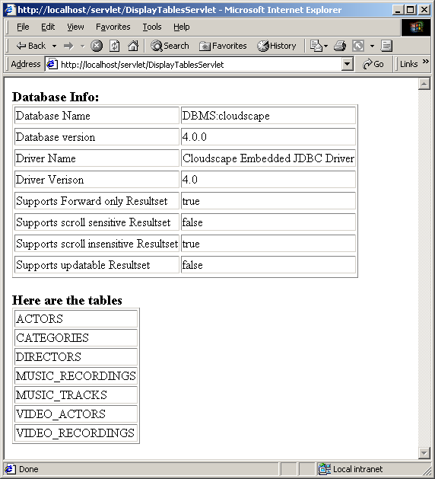

Notice Cloudscape does not support sensitive scrolling and updatable resultsets.

Extracting ResultSetMetaData
JDBC API provides another interface ResultSetMetaData that provides information about the resultset on hand. You get ResultSetMetaData object by calling getMetaData() method on the resultset object as follows:

// execute a query using the statement.
// this will return a resultset.
videos = statement.executeQuery("select * from Video_Recordings");
// get the resultset metadata
ResultSetMetaData metadata = videos.getMetaData();

Once we have the metadata object, we can call methods on it to find out information about the resultset. Here is a short list of methods of ResultSetMetaData:

getColumnCount() | int | Returns the number of columns in this ResultSet object.
getColumnDisplaySize(int column) | int | Indicates the designated column's normal maximum width in characters.
getColumnName(int column) | String | Get the designated column's name.
getColumnTypeName(int column) | String | Retrieves the designated column's database-specific type name.
GetSchemaName(int column) | String | Get the designated column's table's schema.
getTableName(int column) | String | Gets the designated column's table name.
isAutoIncrement(int column) | boolean | Indicates whether the designated column is automatically numbered, thus read-only.
isCaseSensitive(int column) | boolean | Indicates whether a column's case matters.
isNullable(int column) | int | Indicates the nullability of values in the designated column.
isSearchable(int column) | boolean

Here is an example of using ResultSetMetaData:

// Code 6B
import java.io.*;
import java.util.*;
import javax.servlet.*;
import javax.servlet.http.*;
import java.sql.*;
public class DisplayTableStructureServlet extends HttpServlet
{
Public void doPost(HttpServletRequest request, HttpServletResponse response)
throws ServletException, IOException{
doGet(request,response);
}
Public void doGet(HttpServletRequest request, HttpServletResponse response)
throws ServletException, IOException
{
// set the content type of response.
response.setContentType("text/html");
// get a handle on the print writer of response.
PrintWriter out=response.getWriter();
String tablename =null;
Connection con = null;
Statement statement = null;
ResultSet videos = null;
try{
// get the table name from the servlet input parameter
tablename = request.getParameter("tablename");
// load the driver class.
Class.forName("COM.cloudscape.core.JDBCDriver");
// string url to the database
String url = "jdbc:cloudscape:c:/data/VSTORE";
// connect to the database.
con = DriverManager.getConnection(url);
// create a statement
statement = con.createStatement();
// execute a query using the statement.
// this will return an empty resultset since 2+2<>5.
videos = statement.executeQuery("select * from " + tablename + " where 2+2=5");
// get the resultset metadata
ResultSetMetaData metadata = videos.getMetaData();
out.println("<H3>Here is the structure of " + tablename + " Table");
out.println("<TABLE BORDER=1>");
out.println("<TR>");
out.println("<TH>Field Name</TH>");
out.println("<TH>Type</TH>");
out.println("<TH>Size</TH>");
out.println("</TR>");
//loop through all the items.
for (int i=1; i<= metadata.getColumnCount();i++){
out.println("<TR>");
out.println("<TD>" + metadata.getColumnName(i) + "</TD>");
out.println("<TD>" + metadata.getColumnTypeName(i) + "</TD>");
out.println("<TD>" + metadata.getColumnDisplaySize(i) + "</TD>");
}
out.println("</TABLE>");
}
catch(SQLException e){
System.out.println("\n--- SQLException caught ---\n");
while (e != null)
{
System.out.println("Message: " + e.getMessage());
System.out.println("SQLState: " + e.getSQLState());
System.out.println("Vendor ErrorCode: " + e.getErrorCode());
e = e.getNextException();
System.out.println();
}
}
catch(ClassNotFoundException e){
System.out.println(e.toString());
}
finally
{
out.println("</BODY>");
out.println("</HTML>");
// since close methods throw sqlexception - catch 'em.
try{
videos.close();
statement.close();
con.close();
}
catch(Exception e){
//don't do anything - it is probably just a null pointer exception.
}
}
}
}

Copy this class to c:\tomcat5028\Root\Web-Inf\Classes folder and compile it.

Stop and Start Tomcat and type:

http://localhost/servlet/DisplayTableStructureServlet?tablename=Video_Recordings (assuming Tomcat is running on port 80 otherwise specify the port number). Notice that I passed a valid table name “Video_Recordings” as get parameter.

Here is the output you will get:

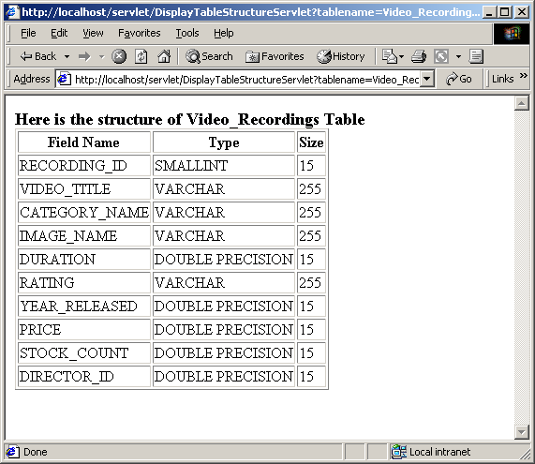

Change the tablename parameter and hit the servlet – you will get the structure of the table – Cool?

Using Properties File
So far, we have been reluctantly hard-coding the database driver class name and JDBC url in the source code. Should we decide to switch from Cloudscape to MySQL – we are in trouble. You have to modify every single servlet, recompile, retest and all that. One nice way to abstract the database stuff out and make it maintenance friendly is by putting this information is a file and reading from the file at runtime. This way, if the database driver changes or the url changes we just have to change the file. The best way to accomplish this in java is to put this information in a text file (.properties) file (that looks sort of like .ini file in windows environment) and read this text file using PropertyResourceBundle.

Here is a sample properties file “database.properties”:

#Database.properties
database.JDBCDriver=COM.cloudscape.core.JDBCDriver
database.url=jdbc:cloudscape:c:/data/VSTORE

PropertyResourceBundle, a concrete subclass of ResourceBundle, manages resources using a set of static strings from a property file. Here are some of the useful methods of PropertyResourceBundle:

static getBundle(String baseName) | ResourceBundle | Get the appropriate ResourceBundle subclass.
getString(String key) | String | Get an object from a ResourceBundle.
static getBundle(String baseName, Locale locale) | ResourceBundle | Get the appropriate ResourceBundle subclass.
static getBundle(String baseName, Locale locale, ClassLoader loader) | ResourceBundle | Get the appropriate ResourceBundle subclass.
getKeys() | Enumeration | Return an enumeration of the keys.
getLocale() | Locale | Return the Locale for this ResourceBundle.
getObject(String key) | Object | Get an object from a ResourceBundle.
getStringArray(String key) | String[] | Get an object from a ResourceBundle.
protected handleGetObject(String key) | Object | Get an object from a ResourceBundle.
protected setParent(ResourceBundle parent) | Void | Set the parent bundle of this bundle.

Basically if you call the getBundle() method with a properties file name, you will get back a ResourceBundle object in return. If you call getString() method on this ResourceBundle with a property name like “database.url” and getString() will return “jdbc:cloudscape:c:/data/VSTORE” as the property value.

Here is an example:

// Code 6C
import java.io.*;
import java.util.*;
import javax.servlet.*;
import javax.servlet.http.*;
import java.sql.*;
public class ResourceBundleDemoServlet extends HttpServlet
{
public void doPost(HttpServletRequest request, HttpServletResponse response)
throws ServletException, IOException{
doGet(request,response);
}
public void doGet(HttpServletRequest request, HttpServletResponse response)
throws ServletException, IOException
{
// set the content type of response.
response.setContentType("text/html");
// get a handle on the print writer of response.
PrintWriter out=response.getWriter();
String tablename =null;
Connection con = null;
Statement statement = null;
ResultSet videos = null;
try{
// get the table name from the servlet input parameter
tablename = request.getParameter("tablename");
// load Database.properties file
PropertyResourceBundle bundle = (PropertyResourceBundle) ResourceBundle.getBundle("Database");
// get the JDBC driver class name from the bundle
String driver = bundle.getString("database.JDBCDriver");
// load the driver class.
Class.forName(driver);
// get the url from the bundle.
String url = bundle.getString("database.url");
// connect to the database.
con = DriverManager.getConnection(url);
// create a statement
statement = con.createStatement();
// execute a query using the statement.
// this will return an empty resultset since 2+2<>5.
videos = statement.executeQuery("select * from " + tablename + " where 2+2=5");
// get the resultset metadata
ResultSetMetaData metadata = videos.getMetaData();
out.println("<H3>Here is the structure of " + tablename + " Table");
out.println("<TABLE BORDER=1>");
out.println("<TR>");
out.println("<TH>Field Name</TH>");
out.println("<TH>Type</TH>");
out.println("<TH>Size</TH>");
out.println("</TR>");
//loop through all the items.
for (int i=1; i<= metadata.getColumnCount();i++){
out.println("<TR>");
out.println("<TD>" + metadata.getColumnName(i) + "</TD>");
out.println("<TD>" + metadata.getColumnTypeName(i) + "</TD>");
out.println("<TD>" + metadata.getColumnDisplaySize(i) + "</TD>");
}
out.println("</TABLE>");
}
catch(SQLException e){
System.out.println("\n--- SQLException caught ---\n");
while (e != null)
{
System.out.println("Message: " + e.getMessage());
System.out.println("SQLState: " + e.getSQLState());
System.out.println("Vendor ErrorCode: " + e.getErrorCode());
e = e.getNextException();
System.out.println();
}
}
catch(ClassNotFoundException e){
System.out.println(e.toString());
}
finally
{
out.println("</BODY>");
out.println("</HTML>");
// since close methods throw sqlexception - catch 'em.
try{
videos.close();
statement.close();
con.close();
}
catch(Exception e){
//don't do anything - it is probably just a null pointer exception.
}
}
}
}

Copy this class and Database.properties to c:\tomcat5028\Root\Web-Inf\Classes folder and compile it.

Stop and Start Tomcat and type:

http://localhost/servlet/ResourceBundleDemoServlet?tablename=Categories (assuming Tomcat is running on port 80 otherwise specify the port number).

You will get the following output:

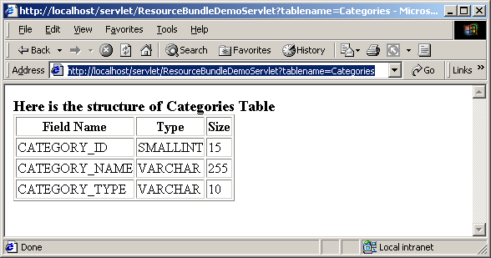

Again, change the table name and have fun.

The JDBC 2.0 Optional Package API (javax.sql)

DataSources
By introducing a properties file we move some of the database connectivity outside of our servlet code. As a second step towards that direction we will use DataSource. JDBC 2.0 Optional Package API has introduced a new way of encapsulating the database connection – DataSource. The basic idea is to create and manage database connection separately from your application. Your application, say a servlet, would use the DataSource object without knowing the connection details. An object that implements the DataSource interface will typically be registered with a JNDI service provider.

There are three basic types of DataSources:

- A basic DataSource that implements javax.sql.DataSource interface
- A connection pooling DataSource that implements javax.sql.ConnectionPoolDataSource
- A distributed transaction DataSource that implements javax.sql.XADataSource

Basic DataSource
The Basic DataSource has a getConnection() method that needs to be called to get a connection. However, usage of DataSource is not that straight forward since we need JNDI to use DataSource.

The process of using a DataSource is very simple:

- Get the JNDI context that has the DataSource.
- Using the context – lookup and retrieve the DataSource object.
- Call getConnection() method on it – to get a Connection object.
- After this step, it is a matter of getting Statement, ResultSet object as before.

The most important question is, how do you put the DataSource object in JNDI context so that you can retrieve it? Here is how you do it:

  - Download FS Service Provider from http://java.sun.com/products/jndi or our class web site. Unzip the zip file extract providerutil.jar and fscontext.jar from the lib folder.
  - Put them in your class path. Also, put them in c:\tomcat5028\common\lib folder so that Tomcat finds them. Now you have FS Context service provider 1.2 beta 3 release.
  - Compile and run the following program to put your datasource in FS Context:

// code 6D
import java.util.*;
import javax.sql.*;
import javax.naming.*;
import COM.cloudscape.core.*;
public class BindDataSource{
public static void main(String[] args){
try{
// create a hash table and put parameters to create the context
Hashtable env = new Hashtable();
env.put(Context.INITIAL_CONTEXT_FACTORY,
"com.sun.jndi.fscontext.RefFSContextFactory");
env.put(Context.PROVIDER_URL,"file:/C:/jndistore");
//create the context
Context context = new InitialContext(env);
// create a datasource and put your database name in it.
BasicDataSource datasource = new BasicDataSource();
datasource.setDatabaseName("c:/data/VSTORE");
//bind the datasource to a name
context.rebind("mydatasource",datasource);
}
catch(Exception e){
System.out.println(e);
}
}
}
This will create a “.binding” file in your c:\jndistore folder that will contain the DataSource.

To be completely free from problems please stop Tomcat . Test your DataSource by compiling and running the following program:

// code 6E
import java.util.*;
import javax.sql.*;
import java.sql.*;
import javax.naming.*;
Public class DataSourceClient{
public static void main(String[] args){
try{
// create a hash table and put parameters to create the context
Hashtable env = new Hashtable();
env.put(Context.INITIAL_CONTEXT_FACTORY,
"com.sun.jndi.fscontext.RefFSContextFactory");
env.put(Context.PROVIDER_URL,"file:/C:/jndistore");
//create the context
Context context = new InitialContext(env);
// find the datasource
DataSource datasource = (DataSource) context.lookup("mydatasource");
// get a connection
Connection connection = datasource.getConnection();
// create a statement
Statement statement = connection.createStatement();
// execute a query using the statement.
// this will return a resultset.
ResultSet categories = statement.executeQuery("select * from categories");
//loop through all the items.
while (categories.next()){
System.out.println(categories.getString("category_name"));
}
}
catch(Exception e){
System.out.println(e);
}
}
}

You will get the following output on your command prompt:

Classical
Country
Hip-Hop
Jazz
Pop
Rock
Action & Advant
Comedy
Drama
Horror
Science Fiction
Suspense

Notice, the client code is not using any database vendor class.

Connection Pooling DataSource
One of the most expensive operations using JDBC will be to establish database connection. So far we have established a new connection with the database to execute query. This becomes a major bottle-neck when you have access database very frequently as more and more people are using your sight. Therefore, it will be nice if a pool of connection is maintained on the server. Everytime a connection request is make, one of the connection from the pool would be used by the servlet and after the use of the connection is over the connection will be returned to the pool. Up until now, this type of feature is accomplished by writing custom code. JDK 2.0 Optional Package API provides ConnectionPoolDataSource Interface that the database vendors should implement for connection pooling.

The process of using ConnectionPoolDataSource is very similar to Basic DataSource. It has only one extra step. Here are the steps:

- Get a JNDI context.
- Using the context – lookup and retrieve the ConnectionPoolDataSource object.
- Call getPooledConnection() method on it – to get a PooledConnection object.
- Call getConnection() method on PooledConnection object to get a Connection Object.
- After this step, it is a matter of getting Statement, ResultSet object as before.

Putting the ConnectionPoolDataSource object in JNDI context is exactly the same process an before.

Compile and run the following program to put your connection pool datasource in FS Context:

// code 6F
Import java.util.*;
Import javax.sql.*;
Import javax.naming.*;
Import COM.cloudscape.core.*;
Public class BindConnectionPoolDataSource{
public static void main(String[] args){
try{
// create a hash table and put parameters to create the context
Hashtable env = new Hashtable();
env.put(Context.INITIAL_CONTEXT_FACTORY,"com.sun.jndi.fscontext.RefFSContextFactory");
env.put(Context.PROVIDER_URL,"file:/C:/jndistore");
//create the context
Context context = new InitialContext(env);
// create a datasource and put your database name in it.
LocalConnectionPoolDataSource datasource = new LocalConnectionPoolDataSource();
datasource.setDatabaseName("c:/data/VSTORE");
//bind the datasource to a name
context.rebind("myconnectionpooldatasource",datasource);
}
catch(Exception e){
System.out.println(e);
}
}
}

This will update the “.binding” file in your c:\jndistore folder that will contain the ConenctionPoolDataSource.

In order to test your ConnectionPoolDataSource compile and run the following program:

// code 6G
Import java.util.*;
Import javax.sql.*;
Import java.sql.*;
Import javax.naming.*;
Public class ConnectionPoolDataSourceClient{
public static void main(String[] args){
try{
// create a hash table and put parameters to create the context
Hashtable env = new Hashtable();
env.put(Context.INITIAL_CONTEXT_FACTORY,
"com.sun.jndi.fscontext.RefFSContextFactory");
env.put(Context.PROVIDER_URL,"file:/C:/jndistore");
//create the context
Context context = new InitialContext(env);
// find the datasource
ConnectionPoolDataSource datasource = (ConnectionPoolDataSource)
context.lookup("myconnectionpooldatasource");
// get a Pooled connection
PooledConnection pooledconnection = datasource.getPooledConnection();
// get a connection from the pool
Connection connection = pooledconnection.getConnection();
// create a statement
Statement statement = connection.createStatement();
// execute a query using the statement.
// this will return a resultset.
ResultSet categories = statement.executeQuery("select * from categories");
//loop through all the items.
while (categories.next()){
System.out.println(categories.getString("category_name"));
}
}
catch(Exception e){
System.out.println(e);
}
}
}

You will get the same output as before.

Here is a Servlet that uses connection pooling and properties file together to get a connection:

// Code 6H
import java.io.*;
import java.util.*;
import javax.servlet.*;
import javax.servlet.http.*;
import java.sql.*;
import javax.sql.*;
import javax.naming.*;
public class PooledConnectionDemoServlet extends HttpServlet
{
public void doPost(HttpServletRequest request, HttpServletResponse response)
throws ServletException, IOException{
doGet(request,response);
}
public void doGet(HttpServletRequest request, HttpServletResponse response)
throws ServletException, IOException
{
// set the content type of response.
response.setContentType("text/html");
// get a handle on the print writer of response.
PrintWriter out=response.getWriter();
PooledConnection pool =null;
Connection con = null;
Statement statement = null;
ResultSet categories = null;
try{
// load Database.properties file
PropertyResourceBundle bundle = (PropertyResourceBundle) ResourceBundle.getBundle("PooledConnection");
// get the initial context factory class name from the bundle
String contextfactory = bundle.getString("connection.contextfactory");
// get the provider url from the bundle.
String providerurl = bundle.getString("connection.providerurl");
// create a hash table and put parameters to create the context
Hashtable env = new Hashtable();
env.put(Context.INITIAL_CONTEXT_FACTORY,contextfactory);
env.put(Context.PROVIDER_URL,providerurl);
//create the context
Context context = new InitialContext(env);
// find the datasource
ConnectionPoolDataSource datasource = (ConnectionPoolDataSource) context.lookup("myconnectionpooldatasource");
// get a Pooled connection
pool = datasource.getPooledConnection();
// get a connection from the pool
con = pool.getConnection();
// create a statement
statement = con.createStatement();
// execute a query using the statement.
// this will return a resultset.
categories = statement.executeQuery("select * from categories order by category_id");
out.println("<H3>Here are the categories");
out.println("<TABLE BORDER=1>");
out.println("<TR>");
out.println("<TH>ID</TH>");
out.println("<TH>Name</TH>");
out.println("<TH>Type</TH>");
out.println("</TR>");
//loop through all the items.
while (categories.next()){
out.println("<TR>");
out.println("<TD>" + categories.getInt("category_id") + "</TD>");
out.println("<TD>" + categories.getString("category_name") + "</TD>");
out.println("<TD>" + categories.getString("category_type") + "</TD>");
out.println("</TR>");
}
out.println("</TABLE>");
}
catch(SQLException e){
System.out.println("\n--- SQLException caught ---\n");
while (e != null)
{
System.out.println("Message: " + e.getMessage());
System.out.println("SQLState: " + e.getSQLState());
System.out.println("Vendor ErrorCode: " + e.getErrorCode());
e = e.getNextException();
System.out.println();
}
}
catch(NamingException e){
System.out.println(e.toString());
}
Finally
{
out.println("</BODY>");
out.println("</HTML>");
// since close methods throw sqlexception - catch 'em.
try{
categories.close();
statement.close();
con.close();
pool.close();
}
catch(Exception e){
//don't do anything - it is probably just a null pointer exception.
}
}
}
}

You need to create “PooledConnection.properties” file before you run it

#PooledConnection.properties
connection.contextfactory=com.sun.jndi.fscontext.RefFSContextFactory
connection.providerurl=file:/C:/jndistore

Copy PooledConnectionDemoServlet.java and PooledConnection.properties file to c:\tomcat5028\Root\Web-Inf\Classes folder and compile the class.
Stop and Start Tomcat and type:

http://localhost/servlet/PooledConnectionDemoServlet (assuming Tomcat is running on port 80 otherwise specify the port number).

You will get the following output:
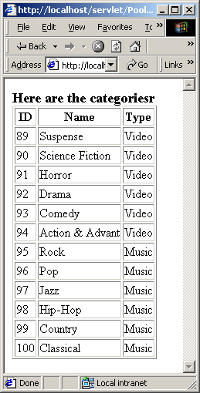

Using Tomcat’s JNDI
Tomcat is not just a Servlet, JSP container and a web server – it also provides a JNDI InitialContext implementation instance to web applications running under it, in a manner that is compatible with those provided by a Java2 Enterprise Edition application server. Entries in this InitialContext are configured in the c:\Tomcat5028\conf\server.xml file. All configured entries and resources will be placed in the java:comp/env portion of the JNDI namespace.

Many web applications need to access a database via a JDBC driver, to support the functionality required by that application. The J2EE Platform Specification requires J2EE Application Servers to make available a DataSource implementation (that is, a connection pool for JDBC connections) for this purpose. Tomcat 4 offers exactly the same support, so that database-based applications you develop on Tomcat using this service will run unchanged on any J2EE server.

Open up server.xml in tomcat’s conf folder and between <Host> and </Host> tag put in the following:

<Context path="" docBase="ROOT" debug="5" reloadable="true" crossContext="true">
<Resource name="jdbc/VStore" auth="Container" type="javax.sql.DataSource" maxActive="100" maxIdle="30" maxWait="10000" driverClassName="COM.cloudscape.core.JDBCDriver" url="jdbc:cloudscape:c:/data/VSTORE"/>
</Context>
<Context path="/servlets-examples" docBase="servlets-examples" debug="5" reloadable="true" crossContext="true">
<Resource name="jdbc/VStore" auth="Container" type="javax.sql.DataSource" maxActive="100" maxIdle="30" maxWait="10000" driverClassName="COM.cloudscape.core.JDBCDriver" url="jdbc:cloudscape:c:/data/VSTORE"/>
</Context>
<Context path="/testapp" docBase="testapp" debug="5" reloadable="true" crossContext="true">
<Resource name="jdbc/VStore" auth="Container" type="javax.sql.DataSource" maxActive="100" maxIdle="30" maxWait="10000" driverClassName="COM.cloudscape.core.JDBCDriver" url="jdbc:cloudscape:c:/data/VSTORE"/>
</Context>

If you don’t have testapp, delete the testapp section above from server.xml file.

(assuming your database is in c:/data/VSTORE folder – if not please change above)

Stop and Start Tomcat. This will set up a datasource in Tomcat for Root Application.

Here is a servlet that looks up datasource from JNDI context of Tomcat:

// Code 6M
import java.io.*;
import java.util.*;
import javax.servlet.*;
import javax.servlet.http.*;
import java.sql.*;
import javax.sql.*;
import javax.naming.*;
public class TomcatContextDemoServlet extends HttpServlet
{
public void doPost(HttpServletRequest request, HttpServletResponse response)
throws ServletException, IOException{
doGet(request,response);
}
public void doGet(HttpServletRequest request, HttpServletResponse response)
throws ServletException, IOException
{
// set the content type of response.
response.setContentType("text/html");
// get a handle on the print writer of response.
PrintWriter out=response.getWriter();
Connection con = null;
Statement statement = null;
ResultSet categories = null;
try{
//create the context
Context context = new InitialContext();
// find the datasource
DataSource datasource = (DataSource)
context.lookup("java:/comp/env/jdbc/VStore");
// get a connection from the pool
con = datasource.getConnection();
// create a statement
statement = con.createStatement();
// execute a query using the statement.
// this will return a resultset.
String sql="select * from categories order by category_id";
categories = statement.executeQuery(sql);
out.println("<H3>Here are the categories");
out.println("<TABLE BORDER=1>");
out.println("<TR>");
out.println("<TH>ID</TH>");
out.println("<TH>Name</TH>");
out.println("<TH>Type</TH>");
out.println("</TR>");
//loop through all the items.
while (categories.next()){
out.println("<TR>");
out.println("<TD>"+categories.getInt("category_id")+ "</TD>");
out.println("<TD>"+categories.getString("category_name")+"</TD>");
out.println("<TD>"+categories.getString("category_type")+"</TD>");
out.println("</TR>");
}
out.println("</TABLE>");
}
catch(SQLException e){
System.out.println("\n--- SQLException caught ---\n");
while (e != null)
{
System.out.println("Message: " + e.getMessage());
System.out.println("SQLState: " + e.getSQLState());
System.out.println("Vendor ErrorCode: " + e.getErrorCode());
e = e.getNextException();
System.out.println();
}
}
catch(NamingException e){
System.out.println(e.toString());
}
Finally
{
out.println("</BODY>");
out.println("</HTML>");
// since close methods throw sqlexception - catch 'em.
try{
categories.close();
statement.close();
con.close();
}
catch(Exception e){
//don't do anything - it is probably just a null pointer exception.
}
}
}
}

Copy the servlet in Tomcat’s Webapps\ROOT\WEB-INF\classes folder.

Hit the following url: http://localhost:8080/servlet/TomcatContextDemoServlet

Here is the output:

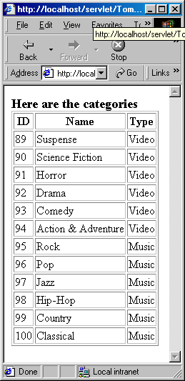

RowSet Interface
RowSet interface is simply an extention of ResultSet interface that maintains a collection of rows not necessarily coming from a Database but from any tabular source, including text files, spread sheets. The problem with ResultSet that is must maintain connection to the database since it is merely a stub. RowSet on the other hand can be completely disconnected. A disconnected RowSet gets a connection to a data soruce to fill itself with the data and then closes the connection.
A RowSet object can also update rows while disconnected from data source and its implementation is open to include custom writer that writes those changes back to the data source. Since it is not continually connected, a disconnected RowSet maintains data in memory.

RowSet interface has the following methods:

setDataSourceName(String name) | void | Set the data source name.
setUsername(String name) | void | Set the user name.
SetPassword(String password) | void | Set the password.
setUrl(String url) | void | Set the url used to create a connection.
setType(int type) | void | Set the rowset type.
setConcurrency(int concurrency) | void | Set the rowset concurrency.
setCommand(String cmd) | void | Set the rowset's command property.
execute() | void | Fills the rowset with data.
getUrl() | String | Get the url used to create a JDBC connection.

Sun provides 3 sample implementations of RowSet:

- CachedRowSet – A disconnected RowSet that keeps data in memory. A Cached RowSet is scrollable and serializable.
- JDBCRowSet – A wrapper around JDBC ResultSet that always maintains a connection to its data source.
- WebRowSet – A RowSet that can produce a representation of its contents in an XML format. WebRowSet is an extention of CachedRowSet.

Please download the RowSets from http://developer.java.sun.com/developer/early/Access/crs/index.html or from the class web site.

Extract the rowset.jar file from the zip and put it in your class path. Also, put it in c:\tomcat5028\common\lib folder so that Tomcat can find it.

CachedRowSet
Like ResultSet CachedRowSet has navigation, getXXX() as well as updateXXX() methods ( that you can actually use). Here is an example of a servlet using disconnected CachedRowSet that will be updated before presentation:

// Code 6J
import java.io.IOException;
import java.io.PrintWriter;
import java.sql.Connection;
import java.sql.PreparedStatement;
import java.sql.ResultSet;
import java.sql.SQLException;
import javax.naming.Context;
import javax.naming.InitialContext;
import javax.naming.NamingException;
import javax.servlet.ServletException;
import javax.servlet.http.HttpServlet;
import javax.servlet.http.HttpServletRequest;
import javax.servlet.http.HttpServletResponse;
import javax.sql.DataSource;
import sun.jdbc.rowset.CachedRowSet;
public class CachedRowSetServlet extends HttpServlet
{
public void doPost(HttpServletRequest request, HttpServletResponse response)
throws ServletException, IOException{
doGet(request,response);
}
public void doGet(HttpServletRequest request, HttpServletResponse response)
throws ServletException, IOException
{
// get the title from request
String title = (String) request.getParameter("title");
// set the content type of response.
response.setContentType("text/html");
// get a handle on the print writer of response.
PrintWriter out=response.getWriter();
// generate response.
out.println("<HTML>");
out.println("<HEAD>");
out.println("<TITLE>");
out.println("Video Search Servlet");
out.println("</TITLE>");
out.println("</HEAD>");
out.println("<BODY>");
if (title==null){
out.println("<H3>You did not specify any serach criteria</H3>");
out.println("</BODY>");
out.println("</HTML>");
return;
}
Connection con = null;
PreparedStatement query = null;
CachedRowSet videos = null;
ResultSet rs = null;
try{
//create the context
Context context = new InitialContext();
// find the datasource
DataSource datasource = (DataSource)
context.lookup("java:comp/env/jdbc/VStore");
// get a connection from the pool
con = datasource.getConnection();
// get data
query = con.prepareStatement("select * from Video_Recordings where video_title like ?");
query.setString(1,"%"+title+"%");
rs = query.executeQuery();
// instantiate
videos = new CachedRowSet();
// populate
videos.populate(rs);
// close the connection but the RowSet should still hold data.
con.close();
// move from BOF to the first record.
// if the resultset is empty - print a message.
if (!videos.next()){
out.println("<H3>There is no video title containing: " + title + "</H3>");
return;
}
// update the rowset.
double value;
videos.beforeFirst();
while (videos.next()){
//add tax to the price
value = Math.round(videos.getDouble("price") * 1.0850);
videos.updateDouble("price",value);
}
out.println("<H3>Here are the video titles containing: " + title + "</H3>");
out.println("<TABLE BORDER=1>");
out.println("<TR>");
out.println("<TH>Title</TH>");
out.println("<TH>Category</TH>");
out.println("<TH>Price + Tax </TH>");
out.println("</TR>");
videos.beforeFirst();
//loop through all the items.
while (videos.next()){
out.println("<TR>");
out.println("<TD>" + videos.getString("video_title") + "</TD>");
out.println("<TD>" + videos.getString("category_name") + "</TD>");
out.println("<TD>" + videos.getDouble("price") + "</TD>");
out.println("</TR>");
}
out.println("</TABLE>");
}
catch(SQLException e){
System.out.println("\n--- SQLException caught ---\n");
while (e != null)
{
System.out.println("Message: " + e.getMessage());
System.out.println("SQLState: " + e.getSQLState());
System.out.println("Vendor ErrorCode: " + e.getErrorCode());
e = e.getNextException();
System.out.println();
}
}
catch(NamingException e){
System.out.println(e.toString());
}
finally
{
out.println("</BODY>");
out.println("</HTML>");
// since close methods throw sqlexception - catch 'em.
try{
videos.close();
query.close();
}
catch(Exception e){
//don't do anything - it is probably just a null pointer exception.
}
}
}
}

Copy this class to c:\tomcat5028\Root\Web-Inf\Classes folder and compile it.

Stop and Start Tomcat and type:

http://localhost/servlet/CachedRowSetServlet?title=man (viedo title is being passed as query stread).

You will get the following output:

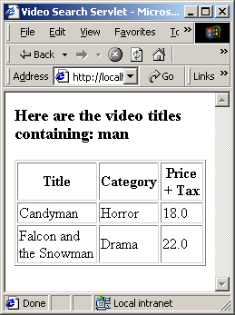

JdbcRowSet
JdbcRowSet is very similar to CacheRowSet – the big difference is that it remains connected to the database. The current implementation of JdbcRowSet is incomplete, does not allow update or back-scrolling. Here is an example:

// Code 6K
import java.io.*;
import java.util.*;
import javax.servlet.*;
import javax.servlet.http.*;
import java.sql.*;
import javax.sql.*;
import javax.naming.*;
import sun.jdbc.rowset.*;
public class JdbcRowSetServlet extends HttpServlet
{
public void doPost(HttpServletRequest request, HttpServletResponse response)
throws ServletException, IOException{
doGet(request,response);
}
public void doGet(HttpServletRequest request, HttpServletResponse response)
throws ServletException, IOException
{
// get the title from request
String title = (String) request.getParameter("title");
// set the content type of response.
response.setContentType("text/html");
// get a handle on the print writer of response.
PrintWriter out=response.getWriter();
// generate response.
out.println("<HTML>");
out.println("<HEAD>");
out.println("<TITLE>");
out.println("Video Search Servlet");
out.println("</TITLE>");
out.println("</HEAD>");
out.println("<BODY>");
if (title==null){
out.println("<H3>You did not specify any serach criteria</H3>");
out.println("</BODY>");
out.println("</HTML>");
return;
}
JdbcRowSet videos = null;
try{
// load the driver class.
Class.forName("COM.cloudscape.core.JDBCDriver");
// string url to the database.
String url = "jdbc:cloudscape:c:/data/VSTORE";
// instantiate
videos = new JdbcRowSet();
// set the url
videos.setUrl(url);
// set the query
videos.setCommand("select * from Video_Recordings where video_title like " + "'%" + title + "%'");
// execute the query.
videos.execute();
// if the resultset is empty - print a message.
if (!videos.next()){
out.println("<H3>There is no video title containing: " + title + "</H3>");
return;
}
out.println("<H3>Here are the video titles containing: " + title + "</H3>");
out.println("<TABLE BORDER=1>");
out.println("<TR>");
out.println("<TH>Title</TH>");
out.println("<TH>Category</TH>");
out.println("<TH>Price");
out.println("</TR>");
//loop through all the items.
do{
out.println("<TR>");
out.println("<TD>" + videos.getString("video_title") + "</TD>");
out.println("<TD>" + videos.getString("category_name") + "</TD>");
out.println("<TD>" + videos.getDouble("price") + "</TD>");
out.println("</TR>");
}while (videos.next());
out.println("</TABLE>");
}
catch(SQLException e){
System.out.println("\n--- SQLException caught ---\n");
while (e != null)
{
System.out.println("Message: " + e.getMessage());
System.out.println("SQLState: " + e.getSQLState());
System.out.println("Vendor ErrorCode: " + e.getErrorCode());
e = e.getNextException();
System.out.println();
}
}
catch(ClassNotFoundException e){
System.out.println(e.toString());
}
finally
{
out.println("</BODY>");
out.println("</HTML>");
// since close methods throw sqlexception - catch 'em.
try{
videos.close();
}
catch(Exception e){
//don't do anything - it is probably just a null pointer exception.
}
}
}
}
Notice, I am using ResultSet style class and url to connect to the database. RowSets do support setDataSourceName() method - we will learn next how to use it.

Copy this class to c:\tomcat5028\Root\Web-Inf\Classes folder and compile it.

Stop and Start Tomcat and type:

http://localhost/servlet/JdbcRowSetServlet?title=man (assuming Tomcat is running on port 80 otherwise specify the port number).

You will get the following output:

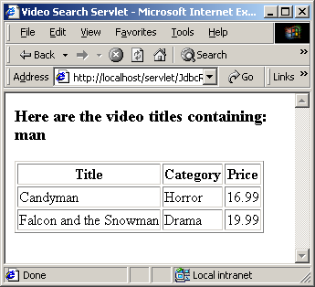

You will also get couple of error messages on Tomcat console since not methods are implemented properly for JdbcRowSet.

WebRowSet
WebRowSet is very similar to CacheRowSet – it is a disconnected row set. The cool thing about WebRowSet is the fact that it can read in or write out XML. XML will be discussed in greate detail later on. Here is an example of a WebRowSet generating XML output:

// Code 6J
import java.io.IOException;
import java.io.PrintWriter;
import java.io.StringWriter;
import java.sql.Connection;
import java.sql.PreparedStatement;
import java.sql.ResultSet;
import java.sql.SQLException;
import javax.naming.Context;
import javax.naming.InitialContext;
import javax.naming.NamingException;
import javax.servlet.ServletException;
import javax.servlet.http.HttpServlet;
import javax.servlet.http.HttpServletRequest;
import javax.servlet.http.HttpServletResponse;
import javax.sql.DataSource;
import sun.jdbc.rowset.WebRowSet;
public class WebRowSetServlet extends HttpServlet
{
public void doPost(HttpServletRequest request, HttpServletResponse response)
throws ServletException, IOException{
doGet(request,response);
}
public void doGet(HttpServletRequest request, HttpServletResponse response)
throws ServletException, IOException
{
// get the title from request
String title = (String) request.getParameter("title");
// get a handle on the print writer of response.
PrintWriter out=response.getWriter();
// generate response.
out.println("<HTML>");
out.println("<HEAD>");
out.println("<TITLE>");
out.println("Video Search Servlet");
out.println("</TITLE>");
out.println("</HEAD>");
out.println("<BODY>");
if (title==null){
// set the content type of response.
response.setContentType("text/html");
out.println("<H3>You did not specify any serach criteria</H3>");
out.println("</BODY>");
out.println("</HTML>");
return;
}
Context context =null;
DataSource datasource =null;
Connection con = null;
PreparedStatement query = null;
WebRowSet videos = null;
ResultSet rs = null;
try{
//create the context
context = new InitialContext();
// find the datasource
datasource = (DataSource) context.lookup("java:comp/env/jdbc/VStore");
// get a connection from the pool
con = datasource.getConnection();
// get data
query = con.prepareStatement("select * from Video_Recordings where video_title like ?");
query.setString(1,"%"+title+"%");
rs = query.executeQuery();
// instantiate
videos = new WebRowSet();
// populate
videos.populate(rs);
// close the connection but the RowSet should still hold data.
con.close();
StringWriter s = new StringWriter();
videos.writeXml(s);
out.println("<TEXTAREA name='xml' rows='40' cols='80' wrap='soft'>");
out.println(s.toString());
out.println("</TEXTAREA>");
}
catch(SQLException e){
System.out.println("\n--- SQLException caught ---\n");
while (e != null)
{
System.out.println("Message: " + e.getMessage());
System.out.println("SQLState: " + e.getSQLState());
System.out.println("Vendor ErrorCode: " + e.getErrorCode());
e = e.getNextException();
System.out.println();
}
}
catch(NamingException e){
System.out.println(e.toString());
}
finally
{
out.println("</BODY>");
out.println("</HTML>");
// since close methods throw sqlexception - catch 'em.
try{
videos.close();
query.close();
}
catch(Exception e){
//don't do anything - it is probably just a null pointer exception.
}
}
}
}

Stop and start Tomcat and hit the following url:

http://localhost:8080/servlet/WebRowSetServlet?title=the

Here is the output:
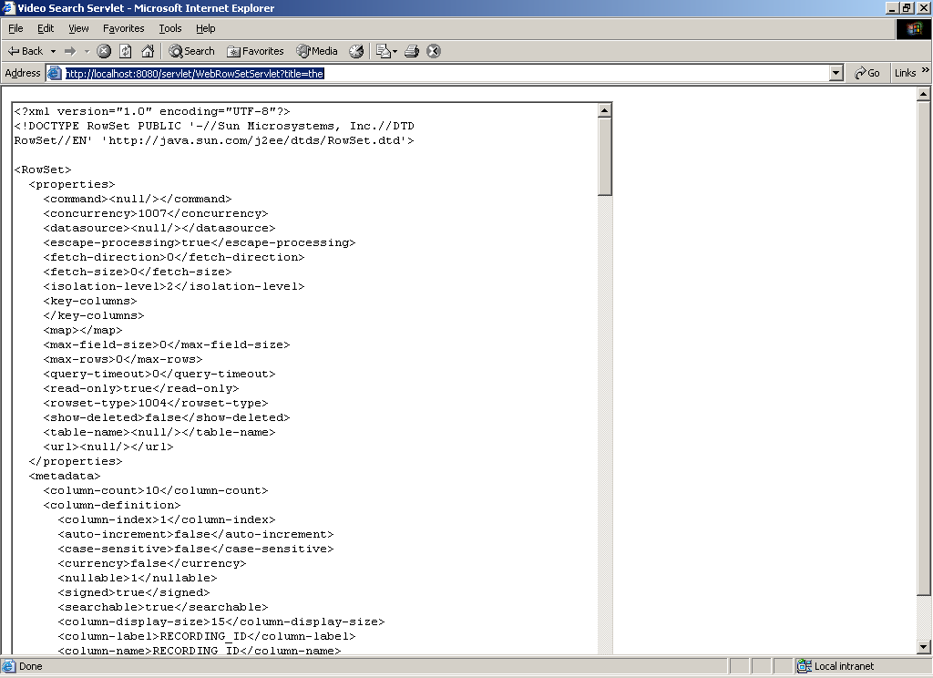
Here is the complete XML:
<?xml version="1.0" encoding="UTF-8"?>
<!DOCTYPE RowSet PUBLIC '-//Sun Microsystems, Inc.//DTD RowSet//EN' 'http://java.sun.com/j2ee/dtds/RowSet.dtd'>

<RowSet>
<properties>
<command><null/></command>
<concurrency>1007</concurrency>
<datasource><null/></datasource>
<escape-processing>true</escape-processing>
<fetch-direction>0</fetch-direction>
<fetch-size>0</fetch-size>
<isolation-level>2</isolation-level>
<key-columns>
</key-columns>
<map></map>
<max-field-size>0</max-field-size>
<max-rows>0</max-rows>
<query-timeout>0</query-timeout>
<read-only>true</read-only>
<rowset-type>1004</rowset-type>
<show-deleted>false</show-deleted>
<table-name><null/></table-name>
<url><null/></url>
</properties>
<metadata>
<column-count>10</column-count>
<column-definition>
<column-index>1</column-index>
<auto-increment>false</auto-increment>
<case-sensitive>false</case-sensitive>
<currency>false</currency>
<nullable>1</nullable>
<signed>true</signed>
<searchable>true</searchable>
<column-display-size>15</column-display-size>
<column-label>RECORDING_ID</column-label>
<column-name>RECORDING_ID</column-name>
<schema-name></schema-name>
<column-precision>5</column-precision>
<column-scale>0</column-scale>
<table-name>VIDEO_RECORDINGS</table-name>
<catalog-name></catalog-name>
<column-type>5</column-type>
<column-type-name>SMALLINT</column-type-name>
</column-definition>
<column-definition>
<column-index>2</column-index>
<auto-increment>false</auto-increment>
<case-sensitive>true</case-sensitive>
<currency>false</currency>
<nullable>1</nullable>
<signed>false</signed>
<searchable>true</searchable>
<column-display-size>255</column-display-size>
<column-label>VIDEO_TITLE</column-label>
<column-name>VIDEO_TITLE</column-name>
<schema-name></schema-name>
<column-precision>255</column-precision>
<column-scale>0</column-scale>
<table-name>VIDEO_RECORDINGS</table-name>
<catalog-name></catalog-name>
<column-type>12</column-type>
<column-type-name>VARCHAR</column-type-name>
</column-definition>
<column-definition>
<column-index>3</column-index>
<auto-increment>false</auto-increment>
<case-sensitive>true</case-sensitive>
<currency>false</currency>
<nullable>1</nullable>
<signed>false</signed>
<searchable>true</searchable>
<column-display-size>255</column-display-size>
<column-label>CATEGORY_NAME</column-label>
<column-name>CATEGORY_NAME</column-name>
<schema-name></schema-name>
<column-precision>255</column-precision>
<column-scale>0</column-scale>
<table-name>VIDEO_RECORDINGS</table-name>
<catalog-name></catalog-name>
<column-type>12</column-type>
<column-type-name>VARCHAR</column-type-name>
</column-definition>
<column-definition>
<column-index>4</column-index>
<auto-increment>false</auto-increment>
<case-sensitive>true</case-sensitive>
<currency>false</currency>
<nullable>1</nullable>
<signed>false</signed>
<searchable>true</searchable>
<column-display-size>255</column-display-size>
<column-label>IMAGE_NAME</column-label>
<column-name>IMAGE_NAME</column-name>
<schema-name></schema-name>
<column-precision>255</column-precision>
<column-scale>0</column-scale>
<table-name>VIDEO_RECORDINGS</table-name>
<catalog-name></catalog-name>
<column-type>12</column-type>
<column-type-name>VARCHAR</column-type-name>
</column-definition>
<column-definition>
<column-index>5</column-index>
<auto-increment>false</auto-increment>
<case-sensitive>false</case-sensitive>
<currency>false</currency>
<nullable>1</nullable>
<signed>true</signed>
<searchable>true</searchable>
<column-display-size>15</column-display-size>
<column-label>DURATION</column-label>
<column-name>DURATION</column-name>
<schema-name></schema-name>
<column-precision>52</column-precision>
<column-scale>0</column-scale>
<table-name>VIDEO_RECORDINGS</table-name>
<catalog-name></catalog-name>
<column-type>8</column-type>
<column-type-name>DOUBLE PRECISION</column-type-name>
</column-definition>
<column-definition>
<column-index>6</column-index>
<auto-increment>false</auto-increment>
<case-sensitive>true</case-sensitive>
<currency>false</currency>
<nullable>1</nullable>
<signed>false</signed>
<searchable>true</searchable>
<column-display-size>255</column-display-size>
<column-label>RATING</column-label>
<column-name>RATING</column-name>
<schema-name></schema-name>
<column-precision>255</column-precision>
<column-scale>0</column-scale>
<table-name>VIDEO_RECORDINGS</table-name>
<catalog-name></catalog-name>
<column-type>12</column-type>
<column-type-name>VARCHAR</column-type-name>
</column-definition>
<column-definition>
<column-index>7</column-index>
<auto-increment>false</auto-increment>
<case-sensitive>false</case-sensitive>
<currency>false</currency>
<nullable>1</nullable>
<signed>true</signed>
<searchable>true</searchable>
<column-display-size>15</column-display-size>
<column-label>YEAR_RELEASED</column-label>
<column-name>YEAR_RELEASED</column-name>
<schema-name></schema-name>
<column-precision>52</column-precision>
<column-scale>0</column-scale>
<table-name>VIDEO_RECORDINGS</table-name>
<catalog-name></catalog-name>
<column-type>8</column-type>
<column-type-name>DOUBLE PRECISION</column-type-name>
</column-definition>
<column-definition>
<column-index>8</column-index>
<auto-increment>false</auto-increment>
<case-sensitive>false</case-sensitive>
<currency>false</currency>
<nullable>1</nullable>
<signed>true</signed>
<searchable>true</searchable>
<column-display-size>15</column-display-size>
<column-label>PRICE</column-label>
<column-name>PRICE</column-name>
<schema-name></schema-name>
<column-precision>52</column-precision>
<column-scale>0</column-scale>
<table-name>VIDEO_RECORDINGS</table-name>
<catalog-name></catalog-name>
<column-type>8</column-type>
<column-type-name>DOUBLE PRECISION</column-type-name>
</column-definition>
<column-definition>
<column-index>9</column-index>
<auto-increment>false</auto-increment>
<case-sensitive>false</case-sensitive>
<currency>false</currency>
<nullable>1</nullable>
<signed>true</signed>
<searchable>true</searchable>
<column-display-size>15</column-display-size>
<column-label>STOCK_COUNT</column-label>
<column-name>STOCK_COUNT</column-name>
<schema-name></schema-name>
<column-precision>52</column-precision>
<column-scale>0</column-scale>
<table-name>VIDEO_RECORDINGS</table-name>
<catalog-name></catalog-name>
<column-type>8</column-type>
<column-type-name>DOUBLE PRECISION</column-type-name>
</column-definition>
<column-definition>
<column-index>10</column-index>
<auto-increment>false</auto-increment>
<case-sensitive>false</case-sensitive>
<currency>false</currency>
<nullable>1</nullable>
<signed>true</signed>
<searchable>true</searchable>
<column-display-size>15</column-display-size>
<column-label>DIRECTOR_ID</column-label>
<column-name>DIRECTOR_ID</column-name>
<schema-name></schema-name>
<column-precision>52</column-precision>
<column-scale>0</column-scale>
<table-name>VIDEO_RECORDINGS</table-name>
<catalog-name></catalog-name>
<column-type>8</column-type>
<column-type-name>DOUBLE PRECISION</column-type-name>
</column-definition>
</metadata>
<data>
<row>
<col>3004</col>
<col>Disco Godfather</col>
<col>Action & Adventure</col>
<col>disco_godfather.gif</col>
<col>5580.0</col>
<col>R</col>
<col>1993.0</col>
<col>17.99</col>
<col>91.0</col>
<col>18.0</col>
</row>
<row>
<col>3018</col>
<col>The Blues Brothers</col>
<col>Comedy</col>
<col>blues_brothers.gif</col>
<col>9180.0</col>
<col>R</col>
<col>1980.0</col>
<col>23.99</col>
<col>0.0</col>
<col>24.0</col>
</row>
<row>
<col>3020</col>
<col>Falcon and the Snowman</col>
<col>Drama</col>
<col>falcon_snowman.jpg</col>
<col>7860.0</col>
<col>R</col>
<col>1985.0</col>
<col>19.99</col>
<col>59.0</col>
<col>26.0</col>
</row>
<row>
<col>3053</col>
<col>The Silence of the Lambs</col>
<col>Suspense</col>
<col>silence_of_the_lambs.gif</col>
<col>7080.0</col>
<col>R</col>
<col>1991.0</col>
<col>17.99</col>
<col>51.0</col>
<col>29.0</col>
</row>
<row>
<col>3032</col>
<col>Friday the 13th Pt 1</col>
<col>Horror</col>
<col>friday_13th_part1.gif</col>
<col>5760.0</col>
<col>NR</col>
<col>1980.0</col>
<col>13.99</col>
<col>70.0</col>
<col>40.0</col>
</row>
</data>
</RowSet>

Notice all the information in the RowSet (including metadata, columns etc.) has been printed out in XML format.

Reading Assignment
- Beginning Java Databases – Chapter 10, 11, 18

Homework Assignment
  - Modify HW5 so that getConnection() method of VStoreDAO looks up DataSource in Tomcat’s JNDI context and uses it.
  - Modify getCategoryByType so that it returns CachedRowSet instead of ArrayList.
  - Modify CategoryByTypeServlet so that it deals with the changes in getCategoryByType method.

