Session 7 Introduction to JSP and JavaBeans

Objective
This session teaches students what JSP is all about. It covers all the basic elements of JSP and teaches how to integrate JavaBean with JSP.

JSP
Let’s step back for a minute. Let’s assume we know nothing about Servlets – all we know is static HTML. Here is a simple html page randomnumber.html that has a hardcoded random number:

randomnumber.html
<HTML>
<HEAD><TITLE>JSP Expression Demo</TITLE></HEAD>
<BODY><H3>Here is your random number: 56</H3>
</BODY>
</HTML>

Copy this page to c:\tomcat5028\webapps\ROOT folder. Start Tomcat and hit the page as:

http://localhost/randomnumber.html

You will get the following output:

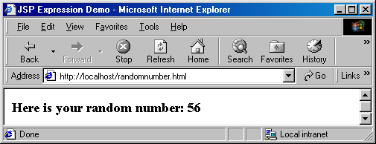

Ok – big deal!!

Now, let’s rename the file to randomnumber.jsp. It looks like a small step for you but it is giant step for mankind. Let’s hit the page:

http://localhost/randomnumber.jsp

The good news is the page is still rendered as the html page, the bad news is refreshing the page does not really dynamically give you new random numbers.

Alright, get go ahead and change the jsp page as follows:
randomnumber.jsp
<HTML>
<HEAD><TITLE>JSP Expression Demo</TITLE></HEAD>
<BODY><H3>Here is your random number: <%= (int) (Math.random()*100) %></H3>
</BODY>
</HTML>

This time you took a giant step for yourself not to mention mankind.

Let’s hit the page:

http://localhost/randomnumber.jsp

Now, we will start getting really random number and each refresh will bring you a new number as follows:

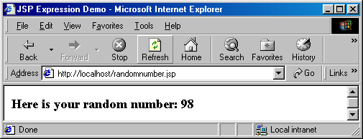

What happened? You just mixed static html with dynamic content without knowing the details behind it.

JavaServer Pages(JSP) technology allows you to mix regular, static HTML with dynamically generated content from servlets. Developing a JSP is really simple. You simply write your regular HTML page using your favorite web development tool. You then enclose the code for the dynamic parts using special tags (mostly with <%..%> tags). Although what you write often looks more like HTML file than a servlet, behind the scenes, the JSP page is automatically converted to a normal-servlet, with the static HTML simply being printed to the output steam associated with the servlet’s service() method. I guess, the basic difference between a servlet and a JSP is that, in case of servlet, you feel like you are writing Java code. Inside your Java code you print HTML tags whenever you need static content. In case of JSP, you feel like you are writing an HTML page. Inside your HTML page, you embed Java code whenever you need dynamic content. In other words, servlets are process driven approach whereas JSPs are presentation driven. But, behind the scenes, you are dealing with only one thing – servlets.

A JSP page obviously contains regular HTML but in addition there are three main types of JSP constructs that you embed in a page:

- Scripting Elements
- Directives
- Actions

Scripting elements let you specify Java code that will become part of the resultant servlet, directives let you control the overall structure of the servlet and actions let you specify existing components that should be used and otherwise control the behavior of the JSP engine.

Scripting Elements
JSP Scripting elements let you insert server-side java code into JSP pages. There are three forms of scripting elements:

- Expressions of the form <%= expression %> which are evaluated on the server and the results of the evaluation are rendered to the client. The expressions are inserted within Out.print() method into the JSP’s _jspService() method (exactly the way static HTMLs are) that is called by the service() method.
- Scriptlets of the form <% code %> which are inserted into the JSP’s _jspService() method. _jspService() method is called by service() method.
- Declarations of the form <%! code %> which are inserted into the body of JSP’s servlet class, outside of any existing methods.

In addition there is way to insert server-side comments in JSP page. These comments appear on the JSP page but not on the resulting HTML page. In order to put this type of comments you use :

<%-- JSP Comments --%>

Please keep in mind that HTML comments – which does appear on the HTML page - have a similar syntax:

<!—HTML Comments -->

Predefined Variable:
JSP pages have a set of predefined variables for programming convenience:

- request – represents HttpServletRequest
- response – represents HttpServletResponse
- out – represents PrintWriter that we get from a servlet by calling getWriter() method of HttpServletResponse
- session – represents HttpSession
- application – represents ServletContext
- config – represents ServletConfig
- pageContext – represents jsp PageContext.
- page – simply a synonym for this

JSP Expressions <%= …. %>
Here is an example of a simple JSP page that uses JSP expression:

randomnumber.jsp
<HTML>
<HEAD><TITLE>JSP Expression Demo</TITLE></HEAD>
<BODY><H3>Here is your random number: <%= (int) (Math.random()*100) %></H3>
</BODY>
</HTML>

Looks familiar? It’s the same page we saw few minutes ago.

The first time the JSP engine intercepts a request for a JSP, it compiles the JSP page into a sophisticated servlet. Here is the generated code for randomnumber.jsp found in c:\tomcat5028\work\localhost\_ folder:

package org.apache.jsp;
import javax.servlet.*;
import javax.servlet.http.*;
import javax.servlet.jsp.*;
import org.apache.jasper.runtime.*;
public class randomnumber_jsp extends HttpJspBase {
private static java.util.Vector _jspx_includes;
public java.util.List getIncludes() {
return _jspx_includes;
}
public void _jspService(HttpServletRequest request, HttpServletResponse response)
throws java.io.IOException, ServletException {
JspFactory _jspxFactory = null;
javax.servlet.jsp.PageContext pageContext = null;
HttpSession session = null;
ServletContext application = null;
ServletConfig config = null;
JspWriter out = null;
Object page = this;
JspWriter _jspx_out = null;
try {
_jspxFactory = JspFactory.getDefaultFactory();
response.setContentType("text/html;charset=ISO-8859-1");
pageContext = _jspxFactory.getPageContext(this, request, response,
null, true, 8192, true);
application = pageContext.getServletContext();
config = pageContext.getServletConfig();
session = pageContext.getSession();
out = pageContext.getOut();
_jspx_out = out;
out.write("<HTML>\r\n\t");
out.write("<HEAD>");
out.write("<TITLE>JSP Expression Demo");
out.write("</TITLE>");
out.write("</HEAD>\r\n\t");
out.write("<BODY>");
out.write("<H3>Here is your random number: ");
out.print( (int) (Math.random()*100) );
out.write("</H3>\r\n\t");
out.write("</BODY>\r\n");
out.write("</HTML>\r\n ");
} catch (Throwable t) {
out = _jspx_out;
if (out != null && out.getBufferSize() != 0)
out.clearBuffer();
if (pageContext != null) pageContext.handlePageException(t);
} finally {
if (_jspxFactory != null) _jspxFactory.releasePageContext(pageContext);
}
}
}

Notice request and response are coming to _jspService as input parameters and page, pageContext, application, config, session, out are being declared and initialized within the method. In other words, when we write a JSP page, these variables are not declared yet. By the time the JSP gets converted to servlet, these variables gets declared and initialized automatically.

As you can see above Tomcat is extending a HttpJspBase class for each JSP page. HttpJspBase is Tomcat’s own class that somehow extends HttpServlet and possibly implements some other interface.

When I ran javap (I hope you are familiar with javap) on HttpJspBase as follows:

javap org.apache.jasper.runtime.HttpJspBase, here is the output I found:

Compiled from HttpJspBase.java
public abstract class org.apache.jasper.runtime.HttpJspBase extends javax.servlet.http.HttpServlet implements javax.servlet.jsp.HttpJspPage {
protected javax.servlet.jsp.PageContext pageContext;
protected org.apache.jasper.runtime.HttpJspBase();
public abstract void _jspService(javax.servlet.http.HttpServletRequest, javax.servlet.http.HttpServletResponse) throws javax.servlet.ServletException, java.io.IOException;
public final void destroy();
protected java.lang.ClassLoader getClassLoader();
public java.lang.String getServletInfo();
public final void init(javax.servlet.ServletConfig) throws javax.servlet.ServletException;
public void jspDestroy();
public void jspInit();
public final void service(javax.servlet.http.HttpServletRequest, javax.servlet.http.HttpServletResponse) throws javax.servlet.ServletException, java.io.IOException;
public final void setClassLoader(java.lang.ClassLoader);
}

As you can see Tomcat’s HttpJspBase not only extends HttpServlet, it also implements HttpJspPage interface. We need to look at HttpJspPage interface but HttpJspPage interface extends JspPage interface. Therefore, we need to look at JspPage interface first.

JspPage Interface
This is the interface that a JSP processor-generated class must satisfy.

The interface defines a protocol with 3 methods; only two of them: jspInit() and jspDestroy() are part of this interface as the signature of the third method: _jspService() depends on the specific protocol used and cannot be expressed in a generic way in Java.
A class implementing this interface is responsible for invoking the above methods at the appropriate time based on the corresponding Servlet-based method invocations.

The jspInit() and jspDestroy() methods can be defined by a JSP author, but the _jspService() method is defined automatically by the JSP processor based on the contents of the JSP page. Here are two methods in the interface:

jspInit() | void | jspInit() is invoked when the JspPage is initialized. This is similar to the init() method in servlet. Page authors are free to provide initialization code of the JSP by implementing this method in their JSP page – although people rarely do.
jspDestroy() | void | jspDestroy() is invoked when the JspPage is about to be destroyed. This is similar to the destroy() method in servlet. Page authors are free to provide cleanup code of the JSP by implementing this method in their JSP page – although people rarely do.

HttpJspPage Interface
HttpJspPage interface extends JspPage interface. This is the interface that a JSP processor-generated class for the HTTP protocol must satisfy. There is only one method in this interface:

_jspService(HttpServletRequest request, HttpServletResponse response) | void | _jspService corresponds to the body of the JSP page – the entire body of a JSP page ends up here. This method is defined automatically by the JSP processor and should NEVER BE DEFINED BY THE JSP AUTHOR. This method is similar to service() method of servlet. Everytime a request comes to a JSP page, the service() method of the Servlet interface invokes this method.

JspFactory Class
If we examine the body of the _jspService() method carefully, we will see that the first thing that is being used is the JspFactory class. This abstract factory class provides mechanism to instantiate platform-dependent objects in a platform-independent manner. Typically, at initialization time, a JSP container like Tomcat will call the static setDefaultFactory() method on JspFactory in order to register object that is instantiated from Tomcat’s non-abstract subclass of JspFactory. Each servlet behind each JSP page will use the getDefaultFactory() method in order to obtain this factory object registered by the container and use it to construct PageContext instance to process the request.

setDefaultFactory(JspFactory deflt) | static void | set the default factory object instantiated from the non-abstract subclass of JspFactory for this implementation.
getDefaultFactory() | static JspFactory | called to get the default factory instantiated from the non-abstract subclass of JspFactory implemented by this container.
getPageContext(Servlet servlet, ServletRequest request, ServletResponse response, String errorPageURL, boolean needsSession, int buffer, boolean autoflush) | abstract PageContext | obtains an instance of an page context object instantiated from a subclass of PageContext abstract class implemented by this container for the calling Servlet and currently pending request and response.
releasePageContext(PageContext pc) | abstract void | called to release a previously allocated PageContext object.
getEngineInfo() | abstract JspEngineInfo | called to get implementation-specific information on the current JSP engine

PageContext Class
_jspService() method calls the getPageContext() method on the default factory that returns an object instantiated by the container from non-abstract subclass of PageContext class. PageContext is an abstract class that encapsulates the container from the servlet behind JSP. A servlet generated by a JSP page in Tomcat (for eaxample the servlet above) can run unmodified in any other container (like JRUN) because of PageContext indirection that it uses. Not only that, the servlet will be able to take advantage of container specific performance improvements like high performance JspWriter of the container it ends up executing in, without any knowledge of the actual implementation of JspWriter.

PageContext provides a number of facilities, including:

- A single API that manages the operations like setAttribut(), getAttribute etc. over various scope namespaces like page, request, session, application etc.
- A mechanism for obtaining a platform-dependent implementatin of the JspWriter that is assigned to the “out” variable.
- A number of convenient getter methods like getSession(), getServletContext() etc.
- Mechanisms to forward or include.

Here are the methods of PageContext:

getOut() | abstract JspWriter | The current value of the out object (a JspWriter).
getPage() | abstract Object | The current value of the page object (a Servlet).
getRequest() | abstract ServletRequest | The current value of the request object (a ServletRequest).
getResponse() | abstract ServletResponse | The current value of the response object (a ServletResponse).
getServletConfig() | abstract ServletConfig | The ServletConfig instance.
getServletContext() | abstract ServletContext | The ServletContext instance.
getSession() | abstract HttpSession | The current value of the session object (an HttpSession).
initialize(Servlet servlet, ServletRequest request, ServletResponse response, java.lang.String errorPageURL, boolean needsSession, int bufferSize, boolean autoFlush) | abstract void | The initialize method is called to initialize an uninitialized PageContext so that it may be used by a JSP Implementation class to service an incoming request and response within it's _jspService() method.
findAttribute(String name) | abstract Object | Searches for the named attribute in page, request, session (if valid), and application scope(s) in order and returns the value associated or null.
setAttribute(String name, Object attribute) | abstract void | Register the name and object specified with page scope semantics.
setAttribute(String name, Object o, int scope) | abstract void | register the name and object specified with appropriate scope semantics
getAttribute(String name) | abstract Object | Return the object associated with the name in the page scope or null if not found.
getAttribute(String name, int scope) | abstract Object | Return the object associated with the name in the specified scope or null if not found.
removeAttribute(String name) | abstract void | Remove the object reference associated with the given name, look in all scopes in the scope order.
removeAttribute(String name, int scope) | abstract void | Remove the object reference associated with the specified name in the given scope.
getAttributesScope(String name) | abstract int | Get the scope where a given attribute is defined.
getAttributeNamesInScope(int scope) | abstract Enumeration | Enumerate all the attributes in a given scope
getException() | abstract Exception | The current value of the exception object (an Exception).
handlePageException(Exception e) | abstract void | This method is intended to process an unhandled "page" level exception by redirecting the exception to either the specified error page for this JSP, or if none was specified, to perform some implementation dependent action.
handlePageException(Throwable t) | abstract void | This method is identical to the handlePageException(Exception), except that it accepts a Throwable.
forward(String relativeUrlPath) | abstract void | This method is used to re-direct, or "forward" the current ServletRequest and ServletResponse to another active component in the application.
include(java.lang.String relativeUrlPath) | abstract void | Causes the resource specified to be processed as part of the current ServletRequest and ServletResponse being processed by the calling Thread.
popBody() | JspWriter | Return the previous JspWriter "out" saved by the matching pushBody(), and update the value of the "out" attribute in the page scope attribute namespace of the PageConxtext
pushBody() | BodyContent | Return a new BodyContent object, save the current "out" JspWriter, and update the value of the "out" attribute in the page scope attribute namespace of the PageContext
release() | abstract void | This method shall "reset" the internal state of a PageContext, releasing all internal references, and preparing the PageContext for potential reuse by a later invocation of initialize().

JspWriter Class
Surprisingly, the getOut() method of the PageContext returns JspWriter object as opposed to getWriter() method of response that returns PrintWriter.

This abstract JspWriter class emulates some of the functionality found in the BufferedWriter and PrintWriter classes, however it differs in that it throws java.io.IOException from even the print() methods while PrintWriter does not.

There are a couple of reasons for having this class. The initial JspWriter object is associated with the PrintWriter object of the ServletResponse in a way that depends on whether the page is or is not buffered. If the page is not buffered, output written to this JspWriter object will be written through to the PrintWriter directly, which will be created if necessary by invoking the getWriter() method on the response object. But if the page is buffered, the PrintWriter object will not be created until the buffer is flushed and operations like setContentType() are legal. Since this flexibility simplifies programming substantially, buffering is the default for JSP pages.

The methods of JspWriter is pretty much the same as PrintWriter (it has overloaded print() and println() methods) except for the fact that it has additional buffer related methods like isAutoFlush(), clear() clearBufffer(), getRemaining() etc.

JSP Scriptlets <% … %>
If we want to do something more complex than inserting a simple expression, JSP scriptlets let you insert arbitrary code in the JSP page’s _jspService method.

Scriptlets have access to the same set of automatically defined variables such as session, application etc. If you want your output to appear in the resultant page, you will use the out variable.

In general, scriptlets can do things that can’t be accomplished with expressions alone. For example, setting the response headers, status code, updating database, loops, conditional statements etc. can only be done in scriptlets.

Here is an example of a JSP page using scriptlets:

color.jsp
<HTML>
<HEAD><TITLE>Color JSP</TITLE></HEAD>
<%
String color=request.getParameter("color");
boolean found=true;
if (color==null){
color="white";
found=false;
}
%>
<BODY bgColor="<%= color %>">
<%
if (found){
out.println("<H3>Here is your backcolor: " + color + "<H3>");
}
else{
out.println("<H3>Using default white backcolor</H3>");
}
%>
<FORM method="GET">
<TABLE>
<TR><TD>Backgroud Color Please</TD><TD><INPUT type="text" name="color" value=<%= color %> size=20></TD></TR>
</TABLE>
<BR><BR>
<INPUT type="submit" value="Send"> <input type="reset" value="Clear">
</FORM>
</BODY>
</HTML>

Here is the output:
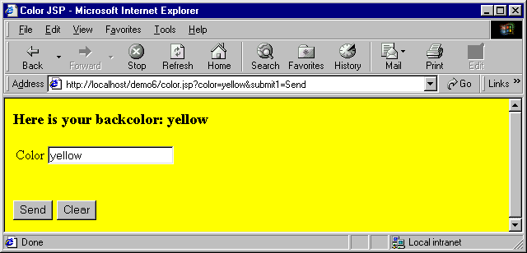

There are few things to notice above. There is no “Action” attribute of the FORM tag. What that means is that the page will call itself everytime you submit – this has nothing to do with jsp, that’s how form action works – if not specified returns itself. Variable “color” declared in one scriptlet are accessed from another scriptlet. That’s because all the scriptlets go into one _jspService() method. Also, notice that response remembers the color value from previous request. The trick to do this is to put it on the value of the input text box, to be specific, value=<%= color %> does the trick as follows:

<INPUT type="text" name="color" value=<%= color %> size=20>

Here is the servlet that Tomcat generates for color.jsp found in c:\tomcat5028\work\localhost\_ folder::

package org.apache.jsp;
import javax.servlet.*;
import javax.servlet.http.*;
import javax.servlet.jsp.*;
import org.apache.jasper.runtime.*;
public class color_jsp extends HttpJspBase {
private static java.util.Vector _jspx_includes;
public java.util.List getIncludes() {
return _jspx_includes;
}
public void _jspService(HttpServletRequest request, HttpServletResponse response)
throws java.io.IOException, ServletException {
JspFactory _jspxFactory = null;
javax.servlet.jsp.PageContext pageContext = null;
HttpSession session = null;
ServletContext application = null;
ServletConfig config = null;
JspWriter out = null;
Object page = this;
JspWriter _jspx_out = null;
try {
_jspxFactory = JspFactory.getDefaultFactory();
response.setContentType("text/html;charset=ISO-8859-1");
pageContext = _jspxFactory.getPageContext(this, request, response,
null, true, 8192, true);
application = pageContext.getServletContext();
config = pageContext.getServletConfig();
session = pageContext.getSession();
out = pageContext.getOut();
_jspx_out = out;
out.write("<HTML>\r\n");
out.write("<HEAD>");
out.write("<TITLE>Color JSP");
out.write("</TITLE>");
out.write("</HEAD>\r\n");
String color=request.getParameter("color");
boolean found=true;
if (color==null){
color="white";
found=false;
}
out.write("\r\n");
out.write("<BODY bgColor=\"");
out.print( color );
out.write("\">\r\n");
if (found){
out.println("<H3>Here is your backcolor: " + color + "<H3>");
}
else{
out.println("<H3>Using default white backcolor</H3>");
}
out.write("\r\n");
out.write("<FORM method=\"GET\">\r\n");
out.write("<TABLE>\r\n");
out.write("<TR>");
out.write("<TD>Backgroud Color Please");
out.write("</TD>");
out.write("<TD>");
out.write("<INPUT type=\"text\" name=\"color\" value=");
out.print( color );
out.write(" size=20>");
out.write("</TD>");
out.write("</TR>\r\n");
out.write("</TABLE>\r\n");
out.write("<BR>");
out.write("<BR> \r\n");
out.write("<INPUT type=\"submit\" value=\"Send\"> ");
out.write("<input type=\"reset\" value=\"Clear\">\r\n");
out.write("</FORM>\r\n");
out.write("</BODY>\r\n");
out.write("</HTML>\r\n");
} catch (Throwable t) {
out = _jspx_out;
if (out != null && out.getBufferSize() != 0)
out.clearBuffer();
if (pageContext != null) pageContext.handlePageException(t);
} finally {
if (_jspxFactory != null) _jspxFactory.releasePageContext(pageContext);
}
}
}

Notice how Jsp Expressions (<%= … %>) are appearing within out.print and Jsp Scriplets (<% .. %>) are appearing as pure code within _jspService() method sequentially.

JSP Declarations <%! … %>
A JSP declaration lets you define fields and methods that gets inserted into the resultant servlet outside of the _jspService() method. Please keep in mind that the same instance of a servlet (generated from a JSP page) may be accessed by multiple clients (unless the servlet implements SingleThreadModel). Therefore, you have to careful about defining fields in a JSP page.

Here is a JSP page that counts the number of hits to the page.

hitcount.jsp
<HTML>
<HEAD><TITLE>JSP Declaration Demo</TITLE></HEAD>
<%! private int count=0; %>
<%
synchronized (page){
++count;
}
%>
<BODY><H3>This page has been visited: <%= count %> times </H3>
</BODY>
</HTML>

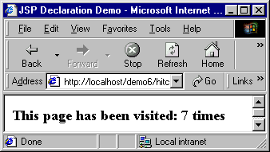
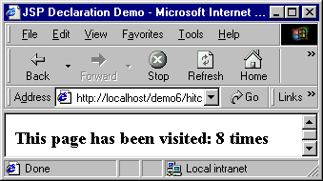
Here are the outputs from two instances of browser:

Notice that the hit count in cumulating regardless of the browsers.

Here is the servlet behind the scene found in c:\tomcat5028\work\localhost\_ folder::

package org.apache.jsp;
import javax.servlet.*;
import javax.servlet.http.*;
import javax.servlet.jsp.*;
import org.apache.jasper.runtime.*;
public class hitcount_jsp extends HttpJspBase {
private int count=0;
private static java.util.Vector _jspx_includes;
public java.util.List getIncludes() {
return _jspx_includes;
}
public void _jspService(HttpServletRequest request, HttpServletResponse response)
throws java.io.IOException, ServletException {
JspFactory _jspxFactory = null;
javax.servlet.jsp.PageContext pageContext = null;
HttpSession session = null;
ServletContext application = null;
ServletConfig config = null;
JspWriter out = null;
Object page = this;
JspWriter _jspx_out = null;
try {
_jspxFactory = JspFactory.getDefaultFactory();
response.setContentType("text/html;charset=ISO-8859-1");
pageContext = _jspxFactory.getPageContext(this, request, response,
null, true, 8192, true);
application = pageContext.getServletContext();
config = pageContext.getServletConfig();
session = pageContext.getSession();
out = pageContext.getOut();
_jspx_out = out;
out.write("<HTML>\r\n\t");
out.write("<HEAD>");
out.write("<TITLE>JSP Declaration Demo");
out.write("</TITLE>");
out.write("</HEAD>\r\n\t");
out.write("\r\n\t");
synchronized (page){
++count;
}
out.write("\r\n\t");
out.write("<BODY>");
out.write("<H3>This page has been visited: ");
out.print( count );
out.write(" times ");
out.write("</H3>\r\n\t");
out.write("</BODY>\r\n");
out.write("</HTML>\r\n");
} catch (Throwable t) {
out = _jspx_out;
if (out != null && out.getBufferSize() != 0)
out.clearBuffer();
if (pageContext != null) pageContext.handlePageException(t);
} finally {
if (_jspxFactory != null) _jspxFactory.releasePageContext(pageContext);
}
}
}

Notice that “private int count=0;” got inserted in the body of the class outside of the _jspService() method.

JSP Directives <%@ …. %>
A JSP Directive effects the overall structure of the servlet that results from the JSP page. A page directive looks as follows:

<%@ directivename attribute1=”value1” attribute2=”value2” ….. attributeN=”valueN” %>

Single quotes can be used instead of double quotes but can not be omitted altogether. To obtain quote marks you have to use \” (slash as the escape character).

In JSP there are three types of directives:

- page
- include
- taglib

The Page Directive <%@ page …. %>
The page directive lets you control the structure (and behavior) of the servlet. The page directive has the following attributes:

Attribute | Description | Default Value
language | Defines the scripting language to be used in the JSP page. This attribute is for future use when JSP supports multiple language. | “Java”
extends | This value is a fully qualified class name of the superclass that the generated servlet class should extend from. In general, you can’t use it since the container has to subclass certain class already. In case of Tomcat, it subclasses HttpJspBase class. | Omitted by default.
import | Comma separated list o packages or classes that you would like to import for convenience. | Omitted by default.
session | Specifies whether the page participates in session. When is value is true(default) a variable names session is available and can be used to access the session. | “true”
buffer | Specifies the buffering model for the output. If the value is “none”, then no buffering occurs and the all output is written directly to the response. | Depends on container – at least 8 KB.
autoFlash | If “true” the output buffer to the client is flushed automatically when it is full. If “false” a runtime exception is raised to indicate that buffer overflow. | “true”
isThreadSafe | Defines the thread safety of the page. If the value is “true” the JSP engine can send multiple client request to the same instance of the of the page servlet. | “true”
Info | Defines information string that can be retrieved from the servlet’s getServletInfo() method | Omitted by default.
errorPage | Defines the URL of another page, which is included if an unchecked runtime exception is thrown. The page catches the exception and passes it to the error processing page. | Omitted by default.
isErrorPage | Indicates if the current page itself is intended to be the error page of another page. If “true” an implicit variable exception is available that has the runtime exception information. | “false”
ContentType | Defines the MIME type and character encoding of the JSP page. | The default value for the MIMETYPE is text/html and the default value for the CHARSET is ISO-8859-1.

Here is a page that uses all of the above page directives:

number.jsp
<%@ page language="Java" import="java.util.*,java.math.*" session="true" buffer="12kb"
autoFlush="true" isThreadSafe="true" info="'My test page" errorPage="error.jsp"
isErrorPage="false" contentType="text/html;CHARSET=ISO-8859-1"%>
<HTML>
<HEAD><TITLE>Number JSP</TITLE></HEAD>
<%
String number = request.getParameter("number");
boolean found=true;
if (number==null){
found=false;
number="";
}
%>
<BODY>
<%
if (found){
int num=0;
num=Integer.parseInt(number);
// If I make it here - no number format exception.
out.println("<H3>Here is your number: " + num + "<H3>");
}
%>
<FORM method="GET">
<TABLE>
<TR>
<TD>Please enter a number</TD>
<TD><INPUT type="text" name="number" value="<%= number %>" size=20></TD>
</TR>
</TABLE>
<BR><BR>
<INPUT type="submit" name="send" value="Send"> <input type="reset" value="Clear">
</FORM>
</BODY>
</HTML>

Here is error.jsp
<%@ page language="Java" session="true" buffer="12kb" autoFlush="true" isThreadSafe="true"
info="'My error page" isErrorPage="true" contentType="text/html;CHARSET=ISO-8859-1"%>
<HTML>
<HEAD><TITLE>Error JSP</TITLE></HEAD>
<BODY>
<H3>Error: <%=exception.toString() %></H3>
</BODY>
</HTML>

Here is the output of number.jsp when you enter a good number:

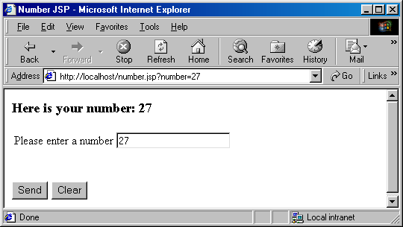

Here is the output of error.jsp when you enter text:

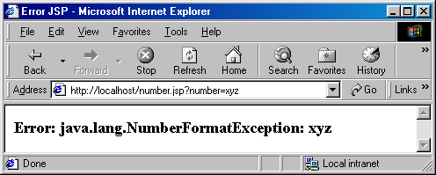

Here is the servlet behind number.jsp:

package org.apache.jsp;
import javax.servlet.*;
import javax.servlet.http.*;
import javax.servlet.jsp.*;
import org.apache.jasper.runtime.*;
import java.util.*;
import java.math.*;
public class number_jsp extends HttpJspBase {
public String getServletInfo() {
return "'My test page";
}
private static java.util.Vector _jspx_includes;
public java.util.List getIncludes() {
return _jspx_includes;
}
public void _jspService(HttpServletRequest request, HttpServletResponse response)
throws java.io.IOException, ServletException {
JspFactory _jspxFactory = null;
javax.servlet.jsp.PageContext pageContext = null;
HttpSession session = null;
ServletContext application = null;
ServletConfig config = null;
JspWriter out = null;
Object page = this;
JspWriter _jspx_out = null;
try {
_jspxFactory = JspFactory.getDefaultFactory();
response.setContentType("text/html;CHARSET=ISO-8859-1;charset=ISO-8859-1");
pageContext = _jspxFactory.getPageContext(this, request, response,
"error.jsp", true, 12288, true);
application = pageContext.getServletContext();
config = pageContext.getServletConfig();
session = pageContext.getSession();
out = pageContext.getOut();
_jspx_out = out;
out.write("\r\n");
out.write("<HTML>\r\n");
out.write("<HEAD>");
out.write("<TITLE>Number JSP");
out.write("</TITLE>");
out.write("</HEAD>\r\n");
String number = request.getParameter("number");
boolean found=true;
if (number==null){
found=false;
number="";
}
out.write("\r\n");
out.write("<BODY>\r\n");
if (found){
int num=0;
num=Integer.parseInt(number);
// If I make it here - no number format exception.
out.println("<H3>Here is your number: " + num + "<H3>");
}
out.write("\r\n");
out.write("<FORM method=\"GET\">\r\n");
out.write("<TABLE>\r\n");
out.write("<TR>\r\n");
out.write("<TD>Please enter a number");
out.write("</TD>\r\n");
out.write("<TD>");
out.write("<INPUT type=\"text\" name=\"number\" value=\"");
out.print( number );
out.write("\" size=20>");
out.write("</TD>\r\n");
out.write("</TR>\r\n");
out.write("</TABLE>\r\n");
out.write("<BR>");
out.write("<BR> \r\n");
out.write("<INPUT type=\"submit\" name=\"send\" value=\"Send\"> ");
out.write("<input type=\"reset\" value=\"Clear\">\r\n");
out.write("</FORM>\r\n");
out.write("</BODY>\r\n");
out.write("</HTML>\r\n");
} catch (Throwable t) {
out = _jspx_out;
if (out != null && out.getBufferSize() != 0)
out.clearBuffer();
if (pageContext != null) pageContext.handlePageException(t);
} finally {
if (_jspxFactory != null) _jspxFactory.releasePageContext(pageContext);
}
}
}

Here is the servlet behind error.jsp:

package org.apache.jsp;
import javax.servlet.*;
import javax.servlet.http.*;
import javax.servlet.jsp.*;
import org.apache.jasper.runtime.*;
public class error_jsp extends HttpJspBase {
public String getServletInfo() {
return "'My error page";
}
private static java.util.Vector _jspx_includes;
public java.util.List getIncludes() {
return _jspx_includes;
}
public void _jspService(HttpServletRequest request, HttpServletResponse response)
throws java.io.IOException, ServletException {
JspFactory _jspxFactory = null;
javax.servlet.jsp.PageContext pageContext = null;
HttpSession session = null;
Throwable exception = (Throwable) request.getAttribute("javax.servlet.jsp.jspException");
ServletContext application = null;
ServletConfig config = null;
JspWriter out = null;
Object page = this;
JspWriter _jspx_out = null;
try {
_jspxFactory = JspFactory.getDefaultFactory();
response.setContentType("text/html;CHARSET=ISO-8859-1;charset=ISO-8859-1");
pageContext = _jspxFactory.getPageContext(this, request, response,
null, true, 12288, true);
application = pageContext.getServletContext();
config = pageContext.getServletConfig();
session = pageContext.getSession();
out = pageContext.getOut();
_jspx_out = out;
out.write("\r\n");
out.write("<HTML>\r\n\t");
out.write("<HEAD>");
out.write("<TITLE>Error JSP");
out.write("</TITLE>");
out.write("</HEAD>\r\n\t");
out.write("<BODY>\r\n\t");
out.write("<H3>Error: ");
out.print(exception.toString() );
out.write("</H3>\r\n\t");
out.write("</BODY>\r\n");
out.write("</HTML>\r\n");
} catch (Throwable t) {
out = _jspx_out;
if (out != null && out.getBufferSize() != 0)
out.clearBuffer();
if (pageContext != null) pageContext.handlePageException(t);
} finally {
if (_jspxFactory != null) _jspxFactory.releasePageContext(pageContext);
}
}
}

Notice the extra exception variable available and initialized in this error page. That’s what “isErrorPage=true” directive does.

Limitation of Page Directive
We want to generate Excel spreadsheet by specifying content type as application/vnd.ms-excel only if the browser supports Excel and by formatting the content as HTML table. Excel can present HTML table as Excel table. But page attribute values can not be computed at run-time, nor can page directives be conditionally inserted. Here is the work-around:

excel.jsp
<%@ page import="java.util.*" %>
<%
boolean excel=true;
String accept=request.getHeader("Accept");
if (accept==null){
excel=false;
}
else{
if (accept.indexOf("ms-excel")>= 0){
excel=true;
}
}
if (excel){
response.setContentType("application/vnd.ms-excel");
}
%>
<HTML>
<HEAD><TITLE>Excel JSP</TITLE></HEAD>
<BODY>
<TABLE BORDER="1">
<TR><TH>&nbsp</TH><TH>Grades</TH><TH>&nbsp</TH></TR>
<TR><TH>Name</TH><TH>Assignment 1</TH><TH>Assignment 2</TH></TR>
<TR><TD>John Smith</TD><TD>10</TD><TD>9</TD></TR>
<TR><TD>Bill Bond</TD><TD>10</TD><TD>10</TD></TR>
<TR><TD>Sue Lee</TD><TD>9</TD><TD>10</TD></TR>
</TABLE>
</BODY>
</HTML>

Here is the output:

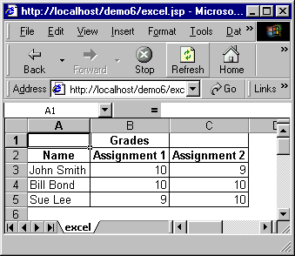

The Include Directive <%@ include …. %>
The include directive instructs the container to include the content of a file in the current JSP, by inserting it, inline, in the JSP in place of the directive. It is important to note that the content of the included file is parsed and inserted during the translation time – when the JSP page is compiled into a servlet – which typically happens when the first time the page is accessed. The syntax is as follows:

<%@ include file =”Relative URL” %>

There are two ramifications of the fact that the included file is inserted at translation time not at request time:

- The included file is permitted to have JSP code not just static HTML. However, the content of the included file is inserted by the container during the translation to servlet.
- If the static contain of the included file changes, all the JSP pages that use is needs to be updated. Although, most JSP containers usually keep track of the included file and recompiles the JSP if it changes – the containers are not mandated to do so. For example, Tomcat does not do this – you have to manually update the included files.

In order to get dynamic request time include, you have to use jsp:include – which is discussed later.

Here is an example of a file that is included at translation time.

translationtime.jsp
<%@ page import="java.util.Date" %>
This line is included at translation time.
<p>
The Current Server Date and Time is <%=new Date() %> (From translationtime.jsp)

Here is the file that includes the above file using include directive:

icludedrectivedemo.jsp
<HTML>
<HEAD><TITLE> Include Directive Demo</TITLE></HEAD>
<BODY>
<%@ page import="java.util.Date" %>
<%@ include file="translationtime.jsp" %>
<p>
This line is included at response time.
<p>
The Current Server Date and Time is <%=new Date() %> (From includedirectivedemo.jsp)
</BODY>
</HTML>

Here is what the output looks like when we hit includedirectivedemo.jsp

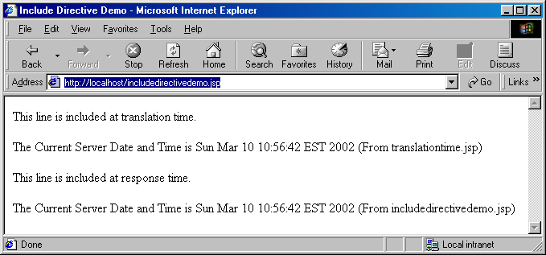

Now, let’s change the translationtime.jsp to the follows:

<%@ page import="java.util.Date" %>
Here is a change - we will not see this change.
<p>
The Current Server Date and Time is <%=new Date() %> (From translationtime.jsp)

If we run the file again, here is the output we get:
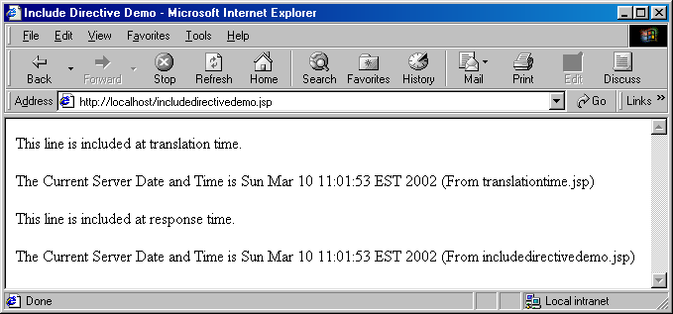

As you can see, the output has not changed a bit. However, the server time is correct for both include file and main file. Which simply implies that the problem is actually on the static part of the include file not on the dynamic part.

In other words, the lines from translationtime.jsp is literally added in includedirectivedemo.jsp first time we hit the jsp and it did not change if translationtime.jsp changed since translationtime.jsp is merely a include jsp and the container has no obligation to keep track of its changes. However, if we change one thing in includedirectivedemo.jsp so that it needs to be recompiled – the new version of translationtime.jsp will be automatically inserted and everything will be ok.

The taglib Directive <jsp: …. >
The taglib directive allows the page to use custom tags on a JSP page. The taglib directive will be discussed later in details along with custom tags.

Standard Actions
Standard actions are tags that affect the runtime behavior of the JSP and the response sent back to the client. Effectively, a standard action is a tag that can be embedded in a JSP page. During compilation into a servlet, the container comes across this tag and replaces it with Java code that corresponds to the required predefined task.

The standard action types are:

- <jsp:useBean>
- <jsp:setProperty>
- <jsp:getProperty>
- <jsp:param>
- <jsp:include>
- <jsp:forward>
- <jsp:plugin>

<jsp:useBean>, <jsp:setPropety> and <jsp:getProperty> will be discussed later with JavaBean.

<jsp: param>
The <jsp:Param> action is used to provide other tags with additional information in the form of name-value pairs. It is used with <jsp:include>, <jsp:forward>, <jsp:plugin> actions as shown below. The syntax is:

<jsp:param name=”paramname” value=”paramvalue”/>

<jsp:include>
This action allows a static or dynamic resource, specified by a URL, to be included in the current JSP at request processing time. An included page has access to only the JspWriter object, and it can not set headers or cookies. The included file can not contain other JSPs but itself can contain JSP contents. This action internally uses RequestDispatcher’s include() method, which is what servlet uses. The syntax is:

<jsp:include page=”pagename” flush=”true”/>

or

<jsp:include page=”pagename” flush=”true”>
<jsp:param name=”paramname” value=”paramvalue”/>
</jsp:include>

The attributes of the <jsp:include> action are:

Attribute | Description
page | The page to be included.
flush | The buffer in the output stream is flushed before the inclusion is performed. In JSP 1.1 this value must always be “true”

A <jsp:include> action may have one or more <jsp:param> tags in its body, providing additional name-value pairs. The included page can access the original request object, which will contain both original parameters, and the new parameters specified using <jsp: param> tag. If the parameter names are the same, the old values are kept intact, but the new values take precedence over the existing values.

Here is a jsp that uses <jsp:include>:
jspincludedemo.jsp
<HTML>
<HEAD><TITLE> JSP Include Demo</TITLE></HEAD>
<BODY>
<%@ page import="java.util.Date" %>
<jsp:include page="runtime.jsp" flush="true" />
<p>
This line is included at response time.
<p>
The Current Server Date and Time is <%=new Date() %> (From jspincludedemo.jsp)
</BODY>
</HTML>

Here is the included page:
runtime.jsp
<%@ page import="java.util.Date" %>
This line is included at run time.
<p>
The Current Server Date and Time is <%=new Date() %> (From runtime.jsp)

Here is the output:

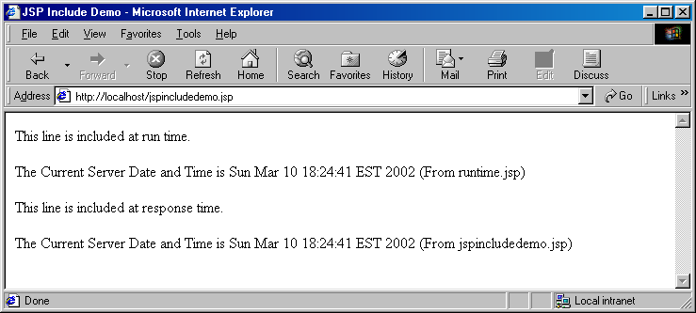

Now, if I change the included page runtime.jsp as follows:
runtime.jsp
<%@ page import="java.util.Date" %>
This line has just been changed. This line is included at run time.
<p>
The Current Server Date and Time is <%=new Date() %> (From runtime.jsp)

Here the output:
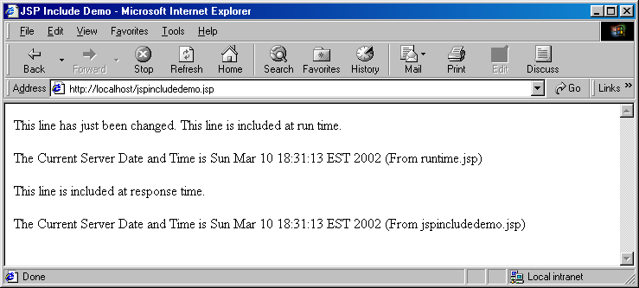

<jsp:forward>
This action allows the request to be forwarded to another JSP, to a servlet, or to a static HTML page. specified by a URL. This action internally uses RequestDispatcher’s forward() method, which is what servlet uses. The resource to which the request is being forwarded must be in the same context as the JSP dispatched the quest. Execution in the current JSP stops when it encounters a <jsp:forward> tag, the buffer is cleared, and the request is forwarded. The syntax is:

<jsp:forward page=”pagename”/>

or

<jsp:forward page=”pagename”>
<jsp:param name=”paramname” value=”paramvalue”/>
</jsp:forward>

Here is a jsp that uses <jsp:forward>:

jspforwarddemo.jsp
<HTML>
<HEAD><TITLE> JSP Forward Demo</TITLE></HEAD>
<BODY>
<%@ page import="java.util.Date" %>
<p>
This is the original page.
<p>
The Current Server Date and Time is <%=new Date() %> (From jspforwarddemo.jsp)
<jsp:forward page="next.jsp" />
</BODY>
</HTML>

Here is next.jsp where it forwards:
next.jsp
<%@ page import="java.util.Date" %>
This is the next page.
<p>
The Current Server Date and Time is <%=new Date() %> (From next.jsp)

Here is the output:

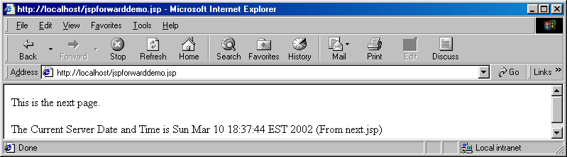

Notice that the output from the original jsp disappeared. That’s ‘cause the buffer is cleared
<jsp:plugin>
This action is used in pages to generate client browser specific HTML tags (<BOJECT> or <EMBED>) that result in the download of the java plug-in software, if required, followed by the execution of the component specified in the tag.

The <jsp:plugin> tag can optionally have <jsp:fallback> tag which allows to specify the content to be displayed in the client browser if the plugin cannot be started ( exactly like HTML ALT attribute) as well as <jsp:params> tag. The syntax is:

<jsp:plugin type=”bean|applet” code=”CodeName” codebase=”CodeBaseName” align=”Alignment” archive=”ArchiveList” height=”Height” width=”Width” hspace=”Hspace” vspace=”Vspace” jreversion=”JREversion” name=”ComponentName” nspluginurl=”Netscape Plugin URL” iepluginurl=”IE Plugin URL”/>

or

<jsp:plugin type=”bean|applet” code=”CodeName” codebase=”CodeBaseName” align=”Alignment” archive=”ArchiveList” height=”Height” width=”Width” hspace=”Hspace” vspace=”Vspace” jreversion=”JREversion” name=”ComponentName” nspluginurl=”Netscape Plugin URL” iepluginurl=”IE Plugin URL”>
<jsp:params>
<jsp:param name=”paramname” value=”paramvalue”/>
</jsp:params>
<jsp:fallback> Alternate text </jsp:fallback>
</jsp:plugin>

JavaBeans
To separate code from presentation, it would be a good idea to encapsulate the code in a java object (a JavaBean) and then instantiate and the use this object within our JSP. The <jsp:useBean>, <jsp:setProperty> and <jsp:getProperty> tags assist with this task. JavaBean is a simple java class with the following characteristics:

- A bean class must have a zero-argument (empty) constructor.
- A bean class should have no public instance variables (fields)
- Persistent values should be accessed through setXxx() and getXxx() methods. The only exception to this naming convention is with Boolean fields – instead of getXxx() it should be isXxx().

<jsp:useBean>
This action is used to instantiate a JavaBean, or locate an existing bean instance, and assign it to a variable name. We can specify the lifetime of the object by giving it a scope. The syntax is:

<jsp:useBean id=”BeanID” scope=”scopeName” class=”ClassName” beanName=”BeanName” type=”ClassName”/>

The attributes of the <jsp:useBean> action are:

Attribute | Description | Default Value
Id | The case sensitive name used to identify the object. | No default value
scope | The scope within which the reference is available. Possible values are “page”, “request”, “session” and “application” | page
class | The fully qualified name of the bean class. | No default value
beanName | The name of the bean. | Optional. No default value
type | This optional attribute specifies the type of the variable to be created. The type name must be the bean’s class name itself or a superclass of the bean’s class or an interface name that the bean implements | The class of the bean itself.

<jsp:setProperty>
This action is used in conjunction with the <jsp:useBean> action to set the value of a bean property(field).

To modify bean properties, you normally use <jsp:setProperty> action with the following syntax:

<jsp:setProperty name=”BeanName” property=”PropertyName” param=”ParameterName” value=”Value”/>

The attributes of the <jsp:setProperty> action are:

Attribute | Description
name | The name of the bean instance. This should match the id given by <jsp:useBean>
property | The name of the bean property whose value is being set. If the property attribute has the value “*”, the tag looks through all the request parameters and tries to match the request parameter names and types to the property names and types and assigns the request parameters to the bean properties – all in one shot.
param | This optional attribute is used to specify request parameter name when request parameter name does not match the property name.
value | The property value if the value is not coming from a parameter.

<jsp:getProperty>
This action is used to retrieve the value of a bean property. It accesses the value of the property, converts it to a String and prints it to the output stream. The syntax is:

<jsp:getProperty name=”BeanName” property=”PropertyName”/>

The attributes of the <jsp:getProperty> action are:

Attribute | Description
name | The name of the bean instance. This should match the id given by <jsp:useBean>
property | The name of the bean property whose value is being retrieved.

Here is an example of a simple bean class:

package bean;
public class MessageBean implements java.io.Serializable
{
private String message;
public String getMessage(){
return message;
}
public void setMessage(String newmessage){
message = newmessage;
}
public String generateDefaultMessage(){
return "Beans are cool, EJBs are pain in the neck";
}
}

Notice that there is nothing special about this class. It has a get and set method and a default empty constructor (not even defined). That’s it. That’s a good example of a bean.

Create a folder “bean” (package folder) under c:\tomcat5028\webapps\ROOT\WEB-INF\classes folder and copy this class file and compile.

Let’s use this bean is a JSP file:

messagebeandemo.jsp
<HTML>
<HEAD>
<TITLE>Message Bean Demo</TITLE>
</HEAD>
<BODY>
<jsp:useBean id="messagebean" class="bean.MessageBean" />
<jsp:setProperty name="messagebean" property="message" value="How are you?"/>
Here is the message:
<P>
<B><jsp:getProperty name="messagebean" property="message"/></B>
</BODY>
</HTML>

Move this JSP to the ROOT folder of the application.

Notice that the class in is “bean” folder – which represents package. Therefore, the class name is bean.MessageBean (package name followed by classname)
Notice that I declared the id is lowercase “messagebean” and subsequently used the lowercase id in <jsp:setProperty> and <jsp:getProperty> actions.

Also notice that, the property name is “message” is lowercase but the method names are setMessage() and getMessage() (uppercase “M”) – that’s the convention.

Also notice that I neglected to declare the scope and it is by default “page”. For any other scope you have to declare it explicitly.

Here is the output:

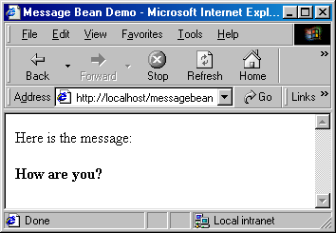

Here is another example where the message is read from the request parameter and request parameter and the bean property does not match:

messagebeandemo2.jsp
<HTML>
<HEAD>
<TITLE>Message Bean Demo2</TITLE>
</HEAD>
<BODY>
<jsp:useBean id="messagebean" class="bean.MessageBean" />
<jsp:setProperty name="messagebean" property="message" param="mymessage" />
Here is the message:
<P>
<B><jsp:getProperty name="messagebean" property="message"/></B>
</BODY>
</HTML>

In order to test this JSP, append the following to your URL:

?mymessage=Hi there

as follows:

http://localhost/messagebeandemo2.jsp?mymessage=Hi there

Here is the output:

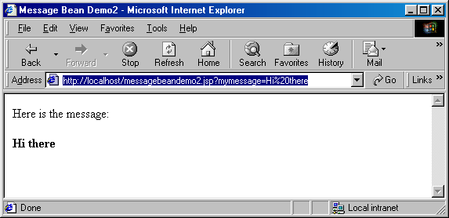

Notice, I am manually passing the request parameter as a GET request. Change “Hi there” to something else to see the dynamic behavior.

Here is the same example again, but this time the request parameter name and bean property matches exactly (case sensitive):

messagebeandemo3.jsp
<HTML>
<HEAD>
<TITLE>Message Bean Demo3</TITLE>
</HEAD>
<BODY>
<jsp:useBean id="messagebean" class="bean.MessageBean" />
<jsp:setProperty name="messagebean" property="*" />
Here is the message:
<P>
<B><jsp:getProperty name="messagebean" property="message"/></B>
</BODY>
</HTML>

Notice, on <jsp:setProperty> action the property=”*” and param attribute is missing – which basically means that the set all the properties of the bean from the request parameters and the property name will match with the corresponding request parameter. Very convenient!!

In order to test this JSP, append the following to your URL:

?message=To be or not to be ...

as follows:

http://localhost/messagebeandemo3.jsp?message=To be or not to be ..

Here is the output:

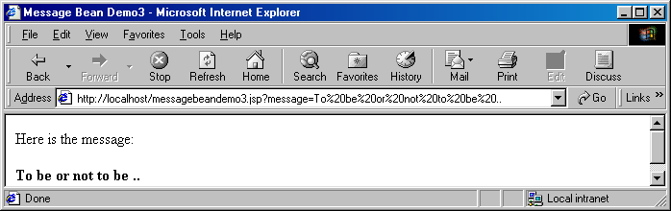

Notice the request parameter name is now “message” (instead of “mymessage”) which exactly matches with the bean property.

Calling Methods on JavaBean
Once a JavaBean is declared using <jsp:useBean> it is possible to call any method (including the setters and getters) on the bean from and within expressions and scriptlets. Here is an example:

messagebeandemo4.jsp
<HTML>
<HEAD>
<TITLE>Message Bean Demo4</TITLE>
</HEAD>
<BODY>
<jsp:useBean id="messagebean" class="bean.MessageBean" />
Here is the default message:<B> <%= messagebean.generateDefaultMessage() %></B>
</BODY>
</HTML>

Notice that generateDefaultMessage() was called on the bean by using server side expression.

Reading Assignment
- Core Servlet and JavaServer Pages – Chapter 10, 11, 12, 13

Homework Assignment
- Create an HTML page mortgagerequest.html that takes mortgage information as follows:

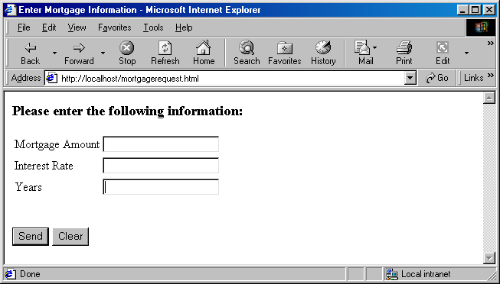

- Create a JavaBean named MortagageBean in bean package that is serializable and has three properties amount, interest rate and years. This bean also has a method calculateMortgage() that returns Monthly Mortgage Amount based on the three property values. Here is the formula:

interest per dollar per month = interest rate / 100 /12
monthly simple interest amount = amount * interest per dollar per month
mortgage = monthly simple interest amount / factor

factor = 1 – (1 + interest per dollar per month) ^{- months}

Use Math.pow() to calculate the exponential part of factor. Use Math.round() to round up the monthly mortgage amount.

Factor should be less than 1. Therefore, mortgage should be higher than just simple monthly interest amount - which is logical since mortgage amount has interest amount as well as principal repayment.

- Create a jsp page named “mortgage.jsp” that uses MortgageBean. The jsp must:
  - set the bean in one line using setProperty and “*”
  - display the input values using getProperty – not from request parameter.

Here is what the output looks like when the jsp returns Monthly Mortgage Amount information:

