Session 8 JSP Tag Libraries

Objective
This session introduces JSP Tag Libraries to the students. JSP Tag Libraries (custom tags) are new to JSP 1.1 and has drawn a lot of attention. Students will get comfortable making these tags and using them in JSP.

JSP Tags
JSP 1.1 introduced a very significant new feature, the ability to define your own tags – custom tags. These tags look like HTML (or rather XML) tags embedded in a JSP page. You define how these tags, their attributes and their bodies are interpreted (using Java code), then group these tags into collections – called tag libraries – and use them in any JSP page. These special tags are handled by the JSP engine at translation time to provide the functionality they are intended for. The ability to define tags in this way to embed complex server-side functionality into simple easy-to-use page level elements is very significant. This allows a clean separation of duty between the middle-tier developers and the presentation-tier HTML developers.

In many respect, custom tags accomplish many functionality that beans do. However, there are several differences:

- Custom tags manipulate JSP content – beans can not.
- Complex presentation can be greatly simplified using custom tags than beans.
- Beans are often setup in one page and used in subsequent pages but custom tags are usually self-contained.
- Custom tags, in general, are more reusable in nature than beans.

In order to understand the concept of custom tag, let’s look at the <jsp:forward> action provided by the JSP specification. It can be invoked with the following syntax:

<jsp:forward page=”pagename”/>

or

<jsp:forward page=”pagename”>
<jsp:param name=”ParameterName” value=”ParameterValue”/>
</jsp:forward>

Now, consider the fact that you can define your own custom tag <nyu:forward> which allows you define your version of forward functionality. That’s exactly what custom tags allow you to do.

Before we go any further, let’s try to understand some of the key concepts in tags:

Tag Name: A JSP tag is identified by a combination of prefix(in the above example “jsp” or “nyu”) and suffix(in the above example “forward”), separated by a colon.

Tag Attributes: Tags may have one or more attributes, which use XML syntax. The <jsp:forward> tag has one attribute “page” whereas the <jsp:param> tag has two “name” and “value”

Nesting: A tag can be nested within another tag. In the above example, <jsp:param> tag is nested within <jsp:forward> tag. Tags can detect nested tags at runtime and cooperate. A tag directly enclosing another tag is called the parent of the tag it encloses. In the above example, <jsp:forward> is the parent tag of <jsp:param>.

Body content: This is anything between the start and end elements in a JSP tag, excluding nested tags. A custom tag can access and manipulate its body content – an extremely powerful and useful concept. In the above example there is no body content. Consider the following example, the body content is shown in bold:

<nyu:message>
How are you?
</nyu:message>

Creating your own Tags
In order to use your own custom tag in a JSP file, you have to do the following:

- Write a Java class – known as tag handler - that implements Tag interface or better yet, a class that implements IterationTag Interface which extends Tag interface. This is usually accomplished by extending TagSupport class.

In some cases you have to implement BodyTag interface. This is usually accomplished by extending BodyTagSupport class.

- Associate your tag handler java class with a tag name. This task is accomplished by creating a tag library descriptor file – an XML file. A tag library can and normally do, store java class to tag name association for more that one tag.

Once the above two steps are done, any JSP page can use the tag.

Tag Interface
The tag interface defines a simple interaction between the JSP engine and the tag handler, sufficient for tags that do not need to manipulate their body. Here are the methods of Tag interface:

setPageContext(PageContext pc) | void | Set the current page context.
SetParent(Tag t) | void | Set the parent (closest enclosing tag handler) of this tag handler.
GetParent() | Tag | Get the parent (closest enclosing tag handler) for this tag handler.
doStartTag() | int | Process the start tag for this instance.
doEndTag() | int | Process the end tag for this instance.
release() | void | Called on a Tag handler to release state.

Here is how a JSP engine interacts with a tag handler:

- The JSP engine initializes the tag handler by setting the tag handler’s pageContext property, which the tag handler uses to access information about the JSP that is currently using the tag.
- The JSP engine sets the tags parent property (which is set to null if the tag is not nested)
- The JSP engine sets the tag attributes defined by the tag developer.
- The JSP engine calls the doStartTag() method of the tag handler. This method is called when the JSP engine encounters the opening of a tag at run time. The return value of this method is very important – the return value directs what to do with the body of the tag. There are only two possible return values defined as constants in Tag interface:
  - EVAL_BODY_INCLUDE – instructs the JSP engine to evaluate both the tag’s body and any child tags it has. This constant must be used if you have tag body (regardless whether is needs to be evaluated or not) as follows:
<prefix:tagname>
Some tag body here
</prefix:tagname>

  - SKIP_BODY – instructs the JSP engine to ignore the body. This return value should be used with caution since it will ignore the body content of tag completely.
If the Tag Library Descriptor file indicates that the action must always have an empty action, by an <body-content> entry of "empty", then the doStartTag() method must return SKIP_BODY. Otherwise, the doStartTag() method may return SKIP_BODY or EVAL_BODY_INCLUDE.

- The JSP engine calls the doEndTag() method of the tag handler. This method is called when the JSP engine encounters the closing of a tag at run time. The return value of this method is also very important not so much for the tag itself but for the rest of the JSP page. There are two possible return values defined as constants in Tag interface:
  - EVAL_PAGE – instructs the JSP engine to evaluate the rest of the JSP. Recommended to be used.
  - SKIP_PAGE – instructs the JSP engine to ignore the rest of the JSP. This return value should be used with caution since it has the possibility of returning a very incomplete page.

- The JSP engine calls the release() method to release any resources. Once all invocations on the tag handler are completed, the release method is invoked on it. Once a release method is invoked all properties, including parent and pageContext, are assumed to have been reset to an unspecified value. The page compiler guarantees that release() will be invoked on the Tag handler before the handler is released to the GC.

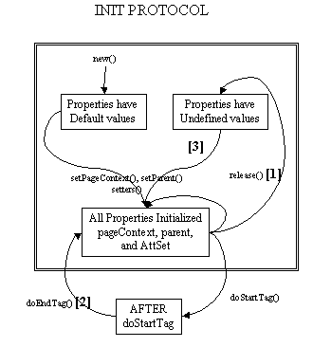

IterationTag Interface
The IterationTag interface extends Tag by defining one additional method doAfterBody() and a constant EVAL_BODY_AGAIN - that controls the reevaluation of its body.
The doAfterBody() method is invoked after every body evaluation to control whether the body will be reevaluated or not. If doAfterBody() returns EVAL_BODY_AGAIN, then the body will be reevaluated. If doAfterBody() returns SKIP_BODY, then the body will be skipped and doEndTag() will be evaluated instead.

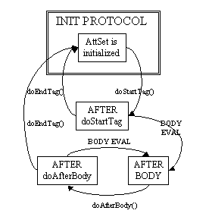

TagSupport Class
Tag handler that either have no body or that merely includes the body as is - should extend the TagSupport class. This is a built-in class in the javax.servlet.jsp.tagext package. This is a utility class intended to be used as the base class for new tag handlers. TagSupport implements the IterationTag interface (hence Tag interface) and contains the standard functionality that a basic tag could need. TagSupport has additional convenience methods including getter methods for the properties in Tag. TagSupport has one static method that is included to facilitate coordination among cooperating tags. Here are the convenience methods added in TagSupport class:

setId(String id) | Void | Set the id attribute for this tag.
getId() | String | The value of the id attribute of this tag; or null.
setValue(String k, java.lang.Object o) | Void | Associate a value with a String key.
getValue(String k) | Object | Get a the value associated with a key.
getValues() | Enumeration | Enumerate the values kept by this tag handler.
removeValue(String k) | Void | Remove a value associated with a key.
findAncestorWithClass(Tag from, java.lang.Class klass) | Static Tag | Find the instance of a given class type that is closest to a given instance.

Because of the other classes you will use, your tag handler should normally import classes in javax.servlet.jsp and java.io packages as well.

Please include jsp-api.jar from tomcat’s common\lib folder.

Here is a simple example of my tag handler:

//code 8A
package tags;
import javax.servlet.jsp.tagext.*;
import javax.servlet.jsp.*;
import java.io.*;
public class TestTag extends TagSupport{
public int doStartTag(){
try{
JspWriter out = pageContext.getOut();
out.println("<B><FONT color=red>This line is from doStartTag method.</FONT></B><BR>");
}
catch(IOException e){
System.out.println(e);
}
return (EVAL_BODY_INCLUDE);
}
public int doEndTag(){
try{
JspWriter out = pageContext.getOut();
out.println("<B><FONT color=red>This line is from doEndTag method.</FONT></B><BR>");
}
catch(IOException e){
System.out.println(e);
}
return (EVAL_PAGE);
}
public int doAfterBody(){
try{
JspWriter out = pageContext.getOut();
out.println("<B><FONT color=black>This line is from doAfterBody method.</FONT></B><BR>");
}
catch(IOException e){
System.out.println(e);
}
return (SKIP_BODY);
}
}

Create a folder “tags” under WEB-INF\classes folder of the application you like (for example ROOT), move this file and compile.

Tag Library Descriptor File
The Tag Library Descriptor or TLD is a XML document with a .tld extension that describes one or more custom tags in one place. The general format of a tag library descriptor file is always the same:

- It should contain an XML version identifier followed by a DOCTYPE declaration followed by a taglib element. The taglib element has the following elements (besides tag elements):
  - tlibversion: is the version defined by the tag author.
  - jspversion: is the version of JSP specification the tag library depends on. This value should 1.2 for now. The element is optional.
  - shortname: is a simple short name that could be used by the JSP authoring tool.
  - uri: is an optional URI uniquely identifying this tag library.
  - info : is an arbitrary text string describing the tag library.
- One or many tag elements nested within the taglib element. The tag element has the following elements:
  - name: is the name that will identify this tag (used with tag library prefix)
  - tagclass: is the fully qualified name of the tag handler class
  - teiclass: is the fully qualified class that will provide extra information about the tag at runtime. Not all tags require this.
  - bodycontent: is the optional body content element specifying the type of body content the tag should have. Three values are legal:
    - JSP (default): means that the tag’s body content will be evaluated at run time like any other JSP content.
    - tagdependent: signifies that the JSP engine should not attempt to evaluate it but should pass it as is.
    - empty: means the tag should not have any body content – if it does, JSP translation will fail.
  - info: is an arbitrary text string describing the tag.

Here is a simple example of my tag library descriptor for my tag handler:

testtaglib.tld
<?xml version="1.0" encoding="ISO-8859-1" ?>
<!DOCTYPE taglib
PUBLIC "-//Sun Microsystems, Inc.//DTD JSP Tag Library 1.1//EN"
"http://java.sun.com/j2ee/dtds/web-jsptaglibrary_1_1.dtd">
<!-- a tag library descriptor -->
<taglib>
<tlibversion>1.0</tlibversion>
<jspversion>1.2</jspversion>
<shortname>testtaglib</shortname>
<uri></uri>
<info>A simple tab library for the examples</info>
<tag>
<name>testtag</name>
<tagclass>tags.TestTag</tagclass>
<bodycontent>JSP</bodycontent>
<info>Display doStartTag() and doEndTag()</info>
</tag>
</taglib>

Create a folder “tlds” under WEB-INF folder of your application (for example, ROOT) and copy is file to the folder.

Using Custom Tags in JSP Pages
Custom tags must be explicitly imported into JSP pages that wish to use them. The syntax is as follows:

<%@ taglib uri=”TagLibDescriptorURI” prefix=”TagLibPrefix” %>

The uri attribute tells the JSP engine where to find the TLD for the tag library. The prefix is the short name of the TLD file that will be used throughout the JSP.

A JSP can import any number of tag libraries.

Once the tag library is imported into the page, tags in the library can be called as follows:

<prefix:name>
Tag Body content
</prefix:name>
or
<prefix:name/>

Here is an example of a JSP page that uses my tag:

tagtester.jsp
<HTML>
<HEAD>
<TITLE>Tag Library Test</TITLE>
</HEAD>
<BODY>
<%@ taglib uri="/WEB-INF/tlds/testtaglib.tld" prefix="testlib" %>
<B><FONT color=blue>This line is before the start tag.</FONT></B><BR>
<testlib:testtag>
<B><FONT color=green>This line is in the body of the tag.</FONT></B><BR>
</testlib:testtag>
<B><FONT color=blue>This line is after end tag.</FONT></B><BR>
</BODY>
</HTML>

Copy the JSP file anywhere you like within your application. Notice that I am referencing the tag library using it absolute url from the root of the application so that I can move the JSP file anywhere I like without changing anything.

Here is the output:
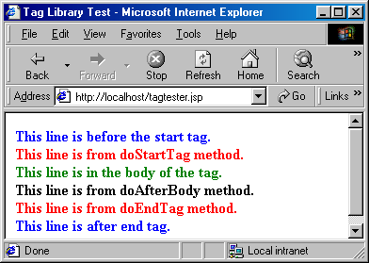

In order to understand what goes on behind the scene when it comes to custom tags, lets look at the servlet generated:

package org.apache.jsp;
import javax.servlet.*;
import javax.servlet.http.*;
import javax.servlet.jsp.*;
import org.apache.jasper.runtime.*;
public class tagtester_jsp extends HttpJspBase {
private static java.util.Vector _jspx_includes;
private org.apache.jasper.runtime.TagHandlerPool _jspx_tagPool_testlib_testtag;
public tagtester_jsp() {
_jspx_tagPool_testlib_testtag = new org.apache.jasper.runtime.TagHandlerPool();
}
public java.util.List getIncludes() {
return _jspx_includes;
}
public void _jspDestroy() {
_jspx_tagPool_testlib_testtag.release();
}
public void _jspService(HttpServletRequest request, HttpServletResponse response)
throws java.io.IOException, ServletException {
JspFactory _jspxFactory = null;
javax.servlet.jsp.PageContext pageContext = null;
HttpSession session = null;
ServletContext application = null;
ServletConfig config = null;
JspWriter out = null;
Object page = this;
JspWriter _jspx_out = null;
try {
_jspxFactory = JspFactory.getDefaultFactory();
response.setContentType("text/html;charset=ISO-8859-1");
pageContext = _jspxFactory.getPageContext(this, request, response,
null, true, 8192, true);
application = pageContext.getServletContext();
config = pageContext.getServletConfig();
session = pageContext.getSession();
out = pageContext.getOut();
_jspx_out = out;
out.write("<HTML>\r\n");
out.write("<HEAD>\r\n");
out.write("<TITLE>Tag Library Test");
out.write("</TITLE>\r\n");
out.write("</HEAD>\r\n");
out.write("<BODY>\r\n");
out.write("\r\n");
out.write("<B>");
out.write("<FONT color=blue>This line is before the start tag.");
out.write("</FONT>");
out.write("</B>");
out.write("<BR>\r\n");
if (_jspx_meth_testlib_testtag_0(pageContext))
return;
out.write("\r\n");
out.write("<B>");
out.write("<FONT color=blue>This line is after end tag.");
out.write("</FONT>");
out.write("</B>");
out.write("<BR>\r\n");
out.write("</BODY>\r\n");
out.write("</HTML>");
} catch (Throwable t) {
out = _jspx_out;
if (out != null && out.getBufferSize() != 0)
out.clearBuffer();
if (pageContext != null) pageContext.handlePageException(t);
} finally {
if (_jspxFactory != null) _jspxFactory.releasePageContext(pageContext);
}
}
private boolean _jspx_meth_testlib_testtag_0(javax.servlet.jsp.PageContext pageContext)
throws Throwable {
JspWriter out = pageContext.getOut();
/* ---- testlib:testtag ---- */
tags.TestTag _jspx_th_testlib_testtag_0 = (tags.TestTag) _jspx_tagPool_testlib_testtag.get(tags.TestTag.class);
_jspx_th_testlib_testtag_0.setPageContext(pageContext);
_jspx_th_testlib_testtag_0.setParent(null);
int _jspx_eval_testlib_testtag_0 = _jspx_th_testlib_testtag_0.doStartTag();
if (_jspx_eval_testlib_testtag_0 != javax.servlet.jsp.tagext.Tag.SKIP_BODY) {
do {
out.write("\r\n");
out.write("<B>");
out.write("<FONT color=green>This line is in the body of the tag.");
out.write("</FONT>");
out.write("</B>");
out.write("<BR>\r\n");
int evalDoAfterBody = _jspx_th_testlib_testtag_0.doAfterBody();
if (evalDoAfterBody != javax.servlet.jsp.tagext.BodyTag.EVAL_BODY_AGAIN)
break;
} while (true);
}
if (_jspx_th_testlib_testtag_0.doEndTag() == javax.servlet.jsp.tagext.Tag.SKIP_PAGE)
return true;
_jspx_tagPool_testlib_testtag.reuse(_jspx_th_testlib_testtag_0);
return false;
}
}

Notice Tomcat does not really check for EVAL_BODY_INCLUDE – it checks for SKIP_BODY as the return from doStartTag() method. Let’s change the return of doStartTag() to SKIP_BODY and recompile, stop and start Tomcat. I will get the following the output:

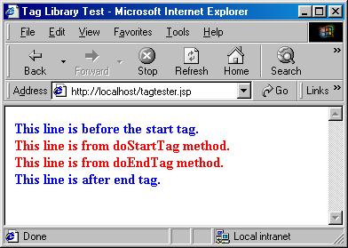

Notice, the tag body is missing in the above output. Also, the output from doAfterBody() is missing since doAfterBody() is only called if doStartTag does not return SKIP_BODY.

Now, let’s change the return of doEndTag() to SKIP_PAGE. Compile the tag class, stop and start Tomcat.

Here is the output:
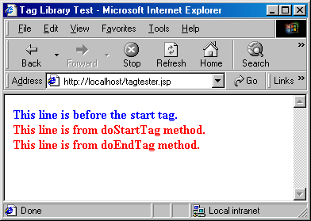

Now, notice there is a do loop around the body of the tag that depends on the return value of doAfterBofy() method. Which indicates that the body of the tag keeps printing itself until doAfterBody() returns SKIP_BODY.

Assigning Attributes to Tags
Allowing tags like:
<prefix:name attribute1=”value1” attribute2=”value2” ….>
…..
</prefix:name>

adds significant flexibility to your custom tag. Providing such support is surprisingly straightforward. As we already know from Java beans, setting an attribute value simply results in a call to a method setXxx() in your class (where xxx is the attribute name) that extends TagSupport (or implements Tag interface). Therefore, adding support for an attribute attribute1 is simply a matter of adding the following method in your class:

public void setAttribute1(String value1)
{
//your code goes in here.
}

Note that an attribute of attribute1 (lowercase a) corresponds to a method setAttribute1(uppercase A).

The most useful thing to do in the attribute handler is to store the attribute in a private field that will later be used by doStartTag() or doEndTag() or any other method of the tag.

Here is a simple example of using tag attributes:

// Code 8B
package tags;
import javax.servlet.jsp.tagext.*;
public class RepeatTag extends TagSupport{
private int repeat = 1;
private int i =1 ;
public void setRepeat(String repeatValue)
{
try{
repeat= Integer.parseInt(repeatValue);
}
catch(NumberFormatException e){
System.out.println(e);
}
}
public int doStartTag(){
if (repeat <=0){
repeat=1;
return SKIP_BODY;
}
else
{
return (EVAL_BODY_INCLUDE);
}
}
public int doAfterBody(){
if (i < repeat){
i++;
return (EVAL_BODY_AGAIN);
}
else{
i=1;
return (SKIP_BODY);
}
}
public int doEndTag()
{
return (EVAL_PAGE);
}
}

Copy this file to c:\Tomcat5028\\webapps\ ROOT \WEB-INF\classes\tags folder and compile

Defining Tag Attributes in Tag Library Descriptor File
Just the presence of setXxx() method in tag handler class does not define a tag attribute. Tag attributes must be defined in tag library descriptor by defining attribute element within tag element. The attribute element has three nested elements that can appear in your tag library descriptor:

- name: a mandatory element that defines the case-sensitive attribute name.
- required: a mandatory element that defines whether the attribute must always be supplied(true) or is optional(false). If you forget to provide this element no call is made to the setXxx() method.
- rtexprvalue: an optional attribute that indicates whether the attribute value can be a JSP expression like <%= expression %> (true) or whether it must be a fixed string (false). The default is false.

Here is the modified tag library testtaglib.tld located in c:\Tomcat \webapps\ROOT \WEB-INF\tlds folder:

<?xml version="1.0" encoding="ISO-8859-1" ?>
<!DOCTYPE taglib
PUBLIC "-//Sun Microsystems, Inc.//DTD JSP Tag Library 1.1//EN"
"http://java.sun.com/j2ee/dtds/web-jsptaglibrary_1_1.dtd">
<!—a tag library descriptor -->
<taglib>
<tlibversion>1.0</tlibversion>
<jspversion>1.2</jspversion>
<shortname>testtaglib</shortname>
<uri></uri>
<info>A simple tab library for the examples</info>
<tag>
<name>testtag</name>
<tagclass>tags.TestTag</tagclass>
<bodycontent>JSP</bodycontent>
<info>Display doStartTag() and doEndTag()</info>
</tag>
<tag>
<name>repeattag</name>
<tagclass>tags.RepeatTag</tagclass>
<bodycontent>JSP</bodycontent>
<info>Repeats body specified by the repeat attribute</info>
<attribute>
<name>repeat</name>
<required>true</required>
<rtexprvalue>true</rtexprvalue>
</attribute>
</tag>
</taglib>

Here is a JSP page testrepeattag.jsp that uses the tag:

<HTML>
<HEAD>
<TITLE>Tag Library Test</TITLE>
</HEAD>
<BODY>
<%@ taglib uri="/WEB-INF/tlds/testtaglib.tld" prefix="testlib" %>
<B><FONT color=blue>This line is before the tag.</FONT></B><BR>
<testlib:repeattag repeat="5">
<B><FONT color=green>This line is in the body of the tag.</FONT></B><BR>
</testlib:repeattag>
<B><FONT color=blue>This line is after the tag.</FONT></B><BR>
</BODY>
</HTML>

Copy the jsp file to c:\Tomcat5028\webapps\ROOT folder and hit it from the browser.

Here is the output:

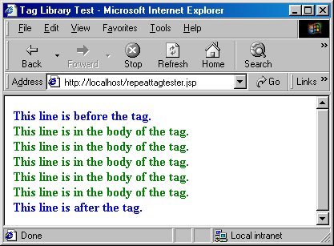

Notice how the repeat tag on the page is being used by the tag to repeat the body.

Here is another tester page that uses runtime expression for the attribute value:

<HTML>
<HEAD>
<TITLE>Tag Library Test</TITLE>
</HEAD>
<BODY>
<%
String repeatValue=request.getParameter("repeat");
%>
<%@ taglib uri="/WEB-INF/tlds/testtaglib.tld" prefix="testlib" %>
<B><FONT color=blue>This line is before the tag.</FONT></B><BR>
<testlib:repeattag repeat="<%=repeatValue%>">
<B><FONT color=green>This line is in the body of the tag.</FONT></B><BR>
</testlib:repeattag>
<B><FONT color=blue>This line is after the tag.</FONT></B><BR>
</BODY>
</HTML>

Notice, the jsp receives the repeat value as input parameter and uses it as an attribute of the tag.
Copy the jsp to to c:\Tomcat5028\webapps\ROOT folder and hit it as:
http://localhost/repeattagtester2.jsp?repeat=3
Here is the output:
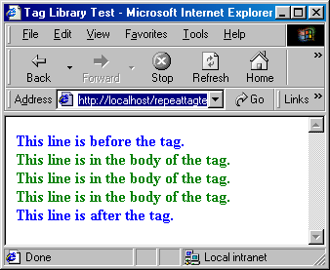
Change value of repeat on the url and have fun.

Indirection for Tag Library
In all the examples above I have put in the absolute location of the tag library testtaglib.tld. However, there is a way to hide the actual location of tag library – by adding entries to web.xml.
Here is our new web.xml:
<?xml version="1.0" encoding="ISO-8859-1"?>
<!DOCTYPE web-app
PUBLIC "-//Sun Microsystems, Inc.//DTD Web Application 2.3//EN"
"http://java.sun.com/dtd/web-app_2_3.dtd">
<web-app>
<taglib>
<taglib-uri>
/testtaglib.tld
</taglib-uri>
<taglib-location>
/WEB-INF/tlds/testtaglib.tld
</taglib-location>
</taglib>
</web-app>

Here is a page that uses the indirection:
testrepeattag3.jsp
<HTML>
<HEAD>
<TITLE>Tag Library Test</TITLE>
</HEAD>
<BODY>
<%
String repeatValue=request.getParameter("repeat");
%>
<%@ taglib uri="/testtaglib.tld" prefix="testlib" %>
<B><FONT color=blue>This line is before the tag.</FONT></B><BR>
<testlib:repeattag repeat="<%=repeatValue%>">
<B><FONT color=green>This line is in the body of the tag.</FONT></B><BR>
</testlib:repeattag>
<B><FONT color=blue>This line is after the tag.</FONT></B><BR>
</BODY>
</HTML>

Notice the uri is “/testtaglib.tld”. You will still get the same output.

Tags and Beans together in JSP
Here is an example of tags and beans together in action:

testrepeattag4.jsp
<HTML>
<HEAD>
<TITLE>Tag Library & Bean Test</TITLE>
</HEAD>
<BODY>
<%
String repeatValue=request.getParameter("repeat");
%>
<%@ taglib uri="/testtaglib.tld" prefix="testlib" %>
<B><FONT color=blue>This line is before the tag.</FONT></B><BR>
<testlib:repeattag repeat="<%=repeatValue%>">
<jsp:useBean id="messagebean" class="bean.MessageBean" />
<jsp:setProperty name="messagebean" property="*" />
<B><FONT color=green>Here is the message: <jsp:getProperty name="messagebean" property="message"/>
</FONT></B><BR>
</testlib:repeattag>
<B><FONT color=blue>This line is after the tag.</FONT></B><BR>
</BODY>
</HTML>
Before you try to run this, please make sure that you have the bean folder copied from session 7 that has MessageBean copiled.

Hit the jsp as follows:

http://localhost/repeattagtester4.jsp?repeat=7&message=I am an American

Here is the output:
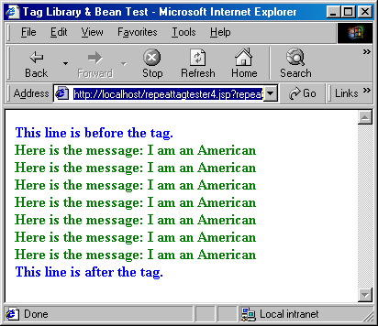

Change the repeat value and your message and have fun.

Now, it’s time to apply all these to a practical example.

Here is a servlet that receives a music category and looks up the database for all the music recordings that match the category and return them:

Code 8C
import java.io.*;
import java.util.*;
import javax.servlet.*;
import javax.servlet.http.*;
public class ProcessMusicCategory extends HttpServlet{
public void doPost(HttpServletRequest request, HttpServletResponse response)
throws ServletException, IOException{
doGet(request,response);
}
public void doGet(HttpServletRequest request, HttpServletResponse response)
throws ServletException, IOException{
// get the category
String category = (String) request.getParameter("category");
//get a list of records
ArrayList musicList = MusicDAO.getMusicByCategory(category);
request.setAttribute("musicList",musicList);
RequestDispatcher requestdispatcher=request.getRequestDispatcher("/music.jsp");
requestdispatcher.forward(request,response);
}
}

Obviously, the servlet is using MusicDAO. Here is MusicDAO:

// Code 8D
import bean.*;
import java.util.*;
import java.sql.*;
import javax.sql.*;
import javax.naming.*;
public class MusicDAO{
private static Connection getConnection(){
Connection con = null;
try{
//create the context
Context context = new InitialContext();
// find the datasource
DataSource datasource = (DataSource) context.lookup("java:/comp/env/jdbc/VStore");
// get a connection from the pool
con = datasource.getConnection();
}
catch(SQLException e){
HandleSQLError(e);
}
catch(NamingException e){
System.out.println(e.toString());
}
return con;
}
public static ArrayList getMusicByCategory(String category){
// create a temp list
ArrayList categorizedmusic = new ArrayList();
Connection con = null;
Statement statement = null;
ResultSet music = null;
try{
// get the connection
con = getConnection();
// create a statement
statement = con.createStatement();
// execute a query using the statement.
// this will return a resultset.
music = statement.executeQuery("select * from music_recordings where category_name = '" + category + "' order by album_title");
//loop through all the items.
while (music.next()){
// create item.
Item item = new Item(music.getString("recording_id"),music.getString("artist_name"),music.getString("album_title"),music.getString("category_name"),music.getDouble("price"));
categorizedmusic.add(item);
}
}
catch(SQLException e){
HandleSQLError(e);
}
finally
{
// since close methods throw sqlexception - catch 'em.
try{
music.close();
statement.close();
con.close();
}
catch(Exception e){
//don't do anything - it is probably just a null pointer exception.
}
}
return categorizedmusic;
}
private static void HandleSQLError(SQLException e){
System.out.println("\n--- SQLException caught ---\n");
while (e != null){
System.out.println("Message: " + e.getMessage());
System.out.println("SQLState: " + e.getSQLState());
System.out.println("Vendor ErrorCode: " + e.getErrorCode());
e = e.getNextException();
System.out.println();
}
}
}

ProcessMusicCategory servlet creates Item object for each RecordSet row and adds it to an ArrayList. Then it adds the ArrayList as an attribute to the request object and forwards the request to music.jsp.

The Item class has been modified as follows to make it a JavaBean:

// Code 8E
package bean;
public class Item implements java.io.Serializable
{
Private String id;
Private String artist;
Private String title;
Private String category;
Private double price;
// empty constructor to make it a bean.
public Item(){
}
// constructor
public Item(String theId, String theArtist,String theTitle,
String theCategory,double thePrice){
// convert int to string
id = theId;
artist = theArtist;
title = theTitle;
category = theCategory;
price = thePrice;
}
public String getId(){
return id;
}
public String getArtist(){
return artist;
}
public void setArtist(String theArtist){
artist = theArtist;
}
public String getTitle(){
return title;
}
public void setTitle(String theTitle){
title = theTitle;
}
public String getCategory(){
return category;
}
public void setCategory(String theCategory){
category = theCategory;
}
public double getPrice(){
return price;
}
public void setPrice(double thePrice){
price = thePrice;
}
}

Here is music.jsp:
music.jsp
<HTML>
<HEAD><TITLE>Music List Page</TITLE></HEAD>
<BODY>
<TABLE BORDER=1>
<TR>
<TD>Artist</TD>
<TD>Title</TD>
<TD>Price</TD>
</TR>
<%@ taglib uri="/testtaglib.tld" prefix="testlib" %>
<testlib:looptag element="item" list='<%= (java.util.ArrayList) request.getAttribute("musicList") %>'>
<jsp:useBean id="item" class="bean.Item" scope="page"/>
<tr>
<td><jsp:getProperty name="item" property="artist" /></td>
<td><jsp:getProperty name="item" property="title" /></td>
<td>$<jsp:getProperty name="item" property="price" /></td>
</tr>
</testlib:looptag>
</TABLE>
</BODY>
</HTML>

The very first thing that the jsp does, is it retrieves the ArrayList that ProcessMusicCategory servlet put in from request object and passes it to the looptag.

Here is the LoopTag class:

// Code 8F
package tags;
import javax.servlet.jsp.*;
import javax.servlet.jsp.tagext.*;
import java.util.*;
public class LoopTag extends TagSupport{
private String element;
private Iterator iterator;
public void setList(ArrayList aList){
iterator=aList.iterator();
}
public void setElement(String aElement) {
element = aElement;
}
public int doStartTag(){
if (iterator == null) {
return (SKIP_BODY);
}
else{
if (iterator.hasNext()) {
Object item = iterator.next();
pageContext.setAttribute(element, item);
}
return (EVAL_BODY_INCLUDE);
}
}
public int doAfterBody(){
if (iterator.hasNext()) {
Object item = iterator.next();
pageContext.setAttribute(element, item);
return (EVAL_BODY_AGAIN);
}
else {
return (SKIP_BODY);
}
}
public int doEndTag(){
return Tag.EVAL_PAGE;
}
}

Here is the tag library :

<?xml version="1.0" encoding="ISO-8859-1" ?>
<!DOCTYPE taglib
PUBLIC "-//Sun Microsystems, Inc.//DTD JSP Tag Library 1.1//EN"
"http://java.sun.com/j2ee/dtds/web-jsptaglibrary_1_1.dtd">
<!-- a tag library descriptor -->
<taglib>
<tlibversion>1.0</tlibversion>
<jspversion>1.2</jspversion>
<shortname>testtaglib</shortname>
<uri></uri>
<info>A simple tab library for the examples</info>
<tag>
<name>testtag</name>
<tagclass>tags.TestTag</tagclass>
<bodycontent>JSP</bodycontent>
<info>Display doStartTag() and doEndTag()</info>
</tag>
<tag>
<name>repeattag</name>
<tagclass>tags.RepeatTag</tagclass>
<bodycontent>JSP</bodycontent>
<info>Repeats body specified by the repeat attribute</info>
<attribute>
<name>repeat</name>
<required>true</required>
<rtexprvalue>true</rtexprvalue>
</attribute>
</tag>
<tag>
<name>looptag</name>
<tagclass>tags.LoopTag</tagclass>
<bodycontent>JSP</bodycontent>
<info>loops through the arraylist</info>
<attribute>
<name>element</name>
<required>true</required>
<rtexprvalue>true</rtexprvalue>
</attribute>
<attribute>
<name>list</name>
<required>true</required>
<rtexprvalue>true</rtexprvalue>
</attribute>
</tag>
</taglib>

Basically this tag loops through the Iterator of the ArrayList, extract one Item at a time and put the item as an attribute of the PageContext. Therefore, the body of the tag will be repeated by the size of the ArrayList.

Inside the body of the looptag, we extract the item object from the PageContext as JavaBean and then retrieve it’s properties.

Here is the output, when we hit the servlet as http://localhost/servlet/ProcessMusicCategory?category=Classical

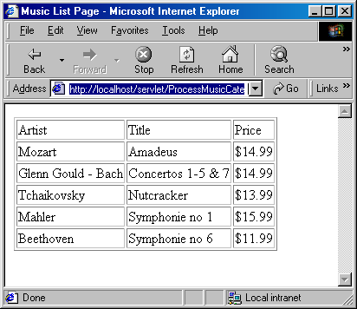

Here is the servlet behind music.jsp:

package org.apache.jsp;
import javax.servlet.*;
import javax.servlet.http.*;
import javax.servlet.jsp.*;
import org.apache.jasper.runtime.*;
public class music_jsp extends HttpJspBase {
private static java.util.Vector _jspx_includes;
private org.apache.jasper.runtime.TagHandlerPool _jspx_tagPool_testlib_looptag_list_element;
public music_jsp() {
_jspx_tagPool_testlib_looptag_list_element = new org.apache.jasper.runtime.TagHandlerPool();
}
public java.util.List getIncludes() {
return _jspx_includes;
}
public void _jspDestroy() {
_jspx_tagPool_testlib_looptag_list_element.release();
}
public void _jspService(HttpServletRequest request, HttpServletResponse response)
throws java.io.IOException, ServletException {
JspFactory _jspxFactory = null;
javax.servlet.jsp.PageContext pageContext = null;
HttpSession session = null;
ServletContext application = null;
ServletConfig config = null;
JspWriter out = null;
Object page = this;
JspWriter _jspx_out = null;
try {
_jspxFactory = JspFactory.getDefaultFactory();
response.setContentType("text/html;charset=ISO-8859-1");
pageContext = _jspxFactory.getPageContext(this, request, response,
null, true, 8192, true);
application = pageContext.getServletContext();
config = pageContext.getServletConfig();
session = pageContext.getSession();
out = pageContext.getOut();
_jspx_out = out;
out.write("<HTML>\r\n");
out.write("<HEAD>");
out.write("<TITLE>Music List Page");
out.write("</TITLE>");
out.write("</HEAD>\r\n");
out.write("<BODY>\r\n");
out.write("<TABLE BORDER=1>\r\n");
out.write("<TR>\r\n");
out.write("<TD>Artist");
out.write("</TD>\r\n");
out.write("<TD>Title");
out.write("</TD>\r\n");
out.write("<TD>Price");
out.write("</TD>\r\n");
out.write("</TR>\r\n");
out.write("\r\n");
/* ---- testlib:looptag ---- */
tags.LoopTag _jspx_th_testlib_looptag_0 = (tags.LoopTag) _jspx_tagPool_testlib_looptag_list_element.get(tags.LoopTag.class);
_jspx_th_testlib_looptag_0.setPageContext(pageContext);
_jspx_th_testlib_looptag_0.setParent(null);
_jspx_th_testlib_looptag_0.setElement("item");
_jspx_th_testlib_looptag_0.setList( (java.util.ArrayList) request.getAttribute("musicList") );
int _jspx_eval_testlib_looptag_0 = _jspx_th_testlib_looptag_0.doStartTag();
if (_jspx_eval_testlib_looptag_0 != javax.servlet.jsp.tagext.Tag.SKIP_BODY) {
do {
out.write("\r\n\t\t");
bean.Item item = null;
synchronized (pageContext) {
item = (bean.Item) pageContext.getAttribute("item", PageContext.PAGE_SCOPE);
if (item == null){
try {
item = (bean.Item) java.beans.Beans.instantiate(this.getClass().getClassLoader(), "bean.Item");
} catch (ClassNotFoundException exc) {
throw new InstantiationException(exc.getMessage());
} catch (Exception exc) {
throw new ServletException("Cannot create bean of class " + "bean.Item", exc);
}
pageContext.setAttribute("item", item, PageContext.PAGE_SCOPE);
}
}
out.write("\r\n\t\t");
out.write("<tr>\r\n\t\t\t");
out.write("<td>");
out.print(JspRuntimeLibrary.toString((((bean.Item)pageContext.findAttribute("item")).getArtist())));
out.write("</td>\r\n\t\t\t");
out.write("<td>");
out.print(JspRuntimeLibrary.toString((((bean.Item)pageContext.findAttribute("item")).getTitle())));
out.write("</td>\r\n\t\t\t");
out.write("<td>$");
out.print(JspRuntimeLibrary.toString((((bean.Item)pageContext.findAttribute("item")).getPrice())));
out.write("</td>\r\n\t\t");
out.write("</tr>\r\n");
int evalDoAfterBody = _jspx_th_testlib_looptag_0.doAfterBody();
if (evalDoAfterBody != javax.servlet.jsp.tagext.BodyTag.EVAL_BODY_AGAIN)
break;
} while (true);
}
if (_jspx_th_testlib_looptag_0.doEndTag() == javax.servlet.jsp.tagext.Tag.SKIP_PAGE)
return;
_jspx_tagPool_testlib_looptag_list_element.reuse(_jspx_th_testlib_looptag_0);
out.write("\r\n");
out.write("</TABLE>\r\n");
out.write("</BODY>\r\n");
out.write("</HTML>\r\n");
} catch (Throwable t) {
out = _jspx_out;
if (out != null && out.getBufferSize() != 0)
out.clearBuffer();
if (pageContext != null) pageContext.handlePageException(t);
} finally {
if (_jspxFactory != null) _jspxFactory.releasePageContext(pageContext);
}
}
}

Notice, our page has very little java code, but if we want to remove it, we can. By using the ArrayList as a JavaBean in our jsp page we get the following:

music.jsp
<HTML>
<HEAD><TITLE>Music List Page</TITLE></HEAD>
<BODY>
<TABLE BORDER=1>
<TR>
<TD>Artist</TD>
<TD>Title</TD>
<TD>Price</TD>
</TR>
<%@ taglib uri="/testtaglib.tld" prefix="testlib" %>
<jsp:useBean id="musicList" class="java.util.ArrayList" scope="request" />
<testlib:looptag element="item" list="<%= musicList %>">
<jsp:useBean id="item" class="bean.Item" scope="page" />
<tr>
<td><jsp:getProperty name="item" property="artist" /></td>
<td><jsp:getProperty name="item" property="title" /></td>
<td>$<jsp:getProperty name="item" property="price" /></td>
</tr>
</testlib:looptag>
</TABLE>
</BODY>
</HTML>

This will give the same output.

BodyTag Interface
Although Tag and IterationTag interface allowed body content (and even repeat body content) they is not powerful enough to manipulate body content. BodyTag interface extends IterationTag interface, adding the following to extra two methods that allows the developer to work with the body content of the tag.

doInitBody() | void | Prepare for evaluation of the body.
setBodyContent(BodyContent b) | void | Set the bodyContent property.
A tag handler that implements BodyTag is treated as one that implements IterationTag, except that the doStartTag() method can return SKIP_BODY, EVAL_BODY_INCLUDE or EVAL_BODY_BUFFERED.
If EVAL_BODY_INCLUDE is returned, then evaluation happens as in IterationTag.
If EVAL_BODY_BUFFERED is returned, then a BodyContent object will be created (by code generated by the JSP compiler) to capture the body evaluation. The code generated by the JSP compiler obtains the BodyContent object by calling the pushBody() method of the current pageContext, which additionally has the effect of saving the previous out value. The page compiler returns this object by calling the popBody() method of the PageContext class; the call also restores the value of out.

The setBodyContent() method defined in BodyTag interface is to set the BodyConent object that allows manipulation of body content. This will only be invoked if doStartTag() returns EVAL_BODY_BUFFERED.

doInitBody(), which is invoked right after setBodyContent() and before the body evaluation. This method is only invoked if doStartTag() returns EVAL_BODY_BUFFERED.

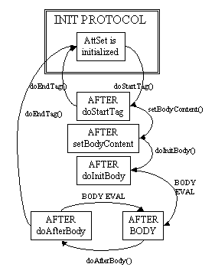

BodyContent Class
The abstract class BodyContent class is the key to BodyTag functionality. BodyContent is a subclass of JspWriter that can be used to manipulate the body content of a tag. The container implements a subclass of BodyContent (since BodyContent is abstract) and uses it for all BodyContent purposes.

BodyContent class has a getReader() method that returns a Reader object that can read the tag’s body. The getString() method of BodyConent returns a String containing the entire tag body. The getEnclosingWriter() method of BodyConent returns a JspWriter object that is being used by doStartTag() and doEndTag() method since the BodyContent class itself is a separate JspWriter for the body content. The clearBody() method of BodyContent allows you to clear the body content entirely.

Here are the methods of BodyContent Class:
getReader() | abstract Reader | Return the value of this BodyContent as a Reader.
writeOut(Writer out) | abstract void | Write the contents of this BodyContent into a Writer.
getEnclosingWriter() | JspWriter | Get the enclosing JspWriter.
clearBody() | void | Clear the body without throwing any exceptions.
flush() | void | Redefined flush() so it is not legal.
getString() | abstract String | Return the value of the BodyContent as a String.

BodyTagSupport Class
Tag handler that intends to manipulate the body content should extend the BodyTagSupport class. This is a built-in class in the javax.servlet.jsp.tagext package that implements the BodyTag interface and contains the standard functionality that a basic tag could need. Because of the other classes you will use, your tag handler should normally import classes in javax.servlet.jsp and java.io packages as well.

BodyTagSupport implements the BodyTag interface methods as follows:

setBodyContent(BodyContent b) | void | Prepare for evaluation of the body: stash the bodyContent away.
doInitBody() | void | Prepare for evaluation of the body just before the first body evaluation: no action.
doStartTag() | int | Default processing of the start tag returning EVAL_BODY_BUFFERED
doEndTag() | int | Default processing of the end tag returning EVAL_PAGE.
doAfterBody() | int | After the body evaluation: do not reevaluate and continue with the page.
release() | void | Release state.

Besides implementing BodyTag interface, BodyTapSupport has the following two convenience methods:

getBodyContent() | BodyContent | Get current bodyContent.
getPreviousOut() | JspWriter | Get surrounding out JspWriter.

Since BodyTagSupport class saves of the BodyContent as private field in setBodyContent() method, it provides a getBodyContent() that returns BodyContent object of the tag. It also provides getPreviousOut() method that returns the enclosing JspWriter, from the BodyContent (instead of calling getBodyContent.getEnclosingWriter()).

Here is an example of tag that converts the body to uppercase:

//code 8G
package tags;
import javax.servlet.jsp.tagext.*;
import javax.servlet.jsp.*;
import java.io.*;
public class TestBodyTag extends BodyTagSupport{
public int doAfterBody()throws JspException{
try{
BodyContent bodyContent= getBodyContent();
String bodytext = bodyContent.getString();
bodytext=bodytext.toUpperCase();
bodyContent.clear();
bodyContent.print(bodytext);
bodyContent.writeOut(getPreviousOut());
}
catch(IOException e){
System.out.println(e);
}
return (SKIP_BODY);
}
}

Here is the entry on the tag library testtaglib.tld:

<tag>
<name>testbodytag</name>
<tagclass>tags.TestBodyTag</tagclass>
<bodycontent>JSP</bodycontent>
<info>converts body to uppercase</info>
</tag>

Here is a jsp that uses it:

bodytagtester.jsp
<HTML>
<HEAD>
<TITLE>Tag Library Test</TITLE>
</HEAD>
<BODY>
<%@ taglib uri="/WEB-INF/tlds/testtaglib.tld" prefix="testlib" %>
<B><FONT color=blue>This line is before the start tag.</FONT></B><BR>
<testlib:testbodytag>
<B><FONT color=green>This line is in the body of the tag.</FONT></B><BR>
</testlib:testbodytag>
<B><FONT color=blue>This line is after end tag.</FONT></B><BR>
</BODY>
</HTML>

Here is the output:

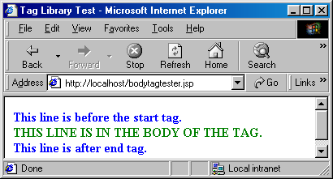

Expression Language and JSTL

Expression Language

Before JSP 2.0, you could use only a scriptlet, JSP expression, or a custom tag to include server state in the JSP page output. JSP 2.0 incorporates the Expression Language (EL) first introduced in JSTL 1.0. EL makes it easier to integrate server-side state with presentation output. Let's start with a quick review of scriptlets, JSP expressions, and custom tags.

Consider a Web application that maintains information about usage statistics in an object of class ServerStats. Class ServerStats has a method getUserCount, which returns the number of users currently logged on. The application maintains a single instance of ServerStats in a ServletContext attribute called stats. Here's a comparison of how you could create usage statistics output using a scriptlet, a JSP expression, and a custom tag:

A) Creating output with a scriptlet: With JSP version 1, you can print the number of users logged on to the system using a scriptlet. Any output the scriptlet produces has to be explicitly written to the out stream. A JSP page could report the number of users with the following scriptlet and template text:

There are currently <%

ServerStats ss =

(ServerStats)application.getAttribute("stats");

out.print(ss.getUserCount());

%> userslogged on.

B) Creating output with a JSP expression: You can simplify things a bit by placing the code in a JSP expression. The expression text within the JSP expression is evaluated, and the result is coerced to a String for output. The result of the expression replaces the expression tag in the JSP page output. Writing the resulting text to the JSP page output is implicit.

There are currently

<%= (ServerStats)(application.getAttribute("stats")).

getUserCount() %> users logged on.

This is somewhat easier to write, but is still a bit difficult to read and maintain.

C) Creating output with a custom tag: In JSP 1, the way to make dynamic content on a page more readable and reusable is to create custom tags. Remembering that the actual code that implements the lookup is in the handler class, the JSP code for the example message would look like this:

There are currently <myTags:userCount/> users logged in.

Of course, to get to such a clean presentation, a developer would have to write both a Java class and an XML-format TLD file.

JSP 2.0 now offers a expression language that makes accessing server-side state even easier. The syntax of the expression language is simpler than a custom tag, and usually requires no associated Java code. Also, the expression language automatically handles typecasting, null values, and error handling. The JSP 2.0 expression language provides a way to access server-side state with less effort than the approaches shown above. The JSP 2.0 way to print the "number of users" message would look like this:

There are currently ${applicationScope.stats.userCount} users logged in.

Implicit Variables
EL supports the following implicit (predefined) variables:

Variable name | Description
pageScope | A collection (a java.util.Map) of all page scope variables.
requestScope | A collection (a java.util.Map) of all request scope variables.
sessionScope | A collection (a java.util.Map) of all session scope variables.
applicationScope | A collection (a java.util.Map) of all application scope variables.
param | A collection (a java.util.Map) of all request parameter values as a single String value per parameter.
paramValues | A collection (a java.util.Map) of all request parameter values as a String array per parameter.
header | A collection (a java.util.Map) of all request header values as a single String value per header.
headerValues | A collection (a java.util.Map) of all request header values as a String array per header.
cookie | A collection (a java.util.Map) of all request cookie values as a single javax.servlet.http.Cookie value per cookie.
initParam | A collection (a java.util.Map) of all application initialization parameter values as a single String value per parameter.
pageContext | An instance of the javax.servlet.jsp.PageContext class, providing access to various request data.

Operators

Operators describe what you want to do with the variables. Most of the operators you can use in an EL expression look familiar:

Operator | Description
. | Access a bean property or Map entry.
[] | Access an array or List element as well as bean property or Map entry.
() | Group a subexpression to change the evaluation order.
? : | Conditional test: condition ? ifTrue : ifFalse.
+ | Addition.
- | Subtraction or negation of a value.
* | Multiplication.
/ or div | Division.
% or mod | Modulo (remainder).
== or eq | Test for equality.
!= or ne | Test for inequality.
< or lt | Test for less than.
> or gt | Test for greater than.
<= or le | Test for less than or equal.
>= or ge | Test for greater than or equal.
&& or and | Test for logical AND.
|| or or | Test for logical OR.
! or not Unary | Boolean complement.
Empty | Test for an empty variable value: null, an empty String, or an array, Map, or Collection without entries).
func(args) | A function call, where func is the function name and args is zero, one or more comma-separated function arguments.

Dot (.) vs. []
In EL, if the object being accessed is a Map, the “.” operator uses the name of right-hand side as a string literal and uses in as a key to fetch the result. For example,

${header.host} will return will return the element with key “host” from the map “header”.

The “.” operator can also be used for a completely different purpose – to call property accessors (getters). For example,

${applicationScope.stats.userCount}

In the above example, the ”.stats” is used to access an element “.stats” in applicationScope map but “.userCount” is used to call getUserCount() accessor method on “stats”.

We can also use the [] operator instead of “.” is all cases. Here is an example:

${header[“host”]}
[] operator can also be used to access an indexed collection – lists as well as maps. Here is an example:

${colors[4]}

When accessing collection, [] syntax is more full-proof since “.” can fail to do the job in certain scenario. Here is an example:

${header.user-agent} returns 0 but ${header[“user-agent”] returns Mozilla/5.0…. the right value. This is because of dash is considered as minus by the jsp compiler in this case.
Another advantage of using [] is that the value can be an expression as follows:

${header[param["name"]]}

The lesson here is that is it always better to use “[]” for accessing collections and use “.” for accessing property accessors.

Installing Expression Language and JSTL in Tomcat
Tomcat’s ROOT application is probably configured to ignore expression language. Please don’t use ROOT for the following examples. Copy standard.jar and jstl.jar available in session8.zip download to Tomcat’s common\lib folder. You are good to go. Create a brand you application called testapp as follows:
    - create a folder “testapp” under webapps.
    - create a folder “WEB-INF” (in uppercase letters) under testapp.
    - create an web.xml in WEB-INF folder and add the following content:

<?xml version="1.0" encoding="ISO-8859-1"?>

<web-app xmlns="http://java.sun.com/xml/ns/j2ee"
xmlns:xsi="http://www.w3.org/2001/XMLSchema-instance"
xsi:schemaLocation="http://java.sun.com/xml/ns/j2ee http://java.sun.com/xml/ns/j2ee/web-app_2_4.xsd"
version="2.4">

</web-app>

    - create a folder “classes” (in lower case letters) under testapp.
    - create a “bean” folder under classes folder.
    - copy Item.class from session8.zip download in to bean folder (because Item is in bean package).
    - copy all the jsp files provided in session8.zip to testapp folder.

Here is a page eltest.jsp that put’s all kinds of stuff on different objects and try to retrieve them using EL:

<%
pageContext.setAttribute("pageContextAttr", "page context attribute 1");
request.setAttribute("requestAttr","request attribute 1");
session.setAttribute("sessionAttr","session attribute 1");
application.setAttribute("appAttr","application attribute 1");

%>
<html>
<body>
Servlet Name = ${pageContext.servletConfig.servletName}<br>
pageContextAttr = ${pageScope["pageContextAttr"]}<br>
requestAttr = ${requestScope["requestAttr"]}<br>
sessionAttr = ${sessionScope["sessionAttr"]}<br>
applicationAttr = ${applicationScope["appAttr"]}<br>
Host Header = ${header["host"]}<br>
Parameter message = ${param["message"]}<br>
Cookie JSESSIONID= ${cookie["JSESSIONID"].value}<br>

</br>
</body>
</html>

Hit the following url:

http://localhost:8080/testapp/eltest.jsp?message=hi%20there

Here is the output:

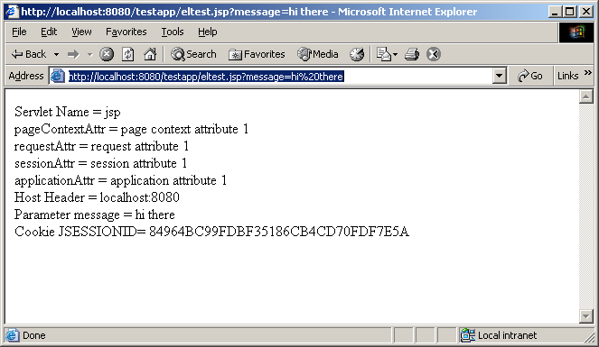
Of course, first time you will not see JSESSIONID cookie but hit refresh and you will get the cookie. Why is that? Can you explain? If not, go back to session 4 and read cookie again.

Java Standard Tag Library (JSTL)
JSTL includes a wide variety of actions that naturally fit into discrete functional areas. This is why JSTL, although referred to as the standard tag library (singular), is exposed via multiple tag libraries to clearly identify the functional areas it covers, as well as to give each area its own namespace. The tables below lists these functional areas along with the URIs used to reference the libraries.
The tables also show the prefixes used in this handou although page authors are free to use any prefix they want.

Functional Area | URI | Prefix
Core | http://java.sun.com/jsp/jstl/core | c
XML processing | http://java.sun.com/jsp/jstl/xml | x
Internationalization capable formatting | http://java.sun.com/jsp/jstl/fmt | fmt
relational db access (SQL) | http://java.sun.com/jsp/jstl/sql | sql
Functions | http://java.sun.com/jsp/jstl/functions | fn

<c:out>
Evaluates an expression and outputs the result of the evaluation to the current JspWriter object. If value is null, the default value takes over. If no default value is specified, it itself defaults to an empty string. The default value can be specified either via the default attribute (using the syntax
without a body), or within the body of the tag (using the syntax with a body). It defaults to an empty string.

If the result of the evaluation is not a java.io.Reader object, then it is coerced to a String and is subsequently emitted into the current JspWriter object. If the result of the evaluation is a java.io.Reader object, data is first read from the Reader object and then written into the current JspWriter object. This special processing associated with Reader objects should help improve performance when large amount of data must be read and then displayed to the page.

If escapeXml is true, the following character conversions are applied:

Character | Character Entity Code
< | &lt;
> | &gt;
& | &amp;
‘ | &#039;
‘’ | &#034;

Syntax
Without a body
<c:out value=”value” [escapeXml=”{true|false}”]
[default=”defaultValue”] />
With a body
<c:out value=”value” [escapeXml=”{true|false}”]>
default value
</c:out>

Attributes
Name | Expression | Type | Description
Value | true | Object | Expression to be evaluated.
escapeXml | true | boolean | Determines whether characters <,>,&,’,” in the resulting string should be converted to their corresponding character entity codes. Default value is true.
Default | true | Object | Default value if the resulting value is null.

<c:set>
Sets the value of a scoped variable or a property of a target object.
Syntax
Syntax 1: Set the value of a scoped variable using attribute value
<c:set value=”value”
var=”varName” [scope=”{page|request|session|application}”]/>

Syntax 2: Set the value of a scoped variable using body content
<c:set var=”varName” [scope=”{page|request|session|application}”]>
body content
</c:set>

Syntax 3: Set a property of a target object using attribute value
<c:set value=”value”
target=”target” property=”propertyName”/>

Syntax 4: Set a property of a target object using body content
<c:set target=”target” property=”propertyName”>
body content
</c:set>

Syntax 1 and 2 set the value of a the scoped variable identified by var and scope.
Syntax 3 and 4:
- If the target expression evaluates to a java.util.Map object, set the value of the
element associated with the key identified by property. If the element does not
exist, add it to the Map object.
- Otherwise, set the value of the property property of the JavaBeans object
target. If the type of the value to be set does not match the type of the bean
property, conversion is performed according to the conversion rules defined in
the expression language (see Section A.7). With the exception of a null value,
setting a bean property with <c:set> is therefore exactly the same as setting an
attribute value of an action using the EL. A failure of these conversion rules to
determine an appropriate type coersion leads to a JspException at runtime.
Attributes
Name | Expression | Type | Description
value | true | Object | Expression to be evaluated.
var | false | String | Name of the exported scoped variable to hold the value specified in the action. The type of the scoped variable is whatever type the value expression evaluates to.
scope | false | String | Scope for var.
target | true | Object | Target object whose property will be set. Must evaluate to a JavaBeans object with setter property, or to a java.util.Map object.
property | true | String | Name of the property to be set in the target object.

<c:remove>
Removes a scoped variable.
Syntax
<c:remove var=”varName” [scope=”{page|request|session|application}”]/>

Attributes
Name | Expression | Type | Description
var | false | String | Name of the variable to be removed.
scope | false | String | Scope for var. If attribute scope is not specified, the scoped variable is removed according to the  semantics of PageContext.removeAttribute(varName). If attribute scope is specified, the scoped variable is removed according to the semantics of PageContext.removeAttribute(varName, scope).

Here is a page setremove.jsp that demonstrates these tags:

<%@ taglib uri="http://java.sun.com/jsp/jstl/core" prefix="c" %>
<c:set var="age" value="${param.myage}" scope="session" />
<html>
<body>
Well, look at the bright side, you still need <c:out value="${sessionScope.age}" /> years to be <c:out value="${sessionScope.age*2}" /> years old.
<c:remove var="age" scope="session" />
</body>
</html>

Hit the following url:

http://localhost:8080/testapp/setremove.jsp?myage=30

You will get the following output:

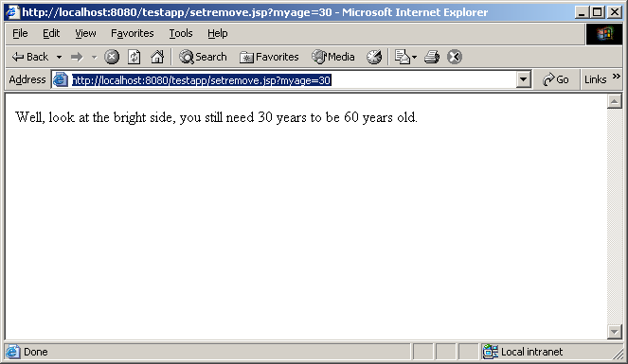
Here is another set example that sets bean property:

<%@ taglib uri="http://java.sun.com/jsp/jstl/core" prefix="c" %>
<%
bean.Item i =new bean.Item("1", "Beethoven","Symphonie no 6","Classical",11.99);
session.setAttribute("item", i);

%>
<html>
<body>
Original Price: <c:out value="${sessionScope.item.price}" />
<br></br>
Param Price: <c:out value="${param.price}" />
<c:set target="${sessionScope.item}" property="price" value="${param.price}" />
<br></br>
New Price: <c:out value="${sessionScope.item.price}" />
<c:remove var="item" scope="session" />
<br>
<br>
After removal, Price: <c:out value="${sessionScope.item.price}" />
</body>
</html>

Hit the following url:

http://localhost:8080/testapp/setbean.jsp?price=30

Here is the output:

This page will bomb if price parameter is not provided. We can fix this problem by using the following <c:if> tag.
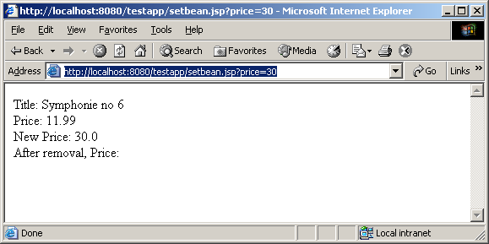
<c:catch>
Catches a java.lang.Throwable thrown by any of its nested actions.
Syntax
<c:catch [var=”varName”]>
nested actions
</c:catch>

The <c:catch> action allows page authors to handle errors from any action in a
uniform fashion, and allows for error handling for multiple actions at once.
<c:catch> provides page authors with granular error handling: Actions that are of
central importance to a page should not be encapsulated in a <c:catch>, so their
exceptions will propagate to an error page, whereas actions with secondary
importance to the page should be wrapped in a <c:catch>, so they never cause the
error page mechanism to be invoked.

The exception thrown is stored in the scoped variable identified by var, which
always has page scope. If no exception occurred, the scoped variable identified by
var is removed if it existed.

If var is missing, the exception is simply caught and not saved.

Attribute
Name | Expression | Type | Description
var | false | String | Name of the exported scoped variable for the exception thrown from a nested action. The type of the scoped variable is the type of the exception thrown.

<c:if>
Evaluates its body content if the expression specified with the test attribute is true.
Syntax
Syntax 1: Without body content
<c:if test=”testCondition”
var=”varName” [scope=”{page|request|session|application}”]/>
Syntax 2: With body content
<c:if test=”testCondition”
[var=”varName”] [scope=”{page|request|session|application}”]>
body content
</c:if>

Attributes
Name | Expression | Type | Description
test | true | boolean | The test condition that determines whether or not the body content should be processed.
var | false | String | Name of the exported scoped variable for the resulting value of the test condition. The type of the scoped variable is Boolean.
scope | false | String | Scope for var. If scope is specified, var must also be specified.

Here is an example page setbeanwithif.jsp that uses <c:if> tag:

<%@ taglib uri="http://java.sun.com/jsp/jstl/core" prefix="c" %>
<%
bean.Item i =new bean.Item("1", "Beethoven","Symphonie no 6","Classical",11.99);
session.setAttribute("item", i);

%>
<html>
<body>
Title: <c:out value="${sessionScope.item.title}" />
<br>
Price: <c:out value="${sessionScope.item.price}" />
<br>
<c:if test="${(not empty param.price)}">
<c:set target="${sessionScope.item}" property="price" value="${param.price}" />
</c:if>
New Price: <c:out value="${sessionScope.item.price}" />
<c:remove var="item" scope="session" />
<br>
After removal, Price: <c:out value="${sessionScope.item.price}" />
</body>
</html>

Hit the following url:

http://localhost:8080/testapp/setbeanwithif.jsp

Notice the page does not bomb anymore, it gives the following output:

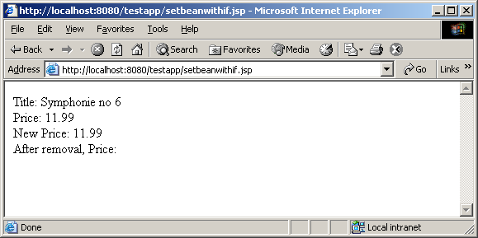
<c:choose>
Provides the context for mutually exclusive conditional execution.
The body of the <c:choose> action can only contain:
- White spaces
- 1 or more <c:when> actions. Must all <c:when> appear before <c:otherwise>
- 0 or 1 <c:otherwise> action. Must be the last action nested within <c:choose>
Syntax
<c:choose>
<when> and <otherwise>
</c:choose>

<c:when>
Represents an alternative within a <c:choose> action. Must have <c:choose> as an immediate parent. Must appear before an <c:otherwise> action that has the same parent.

Within a <c:choose> action, the body content of the first <c:when> action whose test
condition evaluates to true is evaluated by the JSP container, and the result is output
to the current JspWriter.

Syntax
<c:when test=”testCondition”>
body content
</c:when>
Body Content
JSP. If this is the first <c:when> action to evaluate to true within <c:choose>, the JSP
container processes the body content and then writes it to the current JspWriter.

Name | Expression | Type | Description
test | true | boolean | The test condition that determines whether or not the body content should be processed.

<c:otherwise>
Represents the last alternative within a <c:choose> action. Must have <c:choose> as an immediate parent. Must be the last nested action within <c:choose>.

If no <c:when> action nested within <c:choose> evaluates to true, the JSP container processes the body content and then writes it to the current JspWriter.

Syntax
<c:otherwise>
conditional block
</c:otherwise>

Here is a page choose.jsp that uses those tags mentioned above:

<%@ taglib uri="http://java.sun.com/jsp/jstl/core" prefix="c" %>
<%
bean.Item i =new bean.Item("1", "Beethoven","Symphonie no 6","Classical",11.99);
session.setAttribute("item", i);

%>
<html>
<body>
Title: <c:out value="${sessionScope.item.title}" />
<br>
Price: <c:out value="${sessionScope.item.price}" />
<br>
<c:if test="${(not empty param.price)}">
<c:set target="${sessionScope.item}" property="price" value="${param.price}" />
</c:if>
New Price: <c:out value="${sessionScope.item.price}" />
<c:choose>
<c:when test="${sessionScope.item.price<10}">
The new price is really cheap.
</c:when>
<c:when test="${sessionScope.item.price>=10 and sessionScope.item.price<20}">
The new price is still reasonable.
</c:when>
<c:otherwise>
The new price is really high.
</c:otherwise>
</c:choose>

<c:remove var="item" scope="session" />
<br>
After removal, Price: <c:out value="${sessionScope.item.price}" />
</body>
</html>

Hit the following url:

http://localhost:8080/testapp/choose.jsp?price=30

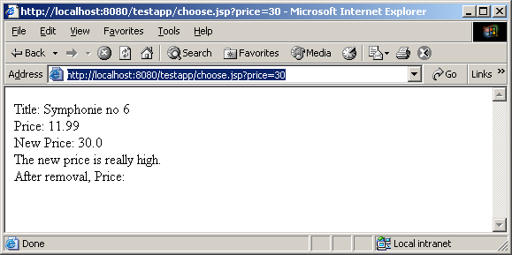
Change the price parameter value, you will get different output.

<c:forEach>
The <c:forEach> action repeats its nested body content over the collection of objects specified by the items attribute. A large number of collection types are supported by <c:forEach>, including all implementations of java.util.Collection (includes List, LinkedList, ArrayList, Vector, Stack, Set), and java.util.Map (includes HashMap, Hashtable, Properties, Provider, Attributes). Arrays of objects as well as arrays of primitive types (e.g. int) are also supported. For arrays of primitive types, the current item for the iteration is automatically wrapped with its standard wrapper class (e.g. Integer for int, Float for float, etc.). If the items attribute is of type java.util.Map, then the current item will be of
type java.util.Map.Entry, which has the following two properties:

_ key - the key under which this item is stored in the underlying Map
_ value - the value that corresponds to this key

Syntax

Syntax 1: Iterate over a collection of objects
<c:forEach[var=”varName”] items=”collection”
[varStatus=”varStatusName”]
[begin=”begin”] [end=”end”] [step=”step”]>
body content
</c:forEach>

Syntax 2: Iterate a fixed number of times
<c:forEach [var=”varName”]
[varStatus=”varStatusName”]
begin=”begin” end=”end” [step=”step”]>
body content
</c:forEach>
Here is a jsp, fortest.jsp that uses for loop:

<%@ page import="java.util.*,bean.*" %>
<%@ taglib uri="http://java.sun.com/jsp/jstl/core" prefix="c" %>
<%
Item i1 =new Item("1", "Beethoven","Symphonie no 6","Classical",11.99);
Item i2 =new Item("2","Mozart","Amadeus","Classical",14.99);
Item i3 =new Item("3","Dizzy Gillespie","Groovin High","Jazz",10.99);
Item i4 =new Item("4","John Coltrane","Bags and Trane","Jazz",13.99);

ArrayList a = new ArrayList();
a.add(i1);
a.add(i2);
a.add(i3);
a.add(i4);
session.setAttribute("myarray", a);

%>
<html>
<body>
<table border="1">
<c:forEach var="entry" items="${sessionScope.myarray}">
<tr>
<td>${entry.title}</td>
<td>${entry.price}</td>
</tr>
</c:forEach>
</table>
</body>
</html>

Hit the following url:

http://localhost:8080/testapp/fortest.jsp

Here is the output:

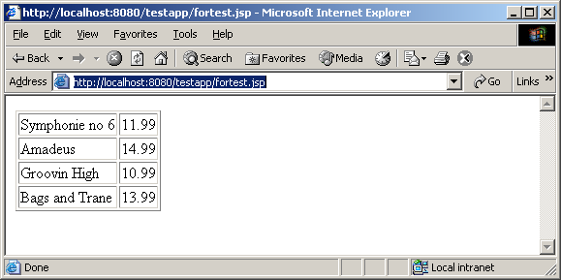

Reading Assignment
- Core Servlet and JavaServer Pages – Chapter 14,15
- Expression Language and JSTL in any new edition of JSP book.

Homework Assignment
This homework has two parts.

Part 1
- Write a VideoDAO that has the following 2 methods:
private static Connection getConnection()
public static ArrayList getVideoByCategory(String category)

This is a slim down version of VStoreDAO from hw6 that has two methods getConnection() and getVideoByCategory(), Just remove other methods and rename the class.

- Write a servlet ProcessVideoCategory that does exactly what my ProcessMusicCategory servlet does except for the fact that it deals with Video Items and it forwards to video.jsp

- Write a jsp video.jsp that presents the result of ProcessVideoCategory. video.jsp should use tags and beans just like my music.jsp does.

Deploy everything in ROOT app.

Here is a what the output should look like when the user types:

http://localhost/servlet/ProcessVideoCategory?category=Horror

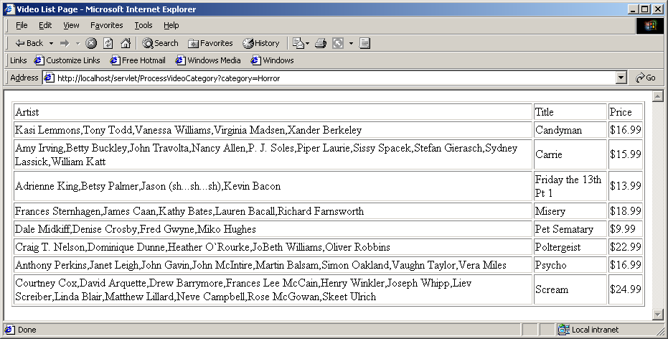

Part 2

Standard Tag library does not work in ROOT. You need testapp application.

Assuming you have an application called testapp like I have in demo8:

- Copy the following testapp.xml in Tomcat’s conf\catalina\localhost folder:

<Context path="/testapp" docBase="testapp" debug="0" reloadable="true">
<Resource name="jdbc/VStore" auth="Container" type="javax.sql.DataSource"/>
<ResourceParams name="jdbc/VStore">
<parameter>
<name>driverClassName</name>
<value>COM.cloudscape.core.JDBCDriver</value>
</parameter>
<parameter>
<name>url</name>
<value>jdbc:cloudscape:c:/data/VSTORE</value>
</parameter>
</ResourceParams>
</Context>

This will setup testapp for the database access.

- Copy VideDAO in testapp’s WEB-INF\classes folder
- Copy the ProcessVideoCategory in testapp’s WEB-INF\classes folder
- Write a jstlvideo.jsp that presents the data the same way video.jsp does – except, it uses JSTL just the same way my fortest.jsp does.

http://localhost:8080/testapp/servlet/ProcessVideoCategory?category=Comedy

