Objective

This session teaches students what JSP is all about. It covers all the basic elements of JSP and teaches how to integrate JSTL, Expression Language, JavaBean with JSP.

JSP
Let’s step back for a minute. Let’s assume we know nothing about Servlets – all we know is static HTML. Here is a simple html page randomnumber.html that has a hardcoded random number:

randomnumber.html
<!DOCTYPE html PUBLIC "-//W3C//DTD HTML 4.01 Transitional//EN" "http://www.w3.org/TR/html4/loose.dtd">
<HTML>
<HEAD><TITLE>JSP Expression Demo</TITLE></HEAD>
<BODY><H3>Here is your random number: 56</H3>
</BODY>
</HTML>

Here is the url:

http://localhost:8080/JPIDemo9/randomnumber.html

You will get 56 as hardcoded random number.

Ok – big deal!!

Now, let’s rename the file to randomnumber.jsp. It looks like a small step for you but it is giant step for mankind. Let’s hit the page:

http://localhost:8080/JPIDemo9/randomnumber.jsp

The good news is the page is still rendered as the html page, the bad news is refreshing the page does not really dynamically give you new random numbers.

Alright, get go ahead and change the jsp page as follows:

randomnumber.jsp
<!DOCTYPE html PUBLIC "-//W3C//DTD HTML 4.01 Transitional//EN" "http://www.w3.org/TR/html4/loose.dtd">
<HTML>
<HEAD><TITLE>JSP Expression Demo</TITLE></HEAD>
<BODY><H3>Here is your random number: <%= (int) (Math.random()*100) %></H3>
</BODY>
</HTML>

This time you took a giant step for yourself not to mention mankind.

Let’s hit the page:

http://localhost:8080/JPIDemo9/randomnumber.jsp

Now, we will start getting really random number and each refresh will bring you a new number.

What happened? You just mixed static html with dynamic content without knowing the details behind it.

JavaServer Pages(JSP) technology allows you to mix regular, static HTML with dynamically generated content from servlets. Developing a JSP is really simple. You simply write your regular HTML page using your favorite web development tool. You then enclose the code for the dynamic parts using special tags (mostly with <%..%> tags). Although what you write often looks more like HTML file than a servlet, behind the scenes, the JSP page is automatically converted to a normal-servlet, with the static HTML simply being printed to the output steam associated with the servlet’s service() method. I guess, the basic difference between a servlet and a JSP is that, in case of servlet, you feel like you are writing Java code. Inside your Java code you print HTML tags whenever you need static content. In case of JSP, you feel like you are writing an HTML page. Inside your HTML page, you embed Java code whenever you need dynamic content. In other words, servlets are process driven approach whereas JSPs are presentation driven. But, behind the scenes, you are dealing with only one thing – servlets.

A JSP page obviously contains regular HTML but in addition there are three main types of JSP constructs that you embed in a page:

- Scripting Elements
- Directives
- Actions

Scripting elements let you specify Java code that will become part of the resultant servlet, directives let you control the overall structure of the servlet and actions let you specify existing components that should be used and otherwise control the behavior of the JSP engine.

Scripting Elements
JSP Scripting elements let you insert server-side java code into JSP pages. There are three forms of scripting elements:

- Expressions of the form <%= expression %> which are evaluated on the server and the results of the evaluation are rendered to the client. The expressions are inserted within Out.print() method into the JSP’s _jspService() method (exactly the way static HTMLs are) that is called by the service() method.
- Scriptlets of the form <% code %> which are inserted into the JSP’s _jspService() method. _jspService() method is called by service() method.
- Declarations of the form <%! code %> which are inserted into the body of JSP’s servlet class, outside of any existing methods.

In addition there is way to insert server-side comments in JSP page. These comments appear on the JSP page but not on the resulting HTML page. In order to put this type of comments you use :

<%-- JSP Comments --%>

Please keep in mind that HTML comments – which does appear on the HTML page - have a similar syntax:

<!—HTML Comments -->

Predefined Variable:
JSP pages have a set of predefined variables for programming convenience:

- request – represents HttpServletRequest
- response – represents HttpServletResponse
- out – represents PrintWriter that we get from a servlet by calling getWriter() method of HttpServletResponse
- session – represents HttpSession
- application – represents ServletContext
- config – represents ServletConfig
- pageContext – represents jsp PageContext.
- page – simply a synonym for this

JSP Expressions <%= …. %>
Here is an example of a simple JSP page that uses JSP expression:

randomnumber.jsp
<!DOCTYPE html PUBLIC "-//W3C//DTD HTML 4.01 Transitional//EN" "http://www.w3.org/TR/html4/loose.dtd">
<HTML>
<HEAD><TITLE>JSP Expression Demo</TITLE></HEAD>
<BODY><H3>Here is your random number: <%= (int) (Math.random()*100) %></H3>
</BODY>
</HTML>

Looks familiar? It’s the same page we saw few minutes ago.

The first time the JSP engine intercepts a request for a JSP, it compiles the JSP page into a sophisticated servlet.

If you run the above application in StandAlone Tomcat (Outside of Eclipse), here is the generated code for randomnumber.jsp found in tomcat’s work\Catalina\localhost\JPIDemo9\org\apache\jsp folder:

package org.apache.jsp;

import javax.servlet.*;
import javax.servlet.http.*;
import javax.servlet.jsp.*;

public final class randomnumber_jsp extends org.apache.jasper.runtime.HttpJspBase
implements org.apache.jasper.runtime.JspSourceDependent {

private static final JspFactory _jspxFactory = JspFactory.getDefaultFactory();

private static java.util.List _jspx_dependants;

private javax.el.ExpressionFactory _el_expressionfactory;
private org.apache.AnnotationProcessor _jsp_annotationprocessor;

public Object getDependants() {
return _jspx_dependants;
}

public void _jspInit() {
_el_expressionfactory = _jspxFactory.getJspApplicationContext(getServletConfig().getServletContext()).getExpressionFactory();
_jsp_annotationprocessor = (org.apache.AnnotationProcessor) getServletConfig().getServletContext().getAttribute(org.apache.AnnotationProcessor.class.getName());
}

public void _jspDestroy() {
}

public void _jspService(HttpServletRequest request, HttpServletResponse response)
throws java.io.IOException, ServletException {

PageContext pageContext = null;
HttpSession session = null;
ServletContext application = null;
ServletConfig config = null;
JspWriter out = null;
Object page = this;
JspWriter _jspx_out = null;
PageContext _jspx_page_context = null;

try {
response.setContentType("text/html");
pageContext = _jspxFactory.getPageContext(this, request, response,
null, true, 8192, true);
_jspx_page_context = pageContext;
application = pageContext.getServletContext();
config = pageContext.getServletConfig();
session = pageContext.getSession();
out = pageContext.getOut();
_jspx_out = out;

out.write("<!DOCTYPE html PUBLIC \"-//W3C//DTD HTML 4.01 Transitional//EN\" \"http://www.w3.org/TR/html4/loose.dtd\">\r\n");
out.write("<HTML>\r\n");
out.write("\t<HEAD><TITLE>JSP Expression Demo</TITLE></HEAD>\r\n");
out.write("\t<BODY><H3>Here is your random number: ");
out.print( (int) (Math.random()*100) );
out.write("</H3>\r\n");
out.write("\t</BODY>\r\n");
out.write("</HTML>\r\n");
} catch (Throwable t) {
if (!(t instanceof SkipPageException)){
out = _jspx_out;
if (out != null && out.getBufferSize() != 0)
try { out.clearBuffer(); } catch (java.io.IOException e) {}
if (_jspx_page_context != null) _jspx_page_context.handlePageException(t);
}
} finally {
_jspxFactory.releasePageContext(_jspx_page_context);
}
}
}

Notice request and response are coming to _jspService as input parameters and page, pageContext, application, config, session, out are being declared and initialized within the method. In other words, when we write a JSP page, these variables are not declared yet. By the time the JSP gets converted to servlet, these variables gets declared and initialized automatically.

As you can see above Tomcat is extending a HttpJspBase class for each JSP page. HttpJspBase is Tomcat’s own class that somehow extends HttpServlet and possibly implements some other interface.

When I ran javap (I hope you are familiar with javap) on HttpJspBase as follows:

javap org.apache.jasper.runtime.HttpJspBase, here is the output I found:

Compiled from HttpJspBase.java
public abstract class org.apache.jasper.runtime.HttpJspBase extends javax.servlet.http.HttpServlet implements javax.servlet.jsp.HttpJspPage {
protected javax.servlet.jsp.PageContext pageContext;
protected org.apache.jasper.runtime.HttpJspBase();
public abstract void _jspService(javax.servlet.http.HttpServletRequest, javax.servlet.http.HttpServletResponse) throws javax.servlet.ServletException, java.io.IOException;
public final void destroy();
protected java.lang.ClassLoader getClassLoader();
public java.lang.String getServletInfo();
public final void init(javax.servlet.ServletConfig) throws javax.servlet.ServletException;
public void jspDestroy();
public void jspInit();
public final void service(javax.servlet.http.HttpServletRequest, javax.servlet.http.HttpServletResponse) throws javax.servlet.ServletException, java.io.IOException;
public final void setClassLoader(java.lang.ClassLoader);
}

As you can see Tomcat’s HttpJspBase not only extends HttpServlet, it also implements HttpJspPage interface. We need to look at HttpJspPage interface but HttpJspPage interface extends JspPage interface. Therefore, we need to look at JspPage interface first.

JspPage Interface
This is the interface that a JSP processor-generated class must satisfy.

The interface defines a protocol with 3 methods; only two of them: jspInit() and jspDestroy() are part of this interface as the signature of the third method: _jspService() depends on the specific protocol used and cannot be expressed in a generic way in Java.
A class implementing this interface is responsible for invoking the above methods at the appropriate time based on the corresponding Servlet-based method invocations.

The jspInit() and jspDestroy() methods can be defined by a JSP author, but the _jspService() method is defined automatically by the JSP processor based on the contents of the JSP page. Here are two methods in the interface:

jspInit() | void | jspInit() is invoked when the JspPage is initialized. This is similar to the init() method in servlet. Page authors are free to provide initialization code of the JSP by implementing this method in their JSP page – although people rarely do.
jspDestroy() | void | jspDestroy() is invoked when the JspPage is about to be destroyed. This is similar to the destroy() method in servlet. Page authors are free to provide cleanup code of the JSP by implementing this method in their JSP page – although people rarely do.

HttpJspPage Interface
HttpJspPage interface extends JspPage interface. This is the interface that a JSP processor-generated class for the HTTP protocol must satisfy. There is only one method in this interface:

_jspService(HttpServletRequest request, HttpServletResponse response) | void | _jspService corresponds to the body of the JSP page – the entire body of a JSP page ends up here. This method is defined automatically by the JSP processor and should NEVER BE DEFINED BY THE JSP AUTHOR. This method is similar to service() method of servlet. Everytime a request comes to a JSP page, the service() method of the Servlet interface invokes this method.

JspFactory Class
If we examine the body of the _jspService() method carefully, we will see that the first thing that is being used is the JspFactory class. This abstract factory class provides mechanism to instantiate platform-dependent objects in a platform-independent manner. Typically, at initialization time, a JSP container like Tomcat will call the static setDefaultFactory() method on JspFactory in order to register object that is instantiated from Tomcat’s non-abstract subclass of JspFactory. Each servlet behind each JSP page will use the getDefaultFactory() method in order to obtain this factory object registered by the container and use it to construct PageContext instance to process the request.

setDefaultFactory(JspFactory deflt) | static void | set the default factory object instantiated from the non-abstract subclass of JspFactory for this implementation.
getDefaultFactory() | static JspFactory | called to get the default factory instantiated from the non-abstract subclass of JspFactory implemented by this container.
getPageContext(Servlet servlet, ServletRequest request, ServletResponse response, String errorPageURL, boolean needsSession, int buffer, boolean autoflush) | abstract PageContext | obtains an instance of an page context object instantiated from a subclass of PageContext abstract class implemented by this container for the calling Servlet and currently pending request and response.
releasePageContext(PageContext pc) | abstract void | called to release a previously allocated PageContext object.
getEngineInfo() | abstract JspEngineInfo | called to get implementation-specific information on the current JSP engine

PageContext Class
_jspService() method calls the getPageContext() method on the default factory that returns an object instantiated by the container from non-abstract subclass of PageContext class. PageContext is an abstract class that encapsulates the container from the servlet behind JSP. A servlet generated by a JSP page in Tomcat (for eaxample the servlet above) can run unmodified in any other container (like JRUN) because of PageContext indirection that it uses. Not only that, the servlet will be able to take advantage of container specific performance improvements like high performance JspWriter of the container it ends up executing in, without any knowledge of the actual implementation of JspWriter.

PageContext provides a number of facilities, including:

- A single API that manages the operations like setAttribut(), getAttribute etc. over various scope namespaces like page, request, session, application etc.
- A mechanism for obtaining a platform-dependent implementatin of the JspWriter that is assigned to the “out” variable.
- A number of convenient getter methods like getSession(), getServletContext() etc.
- Mechanisms to forward or include.

Here are the methods of PageContext:

getOut() | abstract JspWriter | The current value of the out object (a JspWriter).
getPage() | abstract Object | The current value of the page object (a Servlet).
getRequest() | abstract ServletRequest | The current value of the request object (a ServletRequest).
getResponse() | abstract ServletResponse | The current value of the response object (a ServletResponse).
getServletConfig() | abstract ServletConfig | The ServletConfig instance.
getServletContext() | abstract ServletContext | The ServletContext instance.
getSession() | abstract HttpSession | The current value of the session object (an HttpSession).
Initialize(Servlet servlet, ServletRequest request, ServletResponse response, java.lang.String errorPageURL, boolean needsSession, int bufferSize, boolean autoFlush) | abstract void | The initialize method is called to initialize an uninitialized PageContext so that it may be used by a JSP Implementation class to service an incoming request and response within it's _jspService() method.
findAttribute(String name) | abstract Object | Searches for the named attribute in page, request, session (if valid), and application scope(s) in order and returns the value associated or null.
setAttribute(String name, Object attribute) | abstract void | Register the name and object specified with page scope semantics.
setAttribute(String name, Object o, int scope) | abstract void | register the name and object specified with appropriate scope semantics
getAttribute(String name) | abstract Object | Return the object associated with the name in the page scope or null if not found.
getAttribute(String name, int scope) | abstract Object | Return the object associated with the name in the specified scope or null if not found.
removeAttribute(String name) | abstract void | Remove the object reference associated with the given name, look in all scopes in the scope order.
removeAttribute(String name, int scope) | abstract void | Remove the object reference associated with the specified name in the given scope.
getAttributesScope(String name) | abstract int | Get the scope where a given attribute is defined.
getAttributeNamesInScope(int scope) | abstract Enumeration | Enumerate all the attributes in a given scope
getException() | abstract Exception | The current value of the exception object (an Exception).
handlePageException(Exception e) | abstract void | This method is intended to process an unhandled "page" level exception by redirecting the exception to either the specified error page for this JSP, or if none was specified, to perform some implementation dependent action.
handlePageException(Throwable t) | abstract void | This method is identical to the handlePageException(Exception), except that it accepts a Throwable.
forward(String relativeUrlPath) | abstract void | This method is used to re-direct, or "forward" the current ServletRequest and ServletResponse to another active component in the application.
include(java.lang.String relativeUrlPath) | abstract void | Causes the resource specified to be processed as part of the current ServletRequest and ServletResponse being processed by the calling Thread.
popBody() | JspWriter | Return the previous JspWriter "out" saved by the matching pushBody(), and update the value of the "out" attribute in the page scope attribute namespace of the PageConxtext
pushBody() | BodyContent | Return a new BodyContent object, save the current "out" JspWriter, and update the value of the "out" attribute in the page scope attribute namespace of the PageContext
release() | abstract void | This method shall "reset" the internal state of a PageContext, releasing all internal references, and preparing the PageContext for potential reuse by a later invocation of initialize().

JspWriter Class
Surprisingly, the getOut() method of the PageContext returns JspWriter object as opposed to getWriter() method of response that returns PrintWriter.

This abstract JspWriter class emulates some of the functionality found in the BufferedWriter and PrintWriter classes, however it differs in that it throws java.io.IOException from even the print() methods while PrintWriter does not.

There are a couple of reasons for having this class. The initial JspWriter object is associated with the PrintWriter object of the ServletResponse in a way that depends on whether the page is or is not buffered. If the page is not buffered, output written to this JspWriter object will be written through to the PrintWriter directly, which will be created if necessary by invoking the getWriter() method on the response object. But if the page is buffered, the PrintWriter object will not be created until the buffer is flushed and operations like setContentType() are legal. Since this flexibility simplifies programming substantially, buffering is the default for JSP pages.

The methods of JspWriter is pretty much the same as PrintWriter (it has overloaded print() and println() methods) except for the fact that it has additional buffer related methods like isAutoFlush(), clear() clearBufffer(), getRemaining() etc.

JSP Scriptlets <% … %>
If we want to do something more complex than inserting a simple expression, JSP scriptlets let you insert arbitrary code in the JSP page’s _jspService method.

Scriptlets have access to the same set of automatically defined variables such as session, application etc. If you want your output to appear in the resultant page, you will use the out variable.

In general, scriptlets can do things that can’t be accomplished with expressions alone. For example, setting the response headers, status code, updating database, loops, conditional statements etc. can only be done in scriptlets.

Here is an example of a JSP page using scriptlets:
color.jsp
<HTML>
<HEAD><TITLE>Color JSP</TITLE></HEAD>
<%
String color=request.getParameter("color");
boolean found=true;
if (color==null){
color="white";
found=false;
}
%>
<BODY bgColor="<%= color %>">
<%
if (found){
out.println("<H3>Here is your backcolor: " + color + "<H3>");
}
else{
out.println("<H3>Using default white backcolor</H3>");
}
%>
<FORM method="GET">
<TABLE>
<TR><TD>Backgroud Color Please</TD><TD><INPUT type="text" name="color" value=<%= color %> size=20></TD></TR>
</TABLE>
<BR><BR>
<INPUT type="submit" value="Send"> <input type="reset" value="Clear">
</FORM>
</BODY>
</HTML>

Here is the output:
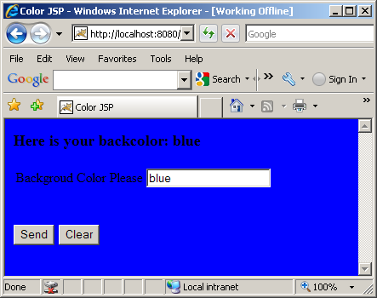

There are few things to notice above. There is no “Action” attribute of the FORM tag. What that means is that the page will call itself everytime you submit – this has nothing to do with jsp, that’s how form action works – if not specified returns itself. Variable “color” declared in one scriptlet are accessed from another scriptlet. That’s because all the scriptlets go into one _jspService() method. Also, notice that response remembers the color value from previous request. The trick to do this is to put it on the value of the input text box, to be specific, value=<%= color %> does the trick as follows:

<INPUT type="text" name="color" value=<%= color %> size=20>

Notice how Jsp Expressions (<%= … %>) are appearing within out.print and Jsp Scriplets (<% .. %>) are appearing as pure code within _jspService() method sequentially.

JSP Declarations <%! … %>
A JSP declaration lets you define fields and methods that gets inserted into the resultant servlet outside of the _jspService() method. Please keep in mind that the same instance of a servlet (generated from a JSP page) may be accessed by multiple clients (unless the servlet implements SingleThreadModel). Therefore, you have to careful about defining fields in a JSP page.

Here is a JSP page that counts the number of hits to the page.

hitcount.jsp

<HTML>
<HEAD><TITLE>JSP Declaration Demo</TITLE></HEAD>
<%! private int count=0; %>
<%
++count;
%>
<BODY><H3>This page has been visited: <%= count %> times </H3>
</BODY>
</HTML>

JSP Directives <%@ …. %>
A JSP Directive effects the overall structure of the servlet that results from the JSP page. A page directive looks as follows:

<%@ directivename attribute1=”value1” attribute2=”value2” ….. attributeN=”valueN” %>

Single quotes can be used instead of double quotes but can not be omitted altogether. To obtain quote marks you have to use \” (slash as the escape character).

In JSP there are three types of directives:

- page
- include
- taglib

The Page Directive <%@ page …. %>
The page directive lets you control the structure (and behavior) of the servlet. The page directive has the following attributes:

Attribute | Description | Default Value
language | Defines the scripting language to be used in the JSP page. This attribute is for future use when JSP supports multiple language. | “Java”
extends | This value is a fully qualified class name of the superclass that the generated servlet class should extend from. In general, you can’t use it since the container has to subclass certain class already. In case of Tomcat, it subclasses HttpJspBase class. | Omitted by default.
import | Comma separated list o packages or classes that you would like to import for convenience. | Omitted by default.
session | Specifies whether the page participates in session. When is value is true(default) a variable names session is available and can be used to access the session. | “true”
buffer | Specifies the buffering model for the output. If the value is “none”, then no buffering occurs and the all output is written directly to the response. | Depends on container – at least 8 KB.
autoFlash | If “true” the output buffer to the client is flushed automatically when it is full. If “false” a runtime exception is raised to indicate that buffer overflow. | “true”
isThreadSafe | Defines the thread safety of the page. If the value is “true” the JSP engine can send multiple client request to the same instance of the of the page servlet. | “true”
Info | Defines information string that can be retrieved from the servlet’s getServletInfo() method | Omitted by default.
errorPage | Defines the URL of another page, which is included if an unchecked runtime exception is thrown. The page catches the exception and passes it to the error processing page. | Omitted by default.
isErrorPage | Indicates if the current page itself is intended to be the error page of another page. If “true” an implicit variable exception is available that has the runtime exception information. | “false”
ContentType | Defines the MIME type and character encoding of the JSP page. | The default value for the MIMETYPE is text/html and the default value for the CHARSET is ISO-8859-1.

Here is a page that uses all of the above page directives:

number.jsp
<%@ page language="Java" import="java.util.*,java.math.*" session="true" buffer="12kb"
autoFlush="true" isThreadSafe="true" info="'My test page" errorPage="error.jsp"
isErrorPage="false" contentType="text/html;CHARSET=ISO-8859-1"%>
<HTML>
<HEAD><TITLE>Number JSP</TITLE></HEAD>
<%
String number = request.getParameter("number");
boolean found=true;
if (number==null){
found=false;
number="";
}

%>
<BODY>
<%
if (found){
int num=0;
num=Integer.parseInt(number);

// If I make it here - no number format exception.
out.println("<H3>Here is your number: " + num + "<H3>");
}
%>
<FORM method="GET">
<TABLE>
<TR>
<TD>Please enter a number</TD>
<TD><INPUT type="text" name="number" value="<%= number %>" size=20></TD>
</TR>
</TABLE>
<BR><BR>
<INPUT type="submit" name="send" value="Send"> <input type="reset" value="Clear">
</FORM>
</BODY>
</HTML>

Here is error.jsp
<%@ page language="Java" session="true" buffer="12kb" autoFlush="true" isThreadSafe="true"
info="'My error page" isErrorPage="true" contentType="text/html;CHARSET=ISO-8859-1"%>
<HTML>
<HEAD><TITLE>Error JSP</TITLE></HEAD>
<BODY>
<H3>Error: <%=exception.toString() %></H3>
</BODY>
</HTML>

If you enter a non non-numeric value you will get the content of error.jsp. Unfortunately, IE does not show the error correctly, please use firefox to see it. Of course Fiddler2 shows the return content.

Limitation of Page Directive
We want to generate Excel spreadsheet by specifying content type as application/vnd.ms-excel only if the browser supports Excel and by formatting the content as HTML table. Excel can present HTML table as Excel table. But page attribute values can not be computed at run-time, nor can page directives be conditionally inserted. Here is the work-around:

excel.jsp
<%@ page import="java.util.*" %>
<%
boolean excel=true;
String accept=request.getHeader("Accept");
if (accept==null){
excel=false;
}
else{
if (accept.indexOf("ms-excel")>= 0){
excel=true;
}
}
if (excel){
response.setContentType("application/vnd.ms-excel");
}
%>
<HTML>
<HEAD><TITLE>Excel JSP</TITLE></HEAD>
<BODY>
<TABLE BORDER="1">
<TR><TH>&nbsp</TH><TH>Grades</TH><TH>&nbsp</TH></TR>
<TR><TH>Name</TH><TH>Assignment 1</TH><TH>Assignment 2</TH></TR>
<TR><TD>John Smith</TD><TD>10</TD><TD>9</TD></TR>
<TR><TD>Bill Bond</TD><TD>10</TD><TD>10</TD></TR>
<TR><TD>Sue Lee</TD><TD>9</TD><TD>10</TD></TR>
</TABLE>
</BODY>
</HTML>

Here is the output:

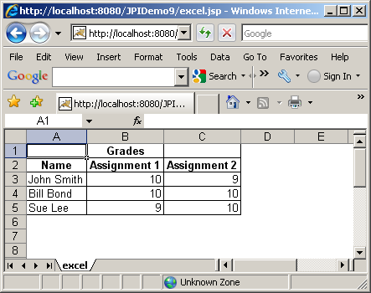

The taglib Directive <jsp: …. >
The taglib directive allows the page to use custom tags on a JSP page. The taglib directive will be discussed later in details along with custom tags.

Standard Actions
Standard actions are tags that affect the runtime behavior of the JSP and the response sent back to the client. Effectively, a standard action is a tag that can be embedded in a JSP page. During compilation into a servlet, the container comes across this tag and replaces it with Java code that corresponds to the required predefined task.

The standard action types are:

- <jsp:useBean>
- <jsp:setProperty>
- <jsp:getProperty>
- <jsp:param>
- <jsp:include>
- <jsp:forward>
- <jsp:plugin>

<jsp:useBean>, <jsp:setPropety> and <jsp:getProperty> will be discussed later with JavaBean.

<jsp: param>
The <jsp:Param> action is used to provide other tags with additional information in the form of name-value pairs. It is used with <jsp:include>, <jsp:forward>, <jsp:plugin> actions as shown below. The syntax is:

<jsp:param name=”paramname” value=”paramvalue”/>

<jsp:include>
This action allows a static or dynamic resource, specified by a URL, to be included in the current JSP at request processing time. An included page has access to only the JspWriter object, and it can not set headers or cookies. The included file can not contain other JSPs but itself can contain JSP contents. This action internally uses RequestDispatcher’s include() method, which is what servlet uses. The syntax is:

<jsp:include page=”pagename” flush=”true”/>

or

<jsp:include page=”pagename” flush=”true”>
<jsp:param name=”paramname” value=”paramvalue”/>
</jsp:include>

The attributes of the <jsp:include> action are:

Attribute | Description
page | The page to be included.
flush | The buffer in the output stream is flushed before the inclusion is performed. In JSP 1.1 this value must always be “true”

A <jsp:include> action may have one or more <jsp:param> tags in its body, providing additional name-value pairs. The included page can access the original request object, which will contain both original parameters, and the new parameters specified using <jsp: param> tag. If the parameter names are the same, the old values are kept intact, but the new values take precedence over the existing values.

Here is a jsp that uses <jsp:include>:
jspincludedemo.jsp
<%@ page import="java.util.Date" %>
<HTML>
<HEAD><TITLE> JSP Include Demo</TITLE></HEAD>
<BODY>
<jsp:include page="runtime.jsp" flush="true" />
<p>
This line is included at response time.
<p>
The Current Server Date and Time is <%=new Date() %> (From jspincludedemo.jsp)
</BODY>
</HTML>

Here is the included page:
runtime.jsp
<%@ page import="java.util.Date" %>
This line is included at run time.
<p>
The Current Server Date and Time is <%=new Date() %> (From runtime.jsp)

Here is the output:

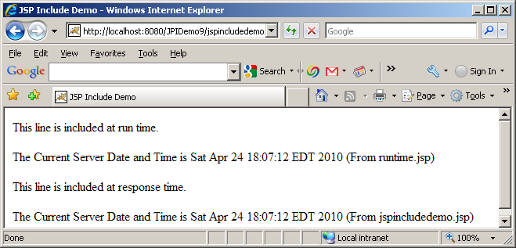

<jsp:forward>
This action allows the request to be forwarded to another JSP, to a servlet, or to a static HTML page. specified by a URL. This action internally uses RequestDispatcher’s forward() method, which is what servlet uses. The resource to which the request is being forwarded must be in the same context as the JSP dispatched the quest. Execution in the current JSP stops when it encounters a <jsp:forward> tag, the buffer is cleared, and the request is forwarded. The syntax is:

<jsp:forward page=”pagename”/>

or

<jsp:forward page=”pagename”>
<jsp:param name=”paramname” value=”paramvalue”/>
</jsp:forward>

Here is a jsp that uses <jsp:forward>:

jspforwarddemo.jsp
<%@ page import="java.util.Date" %>
<HTML>
<HEAD><TITLE> JSP Forward Demo</TITLE></HEAD>
<BODY>
This is the original page.<br/>
The Current Server Date and Time is <%=new Date() %> (From jspforwarddemo.jsp)
<jsp:forward page="next.jsp" />
</BODY>
</HTML>

Here is next.jsp where it forwards:
next.jsp
<%@ page import="java.util.Date" %>
This is the next page.
<p>
The Current Server Date and Time is <%=new Date() %> (From next.jsp)

Here is the output:

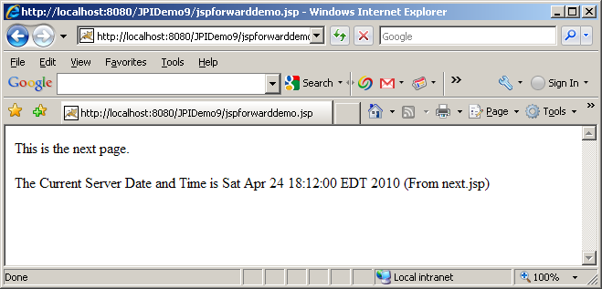

Notice that the output from the original jsp disappeared. That’s ‘cause the buffer is cleared
<jsp:plugin>
This action is used in pages to generate client browser specific HTML tags (<BOJECT> or <EMBED>) that result in the download of the java plug-in software, if required, followed by the execution of the component specified in the tag.

The <jsp:plugin> tag can optionally have <jsp:fallback> tag which allows to specify the content to be displayed in the client browser if the plugin cannot be started ( exactly like HTML ALT attribute) as well as <jsp:params> tag. The syntax is:

<jsp:plugin type=”bean|applet” code=”CodeName” codebase=”CodeBaseName” align=”Alignment” archive=”ArchiveList” height=”Height” width=”Width” hspace=”Hspace” vspace=”Vspace” jreversion=”JREversion” name=”ComponentName” nspluginurl=”Netscape Plugin URL” iepluginurl=”IE Plugin URL”/>

or

<jsp:plugin type=”bean|applet” code=”CodeName” codebase=”CodeBaseName” align=”Alignment” archive=”ArchiveList” height=”Height” width=”Width” hspace=”Hspace” vspace=”Vspace” jreversion=”JREversion” name=”ComponentName” nspluginurl=”Netscape Plugin URL” iepluginurl=”IE Plugin URL”>
<jsp:params>
<jsp:param name=”paramname” value=”paramvalue”/>
</jsp:params>
<jsp:fallback> Alternate text </jsp:fallback>
</jsp:plugin>

JavaBeans
To separate code from presentation, it would be a good idea to encapsulate the code in a java object (a JavaBean) and then instantiate and the use this object within our JSP. The <jsp:useBean>, <jsp:setProperty> and <jsp:getProperty> tags assist with this task. JavaBean is a simple java class with the following characteristics:

- A bean class must have a zero-argument (empty) constructor.
- A bean class should have no public instance variables (fields)
- Persistent values should be accessed through setXxx() and getXxx() methods. The only exception to this naming convention is with Boolean fields – instead of getXxx() it should be isXxx().

<jsp:useBean>
This action is used to instantiate a JavaBean, or locate an existing bean instance, and assign it to a variable name. We can specify the lifetime of the object by giving it a scope. The syntax is:

<jsp:useBean id=”BeanID” scope=”scopeName” class=”ClassName” beanName=”BeanName” type=”ClassName”/>

The attributes of the <jsp:useBean> action are:

Attribute | Description | Default Value
Id | The case sensitive name used to identify the object. | No default value
scope | The scope within which the reference is available. Possible values are “page”, “request”, “session” and “application” | Page
class | The fully qualified name of the bean class. | No default value
beanName | The name of the bean. | Optional. No default value
type | This optional attribute specifies the type of the variable to be created. The type name must be the bean’s class name itself or a superclass of the bean’s class or an interface name that the bean implements | The class of the bean itself.

<jsp:setProperty>
This action is used in conjunction with the <jsp:useBean> action to set the value of a bean property(field).

To modify bean properties, you normally use <jsp:setProperty> action with the following syntax:

<jsp:setProperty name=”BeanName” property=”PropertyName” param=”ParameterName” value=”Value”/>

The attributes of the <jsp:setProperty> action are:

Attribute | Description
name | The name of the bean instance. This should match the id given by <jsp:useBean>
property | The name of the bean property whose value is being set. If the property attribute has the value “*”, the tag looks through all the request parameters and tries to match the request parameter names and types to the property names and types and assigns the request parameters to the bean properties – all in one shot.
param | This optional attribute is used to specify request parameter name when request parameter name does not match the property name.
value | The property value if the value is not coming from a parameter.

<jsp:getProperty>
This action is used to retrieve the value of a bean property. It accesses the value of the property, converts it to a String and prints it to the output stream. The syntax is:

<jsp:getProperty name=”BeanName” property=”PropertyName”/>

The attributes of the <jsp:getProperty> action are:

Attribute | Description
name | The name of the bean instance. This should match the id given by <jsp:useBean>
property | The name of the bean property whose value is being retrieved.

Here is an example of a simple bean class:

package bean;
public class MessageBean implements java.io.Serializable
{
private static final long serialVersionUID = 1L;

private String message;
public String getMessage(){
return message;
}

public void setMessage(String newmessage){
message = newmessage;
}

public String generateDefaultMessage(){
return "Beans are cool, EJBs are pain in the neck";
}

}

Notice that there is nothing special about this class. It has a get and set method and a default empty constructor (not even defined). That’s it. That’s a good example of a bean.

Create a folder “bean” (package folder) under c:\tomcat5028\webapps\ROOT\WEB-INF\classes folder and copy this class file and compile.

Let’s use this bean is a JSP file:

messagebeandemo.jsp
<HTML>
<HEAD>
<TITLE>Message Bean Demo</TITLE>
</HEAD>
<BODY>
<jsp:useBean id="messagebean" class="bean.MessageBean" />
<jsp:setProperty name="messagebean" property="message" value="How are you?"/>
Here is the message:
<P>
<B><jsp:getProperty name="messagebean" property="message"/></B>
</BODY>
</HTML>

Notice that the class in is “bean” folder – which represents package. Therefore, the class name is bean.MessageBean (package name followed by classname)
Notice that I declared the id is lowercase “messagebean” and subsequently used the lowercase id in <jsp:setProperty> and <jsp:getProperty> actions.

Also notice that, the property name is “message” is lowercase but the method names are setMessage() and getMessage() (uppercase “M”) – that’s the convention.

Also notice that I neglected to declare the scope and it is by default “page”. For any other scope you have to declare it explicitly.

Here is the output:

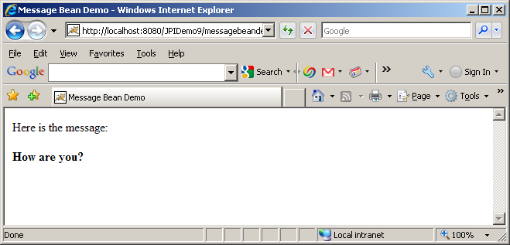

Here is another example where the message is read from the request parameter and request parameter and the bean property does not match:

messagebeandemo2.jsp
<HTML>
<HEAD>
<TITLE>Message Bean Demo2</TITLE>
</HEAD>
<BODY>
<jsp:useBean id="messagebean" class="bean.MessageBean" />
<jsp:setProperty name="messagebean" property="message" param="mymessage" />
Here is the message:
<P>
<B><jsp:getProperty name="messagebean" property="message"/></B>
</BODY>
</HTML>

In order to test this JSP, append the following to your URL:

?mymessage=Hi there

as follows:

http://localhost:8080/JPIDemo9/messagebeandemo2.jsp?mymessage=hi%20there

Here is the output:

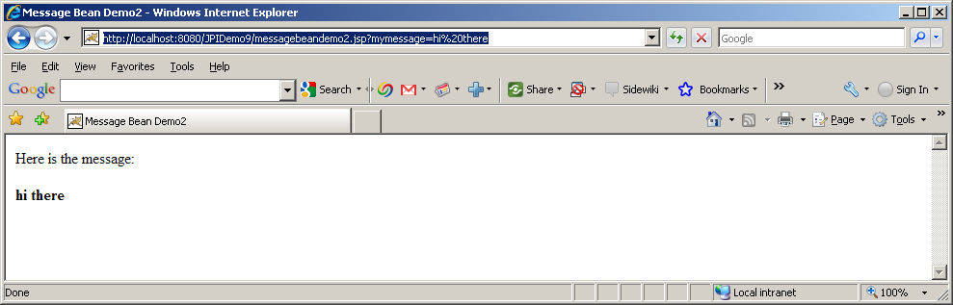

Notice, I am manually passing the request parameter as a GET request. Change “Hi there” to something else to see the dynamic behavior.

Here is the same example again, but this time the request parameter name and bean property matches exactly (case sensitive):

messagebeandemo3.jsp
<HTML>
<HEAD>
<TITLE>Message Bean Demo3</TITLE>
</HEAD>
<BODY>
<jsp:useBean id="messagebean" class="bean.MessageBean" />
<jsp:setProperty name="messagebean" property="*" />
Here is the message:
<P>
<B><jsp:getProperty name="messagebean" property="message"/></B>
</BODY>
</HTML>

Notice, on <jsp:setProperty> action the property=”*” and param attribute is missing – which basically means that the set all the properties of the bean from the request parameters and the property name will match with the corresponding request parameter. Very convenient!!

In order to test this JSP, append the following to your URL:

?message=To be or not to be ...

as follows:

http://localhost:8080/JPIDemo9/messagebeandemo3.jsp?message=to%20be%20or%20to%20be....

Here is the output:

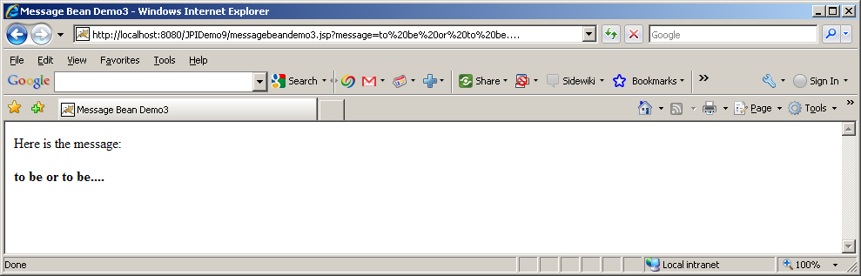

Notice the request parameter name is now “message” (instead of “mymessage”) which exactly matches with the bean property.

Calling Methods on JavaBean
Once a JavaBean is declared using <jsp:useBean> it is possible to call any method (including the setters and getters) on the bean from and within expressions and scriptlets. Here is an example:

messagebeandemo4.jsp
<HTML>
<HEAD>
<TITLE>Message Bean Demo4</TITLE>
</HEAD>
<BODY>
<jsp:useBean id="messagebean" class="bean.MessageBean" />
Here is the default message:<B> <%= messagebean.generateDefaultMessage() %></B>
</BODY>
</HTML>

Notice that generateDefaultMessage() was called on the bean by using server side expression.

JSP Tags
JSP 1.1 introduced a very significant new feature, the ability to define your own tags – custom tags. These tags look like HTML (or rather XML) tags embedded in a JSP page. You define how these tags, their attributes and their bodies are interpreted (using Java code), then group these tags into collections – called tag libraries – and use them in any JSP page. These special tags are handled by the JSP engine at translation time to provide the functionality they are intended for. The ability to define tags in this way to embed complex server-side functionality into simple easy-to-use page level elements is very significant. This allows a clean separation of duty between the middle-tier developers and the presentation-tier HTML developers.

In many respect, custom tags accomplish many functionality that beans do. However, there are several differences:

- Custom tags manipulate JSP content – beans can not.
- Complex presentation can be greatly simplified using custom tags than beans.
- Beans are often setup in one page and used in subsequent pages but custom tags are usually self-contained.
- Custom tags, in general, are more reusable in nature than beans.

In order to understand the concept of custom tag, let’s look at the <jsp:forward> action provided by the JSP specification. It can be invoked with the following syntax:

<jsp:forward page=”pagename”/>

or

<jsp:forward page=”pagename”>
<jsp:param name=”ParameterName” value=”ParameterValue”> Hi there </jsp:param>
</jsp:forward>

Now, consider the fact that you can define your own custom tag <nyu:forward> which allows you define your version of forward functionality. That’s exactly what custom tags allow you to do.

Before we go any further, let’s try to understand some of the key concepts in tags:

Tag Name: A JSP tag is identified by a combination of prefix(in the above example “jsp” or “nyu”) and suffix(in the above example “forward”), separated by a colon.

Tag Attributes: Tags may have one or more attributes, which use XML syntax. The <jsp:forward> tag has one attribute “page” whereas the <jsp:param> tag has two “name” and “value”

Nesting: A tag can be nested within another tag. In the above example, <jsp:param> tag is nested within <jsp:forward> tag. Tags can detect nested tags at runtime and cooperate. A tag directly enclosing another tag is called the parent of the tag it encloses. In the above example, <jsp:forward> is the parent tag of <jsp:param>.

Body content: This is anything between the start and end elements in a JSP tag, excluding nested tags. A custom tag can access and manipulate its body content – an extremely powerful and useful concept. In the above example there is no body content. Consider the following example, the body content is shown in bold:

<nyu:message>
How are you?
</nyu:message>

Creating your own Tags
In order to use your own custom tag in a JSP file, you have to do the following:

- Write a Java class – known as tag handler - that implements Tag interface or better yet, a class that implements IterationTag Interface which extends Tag interface. This is usually accomplished by extending TagSupport class.

In some cases you have to implement BodyTag interface. This is usually accomplished by extending BodyTagSupport class.

- Associate your tag handler java class with a tag name. This task is accomplished by creating a tag library descriptor file – an XML file. A tag library can and normally do, store java class to tag name association for more that one tag.

Once the above two steps are done, any JSP page can use the tag.

Tag Interface
The tag interface defines a simple interaction between the JSP engine and the tag handler, sufficient for tags that do not need to manipulate their body. Here are the methods of Tag interface:

setPageContext(PageContext pc) | void | Set the current page context.
SetParent(Tag t) | void | Set the parent (closest enclosing tag handler) of this tag handler.
GetParent() | Tag | Get the parent (closest enclosing tag handler) for this tag handler.
doStartTag() | int | Process the start tag for this instance.
doEndTag() | int | Process the end tag for this instance.
release() | void | Called on a Tag handler to release state.

Here is how a JSP engine interacts with a tag handler:

- The JSP engine initializes the tag handler by setting the tag handler’s pageContext property, which the tag handler uses to access information about the JSP that is currently using the tag.
- The JSP engine sets the tags parent property (which is set to null if the tag is not nested)
- The JSP engine sets the tag attributes defined by the tag developer.
- The JSP engine calls the doStartTag() method of the tag handler. This method is called when the JSP engine encounters the opening of a tag at run time. The return value of this method is very important – the return value directs what to do with the body of the tag. There are only two possible return values defined as constants in Tag interface:
  - EVAL_BODY_INCLUDE – instructs the JSP engine to evaluate both the tag’s body and any child tags it has. This constant must be used if you have tag body (regardless whether is needs to be evaluated or not) as follows:
<prefix:tagname>
Some tag body here
</prefix:tagname>

  - SKIP_BODY – instructs the JSP engine to ignore the body. This return value should be used with caution since it will ignore the body content of tag completely.
If the Tag Library Descriptor file indicates that the action must always have an empty action, by an <body-content> entry of "empty", then the doStartTag() method must return SKIP_BODY. Otherwise, the doStartTag() method may return SKIP_BODY or EVAL_BODY_INCLUDE.

- The JSP engine calls the doEndTag() method of the tag handler. This method is called when the JSP engine encounters the closing of a tag at run time. The return value of this method is also very important not so much for the tag itself but for the rest of the JSP page. There are two possible return values defined as constants in Tag interface:
  - EVAL_PAGE – instructs the JSP engine to evaluate the rest of the JSP. Recommended to be used.
  - SKIP_PAGE – instructs the JSP engine to ignore the rest of the JSP. This return value should be used with caution since it has the possibility of returning a very incomplete page.

- The JSP engine calls the release() method to release any resources. Once all invocations on the tag handler are completed, the release method is invoked on it. Once a release method is invoked all properties, including parent and pageContext, are assumed to have been reset to an unspecified value. The page compiler guarantees that release() will be invoked on the Tag handler before the handler is released to the GC.

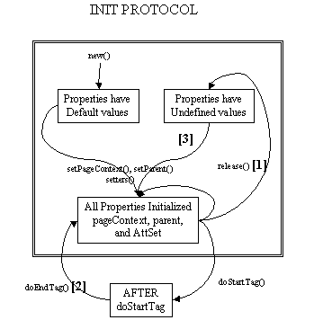

IterationTag Interface
The IterationTag interface extends Tag by defining one additional method doAfterBody() and a constant EVAL_BODY_AGAIN - that controls the reevaluation of its body.
The doAfterBody() method is invoked after every body evaluation to control whether the body will be reevaluated or not. If doAfterBody() returns EVAL_BODY_AGAIN, then the body will be reevaluated. If doAfterBody() returns SKIP_BODY, then the body will be skipped and doEndTag() will be evaluated instead.

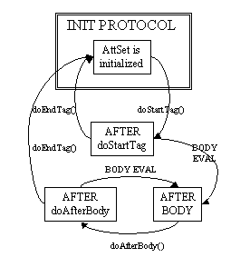

TagSupport Class
Tag handler that either have no body or that merely includes the body as is - should extend the TagSupport class. This is a built-in class in the javax.servlet.jsp.tagext package. This is a utility class intended to be used as the base class for new tag handlers. TagSupport implements the IterationTag interface (hence Tag interface) and contains the standard functionality that a basic tag could need. TagSupport has additional convenience methods including getter methods for the properties in Tag. TagSupport has one static method that is included to facilitate coordination among cooperating tags. Here are the convenience methods added in TagSupport class:

setId(String id) | Void | Set the id attribute for this tag.
getId() | String | The value of the id attribute of this tag; or null.
setValue(String k, java.lang.Object o) | Void | Associate a value with a String key.
getValue(String k) | Object | Get a the value associated with a key.
getValues() | Enumeration | Enumerate the values kept by this tag handler.
removeValue(String k) | Void | Remove a value associated with a key.
findAncestorWithClass(Tag from, java.lang.Class klass) | Static Tag | Find the instance of a given class type that is closest to a given instance.

Because of the other classes you will use, your tag handler should normally import classes in javax.servlet.jsp and java.io packages as well.

Please include jsp-api.jar from tomcat’s common\lib folder.

Here is a simple example of my tag handler:

package tags;
import javax.servlet.jsp.tagext.*;
import javax.servlet.jsp.*;
import java.io.*;
public class TestTag extends TagSupport{
private static final long serialVersionUID = 1L;

public int doStartTag(){
try{
JspWriter out = pageContext.getOut();
out.println("<B><FONT color=red>This line is from doStartTag method.</FONT></B><BR>");
}
catch(IOException e){
System.out.println(e);
}
return (EVAL_BODY_INCLUDE);
}
public int doEndTag(){
try{
JspWriter out = pageContext.getOut();
out.println("<B><FONT color=red>This line is from doEndTag method.</FONT></B><BR>");
}
catch(IOException e){
System.out.println(e);
}
return (EVAL_PAGE);
}
public int doAfterBody(){
try{
JspWriter out = pageContext.getOut();
out.println("<B><FONT color=black>This line is from doAfterBody method.</FONT></B><BR>");
}
catch(IOException e){
System.out.println(e);
}
return (SKIP_BODY);
}
}

Tag Library Descriptor File
The Tag Library Descriptor or TLD is a XML document with a .tld extension that describes one or more custom tags in one place. The general format of a tag library descriptor file is always the same:

- It should contain an XML version identifier followed by a DOCTYPE declaration followed by a taglib element. The taglib element has the following elements (besides tag elements):
  - tlibversion: is the version defined by the tag author.
  - jspversion: is the version of JSP specification the tag library depends on. This value should 1.2 for now. The element is optional.
  - shortname: is a simple short name that could be used by the JSP authoring tool.
  - uri: is an optional URI uniquely identifying this tag library.
  - info : is an arbitrary text string describing the tag library.
- One or many tag elements nested within the taglib element. The tag element has the following elements:
  - name: is the name that will identify this tag (used with tag library prefix)
  - tagclass: is the fully qualified name of the tag handler class
  - teiclass: is the fully qualified class that will provide extra information about the tag at runtime. Not all tags require this.
  - bodycontent: is the optional body content element specifying the type of body content the tag should have. Three values are legal:
    - JSP (default): means that the tag’s body content will be evaluated at run time like any other JSP content.
    - tagdependent: signifies that the JSP engine should not attempt to evaluate it but should pass it as is.
    - empty: means the tag should not have any body content – if it does, JSP translation will fail.
  - info: is an arbitrary text string describing the tag.

Here is a simple example of my tag library descriptor for my tag handler:

testtaglib.tld
<?xml version="1.0" encoding="ISO-8859-1" ?>
<!DOCTYPE taglib
PUBLIC "-//Sun Microsystems, Inc.//DTD JSP Tag Library 1.1//EN"
"http://java.sun.com/j2ee/dtds/web-jsptaglibrary_1_1.dtd">

<!-- a tag library descriptor -->

<taglib>
<tlibversion>1.0</tlibversion>
<jspversion>1.2</jspversion>
<shortname>testtaglib</shortname>
<uri></uri>
<info>A simple tab library for the examples</info>

<tag>
<name>testtag</name>
<tagclass>tags.TestTag</tagclass>
<bodycontent>JSP</bodycontent>
<info>Display doStartTag() and doEndTag()</info>
</tag>
</taglib>

Create a folder “tlds” under WEB-INF folder of your application and copy is file to the folder.

Using Custom Tags in JSP Pages
Custom tags must be explicitly imported into JSP pages that wish to use them. The syntax is as follows:

<%@ taglib uri=”TagLibDescriptorURI” prefix=”TagLibPrefix” %>

The uri attribute tells the JSP engine where to find the TLD for the tag library. The prefix is the short name of the TLD file that will be used throughout the JSP.

A JSP can import any number of tag libraries.

Once the tag library is imported into the page, tags in the library can be called as follows:

<prefix:name>
Tag Body content
</prefix:name>
or
<prefix:name/>

Here is an example of a JSP page that uses my tag:

tagtester.jsp
<%@ taglib uri="/WEB-INF/tlds/testtaglib.tld" prefix="testlib" %>
<HTML>
<HEAD>
<TITLE>Tag Library Test</TITLE>
</HEAD>
<BODY>
<B><FONT color=blue>This line is before the start tag.</FONT></B><BR>
<testlib:testtag>
<B><FONT color=green>This line is in the body of the tag.</FONT></B><BR>
</testlib:testtag>
<B><FONT color=blue>This line is after end tag.</FONT></B><BR>
</BODY>
</HTML>
Copy the JSP file anywhere you like within your application. Notice that I am referencing the tag library using it absolute url from the root of the application so that I can move the JSP file anywhere I like without changing anything.

Here is the output:
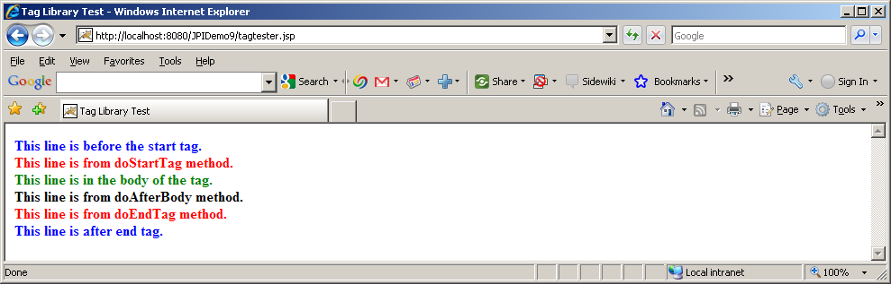

Notice, the tag body is missing in the above output. Also, the output from doAfterBody() is missing since doAfterBody() is only called if doStartTag does not return SKIP_BODY.

Now, let’s change the return of doEndTag() to SKIP_PAGE. Compile the tag class, stop and start Tomcat.

Here is the output:
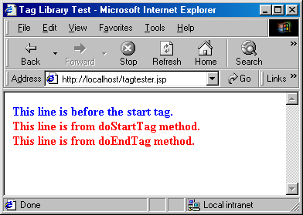

Now, notice there is a do loop around the body of the tag that depends on the return value of doAfterBofy() method. Which indicates that the body of the tag keeps printing itself until doAfterBody() returns SKIP_BODY.

Assigning Attributes to Tags
Allowing tags like:
<prefix:name attribute1=”value1” attribute2=”value2” ….>
…..
</prefix:name>

adds significant flexibility to your custom tag. Providing such support is surprisingly straightforward. As we already know from Java beans, setting an attribute value simply results in a call to a method setXxx() in your class (where xxx is the attribute name) that extends TagSupport (or implements Tag interface). Therefore, adding support for an attribute attribute1 is simply a matter of adding the following method in your class:

public void setAttribute1(String value1)
{
//your code goes in here.
}

Note that an attribute of attribute1 (lowercase a) corresponds to a method setAttribute1(uppercase A).

The most useful thing to do in the attribute handler is to store the attribute in a private field that will later be used by doStartTag() or doEndTag() or any other method of the tag.

Here is a simple example of using tag attributes:

package tags;
import javax.servlet.jsp.tagext.*;
public class RepeatTag extends TagSupport{
private static final long serialVersionUID = 1L;
private int repeat = 1;
private int i =1 ;
public void setRepeat(String repeatValue)
{
try{
repeat= Integer.parseInt(repeatValue);
}
catch(NumberFormatException e){
System.out.println(e);
}
}
public int doStartTag(){
if (repeat <=0){
repeat=1;
return SKIP_BODY;
}
else
{
return (EVAL_BODY_INCLUDE);
}
}

public int doAfterBody(){
if (i < repeat){
i++;
return (EVAL_BODY_AGAIN);
}
else{
i=1;
return (SKIP_BODY);
}
}

public int doEndTag()
{
return (EVAL_PAGE);
}
}

Defining Tag Attributes in Tag Library Descriptor File
Just the presence of setXxx() method in tag handler class does not define a tag attribute. Tag attributes must be defined in tag library descriptor by defining attribute element within tag element. The attribute element has three nested elements that can appear in your tag library descriptor:

- name: a mandatory element that defines the case-sensitive attribute name.
- required: a mandatory element that defines whether the attribute must always be supplied(true) or is optional(false). If you forget to provide this element no call is made to the setXxx() method.
- rtexprvalue: an optional attribute that indicates whether the attribute value can be a JSP expression like <%= expression %> (true) or whether it must be a fixed string (false). The default is false.

<?xml version="1.0" encoding="ISO-8859-1" ?>
<!DOCTYPE taglib
PUBLIC "-//Sun Microsystems, Inc.//DTD JSP Tag Library 1.1//EN"
"http://java.sun.com/j2ee/dtds/web-jsptaglibrary_1_1.dtd">

<!-- a tag library descriptor -->

<taglib>
<tlibversion>1.0</tlibversion>
<jspversion>1.2</jspversion>
<shortname>testtaglib</shortname>
<uri></uri>
<info>A simple tab library for the examples</info>

<tag>
<name>testtag</name>
<tagclass>tags.TestTag</tagclass>
<bodycontent>JSP</bodycontent>
<info>Display doStartTag() and doEndTag()</info>
</tag>

<tag>
<name>repeattag</name>
<tagclass>tags.RepeatTag</tagclass>
<bodycontent>JSP</bodycontent>
<info>Repeats body specified by the repeat attribute</info>
<attribute>
<name>repeat</name>
<required>true</required>
<rtexprvalue>true</rtexprvalue>
</attribute>
</tag>

</taglib>

Here is a JSP page testrepeattag.jsp that uses the tag:

<%@ taglib uri="/WEB-INF/tlds/testtaglib.tld" prefix="testlib" %>
<HTML>
<HEAD>
<TITLE>Tag Library Test</TITLE>
</HEAD>
<BODY>
<B><FONT color=blue>This line is before the tag.</FONT></B><BR>
<testlib:repeattag repeat="5">
<B><FONT color=green>This line is in the body of the tag.</FONT></B><BR>
</testlib:repeattag>
<B><FONT color=blue>This line is after the tag.</FONT></B><BR>
</BODY>
</HTML>

Here is the output:

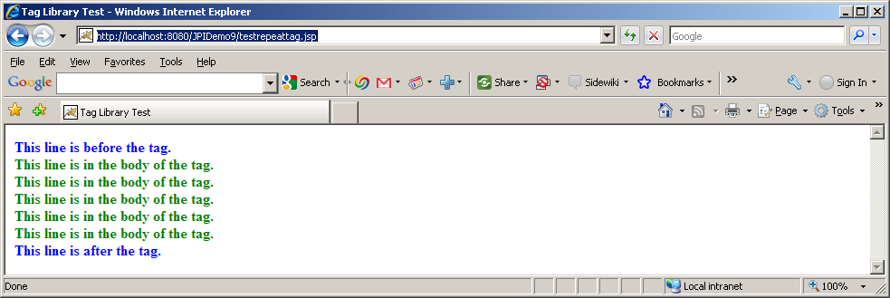

Notice how the repeat tag on the page is being used by the tag to repeat the body.

Here is another tester page that uses runtime expression for the attribute value:

<%@ taglib uri="/WEB-INF/tlds/testtaglib.tld" prefix="testlib" %>
<HTML>
<HEAD>
<TITLE>Tag Library Test</TITLE>
</HEAD>
<BODY>
<%
String repeatValue=request.getParameter("repeat");
%>
<B><FONT color=blue>This line is before the tag.</FONT></B><BR>
<testlib:repeattag repeat="<%=repeatValue%>">
<B><FONT color=green>This line is in the body of the tag.</FONT></B><BR>
</testlib:repeattag>
<B><FONT color=blue>This line is after the tag.</FONT></B><BR>
</BODY>
</HTML>

Notice, the jsp receives the repeat value as input parameter and uses it as an attribute of the tag.
http://localhost:8080/JPIDemo9/testrepeattag2.jsp?repeat=3

Here is the output:
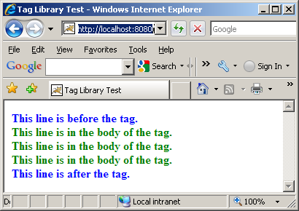
Change value of repeat on the url and have fun.

BodyTag Interface
Although Tag and IterationTag interface allowed body content (and even repeat body content) they is not powerful enough to manipulate body content. BodyTag interface extends IterationTag interface, adding the following to extra two methods that allows the developer to work with the body content of the tag.

doInitBody() | void | Prepare for evaluation of the body.
setBodyContent(BodyContent b) | void | Set the bodyContent property.
A tag handler that implements BodyTag is treated as one that implements IterationTag, except that the doStartTag() method can return SKIP_BODY, EVAL_BODY_INCLUDE or EVAL_BODY_BUFFERED.
If EVAL_BODY_INCLUDE is returned, then evaluation happens as in IterationTag.
If EVAL_BODY_BUFFERED is returned, then a BodyContent object will be created (by code generated by the JSP compiler) to capture the body evaluation. The code generated by the JSP compiler obtains the BodyContent object by calling the pushBody() method of the current pageContext, which additionally has the effect of saving the previous out value. The page compiler returns this object by calling the popBody() method of the PageContext class; the call also restores the value of out.

The setBodyContent() method defined in BodyTag interface is to set the BodyConent object that allows manipulation of body content. This will only be invoked if doStartTag() returns EVAL_BODY_BUFFERED.

doInitBody(), which is invoked right after setBodyContent() and before the body evaluation. This method is only invoked if doStartTag() returns EVAL_BODY_BUFFERED.

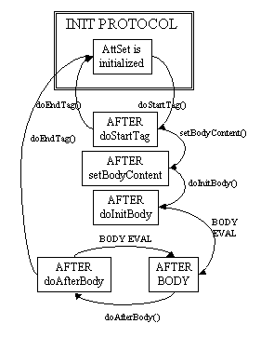

BodyContent Class
The abstract class BodyContent class is the key to BodyTag functionality. BodyContent is a subclass of JspWriter that can be used to manipulate the body content of a tag. The container implements a subclass of BodyContent (since BodyContent is abstract) and uses it for all BodyContent purposes.

BodyContent class has a getReader() method that returns a Reader object that can read the tag’s body. The getString() method of BodyConent returns a String containing the entire tag body. The getEnclosingWriter() method of BodyConent returns a JspWriter object that is being used by doStartTag() and doEndTag() method since the BodyContent class itself is a separate JspWriter for the body content. The clearBody() method of BodyContent allows you to clear the body content entirely.

Here are the methods of BodyContent Class:
getReader() | abstract Reader | Return the value of this BodyContent as a Reader.
writeOut(Writer out) | abstract void | Write the contents of this BodyContent into a Writer.
getEnclosingWriter() | JspWriter | Get the enclosing JspWriter.
clearBody() | void | Clear the body without throwing any exceptions.
flush() | void | Redefined flush() so it is not legal.
getString() | abstract String | Return the value of the BodyContent as a String.

BodyTagSupport Class
Tag handler that intends to manipulate the body content should extend the BodyTagSupport class. This is a built-in class in the javax.servlet.jsp.tagext package that implements the BodyTag interface and contains the standard functionality that a basic tag could need. Because of the other classes you will use, your tag handler should normally import classes in javax.servlet.jsp and java.io packages as well.

BodyTagSupport implements the BodyTag interface methods as follows:

setBodyContent(BodyContent b) | void | Prepare for evaluation of the body: stash the bodyContent away.
doInitBody() | void | Prepare for evaluation of the body just before the first body evaluation: no action.
doStartTag() | int | Default processing of the start tag returning EVAL_BODY_BUFFERED
doEndTag() | int | Default processing of the end tag returning EVAL_PAGE.
doAfterBody() | int | After the body evaluation: do not reevaluate and continue with the page.
Release() | void | Release state.

Besides implementing BodyTag interface, BodyTapSupport has the following two convenience methods:

getBodyContent() | BodyContent | Get current bodyContent.
getPreviousOut() | JspWriter | Get surrounding out JspWriter.

Since BodyTagSupport class saves of the BodyContent as private field in setBodyContent() method, it provides a getBodyContent() that returns BodyContent object of the tag. It also provides getPreviousOut() method that returns the enclosing JspWriter, from the BodyContent (instead of calling getBodyContent.getEnclosingWriter()).

Here is an example of tag that converts the body to uppercase:

package tags;
import javax.servlet.jsp.tagext.*;
import javax.servlet.jsp.*;
import java.io.*;
public class TestBodyTag extends BodyTagSupport{
private static final long serialVersionUID = 1L;

public int doAfterBody()throws JspException{
try{
BodyContent bodyContent= getBodyContent();
String bodytext = bodyContent.getString();
bodytext=bodytext.toUpperCase();
bodyContent.clear();
bodyContent.print(bodytext);
bodyContent.writeOut(getPreviousOut());
}
catch(IOException e){
System.out.println(e);
}
return (SKIP_BODY);
}
}

Here is the entry on the tag library testtaglib.tld:

<tag>
<name>testbodytag</name>
<tagclass>tags.TestBodyTag</tagclass>
<bodycontent>JSP</bodycontent>
<info>converts body to uppercase</info>
</tag>

Here is a jsp that uses it:

bodytagtester.jsp
<%@ taglib uri="/WEB-INF/tlds/testtaglib.tld" prefix="testlib" %>
<HTML>
<HEAD>
<TITLE>Tag Library Test</TITLE>
</HEAD>
<BODY>
<B><FONT color=blue>This line is before the start tag.</FONT></B><BR>
<testlib:testbodytag>
<B><FONT color=green>This line is in the body of the tag.</FONT></B><BR>
</testlib:testbodytag>
<B><FONT color=blue>This line is after end tag.</FONT></B><BR>
</BODY>
</HTML>

Here is the output:

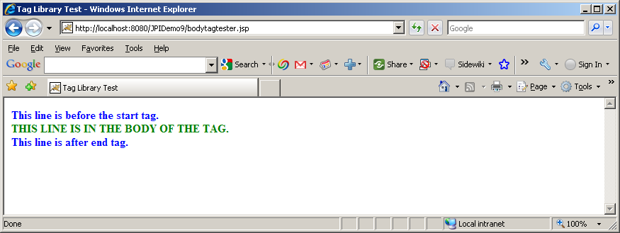

Expression Language and JSTL

Expression Language

Before JSP 2.0, you could use only a scriptlet, JSP expression, or a custom tag to include server state in the JSP page output. JSP 2.0 incorporates the Expression Language (EL) first introduced in JSTL 1.0. EL makes it easier to integrate server-side state with presentation output. Let's start with a quick review of scriptlets, JSP expressions, and custom tags.

Consider a Web application that maintains information about usage statistics in an object of class ServerStats. Class ServerStats has a method getUserCount, which returns the number of users currently logged on. The application maintains a single instance of ServerStats in a ServletContext attribute called stats. Here's a comparison of how you could create usage statistics output using a scriptlet, a JSP expression, and a custom tag:

A) Creating output with a scriptlet: With JSP version 1, you can print the number of users logged on to the system using a scriptlet. Any output the scriptlet produces has to be explicitly written to the out stream. A JSP page could report the number of users with the following scriptlet and template text:

There are currently <%

ServerStats ss =

(ServerStats)application.getAttribute("stats");

out.print(ss.getUserCount());

%> userslogged on.

B) Creating output with a JSP expression: You can simplify things a bit by placing the code in a JSP expression. The expression text within the JSP expression is evaluated, and the result is coerced to a String for output. The result of the expression replaces the expression tag in the JSP page output. Writing the resulting text to the JSP page output is implicit.

There are currently

<%= (ServerStats)(application.getAttribute("stats")).

getUserCount() %> users logged on.

This is somewhat easier to write, but is still a bit difficult to read and maintain.

C) Creating output with a custom tag: In JSP 1, the way to make dynamic content on a page more readable and reusable is to create custom tags. Remembering that the actual code that implements the lookup is in the handler class, the JSP code for the example message would look like this:

There are currently <myTags:userCount/> users logged in.

Of course, to get to such a clean presentation, a developer would have to write both a Java class and an XML-format TLD file.

JSP 2.0 now offers a expression language that makes accessing server-side state even easier. The syntax of the expression language is simpler than a custom tag, and usually requires no associated Java code. Also, the expression language automatically handles typecasting, null values, and error handling. The JSP 2.0 expression language provides a way to access server-side state with less effort than the approaches shown above. The JSP 2.0 way to print the "number of users" message would look like this:

<%= (ServerStats)(application.getAttribute("stats")).

getUserCount() %>

There are currently ${applicationScope.stats.userCount} users logged in.

Implicit Variables
EL supports the following implicit (predefined) variables:

Variable name | Description
pageScope | A collection (a java.util.Map) of all page scope variables.
requestScope | A collection (a java.util.Map) of all request scope variables.
sessionScope | A collection (a java.util.Map) of all session scope variables.
applicationScope | A collection (a java.util.Map) of all application scope variables.
param | A collection (a java.util.Map) of all request parameter values as a single String value per parameter.
paramValues | A collection (a java.util.Map) of all request parameter values as a String array per parameter.
header | A collection (a java.util.Map) of all request header values as a single String value per header.
headerValues | A collection (a java.util.Map) of all request header values as a String array per header.
cookie | A collection (a java.util.Map) of all request cookie values as a single javax.servlet.http.Cookie value per cookie.
initParam | A collection (a java.util.Map) of all application initialization parameter values as a single String value per parameter.
pageContext | An instance of the javax.servlet.jsp.PageContext class, providing access to various request data.

Operators

Operators describe what you want to do with the variables. Most of the operators you can use in an EL expression look familiar:

Operator | Description
. | Access a bean property or Map entry.
[] | Access an array or List element as well as bean property or Map entry.
() | Group a subexpression to change the evaluation order.
? : | Conditional test: condition ? ifTrue : ifFalse.
+ | Addition.
- | Subtraction or negation of a value.
* | Multiplication.
/ or div | Division.
% or mod | Modulo (remainder).
== or eq | Test for equality.
!= or ne | Test for inequality.
< or lt | Test for less than.
> or gt | Test for greater than.
<= or le | Test for less than or equal.
>= or ge | Test for greater than or equal.
&& or and | Test for logical AND.
|| or or | Test for logical OR.
! or not Unary | Boolean complement.
Empty | Test for an empty variable value: null, an empty String, or an array, Map, or Collection without entries).
func(args) | A function call, where func is the function name and args is zero, one or more comma-separated function arguments.

Dot (.) vs. []
In EL, if the object being accessed is a Map, the “.” operator uses the name of right-hand side as a string literal and uses in as a key to fetch the result. For example,

${header.host} will return will return the element with key “host” from the map “header”.

The “.” operator can also be used for a completely different purpose – to call property accessors (getters). For example,

${applicationScope.stats.userCount}

In the above example, the ”.stats” is used to access an element “.stats” in applicationScope map but “.userCount” is used to call getUserCount() accessor method on “stats”.

We can also use the [] operator instead of “.” is all cases. Here is an example:

${header[“host”]}
[] operator can also be used to access an indexed collection – lists as well as maps. Here is an example:

${colors[4]}

When accessing collection, [] syntax is more full-proof since “.” can fail to do the job in certain scenario. Here is an example:

${header.user-agent} returns 0 but ${header[“user-agent”] returns Mozilla/5.0…. the right value. This is because of dash is considered as minus by the jsp compiler in this case.
Another advantage of using [] is that the value can be an expression as follows:

${header[param["name"]]}

The lesson here is that is it always better to use “[]” for accessing collections and use “.” for accessing property accessors.

Installing Expression Language and JSTL in Tomcat
Please make sure that a) jstl-api-1.2.jar and b) jstl-impl-1.2.jar are in your applications lib folder.

Here is a page eltest.jsp that put’s all kinds of stuff on different objects and try to retrieve them using EL:

<%
pageContext.setAttribute("pageContextAttr", "page context attribute 1");
request.setAttribute("requestAttr","request attribute 1");
session.setAttribute("sessionAttr","session attribute 1");
application.setAttribute("appAttr","application attribute 1");

%>
<html>
<body>
Servlet Name = ${pageContext.servletConfig.servletName}<br>
pageContextAttr = ${pageScope["pageContextAttr"]}<br>
requestAttr = ${requestScope["requestAttr"]}<br>
sessionAttr = ${sessionScope["sessionAttr"]}<br>
applicationAttr = ${applicationScope["appAttr"]}<br>
Host Header = ${header["host"]}<br>
Parameter message = ${param["message"]}<br>
Cookie JSESSIONID= ${cookie["JSESSIONID"].value}<br>

</br>
</body>
</html>

Hit the following url:

http://localhost:8080/JPIDemo9/eltest.jsp

Here is the output:

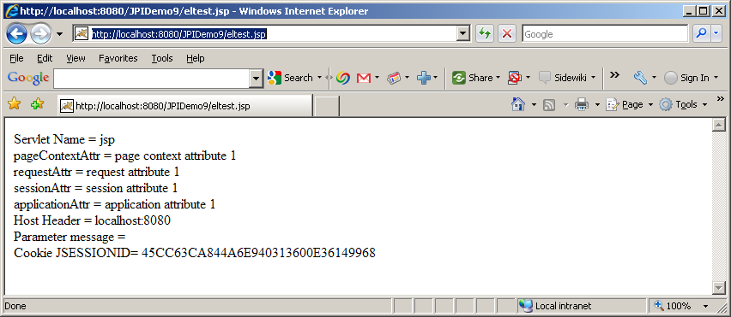

Of course, first time you will not see JSESSIONID cookie but hit refresh and you will get the cookie. Why is that? Can you explain? If not, go back to session 4 and read cookie again.

Java Standard Tag Library (JSTL)
JSTL includes a wide variety of actions that naturally fit into discrete functional areas. This is why JSTL, although referred to as the standard tag library (singular), is exposed via multiple tag libraries to clearly identify the functional areas it covers, as well as to give each area its own namespace. The tables below lists these functional areas along with the URIs used to reference the libraries.
The tables also show the prefixes used in this handou although page authors are free to use any prefix they want.

Functional Area | URI | Prefix
Core | http://java.sun.com/jsp/jstl/core | c
XML processing | http://java.sun.com/jsp/jstl/xml | x
Internationalization capable formatting | http://java.sun.com/jsp/jstl/fmt | fmt
relational db access (SQL) | http://java.sun.com/jsp/jstl/sql | sql
Functions | http://java.sun.com/jsp/jstl/functions | fn

<c:out>
Evaluates an expression and outputs the result of the evaluation to the current JspWriter object. If value is null, the default value takes over. If no default value is specified, it itself defaults to an empty string. The default value can be specified either via the default attribute (using the syntax
without a body), or within the body of the tag (using the syntax with a body). It defaults to an empty string.

If the result of the evaluation is not a java.io.Reader object, then it is coerced to a String and is subsequently emitted into the current JspWriter object. If the result of the evaluation is a java.io.Reader object, data is first read from the Reader object and then written into the current JspWriter object. This special processing associated with Reader objects should help improve performance when large amount of data must be read and then displayed to the page.

If escapeXml is true, the following character conversions are applied:

Character | Character Entity Code
< | &lt;
> | &gt;
& | &amp;
‘ | &#039;
‘’ | &#034;

Syntax
Without a body
<c:out value=”value” [escapeXml=”{true|false}”]
[default=”defaultValue”] />
With a body
<c:out value=”value” [escapeXml=”{true|false}”]>
default value
</c:out>

Attributes
Name | Expression | Type | Description
Value | true | Object | Expression to be evaluated.
escapeXml | true | boolean | Determines whether characters <,>,&,’,” in the resulting string should be converted to their corresponding character entity codes. Default value is true.
Default | true | Object | Default value if the resulting value is null.

<c:set>
Sets the value of a scoped variable or a property of a target object.
Syntax
Syntax 1: Set the value of a scoped variable using attribute value
<c:set value=”value”
var=”varName” [scope=”{page|request|session|application}”]/>

Syntax 2: Set the value of a scoped variable using body content
<c:set var=”varName” [scope=”{page|request|session|application}”]>
body content
</c:set>

Syntax 3: Set a property of a target object using attribute value
<c:set value=”value”
target=”target” property=”propertyName”/>

Syntax 4: Set a property of a target object using body content
<c:set target=”target” property=”propertyName”>
body content
</c:set>

Syntax 1 and 2 set the value of a the scoped variable identified by var and scope.
Syntax 3 and 4:
- If the target expression evaluates to a java.util.Map object, set the value of the
element associated with the key identified by property. If the element does not
exist, add it to the Map object.
- Otherwise, set the value of the property property of the JavaBeans object
target. If the type of the value to be set does not match the type of the bean
property, conversion is performed according to the conversion rules defined in
the expression language (see Section A.7). With the exception of a null value,
setting a bean property with <c:set> is therefore exactly the same as setting an
attribute value of an action using the EL. A failure of these conversion rules to
determine an appropriate type coersion leads to a JspException at runtime.
Attributes
Name | Expression | Type | Description
Value | true | Object | Expression to be evaluated.
Var | false | String | Name of the exported scoped variable to hold the value specified in the action. The type of the scoped variable is whatever type the value expression evaluates to.
Scope | false | String | Scope for var.
Target | true | Object | Target object whose property will be set. Must evaluate to a JavaBeans object with setter property, or to a java.util.Map object.
property | true | String | Name of the property to be set in the target object.

<c:remove>
Removes a scoped variable.
Syntax
<c:remove var=”varName” [scope=”{page|request|session|application}”]/>

Attributes
Name | Expression | Type | Description
Var | false | String | Name of the variable to be removed.
Scope | false | String | Scope for var. If attribute scope is not specified, the scoped variable is removed according to the  semantics of PageContext.removeAttribute(varName). If attribute scope is specified, the scoped variable is removed according to the semantics of PageContext.removeAttribute(varName, scope).

Here is a page setremove.jsp that demonstrates these tags:

<%@ taglib uri="http://java.sun.com/jsp/jstl/core" prefix="c" %>
<c:set var="age" value="${param.myage}" scope="session" />
<html>
<body>
Well, look at the bright side, you still need <c:out value="${sessionScope.age}" /> years to be <c:out value="${sessionScope.age*2}" /> years old.
<c:remove var="age" scope="session" />
</body>
</html>

Hit the following url:

http://localhost:8080/JPIDemo9/setremove.jsp?myage=30

You will get the following output:

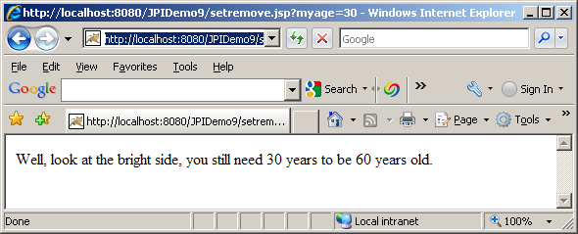

Here is another set example that sets bean property:

<%@ taglib uri="http://java.sun.com/jsp/jstl/core" prefix="c" %>
<%@page import="model.Music"%><html>
<%
Music music =new Music();
music.setTitle("BreathLess");
music.setPrice(50.99);
session.setAttribute("music", music);

%>

<body>
Original Price: <c:out value="${sessionScope.music.price}" />
<br></br>
Param Price: <c:out value="${param.price}" />
<c:set target="${sessionScope.music}" property="price" value="${param.price}" />
<br></br>
New Price: <c:out value="${sessionScope.music.price}" />
<c:remove var="music" scope="session" />
<br>
<br>
After removal, Price: <c:out value="${sessionScope.music.price}" />
</body>
</html>

Hit the following url:

http://localhost:8080/testapp/setbean.jsp?price=30

Here is the output:
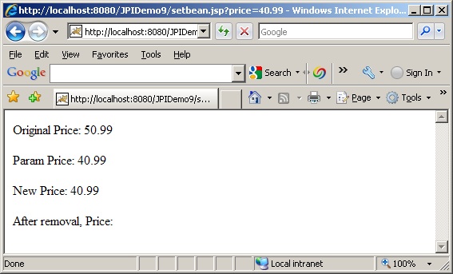

This page will bomb if price parameter is not provided. We can fix this problem by using the following <c:if> tag.

<c:catch>
Catches a java.lang.Throwable thrown by any of its nested actions.
Syntax
<c:catch [var=”varName”]>
nested actions
</c:catch>

The <c:catch> action allows page authors to handle errors from any action in a
uniform fashion, and allows for error handling for multiple actions at once.
<c:catch> provides page authors with granular error handling: Actions that are of
central importance to a page should not be encapsulated in a <c:catch>, so their
exceptions will propagate to an error page, whereas actions with secondary
importance to the page should be wrapped in a <c:catch>, so they never cause the
error page mechanism to be invoked.

The exception thrown is stored in the scoped variable identified by var, which
always has page scope. If no exception occurred, the scoped variable identified by
var is removed if it existed.

If var is missing, the exception is simply caught and not saved.

Attribute
Name | Expression | Type | Description
var | false | String | Name of the exported scoped variable for the exception thrown from a nested action. The type of the scoped variable is the type of the exception thrown.

<c:if>
Evaluates its body content if the expression specified with the test attribute is true.
Syntax
Syntax 1: Without body content
<c:if test=”testCondition”
var=”varName” [scope=”{page|request|session|application}”]/>
Syntax 2: With body content
<c:if test=”testCondition”
[var=”varName”] [scope=”{page|request|session|application}”]>
body content
</c:if>

Attributes
Name | Expression | Type | Description
test | true | boolean | The test condition that determines whether or not the body content should be processed.
var | false | String | Name of the exported scoped variable for the resulting value of the test condition. The type of the scoped variable is Boolean.
scope | false | String | Scope for var. If scope is specified, var must also be specified.

Here is an example page setbeanwithif.jsp that uses <c:if> tag:

<%@ taglib uri="http://java.sun.com/jsp/jstl/core" prefix="c" %>
<%@page import="model.Music"%><html>
<%
Music music =new Music();
music.setTitle("BreathLess");
music.setPrice(50.99);
session.setAttribute("music", music);

%>

<body>
Original Price: <c:out value="${sessionScope.music.price}" />
<br></br>
Param Price: <c:out value="${param.price}" />
<c:if test="${(not empty param.price)}">
<c:set target="${sessionScope.music}" property="price" value="${param.price}" />
</c:if>
<br></br>
New Price: <c:out value="${sessionScope.music.price}" />
<c:remove var="music" scope="session" />
<br>
<br>
After removal, Price: <c:out value="${sessionScope.music.price}" />
</body>
</html>

Hit the following url:

http://localhost:8080/testapp/setbeanwithif.jsp

Notice the page does not bomb anymore, it gives the following output:

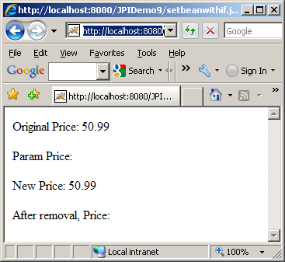
<c:choose>
Provides the context for mutually exclusive conditional execution.
The body of the <c:choose> action can only contain:
- White spaces
- 1 or more <c:when> actions. Must all <c:when> appear before <c:otherwise>
- 0 or 1 <c:otherwise> action. Must be the last action nested within <c:choose>
Syntax
<c:choose>
<when> and <otherwise>
</c:choose>

<c:when>
Represents an alternative within a <c:choose> action. Must have <c:choose> as an immediate parent. Must appear before an <c:otherwise> action that has the same parent.

Within a <c:choose> action, the body content of the first <c:when> action whose test
condition evaluates to true is evaluated by the JSP container, and the result is output
to the current JspWriter.

Syntax
<c:when test=”testCondition”>
body content
</c:when>
Body Content
JSP. If this is the first <c:when> action to evaluate to true within <c:choose>, the JSP
container processes the body content and then writes it to the current JspWriter.

Name | Expression | Type | Description
test | true | boolean | The test condition that determines whether or not the body content should be processed.

<c:otherwise>
Represents the last alternative within a <c:choose> action. Must have <c:choose> as an immediate parent. Must be the last nested action within <c:choose>.

If no <c:when> action nested within <c:choose> evaluates to true, the JSP container processes the body content and then writes it to the current JspWriter.

Syntax
<c:otherwise>
conditional block
</c:otherwise>

Here is a page choose.jsp that uses those tags mentioned above:

<%@ taglib uri="http://java.sun.com/jsp/jstl/core" prefix="c" %>
<%@page import="model.Music"%><html>
<%
Music music =new Music();
music.setTitle("BreathLess");
music.setPrice(50.99);
session.setAttribute("music", music);

%>

<body>
Original Price: <c:out value="${sessionScope.music.price}" />
<br></br>
Param Price: <c:out value="${param.price}" />
<c:if test="${(not empty param.price)}">
<c:set target="${sessionScope.music}" property="price" value="${param.price}" />
</c:if>
<br></br>
New Price: <c:out value="${sessionScope.music.price}" />
<br/>
<c:choose>
<c:when test="${sessionScope.music.price<10}">
The new price is really cheap.
</c:when>
<c:when test="${sessionScope.music.price>=10 and sessionScope.music.price<20}">
The new price is still reasonable.
</c:when>
<c:otherwise>
The new price is really high.
</c:otherwise>
</c:choose>

<c:remove var="music" scope="session" />
<br>
<br>
After removal, Price: <c:out value="${sessionScope.music.price}" />
</body>
</html>

Hit the following url:

http://localhost:8080/testapp/choose.jsp?price=30

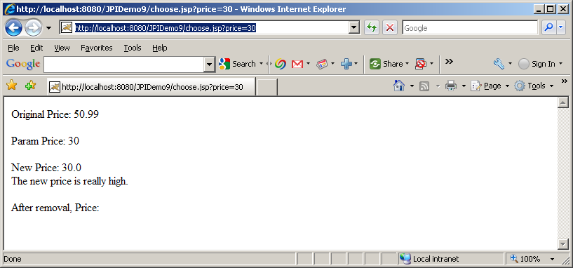
Change the price parameter value, you will get different output.

<c:forEach>
The <c:forEach> action repeats its nested body content over the collection of objects specified by the items attribute. A large number of collection types are supported by <c:forEach>, including all implementations of java.util.Collection (includes List, LinkedList, ArrayList, Vector, Stack, Set), and java.util.Map (includes HashMap, Hashtable, Properties, Provider, Attributes). Arrays of objects as well as arrays of primitive types (e.g. int) are also supported. For arrays of primitive types, the current item for the iteration is automatically wrapped with its standard wrapper class (e.g. Integer for int, Float for float, etc.). If the items attribute is of type java.util.Map, then the current item will be of
type java.util.Map.Entry, which has the following two properties:

_ key - the key under which this item is stored in the underlying Map
_ value - the value that corresponds to this key

Syntax

Syntax 1: Iterate over a collection of objects
<c:forEach[var=”varName”] items=”collection”
[varStatus=”varStatusName”]
[begin=”begin”] [end=”end”] [step=”step”]>
body content
</c:forEach>

Syntax 2: Iterate a fixed number of times
<c:forEach [var=”varName”]
[varStatus=”varStatusName”]
begin=”begin” end=”end” [step=”step”]>
body content
</c:forEach>

Here is a jsp, fortest.jsp that uses for loop:

<%@page import="model.Music,java.util.*"%>
<%@ taglib uri="http://java.sun.com/jsp/jstl/core" prefix="c" %>

<%
List<Music> musicList = new ArrayList<Music>();
Music music1 =new Music();
music1.setTitle("BreathLess");
music1.setPrice(50.99);
Music music2 =new Music();
music2.setTitle("Just An Illusion");
music2.setPrice(30.99);
musicList.add(music1);
musicList.add(music2);
request.setAttribute("musicList", musicList);
%>
<html>
<body>
<table border="1">
<c:forEach var="entry" items="${musicList}">
<tr>
<td>${entry.title}</td>
<td>${entry.price}</td>
</tr>
</c:forEach>
</table>
</body>
</html>

Hit the following url:

http://localhost:8080/JPIDemo9/fortest.jsp

Here is the output:

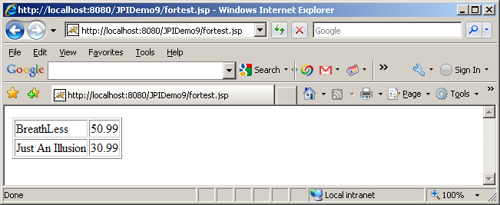

Finally, here is our MusicCatalogServlet:

package servlet;

import java.io.IOException;
import java.io.PrintWriter;
import java.util.Iterator;
import java.util.List;

import javax.servlet.RequestDispatcher;
import javax.servlet.ServletException;
import javax.servlet.http.HttpServlet;
import javax.servlet.http.HttpServletRequest;
import javax.servlet.http.HttpServletResponse;

import model.Music;

import org.apache.log4j.Logger;

import dao.ProductDAO;
import dao.ProductDAOIF;

public class MusicCatalogServlet extends HttpServlet {
private static final long serialVersionUID = 1L;
private static final Logger logger = Logger.getLogger(MusicCatalogServlet.class);

protected void doGet(HttpServletRequest request, HttpServletResponse response) throws ServletException, IOException {
try{
String category = request.getParameter("category");
List<Music> musics = null;
if (category!= null){
ProductDAOIF dao = new ProductDAO();
musics = dao.getMusic(category);
}
request.setAttribute("musicList", musics);
RequestDispatcher dispatcher = request.getRequestDispatcher("musiccatalog.jsp");
dispatcher.forward(request, response);
}
catch(Exception e){
throw new ServletException(e.toString());
}
finally{
logger.info("Finished doGet");
}
}

protected void doPost(HttpServletRequest request, HttpServletResponse response) throws ServletException, IOException {
doGet(request,response);
}

}

Here is the jsp:

<%@page import="model.Music,java.util.*"%>
<%@ taglib uri="http://java.sun.com/jsp/jstl/core" prefix="c" %>
<html>
<body>
<c:choose>
<c:when test="${(empty param.category)}">
No music category selected
</c:when>
<c:when test="${(not empty param.category)}">
<c:choose>
<c:when test="${(empty musicList)}">
No music found for category: ${param.category}
</c:when>
<c:when test="${(not empty musicList)}">
<table border="1">
<tr>
<th>Id</th>
<th>Title</th>
<th>Price</th>
<th>Stock Quantity</th>
<th># of Tracks</th>
<th>Artist</th>
<th> </th>
</tr>
<c:forEach var="entry" items="${musicList}">
<tr>
<td>${entry.id}</td>
<td>${entry.title}</td>
<td>${entry.price}</td>
<td>${entry.stockCount}</td>
<td>${entry.numberOfTracks}</td>
<td>${entry.artist.name}</td>
<td><A HREF='./AddToShoppingCartServlet?price=${entry.price}&type=music&id=${entry.id}'>Buy</A></td>
</tr>
</c:forEach>
</table>
</c:when>
</c:choose>
</c:when>
</c:choose>
</body>
</html>

Here is the output:
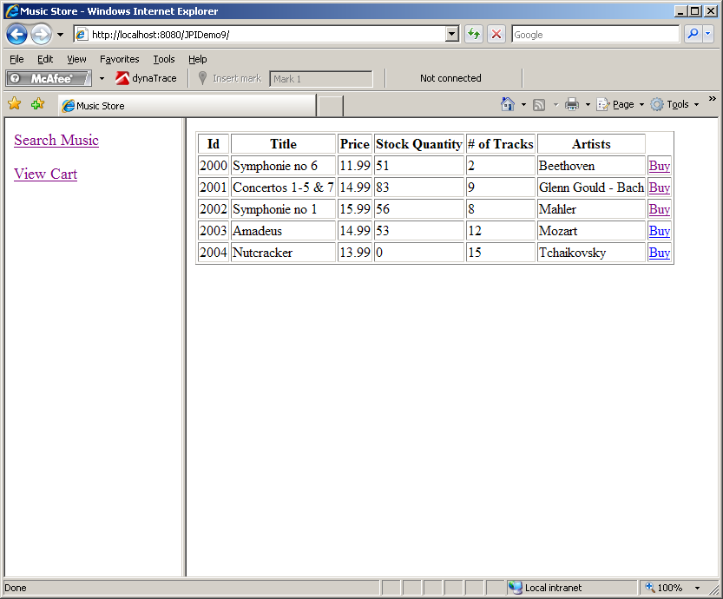

However, ShowShoppingCartServet is not so easy to work with. We need to add title and artist fields to CartLineItem first. Then Shoe ShoppingCartServlet looks like the following:

package servlet;

import java.io.IOException;
import java.io.PrintWriter;
import java.util.Iterator;

import javax.servlet.RequestDispatcher;
import javax.servlet.ServletException;
import javax.servlet.http.HttpServlet;
import javax.servlet.http.HttpServletRequest;
import javax.servlet.http.HttpServletResponse;
import javax.servlet.http.HttpSession;

import model.Music;

import org.apache.log4j.Logger;

import cart.CartLineItem;
import cart.ShoppingCart;

import dao.ProductDAO;
import dao.ProductDAOIF;

public class ShowShoppingCartServlet extends HttpServlet {
private static final long serialVersionUID = 1L;
private static final Logger logger = Logger.getLogger(ShowShoppingCartServlet.class);

protected void doGet(HttpServletRequest request, HttpServletResponse response) throws ServletException, IOException {

PrintWriter out = null;
try{
// get the session
HttpSession session = request.getSession();

//get cart from session
ShoppingCart cart = (ShoppingCart) session.getAttribute("cart");

//if null return
if ( (cart==null) || (cart.getIterator()==null)|| (!cart.getIterator().hasNext())){
}
else{
Iterator<CartLineItem> iterator = cart.getIterator();
while (iterator.hasNext()){
CartLineItem lineItem = iterator.next();
ProductDAOIF dao = new ProductDAO();
if (lineItem.getType().equals("music")){
Music music = dao.getMusic(lineItem.getId());
if (music!=null){
logger.debug("Found music item id: " + lineItem.getId());
lineItem.setArtists(music.getArtist().getName());
lineItem.setTitle(music.getTitle());
}
}
}
}
RequestDispatcher dispatcher = request.getRequestDispatcher("showshoppingcart.jsp");
dispatcher.forward(request, response);

}
catch(Exception e){
throw new ServletException(e.toString());
}

}

protected void doPost(HttpServletRequest request, HttpServletResponse response) throws ServletException, IOException {
doGet(request,response);
}

}

Finally, here is the jsp showshoppingcart.jsp

<%@page import="model.Music,java.util.*"%>
<%@ taglib uri="http://java.sun.com/jsp/jstl/core" prefix="c" %>
<html>
<body>
<c:choose>
<c:when test="${(empty sessionScope.cart) || (empty sessionScope.cart.iterator)}">
shopping cart is empty
</c:when>
<c:when test="${(not empty sessionScope.cart.iterator)}">
<table border="1">
<tr>
<th>Id</th>
<th>Type</th>
<th>Title</th>
<th>Price</th>
<th>Quantity</th>
<th>Artists</th>
<th> </th>
</tr>
<c:forEach var="entry" items="${cart.iterator }">
<tr>
<td>${entry.id}</td>
<td>${entry.type}</td>
<td>${entry.title}</td>
<td>${entry.price}</td>
<td>${entry.quantity}</td>
<td>${entry.artists}</td>
</tr>
</c:forEach>
</table>
</c:when>
</c:choose>
</body>
</html>

Homework Assignment

You should export the entire project in a zip a file and submit it.

Modify Homework Solution 8 that you have you have Servlets to process data and jsps to process request. You should have 3 jsps as follows: a) musiccatalog.jsp b)videocatalog.jsp and c) showshoppingcart.jsp

Please remember, the following was homework 8:

- Add Search Video on the left menu.
- Add a page with Search Text box on the right hand side.
- Add the following method in the ProductDAOIF and implement it in ProductDAO:
/**
* @param id - Id of a video
* @return - returns on Video Object
*/
public Video getVideo(int id) throws SQLException, ClassNotFoundException;
- Add a VideoTitleServlet that will search for partial video titles.
- Modify ShowShoppingCart to show Video Items as well.
- Show the total for quantity and total for price on the shopping cart. These two should be methods of ShoppingCart not computed on the Servlet.
- Right now, there is no way to remove items from the shopping cart. Add a remove column to the shopping cart. Add a new servlet RemoveFromShoppingCart. The remove link (pointing to RemoveFromShoppingCart) should remove one quantity at a time. If there is only one quantity of the item and the user removes it – the items should disappear from the cart. If all the items are removed from the shopping cart – “Shopping cart is empty” should appear.

