Objective
This session introduces students to the challenge of maintaining state in HTTP protocol and describes how it is done is Java. Cookies are discussed in details as the preferred way of maintaining state in HTTP protocol. Students are then introduced to session tracking APIs of servlet used to maintain state.

Stateless HTTP
Http is a “stateless” protocol – it provides no way for a server to recognize that sequence of requests are all from the same client. Each time a client retrieve a page, it opens a separate connection to the web server and the server does not automatically know if this is the first connection from the client, or the second or the third. In other words, the server does not maintain contextual information about a client. Even with servers that support persistent (keep-alive) HTTP connections and keep a socket open for multiple client requests that occur very close together, there is no built-in support for maintaining context.

Initially, this does not bother us since we are so used to seeing application maintaining state in client-server environment that statelessness does not strike us as a major problem. What stateless basically means is that while using an on-line banking service we have to log-on on every click/transaction since every click/transaction is a new request to the server. What is also means that while shopping on-line we have to buy every item separately since the concept of shopping cart requires state maintenance.

Fortunately, there are four typical solutions to this problem:

- User Authorization
- URL Rewriting
- Hidden Form Fields
- Cookies

Here are the details on these options.

a) User Authorization
Every HTTP server has a built-in capability to restrict access to some or all its pages to a given set of registered users. How you set up restricted access depends on the server but here is how it works. The first time the browser attempts to access one of these pages, the HTTP server replies that user authentication is required. When the browser receives this response, it usually opens a window asking the user for a name and password appropriate for the page.

Once the user enters his information, the browser again attempts to access the page, this time attaching the user’s name and password along with the request. Once, a user has logged in, the browser remembers and resends user name with each request as the user views new pages on the site. After the client successfully logs in using user id and password, the username (not the password) is available to a servlet through getRemoteUser() method. Now, we can use the username on the server to track the client session.
The biggest advantage of using authorization to perform session tracking is that it’s easy to implement. Another advantage is that the technique works even when the user accesses your site from a different machine.

The disadvantages are that each user has to register for an account and then log in first. This technique also does not work if the user has two browser sessions running at the same time.

b) URL Rewriting
With this approach, the client appends some extra data on the end of each URL. Due to limited space available in rewriting URL, the extra data is normally an unique ID (session ID). The extra data could be in the form of any of the followings:

- Extra path information
- Added Parameter
- Server-specific URL change.

For example, the following URLs have been rewritten to pass the session ID 999:

http://www.nyu.edu/servlet/TestServlet //Original URL
http://www.nyu.edu/servlet/TestServlet/999 //Extra path
http://www.nyu.edu/servlet/TestServlet?sessionid=999 //Added Parameter
http://www.nyu.edu/servlet/TestServlet;$sessionid$999 //server specific change

Each of the above three techniques has its advantages and disadvantages.

Using extra path works for all servers, it works for both GET and POST method – it does not work if the servlet really needs to use extra path information (very common in CGI environment – very rare for servlets).

Using added parameter works for all servers too but it has a major disadvantage that it fails if the page is using POST method. It also has a risk of naming collision with true parameter.

Using a custom, server-specific change works for a server that supports such a feature. Unfortunately it does not work for server that does not support this change. There is also a risk that the browser (like IE) would make an attempt to interpret this change and give error messages.

Any of the above three URL rewriting techniques only works for dynamically created contents.

C) Hidden Form Field
Another way to support session tracking is to use hidden form field – very similar to URL rewriting. As the name applies each page has an extra hidden field as follows:

<INPUT TYPE=hidden NAME=”sessionid” VALUE=”999”>

When the form is submitted, the hidden field is submitted along with the visible fields and the server can access a hidden fields just like any other parameter.

Using hidden parameter works for all servers and all browsers but it only works for POST method – it does not work for GET method.

Also, just like URL rewriting, this technique only works for dynamically created contents.

d) Cookies
A Cookie is a small bit of textual information sent by the web server to a browser that can be later read back from the browser. When the browser receives a cookie, it saves the cookie and thereafter sends the cookie back to the server each time it accesses a page on that server – even days after the cookie was received. Of course, the rules are not this simple and we will discuss them in detail here. The interesting thing to notice here is that Cookies are server side things stored on client machines. Because a cookie’s value can uniquely identify a client, cookies can easily be used for session tracking, client tracking etc.

Cookies were first introduced by Netscape Navigator but because of their usefulness they quickly became a de facto standard of browsers and it is in the process of becoming part of HTTP specification officially as described in Request For Change(RFC) 2109 of Internet Engineering Task Force(IETF)

Cookie Class
Servlet API provides a Cookie class in javax.servlet.http package for working with Cookies.

A Cookie object has a name, a single value, and optional attributes such as a comment, path and domain qualifiers, a maximum age, and a version number.

The Cookie class supports both the Version 0 (by Netscape) and Version 1 (by RFC 2109) cookie specifications. By default, cookies are created using Version 0 to ensure the best interoperability.

Cookie class has only one constructor as shown below, that takes a name and initial value pair to construct a Cookie object:

public Cookie(String name, String value) | Cookie constructor that takes in a name-value pair to construct a Cookie object.

Neither the name nor the value should contain any of the following characters:

[ ] ( ) = , “ / ? @ : ;

If you recall HttpServletResponse object has an addCookie() method. A servlet can send a cookie to the client by passing the Cookie object to the addCookie() method of HttpServletResponse:

public void addCookie(Cookie cookie) | Adds the specified cookie to the response.

A servlet can send more than one Cookie to the browser by repeatedly calling the addCookie() method. Because Cookies are sent using HTTP response headers, they should be added to the response before you send any content of the response. Browsers are only required to accept 20 Cookies per site, 300 total per user and they can limit each Cookie’s size to 4096 bytes.

If you recall HttpServletRequest object has a getCookies() method. This method returns an array of Cookie objects that contains all the Cookies stored in the browser for this web server.

public Cookie[] getCookies() | Returns an array containing all of the Cookie objects the client sent with this request.

How to add a new Cookie:

- Create a new Cookie object using name and value pair
- add it to current response by calling addCookie() method of HttpServletResponse

How to retrieve a Cookie:

- Call the getCookies() method of HttpServletRequest. This will return an array of Cookies (if any) – null otherwise.
- Loop through the array of Cookies and match with the name of the Cookie you are looking for by calling getName() method of the Cookie object.

Here are some useful methods in Cookie class:

Useful Methods:
Method | Return Type | Description
setValue(String newValue) | void | Assigns a new value to a cookie after the cookie is created.
getValue() | String | Returns the value of the cookie.
getName() | String | Returns the name of the cookie. Notice there is no corresponding setName() method. A Cookie's Name can not be changed after creation.
setMaxAge(int expiry) | void | Sets the maximum age of the cookie in seconds.
getMaxAge() | int | Returns the maximum age of the cookie, specified in seconds, By default, -1 indicating the cookie will persist until browser shutdown.
setDomain(String pattern) | void | Specifies the domain within which this cookie should be presented.
getDomain() | String | Returns the domain name set for this cookie.
setPath(String uri) | void | Specifies a path for the cookie to which the client should return the cookie.
getPath() | String | Returns the path on the server to which the browser returns this cookie.
setSecure(boolean flag) | void | Indicates to the browser whether the cookie should only be sent using a secure protocol, such as HTTPS or SSL.
getSecure() | boolean | Returns true if the browser is sending cookies only over a secure protocol, or false if the browser can send cookies using any protocol.
setVersion(int v) | void | Sets the version of the cookie protocol this cookie complies with. By default, the version is 0.
getVersion() | int | Returns the version of the protocol this cookie complies with.
setComment(String purpose) | void | Specifies a comment that describes a cookie's purpose.
getComment() | String | Returns the comment describing the purpose of this cookie, or null if the cookie has no comment.

Cookies, by default, persist until browser shutdown – therefore, they have session level persistence. However, you can change the lifetime of a Cookie by calling the setMaxAge() method with the number of seconds (as int) as argument. A negative value, which is the default, indicates that the Cookie will last only for the current session. Specifying a value of 0 instructs the browser to delete the cookie. In order for a Cookie to last for a year (assuming 365 days in a year) you have to set the age of the Cookie to 60x60x24x365. The getMaxAge() method returns the maximum age of a Cookie in seconds.

Cookies, by default, are returned by the browser to the exact same server that initially sent them to the browser. However, you can use the setDomain() method to instruct the browser to return them to other servers within the same domain by providing domain pattern as argument. The pattern must begin with a dot and must contain at least two dots for non-country domains (like .com, .edu etc.) and three dots for country domains (like .us .uk etc.). For example, Cookies set by a servlet at cs.nyu.edu will normally not be sent to pages at scps.nyu.edu. In order for that to happen, the servlet at cs.nyu.edu must specify the domain as “.nyu.edu” using setDomain() method.

Cookies, by default, are returned by the browser only to URLs in or below the directory containing the page that sent the Cookie in the first place.

For example, if “/servlet/CookieServlet” sets a Cookie, the default path is “/servlet” and it’s subdirectories. Therefore, “/servlet/ShowCookiesServlet” would receive the cookies fine because they have the same url path “servlet”.

Also, “/servlet/mycookies/GiveMyCookiesServlet” would also receive the cookies fine because it is in a sub-folder of “/servlet” called “/mycookies”.

But, “/ShowCookies” would not receive the cookies because it is in the “/” folder which is a parent folder of “/servlet”.

However, you can use setPath() method to specify something more general by providing path as argument. The path specified must include the current page. For, example, Cookies set by a servlet in “/servlet” path will normally not be sent to pages in “/” directory. In order for that to happen, the servlet at “/servlet” directory must specify “/” as path using setPath() method. A path set to “/” causes a Cookie to be sent to all the pages on the server.

Cookies, by default, are returned by the browser to all connections. However, you can use setSecure() method to instruct the browser to return them to only encrypted (i.e. Secured Socket Layer) connections by providing a boolean “true” as argument.

Cookies, by default, are set as Version 0 – original Netscape specification. However, you can use setVersion() method to set them as Version 1 (RFC 2109).

You can adds comments to a Cookie that describes the purpose of the Cookie by using setComment() method. Browser may choose to display this text to the user. However, Version 0 Cookies don’t send the comment to the client at all.

Here is how to test cookies :

a) Create a Dynamic Web Project called JPIDemo8.
b) Right Click on the project and select New->servlet and type ‘CookieServlet’ as the name of the servlet.
c) Right Click on the project and select New->servlet and type ‘ShowCookiesServlet’ as the name of the servlet.
d) Right click on the Java Resources: src folder and select New ->File and type the name of the file log4j.properties.
e) Copy the log4j-1.2.12.jar file from session 8 folder and paste it in Web Content’s WEB-INF\lib folder.
f) Copy the content of log4j.properties from session 8 folder’s log4j.properties file.
g) Here is the content of CookieServlet:

import java.io.IOException;
import java.io.PrintWriter;

import javax.servlet.ServletException;
import javax.servlet.http.Cookie;
import javax.servlet.http.HttpServlet;
import javax.servlet.http.HttpServletRequest;
import javax.servlet.http.HttpServletResponse;

import org.apache.log4j.Logger;

public class CookieServlet extends HttpServlet {
private static final long serialVersionUID = 1L;

private static final Logger logger = Logger.getLogger(CookieServlet.class);

public void doPost(HttpServletRequest request, HttpServletResponse response)
throws ServletException, IOException{
logger.info("In doPost");
doGet(request,response);
}

public void doGet(HttpServletRequest request, HttpServletResponse response)
throws ServletException, IOException{

PrintWriter out = null;
Cookie[] cookies = null;

logger.info("In doGet");

// set the content type.
response.setContentType("text/html");

// create an array to hold 3 Cookies.
cookies = new Cookie[3];

// create a session-long Cookie(Default)
cookies[0] = new Cookie("Session-Long-Cookie","S");
cookies[0].setPath("/");
logger.debug("Created Session Cookie");

// create a minute long Cookie
cookies[1] = new Cookie("Minute-Long-Cookie","M");
cookies[1].setPath("/");

// set 60 sec. age.
cookies[1].setMaxAge(60);

logger.debug("Created Minute Cookie");

// create instant Cookie.
cookies[2] = new Cookie("Instant-Cookie","I");
cookies[2].setPath("/");

// set 0 sec. age.
cookies[2].setMaxAge(0);

logger.debug("Created Instant Cookie");

// add Cookies to the response object.
response.addCookie(cookies[0]);
response.addCookie(cookies[1]);
response.addCookie(cookies[2]);

logger.debug("Added cookies to response");

// get a handle on the response printwriter.
out=response.getWriter();

logger.debug("Generating Response");

// generate response.
out.println("<HTML>");
out.println("<HEAD>");
out.println("<TITLE>");
out.println("Cookie Servlet");
out.println("</TITLE>");
out.println("</HEAD>");
out.println("<BODY>");
out.println("<H3>This page has set the following Cookies</H3>");
out.println("<TABLE BORDER=1>");
out.println("<TR>");
out.println("<TD>Name</TD>");
out.println("<TD>Value</TD>");
out.println("</TR>");

// loop through the array of Cookies and print their name and value.
for (int i=0;i<cookies.length;i++){
out.println("<TR>");
out.println("<TD>" + cookies[i].getName() + "</TD>");
out.println("<TD>" + cookies[i].getValue() + "</TD>");
out.println("</TR>");
}
out.println("</TABLE>");
out.println("<BR>");

// link to ShowCookies Servlet to see the Cookies again.
out.println("To see them again, visit <A HREF=\"./ShowCookiesServlet\"> ShowCookies servlet</A>");

out.println("</BODY>");
out.println("</HTML>");
logger.info("Finished doGet");
}
}

Here is the content of ShowCookieServlet:

import java.io.IOException;
import java.io.PrintWriter;

import javax.servlet.ServletException;
import javax.servlet.http.Cookie;
import javax.servlet.http.HttpServlet;
import javax.servlet.http.HttpServletRequest;
import javax.servlet.http.HttpServletResponse;

import org.apache.log4j.Logger;

public class ShowCookiesServlet extends HttpServlet{

private static final long serialVersionUID = 1L;
private static final Logger logger = Logger.getLogger(ShowCookiesServlet.class);

public void doPost(HttpServletRequest request, HttpServletResponse response)
throws ServletException, IOException{
logger.info("In doPost");
doGet(request,response);
}

public void doGet(HttpServletRequest request, HttpServletResponse response)
throws ServletException, IOException{

logger.info("In doGet");

PrintWriter out = null;
Cookie[] cookies = null;

// set the content type of response.
response.setContentType("text/html");

// get a handle on the print writer of response.
out=response.getWriter();

logger.debug("Sending Response");

// generate response.
out.println("<HTML>");
out.println("<HEAD>");
out.println("<TITLE>");
out.println("Show Cookies Servlet");
out.println("</TITLE>");
out.println("</HEAD>");
out.println("<BODY>");
out.println("<H3>This page has received the following Cookies</H3>");
out.println("<TABLE BORDER=1>");
out.println("<TR>");
out.println("<TD>Name</TD>");
out.println("<TD>Value</TD>");
out.println("</TR>");

// extract the array of Cookies from request object.
cookies = request.getCookies();

logger.debug("Got cookies from request");

// if any Cookie received at all.
if (!(cookies==null)){

logger.debug("Found " + cookies.length + " cookies");

// loop through the array of Cookies and print their name and value.
for (int i=0;i<cookies.length;i++){

logger.debug("Cookie Name=" + cookies[i].getName() + " Value= " + cookies[i].getValue());
out.println("<TR>");
out.println("<TD>" + cookies[i].getName() + "</TD>");
out.println("<TD>" + cookies[i].getValue() + "</TD>");
out.println("</TR>");
}
}
out.println("</TABLE>");
out.println("</BODY>");
out.println("</HTML>");
logger.info("Finished doGet");
}
}

Please make sure Fiddler2 is running and hit the CookieServlet with your IP address. Here is my output:

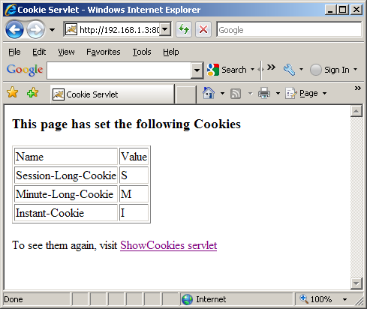

Here is the Response header on Fiddler2:

HTTP/1.1 200 OK
Server: Apache-Coyote/1.1
Set-Cookie: Session-Long-Cookie=S; Path=/
Set-Cookie: Minute-Long-Cookie=M; Expires=Sun, 18-Apr-2010 02:49:45 GMT; Path=/
Set-Cookie: Instant-Cookie=I; Expires=Thu, 01-Jan-1970 00:00:10 GMT; Path=/
Content-Type: text/html
Content-Length: 455
Date: Sun, 18 Apr 2010 02:48:45 GMT

Click on ShowCookies servlet link and here is the output:

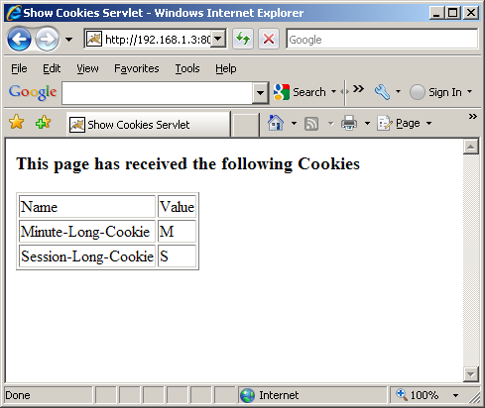

Notice the instance cookie has disappeared.

Here is the Request Header for ShowCookiesServlet from Fiddler2:

GET http://192.168.1.3:8080/JPIDemo8/ShowCookiesServlet HTTP/1.1
Accept: image/gif, image/x-xbitmap, image/jpeg, image/pjpeg, application/x-shockwave-flash, application/x-ms-application, application/x-ms-xbap, application/vnd.ms-xpsdocument, application/xaml+xml, */*
Referer: http://192.168.1.3:8080/JPIDemo8/CookieServlet
Accept-Language: en-us
UA-CPU: x86
Accept-Encoding: gzip, deflate
User-Agent: Mozilla/4.0 (compatible; MSIE 7.0; Windows NT 5.1; GTB6.4; .NET CLR 1.1.4322; .NET CLR 2.0.50727; .NET CLR 3.0.04506.648; .NET CLR 3.5.21022)
Connection: Keep-Alive
Host: 192.168.1.3:8080
Cookie: Minute-Long-Cookie=M; Session-Long-Cookie=S

Here is the Response Header for ShowCookiesServlet from Fiddler2:

HTTP/1.1 200 OK
Server: Apache-Coyote/1.1
Content-Type: text/html
Content-Length: 328
Date: Sun, 18 Apr 2010 02:51:12 GMT

Notice, the response do not have any cookie since ShowCookiesServlet is not sending any cookie back to browser, that was done by CookieServlet.

Wait for a minute and then refresh your browser. You will get the following output:
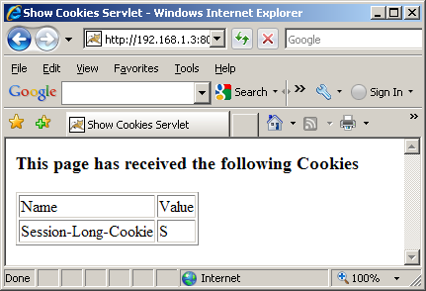

Notice, the Minute-Long-Cookie has disappeared now.

Here is the Request Header in Fiddler2:

GET http://192.168.1.3:8080/JPIDemo8/ShowCookiesServlet HTTP/1.1
Accept: */*
Referer: http://192.168.1.3:8080/JPIDemo8/CookieServlet
Accept-Language: en-us
UA-CPU: x86
Accept-Encoding: gzip, deflate
User-Agent: Mozilla/4.0 (compatible; MSIE 7.0; Windows NT 5.1; GTB6.4; .NET CLR 1.1.4322; .NET CLR 2.0.50727; .NET CLR 3.0.04506.648; .NET CLR 3.5.21022)
Connection: Keep-Alive
Host: 192.168.1.3:8080
Pragma: no-cache
Cookie: Session-Long-Cookie=S

If you close your browser and reopen with ShowCookiesServlet you will get the following output because now even the session cookie does not exist:
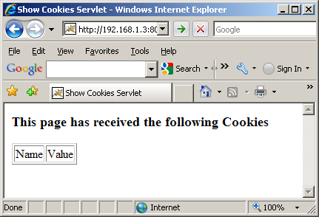

Here is the Request Header from Fiddler2:

GET http://192.168.1.3:8080/JPIDemo8/ShowCookiesServlet HTTP/1.1
Accept: image/gif, image/x-xbitmap, image/jpeg, image/pjpeg, application/x-shockwave-flash, application/x-ms-application, application/x-ms-xbap, application/vnd.ms-xpsdocument, application/xaml+xml, */*
Accept-Language: en-us
UA-CPU: x86
Accept-Encoding: gzip, deflate
User-Agent: Mozilla/4.0 (compatible; MSIE 7.0; Windows NT 5.1; GTB6.4; .NET CLR 1.1.4322; .NET CLR 2.0.50727; .NET CLR 3.0.04506.648; .NET CLR 3.5.21022)
Host: 192.168.1.3:8080
Connection: Keep-Alive

Managing Session by Cookie
In order to understand how session can be managed using Cookie, consider the following Servlet:

import java.io.IOException;
import java.io.PrintWriter;

import javax.servlet.ServletException;
import javax.servlet.http.Cookie;
import javax.servlet.http.HttpServlet;
import javax.servlet.http.HttpServletRequest;
import javax.servlet.http.HttpServletResponse;

import org.apache.log4j.Logger;

public class Page1Servlet extends HttpServlet{

private static int nextSessionId = 1;

private static final long serialVersionUID = 1L;
private static final Logger logger = Logger.getLogger(Page1Servlet.class);

public void doPost(HttpServletRequest request, HttpServletResponse response)
throws ServletException, IOException{
logger.info("In doPost");
doGet(request,response);
}

public void doGet(HttpServletRequest request, HttpServletResponse response)
throws ServletException, IOException{
logger.info("In doGet");

PrintWriter out = null;
Cookie[] cookies = null;
String cookieValue = null;
boolean found = false;

// set the content type of response.
response.setContentType("text/html");

// get a handle on the print writer of response.
out=response.getWriter();

logger.debug("Sending Response");

// generate response.
out.println("<HTML>");
out.println("<HEAD>");
out.println("<TITLE>");
out.println("Page1Servlet");
out.println("</TITLE>");
out.println("</HEAD>");
out.println("<BODY>");

// extract the array of Cookies from request object.
cookies = request.getCookies();

logger.debug("Got cookies from request");

// if any Cookie received at all.
if (!(cookies==null)){

logger.debug("Found " + cookies.length + " cookies");

// loop through the array of Cookies and find session id cookie.
for (int i=0;i<cookies.length;i++){

if (cookies[i].getName().equals("sessionId")){
cookieValue = cookies[i].getValue();
out.println("Session Id found: " + cookieValue + "<br/>");
found = true;
break;
}
}
}
if (!found){
cookieValue = "" +nextSessionId++;
Cookie c = new Cookie("sessionId", cookieValue );
response.addCookie(c);
out.println("Session Id created: " + cookieValue + "<br/>");
}
out.println("<A HREF=\"./Page2Servlet\">Page2Servlet</A>");
out.println("</BODY>");
out.println("</HTML>");
logger.info("Finished doGet");
}
}

The servlet looks for a cookie called sessionId. If not found, it sets a cookie called sessionId to the next sequence Number.
Page2Servlet does exactly that as well.

Open two browser sessions and Hit Page1Servlet from both of them. One will create sessionId 1 and the other one will create sessionId 2. Now, on both browser as you move back and forth between Page1Servlet an Page2Servlet you will see that sessionId is maintained between the two servlets correctly for both browsers – hence session management using cookie.

The Session Tracking API
Fortunately, it is not necessary for a servlet to manage its own session using Cookies. The Servlet API provides classes specifically designed to handle session tracking of behalf of the servlets.

Any servlet container will support session tracking. However, the level of support depends on the container. The minimal implementation manages sessions through the use of persistent cookies. However, most servlet container has the ability to revert to using URL rewriting when cookies fail.

Session tracking is very elegant. Every user of a site is associated with a HttpSession object that servlets can use to store or retrieve information about the user.

If you recall HttpServletRequest object has two overloaded getSession() methods that allows you to get hold of existing HttpSession object or create a new one if it did not exist:

public HttpSession getSession() | Returns the current session associated with this request, or if the request does not have a session, creates one.
public HttpSession getSession(boolean create) | Returns the current HttpSession associated with this request or, if there is no current session and create is true, returns a new session.

HttpSession is not a class but an interface. Here are some of the useful methods of HttpSession:

Useful Methods:
Method | Return Type | Description
setAttribute(String name, Object value) | void | Binds an object to this session, using the name specified.
removeAttribute(String name) | void | Removes the object bound with the specified name from this session.
getAttribute(String name) | Object | Returns the object bound with the specified name in this session, or null if no object is bound under the name.
getAttributeNames() | Enumeration | Returns an Enumeration of String objects containing the names of all the objects bound to this session. You can review all session attributes using this method in conjuction with getAttribute method in a loop.
isNew() | boolean | Returns true if the client does not yet know about the session or if the client chooses not to join the session.
getCreationTime() | long | Returns the time when this session was created, measured in milliseconds since midnight January 1, 1970 GMT.
getLastAccessedTime() | long | Returns the last time the client sent a request associated with this session, as the number of milliseconds since midnight January 1, 1970 GMT.
invalidate() | void | Invalidates this session and unbinds any objects bound to it.
getId() | String | Returns a string containing the unique identifier assigned to this session.
setMaxInactiveInterval(int interval) | void | Specifies the time, in seconds, between client requests before the servlet container will invalidate this session.
getMaxInactiveInterval() | int | Returns the maximum time interval, in seconds, that the servlet container will keep this session open between client accesses.

Unlike Cookie that allows you to only store strings, HttpSession allows you to attach any object on it by calling the setAttribute() method with a name for the object. You can , later on, retrieve the object by calling the getAttribute() method or can remove the object by calling removeAttribute() method.

Please don’t confuse these methods with the same methods on HttpServletRequest object. The purpose and usage of them are completely different.

You can expire a session object by calling invalidate() method. A session object automatically expires if the user does not respond within a certain amount of time. You can adjust the expiration time by calling the setMaxInactiveInterval() method.

Each session object has an ID associated with it and you can retrieve it by calling getId() method.

Here is a name.html:

<html>
<head><title>Name Entry Screen</title></head>
<body>
<form method="GET" action="Page1SessionServlet">
Please enter your name here:<br/>
<hr/>
First Name <input type="text" name="firstName" size="15" /><br/>
Middle Name <input type="text" name="middleName" size="15" /><br/>
Last Name <input type="text" name="lastName" size="15" /><br/>
<input type="submit" name="submit" value="Send" />
<input type="reset" name="cancel" value="Cancel" />
<p/>
</form>
</body>
</html>

Here is Page1SessionServlet that creates a Name object and puts it on session as attribute:

import java.io.IOException;
import java.io.PrintWriter;

import javax.servlet.ServletException;
import javax.servlet.http.Cookie;
import javax.servlet.http.HttpServlet;
import javax.servlet.http.HttpServletRequest;
import javax.servlet.http.HttpServletResponse;
import javax.servlet.http.HttpSession;

import org.apache.log4j.Logger;

public class Page1SessionServlet extends HttpServlet{

private static int nextSessionId = 1;

private static final long serialVersionUID = 1L;
private static final Logger logger = Logger.getLogger(Page1SessionServlet.class);

public void doPost(HttpServletRequest request, HttpServletResponse response)
throws ServletException, IOException{
logger.info("In doPost");
doGet(request,response);
}

public void doGet(HttpServletRequest request, HttpServletResponse response)
throws ServletException, IOException{
logger.info("In doGet");

PrintWriter out = null;

// set the content type of response.
response.setContentType("text/html");

// get a handle on the print writer of response.
out=response.getWriter();

logger.debug("Sending Response");

// generate response.
out.println("<HTML>");
out.println("<HEAD>");
out.println("<TITLE>");
out.println("Page1SessionServlet");
out.println("</TITLE>");
out.println("</HEAD>");
out.println("<BODY>");

// get the name from request
String firstName = request.getParameter("firstName");
String lastName = request.getParameter("lastName");
String middleName = request.getParameter("middleName");

// get the session
HttpSession session = request.getSession();

//get name from session
Name name = (Name) session.getAttribute("name");

//if null create a new Name object and put it on session
if (name==null){
logger.debug("name not found in session");
name = new Name();
session.setAttribute("name", name);
}
// at least firstName and lastName must be present
if ((firstName!=null) && (lastName!=null)){
name.setFirstName(firstName);
name.setLastName(lastName);
// if no middle name - empty middle name
if (middleName==null){
middleName="";
}
name.setMiddleName(middleName);
}

out.println("Session Id : " + session.getId() + "<br/>");
out.println("New Session? " + session.isNew() + "<br/>");
out.println("Name: " + name.getFirstName() + " " + name.getMiddleName() + " " +name.getLastName() + "<br/>");
out.println("<A HREF=\"./Page2SessionServlet\">Page2SessionServlet</A>");
out.println("</BODY>");
out.println("</HTML>");
logger.info("Finished doGet");
}
}

Here is Page2SessionServlet that retrieves session attribute and displays value:

import java.io.IOException;
import java.io.PrintWriter;

import javax.servlet.ServletException;
import javax.servlet.http.Cookie;
import javax.servlet.http.HttpServlet;
import javax.servlet.http.HttpServletRequest;
import javax.servlet.http.HttpServletResponse;
import javax.servlet.http.HttpSession;

import org.apache.log4j.Logger;

public class Page2SessionServlet extends HttpServlet{

private static int nextSessionId = 1;

private static final long serialVersionUID = 1L;
private static final Logger logger = Logger.getLogger(Page2SessionServlet.class);

public void doPost(HttpServletRequest request, HttpServletResponse response)
throws ServletException, IOException{
logger.info("In doPost");
doGet(request,response);
}

public void doGet(HttpServletRequest request, HttpServletResponse response)
throws ServletException, IOException{
logger.info("In doGet");

PrintWriter out = null;

// set the content type of response.
response.setContentType("text/html");

// get a handle on the print writer of response.
out=response.getWriter();

logger.debug("Sending Response");

// generate response.
out.println("<HTML>");
out.println("<HEAD>");
out.println("<TITLE>");
out.println("Page2SessionServlet");
out.println("</TITLE>");
out.println("</HEAD>");
out.println("<BODY>");

// get the session
HttpSession session = request.getSession();

//get name from session
Name name = (Name) session.getAttribute("name");

out.println("Session Id : " + session.getId() + "<br/>");
out.println("New Session? " + session.isNew() + "<br/>");
if (name==null){
logger.debug("name not found in session");
out.println("No Name object on session <br/>");
}
else{
out.println("Name: " + name.getFirstName() + " " + name.getMiddleName() + " " +name.getLastName() + "<br/>");
}
out.println("<A HREF=\"./Page1SessionServlet\">Page1SessionServlet</A>");
out.println("</BODY>");
out.println("</HTML>");
logger.info("Finished doGet");
}
}

You will see how the Name is maintained between Page1SessionServlet and Page2SessionServlet.

JSP
Let’s step back for a minute. Let’s assume we know nothing about Servlets – all we know is static HTML. Here is a simple html page randomnumber.html that has a hardcoded random number:

randomnumber.html
<!DOCTYPE html PUBLIC "-//W3C//DTD HTML 4.01 Transitional//EN" "http://www.w3.org/TR/html4/loose.dtd">
<HTML>
<HEAD><TITLE>JSP Expression Demo</TITLE></HEAD>
<BODY><H3>Here is your random number: 56</H3>
</BODY>
</HTML>

Here is the url:

http://localhost:8080/JPIDemo9/randomnumber.html

You will get 56 as hardcoded random number.

Ok – big deal!!

Now, let’s rename the file to randomnumber.jsp. It looks like a small step for you but it is giant step for mankind. Let’s hit the page:

http://localhost:8080/JPIDemo9/randomnumber.jsp

The good news is the page is still rendered as the html page, the bad news is refreshing the page does not really dynamically give you new random numbers.

Alright, get go ahead and change the jsp page as follows:

randomnumber.jsp
<!DOCTYPE html PUBLIC "-//W3C//DTD HTML 4.01 Transitional//EN" "http://www.w3.org/TR/html4/loose.dtd">
<HTML>
<HEAD><TITLE>JSP Expression Demo</TITLE></HEAD>
<BODY><H3>Here is your random number: <%= (int) (Math.random()*100) %></H3>
</BODY>
</HTML>

This time you took a giant step for yourself not to mention mankind.

Let’s hit the page:

http://localhost:8080/JPIDemo9/randomnumber.jsp

Now, we will start getting really random number and each refresh will bring you a new number.

What happened? You just mixed static html with dynamic content without knowing the details behind it.

JavaServer Pages(JSP) technology allows you to mix regular, static HTML with dynamically generated content from servlets. Developing a JSP is really simple. You simply write your regular HTML page using your favorite web development tool. You then enclose the code for the dynamic parts using special tags (mostly with <%..%> tags). Although what you write often looks more like HTML file than a servlet, behind the scenes, the JSP page is automatically converted to a normal-servlet, with the static HTML simply being printed to the output steam associated with the servlet’s service() method. I guess, the basic difference between a servlet and a JSP is that, in case of servlet, you feel like you are writing Java code. Inside your Java code you print HTML tags whenever you need static content. In case of JSP, you feel like you are writing an HTML page. Inside your HTML page, you embed Java code whenever you need dynamic content. In other words, servlets are process driven approach whereas JSPs are presentation driven. But, behind the scenes, you are dealing with only one thing – servlets.

A JSP page obviously contains regular HTML but in addition there are three main types of JSP constructs that you embed in a page:

- Scripting Elements
- Directives
- Actions

Scripting elements let you specify Java code that will become part of the resultant servlet, directives let you control the overall structure of the servlet and actions let you specify existing components that should be used and otherwise control the behavior of the JSP engine.

Scripting Elements
JSP Scripting elements let you insert server-side java code into JSP pages. There are three forms of scripting elements:

- Expressions of the form <%= expression %> which are evaluated on the server and the results of the evaluation are rendered to the client. The expressions are inserted within Out.print() method into the JSP’s _jspService() method (exactly the way static HTMLs are) that is called by the service() method.
- Scriptlets of the form <% code %> which are inserted into the JSP’s _jspService() method. _jspService() method is called by service() method.
- Declarations of the form <%! code %> which are inserted into the body of JSP’s servlet class, outside of any existing methods.

In addition there is way to insert server-side comments in JSP page. These comments appear on the JSP page but not on the resulting HTML page. In order to put this type of comments you use :

<%-- JSP Comments --%>

Please keep in mind that HTML comments – which does appear on the HTML page - have a similar syntax:

<!—HTML Comments -->

Homework Assignment
Write an HTML file random.html that looks like this:

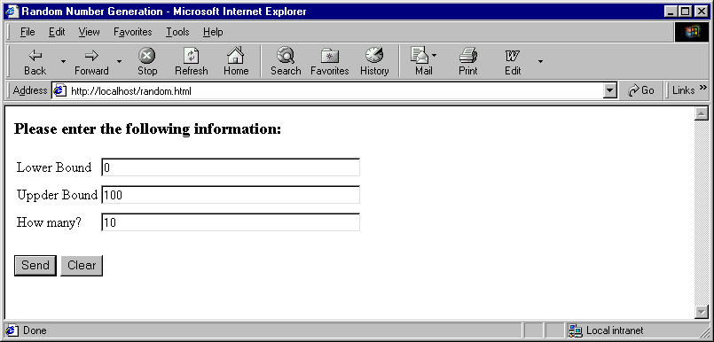
Please note the default values.

Write a servlet “RandomServlet” that meets the following requirements:

- If the user sends non-numeric or negative data for any of the fields the response looks like this:

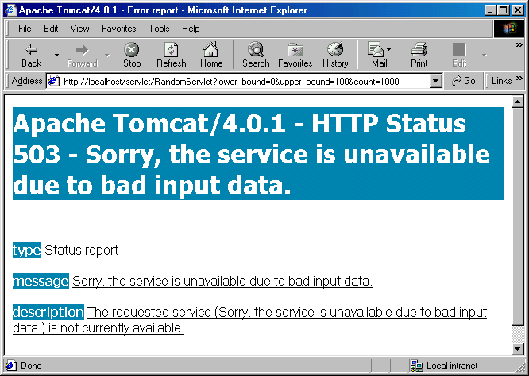

- Upper limit must be greater than lower limit. Otherwise the response should still be the error page shown above.
- If the user enters “how many” greater than or equal to the difference between upper and lower limit the response should still be the error page shown above.
- “how many” should be greater than zero.
- There is no duplicate numbers.
- The numbers are sorted in ascending order and numbered as 1,2,3 … etc.

Here is the normal output:

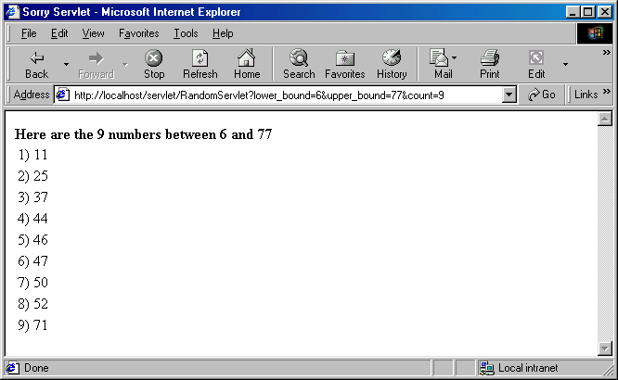

Please make sure of the followings:

Please use TreeSet from java collection classes so that the numbers are sorted and duplicate numbers are avoided. Usage of TreeSet is mandatory.

You can use the following formula to get random numbers between a range:

(int) ((Upperbound - Lowerbound+ 1) * Math.random() + Lowerbound)

