Objective

ServletConfig Interface
As part of the configuration of servlets, each registered servlet can have specific initialization parameters associated with it. These parameters are often used in init() method to set default values of a servlet or to customize a servlet is certain way. The initialization parameters are passed to the init() method through an object as an argument to the init() method. The object that is passed to the init() method implements ServletConfig interface. A ServletConfig interface provides methods to access these initialization parameters.

The Servlet interface has init() method that receives a ServletConfig object as an argument as follows:

init(ServletConfig config) | void | Called by the servlet container to indicate to a servlet that the servlet is being placed into service.

Therefore, the ServletConfig object is readily available in init() method. If you are not in init() method but would like to access ServletConfig object – no problem. The Servlet interface has a getServletConfig() method that returns ServletConfig object. As it turns out, you don’t even have to call the getServletConfig() method at all to access ServletConfig methods since GenericServlet - the superclass of HttpServlet - implements ServletConfig interface – just for convenience. Therefore, all the methods in ServletConfig interface are also methods of HttpServlet class.

Here are the methods in ServletConfig interface:

Method | Return Type | Description
getInitParameter(String name) | String | Returns a String containing the value of the named initialization parameter, or null if the parameter does not exist.
getInitParameterNames() | Enumeration | Returns the names of the servlet's initialization parameters as an Enumeration of String objects, or an empty Enumeration if the servlet has no initialization parameters.
getServletContext() | ServletContext | Returns a reference to the ServletContext in which the servlet is executing.
getServletName() | String | Returns the name of this servlet instance defined in its deployment descriptor. If no name is assigned it returns the servlet class name instead.

The initialization parameters are setup using a deployment descriptor “web.xml” is located in the web-inf directory of the web application.

Here is a ServletConfigInitParameterDemoServlet:
package servlet;

import java.io.IOException;
import java.io.PrintWriter;

import javax.servlet.ServletException;
import javax.servlet.http.HttpServlet;
import javax.servlet.http.HttpServletRequest;
import javax.servlet.http.HttpServletResponse;

import org.apache.log4j.Logger;

public class ServletConfigInitParameterDemoServlet extends HttpServlet {

private static final Logger logger = Logger.getLogger(ServletConfigInitParameterDemoServlet.class);

//Process the HTTP Get request
protected void doGet(HttpServletRequest request, HttpServletResponse response) throws ServletException, IOException{

logger.info("In doGet");
String message=null;
if (getInitParameter("message")==null){
logger.debug("Servlet Init Parameter 'message' is missing");
message="I am sorry, weather forecast for this week has not arrived yet.";
}
else{
message=getInitParameter("message");
logger.debug("Servlet Init Parameter 'message'= " + message );
}
response.setContentType("text/html");
logger.debug("Sending Response....");
PrintWriter out=response.getWriter();
out.println("<HTML>");
out.println("<HEAD>");
out.println("<TITLE>");
out.println("Weather Forcast Servlet");
out.println("</TITLE>");
out.println("</HEAD>");
out.println("<BODY>");
out.println("<H3>"+message+"</H3>");
out.println("</BODY>");
out.println("</HTML>");
logger.info("Finished doGet");
}

//Process the HTTP Post request
protected void doPost(HttpServletRequest request, HttpServletResponse response) throws ServletException, IOException{
logger.info("In doPost");
doGet(request,response);
logger.info("Finished doPost");
}
}

Here is the entry in web.xml file:

<servlet>
<description>
</description>
<display-name>ServletConfigInitParameterDemoServlet</display-name>
<servlet-name>ServletConfigInitParameterDemoServlet</servlet-name>
<servlet-class>
servlet.ServletConfigInitParameterDemoServlet</servlet-class>
<init-param>
<param-name>message</param-name>
<param-value>Weather Today: Mostly cloudy. High around 46F. Winds SW 15 to 20 mph.</param-value>
</init-param>
</servlet>
<servlet-mapping>
<servlet-name>ServletConfigInitParameterDemoServlet</servlet-name>
<url-pattern>/ServletConfigInitParameterDemoServlet</url-pattern>
</servlet-mapping>

Here is the output:

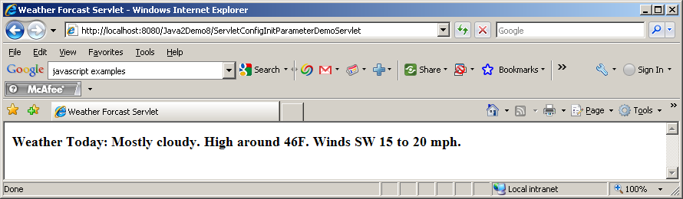

ServletContext Interface
ServletConfig interface has a method getServletContext() that returns an object that implement ServletContext interface. So, what is ServletContext? The ServletContext is a reference to the web application a Servlet is part of, and provides access to resources and facilities common to all servlets in the same application. Unlike Session that is specific to a client, the ServletContext is specific to a particular web application – sort of like a global object on the server. Each web application in a container will have a ServletContext object associated with it. Therefore ServletContext literally represents web application.

ServletContext is a very powerful concept. The ServletContext allows you to maintain application level state for all servlets and all clients in the application. ServletContext starts at the root of the application and it encompasses all the sub-folders and files under that root. In Tomcat, you define the root of an application by putting a context tag in server.xml located in conf directory.

ServletContext is not a class but an interface. Here are the methods available in ServletContext interface:

Method | Return Type | Description
setAttribute(String name, Object object) | void | Binds an object to a given attribute name in this servlet context. This is an extremely useful feature. This object is visible to all other servlets within the application and can be used as a global object. This object will live as long as the application is running – which means until you shut down Tomcat.
getAttribute(String name) | Object | Returns the servlet container attribute with the given name, or null if there is no attribute by that name. This method allows you to access can object from a servlet that is placed by another servlet.
getAttributeNames() | Enumeration | Returns an Enumeration containing the attribute names available within this servlet context. Using this method with getAttribute() you can access all the attribute objects.
removeAttribute(String name) | void | Removes the attribute with the given name from the servlet context. Using this method one servlet can remove an object placed by a previous servlet.
getInitParameter(String name) | String | Returns a String containing the value of the named context-wide initialization parameter, or null if the parameter does not exist. This method can make available configuration information useful to an entire "web application". For example, it can provide the name of an application available to every servlet. In Tomcat, you have to declare the init parameters in web.xml file located in web-inf folder of the application using <context-param> tag.
getInitParameterNames() | Enumeration | Returns the names of the context's initialization parameters as an Enumeration of String objects, or an empty Enumeration if the context has no initialization parameters. Using this method with getInitParameter() you can access all initialization parameters of the application.
getRequestDispatcher(String path) | RequestDispatcher | Returns a RequestDispatcher object that acts as a wrapper for the resource located at the given path. This is another extremely useful feature. Using this method one servlet can forward partially processed request and response object to the next servlet – resulting servlet chaining.
getNamedDispatcher(String name) | RequestDispatcher | Returns a RequestDispatcher object that acts as a wrapper for the named servlet. This method is identical to getRequestDispatcher – the only difference is that you can use servlet name here (defined in web.xml) instead of the servlet URL.
getMimeType(String file) | String | Returns the MIME type of the specified file, or null if the MIME type is not known. The MIME type is determined by the configuration of the servlet container, and may be specified in a web application deployment descriptor - server.xml.
getRealPath(String path) | String | Returns a String containing the real path for a given virtual path. For example, it is possible to name a servlet “web-inf/classes/TestServlet” as "/main.html" in web.xml. getRealPath will return you the full path of “TestServlet”.
getResource(String path) | URL | Returns a URL to the resource that is mapped to a specified path – basically convert a String to an URL object.
getResourceAsStream(String path) | InputStream | Returns the resource located at the named path as an InputStream object.  This method is very similar to getResource() except that it returns an InputStram() already opened to the resource.
Log(String msg) | void | Writes the specified message to a servlet log file, usually an event log. You don’t really need to access this method through ServletContext since GenericServlet already implemented this method for convenience.
Log(String message, Throwable throwable) | void | Writes an explanatory message and a stack trace for a given Throwable exception to the servlet log file. You don’t really need to access this method through ServletContext since GenericServlet already implemented this method for convenience.
getContext(String uripath) | ServletContext | This is a very powerful feature of servlet API. This method returns a ServletContext object that corresponds to a specified URL on the server – possibly the URL belongs to another web application. However, due to possible security limitations imposed by the web container this method might return null. However, without security restriction servlets on two different web applications running on the same web container can share data and communicate with each other using this method.
getMajorVersion() | int | Returns the major version of the Java Servlet API that this servlet container supports.
getMinorVersion() | int | Returns the minor version of the Servlet API that this servlet container supports.
getServerInfo() | String | Returns the name and version of the servlet container on which the servlet is running.

Here is an example of a servlet using the context init parameter to display the application name on the title bar:

package servlet;

import java.io.IOException;
import java.io.PrintWriter;

import javax.servlet.ServletException;
import javax.servlet.http.HttpServlet;
import javax.servlet.http.HttpServletRequest;
import javax.servlet.http.HttpServletResponse;

import org.apache.log4j.Logger;

public class ServletContextInitParameterDemoServlet extends HttpServlet{
private static final Logger logger = Logger.getLogger(ServletContextInitParameterDemoServlet.class);

protected void doPost(HttpServletRequest request, HttpServletResponse response)
throws ServletException, IOException{
logger.info("In doPost");
doGet(request,response);
}

protected void doGet(HttpServletRequest request, HttpServletResponse response)
throws ServletException, IOException{

logger.info("In doGet");

String title = getServletContext().getInitParameter("caption");
logger.debug("Sending Response...");
response.setContentType("text/html");
PrintWriter out=response.getWriter();
out.println("<HTML>");
out.println("<HEAD>");
out.println("<TITLE>");
if (title==null){
logger.debug("Caption missing");
out.println("No Application Title Found");
}
else{
out.println(title);
logger.debug("Caption: " + title);
}
out.println("</TITLE>");
out.println("</HEAD>");
out.println("<BODY>");
if (title==null){
out.println("<h3> No Application Title Found");
}
else{
out.println("<H3> This servlet receives application title as context init parameter: "+ title + "</H3>");
}
out.println("</BODY>");
out.println("</HTML>");
out.close();
logger.debug("Finished doGet");
}
}

Here is the entry of web.xml:

<context-param>
<param-name>caption</param-name>
<param-value>Java 2 Demo 8 App</param-value>
</context-param>
<servlet>
<description>
</description>
<display-name>ServletContextInitParameterDemoServlet</display-name>
<servlet-name>ServletContextInitParameterDemoServlet</servlet-name>
<servlet-class>
servlet.ServletContextInitParameterDemoServlet</servlet-class>
</servlet>
<servlet-mapping>
<servlet-name>ServletContextInitParameterDemoServlet</servlet-name>
<url-pattern>/ServletContextInitParameterDemoServlet</url-pattern>
</servlet-mapping>

Here is the output:

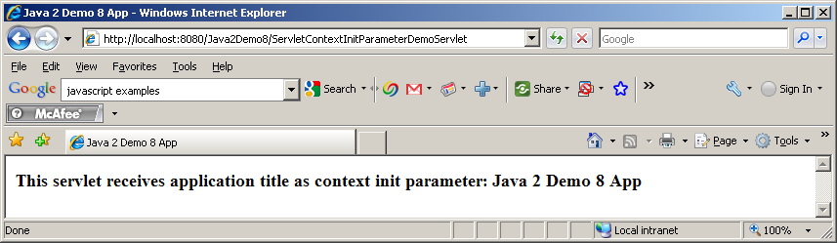

Here is an example of one servlet setting up an application level attribute.

package servlet;
import java.io.IOException;
import java.io.PrintWriter;

import javax.servlet.ServletException;
import javax.servlet.http.HttpServlet;
import javax.servlet.http.HttpServletRequest;
import javax.servlet.http.HttpServletResponse;

import org.apache.log4j.Logger;

public class SetServletContextAttributeDemoServlet extends HttpServlet {

private static final Logger logger = Logger.getLogger(SetServletContextAttributeDemoServlet.class);
private static final long serialVersionUID = 1L;

//Process the HTTP Get request
protected void doGet(HttpServletRequest request, HttpServletResponse response)
throws ServletException, IOException{

logger.info("In doGet");

// get a random number between 0 and 100
int random = (int) (Math.random()*100);

logger.debug("Got Random Number: " + random);

// convert it to Integer object - since context attribute values can only be objects.
Integer randomInteger = new Integer(random);

getServletContext().setAttribute("random", randomInteger);
logger.debug("Context attribute 'random' is set to: " + randomInteger);
response.setContentType("text/html");
PrintWriter out=response.getWriter();
logger.debug("Sending Response...");
out.println("<HTML>");
out.println("<HEAD>");
out.println("<TITLE>");
out.println("Set Context Attribute Servlet");
out.println("</TITLE>");
out.println("</HEAD>");
out.println("<BODY>");
out.println("<H3> Context Attribute 'random' has been set to a value: "+ getServletContext().getAttribute("random") +"</H3>");
out.println("</BODY>");
out.println("</HTML>");
logger.info("Finished doGet");
}

//Process the HTTP Post request
protected void doPost(HttpServletRequest request, HttpServletResponse response)
throws ServletException, IOException{
logger.info("In doPost");
doGet(request,response);
logger.info("Finished doPost");
}

}

Here is out output:

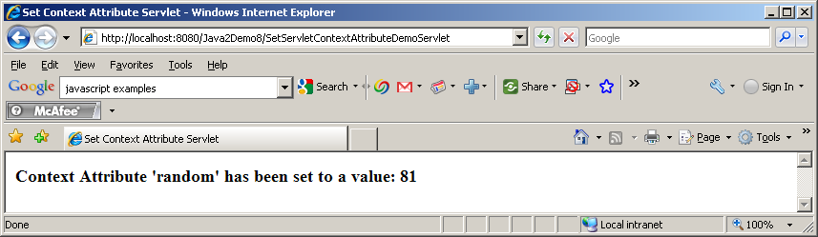

Here is an example of one servlet retrieving an application level attribute.
package servlet;

import java.io.IOException;
import java.io.PrintWriter;

import javax.servlet.ServletException;
import javax.servlet.http.HttpServlet;
import javax.servlet.http.HttpServletRequest;
import javax.servlet.http.HttpServletResponse;

import org.apache.log4j.Logger;

public class GetServletContextAttributeDemoServlet extends HttpServlet {
private static final long serialVersionUID = 1L;
private static final Logger logger = Logger.getLogger(GetServletContextAttributeDemoServlet.class);

//Process the HTTP Get request
protected void doGet(HttpServletRequest request, HttpServletResponse response)
throws ServletException, IOException{

logger.info("In doGet");

// get the context attribute random and cast it to Integer
Integer randominteger = (Integer) getServletContext().getAttribute("random");

String message=null;

if (randominteger==null){
logger.debug("No Context Attribute");
message= "<H3>No Context Attribute Found<H3>";
}
else{
// convert it int.
int random = randominteger.intValue();
logger.debug("Context Attribute: " + random);
message = "<H3> Context Attribute value of 'random' has been retrieved: "+ random +"</H3>";
}

logger.debug("Sending response...");
response.setContentType("text/html");
PrintWriter out=response.getWriter();
out.println("<HTML>");
out.println("<HEAD>");
out.println("<TITLE>");
out.println("Get Context Attribute Servlet");
out.println("</TITLE>");
out.println("</HEAD>");
out.println("<BODY>");
out.println(message);
out.println("</BODY>");
out.println("</HTML>");
logger.info("Finished doGet");
}

//Process the HTTP Post request
protected void doPost(HttpServletRequest request, HttpServletResponse response)
throws ServletException, IOException{

logger.info("In doPost");
doGet(request,response);
}

}

Here is the output:

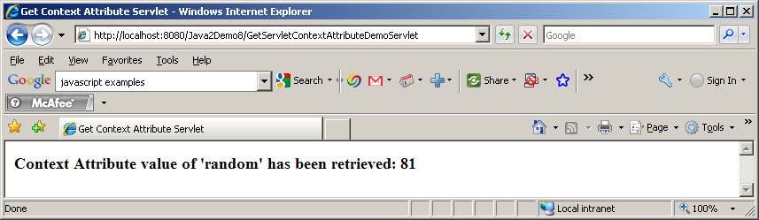
RequestDispatcher Interface
ServletContext has two methods getRequestDispatcher() and getNamedDispatcher() both return an object that implements RequestDispatcher interface.

A ReqeustDispatcher allows a servlet to dispatch a request to another servlet. For every request, the servlet container creates the RequestDispatcher object, which is used to dispatch requests to a component (servlet, JSP, static page) by a path or by a name of the component.

Here are the signature of the two methods that brings back RequestDispatcher():

public RequestDispatcher ServletContext.getRequestDispatcher(String path)
public RequestDispatcher ServletContext.getNamedDispatcher(String name)

RequestDispatcher interface has the following two methods:

Method | Return Type | Description
forward(ServletRequest request, ServletResponse response) | void | Forwards a request from a servlet to another resource (servlet, JSP file, or HTML file) on the server. This method allows one servlet to do preliminary processing of a request and another resource to generate the response.
Include(ServletRequest request, ServletResponse response) | void | Includes the content of a resource (servlet, JSP page, HTML file) in the response. In essence, this method enables programmatic server-side includes. The included servlet cannot change the response status code or set headers; any attempt to make a change is ignored.

As it turns out, the RequestDispatcher can be obtained on another servlet by two ways:

- By calling the getRequestDispatcher() or getNamedDispatcher() on ServletContext object
- By calling the getRequestDispatcher() on the ServletRequest (or HttpServletRequest) object.

There is a slight difference between the two. If you get the RequestDispatcher on another servlet from ServletContext you should provide the full path of the second servlet. In other words, if ShowRecordsServlet is calling getRequestDispatcher() of ServletContext to get the RequestDispatcher on RecordsPresentationServlet it must do so as follows:

RequestDispatcher requestdispatcher = getServletContext().getRequestDispatcher("/servlet/RecordsPresentationServlet");

However, if ShowRecordsServlet is calling getRequestDispatcher() of it’s own HttpServletRequest it can use relative path as follows:

RequestDispatcher requestdispatcher = request.getRequestDispatcher("RecordsPresentationServlet");

Notice, in the second case, you don’t have to prefix the servlet name with “/servlet”. Please be careful about using relative path. My experience shows that relative path could easily become a troubleshooting issue and you are better off using absolute path if possible.

Forwarding Data
While forwarding to or including from another servlet, a servlet may need to forward some processed data that did not come from the client as request parameters. Of course, the servlet can start a session and attach data to the session object. Another way to do this is to attach the data on the ServletContext object so that the data is available everywhere in the application. As it turns out Session or ServletContext is not really needed (and is overkill) for this purpose. Also, by using either Session or ServletContext object you are exposing your data to all the Servlets within the application unnecessarily. The best way to forward data is to use the Request Object itself. The Request object has setAttribute() method (just like Session object does) that allows a servlet to attach additional data to the request object. The receiving servlet can get the data from the Request object by calling getAttribute() method on the Request object.

Difference between sendRedirect() and forward()
You might think that sendRedirect() of a response object and forward() method of a request object are very similar but there is significant differences between these two.

- sendRedirect() generates a brand new HTTP GET request. Therefore, all the parameters that this servlet received does not get propagated to the next servlet (unless the programmer appends as QueryString manually). The forward() method takes the request and response object and simply forwards it the next servlet. All the parameters and attributes of the request are intact.
- In case of sendRedirect() the client sees the URL transfer on his browser. He knows that he requested “servlet1” but the response came from “servlet2”. in case of forward() – the client is unaware of this transfer from one servlet to the next.
- In case of forward(), the sender can append more data(any kind of Object) using the setAttribute() method of the request object. In case of sendRedirect() – then sender have to do it manually by appending QueryString which – by the way – can only be String.
- In a nutshell, in case of sendRedirect(), you are forwarding the response (after all, it is a method on Response object) assuming the request has completely been processed. In case of forward(), you are forwarding request (after all, it is a method on the Request object) assuming partial or no processing has been done on the request. The forward() method also allows the separation of processing from presentation which is the key to JSP programming.

Here is a servlet that forwards request:

package servlet;

import java.io.IOException;
import java.io.PrintWriter;

import javax.servlet.RequestDispatcher;
import javax.servlet.ServletException;
import javax.servlet.http.HttpServlet;
import javax.servlet.http.HttpServletRequest;
import javax.servlet.http.HttpServletResponse;

import org.apache.log4j.Logger;

public class ForwardingServlet extends HttpServlet{
private static final long serialVersionUID = 1L;
private static final Logger logger = Logger.getLogger(ForwardingServlet.class);

public void doPost(HttpServletRequest request, HttpServletResponse response)
throws ServletException, IOException{
logger.info("In doPost");
doGet(request,response);
logger.info("Finished doPost");
}

public void doGet(HttpServletRequest request, HttpServletResponse response)
throws ServletException, IOException{
logger.info("In doGet");

// set the content type of response.
response.setContentType("text/html");
// get a handle on the print writer of response.
PrintWriter out=response.getWriter();

// generate response.
out.println("<HTML>");
out.println("<HEAD>");
out.println("<TITLE>");
out.println("Forwarding Servlet");
out.println("</TITLE>");
out.println("</HEAD>");
out.println("<BODY>");
out.println("<H3>This line is from the original 'Forwarding Servlet'</H3>");
//get request parameter
String name = request.getParameter("inputname");
logger.debug("Got Request parameter 'inputname': " + name);
request.setAttribute("username", name);

logger.debug("Saved Request parameter 'inputname' in Request attribute 'username'");
logger.debug("Forwading to Forwarded Servlet....");
RequestDispatcher requestdispatcher= getServletContext().getRequestDispatcher("/servlet/ForwardedServlet");
requestdispatcher.forward(request,response);

logger.info("Writing Response, that will never be returned since forwarded already");
out.println("<H3>Again, This line is from the original 'Forwarding Servlet'</H3>");
out.println("</BODY>");
out.println("</HTML>");
logger.info("Finished doGet");
}
}

Here is a servlet that gets forwarded request:

package servlet;

import java.io.IOException;
import java.io.PrintWriter;

import javax.servlet.ServletException;
import javax.servlet.http.HttpServlet;
import javax.servlet.http.HttpServletRequest;
import javax.servlet.http.HttpServletResponse;

import org.apache.log4j.Logger;

public class ForwardedServlet extends HttpServlet{
private static final long serialVersionUID = 1L;
private static final Logger logger = Logger.getLogger(ForwardedServlet.class);

protected void doPost(HttpServletRequest request, HttpServletResponse response)
throws ServletException, IOException{
logger.info("In doPost");
doGet(request,response);
logger.info("Finished doPost");
}

protected void doGet(HttpServletRequest request, HttpServletResponse response)
throws ServletException, IOException{
logger.info("In doGet");

//get request attribute
String name = (String) request.getAttribute("username");
logger.debug("Got Request attribute 'username': " + name);

// get a handle on the print writer of response.
PrintWriter out=response.getWriter();

out.println("<H3>This line is from the 'Forwarded Servlet'</H3>");
out.println("<B>Hello " + name + ", How are you?</B>");
}
}

Here is the output:

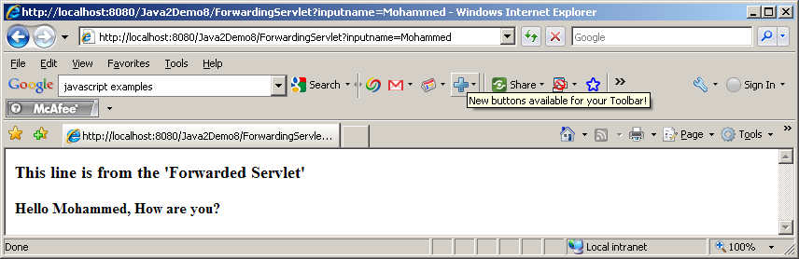

JSP
Let’s step back for a minute. Let’s assume we know nothing about Servlets – all we know is static HTML. Here is a simple html page randomnumber.html that has a hardcoded random number:

randomnumber.html
<!DOCTYPE html PUBLIC "-//W3C//DTD HTML 4.01 Transitional//EN" "http://www.w3.org/TR/html4/loose.dtd">
<HTML>
<HEAD><TITLE>JSP Expression Demo</TITLE></HEAD>
<BODY><H3>Here is your random number: 56</H3>
</BODY>
</HTML>

Here is the url:

http://localhost:8080/JPIDemo9/randomnumber.html

You will get 56 as hardcoded random number.

Ok – big deal!!

Now, let’s rename the file to randomnumber.jsp. It looks like a small step for you but it is giant step for mankind. Let’s hit the page:

http://localhost:8080/JPIDemo9/randomnumber.jsp

The good news is the page is still rendered as the html page, the bad news is refreshing the page does not really dynamically give you new random numbers.

Alright, get go ahead and change the jsp page as follows:

randomnumber.jsp
<!DOCTYPE html PUBLIC "-//W3C//DTD HTML 4.01 Transitional//EN" "http://www.w3.org/TR/html4/loose.dtd">
<HTML>
<HEAD><TITLE>JSP Expression Demo</TITLE></HEAD>
<BODY><H3>Here is your random number: <%= (int) (Math.random()*100) %></H3>
</BODY>
</HTML>

This time you took a giant step for yourself not to mention mankind.

Let’s hit the page:

http://localhost:8080/JPIDemo9/randomnumber.jsp

Now, we will start getting really random number and each refresh will bring you a new number.

What happened? You just mixed static html with dynamic content without knowing the details behind it.

JavaServer Pages(JSP) technology allows you to mix regular, static HTML with dynamically generated content from servlets. Developing a JSP is really simple. You simply write your regular HTML page using your favorite web development tool. You then enclose the code for the dynamic parts using special tags (mostly with <%..%> tags). Although what you write often looks more like HTML file than a servlet, behind the scenes, the JSP page is automatically converted to a normal-servlet, with the static HTML simply being printed to the output steam associated with the servlet’s service() method. I guess, the basic difference between a servlet and a JSP is that, in case of servlet, you feel like you are writing Java code. Inside your Java code you print HTML tags whenever you need static content. In case of JSP, you feel like you are writing an HTML page. Inside your HTML page, you embed Java code whenever you need dynamic content. In other words, servlets are process driven approach whereas JSPs are presentation driven. But, behind the scenes, you are dealing with only one thing – servlets.

A JSP page obviously contains regular HTML but in addition there are three main types of JSP constructs that you embed in a page:

- Scripting Elements
- Directives
- Actions

Scripting elements let you specify Java code that will become part of the resultant servlet, directives let you control the overall structure of the servlet and actions let you specify existing components that should be used and otherwise control the behavior of the JSP engine.

Scripting Elements
JSP Scripting elements let you insert server-side java code into JSP pages. There are three forms of scripting elements:

- Expressions of the form <%= expression %> which are evaluated on the server and the results of the evaluation are rendered to the client. The expressions are inserted within Out.print() method into the JSP’s _jspService() method (exactly the way static HTMLs are) that is called by the service() method.
- Scriptlets of the form <% code %> which are inserted into the JSP’s _jspService() method. _jspService() method is called by service() method.
- Declarations of the form <%! code %> which are inserted into the body of JSP’s servlet class, outside of any existing methods.

In addition there is way to insert server-side comments in JSP page. These comments appear on the JSP page but not on the resulting HTML page. In order to put this type of comments you use :

<%-- JSP Comments --%>

Please keep in mind that HTML comments – which does appear on the HTML page - have a similar syntax:

<!—HTML Comments -->

Predefined Variable:
JSP pages have a set of predefined variables for programming convenience:

- request – represents HttpServletRequest
- response – represents HttpServletResponse
- out – represents PrintWriter that we get from a servlet by calling getWriter() method of HttpServletResponse
- session – represents HttpSession
- application – represents ServletContext
- config – represents ServletConfig
- pageContext – represents jsp PageContext.
- page – simply a synonym for this

JSP Expressions <%= …. %>
Here is an example of a simple JSP page that uses JSP expression:

randomnumber.jsp
<!DOCTYPE html PUBLIC "-//W3C//DTD HTML 4.01 Transitional//EN" "http://www.w3.org/TR/html4/loose.dtd">
<HTML>
<HEAD><TITLE>JSP Expression Demo</TITLE></HEAD>
<BODY><H3>Here is your random number: <%= (int) (Math.random()*100) %></H3>
</BODY>
</HTML>

Looks familiar? It’s the same page we saw few minutes ago.

The first time the JSP engine intercepts a request for a JSP, it compiles the JSP page into a sophisticated servlet.

If you run the above application in StandAlone Tomcat (Outside of Eclipse), here is the generated code for randomnumber.jsp found in tomcat’s work\Catalina\localhost\JPIDemo9\org\apache\jsp folder:

package org.apache.jsp;

import javax.servlet.*;
import javax.servlet.http.*;
import javax.servlet.jsp.*;

public final class randomnumber_jsp extends org.apache.jasper.runtime.HttpJspBase
implements org.apache.jasper.runtime.JspSourceDependent {

private static final JspFactory _jspxFactory = JspFactory.getDefaultFactory();

private static java.util.List _jspx_dependants;

private javax.el.ExpressionFactory _el_expressionfactory;
private org.apache.AnnotationProcessor _jsp_annotationprocessor;

public Object getDependants() {
return _jspx_dependants;
}

public void _jspInit() {
_el_expressionfactory = _jspxFactory.getJspApplicationContext(getServletConfig().getServletContext()).getExpressionFactory();
_jsp_annotationprocessor = (org.apache.AnnotationProcessor) getServletConfig().getServletContext().getAttribute(org.apache.AnnotationProcessor.class.getName());
}

public void _jspDestroy() {
}

public void _jspService(HttpServletRequest request, HttpServletResponse response)
throws java.io.IOException, ServletException {

PageContext pageContext = null;
HttpSession session = null;
ServletContext application = null;
ServletConfig config = null;
JspWriter out = null;
Object page = this;
JspWriter _jspx_out = null;
PageContext _jspx_page_context = null;

try {
response.setContentType("text/html");
pageContext = _jspxFactory.getPageContext(this, request, response,
null, true, 8192, true);
_jspx_page_context = pageContext;
application = pageContext.getServletContext();
config = pageContext.getServletConfig();
session = pageContext.getSession();
out = pageContext.getOut();
_jspx_out = out;

out.write("<!DOCTYPE html PUBLIC \"-//W3C//DTD HTML 4.01 Transitional//EN\" \"http://www.w3.org/TR/html4/loose.dtd\">\r\n");
out.write("<HTML>\r\n");
out.write("\t<HEAD><TITLE>JSP Expression Demo</TITLE></HEAD>\r\n");
out.write("\t<BODY><H3>Here is your random number: ");
out.print( (int) (Math.random()*100) );
out.write("</H3>\r\n");
out.write("\t</BODY>\r\n");
out.write("</HTML>\r\n");
} catch (Throwable t) {
if (!(t instanceof SkipPageException)){
out = _jspx_out;
if (out != null && out.getBufferSize() != 0)
try { out.clearBuffer(); } catch (java.io.IOException e) {}
if (_jspx_page_context != null) _jspx_page_context.handlePageException(t);
}
} finally {
_jspxFactory.releasePageContext(_jspx_page_context);
}
}
}

Notice request and response are coming to _jspService as input parameters and page, pageContext, application, config, session, out are being declared and initialized within the method. In other words, when we write a JSP page, these variables are not declared yet. By the time the JSP gets converted to servlet, these variables gets declared and initialized automatically.

As you can see above Tomcat is extending a HttpJspBase class for each JSP page. HttpJspBase is Tomcat’s own class that somehow extends HttpServlet and possibly implements some other interface.

When I ran javap (I hope you are familiar with javap) on HttpJspBase as follows:

javap org.apache.jasper.runtime.HttpJspBase, here is the output I found:

Compiled from HttpJspBase.java
public abstract class org.apache.jasper.runtime.HttpJspBase extends javax.servlet.http.HttpServlet implements javax.servlet.jsp.HttpJspPage {
protected javax.servlet.jsp.PageContext pageContext;
protected org.apache.jasper.runtime.HttpJspBase();
public abstract void _jspService(javax.servlet.http.HttpServletRequest, javax.servlet.http.HttpServletResponse) throws javax.servlet.ServletException, java.io.IOException;
public final void destroy();
protected java.lang.ClassLoader getClassLoader();
public java.lang.String getServletInfo();
public final void init(javax.servlet.ServletConfig) throws javax.servlet.ServletException;
public void jspDestroy();
public void jspInit();
public final void service(javax.servlet.http.HttpServletRequest, javax.servlet.http.HttpServletResponse) throws javax.servlet.ServletException, java.io.IOException;
public final void setClassLoader(java.lang.ClassLoader);
}

As you can see Tomcat’s HttpJspBase not only extends HttpServlet, it also implements HttpJspPage interface. We need to look at HttpJspPage interface but HttpJspPage interface extends JspPage interface. Therefore, we need to look at JspPage interface first.

JspPage Interface
This is the interface that a JSP processor-generated class must satisfy.

The interface defines a protocol with 3 methods; only two of them: jspInit() and jspDestroy() are part of this interface as the signature of the third method: _jspService() depends on the specific protocol used and cannot be expressed in a generic way in Java.
A class implementing this interface is responsible for invoking the above methods at the appropriate time based on the corresponding Servlet-based method invocations.

The jspInit() and jspDestroy() methods can be defined by a JSP author, but the _jspService() method is defined automatically by the JSP processor based on the contents of the JSP page. Here are two methods in the interface:

jspInit() | void | jspInit() is invoked when the JspPage is initialized. This is similar to the init() method in servlet. Page authors are free to provide initialization code of the JSP by implementing this method in their JSP page – although people rarely do.
jspDestroy() | void | jspDestroy() is invoked when the JspPage is about to be destroyed. This is similar to the destroy() method in servlet. Page authors are free to provide cleanup code of the JSP by implementing this method in their JSP page – although people rarely do.

HttpJspPage Interface
HttpJspPage interface extends JspPage interface. This is the interface that a JSP processor-generated class for the HTTP protocol must satisfy. There is only one method in this interface:

_jspService(HttpServletRequest request, HttpServletResponse response) | void | _jspService corresponds to the body of the JSP page – the entire body of a JSP page ends up here. This method is defined automatically by the JSP processor and should NEVER BE DEFINED BY THE JSP AUTHOR. This method is similar to service() method of servlet. Everytime a request comes to a JSP page, the service() method of the Servlet interface invokes this method.

JspFactory Class
If we examine the body of the _jspService() method carefully, we will see that the first thing that is being used is the JspFactory class. This abstract factory class provides mechanism to instantiate platform-dependent objects in a platform-independent manner. Typically, at initialization time, a JSP container like Tomcat will call the static setDefaultFactory() method on JspFactory in order to register object that is instantiated from Tomcat’s non-abstract subclass of JspFactory. Each servlet behind each JSP page will use the getDefaultFactory() method in order to obtain this factory object registered by the container and use it to construct PageContext instance to process the request.

setDefaultFactory(JspFactory deflt) | static void | set the default factory object instantiated from the non-abstract subclass of JspFactory for this implementation.
getDefaultFactory() | static JspFactory | called to get the default factory instantiated from the non-abstract subclass of JspFactory implemented by this container.
getPageContext(Servlet servlet, ServletRequest request, ServletResponse response, String errorPageURL, boolean needsSession, int buffer, boolean autoflush) | abstract PageContext | obtains an instance of an page context object instantiated from a subclass of PageContext abstract class implemented by this container for the calling Servlet and currently pending request and response.
releasePageContext(PageContext pc) | abstract void | called to release a previously allocated PageContext object.
getEngineInfo() | abstract JspEngineInfo | called to get implementation-specific information on the current JSP engine

PageContext Class
_jspService() method calls the getPageContext() method on the default factory that returns an object instantiated by the container from non-abstract subclass of PageContext class. PageContext is an abstract class that encapsulates the container from the servlet behind JSP. A servlet generated by a JSP page in Tomcat (for eaxample the servlet above) can run unmodified in any other container (like JRUN) because of PageContext indirection that it uses. Not only that, the servlet will be able to take advantage of container specific performance improvements like high performance JspWriter of the container it ends up executing in, without any knowledge of the actual implementation of JspWriter.

PageContext provides a number of facilities, including:

- A single API that manages the operations like setAttribut(), getAttribute etc. over various scope namespaces like page, request, session, application etc.
- A mechanism for obtaining a platform-dependent implementatin of the JspWriter that is assigned to the “out” variable.
- A number of convenient getter methods like getSession(), getServletContext() etc.
- Mechanisms to forward or include.

Here are the methods of PageContext:

getOut() | abstract JspWriter | The current value of the out object (a JspWriter).
getPage() | abstract Object | The current value of the page object (a Servlet).
getRequest() | abstract ServletRequest | The current value of the request object (a ServletRequest).
getResponse() | abstract ServletResponse | The current value of the response object (a ServletResponse).
getServletConfig() | abstract ServletConfig | The ServletConfig instance.
getServletContext() | abstract ServletContext | The ServletContext instance.
getSession() | abstract HttpSession | The current value of the session object (an HttpSession).
initialize(Servlet servlet, ServletRequest request, ServletResponse response, java.lang.String errorPageURL, boolean needsSession, int bufferSize, boolean autoFlush) | abstract void | The initialize method is called to initialize an uninitialized PageContext so that it may be used by a JSP Implementation class to service an incoming request and response within it's _jspService() method.
findAttribute(String name) | abstract Object | Searches for the named attribute in page, request, session (if valid), and application scope(s) in order and returns the value associated or null.
setAttribute(String name, Object attribute) | abstract void | Register the name and object specified with page scope semantics.
setAttribute(String name, Object o, int scope) | abstract void | register the name and object specified with appropriate scope semantics
getAttribute(String name) | abstract Object | Return the object associated with the name in the page scope or null if not found.
getAttribute(String name, int scope) | abstract Object | Return the object associated with the name in the specified scope or null if not found.
removeAttribute(String name) | abstract void | Remove the object reference associated with the given name, look in all scopes in the scope order.
removeAttribute(String name, int scope) | abstract void | Remove the object reference associated with the specified name in the given scope.
getAttributesScope(String name) | abstract int | Get the scope where a given attribute is defined.
getAttributeNamesInScope(int scope) | abstract Enumeration | Enumerate all the attributes in a given scope
getException() | abstract Exception | The current value of the exception object (an Exception).
handlePageException(Exception e) | abstract void | This method is intended to process an unhandled "page" level exception by redirecting the exception to either the specified error page for this JSP, or if none was specified, to perform some implementation dependent action.
handlePageException(Throwable t) | abstract void | This method is identical to the handlePageException(Exception), except that it accepts a Throwable.
forward(String relativeUrlPath) | abstract void | This method is used to re-direct, or "forward" the current ServletRequest and ServletResponse to another active component in the application.
include(java.lang.String relativeUrlPath) | abstract void | Causes the resource specified to be processed as part of the current ServletRequest and ServletResponse being processed by the calling Thread.
popBody() | JspWriter | Return the previous JspWriter "out" saved by the matching pushBody(), and update the value of the "out" attribute in the page scope attribute namespace of the PageConxtext
pushBody() | BodyContent | Return a new BodyContent object, save the current "out" JspWriter, and update the value of the "out" attribute in the page scope attribute namespace of the PageContext
release() | abstract void | This method shall "reset" the internal state of a PageContext, releasing all internal references, and preparing the PageContext for potential reuse by a later invocation of initialize().

JspWriter Class
Surprisingly, the getOut() method of the PageContext returns JspWriter object as opposed to getWriter() method of response that returns PrintWriter.

This abstract JspWriter class emulates some of the functionality found in the BufferedWriter and PrintWriter classes, however it differs in that it throws java.io.IOException from even the print() methods while PrintWriter does not.

There are a couple of reasons for having this class. The initial JspWriter object is associated with the PrintWriter object of the ServletResponse in a way that depends on whether the page is or is not buffered. If the page is not buffered, output written to this JspWriter object will be written through to the PrintWriter directly, which will be created if necessary by invoking the getWriter() method on the response object. But if the page is buffered, the PrintWriter object will not be created until the buffer is flushed and operations like setContentType() are legal. Since this flexibility simplifies programming substantially, buffering is the default for JSP pages.

The methods of JspWriter is pretty much the same as PrintWriter (it has overloaded print() and println() methods) except for the fact that it has additional buffer related methods like isAutoFlush(), clear() clearBufffer(), getRemaining() etc.

JSP Scriptlets <% … %>
If we want to do something more complex than inserting a simple expression, JSP scriptlets let you insert arbitrary code in the JSP page’s _jspService method.

Scriptlets have access to the same set of automatically defined variables such as session, application etc. If you want your output to appear in the resultant page, you will use the out variable.

In general, scriptlets can do things that can’t be accomplished with expressions alone. For example, setting the response headers, status code, updating database, loops, conditional statements etc. can only be done in scriptlets.

Here is an example of a JSP page using scriptlets:
color.jsp
<HTML>
<HEAD><TITLE>Color JSP</TITLE></HEAD>
<%
String color=request.getParameter("color");
boolean found=true;
if (color==null){
color="white";
found=false;
}
%>
<BODY bgColor="<%= color %>">
<%
if (found){
out.println("<H3>Here is your backcolor: " + color + "<H3>");
}
else{
out.println("<H3>Using default white backcolor</H3>");
}
%>
<FORM method="GET">
<TABLE>
<TR><TD>Backgroud Color Please</TD><TD><INPUT type="text" name="color" value=<%= color %> size=20></TD></TR>
</TABLE>
<BR><BR>
<INPUT type="submit" value="Send"> <input type="reset" value="Clear">
</FORM>
</BODY>
</HTML>

Here is the output:
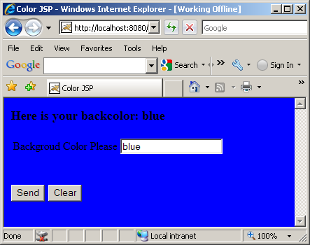

There are few things to notice above. There is no “Action” attribute of the FORM tag. What that means is that the page will call itself everytime you submit – this has nothing to do with jsp, that’s how form action works – if not specified returns itself. Variable “color” declared in one scriptlet are accessed from another scriptlet. That’s because all the scriptlets go into one _jspService() method. Also, notice that response remembers the color value from previous request. The trick to do this is to put it on the value of the input text box, to be specific, value=<%= color %> does the trick as follows:

<INPUT type="text" name="color" value=<%= color %> size=20>

Notice how Jsp Expressions (<%= … %>) are appearing within out.print and Jsp Scriplets (<% .. %>) are appearing as pure code within _jspService() method sequentially.

JSP Declarations <%! … %>
A JSP declaration lets you define fields and methods that gets inserted into the resultant servlet outside of the _jspService() method. Please keep in mind that the same instance of a servlet (generated from a JSP page) may be accessed by multiple clients (unless the servlet implements SingleThreadModel). Therefore, you have to careful about defining fields in a JSP page.

Here is a JSP page that counts the number of hits to the page.

hitcount.jsp

<HTML>
<HEAD><TITLE>JSP Declaration Demo</TITLE></HEAD>
<%! private int count=0; %>
<%
++count;
%>
<BODY><H3>This page has been visited: <%= count %> times </H3>
</BODY>
</HTML>

JSP Directives <%@ …. %>
A JSP Directive effects the overall structure of the servlet that results from the JSP page. A page directive looks as follows:

<%@ directivename attribute1=”value1” attribute2=”value2” ….. attributeN=”valueN” %>

Single quotes can be used instead of double quotes but can not be omitted altogether. To obtain quote marks you have to use \” (slash as the escape character).

In JSP there are three types of directives:

- page
- include
- taglib

The Page Directive <%@ page …. %>
The page directive lets you control the structure (and behavior) of the servlet. The page directive has the following attributes:

Attribute | Description | Default Value
language | Defines the scripting language to be used in the JSP page. This attribute is for future use when JSP supports multiple language. | “Java”
extends | This value is a fully qualified class name of the superclass that the generated servlet class should extend from. In general, you can’t use it since the container has to subclass certain class already. In case of Tomcat, it subclasses HttpJspBase class. | Omitted by default.
import | Comma separated list o packages or classes that you would like to import for convenience. | Omitted by default.
session | Specifies whether the page participates in session. When is value is true(default) a variable names session is available and can be used to access the session. | “true”
buffer | Specifies the buffering model for the output. If the value is “none”, then no buffering occurs and the all output is written directly to the response. | Depends on container – at least 8 KB.
autoFlash | If “true” the output buffer to the client is flushed automatically when it is full. If “false” a runtime exception is raised to indicate that buffer overflow. | “true”
isThreadSafe | Defines the thread safety of the page. If the value is “true” the JSP engine can send multiple client request to the same instance of the of the page servlet. | “true”
Info | Defines information string that can be retrieved from the servlet’s getServletInfo() method | Omitted by default.
errorPage | Defines the URL of another page, which is included if an unchecked runtime exception is thrown. The page catches the exception and passes it to the error processing page. | Omitted by default.
isErrorPage | Indicates if the current page itself is intended to be the error page of another page. If “true” an implicit variable exception is available that has the runtime exception information. | “false”
ContentType | Defines the MIME type and character encoding of the JSP page. | The default value for the MIMETYPE is text/html and the default value for the CHARSET is ISO-8859-1.

Here is a page that uses all of the above page directives:

number.jsp
<%@ page language="Java" import="java.util.*,java.math.*" session="true" buffer="12kb"
autoFlush="true" isThreadSafe="true" info="'My test page" errorPage="error.jsp"
isErrorPage="false" contentType="text/html;CHARSET=ISO-8859-1"%>
<HTML>
<HEAD><TITLE>Number JSP</TITLE></HEAD>
<%
String number = request.getParameter("number");
boolean found=true;
if (number==null){
found=false;
number="";
}

%>
<BODY>
<%
if (found){
int num=0;
num=Integer.parseInt(number);

// If I make it here - no number format exception.
out.println("<H3>Here is your number: " + num + "<H3>");
}
%>
<FORM method="GET">
<TABLE>
<TR>
<TD>Please enter a number</TD>
<TD><INPUT type="text" name="number" value="<%= number %>" size=20></TD>
</TR>
</TABLE>
<BR><BR>
<INPUT type="submit" name="send" value="Send"> <input type="reset" value="Clear">
</FORM>
</BODY>
</HTML>

Here is error.jsp
<%@ page language="Java" session="true" buffer="12kb" autoFlush="true" isThreadSafe="true"
info="'My error page" isErrorPage="true" contentType="text/html;CHARSET=ISO-8859-1"%>
<HTML>
<HEAD><TITLE>Error JSP</TITLE></HEAD>
<BODY>
<H3>Error: <%=exception.toString() %></H3>
</BODY>
</HTML>

If you enter a non non-numeric value you will get the content of error.jsp. Unfortunately, IE does not show the error correctly, please use firefox to see it. Of course Fiddler2 shows the return content.

Limitation of Page Directive
We want to generate Excel spreadsheet by specifying content type as application/vnd.ms-excel only if the browser supports Excel and by formatting the content as HTML table. Excel can present HTML table as Excel table. But page attribute values can not be computed at run-time, nor can page directives be conditionally inserted. Here is the work-around:

excel.jsp
<%@ page import="java.util.*" %>
<%
boolean excel=true;
String accept=request.getHeader("Accept");
if (accept==null){
excel=false;
}
else{
if (accept.indexOf("ms-excel")>= 0){
excel=true;
}
}
if (excel){
response.setContentType("application/vnd.ms-excel");
}
%>
<HTML>
<HEAD><TITLE>Excel JSP</TITLE></HEAD>
<BODY>
<TABLE BORDER="1">
<TR><TH>&nbsp</TH><TH>Grades</TH><TH>&nbsp</TH></TR>
<TR><TH>Name</TH><TH>Assignment 1</TH><TH>Assignment 2</TH></TR>
<TR><TD>John Smith</TD><TD>10</TD><TD>9</TD></TR>
<TR><TD>Bill Bond</TD><TD>10</TD><TD>10</TD></TR>
<TR><TD>Sue Lee</TD><TD>9</TD><TD>10</TD></TR>
</TABLE>
</BODY>
</HTML>

Here is the output:

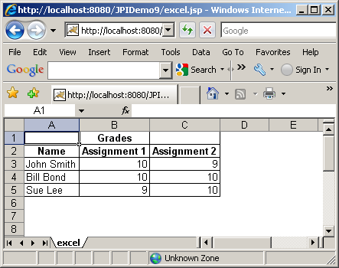

The taglib Directive <jsp: …. >
The taglib directive allows the page to use custom tags on a JSP page. The taglib directive will be discussed later in details along with custom tags.

Standard Actions
Standard actions are tags that affect the runtime behavior of the JSP and the response sent back to the client. Effectively, a standard action is a tag that can be embedded in a JSP page. During compilation into a servlet, the container comes across this tag and replaces it with Java code that corresponds to the required predefined task.

The standard action types are:

- <jsp:useBean>
- <jsp:setProperty>
- <jsp:getProperty>
- <jsp:param>
- <jsp:include>
- <jsp:forward>
- <jsp:plugin>

<jsp:useBean>, <jsp:setPropety> and <jsp:getProperty> will be discussed later with JavaBean.

<jsp: param>
The <jsp:Param> action is used to provide other tags with additional information in the form of name-value pairs. It is used with <jsp:include>, <jsp:forward>, <jsp:plugin> actions as shown below. The syntax is:

<jsp:param name=”paramname” value=”paramvalue”/>

<jsp:include>
This action allows a static or dynamic resource, specified by a URL, to be included in the current JSP at request processing time. An included page has access to only the JspWriter object, and it can not set headers or cookies. The included file can not contain other JSPs but itself can contain JSP contents. This action internally uses RequestDispatcher’s include() method, which is what servlet uses. The syntax is:

<jsp:include page=”pagename” flush=”true”/>

or

<jsp:include page=”pagename” flush=”true”>
<jsp:param name=”paramname” value=”paramvalue”/>
</jsp:include>

The attributes of the <jsp:include> action are:

Attribute | Description
page | The page to be included.
flush | The buffer in the output stream is flushed before the inclusion is performed. In JSP 1.1 this value must always be “true”

A <jsp:include> action may have one or more <jsp:param> tags in its body, providing additional name-value pairs. The included page can access the original request object, which will contain both original parameters, and the new parameters specified using <jsp: param> tag. If the parameter names are the same, the old values are kept intact, but the new values take precedence over the existing values.

Here is a jsp that uses <jsp:include>:
jspincludedemo.jsp
<%@ page language="java" contentType="text/html; charset=ISO-8859-1"
pageEncoding="ISO-8859-1" import="java.util.Date"%>
<!DOCTYPE html PUBLIC "-//W3C//DTD HTML 4.01 Transitional//EN" "http://www.w3.org/TR/html4/loose.dtd">
<html>
<head>
<meta http-equiv="Content-Type" content="text/html; charset=ISO-8859-1">
<title> JSP Include Demo</title>
</head>
<body>
<jsp:include page="runtime.jsp" flush="true" />
<p>
This line is included at response time.
<p>
The Current Server Date and Time is <%=new Date() %> (From jspincludedemo.jsp)
</body>
</html>

Here is the included page:
runtime.jsp
<%@ page language="java" contentType="text/html; charset=ISO-8859-1"
pageEncoding="ISO-8859-1" import="java.util.Date" %>
This line is included at run time.
<p>
The Current Server Date and Time is <%=new Date() %> (From runtime.jsp)
Here is the output:

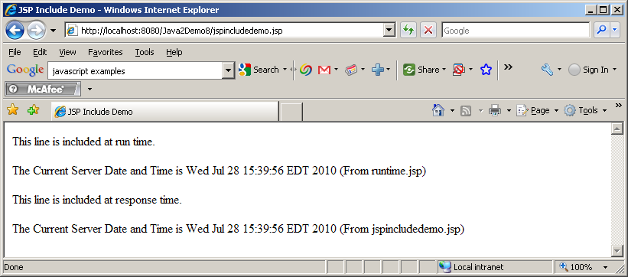

<jsp:forward>
This action allows the request to be forwarded to another JSP, to a servlet, or to a static HTML page. specified by a URL. This action internally uses RequestDispatcher’s forward() method, which is what servlet uses. The resource to which the request is being forwarded must be in the same context as the JSP dispatched the quest. Execution in the current JSP stops when it encounters a <jsp:forward> tag, the buffer is cleared, and the request is forwarded. The syntax is:

<jsp:forward page=”pagename”/>

or

<jsp:forward page=”pagename”>
<jsp:param name=”paramname” value=”paramvalue”/>
</jsp:forward>

Here is a jsp that uses <jsp:forward>:

jspforwarddemo.jsp
<%@ page language="java" contentType="text/html; charset=ISO-8859-1"
pageEncoding="ISO-8859-1" import="java.util.Date"%>
<!DOCTYPE html PUBLIC "-//W3C//DTD HTML 4.01 Transitional//EN" "http://www.w3.org/TR/html4/loose.dtd">
<html>
<head>
<meta http-equiv="Content-Type" content="text/html; charset=ISO-8859-1">
<title> JSP Include Demo</title>
</head>
<body>
This is the original page.<br/>
The Current Server Date and Time is <%=new Date() %> (From jspforwarddemo.jsp)
<jsp:forward page="next.jsp" />
</body>
</html>

Here is next.jsp where it forwards:
next.jsp

<%@ page language="java" contentType="text/html; charset=ISO-8859-1"
pageEncoding="ISO-8859-1" import="java.util.Date" %>
This is the next page.
<p>
The Current Server Date and Time is <%=new Date() %> (From next.jsp)

Here is the output:

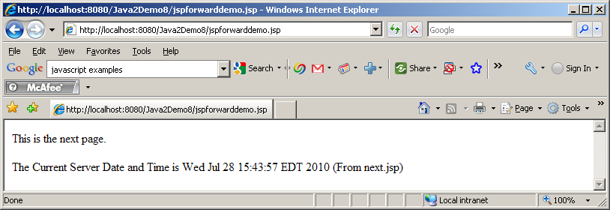

Notice that the output from the original jsp disappeared. That’s ‘cause the buffer is cleared

JSP Tags
JSP 1.1 introduced a very significant new feature, the ability to define your own tags – custom tags. These tags look like HTML (or rather XML) tags embedded in a JSP page. You define how these tags, their attributes and their bodies are interpreted (using Java code), then group these tags into collections – called tag libraries – and use them in any JSP page. These special tags are handled by the JSP engine at translation time to provide the functionality they are intended for. The ability to define tags in this way to embed complex server-side functionality into simple easy-to-use page level elements is very significant. This allows a clean separation of duty between the middle-tier developers and the presentation-tier HTML developers.

In many respect, custom tags accomplish many functionality that beans do. However, there are several differences:

- Custom tags manipulate JSP content – beans can not.
- Complex presentation can be greatly simplified using custom tags than beans.
- Beans are often setup in one page and used in subsequent pages but custom tags are usually self-contained.
- Custom tags, in general, are more reusable in nature than beans.

In order to understand the concept of custom tag, let’s look at the <jsp:forward> action provided by the JSP specification. It can be invoked with the following syntax:

<jsp:forward page=”pagename”/>

or

<jsp:forward page=”pagename”>
<jsp:param name=”ParameterName” value=”ParameterValue”> Hi there </jsp:param>
</jsp:forward>

Now, consider the fact that you can define your own custom tag <nyu:forward> which allows you define your version of forward functionality. That’s exactly what custom tags allow you to do.

Before we go any further, let’s try to understand some of the key concepts in tags:

Tag Name: A JSP tag is identified by a combination of prefix(in the above example “jsp” or “nyu”) and suffix(in the above example “forward”), separated by a colon.

Tag Attributes: Tags may have one or more attributes, which use XML syntax. The <jsp:forward> tag has one attribute “page” whereas the <jsp:param> tag has two “name” and “value”

Nesting: A tag can be nested within another tag. In the above example, <jsp:param> tag is nested within <jsp:forward> tag. Tags can detect nested tags at runtime and cooperate. A tag directly enclosing another tag is called the parent of the tag it encloses. In the above example, <jsp:forward> is the parent tag of <jsp:param>.

Body content: This is anything between the start and end elements in a JSP tag, excluding nested tags. A custom tag can access and manipulate its body content – an extremely powerful and useful concept. In the above example there is no body content. Consider the following example, the body content is shown in bold:

<nyu:message>
How are you?
</nyu:message>

Creating your own Tags
In order to use your own custom tag in a JSP file, you have to do the following:

- Write a Java class – known as tag handler - that implements Tag interface or better yet, a class that implements IterationTag Interface which extends Tag interface. This is usually accomplished by extending TagSupport class.

In some cases you have to implement BodyTag interface. This is usually accomplished by extending BodyTagSupport class.

- Associate your tag handler java class with a tag name. This task is accomplished by creating a tag library descriptor file – an XML file. A tag library can and normally do, store java class to tag name association for more that one tag.

Once the above two steps are done, any JSP page can use the tag.

Tag Interface
The tag interface defines a simple interaction between the JSP engine and the tag handler, sufficient for tags that do not need to manipulate their body. Here are the methods of Tag interface:

setPageContext(PageContext pc) | void | Set the current page context.
SetParent(Tag t) | void | Set the parent (closest enclosing tag handler) of this tag handler.
GetParent() | Tag | Get the parent (closest enclosing tag handler) for this tag handler.
doStartTag() | int | Process the start tag for this instance.
doEndTag() | int | Process the end tag for this instance.
release() | void | Called on a Tag handler to release state.

Here is how a JSP engine interacts with a tag handler:

- The JSP engine initializes the tag handler by setting the tag handler’s pageContext property, which the tag handler uses to access information about the JSP that is currently using the tag.
- The JSP engine sets the tags parent property (which is set to null if the tag is not nested)
- The JSP engine sets the tag attributes defined by the tag developer.
- The JSP engine calls the doStartTag() method of the tag handler. This method is called when the JSP engine encounters the opening of a tag at run time. The return value of this method is very important – the return value directs what to do with the body of the tag. There are only two possible return values defined as constants in Tag interface:
  - EVAL_BODY_INCLUDE – instructs the JSP engine to evaluate both the tag’s body and any child tags it has. This constant must be used if you have tag body (regardless whether is needs to be evaluated or not) as follows:
<prefix:tagname>
Some tag body here
</prefix:tagname>

  - SKIP_BODY – instructs the JSP engine to ignore the body. This return value should be used with caution since it will ignore the body content of tag completely.
If the Tag Library Descriptor file indicates that the action must always have an empty action, by an <body-content> entry of "empty", then the doStartTag() method must return SKIP_BODY. Otherwise, the doStartTag() method may return SKIP_BODY or EVAL_BODY_INCLUDE.

- The JSP engine calls the doEndTag() method of the tag handler. This method is called when the JSP engine encounters the closing of a tag at run time. The return value of this method is also very important not so much for the tag itself but for the rest of the JSP page. There are two possible return values defined as constants in Tag interface:
  - EVAL_PAGE – instructs the JSP engine to evaluate the rest of the JSP. Recommended to be used.
  - SKIP_PAGE – instructs the JSP engine to ignore the rest of the JSP. This return value should be used with caution since it has the possibility of returning a very incomplete page.

- The JSP engine calls the release() method to release any resources. Once all invocations on the tag handler are completed, the release method is invoked on it. Once a release method is invoked all properties, including parent and pageContext, are assumed to have been reset to an unspecified value. The page compiler guarantees that release() will be invoked on the Tag handler before the handler is released to the GC.

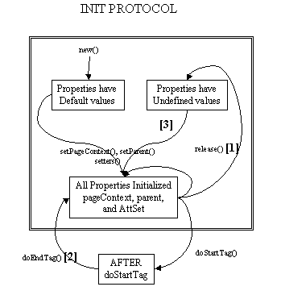

IterationTag Interface
The IterationTag interface extends Tag by defining one additional method doAfterBody() and a constant EVAL_BODY_AGAIN - that controls the reevaluation of its body.
The doAfterBody() method is invoked after every body evaluation to control whether the body will be reevaluated or not. If doAfterBody() returns EVAL_BODY_AGAIN, then the body will be reevaluated. If doAfterBody() returns SKIP_BODY, then the body will be skipped and doEndTag() will be evaluated instead.

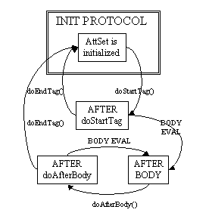

TagSupport Class
Tag handler that either have no body or that merely includes the body as is - should extend the TagSupport class. This is a built-in class in the javax.servlet.jsp.tagext package. This is a utility class intended to be used as the base class for new tag handlers. TagSupport implements the IterationTag interface (hence Tag interface) and contains the standard functionality that a basic tag could need. TagSupport has additional convenience methods including getter methods for the properties in Tag. TagSupport has one static method that is included to facilitate coordination among cooperating tags. Here are the convenience methods added in TagSupport class:

setId(String id) | Void | Set the id attribute for this tag.
getId() | String | The value of the id attribute of this tag; or null.
setValue(String k, java.lang.Object o) | Void | Associate a value with a String key.
getValue(String k) | Object | Get a the value associated with a key.
getValues() | Enumeration | Enumerate the values kept by this tag handler.
removeValue(String k) | Void | Remove a value associated with a key.
findAncestorWithClass(Tag from, java.lang.Class klass) | Static Tag | Find the instance of a given class type that is closest to a given instance.

Because of the other classes you will use, your tag handler should normally import classes in javax.servlet.jsp and java.io packages as well.

Please include jsp-api.jar from tomcat’s common\lib folder.

Here is a simple example of my tag handler:

package tags;
import javax.servlet.jsp.tagext.*;
import javax.servlet.jsp.*;
import java.io.*;
public class TestTag extends TagSupport{
private static final long serialVersionUID = 1L;

public int doStartTag(){
try{
JspWriter out = pageContext.getOut();
out.println("<B><FONT color=red>This line is from doStartTag method.</FONT></B><BR>");
}
catch(IOException e){
System.out.println(e);
}
return (EVAL_BODY_INCLUDE);
}
public int doEndTag(){
try{
JspWriter out = pageContext.getOut();
out.println("<B><FONT color=red>This line is from doEndTag method.</FONT></B><BR>");
}
catch(IOException e){
System.out.println(e);
}
return (EVAL_PAGE);
}
public int doAfterBody(){
try{
JspWriter out = pageContext.getOut();
out.println("<B><FONT color=black>This line is from doAfterBody method.</FONT></B><BR>");
}
catch(IOException e){
System.out.println(e);
}
return (SKIP_BODY);
}
}

Tag Library Descriptor File
The Tag Library Descriptor or TLD is a XML document with a .tld extension that describes one or more custom tags in one place. The general format of a tag library descriptor file is always the same:

- It should contain an XML version identifier followed by a DOCTYPE declaration followed by a taglib element. The taglib element has the following elements (besides tag elements):
  - tlibversion: is the version defined by the tag author.
  - jspversion: is the version of JSP specification the tag library depends on. This value should 1.2 for now. The element is optional.
  - shortname: is a simple short name that could be used by the JSP authoring tool.
  - uri: is an optional URI uniquely identifying this tag library.
  - info : is an arbitrary text string describing the tag library.
- One or many tag elements nested within the taglib element. The tag element has the following elements:
  - name: is the name that will identify this tag (used with tag library prefix)
  - tagclass: is the fully qualified name of the tag handler class
  - teiclass: is the fully qualified class that will provide extra information about the tag at runtime. Not all tags require this.
  - bodycontent: is the optional body content element specifying the type of body content the tag should have. Three values are legal:
    - JSP (default): means that the tag’s body content will be evaluated at run time like any other JSP content.
    - tagdependent: signifies that the JSP engine should not attempt to evaluate it but should pass it as is.
    - empty: means the tag should not have any body content – if it does, JSP translation will fail.
  - info: is an arbitrary text string describing the tag.

Here is a simple example of my tag library descriptor for my tag handler:

testtaglib.tld
<?xml version="1.0" encoding="ISO-8859-1" ?>
<!DOCTYPE taglib
PUBLIC "-//Sun Microsystems, Inc.//DTD JSP Tag Library 1.1//EN"
"http://java.sun.com/j2ee/dtds/web-jsptaglibrary_1_1.dtd">

<!-- a tag library descriptor -->

<taglib>
<tlibversion>1.0</tlibversion>
<jspversion>1.2</jspversion>
<shortname>testtaglib</shortname>
<uri></uri>
<info>A simple tab library for the examples</info>

<tag>
<name>testtag</name>
<tagclass>tags.TestTag</tagclass>
<bodycontent>JSP</bodycontent>
<info>Display doStartTag() and doEndTag()</info>
</tag>
</taglib>

Create a folder “tlds” under WEB-INF folder of your application and copy is file to the folder.

Using Custom Tags in JSP Pages
Custom tags must be explicitly imported into JSP pages that wish to use them. The syntax is as follows:

<%@ taglib uri=”TagLibDescriptorURI” prefix=”TagLibPrefix” %>

The uri attribute tells the JSP engine where to find the TLD for the tag library. The prefix is the short name of the TLD file that will be used throughout the JSP.

A JSP can import any number of tag libraries.

Once the tag library is imported into the page, tags in the library can be called as follows:

<prefix:name>
Tag Body content
</prefix:name>
or
<prefix:name/>

Here is an example of a JSP page that uses my tag:

tagtester.jsp
<%@ page language="java" contentType="text/html; charset=ISO-8859-1"
pageEncoding="ISO-8859-1"%>
<%@ taglib uri="/WEB-INF/tlds/testtaglib.tld" prefix="testlib" %>
<!DOCTYPE html PUBLIC "-//W3C//DTD HTML 4.01 Transitional//EN" "http://www.w3.org/TR/html4/loose.dtd">
<html>
<head>
<meta http-equiv="Content-Type" content="text/html; charset=ISO-8859-1">
<title>Insert title here</title>
</head>
<body>
<B><FONT color=blue>This line is before the start tag.</FONT></B><BR>
<testlib:testtag>
<B><FONT color=green>This line is in the body of the tag.</FONT></B><BR>
</testlib:testtag>
<B><FONT color=blue>This line is after end tag.</FONT></B><BR>
</body>
</html>

Here is the output:
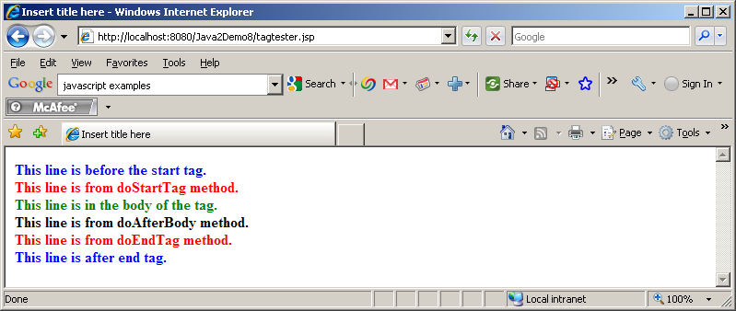

Let’s change the doStartTag() to return SKIP_BODY. Here is the output;

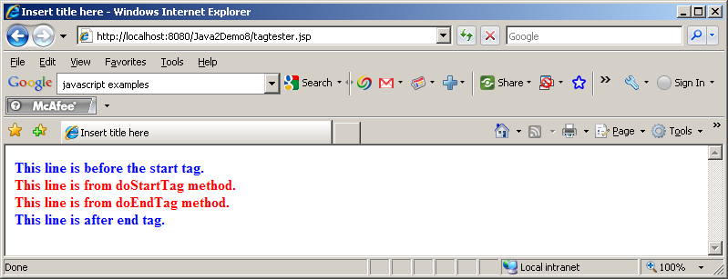
Notice, the tag body is missing in the above output. Also, the output from doAfterBody() is missing since doAfterBody() is only called if doStartTag does not return SKIP_BODY.

Now, let’s change the return of doEndTag() to SKIP_PAGE. Compile the tag class, stop and start Tomcat.

Here is the output:

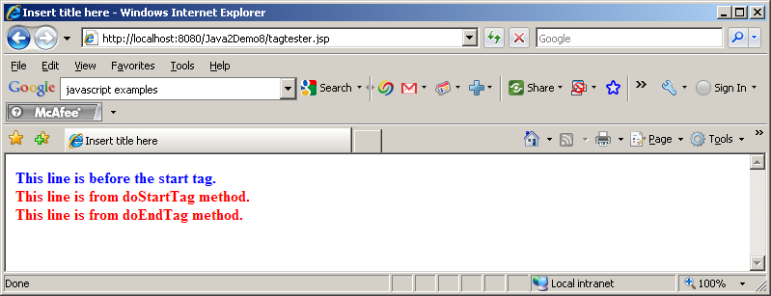

Homework Assignment
Break the code in RandomServlet from last week into a) RandomServlet b) random.jsp and c) randomerror.jsp

Break out the processing and presentation into Servlet and jsp respectively. The idea is, if there is input data validation error the request will be forwarded to randomerror.jsp which will display the error. Otherwise, random.jsp will display the random numbers.

