Gramian Angular Field (GAF)

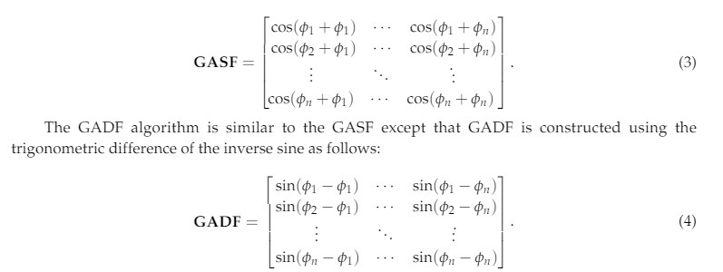

Summation 과 Difference 는

“ The Gramian matrix is then formed where each element is calculated by the cosine of the summed angles for GASF or the sine of the subtracted angles for the GADF”

계산 방법이 다르고

“The polar coordinates of the normalised time series in the[−1, 1]interval fall in the angle boundaries[0,π].

This provides different concentrations of informationin the GASF, which should beneﬁt any classiﬁcation task.”

이렇게 classification 에 Summation 이 효율적인 것 같아서 GASF 로 사용하시면 될 것 같습니다

<https://www.researchgate.net/publication/327661538_Imaging_Time_Series_for_the_Classification_of_EMI_Discharge_Sources>

위 논문에 4. Machine Learning Algorithms 4.1. Gramian Angular Field (GAF) 에 보면 자세히 설명 나와있습니다

작업환경 구성: pyts 설치 - pip install pyts