1 Download binary scala setup for kafka

Scala 2.12  - [kafka_2.12-3.8.0.tgz](https://downloads.apache.org/kafka/3.8.0/kafka_2.12-3.8.0.tgz) ([asc](https://downloads.apache.org/kafka/3.8.0/kafka_2.12-3.8.0.tgz.asc), [sha512](https://downloads.apache.org/kafka/3.8.0/kafka_2.12-3.8.0.tgz.sha512))

Scala 2.13  - [kafka_2.13-3.8.0.tgz](https://downloads.apache.org/kafka/3.8.0/kafka_2.13-3.8.0.tgz) ([asc](https://downloads.apache.org/kafka/3.8.0/kafka_2.13-3.8.0.tgz.asc), [sha512](https://downloads.apache.org/kafka/3.8.0/kafka_2.13-3.8.0.tgz.sha512))

2 Extract the setup and rename the folder as kafka containing bin

4 start the kafka server

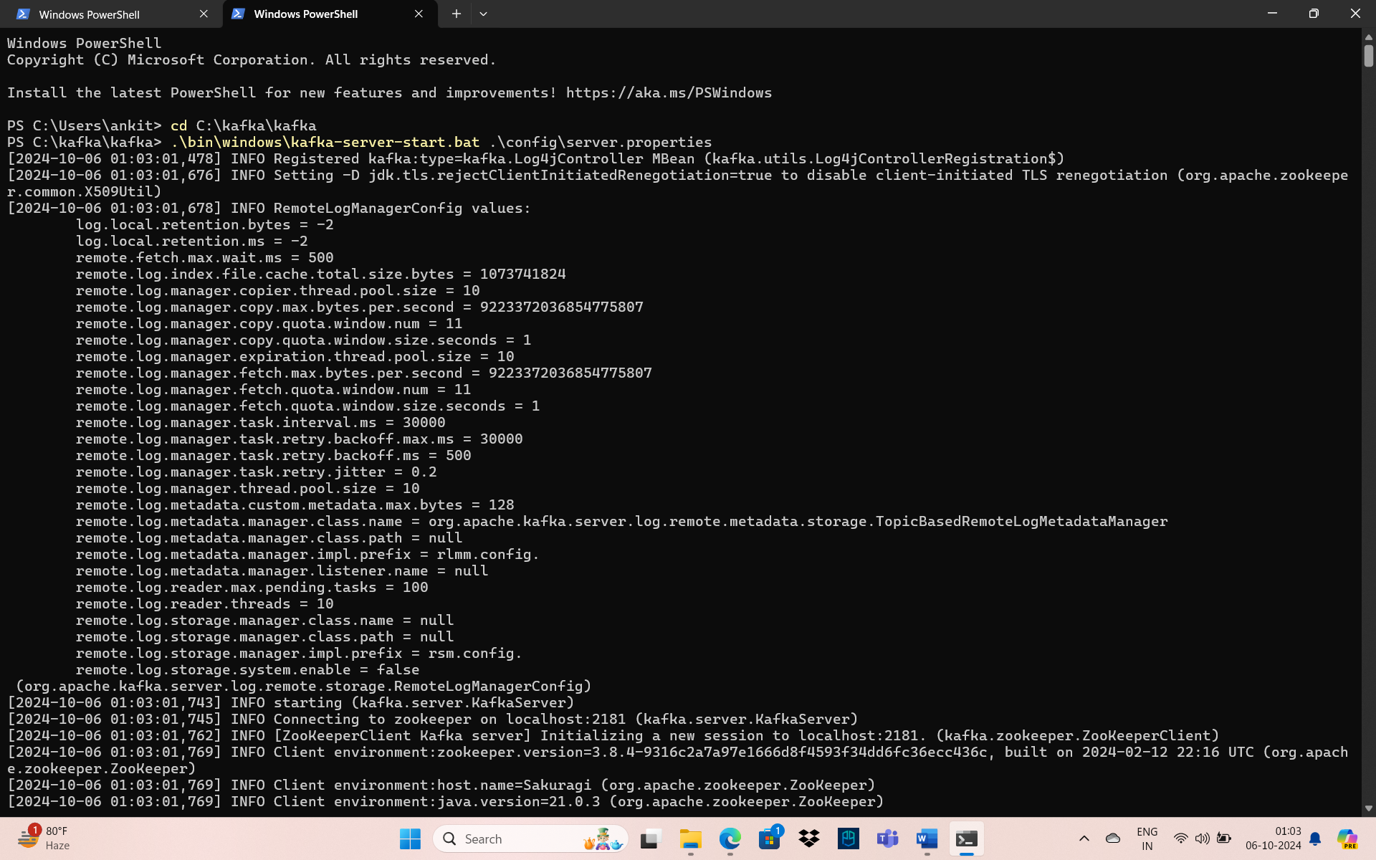

5 Give configuration for kafka server, producer and consumer. Create Producer, Consumer and Topic class inside project.

6 run the application.

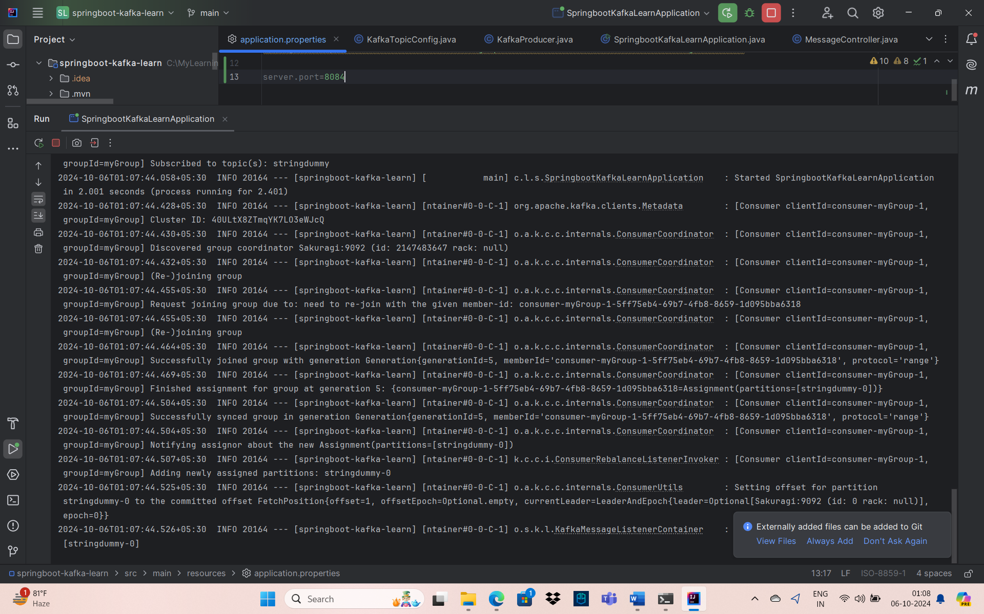

7 Call the rest endpoint.

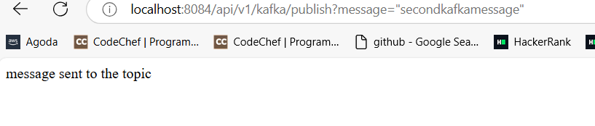

8 In Logging find the message sent through Kafka

