Koala Gaming Studio

**Design Document for:**

# Searching!

**The Most Unique Game**

“It’s always gone when you need it.”™

All work Copyright ©2014 by Koala Gaming Studio

Written by Edward Ho

Version # 2.10

Friday, September 26, 2014Table of Contents

Name of Game 1

Design History 5

Version 1.10 5

Version 2.00 5

Version 2.10 5

Game Overview 6

Philosophy 6

Philosophical point #1 6

Philosophical point #2 6

Philosophical point #3 6

Common Questions 6

What is the game? 6

Why create this game? 6

Where does the game take place? 6

What do I control? 6

How many characters do I control? 6

What is the main focus? 6

What’s different? 7

Feature Set 8

General Features 8

Multi-player Features 8

Editor 8

Game play 8

The Game World 9

Overview 9

World Feature #1 9

World Feature #2 9

The Physical World 9

Overview 9

Key Locations 9

Travel 9

Scale 9

Objects 9

Weather 9

Day and Night 9

Time 10

Rendering System 10

Overview 10

2D/3D Rendering 10

Camera 10

Overview 10

Camera Detail #1 10

Camera Detail #2 10

Game Engine 10

Overview 10

Game Engine Detail #1 10

Water 10

Collision Detection 10

Lighting Models 11

Overview 11

Lighting Model Detail #1 11

Lighting Model Detail #2 11

The World Layout 12

Overview 12

World Layout Detail #1 12

World Layout Detail #2 12

Game Characters 13

Overview 13

Creating a Character 13

Enemies and Monsters 13

User Interface 14

Overview 14

User Interface Detail #1 14

User Interface Detail #2 14

Weapons 15

Overview 15

Weapons Details #1 15

Weapons Details #2 15

Musical Scores and Sound Effects 16

Overview 16

Red Book Audio 16

3D Sound 16

Sound Design 16

Single Player Game 17

Overview 17

Single Player Game Detail #1 17

Single Player Game Detail #2 17

Story 17

Hours of Game-play 17

Victory Conditions 17

Multi-player Game 18

Overview 18

Max Players 18

Servers 18

Customization 18

Internet 18

Gaming Sites 18

Persistence 18

Saving and Loading 18

Character Rendering 19

Overview 19

Character Rendering Detail #1 19

Character Rendering Detail #2 19

World Editing 20

Overview 20

World Editing Detail #1 20

World Editing Detail #2 20

Extra Miscellaneous Stuff 21

Overview 21

Junk I am working on… 21

“XYZ Appendix” 22

“Objects Appendix” 22

“User Interface Appendix” 22

“Networking Appendix” 22

“Character Rendering and Animation Appendix” 22

“Story Appendix” 22

# Design History

This is what the studio’s working process. It shows which part the studio will work on each time. It’ll also tell what is added into the game.

## Version 1.10

Version 1.10 includes some tuning and tweaking that I did after making my initial pass at the design. Here is what I changed.

1. I rewrote the section about what systems the game runs on.
2. I incorporated feedback from the team into all parts of the design however no major changes were made.
3. Just keep listing your changes like this.

## Version 2.00

Version 2.00 added in stage 2 and 3.

## Version 2.10

Version 2.10 included stage 4 and more character information / story.

# Game Overview

## Philosophy

### Philosophical point #1

This game is trying to let players learn the main character’s life style and personality without having a pre story and narrators. Recently many games are having a massive story and have logs to pick up to understand the history of it. This game will revert these styles.

### Philosophical point #2

My game is made to help people learn how to find your lost items and always remember to not forget them. There are well many people lose their USBs and phone and etc. It is necessarily to help these hopeless people.

### Philosophical point #3

My goal of this game is to change the current game styles / level design. Games should not need to give backgrounds stories to tell what a character’s personality is. The level design of the character’s place shall tell how he/she is like.

## Common Questions

### What is the game?

This game is a search simulator game but with story. Players must find the item requested inside the area and within time in order to continue the story. Game also has arcade mode and multiplayer modes. Arcade mode does not have a story and just search for scores. Multiplayer modes have two styles of gameplay. 1) One team find items, another team hide items. 2) Players become items and have restricted movement rules, another team find them.

### Why create this game?

Creating simulator or unique games is a challenge for me. It’ll be an achievement to work on something hard. I do like these style of games where they are different than most of the other ones. The market of this style of games is special. As long as the game is fun to play, the game will get popular for a while.

### Where does the game take place?

This game takes place in a middle class family house in California. Players will get to be in different public places to look for things.

### What do I control?

Player will be controlling a girl from the family. With a first person view, player will use the regular WASD key to move and mouse to aim and pick up things.

### What is the main focus?

Basic story of this game is that main character is going to a friend meet, but before going she must find the basic needs. AKA: make up, car keys, wallet, purse, etc. Player will need to find all these things within time limit in the family house. The main focus is to search for things, which is a discovery game. Looking for things is not time consuming if player use logic. The game is supposed to help players getting used to finding things so they won’t have similar situations in real life.

### What’s different?

Recent games in the market are either driving simulator or shooting or rpg or horror. Horror is sharing the same characteristic towards this game I am making. But horror game generally does not require much of a scripting. The way current horror games are making way too much freedom for players to look for one time. It consumes player’s time getting lost and actually quits the game. Searching! Is a game that will require players to first learn around the environment. Learning the environment will make player understand the life style of the characters. Knowing the character will help player to guess where the item is.

# Feature Set

## General Features

4 Rooms

First person view

3D graphics

32-bit color

## Multiplayer Features

Up to 10 million players

Easy to find a game

Easy to find your pal in huge world

Can chat over voice link

## Editor

Custom editor to allow players drag and drop things for custom map

Allow players to add in custom map and game objects

## Gameplay

Unique level design to show how characters’ personalities are

Hidden pictures of main characters for achievements to unlock special level

Time limited searching

Indie!

Speedrun

Dramatic storyline

A lot of movable objects and active triggers

Increase intelligence

Search simulator

Heavy logic

# The Game World

## Overview

Searching! is a game at current time. Player is in a middle class family trying to have fun with her life.

## World Feature #1

With the great level design, player will have to understand the environment in order to get an idea where the items are.

## World Feature #2

Most of the objects can be interactive with player. Player sometime will have to move or pick up other things in order to get the objective. It has the maximum freedom for player to do most of the things inside mission area.

## The Physical World

### Overview

The physical world of Searching! is at modern time California. Main character will be hanging out locally around her neighborhood area.

### Key Locations

Describe the key locations in the world here.

### Travel

Most of the locations are indoor including home, friends’ homes, and library, etc. Player will not get to run around the city. They are only allowed to be in the mission area.

### Scale

Main character is a senior from highschool. The scale will be 1:1.

### Objects

Most of the objects at home will appear in game. They all will be allowed to pick up and throw or drop. Everything is interactive.

### Weather

Weather does not matter in this game because player will always be inside.

### Day and Night

There are missions during day time and night time. Some missions are required to turn off lights.

### Time

Time will be follow by storyline. It will not change until the mission completes.

## Rendering System

### Overview

Expect objects to look realistic! For more detail I would say it is similar to Half life 2. It does not require hardcore gaming systems.

### 2D/3D Rendering

3D models will mostly be created with 3ds Max.

## Camera

### Overview

It is a first person view game. You will expect to see your own character’s legs.

### Camera Detail #1

Camera will always following mouse cursor control.

### Camera Detail #2

Camera will move sometimes due to character’s movement.

## Game Engine

### 

### Overview

Searching! will be created by “Unity” with all custom scripts but uses default or asset store’s shaders.

### Game Engine Detail #1

Unity is very easy to use and mod. Modelers can change and move things in game to test affect and bugs. It shows clearly if scripts are not working.

### Water

There won’t be water in the world.

### Collision Detection

Unity handles collision very well unless player gets excessive speed, which is never.

## Lighting Models

### Overview

In order to make things not hard to see, there will be more light than usual to make life easier.

### Lighting Model Detail #1

We will add glowing shaders to objects that can be interact at close range.

### Lighting Model Detail #2

During night missions player shall at least still be able to tell what kind of objects or roads in front of them by using minimum lighting effects.

# The World Layout

## Overview

During the summer, main character seem to be bored so she decided to ask for a friends meet. Right before she jumps out she finds out she needs to get her stuffs. Because she is the event host and she also carpool others. She must not be late.

## World Layout Detail #1

At first player will get to search around her family home for phone/keys/etc. Main character is a very messy girl and many things are covered by her clothes and books. On the other hand, her brother has a clean room like hotel. Parent’s room is full of letters and papers. Living room is kind of messy as well. A bunch of girl magazines and workout machines are stuffed. Overall it’s a regular house but has a lot personality. Player must learn the environment in order to find objectives effectively.

## World Layout Detail #2

Many other missions will not be in the same house. Player will be all around the places like library, friend’s house, and karaoke. Different places will have different environment. Player must learn to adapt and find objectives.

Stage 1 - Home



Stage 2 – Karaoke Party



Stage 3 – Friend’s house



Stage 4 - Office

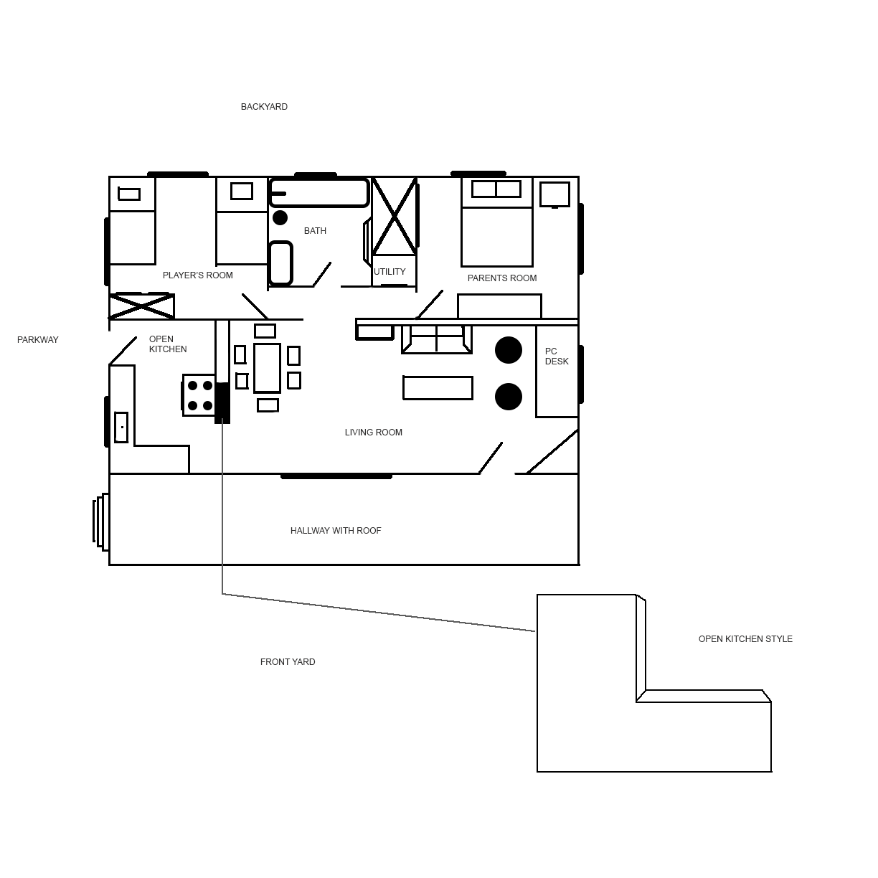

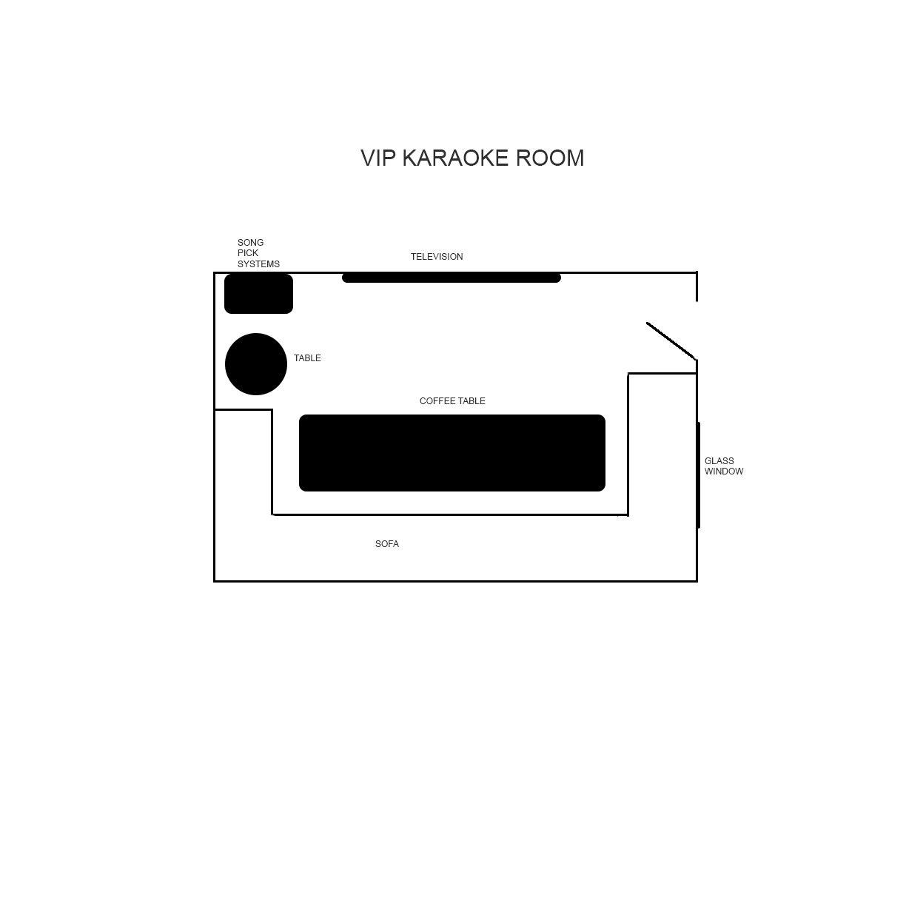

# Game Characters

## Overview

Main character, Jasmine, is a girl who likes to hang out and be beautiful. She does not care how she looks at home. All of her surroundings are quite messy. But she looks “clean” on the outside.

## Creating a Character

I create characters by getting ideas of my surrounding group of people. By studying unknown people at school helps me create all of the characters in game.

## Enemies and Monsters

There are no enemies or monsters, just a bunch of hidden objectives for you to find.

# User Interface

## Overview

Similar to other discovery games, there aren’t many UIs other than the main menu. But main menu will be interesting. It’s basically the main character picks up her cellphone, then it’ll show up the main menu or pause menu, however you call it.

## User Interface Detail #1

Cellphone main menu will appear in the middle. It uses modern interface similar to android’s system. Cellphone background will change upon mission levels.

## User Interface Detail #2

There will be another bar that is permanently on the right side of screen. It is the item bar, which shows what is needed to find and how many is required. It’s like a shortcut toolbar with all the objective icons showing.

# Weapons

## Overview

There are no weapons needed for this game.

## Weapons Details #1

## Weapons Details #2

# Musical Scores and Sound Effects

## Overview

This should probably be broken down into two sections but I think you get the point.

## Red Book Audio

If you are using Red Book then describe what your plan is here. If not, what are you using?

## 3D Sound

Talk about what sort of sound APIs you are going to use or not use as the case may be.

## Sound Design

Take a shot at what you are going to do for sound design at this early stage. Hey, good to let your reader know what you are thinking.

# Single-Player Game

## Overview

Searching! is a game that requires player to understand the surroundings and quickly guess where the possible locations of the objectives. On single player mode, player will learn the character and her life style by playing the story through.

## Single Player Game Detail #1

Player will start in character’s home looking for outdoor requirements within a limit of time. Successfully finding all items will get into movie and end stage, getting into another.

## Single Player Game Detail #2

If player is unsuccessful to find items, stage will restart and requirements to spawn in other places.

## Story

During the summer, main character seem to be bored so she decided to ask for a friends meet. Right before she jumps out she finds out she needs to get her stuffs. Because she is the event host and she also carpools others. She must not be late.

After finding all the outdoor requirements, she went out with her rich friends to a booked karaoke place. Party ends, she wants to find all her outdoor requirements back and gifts from friends. She is very drunk so finding must not be easy.

Main character is too drunk to drive, so she called one of her male friend picked her up from party, but instead of driving her home, her friend decides to bring her to his house for “surprise.” After main character awakes she knows something is not right. She hears her friend is taking bath, so she must get away before he finishes.

## Hours of Gameplay

This game can take up to 30 hours to finish, upon the players logic.

## Victory Conditions

Game will end by finishing the objectives, which is look / search for items.

# Multiplayer Game

## Overview

It is not a multiplayer game for now.

## Max Players

Maximum player is one.

## Servers

No server.

## Customization

No multiplayer.

## Internet

For now game will not be online.

## Gaming Sites

There are so far no gaming sites because it is an indie game. It will be on sale in steam.

## Persistence

Describe if your world is persistent or not.

## Saving and Loading

Game will be saved automatically on every beginning of the mission and after missions complete.

# Character Rendering

## Overview

You will only be able to see your character’s leg the whole gameplay. Other characters will only appear during cut scenes. All the Rendering and cut scenes will be work on in Maya.

## Character Rendering Detail #1

## Character Rendering Detail #2

# World Editing

## Overview

Provide an overview about the world editor.

## World Editing Detail #1

## World Editing Detail #2

# Extra Miscellaneous Stuff

## Overview

Drop anything you are working on and don’t have a good home for here.

## Junk I am working on…

Crazy idea #1

Crazy idea #2

# “XYZ Appendix”

Provide a brief description of what this appendix is for and then get down to business and provide data to the reader.

Here are a few examples of some of the appendices in my latest design…

# “Objects Appendix”

# “User Interface Appendix”

# “Networking Appendix”

# “Character Rendering and Animation Appendix”

# “Story Appendix”

Okay, that’s it. I wanted to spend more time on this and really make it a great roadmap for putting a game design together. Unfortunately it would take a ton of time and that is something that we don’t have enough of in this business. I think you get the idea anyhow. Also, don’t get the impression that I think a design should provide the information in any particular order, this just happened to be the way it fell out of my head when I sat down.

Good luck and all that!

Mark Soderwall