Tongji-KNU Global Capstone Design Project (Proposal 1)

**Project Title:**

Beacon Localization Using Beacon Sensors with Drone

**Project Period:**

2016.3.1. ~ 2016.6.30. (4 months)

**Project Advisor:**

Name: Ho-Kyoung Lee (Professor)

Affiliation : KNU/CSE

E-mail: [hokyounglee@knu.ac.kr](mailto:hokyounglee@knu.ac.kr)

**Background:**

* Recently, the beacon-based technology is spotlighted to prevent missing children, pets and things

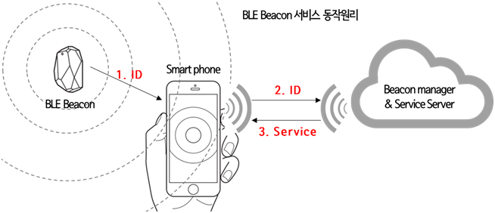

* Beacons technology can be used for indoor positioning because it can determine the location of a given target beacon in the number of meters away.

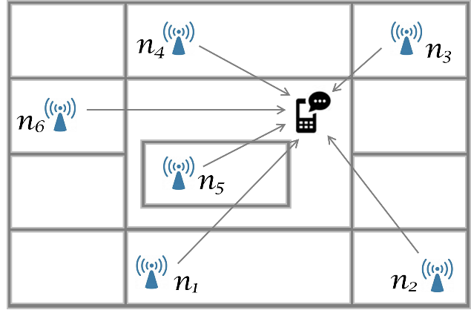

* Crowd GPS technology is a technique for positioning a target beacon in the outdoors using the smart phone of the members who subscribed the crowd GPS service.

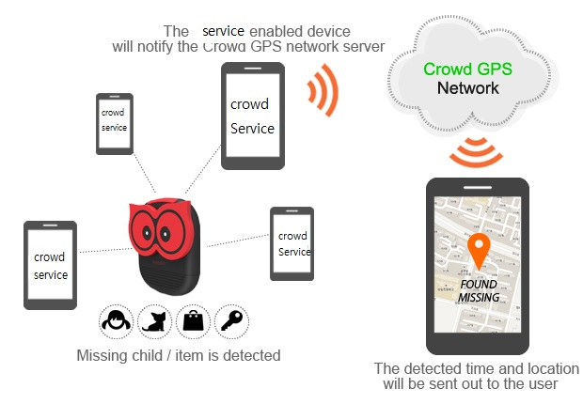

* When positioning using Crowd GPS system, if there are not any members around the target beacon then you can’t identify the location of it.

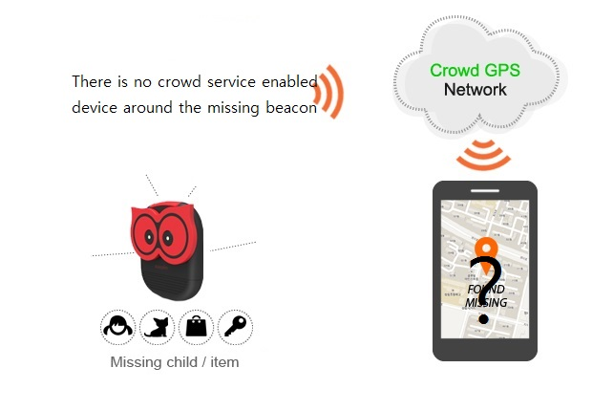

* If you have a portable beacon sensor which forms of drone or car,
  + you can keep up with the moving target which equipped with a beacon.
  + you could find missing children, pets of things equipped with a target beacon, by investigating a predictable area.

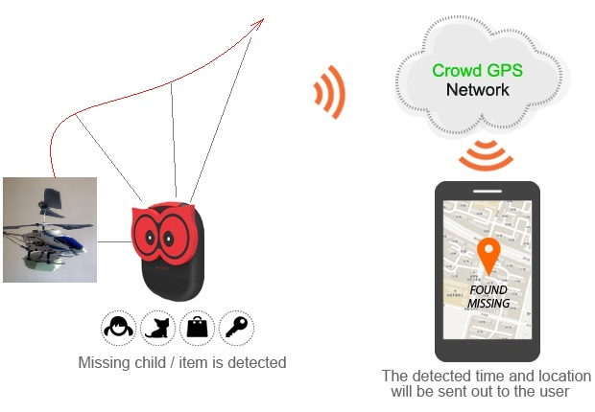

**Project Objectives:**

* Construction of a drone or a radio-controlled car which equipped with iBeacon sensor, which can follow a given iBeacon and can calculate the distance from a given beacon.

**+**

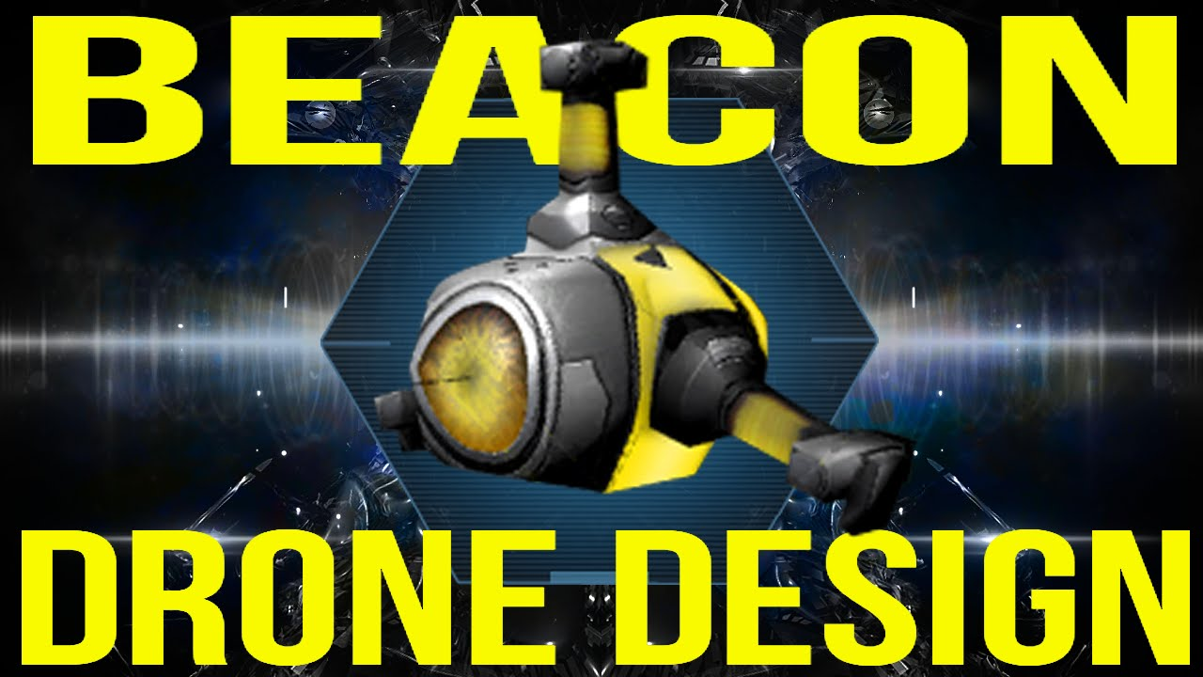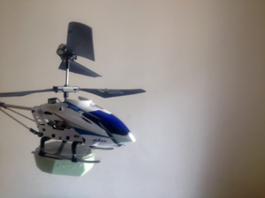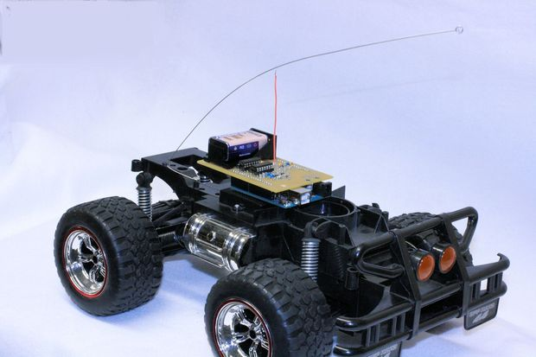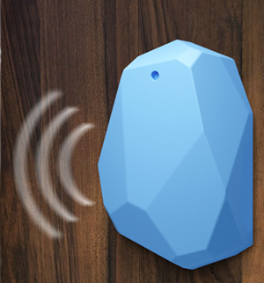

* If you want to locate a lost beacon, you could search expected area systematically using the developed mobile beacon sensor.
* Development of serve which can collect and can calculate the location of target beacon using the information collected by developed mobile type beacon sensor.
* Development of smart-phone applications which can view the location of given target beacons.

**Project Schedule:**

Each work will be done with on-line cooperation between KNU and Tongji students.

* 2016. 3. 15: Team Configuration (KNU 3~4 students, Tongji 3~4 students)
* 2016. 3. 30: Submission of detailed work plan from students (by KNU and Tongji)
* 2016. 4. 30: 1st report on project progress (in each school) and coordination
* 2016. 5. 30: 2nd report on project progress (in each school) and coordination
* 2016. 6. 30: final report on project progress (in each school) and coordination
* 2016. 7. : Presentation of Project Outcome in KNU-Tongji Workshop

**Requirements (pre-requisites) for Students:**

* Describe the requirements or pre-requisites for students to perform this project
* For example, C/C++ programing skills, Experiences on Linux, Open Source SW, etc
* Any other special requirements, if any.