Tongji-KNU Global Capstone Design Project (Proposal 2)

**Project Title:**

IoT-based Intelligent Building for Smart Campus

**Project Period:**

2016.3.1. ~ 2016.6.30. (4 months)

**Project Advisor:**

Name: Anand Paul (Professor)

Affiliation : KNU/CSE

E-mail: [paul.editor@gmail.com](mailto:paul.editor@gmail.com)

**Background:**

* Smart building deliver useful building services that make occupants productive (e.g. illumination, thermal comfort, air quality, auto-power saving, disastrous event management, physical security, sanitation, and many more), as depicted in the following picture.

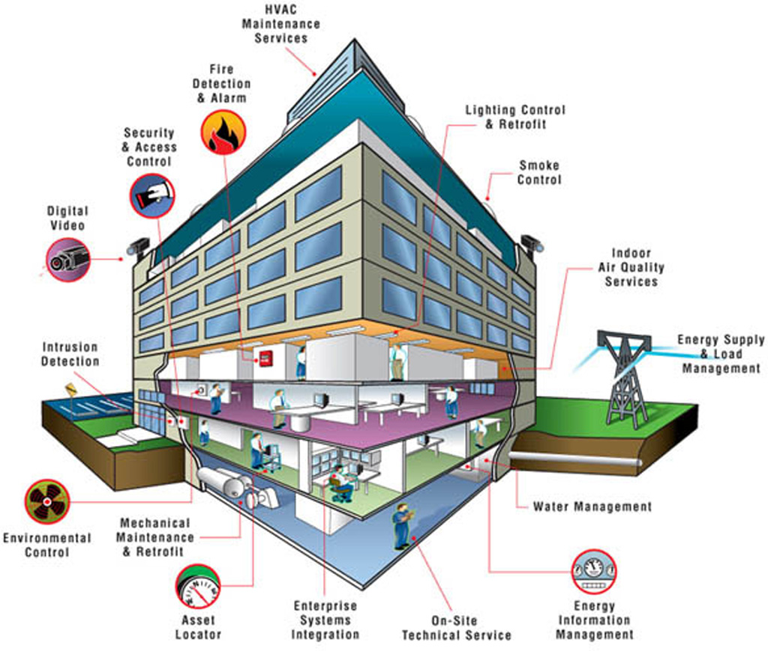

* This can be achieved with IoT devices, such as sensors, actuators, microcontrollers, which are connected to the internet by providing some Wi-Fi or cellular network Internet.

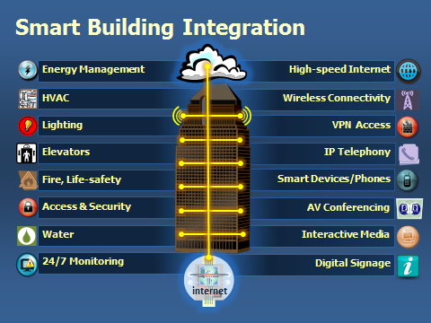

* Application (either web/android) is developed to control the building assets, such as lights, water, air-condition, and protecting other assets in case of fire or other mishaps.
* Video surveillance is also provided in the smart building to achieve the security.
* These facilities can be provided by integrating existing sensors with microcontroller over the Internet.
  + SAG-B0640/B1280: Network gateway controller (64M/128M) used to control monitor log, generate alarm, remotely send the data to the user application
  + SAC-B1612 BACnet: Programmable Controller (28-point) used to control the HVAC facilities including conditioner, refrigerator, boiler etc.
  + SAC-B0608 BACnet: Programmable Controller (14-point), Programmable controller for Rooftop Units, Fan coil Units, Chilled ceilings, Heat pumps, Unit ventilators and air conditioning units
* Similarly, there are a lot of other controllers used for various facilities. Moreover, there are existing sensors that measure the environment.
  + SAF-S0100/S0400: LCD Communicating Sensor (Temperature / Humidity) have Energy efficiency indicating with leaf icon for occupant's greener habit.
  + SAF-S0500: Adjustable Thermostat Sensor
  + Many More …

**Project Objectives:**

* The main objective of the whole project is to make an intelligent building system to achieve the smart university Campus. The system includes various modules, one for each functionality functionalities, using sensors connected to the microcontroller. As shown in the figure bellow.

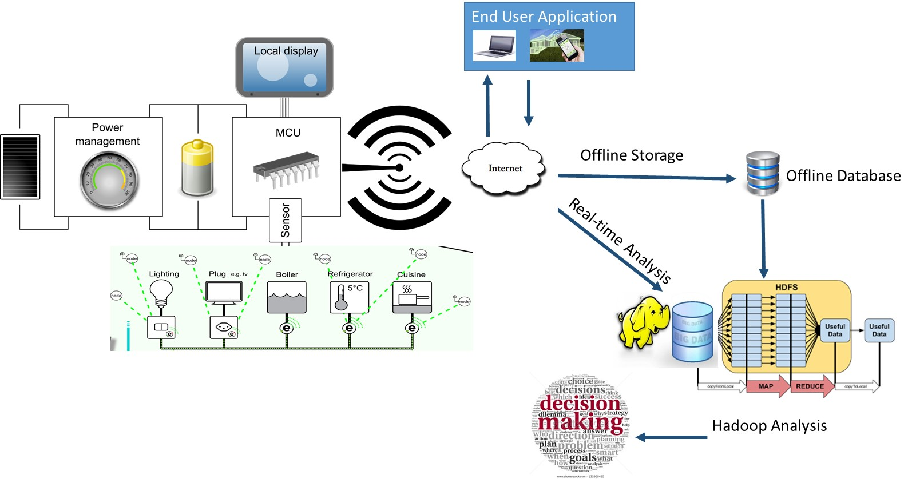

* The sensors monitor the building and send the data to the controller, which makes local decisions.
* The controller is the local processors, which makes the intelligent decision, which does not require massive computing.
* The data is sent the Hadoop server, which will analysis the data efficiently to make real-time/future decisions or planning.
* Overall, the system has the maximum facilities as mention in smart building figures background sections with the extension of real-time data generations and analysis using Hadoop ecosystem.
* The students are expected to perform hardware implementation and real-time data generation using Smart Home sensors and Microcontroller in order to achieve smart buildings. However, the ultimate goal also includes the real-time/offline analysis of smart building Data using Hadoop.
* The Students are also required to develop the user application to monitor and control his room/Lab within a building depending on his access rights. (as Smart Home does)
* The Intelligent Building should, at least, have the functionalities of
  + Control the assets such as lights, air-condition, fans, water, etc., to his room depending on his access rights using user application.
  + Energy consumption depending on the energy needed. (Auto switch on and off electrical appliances such as, air-condition, humidifiers, fire extinguishers, etc.
  + Intelligent management of disastrous events within the building such as, Fire detection and safety control. Auto alarm generation in case of such event within the building and to the remote applications as well.
  + Remote video monitoring. Depending upon user roles.

**Project Schedule:**

Each work will be done with on-line cooperation between KNU and Tongji students.

* 2016. 3. 15: Team Configuration (KNU 3~4 students, Tongji 3~4 students)
* 2016. 3. 30: Submission of detailed work plan from students (by KNU and Tongji)
* 2016. 4. 30: 1st report on project progress (in each school) and coordination
* 2016. 5. 30: 2nd report on project progress (in each school) and coordination
* 2016. 6. 30: final report on project progress (in each school) and coordination
* 2016. 7. : Presentation of Project Outcome in KNU-Tongji Workshop

**Requirements (pre-requisites) for Students:**

* Good programming and analytical skills
* C/C++ and Java programming skills, Experiences on Linux, Open Source SW, etc
* Knowledge of microcontroller, Wireless sensor networks.
* Hadoop implementation (optional).