Tongji-KNU Global Capstone Design Project (Proposal 3)

Project Title:
Tour Guide Application for International Travelers
Project Period:
2016.3.1. ~ 2016.6.30. (4 months)
Project Advisor:
Name: Ho-Kyoung Lee (Professor)
Affiliation : KNU/CSE
E-mail: hokyounglee@knu.ac.kr

Background:
- International travelers require a lot of information.
- The travel information scatters on the many web-sites, it is difficult to find the suitable travel information when you need.

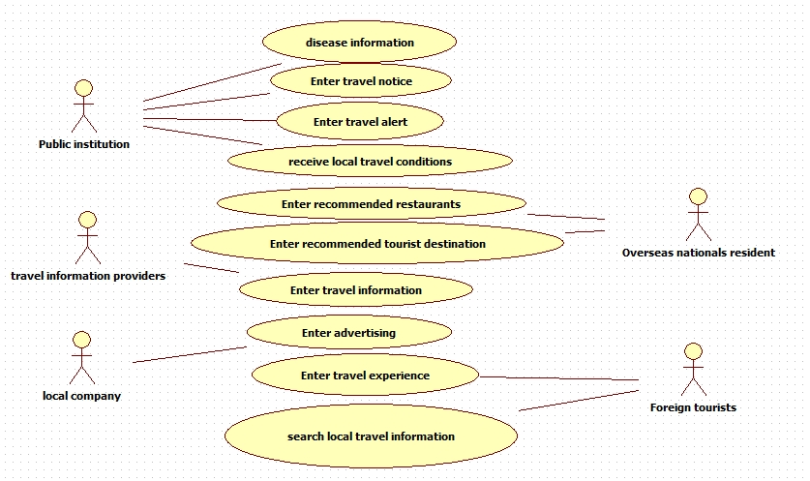
Project Objectives:
- Implementing a Web server which can input various kinds of information, including disease information, travel notices, travel alert, local travel condition, travel experience and various travel related information based on the travel area.
- Development of application which allows you to access the travel information about local area while traveling, via various terminals including web browser and smart phone.

Project Schedule:
Each work will be done with on-line cooperation between KNU and Tongji students.
- 2016. 3. 15: Team Configuration (KNU 3~4 students, Tongji 3~4 students)
- 2016. 3. 30: Submission of detailed work plan from students (by KNU and Tongji)
- 2016. 4. 30: 1st report on project progress (in each school) and coordination
- 2016. 5. 30: 2nd report on project progress (in each school) and coordination
- 2016. 6. 30: final report on project progress (in each school) and coordination
- 2016. 7. : Presentation of Project Outcome in KNU-Tongji Workshop

Requirements (pre-requisites) for Students:
- Java programming skills, Web development skill, smart-phone application development knowledge, DataBase knowledge.

