Sprint review 1

Tutor: Fredy Alexander España García

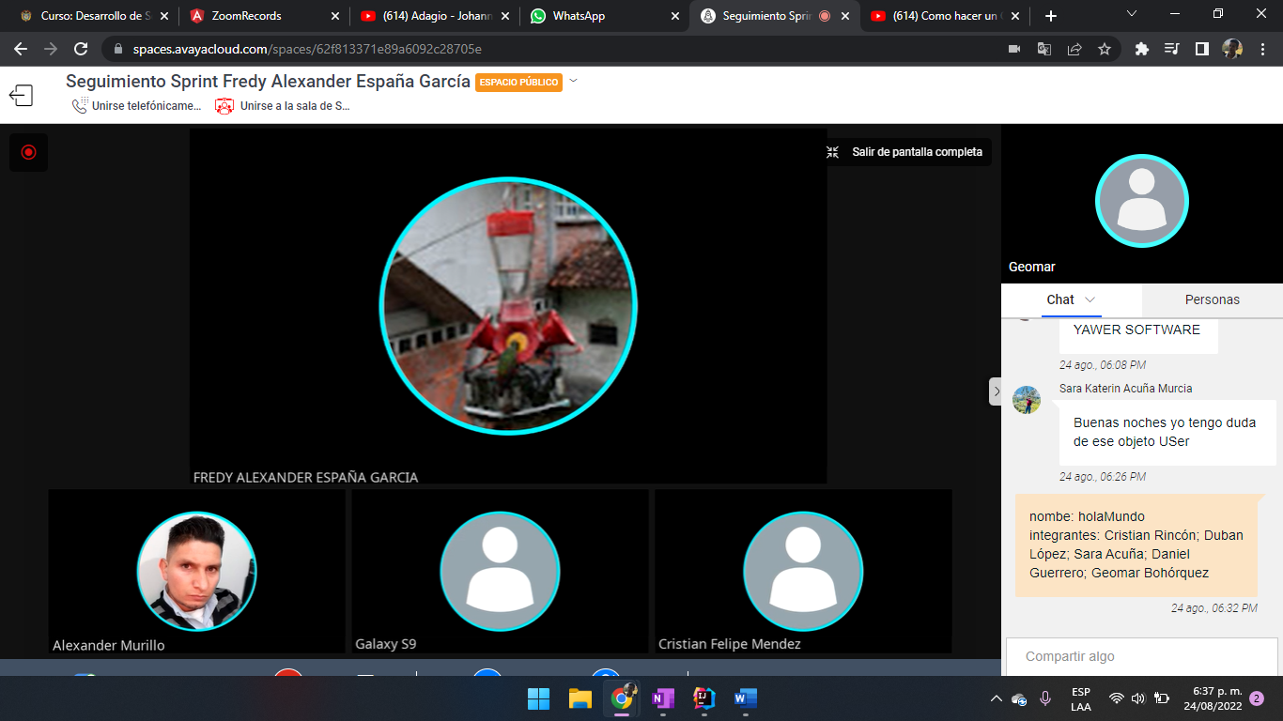

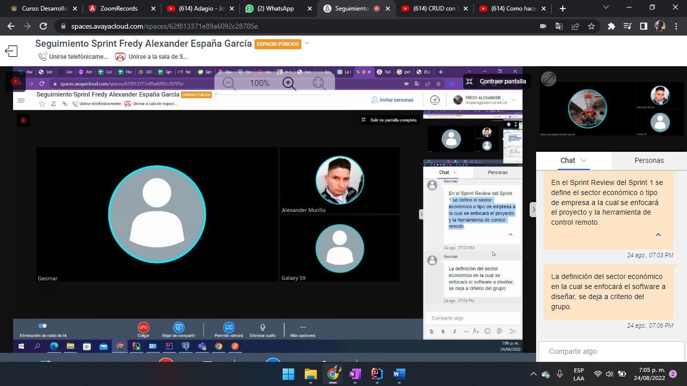

Sprint review 2 27/08/2022

Tutor:

Jose Luis Aguirre Ramirez

