Holden Herrell

17 March 2020

IST 707: Homework 8

**Introduction**

Technology has accelerated the global economy in the past several decades. One of the most revolutionary advances has been the advent of eCommerce. Consumers no longer need to visit brick and mortar locations to obtain essential items, often opting instead to order items online.

One of the few occasions that consumers do still visit physical locations is when choosing to visit a restaurant. However, their choice is not immune to the impacts of the internet and technology. Consumers almost always consult online reviews before frequenting a new restaurant. A negative review can “make or break” a consumer’s decision to visit one restaurant over another—presenting a new challenge to restaurant owners.

What happens when a consumer or perhaps an antagonizing non-consumer posts a negative review that isn’t truthful? Restaurant owners will suffer, and consumers will be unknowingly deprived of a potentially enjoyable experience.

In order to help cut down on false reviews, the Syracuse Neighborhood Association for Culinary Keypersons (SNACK)—an association of local Syracuse restaurant owners—is seeking an automated way to determine the sentiment and authenticity of online reviews. They hope to identify negative reviews and report them to SyraYelp! to be removed, so they can no longer hurt their businesses. SNACK has sponsored a study to help determine if reviews can be flagged as negative and/or lies using machine learning techniques.

**Analysis and Models**

**About the Data**

The data for this study consisted of 92 consumer reviews collected by SNACK from SyraYelp! (the local online review site). The restaurant owners collectively labeled each review as either true or false and positive or negative. The attributes for the original dataset were as follows:

|  |  |
| --- | --- |
| **Attribute** | **Description** |
| Lie | *‘t’* or ‘*f’* for lie or not a lie |
| Sentiment | *‘n’* or *‘p’* for negative or positive |
| Review | text containing review |

These reviews were vectorized and compiled into a corpus where each vector represented one review. This corpus was converted to a document term matrix where each vector became a document in the matrix. Once in document term matrix format, the following manipulations were performed to improve data quality for modeling:

|  |  |
| --- | --- |
| **Transformation** | **Description** |
| Remove rare words | All words with less than a 2.5% frequency were removed |
| Remove stop words | All regularly occurring, less significant words (i.e. ‘the’, ‘so’, etc.) were removed to remove noise from models |
| Remove custom stop words | The four most common restaurant review related words ("went", "order", "restaurant", and "food") were removed |
| To lower case | All words were converted to lower case to prevent capitalization from causing word misclassification |
| Remove numbers | All numbers were removed to prevent noise in the data |
| Remove punctuations and separators | All punctuation and separators were removed to prevent noise in the data |
| Stemming | Word endings such as ‘ing’ were removed to leave only word roots for better classification |
| Word length | All words with a length of less than 3 letters were removed |

Once the data had been cleansed, it was converted to a matrix for manipulation. To enable review to review comparison, all review vectors in the matrix were normalized by divided each word’s frequency by the total number of words in the reviews.

The matrix shows that the reviews are distributed evenly across all possible outcomes:

|  |  |  |  |
| --- | --- | --- | --- |
|  | **Sentiment** | | |
| **Lie** |  | Negative | Positive |
| False | 23 | 23 |
| True | 23 | 23 |

To support modeling, the review data was split into train sets (75% of data) and test sets (25%) of data with a set of train and test for both lie and sentiment. To prevent skewness, each sample consisted of 50% of either true or false, positive or negative for each attribute respectively.

Figure 1 (below) depicts a word cloud of the remaining words and/or word roots that comprise the review data.

**Figure 1: Word Cloud of Review Data**

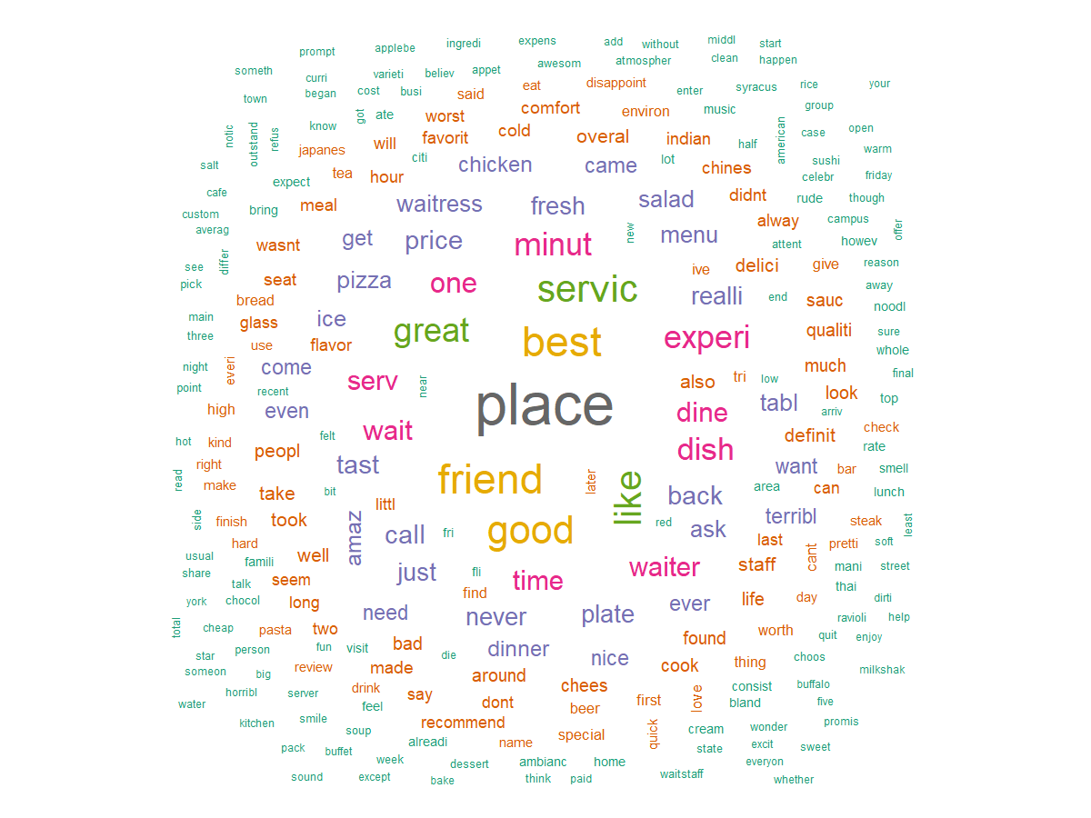

**Naïve Bayes Model**

Initially, a Naïve Bayes Model was applied to the review data. This model uses the learned past probabilities of normalized word frequencies associated with certain classes (true, false, positive, or negative) to predict the most likely label for the current review. Once trained, this model was used to predict the sentiment and factuality of the of the review data.

**SVM Model**

Furthermore, a Support Vector Machines (SVM) Model was applied to the review data. This model attempts to divide the data with vectors so that reviews on either side of a vector are classified as one label or another. A linear kernel transformation was used to make the data divisible by linear vectors. Once this model was trained, it was also used to predict the sentiment and factuality classification for the review data.

**Results**

**Naïve Bayes Model Results**

This model was not very accurate at predicting if a review was factual (lie or not). It was able to successfully predict the lie training data with 69.12% accuracy but was only able to predict with 50.00% accuracy on the test data. This model performed better at classifying the sentiment of reviews with a 79.41% train and 72.73% test accuracy. The summary of this model’s performance is:

|  |  |  |  |  |  |  |  |  |  |
| --- | --- | --- | --- | --- | --- | --- | --- | --- | --- |
| **Model** | **Overall Accuracy** | **Precision in Category I** | | **Recall in Category I** | | **Precision in Category II** | | **Recall in Category II** | |
| Naïve Bayes - Lies | 0.5000 | F | 1.0000 | F | 0.0833 | T | 0.4762 | T | 1.0000 |
| Naïve Bayes - Sentiment | 0.7273 | N | 1.0000 | N | 0.5000 | P | 0.6250 | P | 1.0000 |

If SNACK were to use this model, it might be able to identify reviews with negative sentiment; however, it was be as useful a flipping a coin in determining if the review is a lie or not. Perhaps this model would not be as helpful with automating the selection of falsely negative reviews.

**SVM Model Results**

This model also struggled to correctly predict the factuality of reviews. Despite a 100% accuracy against the training data, it achieved only a 45.45% accuracy on the test data when it came to lies. This model was somewhat better than the Naïve Bayes Model at predicting the sentiment of reviews with accuracies of 100% and 77.27% on train and test data respectively.

The summary of this model’s performance is:

|  |  |  |  |  |  |  |  |  |  |
| --- | --- | --- | --- | --- | --- | --- | --- | --- | --- |
| **Model** | **Overall Accuracy** | **Precision in Category I** | | **Recall in Category I** | | **Precision in Category II** | | **Recall in Category II** | |
| SVM - Lies | 0.4545 | F | 0.5000 | F | 0.2500 | T | 0.4375 | T | 0.7000 |
| SVM - Sentiment | 0.7727 | N | 0.8182 | N | 0.7500 | P | 0.7273 | P | 0.8000 |

Both the Naïve Bayes and SVM Models struggled to correctly classify reviews as factual (lies or not). It’s possible that these models may be feasible for lie detection in the future if they are given a greater volume of sample review data to train with. However, with the currently available data, these models will only be reliable for determining the sentiment of the reviews for the time being.

**Conclusions**

In summation, technology has contributed exponentially to the global economy as of late. Perhaps the most significant of these technological contributions has been the rapid growth of eCommerce. Consumers no longer need face-to-face interactions in physical locations to obtain the goods and services they need.

When consumers do opt to visit physical locations, it is often to try a new restaurant—a decision most likely informed by online reviews. This new dynamic of online review reputations poses a new challenge to business owners such as local restaurant owners: what can be done when people lie about your business in a review and it has negative implications. For the members of SNACK, an association of local Syracuse restaurant owners, they can report a false review to SyraYelp!, but only if they can identify it as a lie. To help them in their efforts, they sponsored a study to use machine learning to classify negative reviews that were lies.

Unfortunately for SNACK, it does not appear that either model tested in this study can identify whether a review is factual more successfully than a coin flip. Both models could help them identify negative reviews, with the SVM Model being slightly more accurate at predicting sentiment. If SNACK wanted to use these models, it would be highly recommended that they collect more reviews to help better train them.