Holden Herrell  
hwherrel  
10/19/2019   
IST 722 Assignment 01—Data Profiling

|  |  |  |  |  |
| --- | --- | --- | --- | --- |
| **Table** | **Type** | **Row Count** | **Business Key** | **One Row Is** |
| Employees | Master Data | 9 | None (PK used) | An employee |
| EmployeeTerritories | Business Process | 49 | None (PKs used) | An employee assigned to a territory |
| Customers | Master Data | 91 | CustomerID | A customer |
| Suppliers | Master Data | 29 | None (PK used) | A supplier |
| Products | Master Data | 77 | Product Name | A product |
| Shipments (of Orders) | Business Process | 830 | OrderID | A shipment made |
| Details (of an Order) | Business Process | 2155 | OrderID | The details of an item shipped in an order (product, price, qty, discount) |

1.

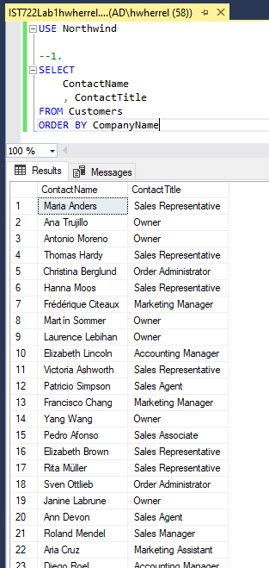

2.

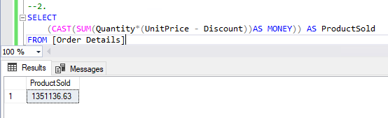

3.

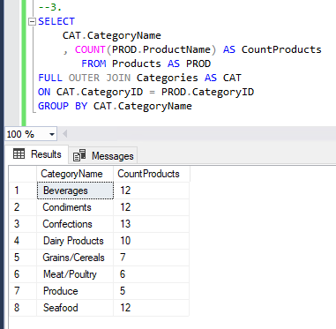

4.

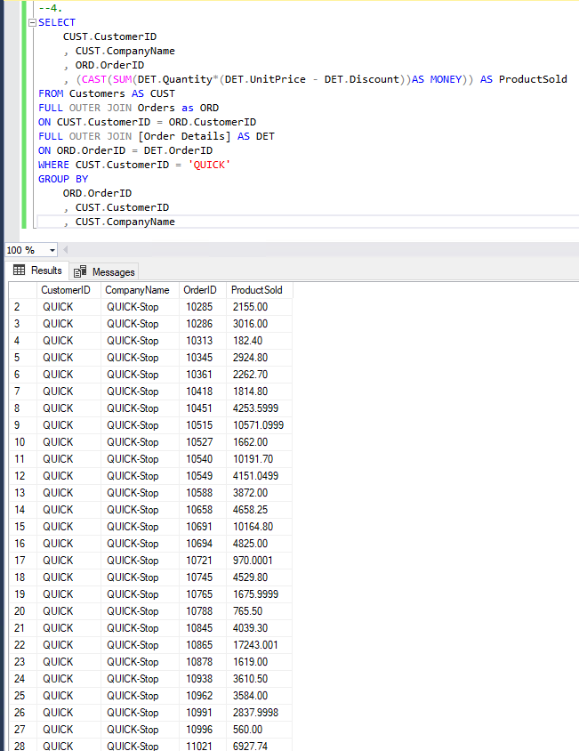

Only 28 orders for QUICK-Stop.

5.

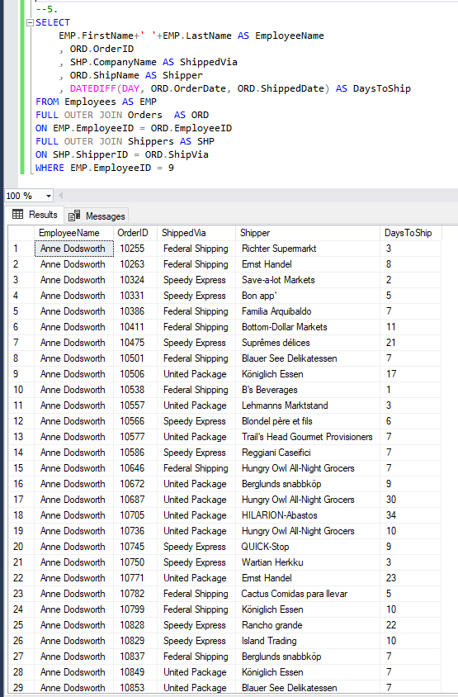

43 Orders total for Anne Dodsworth.