Holden Herrell

hwherrel

12/14/2019

IST722 Assignment 09: Business Intelligence

Pivot Table:

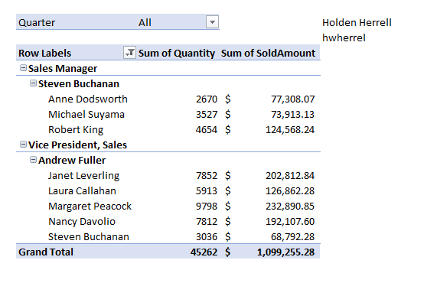

Power View:

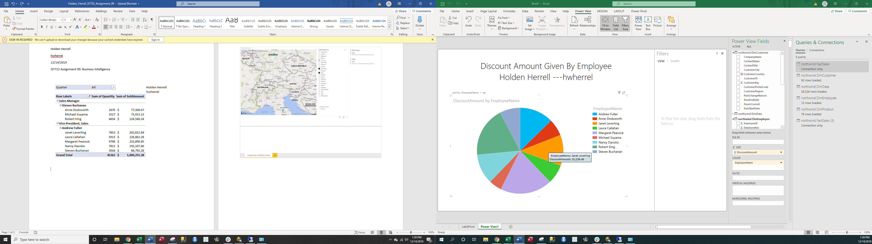

PowerBI:

