Contents
Usage 2
Common Issues 7
Installation and Setup 8
Step 1: Getting API Access 8
Step 2: Python 10
Step 3: Creating Executable 12
How It Works 13
Developer’s Guide 16
Directions for Further Development 16
Assumptions 18
Grievances 19

Usage
If the program is set up already, you can use it to add JBI or QBP orders to the Clover inventory, which starts by downloading the order form.
On JBI this is done by logging in on the website, navigating to orders and then selecting “Processed Orders”. In this section, find the order that was delivered, and click on the order number to load the rest of the information about it. Click the option to “DOWNLOAD .CSV FILE”. A common mistake is downloading the basic csv which does not have MAP and MSRP information for items.
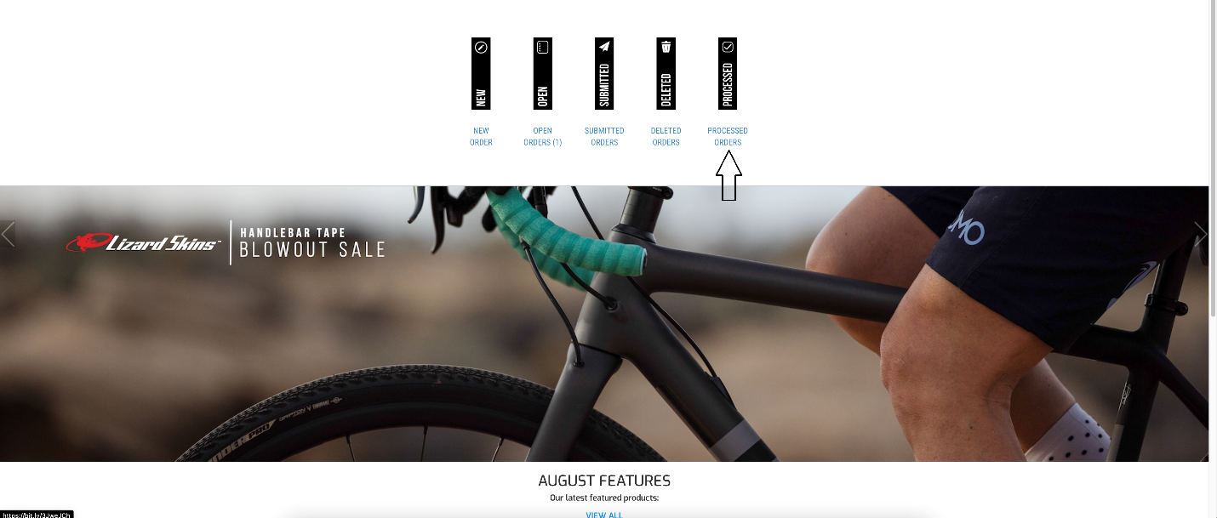
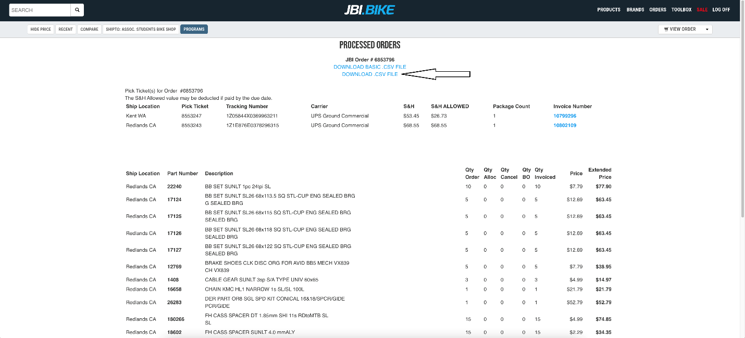
Steps for downloading an order from JBI
On QBP the order form can be downloaded by logging into the QBP account, and selecting “My Account” at the top of the page. From there, select “Account History” > “Order History” on the left sidebar. Find your order in this and click on the link under “Order ID” and then “Print Version”. This will open the order in a separate tab and from here you can download it as an HTML file. QBP does not include SKU codes or manufacturer pricing in the order forms, so you also need to download a copy of their catalog. Which can be downloaded from here. If this link no longer works, you can find it via the QBP website. Next to the “My Account” header you used earlier, there is another option called “Resources”. On this page, you can find “QBP Product Data Downloads” in the Technology Services section. Clicking this link leads to a page with the option to download the “QBP Partlist”. This downloads a ZIP folder which, after unzipping, will give a file called “qbpcatalog.txt”. Move this file into your orders folder and copy its path (how to do this is described here, and a screenshot of the code is shown below). Make sure input_order.py has the variable qbp_catalog_path set to this path, contained within quotes.
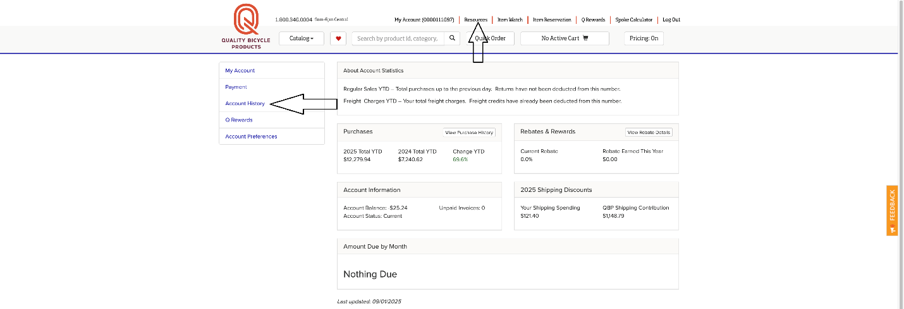
Important links on QBP’s website
Once you’ve gotten your order file, drag it into the orders folder. Now you can run the program. To do this, run the GUI executable by double clicking it. The executable should be pinned to the task bar but if not, you should find it in the file explorer and pin it yourself.
GUI Executable Circled in Red
It may take a few seconds of the terminal running for the GUI to load, but it should look like this once it does:
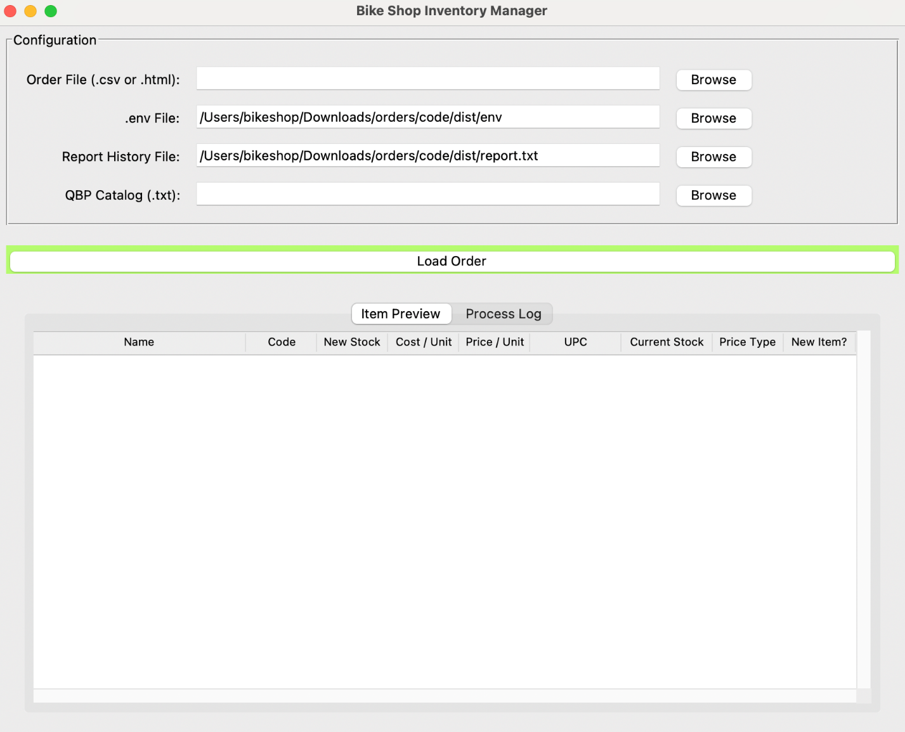
GUI before an order is loaded
To input the order, click “Browse” next to the “Order File” space and find it in the file navigator that pops up. If the order is from QBP, do the same for the qbpcatalog.txt file that you just downloaded. Once these files are added, you can click the “Load Order” button. This will take a few seconds as the program reads the files and connects to the Clover inventory, but the items from the order will show up in the item preview window.
This window allows you to make changes to the order since the default counts and prices from the order form are frequently inconsistent with our inventory system in a few ways which the layout is designed to help you catch. To do this, it is important to understand what all the attributes displayed mean.
Variable | Description / Possible Values
Name | The name of the item in Clover
Code | The product code for the item
New Stock | The number of sale units being added by the order
Cost / Unit | How much the shop paid the vendor per unit of the item
Price / Unit | How much customers will pay per unit of the item
UPC | The barcode number for the item
Current Stock | The current stock of the item in the inventory system
Price Type | FIXED | Each unit sells at a fixed price and count
 | PER_UNIT | Tablet prompts mechanic to put in a unit number
 | VARIABLE | Tablet prompts mechanic to put in a price
New Item? | Yes | The item is new
 | No | The item is already in the Clover inventory
Description of UI Table Columns
To further demonstrate what the different columns mean and how to adjust them during the order input process, the screenshot below shows and example of a possible order.
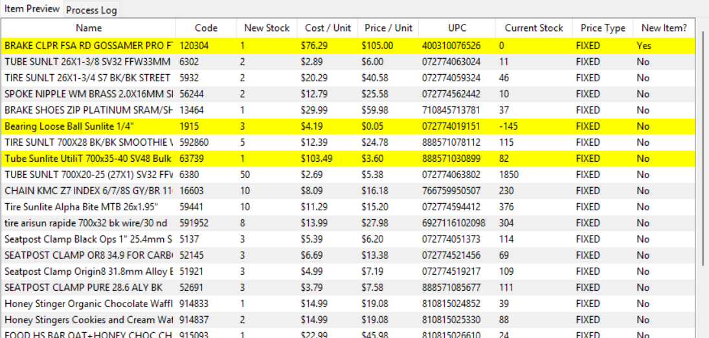
Example UI Table
Before uploading this order to Clover, all items need to be verified for accuracy. Highlighted items are very likely to be incorrect, so starting with Product 120304 (brake caliper), notice that the item is new (far right column). There is one unit of this item on the order, which we bought for $76.29 and plan on selling at the fixed price of $105.00. This makes sense, so no edits need to be made. Product 56244 (spoke nipples) is a little suspicious since it doesn’t make sense for each spoke nipple to be sold for $25.58. We buy them in bulk for $29.99, but this should probably be updated to per-unit pricing for however many spoke nipples we have in stock (likely more than 10). Since the item is not new, this must be done on Clover’s website. The next highlighted item is Product 1915 (bearings) which we bought for $4.15 but currently sell for $0.05. A search on JBI finds that there are 144 bearings per package, and it makes sense that we want to sell by the bearing and not 144 at a time. To fix this, click on the item to edit.
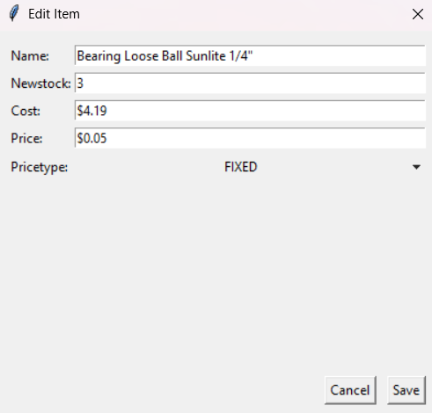
Item Edit Menu, before changes
New stock should be 144 * 3 = 432. The cost should then be $4.19 / 144 = $0.03. The price could be changed to $0.06 as well, but this is not necessary. Click save and continue on to Product 63739 (tubes). This is a similar scenario where the product comes in a box of 50, so we need to go onto the menu and change the new stock and cost. This example doesn’t cover every case, so it is important to have a general workflow for making corrections.
For highlighted items that are new:
- If the far right column of the table is “Yes”, then it does not exist in the inventory system and details should be checked thoroughly.
- Check the pricing type. If a part is sold by length or in bulk (ex: spokes or cable housing), change it to “PER_UNIT” and update the price and count accordingly. Use price / unit = 2 * cost / unit for pricing and make sure to update the count manually.
For other highlighted items:
    - This yellow highlight indicates that sale price is too low compared to cost. This can be ok if we bought a part on sale, but it usually indicates that how we buy the item from a vendor is not how we sell it to customers.
    - To fix this, divide the cost by the number of units contained within each item ordered and update the stock accordingly.
After an order is inputted, you should close the program. If you need to access data from a previous order input, the inv_writes.log file stored at the computer’s root directory saves lots of information.
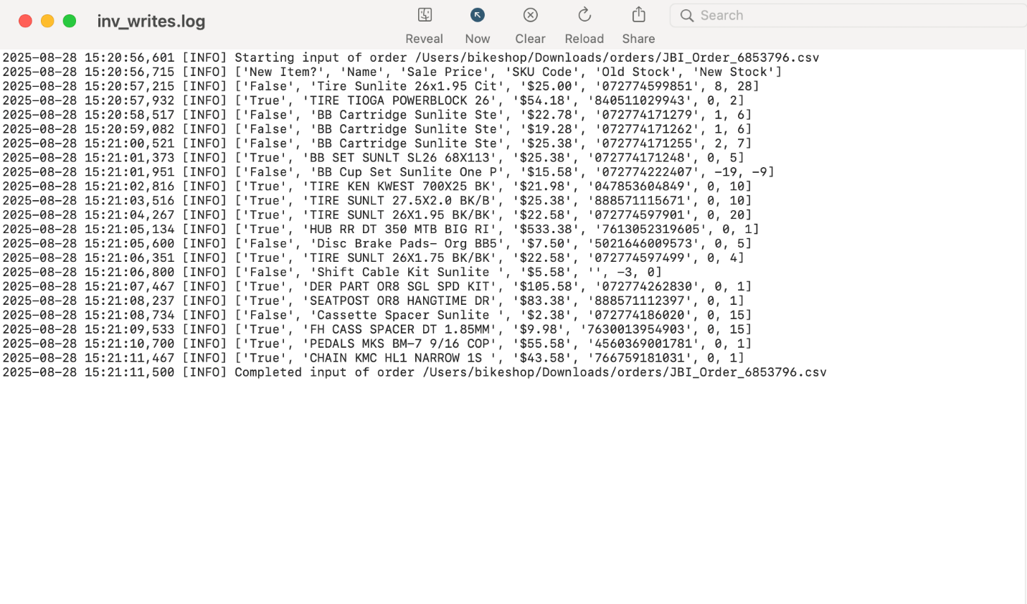
Log file after a successful order input

Common Issues
Order fully uploaded to Clover didn’t print in the log or console.
This statement not being printed will usually be accompanied by another error, but the point is that only a portion of the order was written to inventory. To fix this, run the program again and it should start from where it crashed, but it is still worth going into Clover and confirming that all items were added as indicated by inv_writes.log.
Items aren’t being added to Clover
It is possible that all the outputs and logging look normal, but when you check Clover nothing is actually being added. This is probably because the API key and/or merchant ID point to a different inventory (most likely a test inventory). To fix this, follow Step 1: Getting API Access and then try again. If it works for the most recent order, go back through previous orders and see if they were inputted correctly or not. Hopefully you caught this issue early on or the inventory could be very far off!

Installation and Setup
If someone has used the software on your computer recently, you can ignore this section. If files are missing or you’re experiencing bugs that aren’t documented in Common Issues, this is a good place to be.
The software is currently set up as an executable with a few file dependencies, so to set it up or make changes, you need to set up the proper files and compile the program. This section describes doing this from scratch, as if you downloading it from my GitHub Repo. If you have not used GitHub before, here is a guide on downloading from it. The rest of this section goes over getting API access from Clover, setting up Python, and arranging files and folders in the format that the program expects. Screenshots are included for most steps, but you may need to scroll down through the rest of the section to find them.

Step 1: Getting API Access

To use the program, you need to have access to a Clover Inventory. This must be given by a manager, and it is important that they make you an Admin, otherwise you won’t be able to view the API Key. Once you are given access, you need to enable Two-Factor Authentication (2FA). From the dashboard landing page, navigate to Settings in the top right corner, scroll down and select "View all settings”. The page this takes you to is pictured below, with an arrow pointing towards the important elements. First, you need to get the mId for your inventory, which can be found by following the link to “Merchants”.
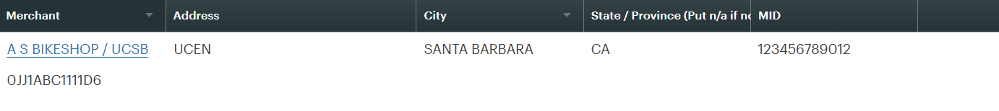Clover Merchant Information Page
For some reason, MID is not the Merchant ID the Clover API wants, instead copy the 13 character alphanumeric ID underneath “Merchant”. Next, go back to the setting pages and select “API Tokens”. If there is already an existing token, you can just copy it. If not, click “Create New Token”, pick a fun name and give read and write permissions for Inventory. Then, after you click “Create Token” you should be able to copy the API key.
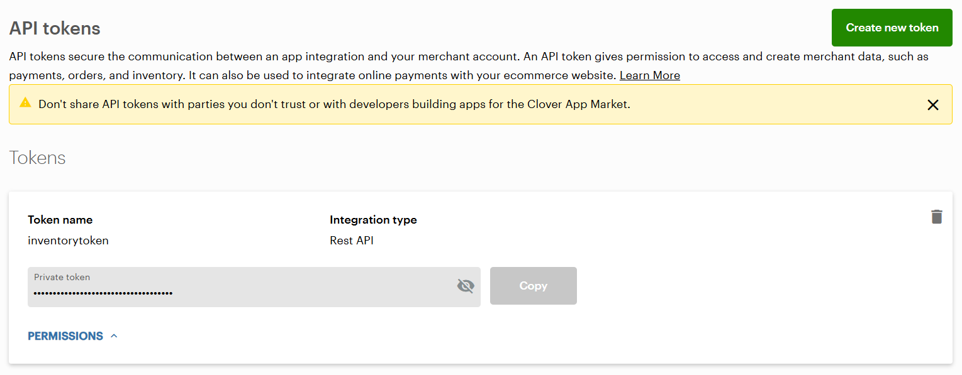
API Tokens Page
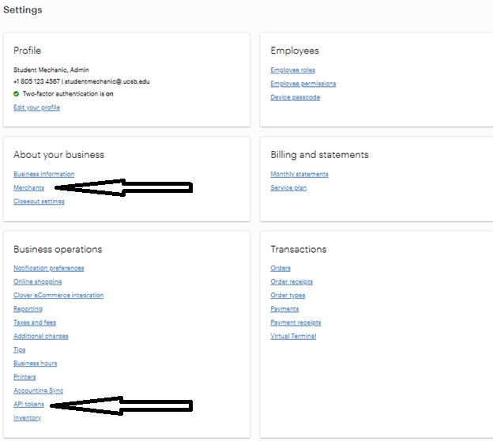
Clover Inventory Settings Page
Once you have your mId and API Key, create a file on your computer called env. If you cloned the project from GitHub, a blank version of this file came with it. Within this file, copy your token and mId into the following format (TOKEN corresponds to the key and CLIENT_ID corresponds to the mId):
Example (using fake data):
TOKEN="abcd1234-1234-5678-4321-aa1234123412"
CLIENT_ID="0JJ1ABC1111D6"

Notes on env files:
It is tempting to take your key and mId and hard-code them into input_order.py, but it is necessary to take the extra steps to create an environment file. This may seem unnecessary, but it is helpful for preventing the accidental sharing of your inventory access when sharing the code. Of less importance, Token and Client ID are the standard names for these variables in API interfacing, so used them when setting up the code.

Step 2: Python
The entire program is written in Python and utilizes a few packages. Start off by downloading Python from python.org. This program was originally written in Python 3.13.5, so for non-developers, downloading this version is recommended. If you are willing to fix a few errors that may arise from running it on a newer version, get the most recent and keep the software up to date!
Once Python has installed, it is worth verifying that it works. Go to your Application in the Finder and open the folder for Python. Inside should be a program called “IDLE”.
Open this program and type:
print("Hello World")
After pressing “return”, the terminal should respond with the blue text “Hello World”, indicating that Python code can run on your computer.
Now it is time to install the packages that the software depends upon. They are:
- requests (originally used version 2.32.4)
- dotenv (originally used version 0.9.9)
- beautifulsoup4 (originally used version 4.13.4)
- lxml (originally used version 6.0.0)
To install them on your computer, navigate to the terminal (Command + Space) and enter the command
python3 -m pip install requests dotenv beautifulsoup4 lxml PyInstaller

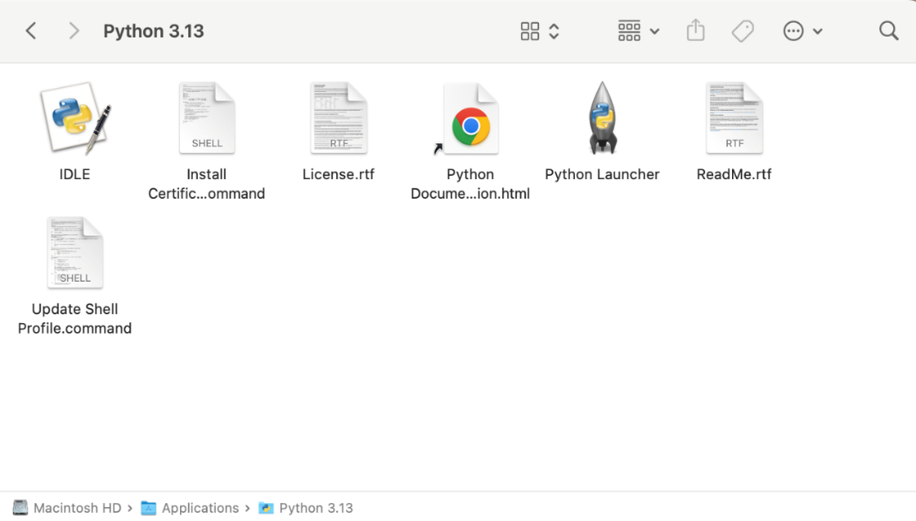
Python Application Folder on Mac
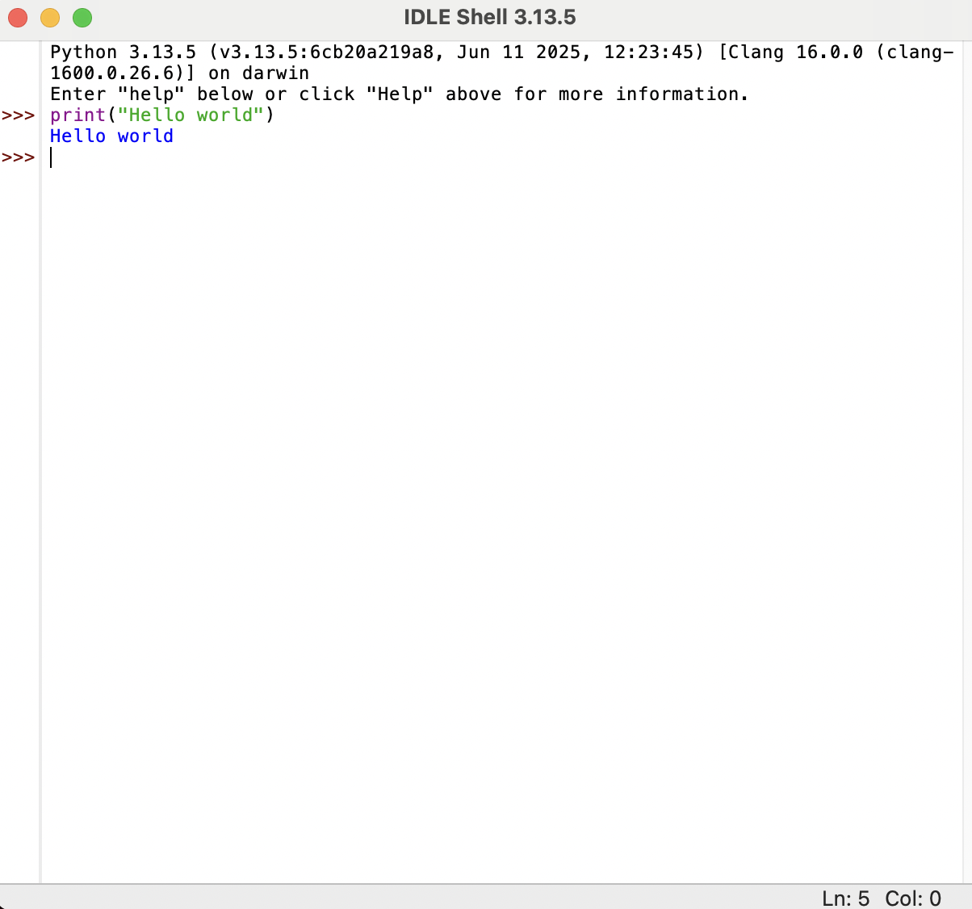
Simple Python Code, Running Successfully
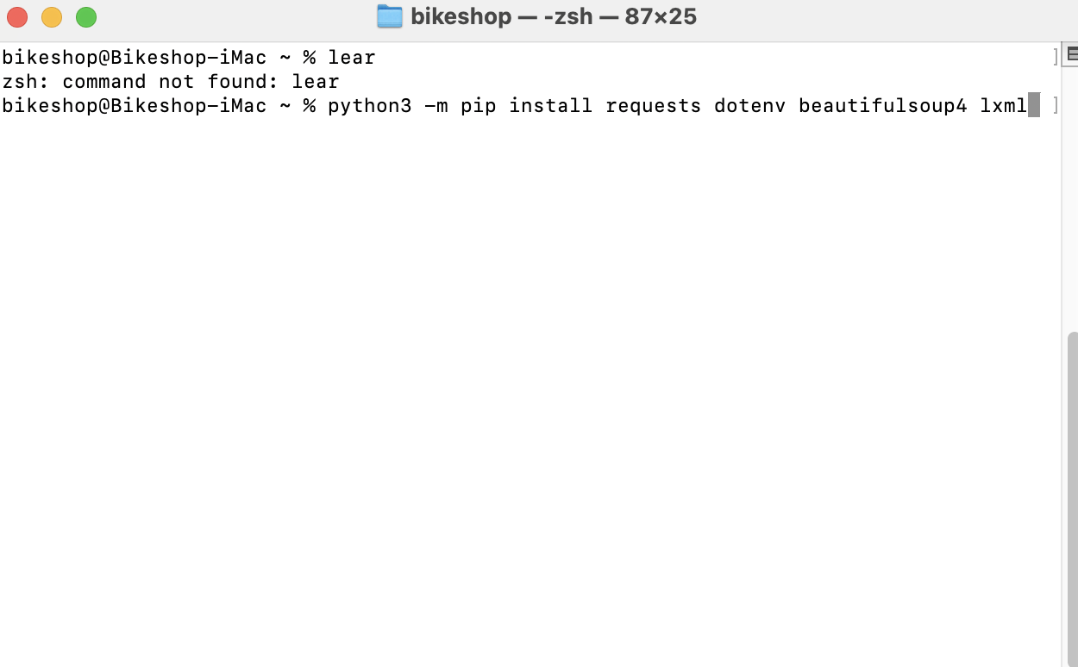
What your terminal should look like

Step 3: Creating Executable
While you can use the program by simply running gui.py, it is best to create a single executable for ease of access. This can be done with the PyInstaller package. Open the terminal and use the “cd” command to navigate to the folder with all the .py files. Once there, enter the command (case sensitive)
python3 -m PyInstaller --onefile gui.py
After a bit, a new folder should be created called “dist” with an executable file in it. Move the env file (from Step 1: Getting API Access) into this folder and create a blank .txt file called “report.txt” in this folder as well.

How It Works
This chapter is not a line-by-line description of the code, instead it is designed to be a broad overview to help build intuition for how the program works. While everything above was very detailed to allow the average bike mechanic to understand it, everything below assumes an understanding of Python (CMPSC 8) including BeautifulSoup, the logger, the os module, object-oriented programming (CMPSC 9 or CMPSC 24), and the requests module. Resources for all of these are linked above.
To understand the general program flow, read over the diagram on the next page. Otherwise, this section just justifies some of the decisions that may appear weird upon reading through the code for the first time.
- gui.py
  - Central hub in the uncompiled program.
  - Interacts with all other files.
- CloverAdapter.py
  - API adapter to interact with Clover
  - Has error handling for bad API responses
- OrderItem.py
  - Implemented to create consistency between QBP and JBI order items
  - Update parsed data with updateFromCatalog() and updateFromInventory()
  - Methods to integrate with the UI: updateAttributes(), price warning(), get_treeview_definition() and get_treeview_values()
- Order.py
  - Parses order files with either parse_html() or parse_csv()
  - Stores QBP inventory sheet, if necessary, so that UPC codes can be added for QBP orders
  - Allows for iteration over items
- report.txt and file_check.py
  - These exist to log previous order entries and make sure that no item is entered multiple times by separate program runs
- jbiqpb_scrape.py
  - Used to parse order forms from vendors.
  - Used to parse qbpcatalog.txt
  - Has some functions for web scraping JBI’s website that are not used by this program.
- CloverOrderReaderAdapter.py
  - Extension of the InventoryAdapter class that allows some functionality to read orders.
  - I originally wrote this method to get all items from a free repair event at the shop subtracted from inventory without AS having to pay each receipt directly.
  - Might be useful to someone in the future :)
- Input_order.py
  - This is the legacy system from before I developed the GUI.
  - If the GUI is having issues, this can be used to input and order
  - It requires a different file structure, so might require some debugging
  - To make edits to the order it needs to be inputted and then updated in Clover.
Below is a diagram showing generally how these different files and functions interact. It’s not 100% accurate, but it may help aspiring developers/maintainers get a high-level understanding of the program flow.

Program Flow Diagram
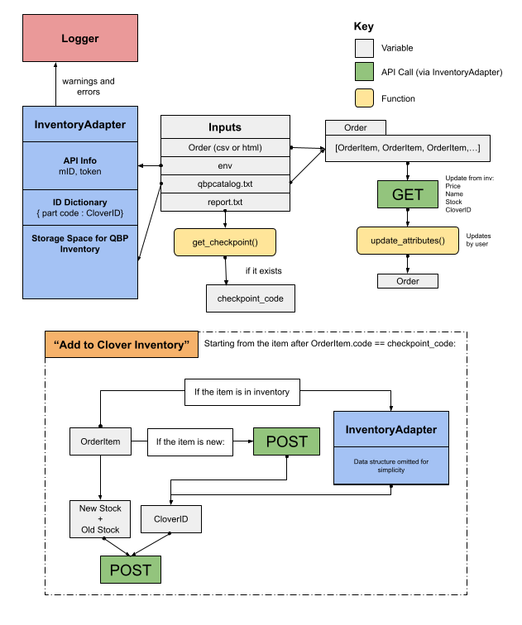

Developer’s Guide
Before reading this, please read through How It Works to get a high-level understanding of the program. It’s possible to make small changes without reading, but many methods are used for different processes, so a change for one purpose may break other processes.

Directions for Further Development
To develop the software further, it is highly recommended to get an IDE other than IDLE. VS Code is one of the best options, and it allows for integration with AI tools like GitHub Copilot. While agentic workflows like Cursor are useful for building projects from scratch, I wouldn’t (as of 2026) recommend them since a lot of the code lacks training data (Clover’s API, the OrderItem class, parsing QBP html files, ect), making any LLM more prone to hallucinations. For this reason, using an assistant where you can manually review any changes is paramount.
You’ll also want to set up a test inventory, so that you don’t accidentally mess up the real inventory. To do this, create a developer account at Clover. It is recommended that a temporary email for this so that you can use an env file for verification instead of OAuth. Once you verify your email, you will be prompted to create a test merchant. You can fill the mandatory fields out with anything and leave the rest blank; it does not affect the test inventory. Once the inventory is created, you can click on “Test Merchants” in the bottom right to bring up this screen, where you can launch the test inventory.
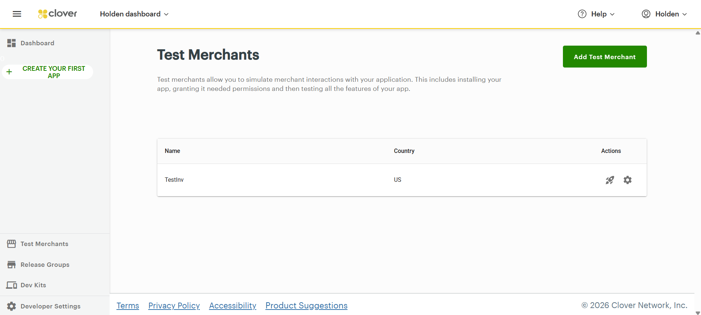
Test Merchant Home Page

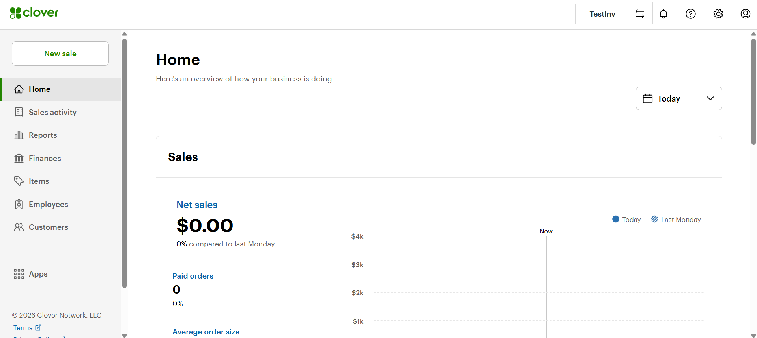
Test Inventory Home Page, after launch
From here, click “Employees” on the far left and add a new employee with your main email, but not the one you use for the real bike shop inventory. Make sure to give Admin permission.
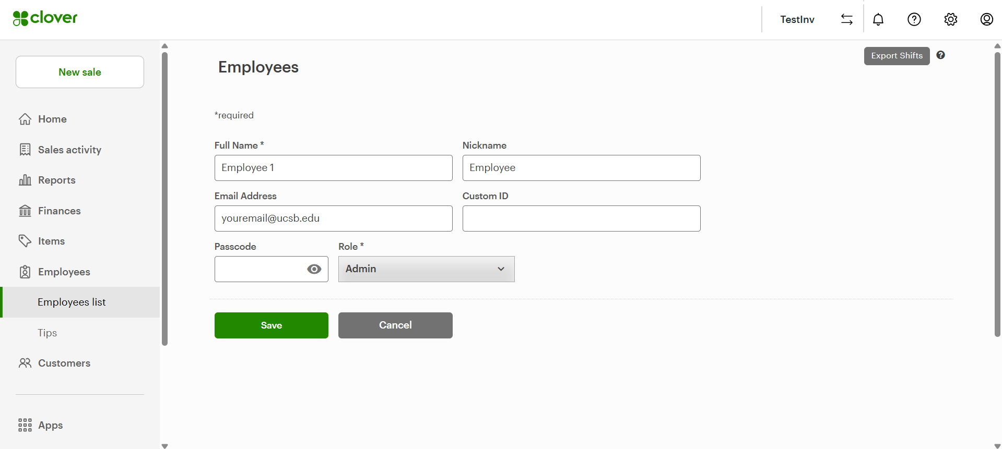
Adding yourself as an employee
Clover should send an email to this account to allow you to create an account. Remember the password for this since you may want to log back in to view the inventory without having to manually make API requests. Once you get logged in, follow the instructions from Step 1: Getting API Access. To avoid accidentally using the main inventory variables during testing, it is best to work on a separate computer or save the variables to a separate file like a .json or .txt.
To populate the test inventory with items, you can either download a .xlsx of the inventory from the main inventory account and import it or use the API to input a few order forms.

Assumptions
During my development process, I made some assumptions that could be problematic in the future. This section details what they are and how to go about correcting for them if they do become problematic. This can be thought of as a section for “Uncommon Issues”.
Length of CloverIDs and Product Codes
To provide some flexibility in the API wrapper, it allows users to look up items by both JBI/QBP product code and CloverID. It can distinguish between these because CloverIDs are always 13 characters long and product codes never are, but if Clover changes their product codes this would stop working. To fix this, go line 18 of CloverAdapter.py.
Format of QBP’s html files
In Order.py, there is code that uses the BeautifulSoup library to extract product data from QBP files. For 2025 and 2026 there have been no issues with this implementation, but if QBP were to change their formatting it would most likely break. If you encounter issues with Order.parse_html(), this is why.
Format of JBI’s csv files
Order.py also has the Order.parse_csv() method. Since csv files are easier to read, this includes a check of the headers, so while it does assume a specific format it will raise an assertion error of “Incorrect order csv formatting” if a change is detected. Despite this, there could be hard to diagnose issues if extra summary rows are added.
In early 2026 JBI started to include blank cells in some of their order forms, which I had not anticipated and it crashed the program.
Format of QBP’s catalog
Just as with the previous two assumptions, we are dependent on a specific file format that QBP uses staying the same. There was a period in early 2026 where QBP formatted their header row wrong (split between two rows) and this caused unhandled errors. QBP was not responsive to my complaints so we just had to manually edit the .txt file.
Deprecation of elements of CloverAPI
Clover’s API is well documented on their website, but it is subject to changes. For example, in 2024 they changed the API endpoint for updating the stock of an item. In May 2026, they changed it again without properly documenting the change. This can happen at any time and suddenly break the software. Even worse, changes may not go fully into effect until months or years later, leaving the changelog entry buried under more recently added features. Additionally, we are currently able to cheat the login process by copying a permanent API key but this may change in the future as well, forcing an OAuth flow to get inventory access. In general, any GET, POST, or PUT method in InventoryAdapter is prone to bugs due to API changes, so carefully read the current documentation from Clover before making changes.

Grievances
If you are feeling ambitious and want to make big changes here are some recommendations based on what I would do differently if I were to redo the project from scratch:
The Checkpoint System
The checkpoint system was a late addition so that the program could handle mid-input crashes. The logic is housed in gui.py and it works well, but it is done through report.txt, which is clunky. I don’t know how to do this better while still making the log human readable, but there certainly is a way.
GUI Integration
While I wrote most of the backend manually, the GUI was mostly vibe coded as an afterthought after I realized how much it would help for the program to be more intuitive for other mechanics.
Unfortunately, most of the functions used for file parsing and the API were designed to integrate with my early version of the program that ran entirely in the terminal with print statements, so the integration of the data into the GUI is messy to say the least. I don’t know what the best data types/formats are for tkinter tables, so I tried my best with OrderItem.get_treeview_values() and OrderItem.get_treeview_definition(), but there certainly is a better way to do this!

