Reducing Gulo 3000 shaft vibration

1 / Experimental basis and mathematical model
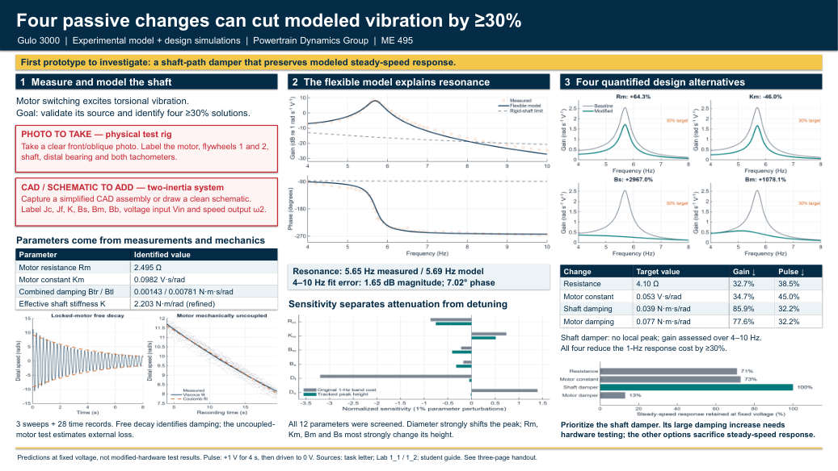 | Recommendation. Investigate a shaft-path damper with Bs = 0.039 N·m·s/rad. It reduces modeled switching ripple by 32.2% and preserves steady-speed gain. Four alternatives meet the nominal 30% target under the stated fixed-voltage test. These are model predictions; no modified hardware was tested.

Data and experimental procedures
The supplied September 10 records contain 3 distinct frequency sweeps (182 rows, 4–10 Hz) and 28 time histories. The copied/renamed exports are byte-identical to the originals and are not counted twice. The LabVIEW headers already express both tachometers in rad/s. Gain is distal-speed amplitude divided by motor-voltage amplitude; repeated complex responses are averaged in 0.05-Hz bins (44 bins). Phase is treated circularly before unwrapping. [2,3]
DC resistance uses the two stationary tests. Km is the slope of V − RmI versus steady motor speed across 14 records, with a free intercept. The 20-Hz recordings are retained as diagnostics rather than pooled as DC resistance. Locked-side free decays give Btr = Bs + Bb and Btl = Bs + Bm. For the two coastdowns, the motor was physically uncoupled while both flywheels remained connected by the shaft (confirmed by the team).

Equations and parameter provenance
States: shaft twist δ = θ1 − θ2, motor speed ω1, distal speed ω2 and armature current i. The model uses Jc = Jm + Jf and the same Jf for both flywheels. [2]
Lm di/dt = Vin − Rm i − Km ω1
Jc dω1/dt = Km i − Bm ω1 − Bs(ω1 − ω2) − Kδ
Jf dω2/dt = Bs(ω1 − ω2) + Kδ − Bb ω2; dδ/dt = ω1 − ω2
The frequency model H(s) = Ω2(s)/Vin(s) neglects Lm; switching simulations retain it. Jf = ρπDf⁴Lf/32 and Kgeometry = πGsDs⁴/(32Ls). The complete third-order polynomial and an independent state-equation check are in the MATLAB functions.
Parameter | Value | Basis
Rm; Km | 2.4947 Ω; 0.09821 V·s/rad | Stationary tests; back-EMF regression
Jf; Jm | 0.003406; 4.23e-05 kg·m² | Given geometry/material; given rotor inertia
Kgeometry → Keffective | 2.4062 → 2.2029 N·m/rad | Geometry; only parameter fitted to sweeps
Btr; Btl | 0.001429; 0.007808 N·m·s/rad | Mean of two free decays per locked side
Bb; Bs; Bm | 0.0001572; 0.001272; 0.006536 N·m·s/rad | Coastdown and subtraction of damping sums
Lm; shaft geometry | 0.002 H; Ds = 3.18 mm; Ls = 305 mm | Given course parameters [2]

Damping extraction and its limits
Free-decay extrema are fitted as ln|ωpeak| = c − αt; B = 2Jα, ωn = √[(2πfd)² + α²] and ζ = α/ωn. Extrema above 15% of the initial amplitude, within 8 s, are retained. The coast fit uses 4.0–19.5 s after disengagement and J = 2Jf, giving Bb ≈ 2Jfα. Then Bs = Btr − Bb and Bm = Btl − Bs. All three are effective coefficients of this assembly, not independently isolated material properties.
The motor regression has R² = 0.99981 and intercept 0.135 V. The intercept and effective resistance absorb offsets/brush effects. Coastdown is slightly better fit by a linear Coulomb model than an exponential model; an equivalent viscous model is retained for frequency-domain design. This approximation limits extrapolation.

2 / Validation and design screening
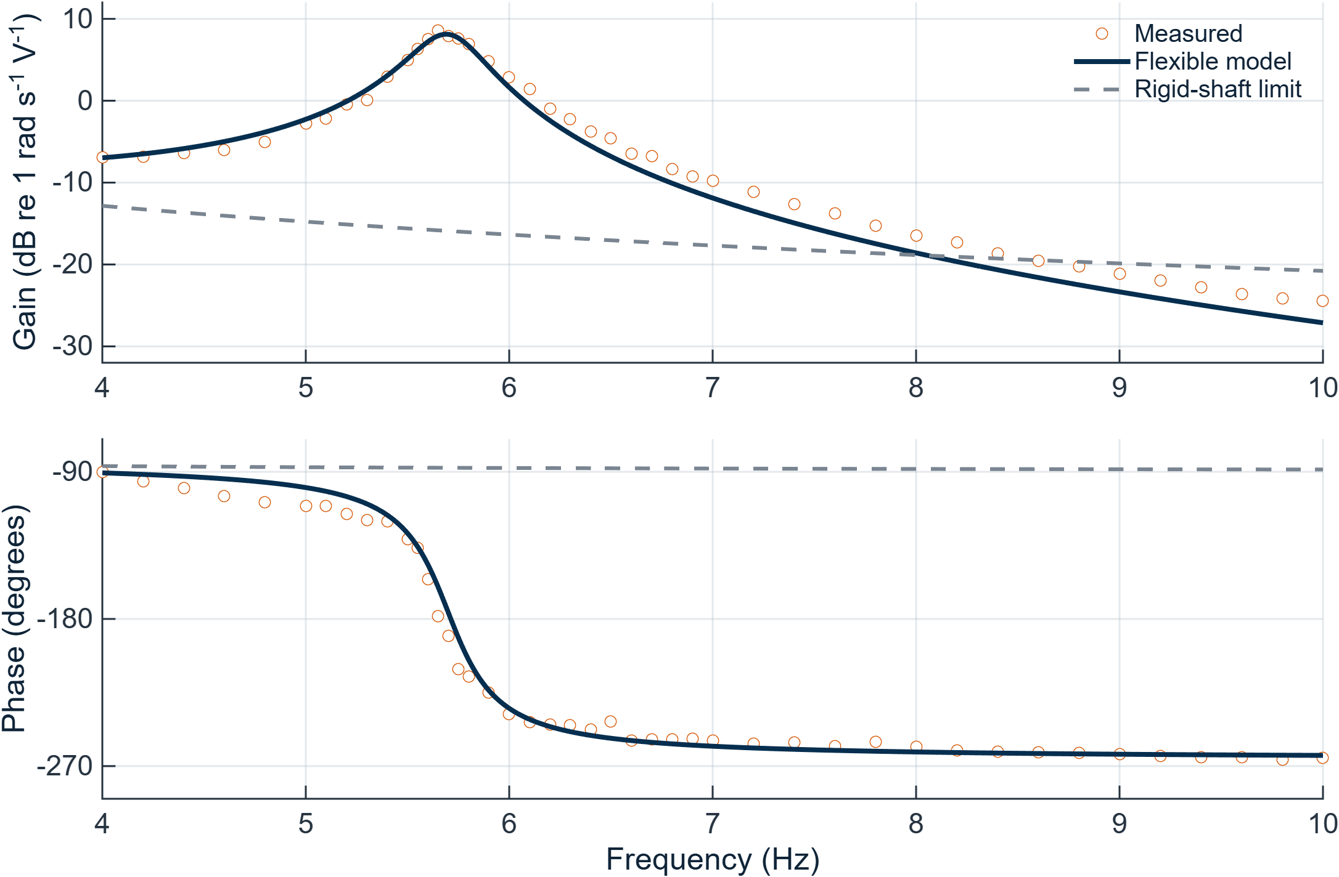
Figure 1. Measured response, flexible model and rigid-shaft limit. A rigid shaft enforces ω1 = ω2 and removes the torsional resonance; setting Bs = 0 does not make a shaft rigid.
Check | Magnitude / frequency result | Phase / interpretation
Measured vs modeled resonance | 5.650 vs 5.690 Hz | Peak gain 2.687 vs 2.547 rad/(s·V)
Before → after K refinement | 2.46 → 1.65 dB RMS | 28.38° → 7.02° RMS
Leave one sweep out | 0.89–1.83 dB RMS | 5.03–17.47° RMS; shared apparatus
Broadband last-test diagnostic | 2.69 dB RMS | 8.98° RMS; coherence ≥0.8
K is refined from geometry by fitting mean squared log-magnitude and wrapped-phase residuals. It is an effective stiffness correction, not a new measured shear modulus. Near resonance (5.2–6.2 Hz), magnitude RMS error is 0.79 dB. Including the given inductance changes predictions by at most 0.031 dB and 2.88° in the measured band.
The broadband record is withheld from fitting: an H1 spectral estimate uses nine 2-s Hann windows with 50% overlap and 0.5-Hz resolution. Nine 4–10 Hz bins meet coherence ≥0.8. Its coarse resolution cannot resolve the narrow peak accurately. The three sweeps share setup and nearly constant excitation (~1.72–1.76 V amplitude); no descending sweep or systematic amplitude sweep establishes broad linearity. The model supports comparative design near the tested range, with residual discrepancies retained.

Sensitivity identifies four attenuation directions
Course cost: J = ∫|H(jω)|dω over ωr ± π (a 1-Hz-wide band); integrate linear magnitude, not dB. Normalized sensitivity is Sp = (ΔJ/J)/(Δp/p), estimated with symmetric ±1% perturbations. Record both the original-band cost and the cost following the new resonance, plus peak-height sensitivity. Recompute linked parameters after each perturbation. [2]
Parameter | Original-band cost S | Tracked-peak S | Interpretation
Rm | -0.869 | -0.757 | Attenuation candidate
Km | +0.737 | +0.513 | Attenuation candidate
Bm | -0.222 | -0.412 | Attenuation candidate
Bs | -0.176 | -0.326 | Attenuation candidate
Df | -3.201 | -0.048 | Primarily moves resonance
Ds | +1.396 | -0.017 | Primarily moves resonance
The four largest absolute peak-height sensitivities are Rm, Km, Bm and Bs. All 12 raw parameters were screened; Jm, Lf, ρf, Ls, Gs and Bb are also included in sensitivity.csv. Changing Df changes both flywheel inertias as Df⁴; Ds changes stiffness as Ds⁴. Geometry can move the resonance out of a fixed cost band while leaving its height nearly unchanged, so it is not selected on fixed-band improvement alone.

3 / Four design alternatives and recommendation
Targets below include a modest parameter margin beyond the minimum joint solution and are rounded outward to two significant digits. Each nominal design reduces both the frequency-response criterion and the defined switching ripple by at least 30%. These are component-level targets for prototype evaluation, not validated vehicle designs.
Parameter change | Gain ↓ | 1-Hz cost ↓ | Pulse ↓ | Speed gain retained
Rm: 2.495 → 4.10 Ω | 32.7% | 35.9% | 38.5% | 71.0%
Km: 0.0982 → 0.053 V·s/rad | 34.7% | 40.5% | 45.0% | 72.9%
Bs: 0.00127 → 0.039 N·m·s/rad | 85.9% | 82.6% | 32.2% | 100.0%
Bm: 0.00654 → 0.077 N·m·s/rad | 77.6% | 65.9% | 32.2% | 13.0%
For Bs the local peak is eliminated: “gain” is the maximum across 4–10 Hz, and the 1-Hz cost stays centered on the baseline resonance. For other designs, both metrics track their shifted local peak. Broadband low-frequency commanded rotation is not relabeled as torsional resonance.
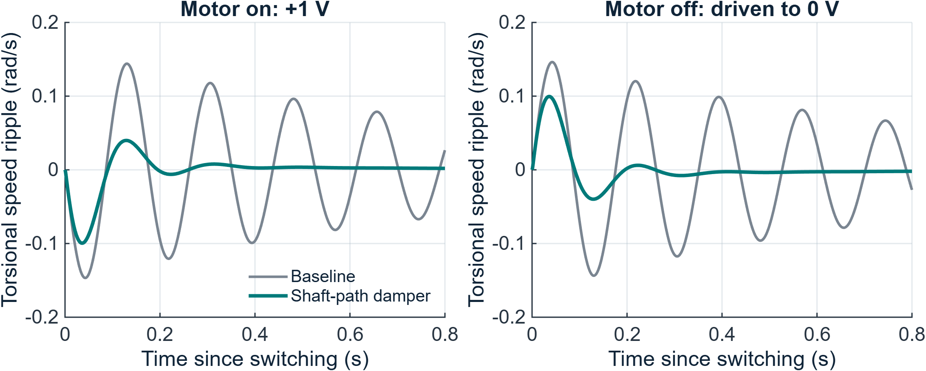
Figure 2. Baseline and shaft-damper switching responses. Exact matrix-exponential simulation retains motor inductance; +1 V for 4 s, then a driven 0-V source for 4 s. Initial state is rest. Plots show the first 0.8 s after each switch.
Torsional ripple is r = ω2 − (Jcω1 + Jfω2)/(Jc + Jf). The criterion is max|r| over the full pulse: baseline 0.1467 rad/s. It measures relative torsional motion, not total wheel speed or passenger acceleration. An open-circuit turn-off variant is also saved. The design gain/cost thresholds alone would need much smaller damping changes (see resonance_only_designs.csv) but would not achieve the pulse target.

Practical comparison and parameter linkage
1. Shaft-path damper — preferred concept. Add relative-motion dissipation across the shaft/coupling path, targeting Bs = 0.039 N·m·s/rad. This is about 30.7 times the baseline coefficient and retains 100% of modeled steady-speed gain. Specify the damper by its measured torque–relative-speed behavior. Added stiffness, inertia, heat and packaging must be included in a new prototype model.
2. Series resistance. Target total Rm = 4.10 Ω (about 1.61 Ω added). It is a simple passive concept, but produces I²R heat and retains only 71% of steady-speed gain. The input is then defined upstream of the added resistor; do not use downstream motor-terminal voltage as the same transfer-function input.
3. Lower-Km motor. Target Km = 0.053 V·s/rad (also N·m/A in SI). The idealized study holds Rm, Jm and damping fixed; real motor replacement changes these together. Refit all coupled properties and verify torque/current requirements. Modeled steady-speed gain retained: 73%.
4. Motor-side damper. Target Bm = 0.077 N·m·s/rad. This resists absolute motor speed and causes continuous dissipation. Only 13% of steady-speed gain remains; this makes it the least attractive of the four despite meeting the fixed-voltage target.
Fixed input is a material limitation. If voltage is rescaled to restore equal final speed, pulse reductions are approximately Rm: 13.5%, Km: 24.6%, Bs: 32.2%, Bm: -420.1%. A negative reduction means worse ripple. These rescaled simulations are diagnostic and are not recommended drive voltages. Eight combinations of the repeated damping tests are checked in replicate_robustness.csv; they are not statistical confidence intervals.

References and reproduction
[1] Meyhofer & Reddy, Task Letter Lab 1, Sept. 4, 2026. [2] ME 495 Lab 1_1, pp. 12–25; Lab 1_2, pp. 4, 19–36, 43. [3] Flexible Shaft — Student Guide, pp. 20–27. Poster format follows Dr. Royston, F26 ME495 Posters-1, pp. 20–28, 48, 54–55. All numerical results: supplied Data/ exports; run MATLAB/run_all.m. Tables, diagnostic plots and verification results are in Analysis/; publication figures are in Figures/.

