Triangles, Part 1

Things you should know:
Triangle Inequality a+b>c
*Extended Law of Sines* 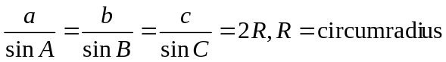
Law of Cosines a²=b²+c²-2bc cosA
Pythagorean Theorem a²+b²=(>,<) c² (acute, obtuse)
Area formulas
Special intersections within triangles
Angle bisectors- incenter, perpendicular bisectors- circumcenter, medians- centroid, altitudes- orthocenter
Angle bisectors divide the opposite side in the proportion of the other 2 sides
Similarity and Congruency
*Cevian- a segment from a vertex to a point on the opposite side
Notation- [ABC]=area of triangle ABC.

Problems: (Difficulty * easy ***** hard) –Draw a picture!
- A=½bh, and proportional areas of triangles:
  - *If the bases are the same the ratio of the areas is the ratio of the __________.
  - If the heights are the same the ratio of the areas is the ratio of the __________.
  - In triangle ABC, if D is on segment BC, and E is on segment AD,
    - A=½·BC·AD·sin(_______)
    - Let 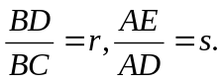 Evaluate the following:
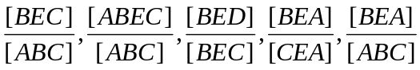
  - **In triangle ABC, D, E, and F are on BC, CA, and AB such that CD, AE, and BF are one third of their respective sides. AD and CF intersect in N₁, AD and BE intersect in N₂ and BE and FC intersect at N₃. AN₂:N₂N₁:N₁D=3:3:1. and similarly for lines BE and CF. [N₁N₂N₃]/[ABC]=?
  - **[AMY 2006] Let ABC be an equilateral triangle, and D, E points on sides AB and AC, respectively such that AD=CE. Let segments BE and CD meet at F. If [ABC]=7 and [BCF]=2, find BD/DA.
  - ***Points D, E, F lie on sides BC, CA, AB of triangle ABC such that 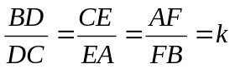. Let KLM be the triangle enclosed by AD, BE, CF. Express in terms of k the ratio [KLM]/[ABC].
  - ***In triangle ABC, D is the midpoint of side BC. Point F lies on side AB. Segments AD and CF meet at E. Compute 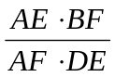.
  - **Three cevians AD, BE, and CF of triangle ABC are concurrent at P. Compute 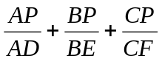.
  - ***[AIME 1984] A point P is chosen in the interior of triangle ABC so that when lines are drawn through P parallel to the sides of triangle ABC, the resulting smaller triangles have areas 4, 9, 49. Find [ABC].
  - ****[AIME 1989] Three cevians AD, BE, and CF of ABC are concurrent at P. Given AP=6, BP=9, PE=3, CF=20, find [ABC].
    - hint: First find PF. Then draw some segments and look for similar triangles. What can you conclude (about D)? The tricky part is letting Q be P reflected over D. What can you say about APCQ given its diagonals? What is <BPD?
  - [AIME 1988] Three cevians AD, BE, CF, of triangle ABC are concurrent at P. Suppose that PD=PE=PF=3 and PA+PB+PC=43, find PA*PB*PC.
- Using Formulas
  - ***Triangle Inequality: Find the point inside a quadrilateral so that the sum of the distance from the vertices is minimal. (Hint: what are some good guesses?)
  - ***In a triangle height from A h_{a}=12, h_{b}=20. Find the range of possible values of h_{c}. Hint: How are heights related to sides? What is the range of values for the sides?
  - [AMC 2002] The altitudes of a triangle are 12, 15, and 20. The largest angle in this triangle is…?
  - ***What is the maximum area of a quadrilateral with sides 1,4,7,8? Hint: look for a special relationship
  - **[ARML 1984]In right triangle ABC, C=90°, c=3, and a+b=√17. What is the area? (hint: what is c? how can you use it?)
  - [NYSML 1984] In triangle ABC altitude AH and median BM intersect inside the triangle and are equal. If <ACB=41°, find <MBC.
  - ***[ARML 1983] In triangle ABC, 2a²+4b²+c²=4ab+2ac. Find cos B. (hint: try factoring into squares.)
  - [ARML 1984] If in triangle ABC, 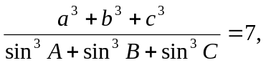 find the maximum possible value of a.
  - [NYSML 1985] Rectangle I is inscribed in rectangle II so that each side of rectangle II contains one and only one vertex of rectangle I. If the dimensions of rectangle I are 1 and 2, and the area of rectangle II is 22/5, find the perimeter of rectangle II.
  - In triangle ABC AB=3, BC=5, AC=7, and AD and CE are angle bisectors meeting at P. Compute AP. (hint: WHAT IS P?)
  - (AHSME 1953-50) One of the sides of a triangle is divided into segments of 6 and 8 units by the point of tangency of the inscribed circle. If the radius of the circle is 4, then the length of the shortest side is…?
  - (ARML 2007) Equilateral triangles are erected on the sides of rectangle ABCE, facing outwards. If the sum of the areas of ABCE and triangles AEF and DEC exceeds the area of BDF by 33, compute the area of rectangle ABCE.
  - Point O lies inside the pentagon ABCDE. Let <BAO=<BCO, <CBO=<CDO, <DCO=<DEO, <EDO=<EAO. If <AEO=24°, what are the possible values of <ABO? (Hint: use the law of sines in different triangles, and try to multiply to cancel out like terms)
- Weird equations: REINTERPRET! Where have you seen similar formulas?
  - ***Let x, y, z be positive real numbers satisfying the system of equations 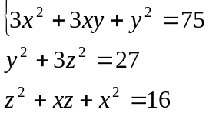 Find xy+2yz+3xz. (Hint: Do NOT solve for x,y,z. You will need to substitute to make these equations match a formula.)
  - ****[AIME 2006] Given that x, y, and z are real numbers that satisfy 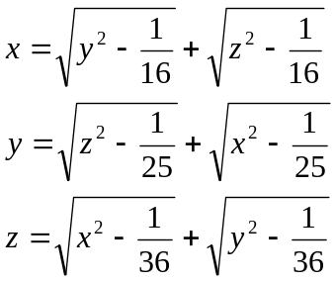 Find x+y+z.
- Proof exercises, with trigonometry
  - **Prove that in a parallelogram ABCD the sum of the squares of the diagonals equals the sum of the squares of the side lengths.
  - ****Let ABC be a triangle and R and K be its circumradius and area. Prove 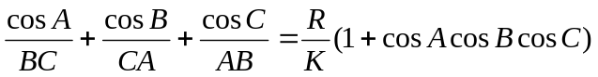
  - Let d_{a},d_{b},d_{c} be the distances from the circumcenter of ABC to the triangle’s sides. Prove 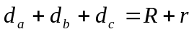, where R and r are the circumradius and inradius.
  - Let ABCD be a convex quadrilateral such that <ABC=<ADC=135° and 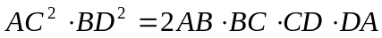. Prove that the diagonals are perpendicular. Hint: Consider area.

