CDC Pipeline Patterns
Overview & Decision Framework
Doc 0 of 6 — Start here. Five patterns, extraction layer, consistency model, decision guide, and how patterns compose.

Architecture
The pipeline has four source types. Databases (Postgres, Oracle) go through an extraction process which reads their native replication streams. Files go through the extraction process too. Events and APIs publish directly to Kafka without an extraction layer.

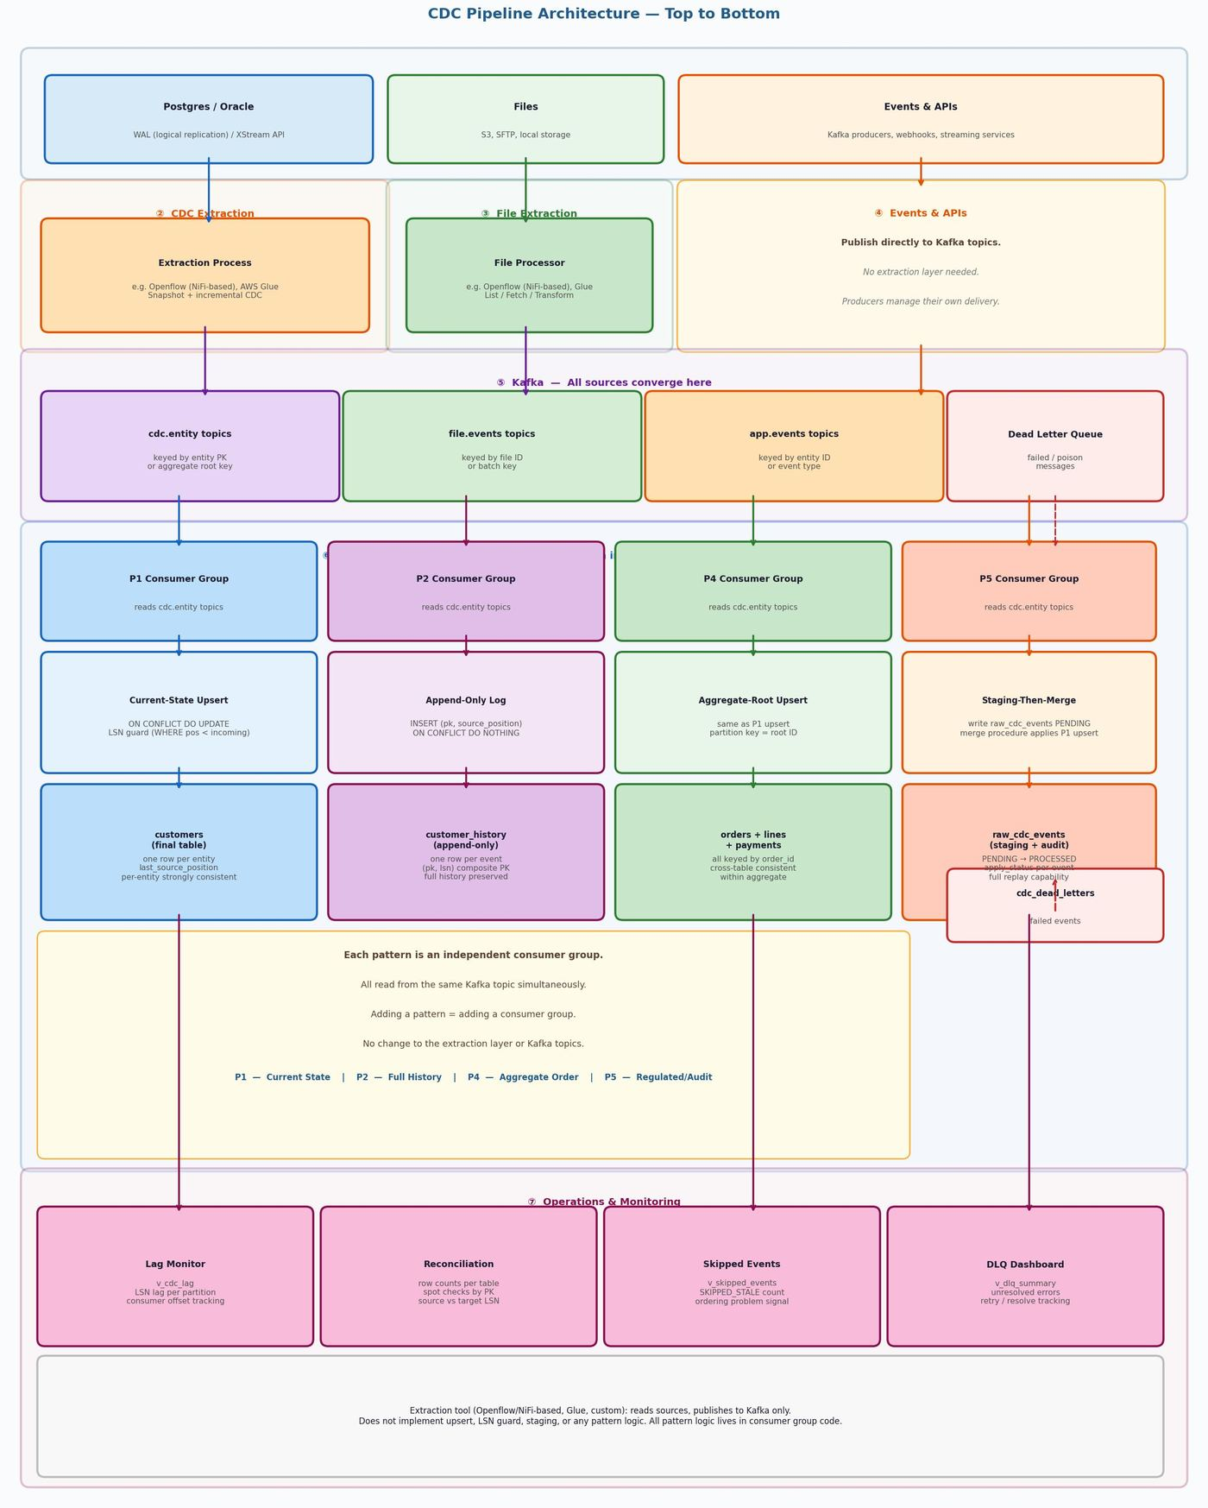
Figure 1 — Full architecture top to bottom: Sources → Extraction Process → Kafka → Consumer Group → Sink Patterns → Ops

Source Types
Postgres (CDC) | WAL via logical replication. Extraction process reads using CaptureChangePostgreSQL or equivalent.
Oracle (CDC) | XStream API. Extraction process reads via OCI driver. Recommended: Openflow Oracle connector (GA, co-engineered with Oracle).
Files | S3, SFTP, local filesystem. Extraction process uses ListS3/FetchS3Object or equivalent file processors.
Events & APIs | Publish directly to Kafka. Kafka producers, webhooks, streaming APIs. No extraction layer needed.

Extraction Process
The extraction process reads from databases and files and publishes to Kafka. The specific tool used is a deployment decision. Candidates:
- Openflow (NiFi-based) — recommended for CDC from Postgres and Oracle. Managed service (SPCS or BYOC). Handles snapshot + incremental, schema changes, at-least-once delivery.
- AWS Glue — alternative where Openflow is not available or Glue is the existing standard.
- Custom NiFi — if self-hosted NiFi is already in use.
- Custom code — for simple cases or where existing tooling already handles extraction.

EXTRACTION SCOPE | The extraction process reads source data and publishes to Kafka. It does not implement any sink pattern logic (upsert, LSN guard, append-only, staging). All pattern logic lives in the Kafka consumer layer downstream.

Note: Openflow also supports S3 as both source and destination via ListS3 + FetchS3Object (read) and PutS3Object (write) processors. Useful for file ingestion and raw event archival alongside CDC.

The Five Patterns
No single pattern solves every requirement. Most production systems run 2–3 simultaneously from the same Kafka topic. The patterns are additive — you choose which ones to add based on requirements. All five can be fed from the same Kafka topic simultaneously.

Pattern | Name | Primary Use | Combine With
P1 | Current-State Upsert | APIs, dashboards, serving layer, current state queries | P2, P4, P5
P2 | Append-Only Log | Audit trail, compliance, GDPR, event sourcing, time-travel | Always with P1
P3 | Transactional Outbox | Cross-service messaging, strictly consistent event delivery | P1 or P2 at consumer
P4 | Aggregate-Root Partition | Multi-table aggregates needing cross-table ordering | P1 variant + P2
P5 | Staging-Then-Merge | Regulated/audit-heavy systems, incident replay without re-reading Kafka | Always with P1

Note: P1 is always the base. P2, P4, P5 add capabilities on top of P1. P3 is a producer-side pattern that applies before Kafka. See the individual pattern documents for full detail.

Decision Guide
Work through the questions below. Each YES adds a pattern. A typical production system answers YES to 2–3 questions.

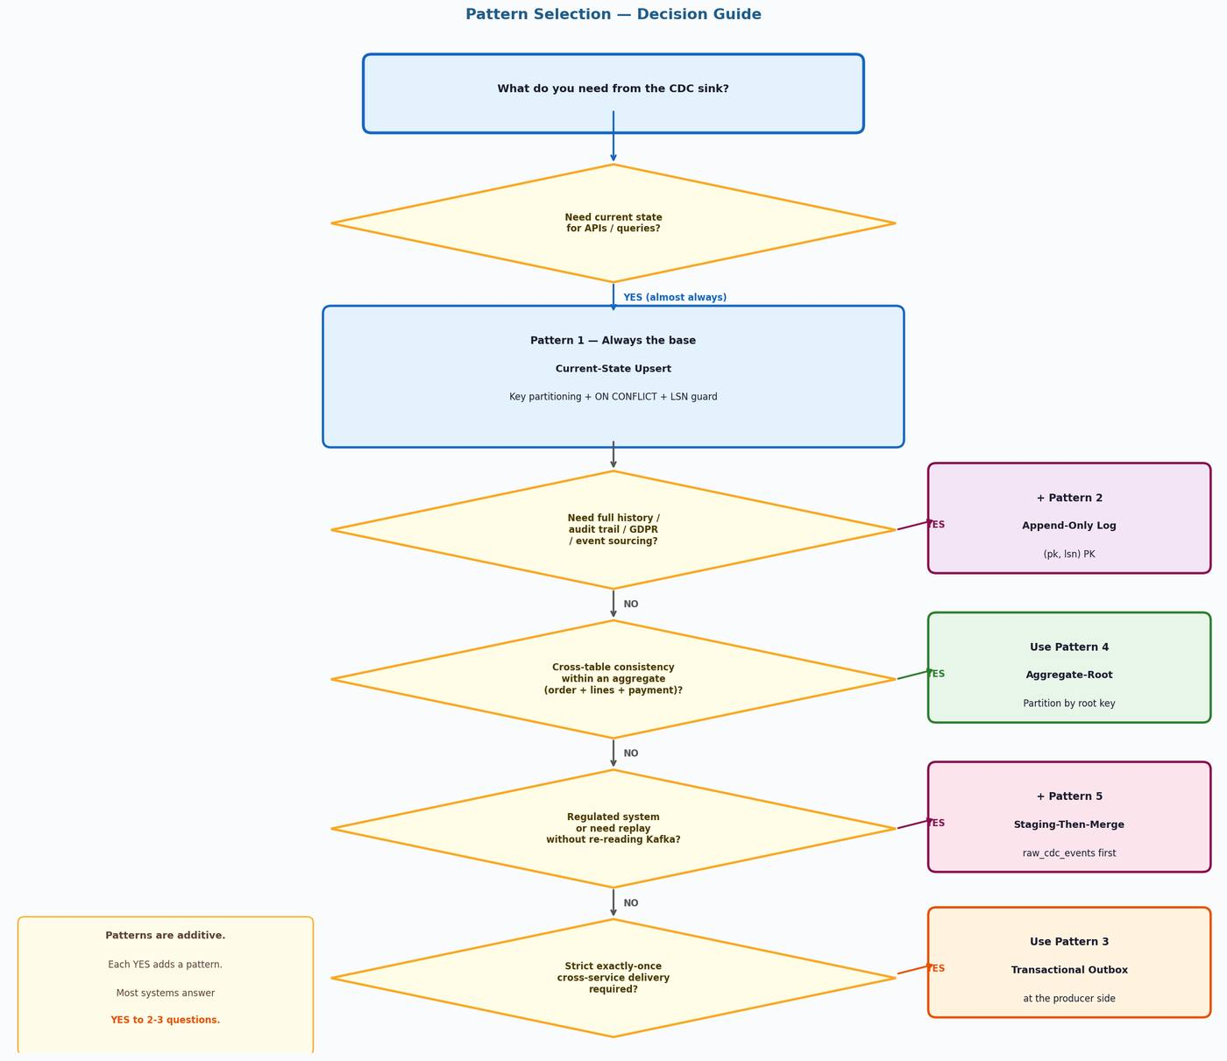
Figure 2 — Pattern selection flowchart: each YES adds a pattern, they are not mutually exclusive

Consistency Model
This pipeline is eventually consistent by default. Key-based partitioning tightens it to per-entity strong consistency. This is the most important concept in the document.

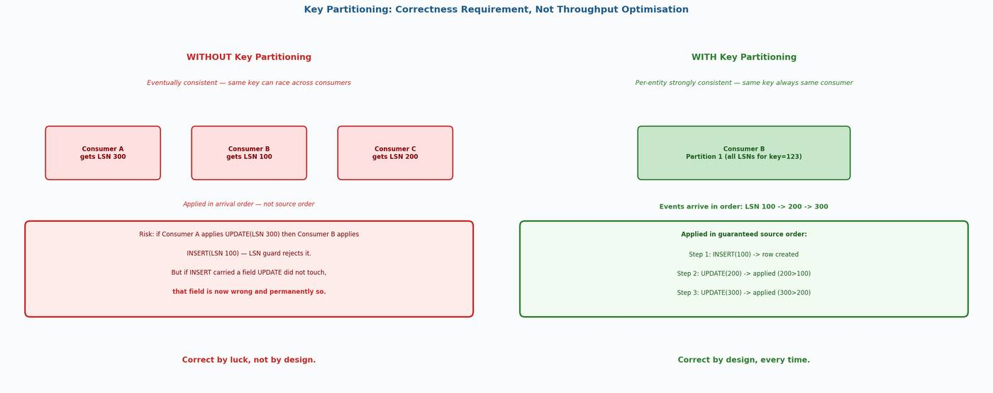
Figure 3 — Without vs with key partitioning: correctness by design, not by luck

Three Mechanisms
Mechanism | What it does | What it does NOT do
Key partitioning | All events for the same entity arrive at the same consumer in source order. | Does not prevent side effects re-firing after a crash restart.
ON CONFLICT DO UPDATE  (upsert) | Prevents duplicate rows in the target table. Standard Postgres merge. | Does not prevent side effects re-firing on a replayed event.
LSN guard  (WHERE pos < incoming) | Rejects stale replays after crash. Rejects late out-of-order arrivals. | Does not guarantee ordering — that is key partitioning's job.

Common Combinations
API + audit trail | P1 + P2. P1 serves the API; P2 feeds compliance and GDPR tooling.
Order management | P4 + P2. P4 gives consistent aggregate views; P2 gives full event history per order.
Regulated / financial | P1 + P2 + P5. P5 staging adds replay capability without re-reading Kafka.
Microservice events | P3 (publisher) + P1 or P2 (consumer). P3 guarantees reliable delivery; P1/P2 persist.
Data warehouse feed | P2 into warehouse for analytics. P1 into Postgres for operational queries. Both from same stream.
File + CDC together | Files and CDC events both flow through extraction process into Kafka. Same consumer patterns apply.

Document Map
Doc 0 (this) | Overview, architecture, source types, extraction tool guidance, decision guide, consistency model
Doc 1 — P1 | Current-State Upsert: critical rules, sequence, SQL, DDL, failure scenarios, reconciliation
Doc 2 — P2 | Append-Only Log: sequence, DDL, query patterns, GDPR, relationship to P1, retention strategy
Doc 3 — P3 | Transactional Outbox: dual-write problem, relay options, DDL, pruning, idempotency on retry
Doc 4 — P4 | Aggregate-Root Partitioning: sequence, key config, DDL (no FK constraints), limitations
Doc 5 — P5 | Staging-Then-Merge: full sequence, raw_cdc_events as staging+audit, merge, batching, replay

CDC Pipeline Patterns — Doc 0: Overview & Decision Framework

